WordPress Day 3 – Assignment – Sandhya Shiwakoti

This assignment uses a fresh Underscores theme. The code is organized into separate files inside an inc/ folder rather than putting everything in functions.php.
The file structure we will create is:

day3-theme/
inc/
cpt-team.php - Custom post type
taxonomy-department.php - Custom taxonomy
metabox-team.php - Metabox and custom fields
assets/
css/
team.css - Custom styles
js/
team.js - Tab functionality
page-team.php - Page template
functions.php - Includes all inc/ files + enqueues assets

Step 1: Get the Underscores Theme

Step 1a: Go to underscores.me, enter a theme name day3-theme.


Step 1b: Go to WordPress dashboard → Appearance → Themes → Add New → Upload Theme → choose the downloaded zip → Install Now → Activate.
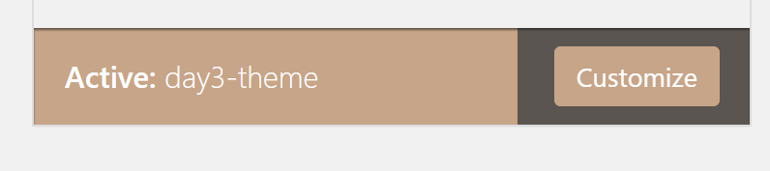

Step 1c: Open the theme folder in VS Code. The theme is located at app/public/wp-content/themes/day3-theme
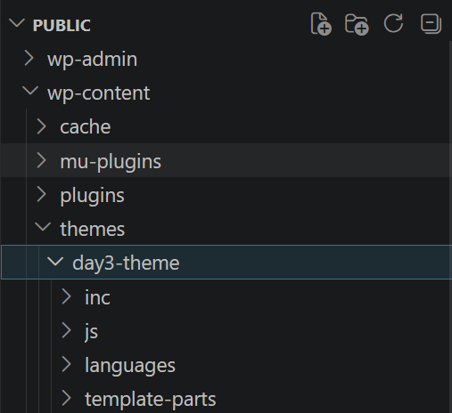

Step 2: Create the inc/ Folder and Custom Post Type

Inside the inc/ folder, create a new file called cpt-team.php and add the following code:
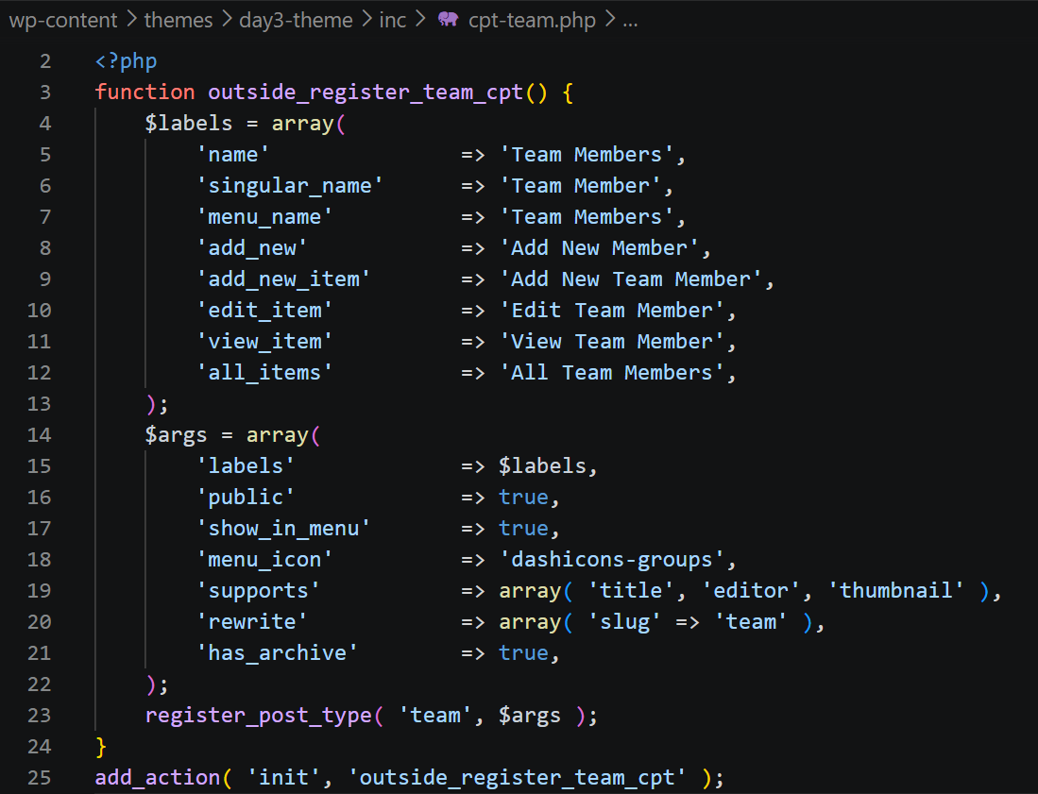

Step 3: Create the Custom Taxonomy - Department

Step 3a: Inside the inc/ folder, create a new file called taxonomy-department.php and add the following code:
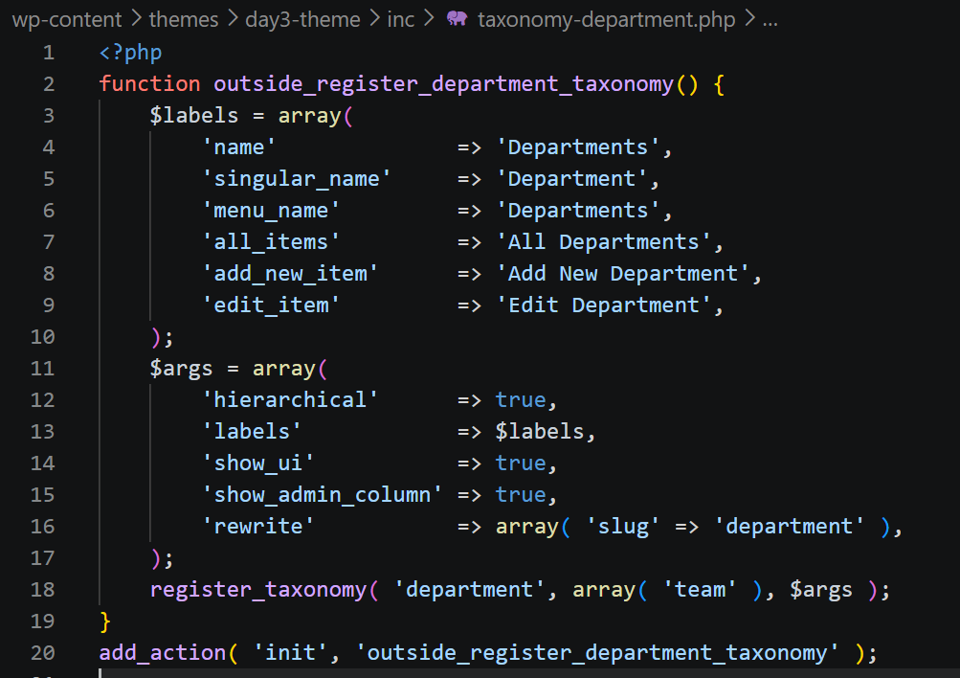

Step 3b: After saving, go to WordPress dashboard → Team Members → Departments. Add multiple departments.

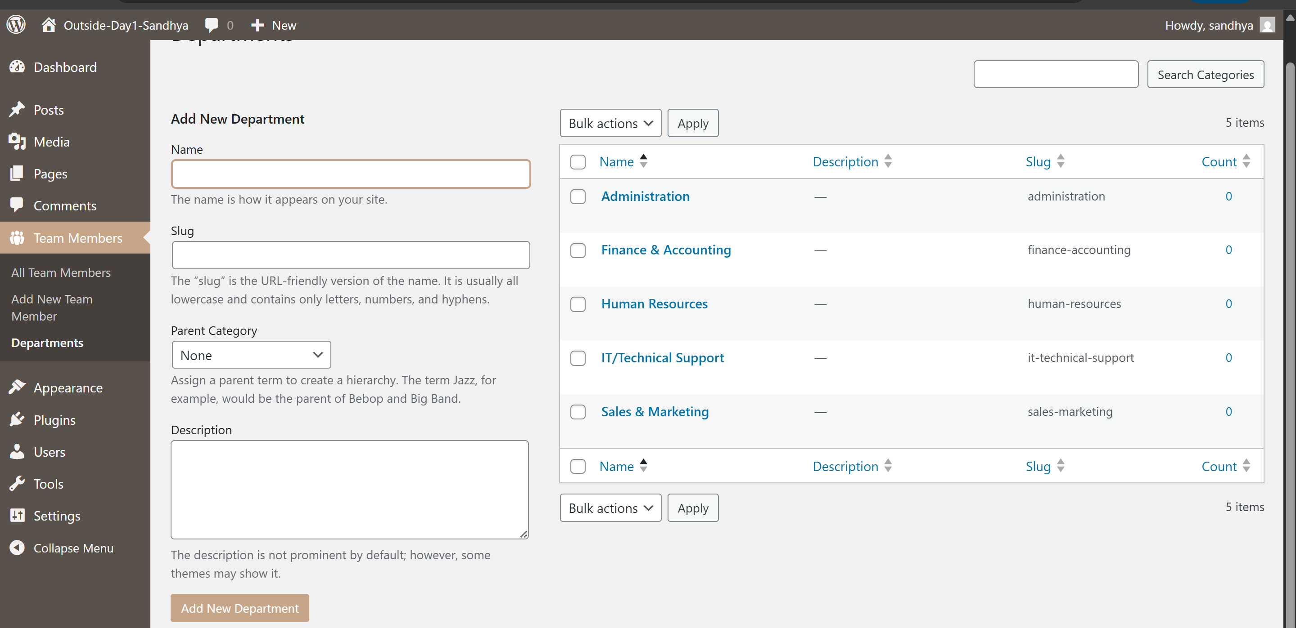

Step 4: Create the Metabox and Custom Fields

Step 4a: Inside the inc/ folder, create a new file called metabox-team.php and add the following code:
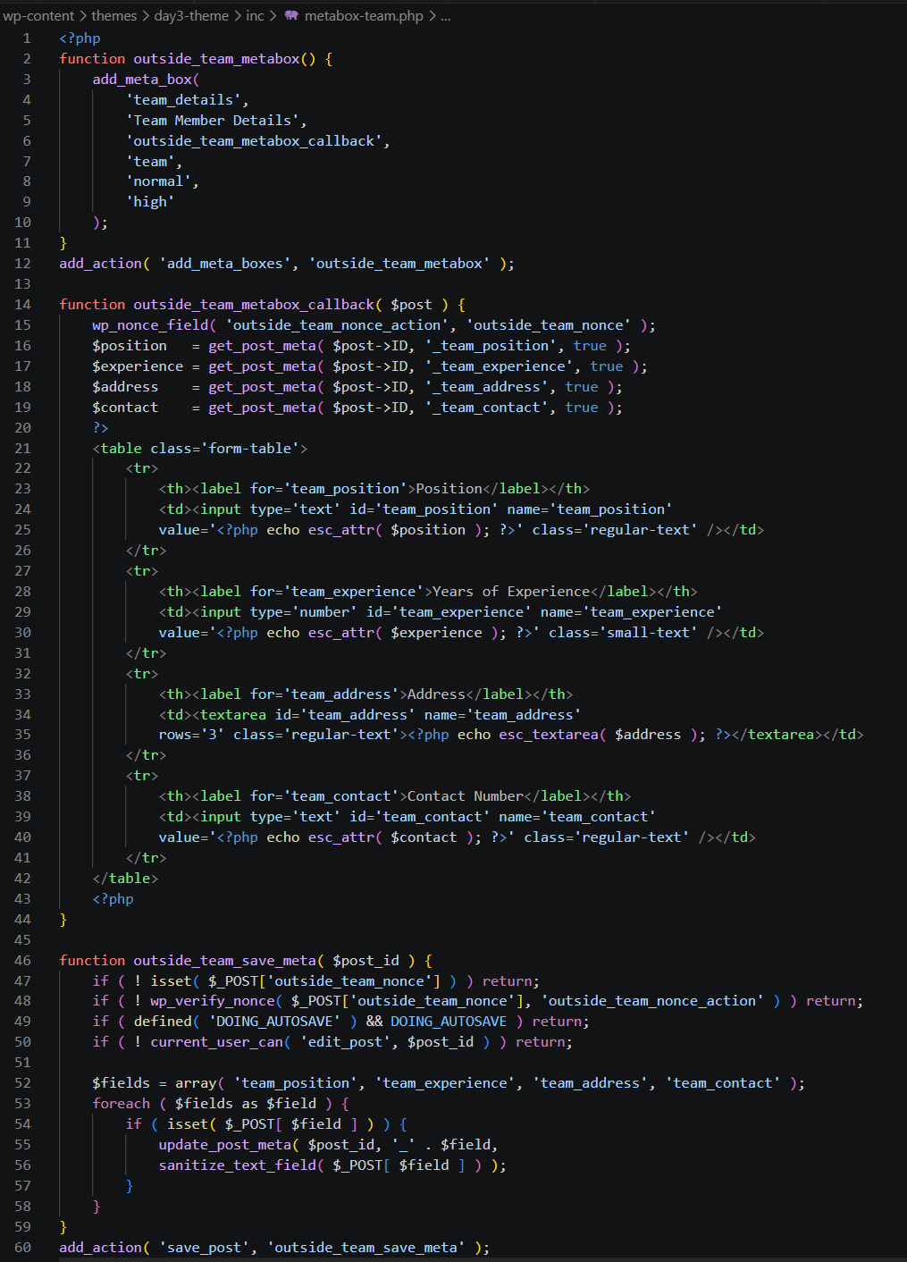

Step 5: Update functions.php to Include All Files and Enqueue Assets

Step 5a: Open functions.php, add these require lines:

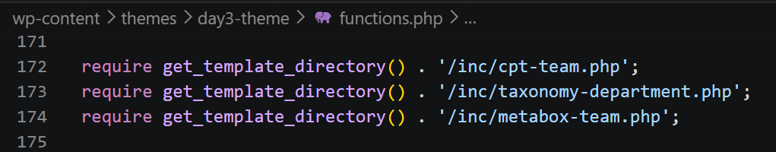

Step 5b: Also add this function in functions.php to enqueue the custom CSS and JS files:
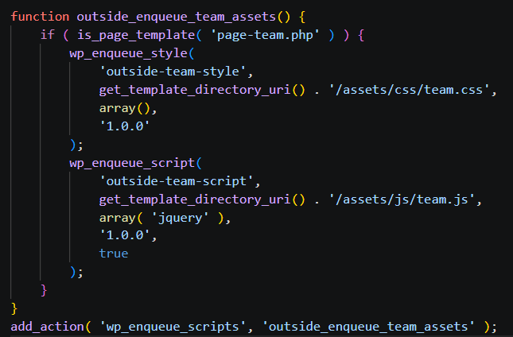

Step 6: Create the CSS and JS Asset Files

Step 6a: Inside the theme folder, create these folders: assets/css/ and assets/js/

Step 6b: Inside assets/css/ create a file called team.css and team.js and add the following codes:
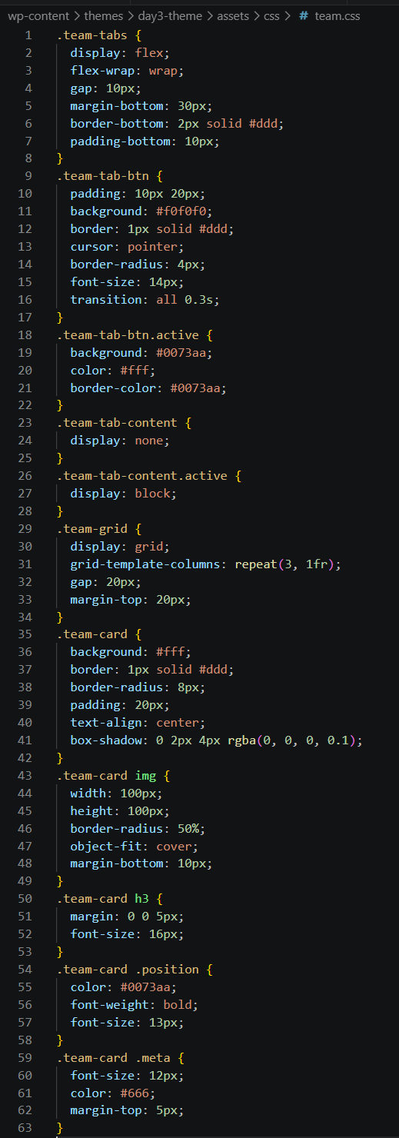
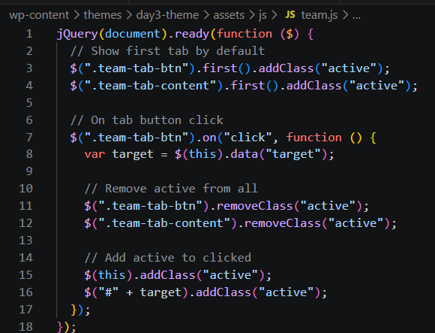

Step 7: Create the Page Template - page-team.php

In the root of the theme folder, create a new file called page-team.php and add the following code:

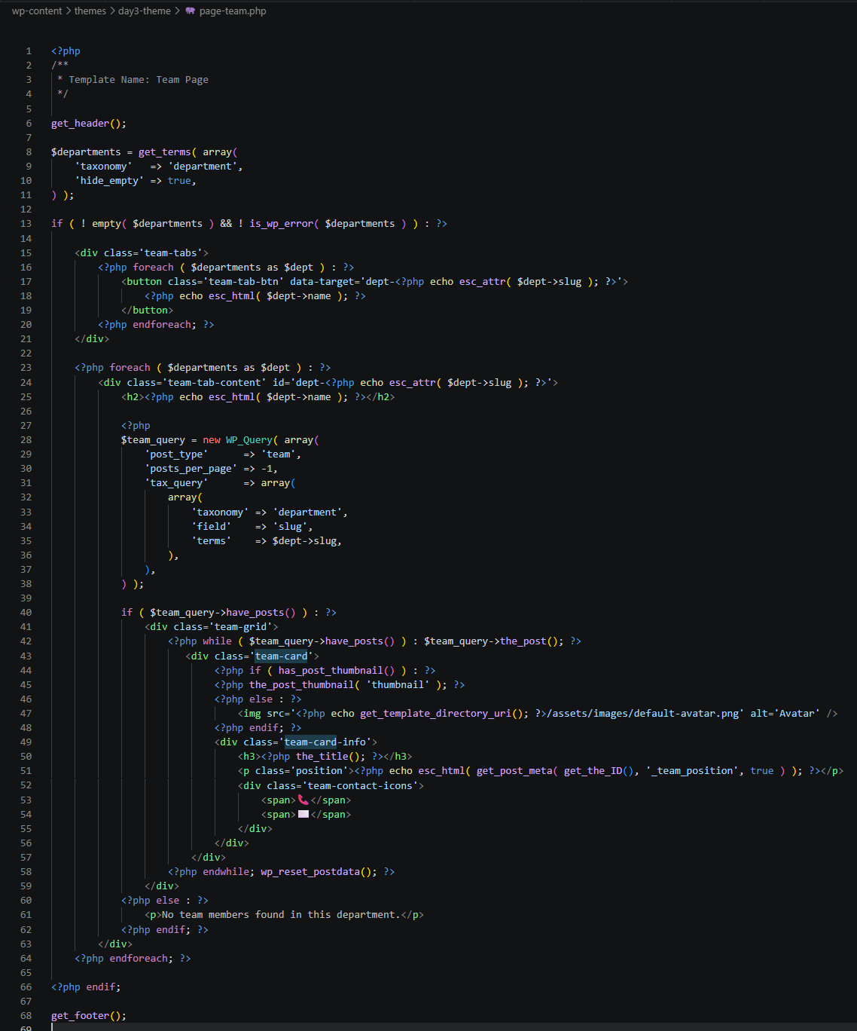

Step 8: Add Team Members

Step 8a: Go to WordPress dashboard → Team Members → Add New. For each team member fill in the form:
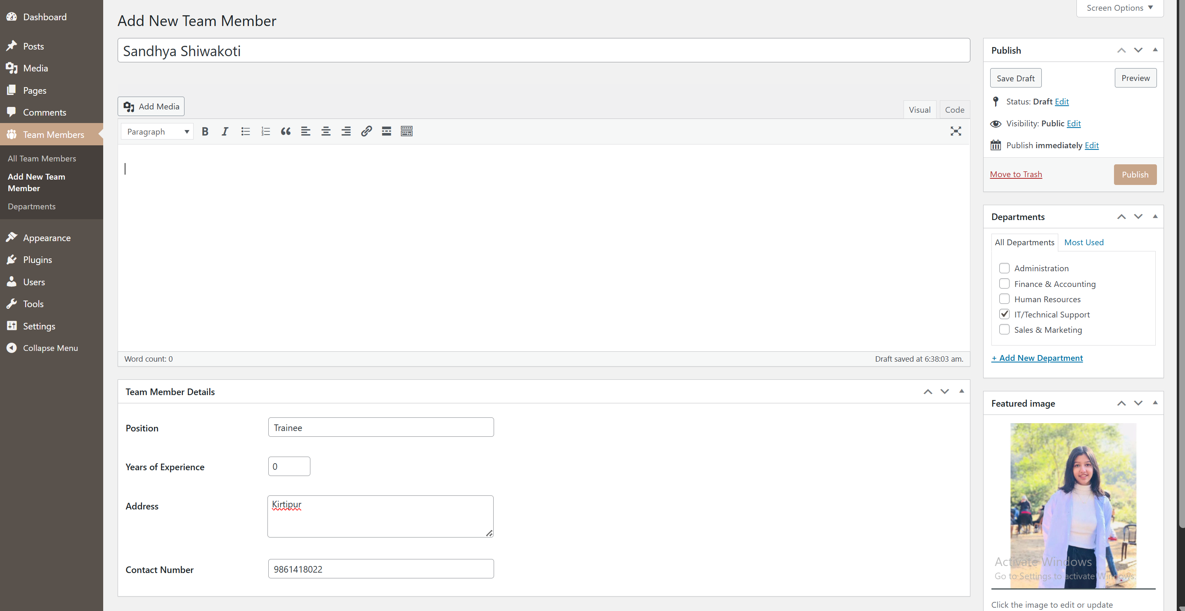

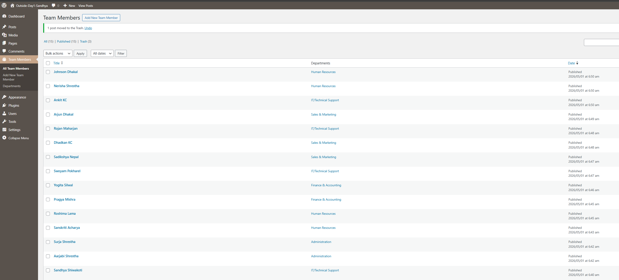
Add at least 15 team members spread across the different departments.
Step 9: Create the Team Page and Assign the Template

Step 9a: Go to WordPress dashboard → Pages → Add New, Title: Our Team.
Step 9c: In the right sidebar under Page Attributes, find the Template dropdown and select Team Page.
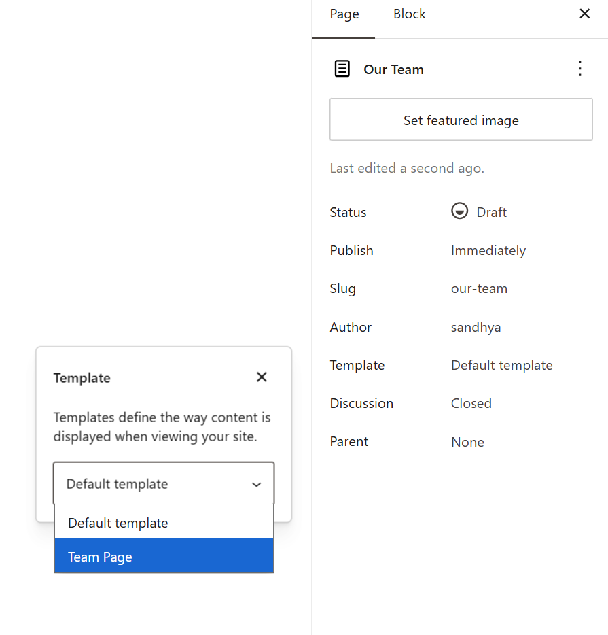

Step 9d: Click Publish. Then click View Page to see the team members displayed in tabs by department.
