1.

#include<stdio.h>

int main() {

   int a, b, sum;

   printf("\nEnter two no: ");

   scanf("%d %d", &a, &b);

   sum = a + b;

   printf("Sum : %d", sum);

   return(0);

}

Output:

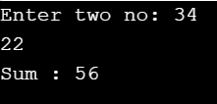

2.

#include<stdio.h>

int main() {

float celsius, fahrenheit;

printf("\nEnter temp in Celsius : ");

scanf("%f", &celsius);

fahrenheit = (1.8 \* celsius) + 32;

printf("\nTemperature in Fahrenheit : %f ", fahrenheit);

return (0);

}

Output:

