RECRUITMENT POLICY

**TABLE OF CONTENTS**

1. **OBJECTIVE**
   1. **BACKGROUND**
   2. **PURPOSE**
   3. **SCOPE**
   4. **EXEMPTIONS**
   5. **RE-HIRE CLAUSE**
2. **FUNCTIONAL OBJECTIVES**
   1. **RECRUITMENT PROCESS**
   2. **CHANGES TO RESOURCE REQUEST**
   3. **APPOINTMENT**
   4. **DOCUMENT REFERENCE**
   5. **FLOW CHART**
3. **DISCLAIMER**

\

|  |  |  |  |  |
| --- | --- | --- | --- | --- |
| **DOCUMENT REVISION HISTORY** | | | | |
| **Release Version** | **Modified Date** | **Modified By** | **Changes** | **Approval Authority** |
| 2 | 01-11-2019 | HR Operations | Recruitment Policy guidelines | Head, HR |
|

1. **OBJECTIVE**

Recruitment is the process which links the employers with the employees. The main objective of recruitment process is when a vacancy comes up; the employer needs to get a most suitable candidate available for the job. The objective of selection process is to get a best applicant available who meets all the selection criteria.

The purposes of recruitment are as follows:

* Attract and empower an ever-increasing number of applicants to apply in the organization.
* Build positive impression of the recruitment process.
* Create a talent pool of candidates to enable the selection of best candidates for the

organization.

* To attract and engage people it needs to achieve its overall organizational objectives
* Increase the pool of job candidates at minimum cost.
* Recruit right people who will fit in to organizations culture and contribute to the

organizations goals.

* Determine Current and future requirements of the organization in conjunction with its

personnel planning and job analysis activities.

* It helps to upward the achievement rate of choice process by diminishing number of

unmistakably under-qualified or overqualified work candidates.

* It helps decrease in the likelihood that activity candidates once enlisted and chose will leave

the organization after a brief time frame.

* Meet the organizations lawful and social commitments with respect to the synthesis of its

workforce.

* Begin identifying and preparing potential job applicants who will be appropriate candidates.
* Increment organization and individual effectiveness of different selecting systems

temporarily and long haul.

* Evaluate the effectiveness of various recruiting technique and sources for all types of job

applicants.

**1.1 BACKGROUND**

The Recruitment and selection is the major function of the human resource department and recruitment process is the first step towards creation of the competitive strength and the strategic advantage for the organizations. Recruitment process involves a systematic procedure from sourcing the potential candidates to on boarding them to fulfill hiring needs to meet Business goals.

**1.2 PURPOSE**

The process defines the recruitment steps performed at Supremology India, in order to have a successful and efficient recruitment of competent employees. Supremology Recruiting Policy, outlining how Supremology should conduct its recruitments, is the first step towards creation of the competitive strength and the strategic advantage for the company.

**1.3 SCOPE**

This process encompasses the following activities

1. Recruitment Hiring from Consultant Level, Internship, Level 1- Level 8
2. Evaluation, Selection, Offers & Joinees

**1.4 EXEMPTIONS**

Supremology values academic achievements as it maintains high quality standards in the academic background and consequently on the knowledge of the potential candidates. It should however not be a barrier to getting a foot in the door. If a candidate has less than a 4-years’ university degree (except for Technicians and Advanced Technicians), then the potential should be assessed during the hiring process. An exception can also be made for specific fields (e.g. Mobile, Java Scrum, .Net, other technical skills, some Support Functions jobs etc.) if a candidate has strong certifications or experience.

**1.5 RE-HIRE CLAUSE**

Employee separation on the below mentioned grounds will not be eligible for rehire

* Violation of Code of Conduct
* Absconding
* POSH
* Performance Issue
* Workplace misbehavior

Employee who have voluntarily separated from the company can be rehired after a cooling period of 6 months from their exit date with prior approvals from Engineering & HR Head.

1. **FUNCTIONAL OBJECTIVES**

Objectives of the Recruitment Process:

Cost effectiveness by focusing on recruitment from various sources

* Employee Referral- 25% ; Agency-15% ; Others-60%
* Position Fulfillment - 30 - 120 Days

**2.1 RECRUITMENT PROCESS**

## **RESOURCE REQUEST**

Based on the business needs and the project requirements in the department, Resource Request Form is filled by the concerned hiring manager.

A Resource Request form includes a brief description of Supremology, a short summary of the role’s purpose, a list of responsibilities, a list of requirements, contract type, start date, location.

The Recruitment Manager delegates the request to the concerned RECRUITER. The RECRUITER shall enter the details into Recruitment tracker to monitor further progress.

In case due to project needs or business needs the approved resource request has to be cancelled, the Requesting Manager shall send an e-mail to the RECRUITER for the same. If the hiring manager does not act upon (short listing profiles, conducting interviews etc.) on open resource request for more than 4 weeks, then the request shall stand cancelled or the ageing of the requirement will get reset.

## **SOURCING AND PRELIMNARY SCREENING**

### **External Sources**

Recruitment team will launch the activity of sourcing the talent as per the requirements through various sources. Choice of one or multiple sources will be made depending on the skill availability and timeframe available to recruit. The various sources explored are mentioned below

* Job Portals (Naukri.com, Monster, etc.)
* Social Media (LinkedIn, Twitter, Facebook)
* Campus placements
* Employee Referrals
* Walk in applicants
* Recruitment Agencies (Consultants)
* Advertisements
* Direct applications from candidates
* Current Resume Database
* Other sources

## **SCREENING**

### **Initial HR Screening**

Based on the relevance, Recruitment Team will source and then shortlist suitable candidates as per the specifications mentioned in Resource Request Form. The recruiter will share the screened profiles with the hiring manager for further shortlisting. Manager Shortlisting step can be skipped in case of walk in tests / fresher tests.

The shortlisted candidates will be intimated regarding the preliminary test/interview via email.

### **Technical Interview**

Technical Screening process can include aptitude tests, technical tests, tool tests and technical Interviews. A choice of screening methodology is made based on the applicant’s skill, technical competencies and experience level.

The technical interview will be conducted by a panel of interviewers selected by the hiring manager / Delivery Head. This interview aims to test the skills, domain expertise, and technical competence of the candidate & the findings are recorded in the Candidate Evaluation Form.

### **Manager Interview**

After the Technical assessment, the Delivery manager/ Head will conduct the final interview. Based on the performance of the candidate

### **HR interview**

If the candidate is found technically suitable at the first level, the Recruiter shall conduct HR interview. The interview aims to test the communication skills, attitude, cultural fitment, job fit and motivation. Salary fitment shall be checked during the HR assessment.

## **Offer Process**

Once a candidate is selected, Hiring Manager/Business Unit Director will approve the offers.

RECRUITER will prepare the offer letter and give to the candidate. The recruitment tracker will be updated at each stage of the recruitment process. The offer letter contains salary, required date of joining, department he/she will be joining and the below documents that need to be submitted to Supremology technologies India by the Employee on the actual date of joining. Candidate is given 3-5 working days to accept the offer. If the candidate accepts the offer, he/she will countersign the offer letter copy and return it to the HR/Accepts the offer through email.

Candidates will be asked to submit relevant documents like

1. Aadhar Card & PAN card (Identity proof)
2. Educational certificates (All degree certificates including the semester marks sheet).
3. Passport size photograph
4. Last 3 months salary slips
5. Reliving / Experience letter (from all the last organizations)

## **Background Verification and Pre-Employment Medical Test**

Post the offer acceptances from the candidate, detailed background verification is done through third party vendor and ensure their Pre-employment medical test is done.

## **Post Offer Engagement**

Prospective joinees engagement is managed by concerned TA Manager, Recruiter and Hiring Manager. Various strategies followed are mentioned below

1. Weekly follow-up calls by recruiters
2. Circulating company’s Newsletters & Corporate communications for the better understanding about the organization
3. Every fortnight or monthly lunch sessions with the TA Manager or Hiring Manager
4. Explaining them about our beneficial policies and the extended referral policy

**2.2 CHANGES TO RESOURCE REQUEST**

The changes to Resource Request are envisaged as follows

|  |  |  |
| --- | --- | --- |
| **SL No** | **Change Envisaged** | **Action** |
| 1 | Change in skill, Competence Requirements, Nature of Position (Permanent to Contract OR Contract to Permanent) | New Resource request form to be raised |
| 2 | Increase in number of positions | New Resource request form to be raised |
| 3 | Decrease in number of positions | Mail notification received from the Requesting manager is attached to the Resource request or the Hiring Request form is updated with an acknowledgment by the Requesting manager |
| 4 | The Hiring need is put on hold after approval. | Mail notification (requesting to hold the requirement) should be attached with the Resource Request. A request can be put on hold for a maximum of 2 weeks beyond which the resource request will stand cancelled. |

**2.3 APPOINTMENT**

On the date of joining the candidate will submit all the necessary documents to the HR SPOC. The appointment letter mentions the employment terms and conditions, compensation & benefit details. The acknowledgement copy of these documents is submitted back to the HR representative. This forms a record in the individual’s dossier. HR initiates the joining formalities and introduces the new joinee to SUPREMOLOGY India through mail.

**2.4 DOCUMENT REFERENCE**

Please refer to Intranet

1. Resource Request Form
2. Assessment Form
3. Background Verification Form
4. Offer Letter
5. Expense Claim Form (Interview and Recruitment)
6. Recruitment Tracker

**2.5 FLOW CHART**

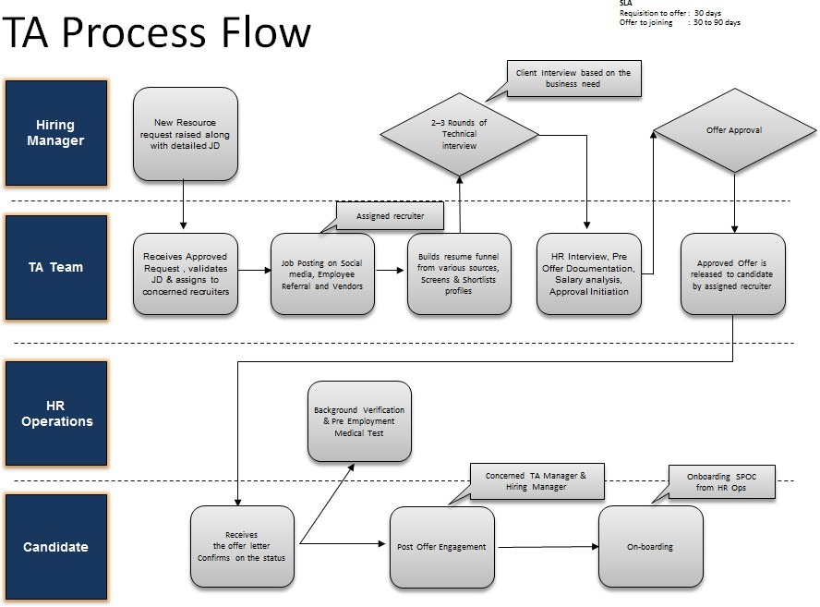

1. **DISCLAIMER**

This policy and its contents are confidential and intended solely for the use by employees of Supremology Software Services Pvt. Ltd. Transmitting, Disclosing, Copying, distributing these contents to other than the intended recipient / users are strictly prohibited. It is the sole discretion of the Management to change, amend the entire policy and/or its clause/s from time to time and/or withdraw the same, without any notice. This policy supersedes all earlier versions if any.