**DOCUMENTATION FOR PIZZA SALES ANALYSIS**

**KPI’s Requirement**

We need to analyse key indicators for our pizza sales data to gain insights into our business performance. Specifically, we want to calculate following Metrics.

**1.Total Revenue**

====================================

Select sum(total_price) as Total_Revenu from pizza;

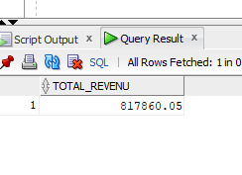

**2.Average order value**

====================================

select round((sum(total_price)/count(Distinct order_id)),2) as Average_order_value from pizza_sales;

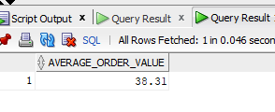

**3.Total pizzas sold**

======================================

Select sum(Quantity) as Total_pizza_sold from pizza_sales;

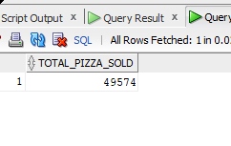

**4.Total orders**

=====================================

select count(distinct order_id) as Total_orders from pizza_sales;

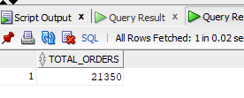

**5.Average pizza per order**

===============

Select round((sum(Quantity)/(count(distinct order_id))),2) as Avg_pizza_per_order from pizza_sales;

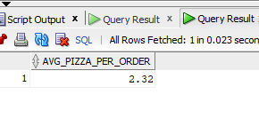

* After Exploring data in Oracle SQL, we are using power BI for Visualization for KPI’s

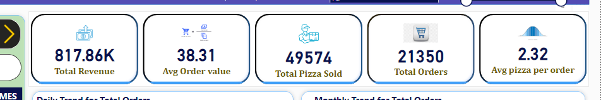

**Charts Requirements**

We Would like to visualize various aspects of our pizza sales data to gain insights and understand key trends. We have identified the following requirements for creating charts

**6.Daily Trend for total Orders**

======================================

select to_char(order_date,'Day') as Week_day, count(distinct order_id) as total_orders

from pizza_sales

group by to_char(order_date,'Day');

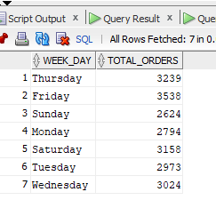

* After Exploring data in Oracle SQL. We are cleaning the data using power query in power BI. we are using power BI for visualise the Daily Trend for total orders

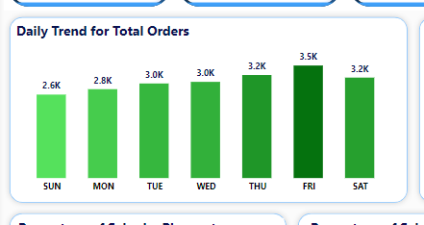

**7.Monthly trend for total orders**

============================

select to_char(order_date,'Month') as Month_name, count(distinct order_id) as total_orders

from pizza_sales

group by to_char(order_date,'Month');

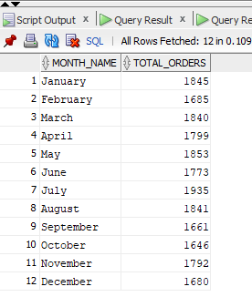

* After Exploring data in Oracle SQL. We are cleaning the data using power query in power BI. we are using power BI for visualise the Monthly trend for total orders

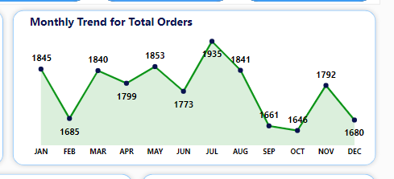

**8.Percentage of sales by pizza category**

=========================================

--select sum(total_price) from pizza_sales

select pizza_category, sum(total_price) as total_revenue, round(sum(total_price)*100/(Select sum(total_price) from pizza_sales),2) as percent_pizza_category from pizza_sales

group by pizza_category

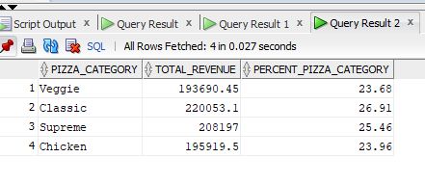

* After Exploring data in Oracle SQL. We are cleaning the data using power query in power BI. we are using power BI for visualise the Percentage of sales by pizza category

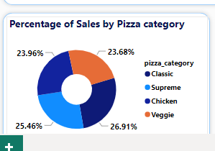

**9.percentage of sales by pizza size**

======================================

select pizza_size, sum(total_price) as total_revenue, round(sum(total_price)*100/(Select sum(total_price) from pizza_sales),2) as percent_pizza_category from pizza_sales

group by pizza_size

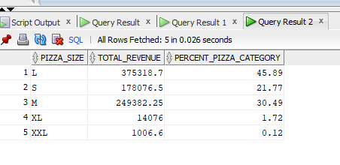

* After Exploring data in Oracle SQL. We are cleaning the data using power query in power BI. we are using power BI for visualise the percentage of sales by pizza size

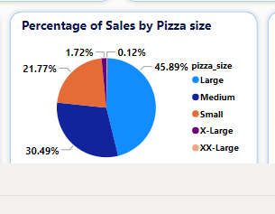

**10.Total pizzas sold by pizza category**

=============================================s

select pizza_category, sum(Quantity) as total_Quantity from pizza_sales

group by pizza_category

order by 2

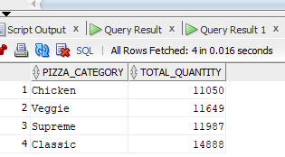

* After Exploring data in Oracle SQL. We are cleaning the data using power query in power BI. we are using power BI for visualise the Total pizzas sold by pizza category

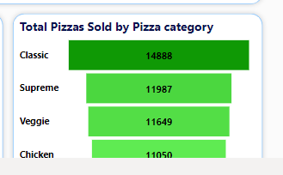

**11.Top 5 best sellers by revenue**

===============================================

SELECT pizza_name, SUM(total_price) AS Total_Revenue

FROM pizza_sales

GROUP BY pizza_name

ORDER BY Total_Revenue DESC

fetch first 5 rows only

-- usin CTE

with row_num as

(

SELECT pizza_name, SUM(total_price) AS Total_Revenue

FROM pizza_sales

GROUP BY pizza_name

ORDER BY Total_Revenue DESC

)

select pizza_name, total_revenue from row_num

where rownum <= 5

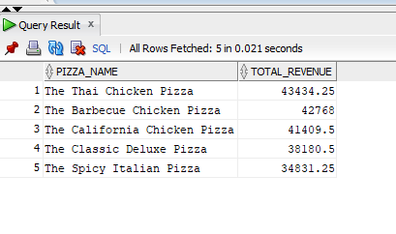

* After Exploring data in Oracle SQL. We are cleaning the data using power query in power BI. we are using power BI for visualise the Top 5 best sellers by revenue

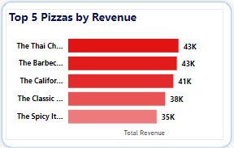

**12. Bottom 5 pizzas**

====================================

SELECT pizza_name, SUM(total_price) AS Total_Revenue

FROM pizza_sales

GROUP BY pizza_name

ORDER BY Total_Revenue

fetch first 5 rows only

--Using CTE

with row_num as

(

SELECT pizza_name, SUM(total_price) AS Total_Revenue

FROM pizza_sales

GROUP BY pizza_name

ORDER BY Total_Revenue

)

select pizza_name, total_revenue from row_num

where rownum <= 5

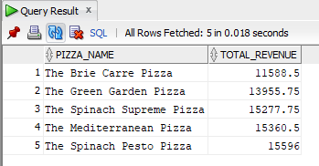

* After Exploring data in Oracle SQL. We are cleaning the data using power query in power BI. we are using power BI for visualise the Bottom 5 pizzas by revenue

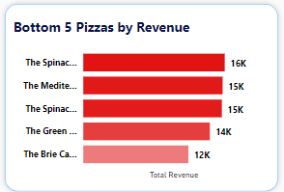

**13. Top 5 pizzas by Quantity**

=================================

SELECT pizza_name, SUM(Quantity) AS pizza_sold

FROM pizza_sales

GROUP BY pizza_name

ORDER BY pizza_sold desc

fetch first 5 rows only

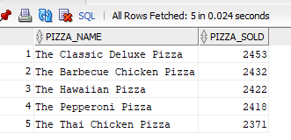

* After Exploring data in Oracle SQL. We are cleaning the data using power query in power BI. we are using power BI for visualise the Top 5 pizzas by Quantity

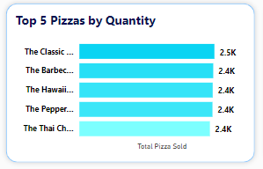

**14.bottom 5 pizzas by quantity**

=================================

SELECT pizza_name, SUM(Quantity) AS pizza_sold

FROM pizza_sales

GROUP BY pizza_name

ORDER BY pizza_sold

fetch first 5 rows only

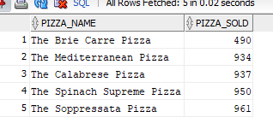

* After Exploring data in Oracle SQL. We are cleaning the data using power query in power BI. we are using power BI for visualise the bottom 5 pizzas by quantity.

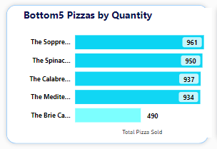

**15.Top 5 pizzas by total orders**

====================================

SELECT pizza_name, count(distinct order_id) AS total_orders

FROM pizza_sales

GROUP BY pizza_name

ORDER BY total_orders desc

fetch first 5 rows only

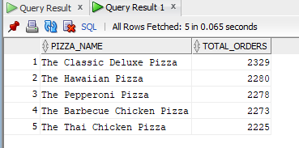

* After Exploring data in Oracle SQL. We are cleaning the data using power query in power BI. we are using power BI for visualise the Top 5 pizzas by total orders.

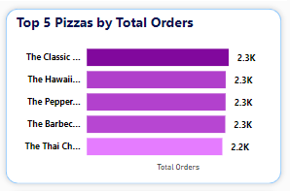

**16.bottom 5 pizzas by total orders**

====================================

SELECT pizza_name, count(distinct order_id) AS total_orders

FROM pizza_sales

GROUP BY pizza_name

ORDER BY total_orders

fetch first 5 rows only

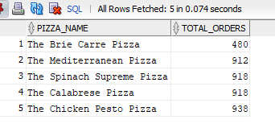

* After Exploring data in Oracle SQL. We are cleaning the data using power query in power BI. we are using power BI for visualise the bottom 5 pizzas by total orders.

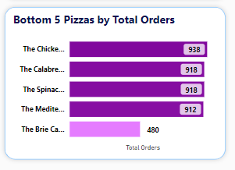

**Complete Visualization for Pizza Sales**

