Description of the General Coliform Model

General
The General Coliform Model is a predefined set of selected state variables, active processes, editable input and output parameters. It has been constructed with the Processes Library Configuration Tool and experienced users may use the same tool to edit the predefined set. This describing document is linked to the files:

Name of PLCT input file | coli_03.0
Name of substance file | coli_03.sub

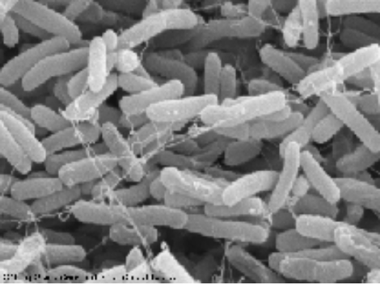
Introduction
Coliform bacteria originate from human and animal faeces and are often used as indicator for the presence of disease factors. The coliform group of bacteria comprises all aerobic and facultative anaerobic, gram-negative, nonspore-forming, rod-shaped bacteria that ferment lactose with gas formation within 48 hr at 35ºC (Thomann and Mueller, 1987). Escherichia coli is the best known member of this group.

As soon as coliform bacteria have been discharged into surface water, they start to die since the conditions that these bacteria meet, are essentially hostile to them. The mortality of coliform bacteria is enhanced by temperature, salinity and solar radiation. The lethal effect of light is associated with short wavelengths, ultraviolet radiation in particular.

The table below gives an overview of the selected state variables and processes.

Substance Group | State variable | Model name | Processes
Coli-Bacteria | Escherichia coli | EColi | Mortality EColi bacteria
General | Salinity | Salinity | –
Suspended matter | Inorganic matter (cohesive sediment) | IM1 | –
Extra processes
- Extinction of ultraviolet light
- UV-Radiation at segment upper and lower boundary
- Calculation of chloride concentration

Description of Processes
For a formal description refer to the Technical Reference Manual (TRM) for the individual processes of the Processes Library.

E. Coli
The mortality rate of E. Coli depends on the ambient salinity (or chloride concentration), temperature and the intensity of the UV radiation.

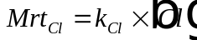
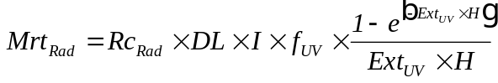

Input item | Description | Unit | Default value | Editable | Range
(E.Coli) | concentration of coliform bacteria | MPN.m⁻³ | n.a. (state variable) | n.a. | –
DL | daylength | d | 0.58 | yes | depends on latitude and season
Ext_{UV} | total extinction of UV-radiation | m⁻¹ | derived from process | n.a. | –
f_{UV} | fraction of UV-radiation in visible light | - | 0.45 | no | –
H | water depth | m | derived from process | n.a. | –
I | solar radiation at segment upper boundary | W.m⁻² | derived from process | n.a. | –
k_{Cl} | chloride related mortality constant | m³.g⁻¹.d⁻¹ | 1.1×10⁻⁵ | no | –
Mrt_{Cl} | chloride dependent mortality rate | d⁻¹ | n.a. | n.a. | –
Mrt_{Rad} | radiation dependent mortality rate | d⁻¹ | n.a. | n.a. | –
Mrt_{E.Coli} | total mortality rate of E.Coli | d⁻¹ | n.a. | n.a. | –
Rc₀ | first order mortality rate | d⁻¹ | 0.8 | yes | 0.8 - 5.0
Rc_{Rad} | radiation related mortality constant | m².W⁻¹.d⁻¹ | 0.086 | no | –
ϑ | temperature coefficient of the mortality rate | - | 1.07 | no | –
T | temperature | ºC | 15 | yes | depends on local conditions
(Cl) | chloride concentration | g.m⁻³ | derived from process | n.a. | –

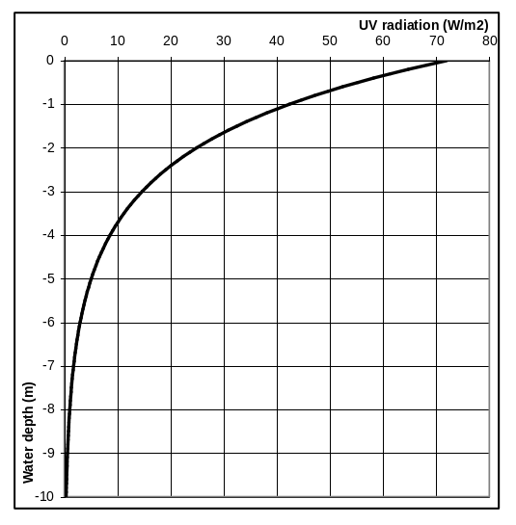
Extinction of UV-light in the water column with UV-radiation at the water surface equal to 72 W.m⁻² and a total extinction coefficient of 0.53 m⁻¹
The chloride concentration is derived from the salinity. The water depth is defined by the model schematisation. The solar radiation at the upper segment boundary is calculated from the total surface radiation at the water surface and the extinction in the segments above (see figure to the right). The extinction of UV-light depends on the suspended matter concentration and a background extinction according to:

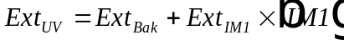

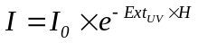

Input item | Description | Unit | Default value | Editable | Range
Ext_{UV} | total extinction of UV-radiation | m⁻¹ | n.a. | n.a. | –
Ext_{Bak} | background extinction | m⁻¹ | 0.08 | yes | 0.08 - 1.0
Ext_{IM1} | extinction coefficient of inorganic suspended matter | m².g | 0.01 | yes | 0.01 - 0.05
(IM1) | concentration of inorganic suspended matter | g.m⁻³ | n.a. (state variable) | n.a. | –
I₀ | total radiation at the water surface | W.m⁻² | 160 | yes | depends on latitude and season
I | solar radiation at segment upper boundary | W.m⁻² | n.a. | n.a. | –
H | water depth | m | n.a. | n.a. | –

Notes
- Pure water has an extinction of 0.08 m⁻¹ and is considered as the background extinction. The Simple Coliform Model has only one other constituent that contributes to the extinction, namely inorganic suspended matter. Other constituents – mainly the organic components – are ignored. A higher background extinction can be used to compensate this.

- Approximately 45% of the total solar radiation reaching the earth’s surface is in the UV range. The water quality model requires input of the total solar radiation, which will be scaled (using the f_{UV} constant) to the UV radiation internally. Radiation is often available in the units MJ/cm²; the conversion factor between MJ.m⁻² and W.m⁻² is 11.57 (= 10⁶/86400).

- Settling of the cohesive sediment (IM1) is ignored in the Simple Coliform Model.

Output items
Apart from the concentration of the state variables, the following parameters are available as extra output:

Parameter id | Description | Unit | Model name
Ext_{UV} | total extinction of UV-radiation | m⁻¹ | ExtUV
Mrt_{E.Coli} | total mortality rate of E.Coli | d⁻¹ | MrtToEColi

References
Thomann, Robert V. , and John A. Mueller (1987): Principles of Surface Water Quality Modelling and Control, Harper & Row publishers, New York.

