WecOptTool currently uses a custom pseudo-spectral discretization method and scipy.optimize.minimize with the sequential least squares quadratic programming (SLSQP) method for solving the wave energy converter optimal control problem. The custom pseudo-spectral method takes advantage of the periodic nature of wave conditions and uses fast Fourier transforms (FFTs), defining the control variable as a set of Fourier coefficients representing the power take-off force. Because the wave energy converter hydrodynamics are also defined as frequency-domain coefficients, the FFT-based pseudo-spectral method is efficient, automatically enforces periodicity, and conversion to time domain is straightforward (inverse FFT) for evaluating objectives and constraints. Despite the efficiency of WecOptTool, the approach can be somewhat limiting because it relies on a single pseudo-spectral method and enforcing a specific solver, both of which can lead to convergence issues.
Dymos is a Python package within the OpenMDAO open-source platform that enables optimal control of dynamic systems. Dymos is a powerful tool for optimization, allowing modeling of custom-defined dynamic systems and trajectory optimization. Key features of Dymos include analytic and/or automatic gradients, constrained systems, multiple pseudo-spectral and explicit shooting methods for control trajectories, and a range of powerful optimization solvers of various types. Dymos is designed to be a versatile optimization tool but it has yet to be employed for wave energy converter optimization.
While not a replacement for WecOptTool, Dymos could be a valuable tool as a backend optimization solver. The ability to use multiple optimization solvers and collocation/shooting methods could enable more effective and efficient optimization. Further, Dymos may offer additional customizability of the dynamic system which could lead to more straightforward development of complex models. Lastly, the OpenMDAO community is very knowledgeable in the optimization space and conforming to their methods and connecting with their developers could be strategically beneficial.
In order to determine if Dymos could be an effective backend tool for WecOptTool, the team worked on solving the first WecOptTool tutorial (WaveBot) using Dymos. The process of developing the WaveBot tutorial using Dymos provides insight into the usability, efficiency, and potential for Dymos.
Dymos setup includes defining constants, states, relationships between states (dynamics), control variables, and gradient methods. Conceptually, Dymos is fairly similar to WecOptTool, but the actual details are very different. These differences provided some resistance, but we were able to translate the main concepts of WecOptTool to Dymos. A few challenges include using automatic differentiation, enforcing periodicity, determining appropriate trajectory segmentation, and the radiation damping problem. The radiation damping, which requires knowledge of the entire timeseries at once, required interpolation of the full states onto an appropriate time vector so that an FFT could be applied at the desired frequencies. After multiplying with the radiation damping coefficients, the force was converted back to the time domain to be applied. This method proved effective but requires careful consideration of the Dymos time vector and interpolated time vector.
After understanding the Dymos setup, we solved the WaveBot dynamics with no control enforced in both WecOptTool and Dymos. Both WecOptTool (WOT) and Dymos solved the problem efficiently and effectively, with results shown in Figure 1. Both the position (x) and the velocity (v) match very well between Dymos and WecOptTool. Energy is not measured for the WecOptTool model since there is no control, but both cases have numerically zero energy.
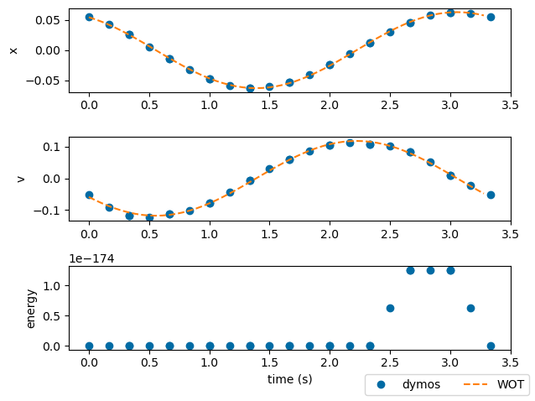
Figure 1: Comparison of Dymos and WecOptTool for solving the uncontrolled WaveBot tutorial.
Next, the control and constraints were added to the same WaveBot model in Dymos. For this case, Dymos produced slightly different results than WecOptTool (Figure 2). The trends in the position (x), velocity (v), PTO force/control (u), and the energy are very similar but the shifts in control force are slightly different and likely cause the rest of the timeseries to be slightly different as well. Still, with additional confidence from the uncontrolled solution, we believe the difference can be minimized with additional testing of variables such as the scaling and segmentation.
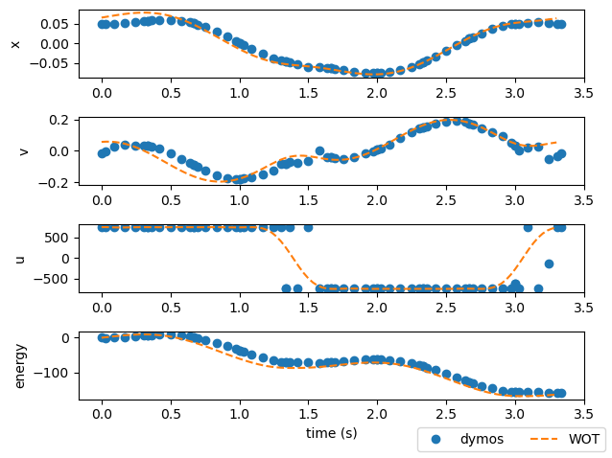
Figure 2: Comparison of Dymos and WecOptTool for solving the controlled, constrained WaveBot tutorial
From the development of the WaveBot tutorial in Dymos, the team has a relatively good understanding of the steps needed to use Dymos as a backend tool. However, the finer details are challenging. Dymos has a relatively steep learning curve, so requiring users to use Dymos directly would be too much. On the other hand, developing a Dymos model setup that could serve as a backend and be generalizable to different WECs with multiple degrees of freedom, various control types, power take-offs, etc. is also not trivial. Dymos is meant to be a tool that users interface with directly, so a unique model would likely need to be created for each WecOptTool case. Further, the challenges encountered by the team (segmentation and generalizability), while likely surmountable individually, present too large of a barrier to using Dymos as a backend for WecOptTool at this time. Since Dymos is still a very powerful tool, the team plans to keep working with Dymos for future model development, potentially allowing for overcoming these issues in the future.

