Can Test Report  
root  
2021-11-24

**Abstract:**

This report is about the numerical simulation of a crushed can.

This document was generated on 2021-11-24, 16:33:48 with the Automatic Report Generator (ARG) version "develop" on the Linux system runner-xxurkrix-project-18732201-concurrent-0.

# Table of Contents

# List of Figures

# List of Tables

# Introduction

# The Can Case

## Model Meta-Information

|  |  |
| --- | --- |
| item | number |
| Exodus II files | 1 |
| element blocks | 2 |
| element fields | 1 |
| elements | 7152 |
| node fields | 3 |
| node sets | 2 |
| nodes | 10088 |
| side sets | 1 |
| time-steps | 44 |

Table : Topological properties of can.ex2

|  |  |
| --- | --- |
| block ID | block name |
| 1 | Unnamed block ID: 1 |
| 2 | Unnamed block ID: 2 |

Table : Element blocks of can.ex2

|  |  |
| --- | --- |
| node set ID | node set name |
| 1 | Unnamed set ID: 1 |
| 100 | Unnamed set ID: 100 |

Table : Node sets of can.ex2

|  |  |
| --- | --- |
| side set ID | side set name |
| 4 | Unnamed set ID: 4 |

Table : Side sets of can.ex2

|  |  |
| --- | --- |
| variable | type |
| ACCL | NODAL |
| DISPL | NODAL |
| VEL | NODAL |
| EQPS | ELEMENT |
| KE | GLOBAL |
| NSTEPS | GLOBAL |
| TMSTEP | GLOBAL |
| XMOM | GLOBAL |
| YMOM | GLOBAL |
| ZMOM | GLOBAL |

Table : Variables of can.ex2

## Mesh Blocks

# Block 1 (Unnamed block ID: 1) summary

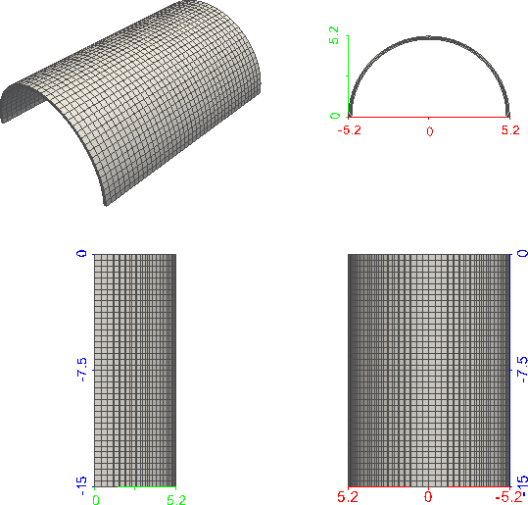

Figure : Perspective (top left) and parallel (top right: XY; bottom left: YZ; bottom right: XZ) rendering of block 1.

|  |  |
| --- | --- |
| property | value |
| number of nodes | 6724 |
| number of elements | 4800 |
| type of first element in block | HEX8 |

Table : Properties of block Unnamed block ID: 1.

# Block 1 (Unnamed block ID: 1) element quality

|  |  |  |  |  |  |
| --- | --- | --- | --- | --- | --- |
| Q | min(Q) | μ(Q) | max(Q) | σ(Q) | σ/μ(Q) |
| scaled Jacobian | 0.9992 | 0.9992 | 0.9992 | 0 | 0 |
| shape | 0.4525 | 0.4549 | 0.4572 | 0.00188 | 0.004134 |

Table : Element quality statistics of block Unnamed block ID: 1.

Histogram of scaled Jacobian element quality in block Unnamed block ID: 1 is too narrow to be inserted (coefficient of variation: 0.0 < 0.001).

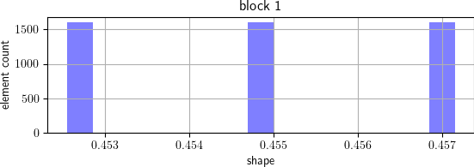

Figure : Histogram of shape element quality in block Unnamed block ID: 1.

Comment by Author:

This block represents only one half of a can in order to simplify the simulation.

# Block 2 (Unnamed block ID: 2) summary

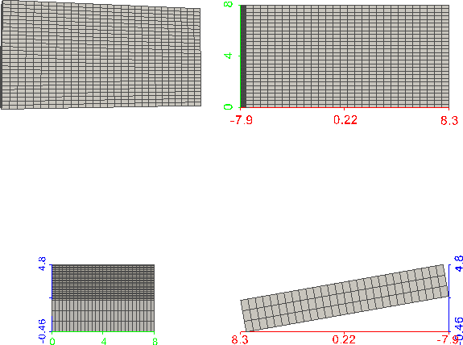

Figure : Perspective (top left) and parallel (top right: XY; bottom left: YZ; bottom right: XZ) rendering of block 2.

|  |  |
| --- | --- |
| property | value |
| number of nodes | 3364 |
| number of elements | 2352 |
| type of first element in block | HEX8 |

Table : Properties of block Unnamed block ID: 2.

# Block 2 (Unnamed block ID: 2) element quality

|  |  |  |  |  |  |
| --- | --- | --- | --- | --- | --- |
| Q | min(Q) | μ(Q) | max(Q) | σ(Q) | σ/μ(Q) |
| scaled Jacobian | 1 | 1 | 1 | 0 | 0 |
| shape | 0.7197 | 0.7197 | 0.7197 | 2.148e-07 | 2.984e-07 |

Table : Element quality statistics of block Unnamed block ID: 2.

Histogram of scaled Jacobian element quality in block Unnamed block ID: 2 is too narrow to be inserted (coefficient of variation: 0.0 < 0.001).

Histogram of shape element quality in block Unnamed block ID: 2 is too narrow to be inserted (coefficient of variation: 2.9841980535307454e-07 < 0.001).

Explanation:

This block represents a plate used to crush the can.

## Visualizations of Some Available Attributes

### Surface Renderings of Initial State

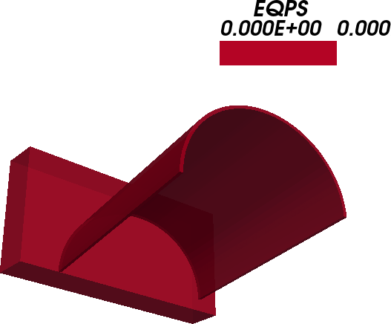

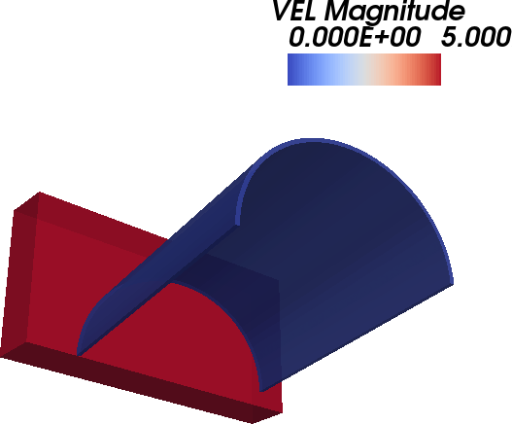

### Surface Renderings at Intermediate Time Step

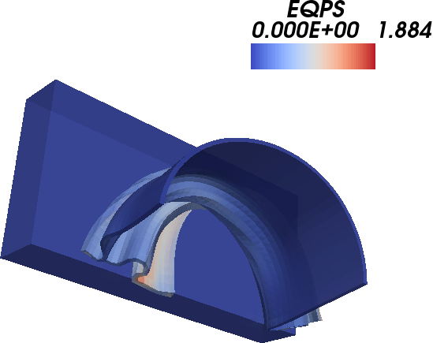

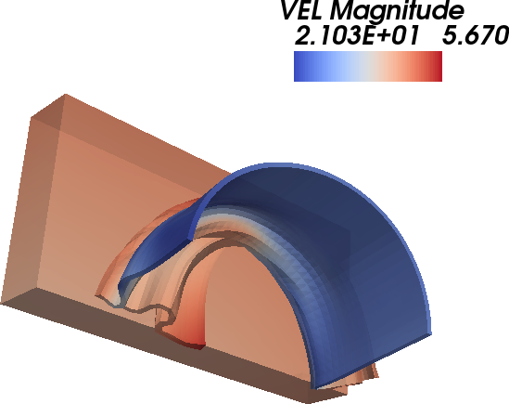

### Surface Renderings of Final State

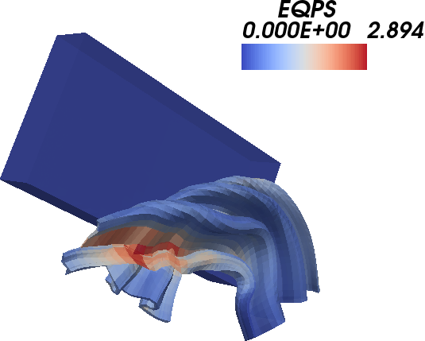

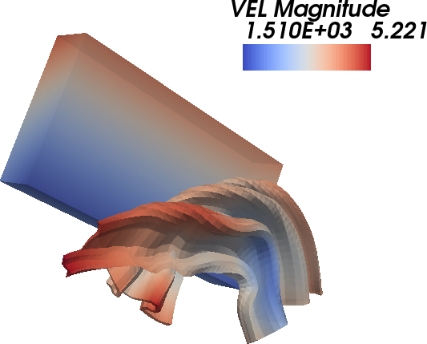

# Results

## Quantities of Interest; Margins

\begin{description}  
\item[Requirements:]\hfill  
\begin{itemize}  
\item  
Tensile yield stress is 20000 psi.  
\item  
Required factor of safety is 3.  
\end{itemize}  
  
\item[Calculated Performance:]\hfill  
\begin{itemize}  
\item The calculated maximum nodal projected Mises stress is 7904.79 psi.  
\item The calculated normalized margin of maximum von Mises stress is -0.062.  
\end{itemize}  
\end{description}