ARG Report  
root  
2021-11-23

This document was generated on 2021-11-23, 15:36:10 with the Automatic Report Generator (ARG) version "develop" on the Linux system runner-j1aldqxs-project-18732201-concurrent-0.

# Table of Contents

# List of Figures

# List of Tables

# Introduction

The structure of this report was built by the Explorator component of ARG, which explored the following directory:

/builds/AutomaticReportGenerator/arg/tests/build_tests/crush/data

and discovered the following relevant data:

ExodusII mesh in crush_assembly.g

# Geometry

This chapter describes the geometry as specified in the parameters file.

The term Electronic Product Definition (EPD) is also often used to denote the CAD geometry of the case.

## Geometry Files

This section provides an overview of the geometry files found in:

/builds/AutomaticReportGenerator/arg/tests/build_tests/crush/data/Interface

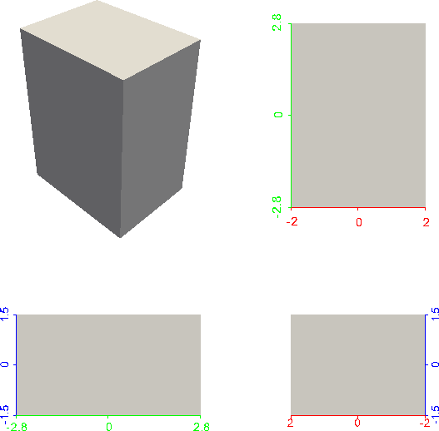

Figure : Perspective (top left) and parallel (top right: XY; bottom left: YZ; bottom right: XZ) rendering of box_shell.stl.

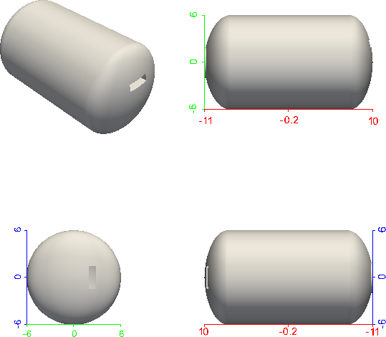

Figure : Perspective (top left) and parallel (top right: XY; bottom left: YZ; bottom right: XZ) rendering of case.stl.

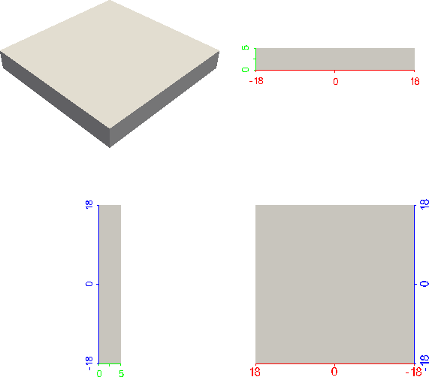

Figure : Perspective (top left) and parallel (top right: XY; bottom left: YZ; bottom right: XZ) rendering of crusher.stl.

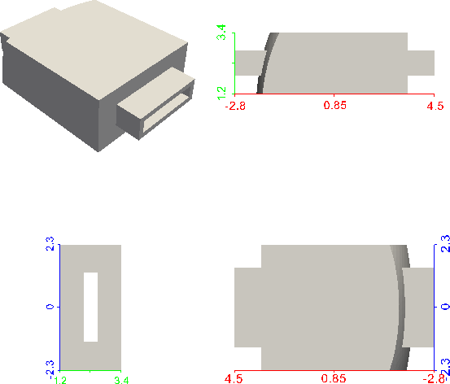

Figure : Perspective (top left) and parallel (top right: XY; bottom left: YZ; bottom right: XZ) rendering of duct.stl.

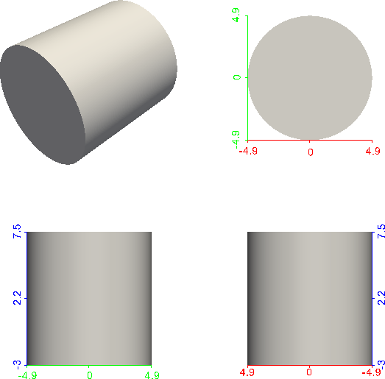

Figure : Perspective (top left) and parallel (top right: XY; bottom left: YZ; bottom right: XZ) rendering of foam.stl.

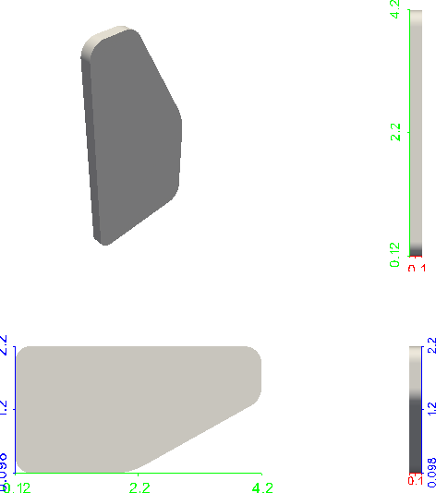

Figure : Perspective (top left) and parallel (top right: XY; bottom left: YZ; bottom right: XZ) rendering of lid.stl.

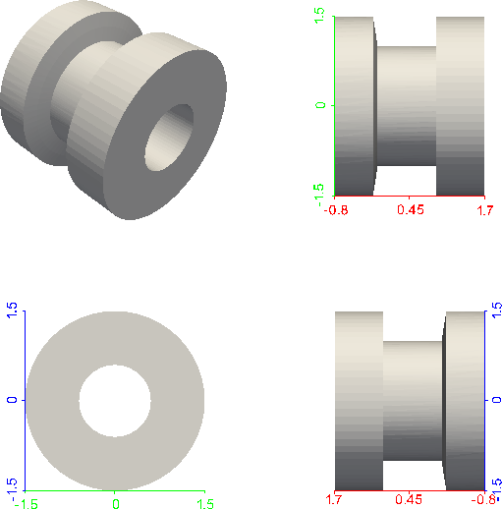

Figure : Perspective (top left) and parallel (top right: XY; bottom left: YZ; bottom right: XZ) rendering of plug.stl.

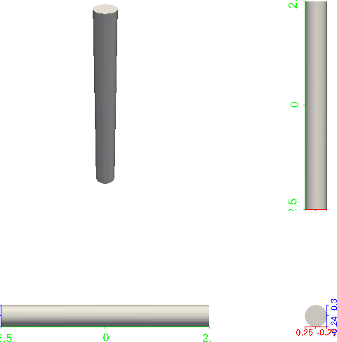

Figure : Perspective (top left) and parallel (top right: XY; bottom left: YZ; bottom right: XZ) rendering of post.stl.

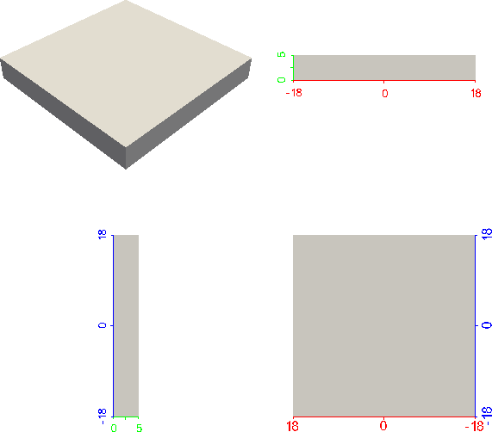

Figure : Perspective (top left) and parallel (top right: XY; bottom left: YZ; bottom right: XZ) rendering of target.stl.

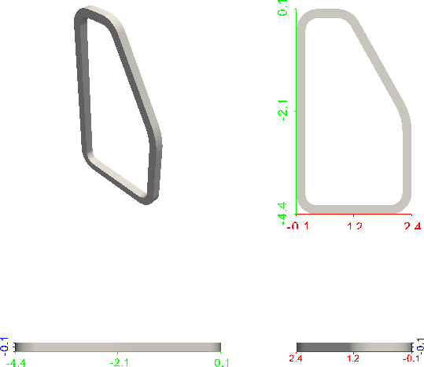

Figure : Perspective (top left) and parallel (top right: XY; bottom left: YZ; bottom right: XZ) rendering of weld.stl.

We note that this is a particular case with a bijection between CAD and FEM items.

## CAD metadata

This section describes the CAD metadata found in:

/builds/AutomaticReportGenerator/arg/tests/build_tests/crush/data/Interface

|  |  |
| --- | --- |
| CAD parameter | parameter value |
| DWG_TITLE1 |  |
| UNITS | INCH |
| MATERIAL | material_1 |

Table : CAD metadata for part box_shell.

|  |  |
| --- | --- |
| CAD parameter | parameter value |
| DWG_TITLE1 |  |
| UNITS | INCH |
| MATERIAL | material_3 |

Table : CAD metadata for part case.

|  |  |
| --- | --- |
| CAD parameter | parameter value |
| DWG_TITLE1 |  |
| UNITS |  |
| MATERIAL |  |

Table : CAD metadata for part post.

|  |  |
| --- | --- |
| CAD parameter | parameter value |
| DWG_TITLE1 |  |
| UNITS | INCH |
| MATERIAL | material_5 |

Table : CAD metadata for part foam.

|  |  |
| --- | --- |
| CAD parameter | parameter value |
| DWG_TITLE1 |  |
| UNITS | INCH |
| MATERIAL | material_2 |

Table : CAD metadata for part target.

|  |  |
| --- | --- |
| CAD parameter | parameter value |
| DWG_TITLE1 |  |
| UNITS |  |
| MATERIAL |  |

Table : CAD metadata for part duct.

|  |  |
| --- | --- |
| CAD parameter | parameter value |
| DWG_TITLE1 |  |
| UNITS |  |
| MATERIAL |  |

Table : CAD metadata for part plug.

|  |  |
| --- | --- |
| CAD parameter | parameter value |
| DWG_TITLE1 |  |
| UNITS |  |
| MATERIAL |  |

Table : CAD metadata for part lid.

|  |  |
| --- | --- |
| CAD parameter | parameter value |
| DWG_TITLE1 |  |
| UNITS |  |
| MATERIAL |  |

Table : CAD metadata for part weld.

|  |  |
| --- | --- |
| CAD parameter | parameter value |
| DWG_TITLE1 |  |
| UNITS | INCH |
| MATERIAL | material_4 |

Table : CAD metadata for part crusher.

# ExodusII Mesh

This chapter describes the ExodusII mesh in:

/builds/AutomaticReportGenerator/arg/tests/build_tests/crush/data/crush_assembly.g

## Overview

This section provides an overview of the meta-data and global properties of this ExodusII mesh.

|  |  |
| --- | --- |
| item | number |
| Exodus II files | 1 |
| element blocks | 10 |
| elements | 994848 |
| node sets | 2 |
| nodes | 1141300 |
| side sets | 8 |

Table : Topological properties of crush_assembly.g

|  |  |
| --- | --- |
| block ID | block name |
| 1 | case |
| 2 | duct |
| 3 | plug |
| 4 | box_shell |
| 5 | lid |
| 6 | weld |
| 7 | post |
| 8 | target |
| 9 | crusher |
| 10 | foam |

Table : Element blocks of crush_assembly.g

|  |  |
| --- | --- |
| node set ID | node set name |
| 1 | z_symmetry_nodeset |
| 2 | target_bottom_nodeset |

Table : Node sets of crush_assembly.g

|  |  |
| --- | --- |
| side set ID | side set name |
| 1 | crusher_sideset |
| 2 | case_outer_sideset |
| 3 | case_inner_sideset |
| 4 | foam_outer_sideset |
| 5 | foam_inner_sideset |
| 6 | box_shell_outer_sideset |
| 7 | interface_case_sideset |
| 8 | interface_plug_sideset |

Table : Side sets of crush_assembly.g

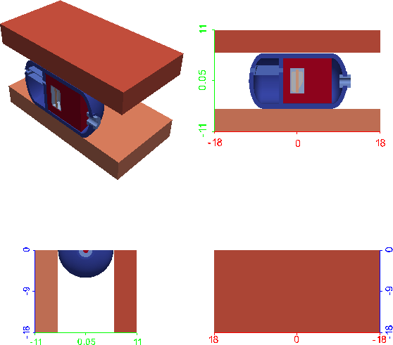

Figure : Perspective (top left) and parallel (top right: XY; bottom left: YZ; bottom right: XZ) rendering of crush_assembly.g.

## Mesh Blocks

This section provides a description of all blocks contained in the mesh.

# Block 1 (case) summary

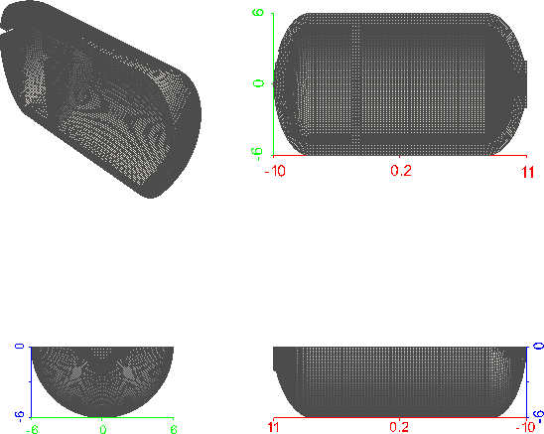

Figure : Perspective (top left) and parallel (top right: XY; bottom left: YZ; bottom right: XZ) rendering of block 1.

|  |  |
| --- | --- |
| property | value |
| number of nodes | 163818 |
| number of elements | 143240 |
| type of first element in block | HEX8 |

Table : Properties of block case.

# Block 1 (case) element quality

|  |  |  |  |  |  |
| --- | --- | --- | --- | --- | --- |
| Q | min(Q) | μ(Q) | max(Q) | σ(Q) | σ/μ(Q) |
| scaled Jacobian | 0.4061 | 0.9816 | 1 | 0.04298 | 0.04379 |
| shape | 0.5047 | 0.8758 | 0.9999 | 0.05902 | 0.06739 |

Table : Element quality statistics of block case.

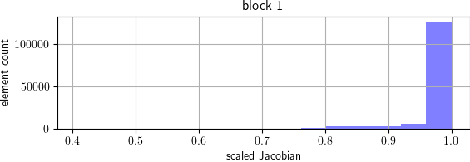

Figure : Histogram of scaled Jacobian element quality in block case.

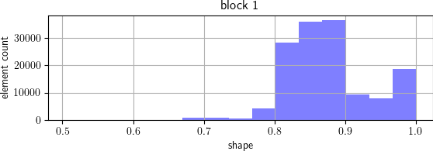

Figure : Histogram of shape element quality in block case.

# Block 2 (duct) summary

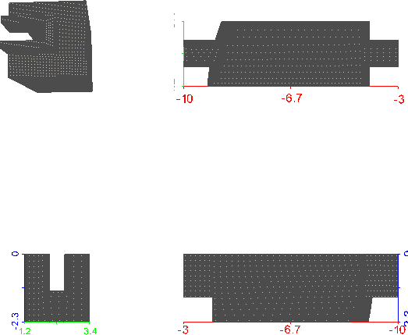

Figure : Perspective (top left) and parallel (top right: XY; bottom left: YZ; bottom right: XZ) rendering of block 2.

|  |  |
| --- | --- |
| property | value |
| number of nodes | 378701 |
| number of elements | 327424 |
| type of first element in block | HEX8 |

Table : Properties of block duct.

# Block 2 (duct) element quality

|  |  |  |  |  |  |
| --- | --- | --- | --- | --- | --- |
| Q | min(Q) | μ(Q) | max(Q) | σ(Q) | σ/μ(Q) |
| scaled Jacobian | 0.8379 | 0.9732 | 1 | 0.0309 | 0.03175 |
| shape | 0.8821 | 0.9745 | 0.9998 | 0.02051 | 0.02105 |

Table : Element quality statistics of block duct.

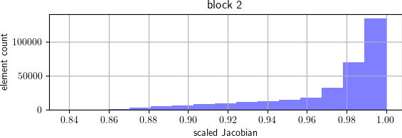

Figure : Histogram of scaled Jacobian element quality in block duct.

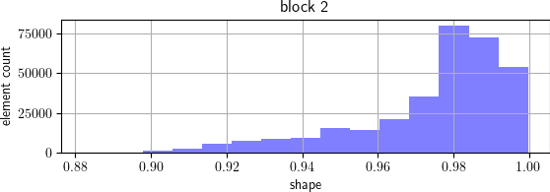

Figure : Histogram of shape element quality in block duct.

# Block 3 (plug) summary

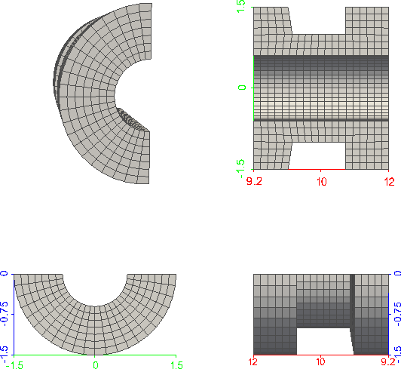

Figure : Perspective (top left) and parallel (top right: XY; bottom left: YZ; bottom right: XZ) rendering of block 3.

|  |  |
| --- | --- |
| property | value |
| number of nodes | 3036 |
| number of elements | 2222 |
| type of first element in block | HEX8 |

Table : Properties of block plug.

# Block 3 (plug) element quality

|  |  |  |  |  |  |
| --- | --- | --- | --- | --- | --- |
| Q | min(Q) | μ(Q) | max(Q) | σ(Q) | σ/μ(Q) |
| scaled Jacobian | 0.9818 | 0.9947 | 0.9974 | 0.003746 | 0.003766 |
| shape | 0.8666 | 0.9496 | 0.9957 | 0.03586 | 0.03776 |

Table : Element quality statistics of block plug.

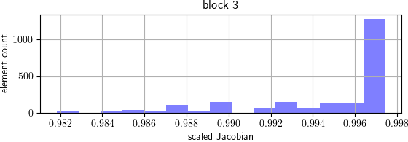

Figure : Histogram of scaled Jacobian element quality in block plug.

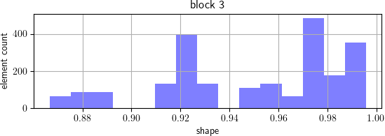

Figure : Histogram of shape element quality in block plug.

# Block 4 (box_shell) summary

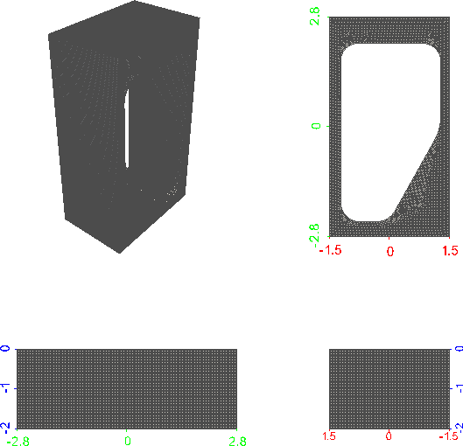

Figure : Perspective (top left) and parallel (top right: XY; bottom left: YZ; bottom right: XZ) rendering of block 4.

|  |  |
| --- | --- |
| property | value |
| number of nodes | 278453 |
| number of elements | 238000 |
| type of first element in block | HEX8 |

Table : Properties of block box_shell.

# Block 4 (box_shell) element quality

|  |  |  |  |  |  |
| --- | --- | --- | --- | --- | --- |
| Q | min(Q) | μ(Q) | max(Q) | σ(Q) | σ/μ(Q) |
| scaled Jacobian | 0.6088 | 0.9951 | 1 | 0.01345 | 0.01352 |
| shape | 0.6524 | 0.9931 | 0.9998 | 0.0164 | 0.01652 |

Table : Element quality statistics of block box_shell.

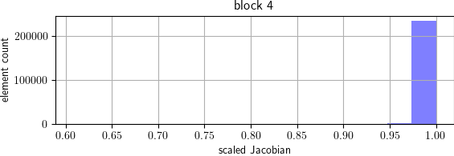

Figure : Histogram of scaled Jacobian element quality in block box_shell.

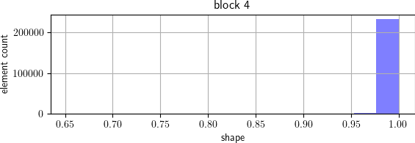

Figure : Histogram of shape element quality in block box_shell.

# Block 5 (lid) summary

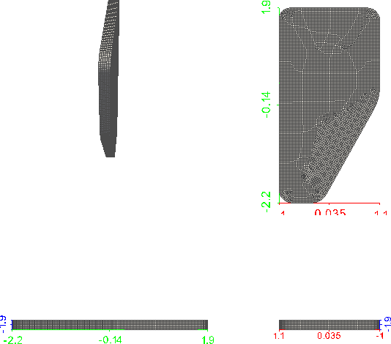

Figure : Perspective (top left) and parallel (top right: XY; bottom left: YZ; bottom right: XZ) rendering of block 5.

|  |  |
| --- | --- |
| property | value |
| number of nodes | 52563 |
| number of elements | 43986 |
| type of first element in block | HEX8 |

Table : Properties of block lid.

# Block 5 (lid) element quality

|  |  |  |  |  |  |
| --- | --- | --- | --- | --- | --- |
| Q | min(Q) | μ(Q) | max(Q) | σ(Q) | σ/μ(Q) |
| scaled Jacobian | 0.7408 | 0.996 | 1 | 0.02035 | 0.02043 |
| shape | 0.7275 | 0.9933 | 0.9999 | 0.02438 | 0.02455 |

Table : Element quality statistics of block lid.

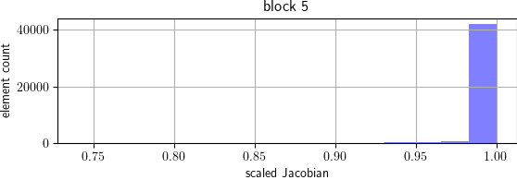

Figure : Histogram of scaled Jacobian element quality in block lid.

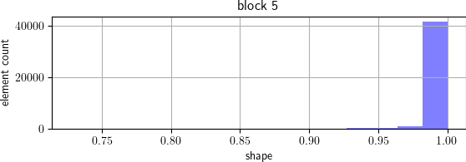

Figure : Histogram of shape element quality in block lid.

# Block 6 (weld) summary

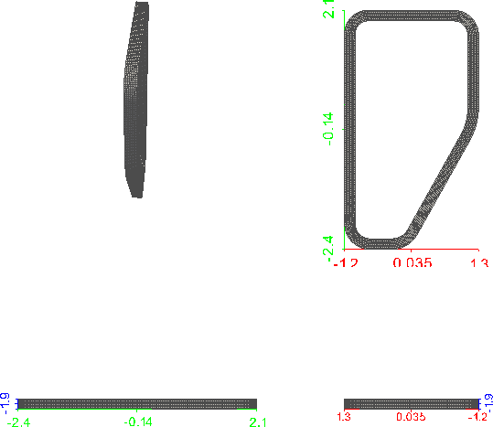

Figure : Perspective (top left) and parallel (top right: XY; bottom left: YZ; bottom right: XZ) rendering of block 6.

|  |  |
| --- | --- |
| property | value |
| number of nodes | 30699 |
| number of elements | 24256 |
| type of first element in block | HEX8 |

Table : Properties of block weld.

# Block 6 (weld) element quality

|  |  |  |  |  |  |
| --- | --- | --- | --- | --- | --- |
| Q | min(Q) | μ(Q) | max(Q) | σ(Q) | σ/μ(Q) |
| scaled Jacobian | 0.3748 | 0.9057 | 0.9999 | 0.1082 | 0.1194 |
| shape | 0.4939 | 0.9138 | 0.9917 | 0.08219 | 0.08994 |

Table : Element quality statistics of block weld.

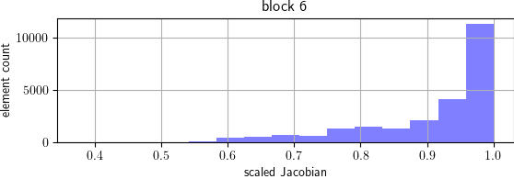

Figure : Histogram of scaled Jacobian element quality in block weld.

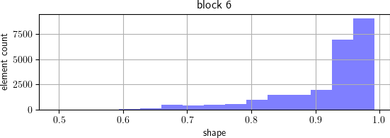

Figure : Histogram of shape element quality in block weld.

# Block 7 (post) summary

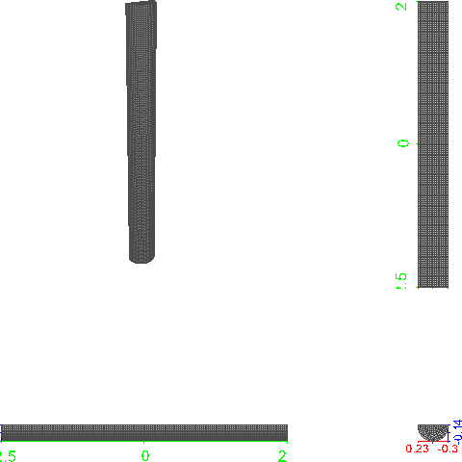

Figure : Perspective (top left) and parallel (top right: XY; bottom left: YZ; bottom right: XZ) rendering of block 7.

|  |  |
| --- | --- |
| property | value |
| number of nodes | 24928 |
| number of elements | 20864 |
| type of first element in block | HEX8 |

Table : Properties of block post.

# Block 7 (post) element quality

|  |  |  |  |  |  |
| --- | --- | --- | --- | --- | --- |
| Q | min(Q) | μ(Q) | max(Q) | σ(Q) | σ/μ(Q) |
| scaled Jacobian | 0.7522 | 0.9528 | 0.9995 | 0.05798 | 0.06086 |
| shape | 0.7608 | 0.951 | 0.9988 | 0.05655 | 0.05947 |

Table : Element quality statistics of block post.

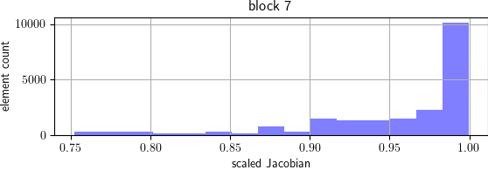

Figure : Histogram of scaled Jacobian element quality in block post.

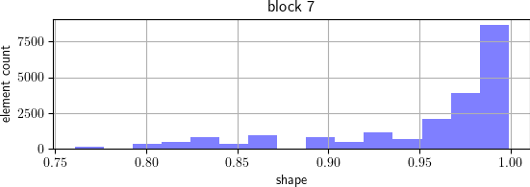

Figure : Histogram of shape element quality in block post.

# Block 8 (target) summary

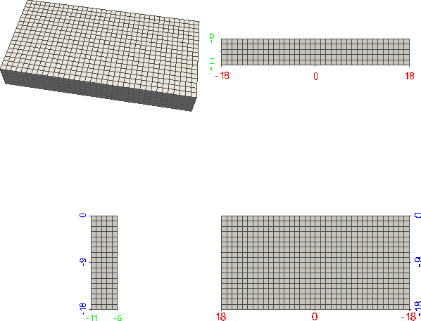

Figure : Perspective (top left) and parallel (top right: XY; bottom left: YZ; bottom right: XZ) rendering of block 8.

|  |  |
| --- | --- |
| property | value |
| number of nodes | 4218 |
| number of elements | 3240 |
| type of first element in block | HEX8 |

Table : Properties of block target.

# Block 8 (target) element quality

|  |  |  |  |  |  |
| --- | --- | --- | --- | --- | --- |
| Q | min(Q) | μ(Q) | max(Q) | σ(Q) | σ/μ(Q) |
| scaled Jacobian | 1 | 1 | 1 | 0 | 0 |
| shape | 1 | 1 | 1 | 0 | 0 |

Table : Element quality statistics of block target.

Histogram of scaled Jacobian element quality in block target is too narrow to be inserted (coefficient of variation: 0.0 < 0.001).

Histogram of shape element quality in block target is too narrow to be inserted (coefficient of variation: 0.0 < 0.001).

# Block 9 (crusher) summary

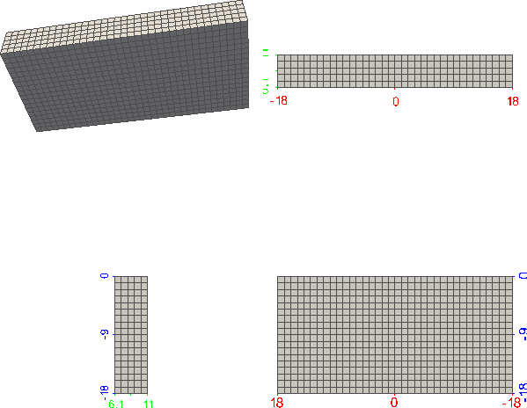

Figure : Perspective (top left) and parallel (top right: XY; bottom left: YZ; bottom right: XZ) rendering of block 9.

|  |  |
| --- | --- |
| property | value |
| number of nodes | 4218 |
| number of elements | 3240 |
| type of first element in block | HEX8 |

Table : Properties of block crusher.

# Block 9 (crusher) element quality

|  |  |  |  |  |  |
| --- | --- | --- | --- | --- | --- |
| Q | min(Q) | μ(Q) | max(Q) | σ(Q) | σ/μ(Q) |
| scaled Jacobian | 1 | 1 | 1 | 0 | 0 |
| shape | 1 | 1 | 1 | 0 | 0 |

Table : Element quality statistics of block crusher.

Histogram of scaled Jacobian element quality in block crusher is too narrow to be inserted (coefficient of variation: 0.0 < 0.001).

Histogram of shape element quality in block crusher is too narrow to be inserted (coefficient of variation: 0.0 < 0.001).

# Block 10 (foam) summary

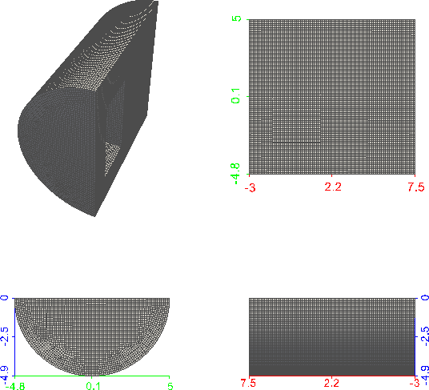

Figure : Perspective (top left) and parallel (top right: XY; bottom left: YZ; bottom right: XZ) rendering of block 10.

|  |  |
| --- | --- |
| property | value |
| number of nodes | 200666 |
| number of elements | 188376 |
| type of first element in block | HEX8 |

Table : Properties of block foam.

# Block 10 (foam) element quality

|  |  |  |  |  |  |
| --- | --- | --- | --- | --- | --- |
| Q | min(Q) | μ(Q) | max(Q) | σ(Q) | σ/μ(Q) |
| scaled Jacobian | 0.6998 | 0.9903 | 1 | 0.03133 | 0.03164 |
| shape | 0.7526 | 0.9884 | 1 | 0.03306 | 0.03344 |

Table : Element quality statistics of block foam.

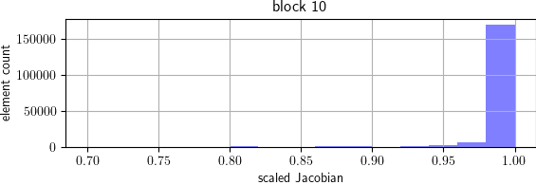

Figure : Histogram of scaled Jacobian element quality in block foam.

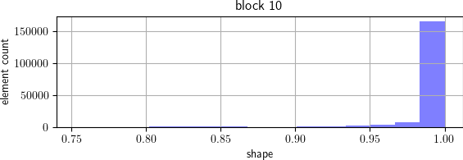

Figure : Histogram of shape element quality in block foam.