Disk Test Report  
pppebay  
2020-05-12

**Abstract:**

This report is about the numerical simulation of a heated disk spinning in air at ambiant temperature.  
  
It was generated using the Automatic Report Generator (ARG).

This document was generated on 2020-05-12, 11:21:13 with the Automatic Report Generator (ARG) version "develop" on the Darwin system loft-macbook.home.

# 1. Table of Contents

# 2. List of Figures

# 3. List of Tables

# 4. Introduction

The current implementation offers the ability to integrate text, VTK-generated  
visualizations, MatPlotLib plots, and other artifacts, in a MS Word document.  
Python-docx is used to glue of all this together.

# 5. The Spinning Heated Disk Case

## 5.1. Model Meta-Information

This section provides an overview of the data set used for this analysis.

|  |  |
| --- | --- |
| item | number |
| Exodus II files | 1 |
| element blocks | 1 |
| elements | 7472 |
| node fields | 7 |
| node sets | 3 |
| nodes | 8499 |
| side sets | 7 |

Table : Topological properties of disk_out_ref.ex2

|  |  |
| --- | --- |
| block ID | block name |
| 1 | Unnamed block ID: 1 Type: HEX8 |

Table : Element blocks of disk_out_ref.ex2

|  |  |
| --- | --- |
| node set ID | node set name |
| 1 | Unnamed set ID: 1 |
| 2 | Unnamed set ID: 2 |
| 3 | Unnamed set ID: 3 |

Table : Node sets of disk_out_ref.ex2

|  |  |
| --- | --- |
| side set ID | side set name |
| 1 | Unnamed set ID: 1 |
| 2 | Unnamed set ID: 2 |
| 3 | Unnamed set ID: 3 |
| 4 | Unnamed set ID: 4 |
| 5 | Unnamed set ID: 5 |
| 6 | Unnamed set ID: 6 |
| 7 | Unnamed set ID: 7 |

Table : Side sets of disk_out_ref.ex2

|  |  |
| --- | --- |
| variable | type |
| AsH3 | NODAL |
| CH4 | NODAL |
| GaMe3 | NODAL |
| H2 | NODAL |
| Pres | NODAL |
| Temp | NODAL |
| V | NODAL |

Table : Variables of disk_out_ref.ex2

## 5.2. Visualizations of Some Available Attributes

### 5.2.1. Surface Renderings

We begin by presenting some surface renderings of the data set for several of its scalar or vector attributes.

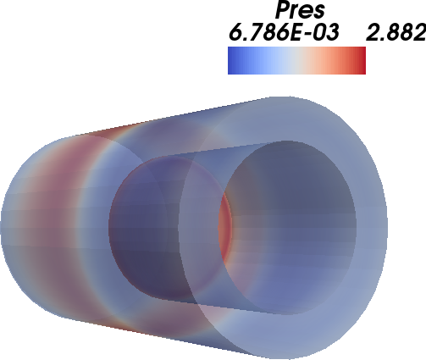

Figure : Translucent surface rendering of disk_out_ref.ex2.

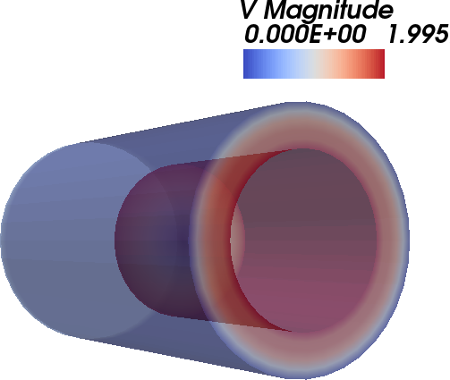

Figure : Translucent surface rendering of disk_out_ref.ex2.

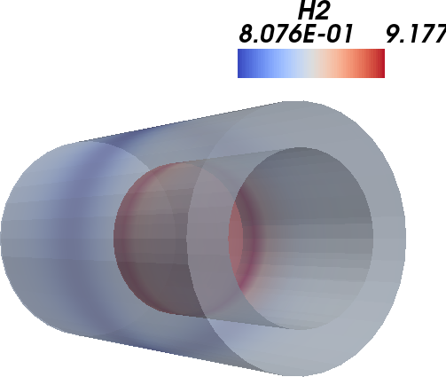

Figure : Translucent surface rendering of disk_out_ref.ex2.

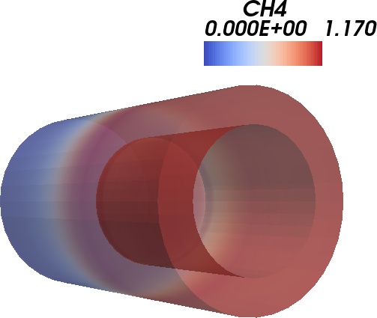

Figure : Translucent surface rendering of disk_out_ref.ex2.

### 5.2.2. Isocontours

We now look at two different isocontours for the temperature values contained in this data set.

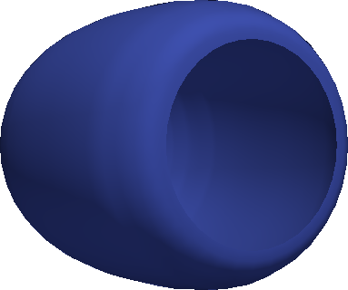

Figure : Isocontour at value 310.0 rendering of disk_out_ref.ex2.



Figure : Isocontour at value 850.0 rendering of disk_out_ref.ex2.

Note that, unlike surface renderings, isocontouring only makes sense for point-centered, scalar attributes. If the variable is cell-centered instead, it must be interpolated before iso-contours can be computed. As a result, interpolation errors will occur.  
  
We chose two isocontour values that are close enough from the minimum and maximum values for that attribute, because we want to highlight:  
- the heated disk;  
- the cooler air mass surrounding it.  
  
In a more refined implementation of this generator, we could specificy a range of values so several contours can be shown in the same image.

### 5.2.3. Clips

We finish by clipping the dataset with a plane, and surface rendering the result.

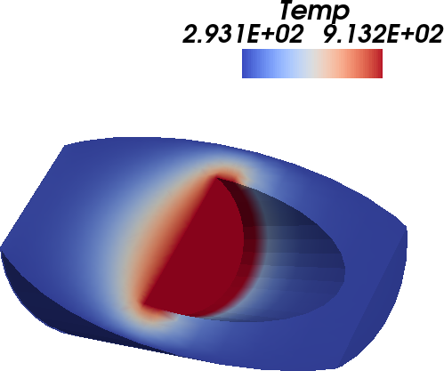

Figure : Plane clip rendering of disk_out_ref.ex2.

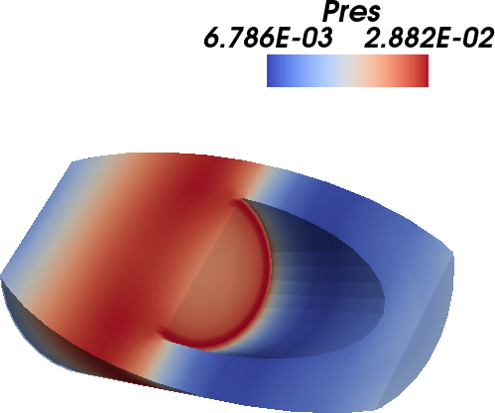

Figure : Plane clip rendering of disk_out_ref.ex2.

# 6. Results

This chapter describes key results of the analysis workflow instance.

## 6.1. Quantities of Interest -- Margin

### 6.1.1. Requirements

Tensile yield stress is 20000 psi

Required factor of safety is 3.

### 6.1.2. Calculated Performance

The calculated maximum nodal projected Mises stress is 7904.79 psi.

The calculated normalized margin of maximum von Mises stress is -0.062.