### Evidence description

We found this critter in the attic:

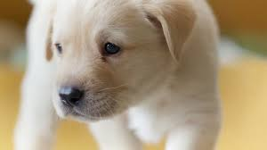

Figure 1: Unauthorized tenant