ARG Report  
root  
2021-01-12

**Abstract:**

This report outlines some plotting capabilities of the ARG's Generator applied to an ExodusII data set.

This document was generated on 2021-01-12, 09:48:20 with the Automatic Report Generator (ARG) version "develop" on the Linux system runner-0277ea0f-project-18732201-concurrent-0.

# 1. Table of Contents

# 2. List of Figures

# 3. List of Tables

# 4. Introduction

This document illustrates some plotting capabilities of the Automatic Report Generator (ARG).

# 5. Simulation Plots

The following pages show time domain plots simulating the cyclical behavior of a flexible foam medium.

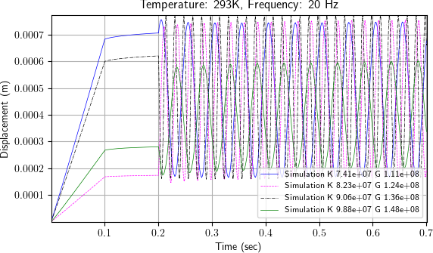

Figure : Time domain displacement plots for a sample at 293K and a frequency of 20Hz.

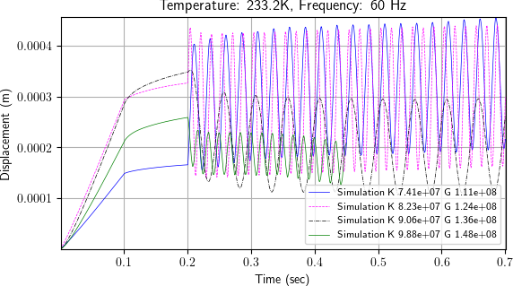

Figure : Time domain displacement plots for a sample at 233.2K and a frequency of 60Hz.