Software Requirements Specification
for
SAW Credibility Framework
Version 0.1
Prepared by George Orient
National Technology & Engineering Solutions of Sandia, LLC
V&V, UQ, Credibility Process

3/3/2019
Table of Contents
Table of Contents ii
Revision History ii
1. Introduction 1
1.1 Purpose 1
1.2 Document Conventions 1
1.3 Intended Audience and Reading Suggestions 1
1.4 Product Scope 1
1.5 References 1
2. Overall Description 2
2.1 Product Perspective 2
2.2 Product Functions 2
2.3 User Classes and Characteristics 2
2.4 Operating Environment 2
2.5 Design and Implementation Constraints 2
2.6 User Documentation 2
2.7 Assumptions and Dependencies 3
3. External Interface Requirements 3
3.1 User Interfaces 3
3.2 Hardware Interfaces 3
3.3 Software Interfaces 3
3.4 Communications Interfaces 3
4. System Features 4
4.1 System Feature 1 4
4.2 System Feature 2 (and so on) 4
5. Other Nonfunctional Requirements 4
5.1 Performance Requirements 4
5.2 Safety Requirements 5
5.3 Security Requirements 5
5.4 Software Quality Attributes 5
5.5 Business Rules 5
6. Other Requirements 5
Appendix A: Glossary 5
Appendix B: Analysis Models 5
Appendix C: To Be Determined List 6

Revision History
Name | Date | Reason for Changes | Version

Introduction

Purpose
This document records the requirements for the preliminary version 0.5 of the SAW Credibility Framework.

<Identify the product whose software requirements are specified in this document, including the revision or release number. Describe the scope of the product that is covered by this SRS, particularly if this SRS describes only part of the system or a single subsystem.>

Document Conventions
Abbreviations:

ModSim – Modeling and Simulation
NTESS - National Technology & Engineering Solutions of Sandia, LLC
PIRT – Phenomena Identification and Ranking Table
PCMM – Predictive Capability Maturity Model
NGA – Next Generation Analytics
UQ – Uncertainty Quantification

<Describe any standards or typographical conventions that were followed when writing this SRS, such as fonts or highlighting that have special significance. For example, state whether priorities for higher-level requirements are assumed to be inherited by detailed requirements, or whether every requirement statement is to have its own priority.>

Intended Audience and Reading Suggestions
Developers implementing the Credibility Framework are the intended audience. Supplementary documents necessary to understand intended features of the software are
- Credibility_Mockup-v0.2 PowerPoint presentation document illustrating the intended user interaction. This document is expected to undergo several revisions in addition to informal amendments during development of the Credibility Framework
- PIRT (Phenomena Identification and Ranking table spreadsheet
- PCMM (Predictive Capability Maturity Model) spreadsheet

<Describe the different types of reader that the document is intended for, such as developers, project managers, marketing staff, users, testers, and documentation writers. Describe what the rest of this SRS contains and how it is organized. Suggest a sequence for reading the document, beginning with the overview sections and proceeding through the sections that are most pertinent to each reader type.>

Product Scope
The Credibility Framework shall provide and intuitive coherent environment for ModSim teams to
- define a Credibility Framework project to track evolution the credibility evidence associated with a particular ModSim task
- communicate credibility of computational simulation models
- provide and maintain links to configuration controlled artifacts constituting the evidence package
- tag the evidence package at significant stages of the ModSim program
- quantitatively assess the state of credibility if they choose
- support internal and external peer reviews
- conduct a historical review of credibility throughout the life of the ModSim project including understanding diverse input from different team and review panel members
An instantiation of the credibility process for qualification support for high consequence ModSim programs will be implemented in the initial release. Since the process will see periodical revisions, and processes for lower consequence ModSim tasks such as design scoping studies, experimental program support will be defined later it is important that all behavior of the Credibility Framework are configurable by non-programmers without having to touch source code.

<Provide a short description of the software being specified and its purpose, including relevant benefits, objectives, and goals. Relate the software to corporate goals or business strategies. If a separate vision and scope document is available, refer to it rather than duplicating its contents here.>

References
What is PIRT?
What is PCMM?

<List any other documents or Web addresses to which this SRS refers. These may include user interface style guides, contracts, standards, system requirements specifications, use case documents, or a vision and scope document. Provide enough information so that the reader could access a copy of each reference, including title, author, version number, date, and source or location.>

Overall Description

Product Perspective

Engineering credibility has been defined in many ways over the past two decades. Fundamentally credibility is a set of tools and processes for decision makers to understand why (or whether) they should trust the ModSim model to make decisions as well as develop a sense risk associated with making such decisions.
The SAW Credibility Framework is an initial implementation of the credibility tools in SAW. It is largely a stand-alone Eclipse application intended to work seamlessly with the SAW analysis data management back-end to identify whether artifacts referenced by the credibility evidence package are under configuration control by the SAW Analysis Data Management layer.

<Describe the context and origin of the product being specified in this SRS. For example, state whether this product is a follow-on member of a product family, a replacement for certain existing systems, or a new, self-contained product. If the SRS defines a component of a larger system, relate the requirements of the larger system to the functionality of this software and identify interfaces between the two. A simple diagram that shows the major components of the overall system, subsystem interconnections, and external interfaces can be helpful.>

Product Functions
On the high-level SAW Credibility framework implements a document management system and a guided information harvesting and ranking tool providing members of the ModSim team and reviewers to collect, disseminate and optionally rank groups of attributes of the ModSim activity. The Credibility Framework is not a physical experiment management of computational model execution platform, but it provides links to artifacts from those processes managed and executed by SAW. For example, definition, execution and post processing of a UQ study on a complex analysis workflow is managed by the SAW workflow engine, the Dakota wizard and results visualization tools. Consequently, the Credibility Framework under the Uncertainty Quantification sub element of PCMM maintains links to instances of the UQ studies and their documentation intended to provide evidence for making statements about margin uncertainties.

<Summarize the major functions the product must perform or must let the user perform. Details will be provided in Section 3, so only a high-level summary (such as a bullet list) is needed here. Organize the functions to make them understandable to any reader of the SRS. A picture of the major groups of related requirements and how they relate, such as a top level data flow diagram or object class diagram, is often effective.>

User Classes and Characteristics
There are three main personas using the Credibility framework, ModSim team member, reviewer and V&V process lead.
ModSim team members are practitioners of different engineering disciplines bringing different perspectives to the credibility evidence and recording this diversity of opinions in the framework is important for dissemination later.
Reviewers need easy access to an arbitrarily detailed trace of the ModSim activity potentially down to the level of analysis system (Sierra) input files and provenance of the data in them.
The V&V process lead configures content and traversal through the system using tools that allow non-programmers to accomplish this task. The resulting template needs to be access controls to ensure that the V&V process is controlled for each program at each consequence level.

<Identify the various user classes that you anticipate will use this product. User classes may be differentiated based on frequency of use, subset of product functions used, technical expertise, security or privilege levels, educational level, or experience. Describe the pertinent characteristics of each user class. Certain requirements may pertain only to certain user classes. Distinguish the most important user classes for this product from those who are less important to satisfy.>

Operating Environment
The SAW Credibility Framework shall function on all platforms SAW is distributed on (Linux, Windows, Mac) with clear path to maintain it as these platforms evolve. Common look and feel is critical, since users are likely to use all these platforms in the V&V process. Computational artifacts exist on Linux while documents are more likely to be on Windows or Mac.

<Describe the environment in which the software will operate, including the hardware platform, operating system and versions, and any other software components or applications with which it must peacefully coexist.>

Design and Implementation Constraints
The state and the history of a Credbility Framework project shall exist in clear text formal (XML, YAML, etc.). No database server is available to perform this task, and the use of binary file formats is no desirable.
The Credibility Framework needs to leverage existing SAW functionality to determine whether an artifact is already under configuration control and allow users to commit artifacts that were found to be not under configuration control.

<Describe any items or issues that will limit the options available to the developers. These might include: corporate or regulatory policies; hardware limitations (timing requirements, memory requirements); interfaces to other applications; specific technologies, tools, and databases to be used; parallel operations; language requirements; communications protocols; security considerations; design conventions or programming standards (for example, if the customer’s organization will be responsible for maintaining the delivered software).>

User Documentation
All Credibility Framework documentation will be in the form of context sensitive help. Links to external documents providing more detailed background information will be provided.

<List the user documentation components (such as user manuals, on-line help, and tutorials) that will be delivered along with the software. Identify any known user documentation delivery formats or standards.>

Assumptions and Dependencies
Concurrent to software development NTESS will perform usability tests on prototypes and/or initial developments. Findings in these tests shall be communicated to NGA.

<List any assumed factors (as opposed to known facts) that could affect the requirements stated in the SRS. These could include third-party or commercial components that you plan to use, issues around the development or operating environment, or constraints. The project could be affected if these assumptions are incorrect, are not shared, or change. Also identify any dependencies the project has on external factors, such as software components that you intend to reuse from another project, unless they are already documented elsewhere (for example, in the vision and scope document or the project plan).>

External Interface Requirements

User Interfaces
<Describe the logical characteristics of each interface between the software product and the users. This may include sample screen images, any GUI standards or product family style guides that are to be followed, screen layout constraints, standard buttons and functions (e.g., help) that will appear on every screen, keyboard shortcuts, error message display standards, and so on. Define the software components for which a user interface is needed. Details of the user interface design should be documented in a separate user interface specification.>

Hardware Interfaces
<Describe the logical and physical characteristics of each interface between the software product and the hardware components of the system. This may include the supported device types, the nature of the data and control interactions between the software and the hardware, and communication protocols to be used.>

Software Interfaces
<Describe the connections between this product and other specific software components (name and version), including databases, operating systems, tools, libraries, and integrated commercial components. Identify the data items or messages coming into the system and going out and describe the purpose of each. Describe the services needed and the nature of communications. Refer to documents that describe detailed application programming interface protocols. Identify data that will be shared across software components. If the data sharing mechanism must be implemented in a specific way (for example, use of a global data area in a multitasking operating system), specify this as an implementation constraint.>

Communications Interfaces
<Describe the requirements associated with any communications functions required by this product, including e-mail, web browser, network server communications protocols, electronic forms, and so on. Define any pertinent message formatting. Identify any communication standards that will be used, such as FTP or HTTP. Specify any communication security or encryption issues, data transfer rates, and synchronization mechanisms.>

System Features
<This template illustrates organizing the functional requirements for the product by system features, the major services provided by the product. You may prefer to organize this section by use case, mode of operation, user class, object class, functional hierarchy, or combinations of these, whatever makes the most logical sense for your product.>

PIRT (Phenomena Identification and Ranking Table)
4.1.1 Description and Priority

This table shall be available to the entire team to assess the state of modeling capabilities of important physical phenomena. Recording and retrieving the history of PIRT tables over the life of the ModSim task in needed, however, tracking separate ranking by team members is not required. Another column for references may be added. References may or may not be required as defined by the V&V partner on the project.

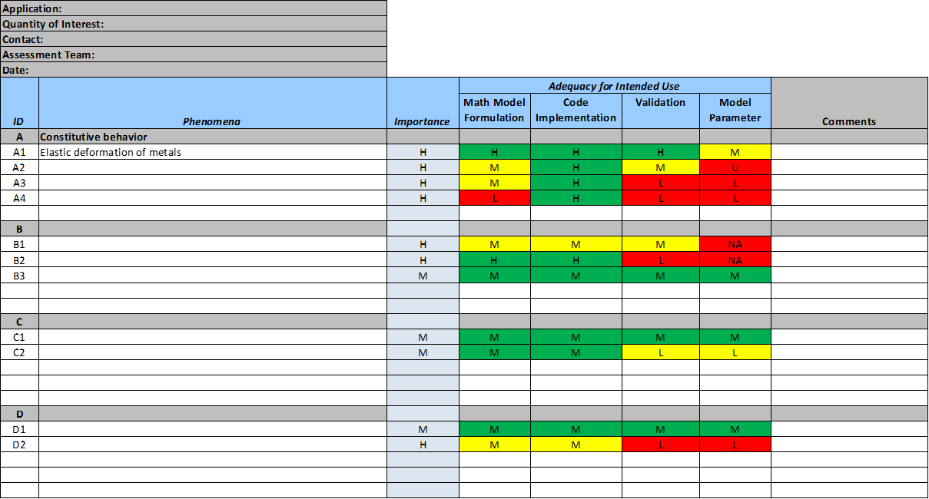
Figure 1: PIRT Table

<Provide a short description of the feature and indicate whether it is of High, Medium, or Low priority. You could also include specific priority component ratings, such as benefit, penalty, cost, and risk (each rated on a relative scale from a low of 1 to a high of 9).>
4.1.2 Stimulus/Response Sequences
Users need to be able to define phenomenon groups, and items within the groups. IDs should be assigned automatically

Three levels, High, Low, Mean (1,2,3, numerically) are available to assign to “Importance” and each “Adequacy” cell. If the “Adequacy Level” is one less than the “Importance Level” then a cell is colored yellow, if the difference is two than the cell is colored red.

<List the sequences of user actions and system responses that stimulate the behavior defined for this feature. These will correspond to the dialog elements associated with use cases.>
4.1.3 Functional Requirements
Functionality of this tool is illustrated by PIRT_Tool_v1.2.xlsx and Credibility_Mockup-v0.2.pptx. Key requirements are repeated here.

<Itemize the detailed functional requirements associated with this feature. These are the software capabilities that must be present in order for the user to carry out the services provided by the feature, or to execute the use case. Include how the product should respond to anticipated error conditions or invalid inputs. Requirements should be concise, complete, unambiguous, verifiable, and necessary. Use “TBD” as a placeholder to indicate when necessary information is not yet available.>

<Each requirement should be uniquely identified with a sequence number or a meaningful tag of some kind.>

REQ-1: An external text based configuration file V&V lead defines the columns, coloring rules and completeness criteria of the PIRT table
REQ-2: Analysts are provided with GUI elements to add/delete new rows as well as row groups
REQ-3: Automatic ID assignment
REQ-4: Automatic “Adequacy” coloring
REQ-5: Print facility
REQ-6: Option to tag PIRT state at significant phases of the ModSim task
REQ-7: Retrieve and report on the evolution of the PIRT over the life of the ModSim task.

PCMM - TBD

Other Nonfunctional Requirements

Performance Requirements
In general, performance of information retrieval shall support interactive team based usage.

<If there are performance requirements for the product under various circumstances, state them here and explain their rationale, to help the developers understand the intent and make suitable design choices. Specify the timing relationships for real time systems. Make such requirements as specific as possible. You may need to state performance requirements for individual functional requirements or features.>

Safety Requirements
No requirements regarding safety

<Specify those requirements that are concerned with possible loss, damage, or harm that could result from the use of the product. Define any safeguards or actions that must be taken, as well as actions that must be prevented. Refer to any external policies or regulations that state safety issues that affect the product’s design or use. Define any safety certifications that must be satisfied.>

Security Requirements
The Credibility Framework project shall be committed to the SAW Analysis Data Management back-end providing access control. Since persistence is based on clear text there is no other security requirement.

<Specify any requirements regarding security or privacy issues surrounding use of the product or protection of the data used or created by the product. Define any user identity authentication requirements. Refer to any external policies or regulations containing security issues that affect the product. Define any security or privacy certifications that must be satisfied.>

Software Quality Attributes
The software shall be Open Source, and it shall be configuration controlled in a Gitlab project. The software shall be developed as an Eclipse Java project. Each Java class shall have JavaDoc tags added when the class is developed. The Javadoc documentation shall be maintained concurrent to software development. A regressions test suite covering unit tests and full system tests shall be developed concurrently with software develpment. A stand-alone Ant build process including tasks for packaging and documentation generation and regression test reporting shall be provided.

<Specify any additional quality characteristics for the product that will be important to either the customers or the developers. Some to consider are: adaptability, availability, correctness, flexibility, interoperability, maintainability, portability, reliability, reusability, robustness, testability, and usability. Write these to be specific, quantitative, and verifiable when possible. At the least, clarify the relative preferences for various attributes, such as ease of use over ease of learning.>

Business Rules
Development of the Credibility Framework is likely to require close cooperation with Sandia personnel. NGA and NTESS shall have weekly telecons, and members of both teams shall be available to support more frequent communication a needed.

This Software Requirement Specification shall be updated bimonthly to record evolving requirements.

<List any operating principles about the product, such as which individuals or roles can perform which functions under specific circumstances. These are not functional requirements in themselves, but they may imply certain functional requirements to enforce the rules.>

Other Requirements
<Define any other requirements not covered elsewhere in the SRS. This might include database requirements, internationalization requirements, legal requirements, reuse objectives for the project, and so on. Add any new sections that are pertinent to the project.>
Appendix A: Glossary
<Define all the terms necessary to properly interpret the SRS, including acronyms and abbreviations. You may wish to build a separate glossary that spans multiple projects or the entire organization, and just include terms specific to a single project in each SRS.>
Appendix B: Analysis Models
<Optionally, include any pertinent analysis models, such as data flow diagrams, class diagrams, state-transition diagrams, or entity-relationship diagrams.>
Appendix C: To Be Determined List
<Collect a numbered list of the TBD (to be determined) references that remain in the SRS so they can be tracked to closure.>

