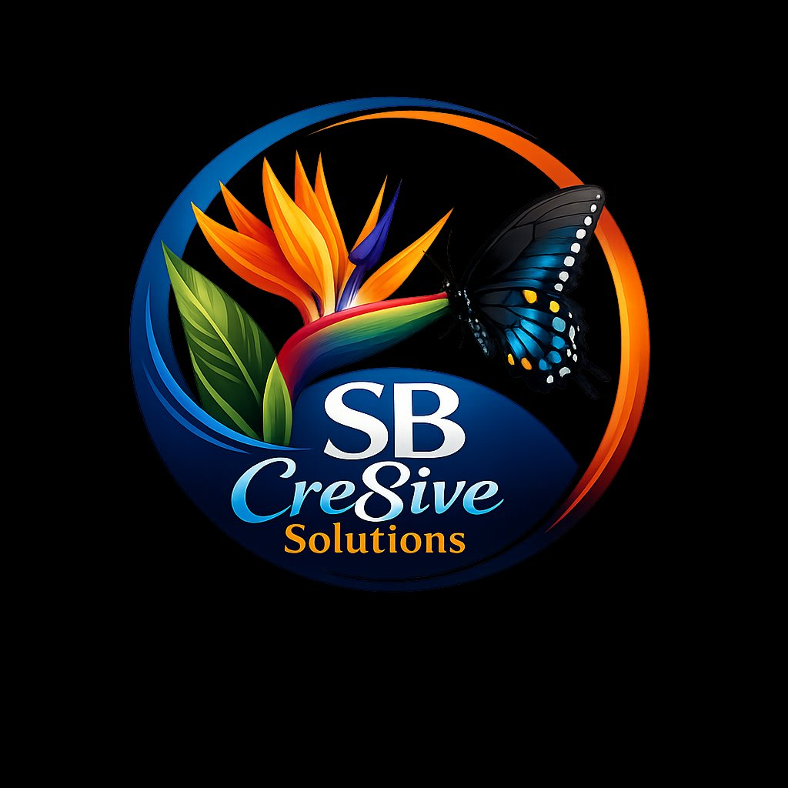 | LinkedIn Profile  Client Requirements Intake Form  SB Cre8ive Solutions

📌 Complete this form as thoroughly as possible. The more detail you provide, the stronger and more authentic your LinkedIn presence will be.

Date Completed | Prepared By (Your Name) | Target Completion Date

SECTION 1 — PERSONAL INFORMATION

First Name | Last Name

Preferred Name / Nickname (if applicable) | Pronouns (optional)

Professional Headline (120 characters max)
Appears directly under your name. E.g., "Chief Revenue Officer | SaaS Growth Strategist | Speaker"

Current Job Title

City / Metro Area | State / Country

Industry (select the closest match):

☐ Technology | ☐ Finance / Banking | ☐ Healthcare | ☐ Marketing / Advertising

☐ Real Estate | ☐ Legal | ☐ Education | ☐ Consulting

☐ Nonprofit / NGO | ☐ Manufacturing | ☐ Construction | ☐ Other:

Desired LinkedIn Custom URL — linkedin.com/in/_______________

SECTION 2 — PROFILE PHOTO & BANNER IMAGE

Do you have a professional headshot ready?

☐ Yes — I will provide it | ☐ No — need photographer recs | ☐ No — using casual photo for now

Photo Style / Dress Code
Describe the look and feel you want to convey (corporate, business casual, creative, approachable, etc.).

Banner / Background Image (1584 × 396 px)

☐ I have a banner ready | ☐ Create one for me | ☐ Use generic default for now

Banner concept, brand colors, or preferred imagery:

SECTION 3 — ABOUT SECTION (SUMMARY)

📌 The About section is your elevator pitch — up to 2,600 characters. Answer the questions below so we can craft a compelling narrative.

What problem do you solve for clients / employers / partners?

What makes you different from others in your field?

Your 3–5 biggest professional accomplishments or results:
Include numbers where possible. E.g., "Grew revenue 42% in 12 months" or "Managed a $5M portfolio."

Who is your primary target audience on LinkedIn?
Recruiters, clients, investors, peers, media — be specific.

Preferred tone for your professional brand:

☐ Authoritative / Expert | ☐ Approachable / Conversational | ☐ Innovative / Visionary

☐ Results-Driven / Analytical | ☐ Compassionate / Mission-Driven | ☐ Other:

Call to Action — What should readers do after viewing your profile?
E.g., "Connect with me," "Visit my website," "Book a consultation."

SECTION 4 — WORK EXPERIENCE

📌 List your most recent positions first. Focus on impact over duties — use numbers whenever possible.

Position 1
Job Title | Company Name

Start Date (Month / Year) | End Date (Month / Year or "Present")

Employment Type | Location or Remote?

Key responsibilities & achievements (use bullet points — quantify results):
E.g., grew revenue 40%, managed $5M budget, led a team of 12.

Position 2
Job Title | Company Name

Start Date (Month / Year) | End Date (Month / Year or "Present")

Employment Type | Location or Remote?

Key responsibilities & achievements (use bullet points — quantify results):
E.g., grew revenue 40%, managed $5M budget, led a team of 12.

Position 3
Job Title | Company Name

Start Date (Month / Year) | End Date (Month / Year or "Present")

Employment Type | Location or Remote?

Key responsibilities & achievements (use bullet points — quantify results):
E.g., grew revenue 40%, managed $5M budget, led a team of 12.

SECTION 5 — EDUCATION

Degree / Credential 1
Degree / Credential | Field of Study / Major

Institution Name | Graduation Year

Honors, activities, or notable projects (optional):

Degree / Credential 2
Degree / Credential | Field of Study / Major

Institution Name | Graduation Year

Honors, activities, or notable projects (optional):

SECTION 6 — SKILLS & ENDORSEMENTS

📌 LinkedIn allows up to 50 skills. List the most relevant to your goals — prioritize quality over quantity.

Top 5 Core Skills (these appear prominently at the top of your Skills section):

Additional Skills (list as many as relevant):

Do you have colleagues or clients who could endorse your skills?

☐ Yes — I will reach out to them | ☐ Possibly — need guidance on how to ask | ☐ No / Not at this time

SECTION 7 — CERTIFICATIONS, LICENSES & AWARDS

Certification / Award 1
Name of Certification / Award | Issuing Organization

Date Issued / Year | Expiration Date (if applicable)

Certification / Award 2
Name of Certification / Award | Issuing Organization

Date Issued / Year | Expiration Date (if applicable)

Certification / Award 3
Name of Certification / Award | Issuing Organization

Date Issued / Year | Expiration Date (if applicable)

SECTION 8 — FEATURED SECTION (MEDIA & LINKS)

📌 The Featured section lets you pin posts, articles, links, or media at the top of your profile. Prime real estate — use it wisely.

Items to feature (links, PDF portfolios, articles, media, posts):
Provide URLs or descriptions of what to include.

SECTION 9 — CONTACT INFORMATION & LINKS

Professional Email Address | Phone Number (optional)

Website / Portfolio URL | Company Website URL

Twitter / X Handle | Other social media (specify)

Mailing Address (city / state is sufficient for most profiles):

SECTION 10 — CONTENT & ENGAGEMENT STRATEGY

Will you be actively posting content on LinkedIn?

☐ Yes — regularly (3–5x/week) | ☐ Yes — occasionally (1–2x/week) | ☐ Rarely / Profile only

Topics you want to be known for on LinkedIn (list 3–5):

Content formats you are open to:

☐ Short text posts | ☐ Long-form articles | ☐ Carousels / Slide posts

☐ Short videos | ☐ Polls | ☐ Sharing content with commentary

Are you open to enabling LinkedIn Creator Mode?
Creator Mode unlocks newsletters, LinkedIn Live, and replaces "Connect" with "Follow."

☐ Yes | ☐ No | ☐ Not sure — please explain the benefits

SECTION 11 — GOALS & TIMELINE

Primary goal for your LinkedIn profile:

☐ New job / career pivot | ☐ Business development / leads | ☐ Thought leadership / speaking

☐ Networking / community | ☐ Recruiting talent | ☐ Investor relations

☐ Personal branding | ☐ Other:

Ideal launch / go-live date for the updated profile:

Any upcoming events, announcements, or launches to align the profile with?
E.g., new book, speaking engagement, company launch, promotion.

LinkedIn profiles you admire (names or URLs):

SECTION 12 — ADDITIONAL NOTES & PREFERENCES

Anything else we should know about your background, brand, or preferences?
Include sensitivities, things to avoid, past branding, preferred writing style examples, etc.

Do you have an existing resume or bio to reference?

☐ Yes — I will attach / share it | ☐ Partially — I have notes | ☐ No — building from scratch

SB Cre8ive Solutions
Thank you for completing this form. Your information is kept confidential and used solely to build your LinkedIn profile.
Questions before submitting? Reach out — we're happy to clarify.

