Netskope DLP On Demand
Databricks Unity AI Gateway Integration — Solutions Guide
This guide walks through deploying the translation adapter that connects an existing Netskope DLP On Demand (DLPoD) appliance to the Databricks Unity AI Gateway External Policy framework, and configuring Databricks to enforce Netskope’s DLP verdicts — including OCR-based DLP on images — on live model and tool traffic.

Assumes: you already have a Netskope DLP On Demand appliance deployed and tethered to your Netskope tenant, reachable via an internal load balancer. This guide covers only the Databricks-side adapter.
Audience: AWS administrators and Databricks workspace/account administrators performing this integration together.
Estimated time: 30–45 minutes, plus any wait time from your Netskope account team for DLP profile configuration or the OCR feature flag.

Table of Contents

1. Overview
This integration deploys one piece: a translation adapter — a small serverless AWS Lambda service that speaks the Databricks Unity AI Gateway “External Policy” contract on one side and DLPoD’s REST content-inspection API on the other, so Databricks can call it directly.

The adapter inspects both text and image content from Databricks model/tool traffic against your configured Netskope DLP profiles, and (when enabled) alerts to SkopeIT so DLP matches are visible alongside the rest of your Netskope telemetry.
Deploy the adapter (Part 2), then configure Databricks to use it (Part 3). Part 4 validates the whole path end to end, including image/OCR-based DLP.

2. Architecture
Once complete, a governed Databricks model, model-provider, or MCP service call flows through the integration as follows:
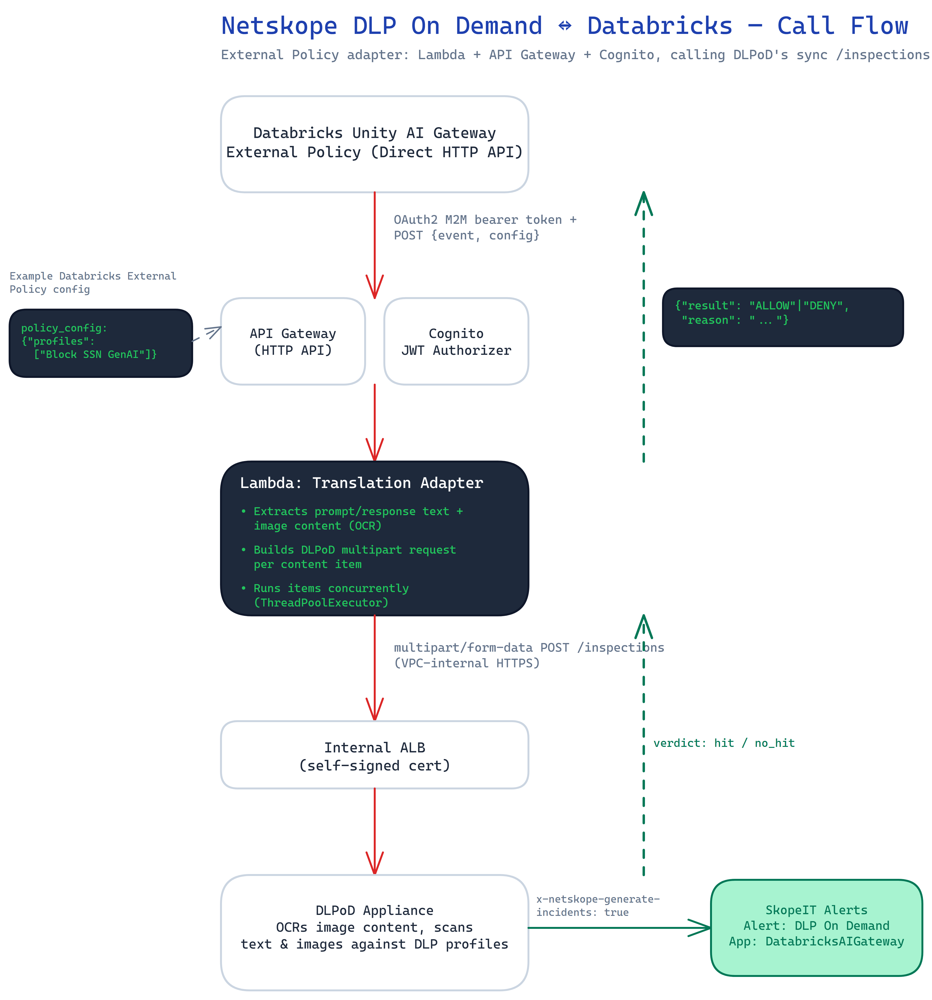

Key properties of this design:
- The adapter’s public entry point (API Gateway) is protected by OAuth2 client-credentials — the only authentication method the Databricks External Policy contract supports. Databricks fetches its own token and presents it as a bearer token on every call; API Gateway validates it before the Lambda ever runs.
- The Lambda only needs VPC-local reachability to the DLPoD appliance’s internal load balancer — it does not need NAT gateway or internet egress for that traffic.
- The DLPoD appliance itself is never exposed to the internet; only the small adapter Lambda is internet-facing, and only via a token-gated API.
- When a message contains both text and image content (for example, a chat turn with a pasted screenshot), the adapter inspects every content item concurrently rather than one after another, so DLPoD round-trip latency does not stack up against Databricks’ short timeout budget for this call.

3. Prerequisites

3.1 Netskope
- An existing DLP On Demand (DLPoD) appliance, already deployed and tethered to your Netskope tenant, reachable via an internal Application Load Balancer.
- At least one DLP profile configured in your Netskope tenant to enforce (custom or predefined). You can list available profiles by calling GET /inspections/profiles on the appliance.
NOTE: If you want OCR-based DLP on image content (a user pasting a screenshot into chat, for example), ask your Netskope account team to enable the backend feature flag DLP_DLPAAS_FEATURE_ENABLE_OCR for your tenant. Without it, DLPoD silently returns a non-match on image content regardless of what the image contains — text-only DLP is unaffected either way.

3.2 AWS
- An AWS account/role with permission to deploy a CloudFormation stack that creates Lambda, API Gateway, Cognito, and IAM resources.
- Any subnet in the same VPC as the DLPoD appliance’s internal load balancer, for the adapter Lambda — it does not need internet access, only VPC-local reachability to that load balancer.
- The SSM parameter name holding the appliance load balancer’s certificate PEM (created when the DLPoD appliance itself was deployed).
- AWS CLI configured with working credentials (aws sts get-caller-identity should succeed).
- PowerShell (the provided deployment script is PowerShell; adapt the underlying aws cloudformation commands if you prefer bash).

3.3 Databricks
- A Databricks workspace with Unity Catalog enabled.
IMPORTANT: The External Policies (Direct HTTP API) feature may be gated behind a preview at the time of this guide. Confirm with your Databricks account team that it is enabled for your workspace before starting — if it isn’t, the connection and policy screens described in Part 3 will not be available.
- Permission to create a Unity Catalog connection: either metastore admin, or the CREATE CONNECTION privilege (plus USE CATALOG / USE SCHEMA on the catalog/schema you’ll create it in).
- MANAGE permission on the schema containing the model, model-provider, or MCP service you plan to govern (needed to attach a policy to it in Part 3). If the service is one of Databricks’ own built-in, system-hosted models, this schema is typically owned by Databricks and MANAGE may need to be granted by a workspace/account admin — see the note in Part 3 for a way to validate the integration without waiting on that grant.

4. Part 1 — Get the Deployment Files
Obtain the deployment package (a templates/ directory containing databricks-adapter.yaml, a deploy-databricks-adapter.ps1 script, and a .env.example file) from your Netskope account team, or from the repository this guide was distributed alongside.

Step 1.1 — Confirm AWS access
aws sts get-caller-identity

Confirm the account ID and region shown are the ones you intend to deploy into — use the same region as your DLPoD appliance.

5. Part 2 — Deploy the Databricks Adapter

Step 2.1 — What this deploys
A CloudFormation stack containing:
- An AWS Lambda function (the translation logic — code is inlined in the template, no build step or artifact upload required).
- An Amazon API Gateway HTTP API — the public HTTPS endpoint Databricks will call.
- An Amazon Cognito User Pool configured for OAuth2 client-credentials — this is what satisfies Databricks’ OAuth M2M requirement.
- A minimal IAM execution role and security group.

Step 2.2 — Configure
Copy .env.example to .env and fill in the values for your environment:
VPC_ID=<same VPC as the DLPoD appliance’s internal ALB>
LAMBDA_SUBNET_IDS=<any subnet in that VPC>

# Optional overrides — defaults match the DLPoD standalone
# reference deployment’s naming convention:
#DLP_EVALUATION_URL=https://dlp.dlpod.internal/inspections
#CERT_PARAMETER_NAME=/netskope-dlpod/dlpod-cert
#DEFAULT_PROFILES=
#GENERATE_INCIDENTS=true

NOTE: Leave GENERATE_INCIDENTS at its default (true) unless you have a specific reason to inspect without logging — without it, DLP matches still correctly block, but nothing shows up in SkopeIT (see Part 4 and the Troubleshooting appendix).

Step 2.3 — Deploy
./deploy-databricks-adapter.ps1

This runs a single aws cloudformation deploy — there is no separate build or upload step. Wait for CREATE_COMPLETE, then note the stack outputs.
IMPORTANT: The script prints the OAuth Client Secret once, at the very end. Copy it immediately into a password manager — it is not stored anywhere else retrievable in plain text after this. If you lose it, you can look it up again with:
aws cognito-idp describe-user-pool-client \
--user-pool-id <UserPoolId output> --client-id <OAuthClientId output> \
--query UserPoolClient.ClientSecret --output text

What you’ll hand to Databricks
Record these five values from the stack outputs — you will enter them into Databricks in Part 3:
Field | Where it comes from
Host | AdapterHost output
API path | Leave blank
Client ID | OAuthClientId output
Client Secret | Printed once at deploy time (see above)
Token endpoint | OAuthTokenEndpoint output
OAuth scope | OAuthScope output

6. Part 3 — Configure Databricks

Step 3.1 — Create the UC HTTP Connection
In the Databricks workspace: Catalog → click the gear icon at the top of the Catalog panel → Connections → New connection. Fill in the six fields from the table in Step 2.3; set the connection type to HTTP and authentication type to OAuth M2M (this is typically fixed/non-editable once selected).
[SCREENSHOT] Databricks — Catalog panel with the gear-icon menu open, showing the Connections option.
[SCREENSHOT] Databricks — New Connection form filled in with the Host, Client ID, Client Secret, Token endpoint, and OAuth scope values.
NOTE: One connection can serve many policies — Databricks routes to the right configuration per policy via the policy_config field (Step 3.2), so create one connection per adapter deployment, not one per policy.

Step 3.2 — Attach an External Policy
Navigate to AI Gateway in the left sidebar, open the Models, Providers, or MCPs tab as appropriate, and select the specific service you want governed. Open its Policies tab (marked Beta) and choose New policy → Service policy → Guardrail type: External.
[SCREENSHOT] Databricks — the governed service’s Policies tab (Beta) with the New policy / Create policy option visible.
Configure:
Field | Value
Connection | The connection created in Step 3.1.
Policy configuration (policy_config) | { "profiles": ["<your DLP profile name(s)>"] }
Phase | Input guardrails (pre-call), Output guardrails (post-call), or both. Enabling both roughly doubles the calls sent to the adapter.
Rank | Only matters if other policies are attached to the same service; lowest rank runs first on the request and last on the response.
Mode | Enforce applies the verdict immediately. Log runs in dry-run mode, recording verdicts without blocking — requires inference tables enabled on the service to view results.

[SCREENSHOT] Databricks — the completed New Policy form: Guardrail type “External”, the connection selected, and policy_config filled in with your DLP profile name(s).
TIP: Databricks recommends starting in Log mode, observing what would be blocked, then switching to Enforce once you’re comfortable. Enforce mode is the recommended target for a real production deployment.
NOTE: Built-in, Databricks-hosted foundation models often live in a Databricks-owned system schema. Attaching a policy there requires MANAGE on that schema, which may need to be granted by a workspace or account admin. To validate the integration without waiting on that grant, you can first attach the policy to a model or model-provider service you’ve registered yourself (AI Gateway → Providers → add a provider service in a catalog/schema you own), then repeat the attachment on the production service once permissions are in place.

Step 3.3 — Wait for propagation
Allow 60–90 seconds after creating or changing a policy before testing — policy changes propagate through a configuration cache, and testing immediately is the most common reason people conclude a policy isn’t working when it actually is.

7. Part 4 — Test and Validate

Step 4.1 — Send a benign request
Send a normal, unremarkable prompt through the governed service (via the Databricks Playground, or a direct API call). It should complete normally.

Step 4.2 — Send a request that should be blocked (text)
Send a prompt containing content your DLP profile is configured to catch (for example, a realistic-looking Social Security Number, if using an SSN-detection profile). You should receive a response similar to:
{
"status": "incomplete",
"incomplete_details": { "reason": "content_filter" },
"output": [{ "content": [{ "type": "output_text",
"text": "This request was blocked by the '<policy name>' service policy." }] }],
"databricks_service_policy": {
"name": "<policy name>",
"action": "deny",
"phase": "pre_call",
"reason": "Blocked: DLP match (profiles=<your profile>, ...)"
}
}

[SCREENSHOT] Databricks — Policies tab “Policy execution flow” view (or Playground showing the blocked response), confirming the policy is wired in at the expected phase(s).

Step 4.3 — Send an image containing sensitive content (OCR)
If the DLP_DLPAAS_FEATURE_ENABLE_OCR flag is enabled for your tenant (see Part 3, Prerequisites), paste or attach an image containing sensitive text (for example, a screenshot with a Social Security Number rendered as legible text) into a chat governed by your policy. Use a clear, reasonably large font — a small or blurry rendering can cause OCR to misread the text and produce a false-negative allow, which is a test-image quality problem, not a policy or integration problem.
Expect the same kind of blocked response as Step 4.2, with the reason indicating the match was found in image content.
[SCREENSHOT] Databricks chat — an image containing sensitive text attached to a prompt, followed by the blocked response.

Step 4.4 — Confirm the SkopeIT alert
In the Netskope UI, check SkopeIT (Skope IT → Alerts) for a new DLP alert corresponding to the blocked request from Step 4.2 or 4.3. Look for:
- Alert Name: DLP On Demand
- Application: DatabricksAIGateway
- DLP Profile / DLP Rule matching what you configured
[SCREENSHOT] SkopeIT — Alert Details panel for the DLP On Demand alert, showing Application: DatabricksAIGateway and the matched DLP Profile/Rule.
NOTE: If the block worked in Databricks but no alert appears in SkopeIT, see the Troubleshooting appendix — this is almost always the x-netskope-generate-incidents header, which the adapter sets by default (GENERATE_INCIDENTS=true).

Step 4.5 — (Optional) Test the adapter directly
To isolate whether an issue is on the Databricks side or the adapter/appliance side, you can call the adapter directly, bypassing Databricks entirely. First obtain a token the same way Databricks does:
curl -X POST "<Token endpoint>" \
-H "Content-Type: application/x-www-form-urlencoded" \
-d "grant_type=client_credentials&client_id=<Client ID>&client_secret=<Client Secret>&scope=<OAuth scope>"

Then call the adapter with that token:
curl -X POST "<Host>/" \
-H "Authorization: Bearer <access_token>" \
-H "Content-Type: application/json" \
-d '{
"event": { "type": "model_call", "target": "catalog.schema.model",
"data": { "messages": [{"role":"user","content":"<test prompt>"}] } },
"config": { "policy_config": { "profiles": ["<your DLP profile name>"] } }
}'

Expect { "result": "ALLOW", "reason": "" } for a benign prompt, or { "result": "DENY", "reason": "Blocked: DLP match (...)" } for one that should be caught.

8. Troubleshooting
Symptom | Likely cause / fix
Image content is never flagged, even with an obviously sensitive image | DLP_DLPAAS_FEATURE_ENABLE_OCR is not enabled for your tenant — ask your Netskope account team to enable it. This is a tenant-level backend setting the adapter cannot control.
A specific test image is not flagged, but text with the same content is | The test image likely has a font too small, low-resolution, or blurry for OCR to read reliably — not a policy or flag problem. Retry with a larger, clearer font (per docs.netskope.com/en/ocr, image quality directly affects OCR accuracy).
Blocks work correctly in Databricks, but nothing appears in SkopeIT | The x-netskope-generate-incidents header was not set on the inspection call. The adapter sets this by default (GENERATE_INCIDENTS=true) — confirm this parameter wasn’t overridden to false when the stack was deployed.
Attaching a policy fails: “User does not have permission… MANAGE on Schema ‘X’” | You need MANAGE on that schema. Ask a workspace/account admin to grant it, or attach the policy to a service you own instead to validate the integration first (see the note in Part 3).
Everything is denied immediately after attaching a policy | You tested inside the 60–90 second propagation window — wait and retry.
Everything is denied, with an “unrecognized result” style reason | The adapter returned something Databricks didn’t recognize. Confirm the adapter is reachable and check its logs in Amazon CloudWatch.
“It works when I call the adapter directly, but not through Databricks” | The issue is on the Databricks side (connection credentials, policy configuration, or permissions) rather than the adapter/appliance. Re-check Part 3.
“It fails even calling the adapter directly” | The issue is on the AWS side, or the DLPoD appliance itself. Confirm the appliance is reachable and healthy, and the adapter’s network/parameter configuration (Part 2) points at the right VPC, subnet, and evaluation URL.

Appendix A — Request and Response Reference
Databricks sends the adapter a JSON body shaped as:
{
"event": {
"type": "model_call" | "model_result" | "tool_call" | "tool_result",
"target": "<catalog>.<schema>.<service>",
"data": { /* the raw request or response body, or MCP tool payload */ },
"request_data": { /* present only on *_result events */ }
},
"config": {
"policy_config": { /* whatever you configured in Step 3.2 */ },
"phases": "pre_call" | "post_call" | "pre_call,post_call"
}
}

NOTE: policy_config may arrive as a parsed JSON object or as a raw JSON-encoded string, depending on how Databricks forwards it — the adapter handles either automatically.
The adapter always responds with a flat JSON body:
{ "result": "ALLOW" | "DENY", "reason": "<human-readable explanation>" }

event.type to evaluated content:
event.type | What is evaluated
model_call | The most recent user message(s) in the request — text and any image content blocks (supports both the Chat Completions "messages" shape and the Responses API "input" shape).
model_result | The assistant’s response content (supports both the "choices" shape and the "output" shape). Text only.
tool_call | The MCP tool’s arguments. Text only.
tool_result | The MCP tool’s result payload. Text only.

DLPoD sync inspection verdict mapping:
DLPoD summary.verdict | Adapter result
hit | DENY, with reason including the matched profile(s) and severity (when present).
no_hit | ALLOW (for that content item — if a message has multiple content items, all must return no_hit for the overall result to be ALLOW).
(status ≠ success, e.g. timeout/error, or an unrecognized verdict) | DENY, fail-closed, with a reason describing the failure.

Appendix B — Support and Resources
Netskope: contact your account team for DLPoD appliance deployment/tethering, DLP profile configuration, and enabling the OCR feature flag.
Databricks: contact your account team to confirm External Policies (Direct HTTP API) availability and to resolve workspace permission questions (CREATE CONNECTION, MANAGE on a given schema).

