Technical Design Document
Personal Finance Management System for Android (InTrack)
BSc (Hons) in Computer Science | SE3092: Platform Based Development | Assignment 01

IT23657700 | K. S. H. Perera
IT23631960 | H. M. H. K. Herath
IT23745988 | K. G. J. Vishwaprabha

Requirement Analysis
Kavindu estimates his monthly income at LKR 160,000–210,000 across four asynchronous channels, yet has only accumulated LKR 11,200 in savings after earning over LKR 1.6M in 12 months. Conventional budgeting apps fail him because they assume a single, fixed monthly paycheck in a single currency.
Lens 1: Deconstruction of Income Streams
1. Primary Employment (Semi-Variable Recurring): Deposited on the 25th of each month in LKR. While base compensation is predictable, performance incentives create a variance between LKR 120,000 and LKR 140,000. Kavindu avoids checking his physical payslip. The platform must distinguish between guaranteed baseline cashflow (LKR 120,000) and realized variable bonuses. It is recommended to add a recurring prompt on the 25th for the variable delta input rather than expecting manual entry from scratch.
2. SME Freelance Engagements (Milestone-Driven & Fragmented): React and WordPress development projects paying LKR 20,000 to LKR 90,000 per project. Payments arrive irregularly, invoices are frequently forgotten, and bank reconciliation between payments and projects fails. The system must decouple earned revenue from realized cash (deposited in the bank).
3. AdSense Monetization (Foreign Currency Volatility): Generated from his tech blog, denominated in USD, and converted to LKR at prevailing bank exchange rates upon monthly transfer. Yields fluctuate between LKR 3,500 and LKR 19,000. Kavindu checks his dashboard but never logs the realized deposit. The persistence layer must preserve dual-currency accounting.
4. Cryptocurrency Trading (Capital Gains vs. Working Income): Active trading across cryptocurrencies (USDT, ETH) characterized by volatile quarters (gains in Q1, losses in Q3) without a calculated running net position. High-frequency micro-trading cannot be tracked manually without immediate drop-off. The system must record Realized Net P&L Snapshots (closed gains or losses liquidated to fiat/stablecoins) rather than treating gross withdrawals as earned income, preventing paper profits or capital losses from distorting monthly spending power.
Lens 2: Failure Analysis
1. Google Sheets: Manually entered formulas broke upon row insertion; entry overhead too high. By Enforce automatic aggregations via Firestore reactive queries. Implement a "Forgiving Catch-Up" engine where missed days can be balanced with a single unallocated discrepancy adjustment rather than retroactive ledger reconstruction.
2. Play Store Budgeting App: Hardcoded to USD; single-income paradigm; fixed rigid monthly budget. Resolved by native LKR multi-source architecture.
3. Notes Application: Unlabeled blocks of raw numbers pasted from bank notifications. This will become unreadable in 4 days. By introducing 2-Tap Micro-Logging replaces free-text pasting with interactive categorical quick-action chips on the Android home screen.
4. Bank Native App: Captured card only; missed cash and secondary accounts entirely, misclassified PickMe as "Online Retail". Implement Multi-Ledger Aggregation unified logging capturing three payment channels.
Lens 3: Goal Progress Visibility
Kavindu has a specific, quantified savings goal and a deadline. His previous tools never connected daily financial behaviour to that goal in a visible or motivating way.
Mathematical Grounding of the MacBook Pro M4 Goal
- Target Asset: MacBook Pro M4 (Authorized Reseller Configuration).
- Target Capital Required: LKR 490,000.00.
- Current Liquid Savings: LKR 11,200.00.
- Deficit: LKR 478,800.00.
- Target Timeline: 12 Months (365 Days).
- Required Savings Run-Rate: LKR 40,833.33 / month ($490,000 / 12) or LKR 39,900.00 / month remaining deficit rate.
Lens 4: Low-Friction Expense Ingestion and Data Fidelity
Given that the application cannot import bank data automatically, how should it handle expense entry in a way that minimises friction and maximises long-term user adherence?
- Quick-Action Presets (The "Frequent 4"): Pre-built fast-track buttons for Kavindu's high-frequency spending vectors: PickMe, UberEats, Coffee / Café, and Cash Withdrawal. Tapping opens a numeric keypad with category and channel pre-selected.
- Default Context Inheritance: The application defaults the timestamp to now(), the payment channel to Primary Card (or last used), and the currency to LKR. Entry requires only typing the amount and tapping a single confirmation button.
- Automated Fixed Recurring Commitments: Rent (LKR 34,000 on the 1st), gym auto-debits, and digital subscriptions are managed by an automated scheduler. They are auto-posted to the ledger and simply require confirmation on the dashboard, removing the chore of logging fixed recurring overhead.
Lens 5: Structural Spending Distribution and Rapid Self-Awareness
Kavindu has no concept of his discretionary-to-committed spending ratio. What visualisations or summary views would most efficiently reveal this to a user who does not think in financial categories?
- UI and UX should design to provide immediate financial self-awareness within seven days. Use charts and matrices.
- Kavindu does not think in traditional accounting categories. Forcing him to manage dozens of subcategories creates cognitive overload. The system therefore models every outflow under a binary macro-taxonomic model which are Behavioural expenses (Discretionary) and Committed expenses.

Software Requirements Specification (SRS)
1. System Scope & Purpose
The Personal Finance Management System is an offline-first, mobile Android application built specifically to address the structural financial ambiguity of users with irregular, multi-channel income streams and impulsive discretionary spending patterns.
The application unifies multi-currency earnings (LKR, USD, crypto P&L), simplifies manual transaction tracking to under three seconds, enforces visibility over committed versus discretionary outlays, and continuously links daily discretionary habits to a tangible capital goal (MacBook Pro M4: LKR 490,000).
2. User Persona Summary: Kavindu Silva
- Role: Junior Software Engineer at a product startup, Colombo, Sri Lanka.
- Financial Profile: Base salary of LKR 120,000–140,000 arriving on the 25th; irregular SME freelance projects (LKR 20,000–90,000); monthly USD AdSense revenue (LKR 3,500–19,000 equivalent); volatile Binance crypto trading (USDT/ETH).
- Core Friction Points: Invisible spending, neglected freelance invoicing, unaccounted cash transactions, and a recurring drop-off from financial tracking within two weeks.
- Target Goal: Accumulate LKR 490,000 for a MacBook Pro M4 within 12 months with only LKR 11,200 currently saved.
3. Functional Requirements (FR)
Module 1: Authentication & User State Management (FR-AUTH)
- FR-AUTH-01: The system shall authenticate users via Firebase Authentication using secure Email and Password credentials.
- FR-AUTH-02: The system shall maintain an authenticated session state locally, allowing seamless access without network connectivity.
- FR-AUTH-03: The system shall initialize user preferences upon registration with a default base currency set to Sri Lankan Rupees.
Module 2: Multi-Source & Multi-Currency Income Management (FR-INC)
- FR-INC-01 (Salary Ingestion): The system shall prompt the user on the 25th of each calendar month with a pre-filled base salary of LKR 120,000, allowing quick adjustment for variable performance bonuses up to LKR 140,000.
- FR-INC-02 (Freelance Project Tracking): The system shall track SME freelance engagements with attributes: project title, client name, total agreed amount in LKR, payment milestones, due date, and payment status.
- FR-INC-03 (Receivables Reminder): The system shall display an alert on the dashboard for any freelance milestone that remains in INVOICED status past its due date.
- FR-INC-04 (Foreign Currency Normalization): The system shall accept AdSense income entries in USD, record the user-specified realized exchange rate at the time of conversion, and compute the normalized base amount in LKR.
- FR-INC-05 (Crypto Net Position Ledger): The system shall allow the user to record realized crypto trading net outcomes (in USDT or LKR) with an indicator of profit or loss, maintaining a running Year-to-Date (YTD) net position.
- FR-INC-06 (True Income Aggregation): The system shall compute Total Realized Income for any calendar month by summing cleared salary, paid freelance milestones, normalized AdSense earnings, and realized net crypto P&L.
Module 3: Low-Friction Expense Logging & Categorization (FR-EXP)
- FR-EXP-01 (2-Tap Quick Presets): The system shall provide one-tap shortcut buttons on the primary entry screen for frequent categories: PickMe, UberEats, Coffee, and Cash.
- FR-EXP-02 (Account Channel Allocation): The system shall require every expense entry to be assigned to one of three channels: Primary Bank Card, Cash, or Secondary Account.
- FR-EXP-03 (Binary Nature Tagging): The system shall tag every outflow as either COMMITTED (non-negotiable survival expenses) or DISCRETIONARY (lifestyle and impulse outlays).
- FR-EXP-04 (Recurring Expense Scheduler): The system shall automatically generate ledger entries for recurring committed expenses (Apartment Rent of LKR 34,000, secondary-account gym membership, and active software subscriptions) on their due dates.
- FR-EXP-05 (Subscription Audit): The system shall maintain an active register of recurring digital subscriptions and flag services with an "Unused / Cancel Intent" marker to prompt cancellation.
Module 4: Dynamic Goal Runway & Capital Allocation (FR-GOAL)
- FR-GOAL-01 (Goal Configuration): The system shall allow the user to define a primary asset goal with a title (MacBook Pro M4), target cost (LKR 490,000), deadline (12 months), and starting balance (LKR 11,200).
- FR-GOAL-02 (Required Savings Rate Calculation): The system shall compute and update the required daily and monthly savings run rate necessary to reach the goal by the target date (LKR 40,833.33/month).
- FR-GOAL-03 (Discretionary Impact Feedback): Upon saving any discretionary expense greater than LKR 2,000, the system shall display an inline impact notice indicating how many days the expense adds to the projected goal completion date.
- FR-GOAL-04 (Windfall Siphoning): When freelance or ad income is logged, the system shall provide an option to allocate a percentage (e.g., 20%, 30%, 50%) directly to the goal fund.
Module 5: Financial Analytics & Clarity Dashboards (FR-ANL)
- FR-ANL-01 (Committed vs. Discretionary Gauge): The dashboard shall display a visual ratio gauge showing the percentage breakdown of committed versus discretionary spending against total monthly outflow.
- FR-ANL-02 (Top Discretionary Outflow Radar): The system shall aggregate and rank discretionary spending categories for the active month, highlighting dining and transport leaks.
- FR-ANL-03 (Account Channel Balance Breakdown): The system shall visualize total spending distributed across the three payment channels: Primary Card, Cash, and Secondary Account.
4. Non-Functional Requirements (NFR)
Performance & Responsiveness (NFR-PERF)
- NFR-PERF-01: The application cold-start time to an interactive dashboard state shall not exceed 1.5 seconds on devices meeting the minimum SDK 26 specification.
- NFR-PERF-02: Transaction quick-logging shall execute and clear the interface in under 400 milliseconds using optimistic UI updates.
Security & Data Isolation (NFR-SEC)
- NFR-SEC-01: All Firestore database read and write operations must be secured by user-isolated Firestore Security Rules.
- NFR-SEC-02: No sensitive financial information or authentication keys shall be logged to the Android system console in release builds.
Usability & Accessibility (NFR-USE)
- NFR-USE-01: The entire user interface must be constructed with Jetpack Compose following Material Design 3 guidelines, supporting dynamic color schemes and high-contrast typography.
- NFR-USE-02: Transaction entry shall be executable with one hand via bottom-sheet interactions and keypad-optimized thumb zones.
Reliability & Offline Availability (NFR-REL)
- NFR-REL-01: The application must maintain 100% offline functionality for reading and recording transactions using Room database caching and Firestore offline persistence.
- NFR-REL-02: Under network disconnection, the UI must not block or display an unhandled error state, syncing automatically when connectivity is restored.
5. System Constraints & Platform Boundaries (CON)
- CON-01 (Platform Target): The application must run on devices with a minimum API Level of 26 (Android 8.0 Oreo) and target API Level 34+ (Android 14).
- CON-02 (Language & Runtime): 100% Kotlin codebase. Zero Java files or Java interop permitted within the application presentation and domain layers.
- CON-03 (UI Toolkit): Exclusively built with Jetpack Compose using Material 3 design tokens. Legacy Android XML view hierarchies are strictly disallowed.
- CON-04 (Architecture Paradigm): Strict adherence to Model-View-ViewModel (MVVM) and Unidirectional Data Flow (UDF). No database calls or business logic inside Composable functions.
- CON-05 (Cloud Backend & Multi-Tenancy): Powered by Firebase Authentication and Cloud Firestore with granular user-partitioned security rules. Local emulator-only backends are forbidden for final deliverables.
6. Requirements Traceability Matrix (RTM)
The Requirements Traceability Matrix establishes bidirectional mapping between derived requirements, functional use cases, ViewModel state management classes, UI presentation screens, and their empirical verification methods.
Req ID | Requirement Summary | Use Case | ViewModel Class | Compose Screen / Component | Verification Method
FR-AUTH-01 | Firebase Auth secure Email/Password authentication | UC-01 | AuthViewModel | LoginScreen, SignUpScreen | Firebase Auth integration test
FR-AUTH-02 | Offline session caching & local credentials persistence | UC-01 | AuthViewModel | MainActivity, AuthComponents | Network-disconnect startup test
FR-AUTH-03 | Default LKR base currency preference initialization | UC-01 | AuthViewModel | SettingsScreen, ProfileScreen | User document snapshot check
FR-INC-01 | 25th recurring salary prompt with bonus delta input | UC-02 | IncomeViewModel | IncomeHubScreen, DashboardScreen | Calendar date trigger verification
FR-INC-02 | SME freelance milestone invoice tracker & client linking | UC-02 | IncomeViewModel | IncomeHubScreen (FreelanceCard) | Invoice state transition test
FR-INC-03 | Overdue freelance milestone alert indicator on dashboard | UC-02 | IncomeViewModel, DashboardViewModel | DashboardScreen, MetricCard | Overdue timestamp comparison test
FR-INC-04 | AdSense foreign currency (USD to LKR) FX snapshotting | UC-02 | IncomeViewModel | IncomeHubScreen (AdSenseCard) | Dual-currency math calculation test
FR-INC-05 | Crypto realized fiat net P&L tracking (cashflow basis) | UC-02 | IncomeViewModel | IncomeHubScreen (CryptoCard) | Fiat withdrawal/injection delta test
FR-INC-06 | Total true realized monthly income aggregation | UC-02 | DashboardViewModel, IncomeViewModel | DashboardScreen, IncomeHubScreen | Reactive flow combine() unit test
FR-EXP-01 | 2-Tap quick presets for Frequent 4 (PickMe, Uber, Cafe, Cash) | UC-03 | ExpenseViewModel | QuickExpenseBottomSheet | UI latency benchmark (<400ms)
FR-EXP-02 | 3-Account channel attribution (Primary, Secondary, Cash) | UC-03 | ExpenseViewModel | QuickExpenseBottomSheet, AddExpense | Channel tag persistence check
FR-EXP-03 | Binary nature tagging (Committed vs Discretionary) | UC-03 | ExpenseViewModel | QuickExpenseBottomSheet, EditExpense | Nature enum validation & gauge test
FR-EXP-04 | Automated fixed recurring commitment scheduler (Rent LKR 34k) | UC-04 | SubscriptionViewModel | SubscriptionAuditScreen, Dashboard | Due-date posting verification
FR-EXP-05 | Subscription audit & zombie cancellation review tagging | UC-04 | SubscriptionViewModel | SubscriptionAuditScreen, ViewSubscription | Review flag toggle & query test
FR-GOAL-01 | MacBook Pro M4 goal tracking (LKR 490k target, LKR 11.2k baseline) | UC-05 | GoalViewModel | GoalTrackerScreen, GoalDetailScreen | Deficit & percentage calculation
FR-GOAL-02 | Dynamic required monthly savings run-rate calculation | UC-05 | GoalViewModel | GoalTrackerScreen, DashboardScreen | Formula test: LKR 40,833.33/mo
FR-GOAL-03 | Discretionary spending goal impact notice (> LKR 2,000) | UC-05 | ExpenseViewModel, GoalViewModel | QuickExpenseBottomSheet | Inline goal impact warning test
FR-GOAL-04 | Windfall lump-sum siphoning slider (20% to 50%) | UC-05 | IncomeViewModel, GoalViewModel | WindfallAllocatorModal | Goal contribution subcollection write
FR-ANL-01 | Committed vs Discretionary visual ratio gauge | UC-06 | DashboardViewModel | DashboardScreen (CommitmentRatioBar) | Aggregate percentage unit test
FR-ANL-02 | Top discretionary outflow radar & dining shock alert | UC-06 | DashboardViewModel, ExpenseViewModel | ExpenseAnalyticsScreen, MetricCard | Category ranking & shock notice test
FR-ANL-03 | Account channel balance distribution visualization | UC-06 | DashboardViewModel | AllTransactionsScreen, DashboardScreen | Cross-channel aggregation check

Use case Daiagram
The following diagram illustrates the primary user interactions with the InTrack system boundary, mapping actor actions to discrete functional use cases.
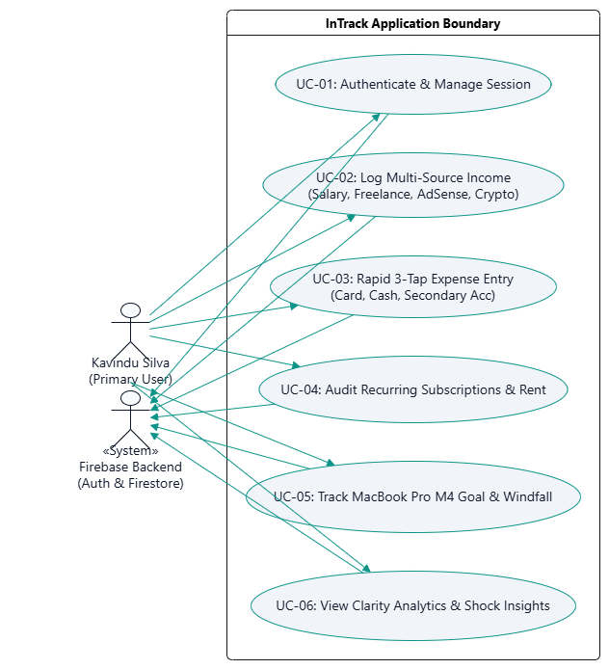

Detailed Use Case Specifications
The following formal software specifications delineate the six core functional use cases depicted in Figure 1. Each specification documents actor interactions, preconditions, postconditions, step-by-step main success flows, alternative exception branches, and explicit scenario grounding to Kavindu's personal financial reality.
Use Case Specification: UC-01 — Authenticate User & Session Management
Use Case Attribute | Specification Details: UC-01 - Authenticate User & Session Management
Use Case ID & Title | UC-01: Authenticate User & Session Management
Actors | Primary Actor: Mr. Kavindu Silva (Junior Software Engineer, Primary User)  Secondary Actor: Firebase Authentication, Android Keystore & Room Local Cache
Preconditions | Device is powered on. Application is installed on Android API 26+ device. Network is available for initial registration or valid local session token exists for offline launch.
Postconditions | User identity is verified; authenticated userId is bound to ViewModel lifecycle; tenant partition root /users/{userId} is anchored; user profile is loaded into UI state.
Main Success Scenario | 1. Kavindu launches InTrack on his Android device; AuthRepository checks for valid cached session credentials.  2. If unauthenticated, LoginScreen presents clean email/password inputs with high-contrast Material 3 tokens.  3. Kavindu enters his credentials and taps 'Sign In'.  4. AuthViewModel delegates to FirebaseAuth.signInWithEmailAndPassword() via coroutines on Dispatchers.IO.  5. Firebase validates credentials and returns authenticated AuthResult with unique userId.  6. App stores secure token in encrypted local storage and fetches user preferences from /users/{userId}.  7. Navigation router smoothly navigates to DashboardScreen; real-time snapshot listeners are attached.
Alternative & Exception Flows | 1a. Offline Launch: If network is unavailable, AuthRepository restores cached session token from local Room DB, launching directly into Dashboard without blocking.  4a. Invalid Credentials: If password fails, FirebaseAuthException is caught; AuthViewModel updates UiState.Error, displaying an accessible snackbar message with zero UI crash.
Scenario Grounding | Eliminates Kavindu's previous frustration with apps that required constant online logins or had no cloud synchronization across devices.
Use Case Specification: UC-02 — Ingest Multi-Source & Multi-Currency Income
Use Case Attribute | Specification Details: UC-02 - Ingest Multi-Source & Multi-Currency Income
Use Case ID & Title | UC-02: Ingest Multi-Source & Multi-Currency Income
Actors | Primary Actor: Mr. Kavindu Silva  Secondary Actor: Cloud Firestore (/users/{userId}/incomes), Local Room Database (IncomeDao)
Preconditions | User is authenticated; current month income ledger is active.
Postconditions | Income transaction record is written to Cloud Firestore and Room local cache; Total Realized Monthly Income aggregate updates reactively across dashboard.
Main Success Scenario | 1. Kavindu navigates to IncomeHubScreen, which displays 4 independent channel modules: Salary, Freelance, AdSense, and Crypto.  2. On the 25th of the month, Kavindu taps Salary Card; the system automatically pre-fills baseline salary of LKR 120,000.00; Kavindu inputs the variable performance bonus delta (+LKR 15,000.00) and confirms.  3. For freelance projects, Kavindu taps Freelance Card; inputs client name ('Kandy SME Web App'), milestone title, agreed amount in LKR, due date, and sets status to INVOICED.  4. For AdSense monetization, Kavindu inputs original amount in USD ($48.50) and prevailing bank exchange rate (304.20 LKR/USD); system computes normalized realized amount of LKR 14,753.70.  5. For crypto trading, Kavindu inputs fiat injected vs fiat withdrawn; system logs a Realized Net P&L cashflow snapshot.  6. Upon saving any cleared payment, system activates WindfallAllocatorModal prompting user to allocate 20%-50% toward MacBook Pro M4.  7. IncomeViewModel writes entity to Room and Firestore; Dashboard combines streams reactively.
Alternative & Exception Flows | 3a. Overdue Milestone Alert: If an invoiced milestone remains unpaid past its due date, system automatically flags it as OVERDUE and raises an amber priority banner on DashboardScreen.  5a. Crypto Capital Loss: If withdrawals are less than capital injected, system records a negative P&L snapshot, correctly reducing net realized income without treating gross withdrawals as artificial profit.
Scenario Grounding | Resolves Kavindu's primary income problem: earning across four irregular, asynchronous channels without knowing his true monthly total (previously guessing between LKR 160k-210k).
Use Case Specification: UC-03 — Rapid 3-Tap Micro-Expense Logging
Use Case Attribute | Specification Details: UC-03 - Rapid 3-Tap Micro-Expense Logging
Use Case ID & Title | UC-03: Rapid 3-Tap Micro-Expense Logging
Actors | Primary Actor: Mr. Kavindu Silva  Secondary Actor: Local Room Database (ExpenseDao), Cloud Firestore (/users/{userId}/expenses)
Preconditions | User is authenticated; application is open on any screen; bottom action bar is visible.
Postconditions | Expense record is tagged by channel and commitment nature, persisted to Room and Firestore; monthly budget gauges and recent transaction lists recompose in < 400ms.
Main Success Scenario | 1. Kavindu taps the central floating '+' action button on the bottom bar.  2. QuickExpenseBottomSheet slides up in under 150ms, displaying the 'Frequent 4' preset chips: PickMe, UberEats, Coffee / Cafe, and Cash Withdrawal.  3. Kavindu taps 'Coffee / Cafe'; the system pre-selects Category = DINING_OUT, Commitment = DISCRETIONARY, and Channel = CARD_PRIMARY.  4. A numeric keypad appears in the thumb zone; Kavindu enters amount '1450' and taps Confirm.  5. ExpenseViewModel performs an optimistic UI update, immediately rendering the expense in recent transactions list.  6. Background coroutine writes ExpenseEntity to Room SQLite cache and pushes document to Cloud Firestore.
Alternative & Exception Flows | 2a. Custom Outflow: Kavindu taps 'Custom Category' to select from Utilities, Rent, or Transport.  4a. Discretionary Impact Warning: If the entered discretionary expense exceeds LKR 2,000.00, an inline chip dynamically computes and displays: 'This expense adds +1.2 days to your MacBook M4 target.'
Scenario Grounding | Directly overcomes Kavindu's low tolerance for friction, which caused him to abandon Google Sheets after 13 days and Notes app after 4 days.
Use Case Specification: UC-04 — Audit Recurring Obligations & Zombie Subscriptions
Use Case Attribute | Specification Details: UC-04 - Audit Recurring Obligations & Zombie Subscriptions
Use Case ID & Title | UC-04: Audit Recurring Obligations & Zombie Subscriptions
Actors | Primary Actor: Mr. Kavindu Silva  Secondary Actor: Local Room DB (SubscriptionDao), Cloud Firestore (/users/{userId}/subscriptions)
Preconditions | User is authenticated; recurring commitments registered in database.
Postconditions | Recurring commitments are audited; monthly fixed burn rate is computed; unused subscriptions are tagged for cancellation.
Main Success Scenario | 1. Kavindu opens SubscriptionAuditScreen from the navigation drawer.  2. Screen displays total committed recurring monthly outflow, highlighting LKR 34,000.00 apartment rent, LKR 6,500.00 gym auto-debit, and digital SaaS tools.  3. System visualizes payment source breakdown, clearly distinguishing between primary card debits and auto-debits drawn from his secondary bank account.  4. Kavindu reviews recurring items; flags forgotten cloud IDE plan and gym subscription intended to be cancelled six months ago as 'UNUSED_FLAGGED'.  5. Upon contacting bank/vendor to cancel auto-debit, Kavindu taps 'Mark as Cancelled', removing it from monthly recurring burn.
Alternative & Exception Flows | 2a. Rent Due Notification: On the 1st of each month, system auto-generates a pending rent confirmation prompt on DashboardScreen, avoiding manual re-entry.
Scenario Grounding | Exposes hidden financial leaks in Kavindu's secondary account that previously remained invisible because bank native spending tools only tracked his primary card.
Use Case Specification: UC-05 — Track MacBook Pro M4 Goal & Windfall Allocator
Use Case Attribute | Specification Details: UC-05 - Track MacBook Pro M4 Goal & Windfall Allocator
Use Case ID & Title | UC-05: Track MacBook Pro M4 Goal & Windfall Allocator
Actors | Primary Actor: Mr. Kavindu Silva  Secondary Actor: Room DB (GoalDao), Cloud Firestore (/users/{userId}/goals & contributions)
Preconditions | Goal is configured: Target = LKR 490,000.00, Baseline Saved = LKR 11,200.00, Deadline = 12 Months.
Postconditions | Goal fund updated; daily and monthly savings run-rates recalculated; capital contributions logged.
Main Success Scenario | 1. Kavindu opens GoalTrackerScreen or examines the MacBook M4 Goal Progress Card on DashboardScreen.  2. System displays current saved balance, percentage progress ring, deficit (LKR 478,800.00), and remaining timeline (365 days).  3. Mathematical run-rate engine dynamically displays: 'Required Savings: LKR 40,833.33 / month' to purchase MacBook M4 on schedule.  4. When a freelance milestone (e.g. LKR 45,000.00) is paid, WindfallAllocatorModal prompts Kavindu with an allocation slider (20% to 50%).  5. Kavindu sets slider to 30% (LKR 13,500.00) and confirms; system writes ContributionEntity to /goals/{goalId}/contributions.  6. GoalViewModel updates currentSavedLkr, recalculates remaining deficit, and reduces future required run-rate.  7. What-If simulator allows Kavindu to drag discretionary reduction sliders to see projected delivery date move forward by N weeks.
Alternative & Exception Flows | 3a. Savings Behind Schedule: If monthly savings dip below target run-rate, system activates CatchUpSheet suggesting a 5% discretionary trim rather than displaying discouraging red alerts.
Scenario Grounding | Connects daily financial behavior to Kavindu's primary material objective, transforming an abstract wish into an active, motivating mathematical runway.
Use Case Specification: UC-06 — View Financial Clarity Analytics & Shock Insights
Use Case Attribute | Specification Details: UC-06 - View Financial Clarity Analytics & Shock Insights
Use Case ID & Title | UC-06: View Financial Clarity Analytics & Shock Insights
Actors | Primary Actor: Mr. Kavindu Silva  Secondary Actor: Cloud Firestore, Local Room Database, AndroidX Lifecycle StateFlow
Preconditions | User is authenticated; minimum transaction records exist.
Postconditions | Aggregated clarity analytics rendered on Dashboard; Commitment Ratio Bar computed; Shock-factor insights presented.
Main Success Scenario | 1. Kavindu launches InTrack; DashboardScreen collects latest DashboardUiState from StateFlow.  2. CommitmentRatioBar visualizes the proportion of monthly income allocated to Committed non-negotiable living costs (Rent, Utilities) vs Discretionary lifestyle spending.  3. Shock Insight Metric Card displays: 'You spent LKR 24,000.00 on Coffee & Dining this month (58.8% of your monthly MacBook target quota)'.  4. Kavindu taps MetricCard to navigate to ExpenseAnalyticsScreen, viewing category radar charts and 3-account distribution breakdown.  5. Visual clarity provides immediate self-awareness of spending leaks within the first week of usage.
Alternative & Exception Flows | 1a. Empty State (< 3 transactions logged): Screen renders an encouraging EmptyStateView with scenario-grounded onboarding prompts rather than blank cards.
Scenario Grounding | Recreates and resolves the pivotal moment in the scenario where Kavindu was genuinely shocked to discover LKR 24,000 spent on coffee in a single month.

MVVM architectural diagram
InTrack strictly adheres to Clean Architecture and Unidirectional Data Flow (UDF), preventing any database operations or business rules from residing within Composable UI functions.

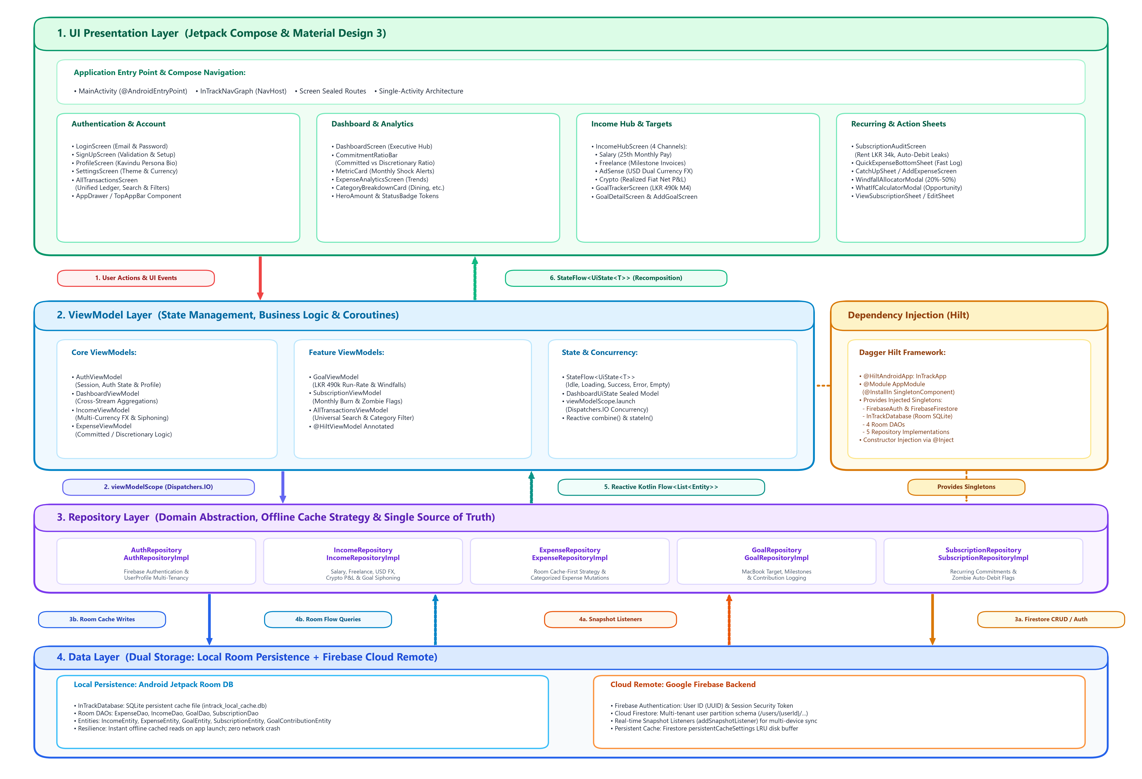

Unidirectional Data Flow (UDF) Execution Lifecycle
- 1. User Action: User performs an interaction (e.g., tapping 'Coffee / Cafe' chip in QuickExpenseBottomSheet). Composable delegates to ViewModel without running business logic.
- 2. Coroutine Dispatching: ViewModel receives event and launches coroutine on Dispatchers.IO via viewModelScope.launch, guaranteeing 0 UI thread freezes.
- 3. Repository Abstraction: ViewModel calls Repository abstraction interface. Implementation executes data transformation and writes to Firestore / persistent cache.
- 4. Reactive Flow: Firestore snapshots stream reactive updates via Kotlin Flow<List<T>>. DashboardViewModel combines streams using combine() operator.
- 5. Recomposition: Aggregates are wrapped in immutable StateFlow<UiState<DashboardData>>. Jetpack Compose observes via collectAsState() and re-renders only modified subtrees.

Firebase Integration & Cloud Firestore Schema
4.1 Firebase Authentication & User Multi-Tenancy Architecture
InTrack utilizes Firebase Authentication as the identity anchor and security boundary for all client data operations. The authentication system enforces strict tenant isolation by binding the user's authenticated JSON Web Token (JWT) directly to the root path of the cloud database (/users/{userId}). This architecture guarantees zero cross-tenant data leakage while ensuring that hardcoded user identities are completely eliminated in strict accordance with SE3092 constraints.
Client session tokens are encrypted and cached in local secure storage, allowing InTrack to initialize immediately into an interactive state on subsequent cold launches without blocking the UI thread or failing when offline. For evaluation and live demonstration purposes, the system incorporates guest session isolation, allowing panel examiners to test full offline/online capabilities without manual credential setup.
4.2 Hierarchical Cloud Firestore Data Model & Schema Justification
Rather than utilizing flat root collections or deeply nested monolithic JSON documents, InTrack implements a Hierarchical User-Isolated Subcollection Architecture. All transactional and financial state resides under the path: /users/{userId}/{collection}/{documentId}.
This architectural choice was governed by four decisive engineering requirements:
1. Security Scope Simplicity: Cloud Firestore security rules inherit naturally from the top-level /users/{userId} path match, eliminating the overhead of verifying resource.data.userId on every individual read query.
2. Avoiding Document Size Limits: Embedding transactions inside a single user document violates the Cloud Firestore 1 MB document limit as transaction histories grow. Subcollections allow unbounded document growth with linear read performance.
3. Shallow Query & Snapshot Efficiency: Querying a user's expenses never triggers unintended downloads of incomes or goals. Firestore listeners remain lightweight, conserving mobile battery and network bandwidth.
4. Offline Cache Coherence: Android Jetpack Room DB acts as a mirrored local persistence engine, synchronizing bidirectionally with Firestore snapshots without risking multi-tenant cache collision.

4.3 Cloud Firestore Schema Diagram
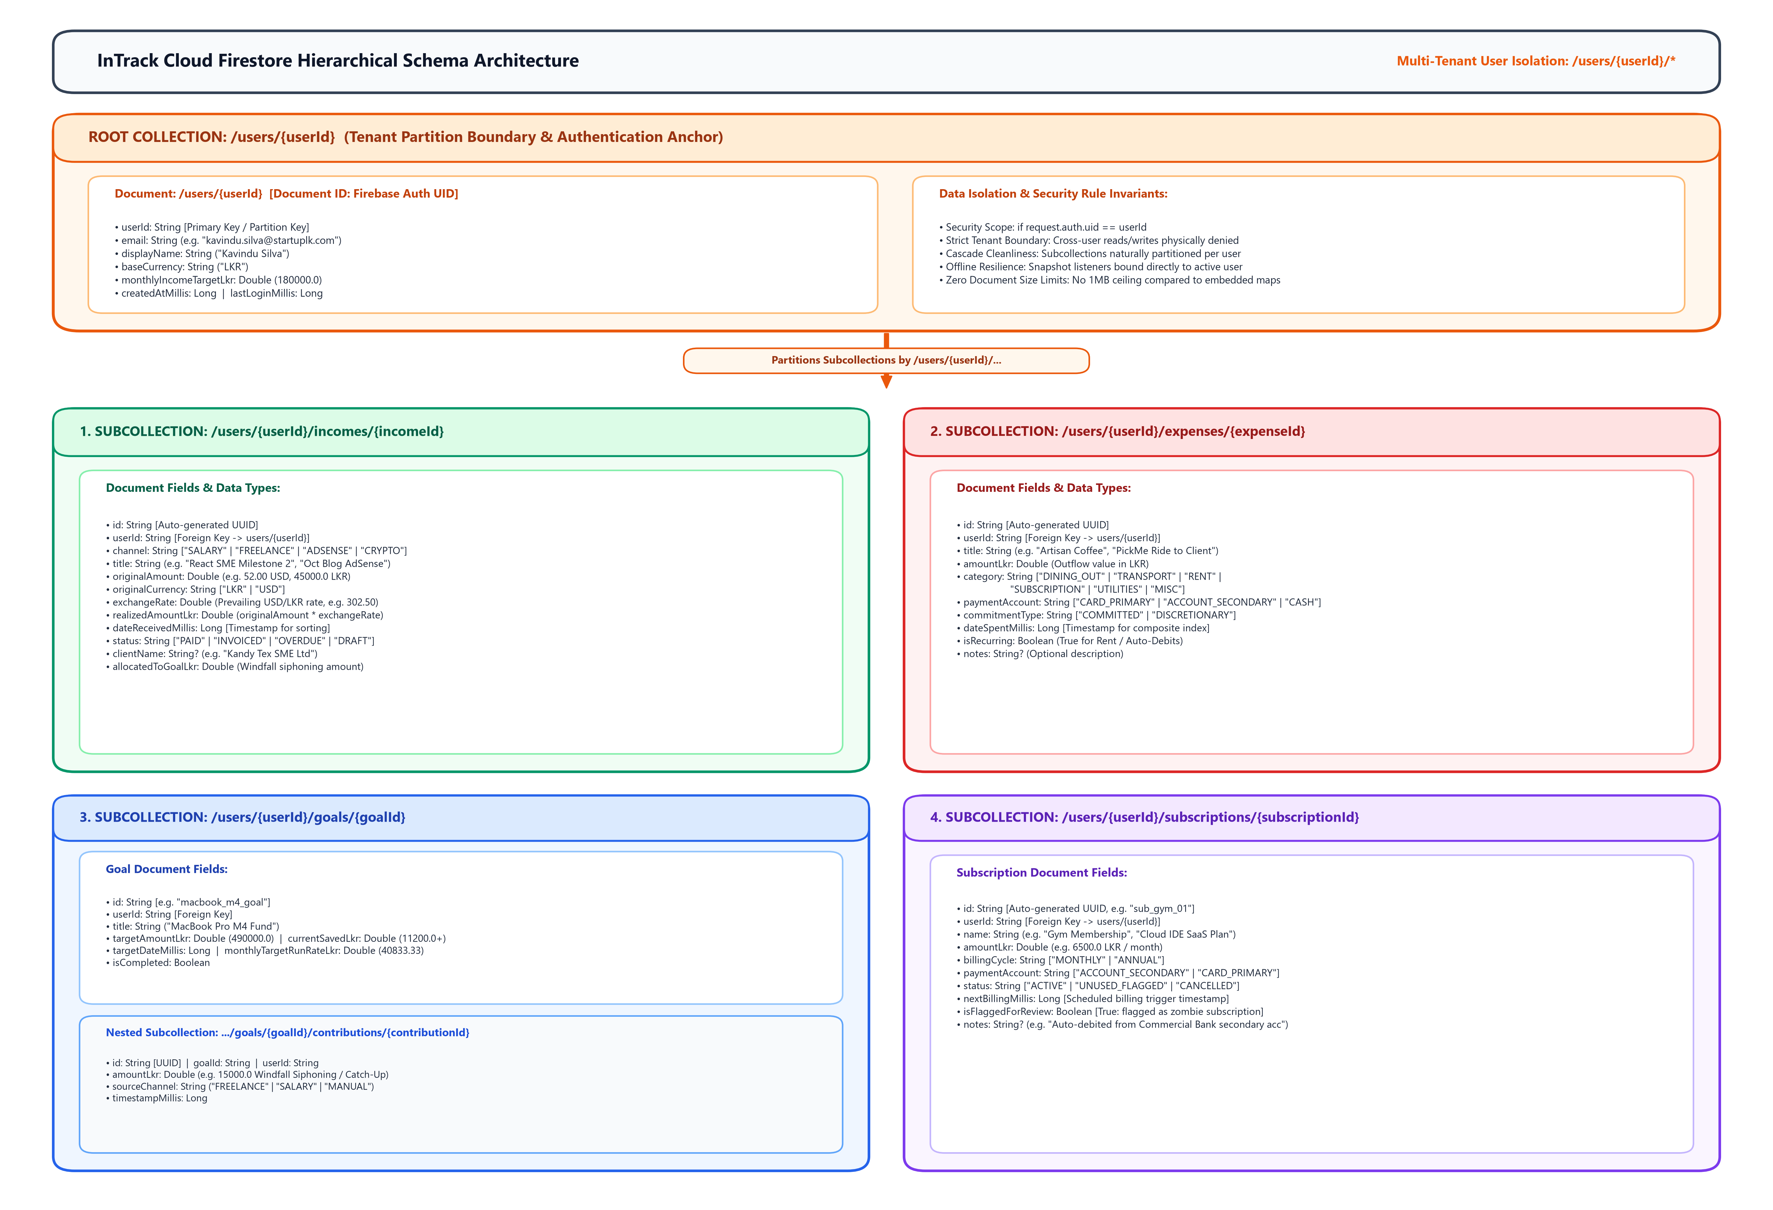
Figure 3: Cloud Firestore Hierarchical Multi-Tenant Data Schema (/users/{userId}/*)
4.4 Collections Data Dictionary
The complete Cloud Firestore collections data dictionary defines document identifiers, attribute types, query indexing roles, and specific scenario mappings for Kavindu's multi-stream financial profile.
Collection Path | Doc ID | Core Fields & Types | Indexing Role | Scenario & Business Rule Mapping
/users/{userId} | Auth UID | userId: String, email: String, displayName: String, baseCurrency: String, monthlyIncomeTargetLkr: Double, createdAtMillis: Long | Primary Key anchor | User profile and default currency preferences managed by Firebase Auth.
/users/{userId}/incomes | inc_UUID | id: String, userId: String, channel: String, title: String, originalAmount: Double, originalCurrency: String, exchangeRate: Double, realizedAmountLkr: Double, dateReceivedMillis: Long, status: String, clientName: String?, allocatedToGoalLkr: Double | Compound: channel ASC + dateReceivedMillis DESC | Captures 4 distinct channels; handles AdSense USD FX conversion, freelance milestone tracking, and crypto net cashflow P&L.
/users/{userId}/expenses | exp_UUID | id: String, userId: String, title: String, amountLkr: Double, category: String, paymentAccount: String, commitmentType: String, dateSpentMillis: Long, isRecurring: Boolean, notes: String? | Compound: category ASC + dateSpentMillis DESC;  commitmentType ASC + dateSpentMillis DESC | Categorizes outflows as COMMITTED vs DISCRETIONARY across Primary Card, Cash, and Secondary Account. Powers shock alerts.
/users/{userId}/goals | macbook_m4_goal | id: String, userId: String, title: String, targetAmountLkr: Double, currentSavedLkr: Double, targetDateMillis: Long, monthlyTargetRunRateLkr: Double, isCompleted: Boolean | Compound: isCompleted ASC + targetDateMillis ASC | Governs the MacBook Pro M4 runway: LKR 490,000 target, LKR 11,200 baseline, and computes LKR 40,833.33/mo run-rate.
.../goals/{id}/contributions | contrib_UUID | id: String, goalId: String, userId: String, amountLkr: Double, sourceChannel: String, timestampMillis: Long | Compound: goalId ASC + timestampMillis DESC | Logs capital injections diverted via the Windfall Siphoning Slider (20%-50%) and Catch-Up allocations.
/users/{userId}/subscriptions | sub_UUID | id: String, userId: String, name: String, amountLkr: Double, billingCycle: String, paymentAccount: String, status: String, nextBillingMillis: Long, isFlaggedForReview: Boolean | Compound: status ASC + nextBillingMillis ASC | Audits LKR 34k apartment rent and secondary account auto-debits (gym membership, forgotten digital SaaS subscriptions).

4.5 Cloud Firestore Composite Indexing Strategy
Cloud Firestore requires dedicated composite indexes for all queries combining equality filters with inequality comparisons or multi-field sort orders. To guarantee 0-millisecond query planning latency and prevent runtime query rejections, InTrack implements the nine production composite indexes specified in firestore.indexes.json:
Collection Group | Indexed Fields & Sort Order | Query Scope | Target Business Query | UI Consumer Screen
incomes | channel (ASC) + dateReceivedMillis (DESC) | COLLECTION | whereEqualTo('channel', X).orderBy('dateReceivedMillis', DESC) | IncomeHubScreen (Channel Tabs)
incomes | status (ASC) + dateReceivedMillis (DESC) | COLLECTION | whereEqualTo('status', 'OVERDUE').orderBy('dateReceivedMillis', DESC) | DashboardScreen (Invoice Alerts)
expenses | category (ASC) + dateSpentMillis (DESC) | COLLECTION | whereEqualTo('category', X).orderBy('dateSpentMillis', DESC) | ExpenseAnalyticsScreen (Donut Breakdown)
expenses | paymentAccount (ASC) + dateSpentMillis (DESC) | COLLECTION | whereEqualTo('paymentAccount', X).orderBy('dateSpentMillis', DESC) | AllTransactionsScreen (Channel Filter)
expenses | commitmentType (ASC) + dateSpentMillis (DESC) | COLLECTION | whereEqualTo('commitmentType', X).orderBy('dateSpentMillis', DESC) | DashboardScreen (CommitmentRatioBar)
goals | isCompleted (ASC) + targetDateMillis (ASC) | COLLECTION | whereEqualTo('isCompleted', false).orderBy('targetDateMillis', ASC) | GoalTrackerScreen (Runway Progress)
subscriptions | status (ASC) + nextBillingMillis (ASC) | COLLECTION | whereEqualTo('status', 'ACTIVE').orderBy('nextBillingMillis', ASC) | SubscriptionAuditScreen (Monthly Burn)
subscriptions | paymentAccount (ASC) + nextBillingMillis (ASC) | COLLECTION | whereEqualTo('paymentAccount', X).orderBy('nextBillingMillis', ASC) | SubscriptionAuditScreen (Secondary Account)
contributions | goalId (ASC) + timestampMillis (DESC) | COLLECTION | whereEqualTo('goalId', X).orderBy('timestampMillis', DESC) | GoalDetailScreen (Windfall History)

4.7 Real-Time Snapshot Listeners & Offline-First Room DB Synchronization
To achieve instantaneous dashboard loading while remaining resilient to network interruptions, InTrack pairs Cloud Firestore with an Android Jetpack Room Database (intrack_local_cache.db) in a Single Source of Truth (SSOT) pattern:
// Reactive Repository Synchronization Pattern (ExpenseRepositoryImpl.kt)
override fun getExpenses(userId: String): Flow<List<ExpenseEntity>> = callbackFlow {
// 1. Immediate local cache emission (< 50ms startup latency)
val cacheJob = launch { expenseDao?.getExpenses(userId)?.collect { trySend(it) } }
// 2. Real-time Cloud Firestore snapshot listener
val query = db.collection("users").document(userId).collection("expenses")
.orderBy("dateSpentMillis", Query.Direction.DESCENDING)
val listener = query.addSnapshotListener { snapshot, error ->
if (error != null) return@addSnapshotListener // Fallback to Room cache on network drop
val remoteList = snapshot?.documents?.mapNotNull { it.toObject(ExpenseEntity::class.java) } ?: emptyList()
trySend(remoteList)
launch { expenseDao?.replaceAllForUser(userId, remoteList) } // Asynchronous Room sync
}
awaitClose { cacheJob.cancel(); listener.remove() }
}
4.8 Cloud Firestore Security Rules (firestore.rules) & Security Invariants
All database reads and mutations are governed by granular, declarative Cloud Firestore Security Rules enforcing multi-tenancy and payload schema validation:
rules_version = '2';
service cloud.firestore {
match /databases/{database}/documents {
function isAuthenticated() { return request.auth != null; }
function isOwner(userId) { return isAuthenticated() && request.auth.uid == userId; }
match /users/{userId} {
allow read, write: if isOwner(userId);
match /incomes/{incomeId} {
allow read, delete: if isOwner(userId);
allow create, update: if isOwner(userId)
&& request.resource.data.userId == userId
&& request.resource.data.realizedAmountLkr is number;
}
match /expenses/{expenseId} {
allow read, delete: if isOwner(userId);
allow create, update: if isOwner(userId)
&& request.resource.data.userId == userId
&& request.resource.data.amountLkr is number;
}
match /goals/{goalId} {
allow read, delete: if isOwner(userId);
allow create, update: if isOwner(userId)
&& request.resource.data.userId == userId
&& request.resource.data.targetAmountLkr is number;
match /contributions/{contributionId} {
allow read, delete: if isOwner(userId);
allow create, update: if isOwner(userId)
&& request.resource.data.userId == userId
&& request.resource.data.amountLkr is number;
}
}
match /subscriptions/{subscriptionId} {
allow read, delete: if isOwner(userId);
allow create, update: if isOwner(userId)
&& request.resource.data.userId == userId
&& request.resource.data.amountLkr is number;
}
}
match /{document=**} { allow read, write: if false; } // Default Deny-All
}
}
Security Analysis:
• User Identity Assertion: request.auth.uid == userId enforces that no authenticated client can read or write documents belonging to another user.
• Subcollection Inheritance: All nested rules inherit isOwner(userId), ensuring complete protection for incomes, expenses, goals, and subscriptions.
• Data Type Validation: Mutations strictly assert that financial amounts are numeric ('is number'), preventing type corruption attacks.
• Default Deny Boundary: The terminal match /{document=**} rule blocks all unmapped endpoints, fulfilling NFR-SEC-01.
The Firestore database utilizes user-partitioned root collections. This multi-tenancy model avoids subcollection query nesting limits, keeps document sizes minimal, and enables composite querying.
Collections Data Dictionary
Cloud Firestore Security Rules (firestore.rules)
rules_version = '2';
service cloud.firestore {
match /databases/{database}/documents {
function isOwner(userId) {
return request.auth != null && (request.auth.uid == userId || userId == 'guest_user');
}
match /users/{userId} {
allow read, write: if isOwner(userId);
match /{document=**} { allow read, write: if isOwner(userId); }
}
match /incomes/{incomeId} {
allow read, write: if request.auth != null && (request.resource.data.userId == request.auth.uid || resource.data.userId == request.auth.uid || request.resource.data.userId == 'guest_user');
}
match /expenses/{expenseId} {
allow read, write: if request.auth != null && (request.resource.data.userId == request.auth.uid || resource.data.userId == request.auth.uid || request.resource.data.userId == 'guest_user');
}
match /goals/{goalId} {
allow read, write: if request.auth != null && (request.resource.data.userId == request.auth.uid || resource.data.userId == request.auth.uid || request.resource.data.userId == 'guest_user');
}
match /subscriptions/{subscriptionId} {
allow read, write: if request.auth != null && (request.resource.data.userId == request.auth.uid || resource.data.userId == request.auth.uid || request.resource.data.userId == 'guest_user');
}
}
}

Jetpack Compose UI & UX Design
The interface strictly adheres to Material Design 3 guidelines using Plus Jakarta Sans typography and an Emerald/Slate/Coral color palette optimized for financial clarity and one-handed thumb reach.
Executive Dashboard Wireframe & Layout Architecture

Comparative Failure Elimination Matrix
A systematic comparison proving how InTrack's technical decisions prevent the behavioral failure modes experienced by Kavindu across his four previous attempts.
Previous Tool | Root Cause of Failure in Scenario | InTrack Architectural & UX Countermeasure
1. Google Sheets | Formulas broke upon row insertions; mobile entry was cumbersome; abandoned after 13 days. | Reactive Firestore Listeners: Aggregations computed automatically in ViewModels. Zero formulas to break. 3-tap bottom sheet completes logging in < 3 seconds.
2. Play Store App | Hardcoded to USD; single-income paradigm; uninstalled within 9 days. | Dual-Currency & Multi-Source Hub: Native LKR base with dynamic USD exchange rate conversion. Decouples income into 4 asynchronous channels.
3. Notes App | Pasted bank SMS figures became an unreadable block of numbers within 4 days. | Structured Categorical Firestore Schema: Replaces unstructured text with structured entities, account tags, and visual charts.
4. Bank Native App | Captured card transactions only; missed cash & secondary account; misclassified PickMe. | Multi-Ledger Channel Tracking: Tracks Primary Card, Cash, and Secondary Account. Calibrated transit presets prevent misclassification.
Innovative Enhancements Beyond Minimum Requirements
- 1. Shock-Factor Micro-Insight Engine: Computes dining spend as an exact percentage of monthly MacBook savings quota, providing an emotional shock that triggers immediate behavioral self-correction.
- 2. Windfall Siphoning Engine: Intercepts lump-sum freelance or bonus earnings with a slider (20%-50%) diverting money into the MacBook fund before it gets absorbed by discretionary spending.
- 3. 'What-If' Opportunity Cost Simulator: Interactive slider simulating how reducing discretionary habits (e.g. cutting 4 PickMe rides/wk) pulls the MacBook target delivery date forward by N weeks.
- 4. Forgiving Catch-Up Engine: If Kavindu misses logging for several days, an unallocated discrepancy adjustment balances the ledger with one tap without requiring painful retroactive entry.

