**Output Of Caesar Cipher**

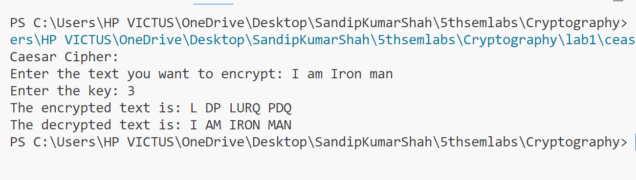

**Output Of Hill Cipher**

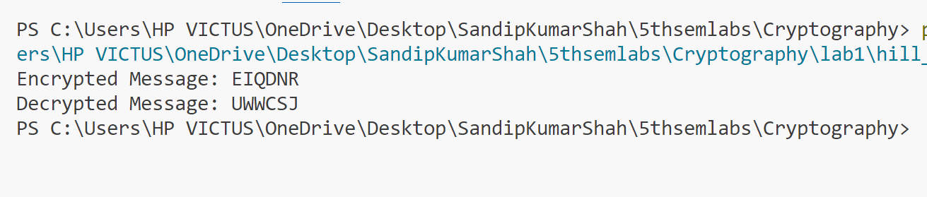

**Output Of Playfair Cipher**

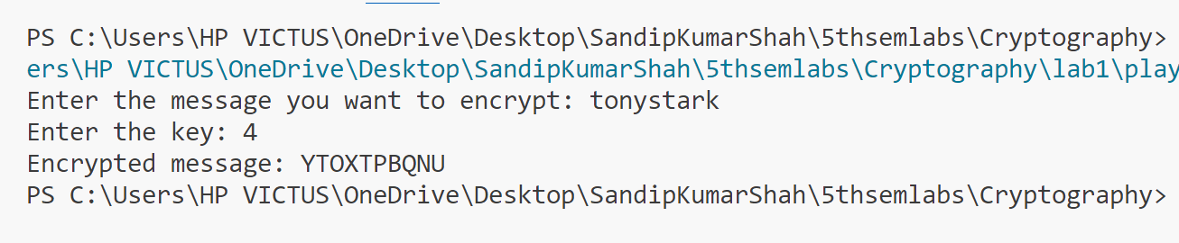

**Output Of Rail fence Cipher**

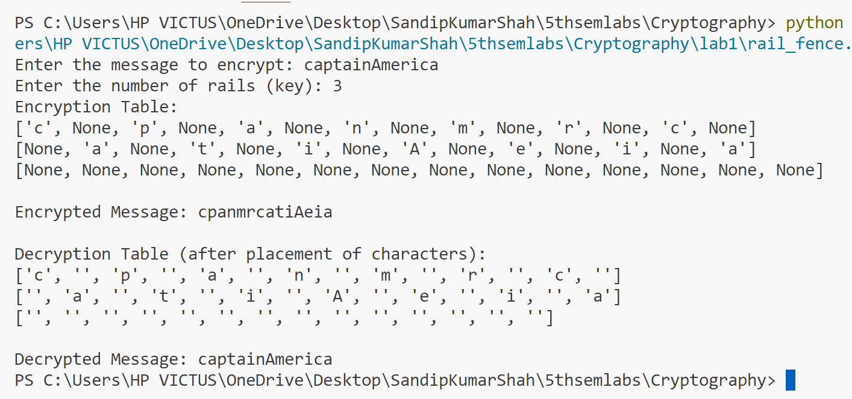

**Output Of vigenere cipher**

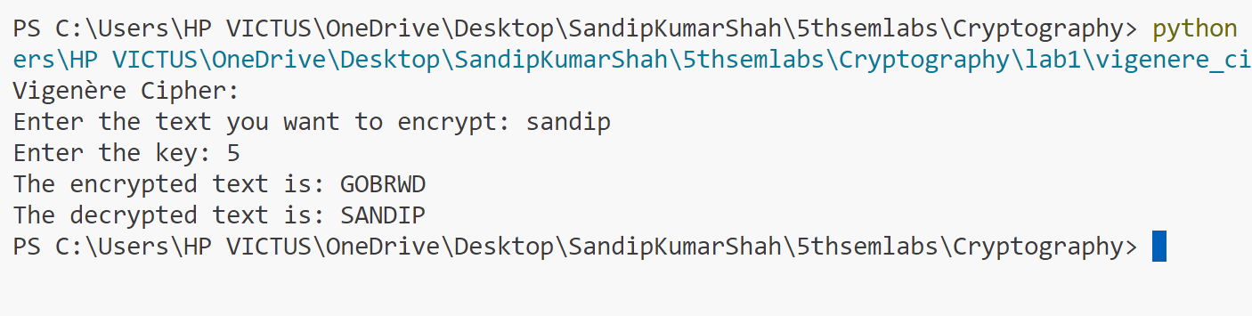

**Output Of DES**

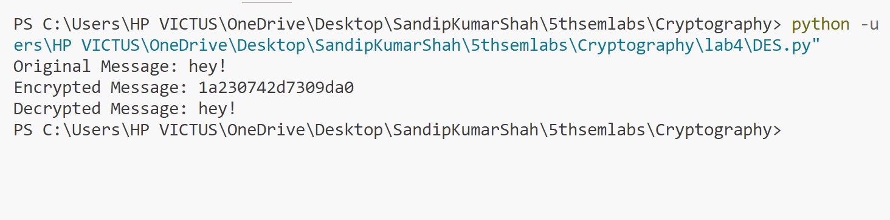

**Output Of AES**

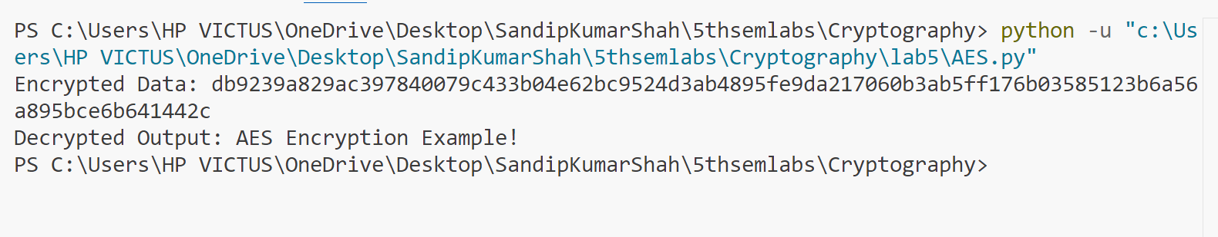

**Output Of Deffehelman Algorithm**

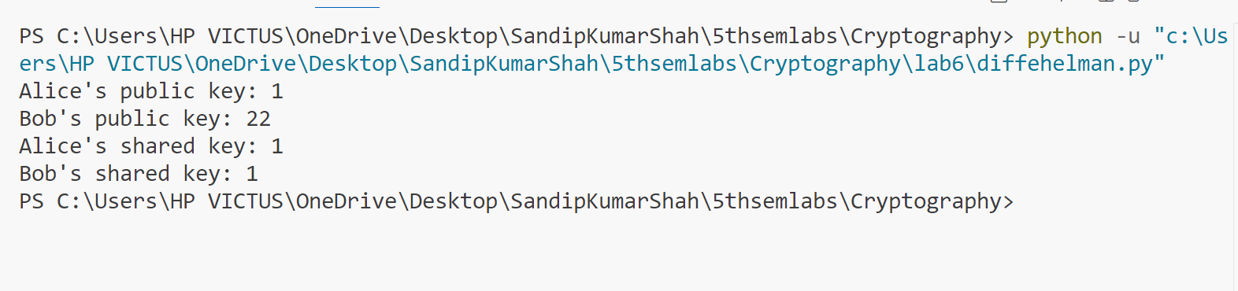

**Output Of Elgamal Algorithm**

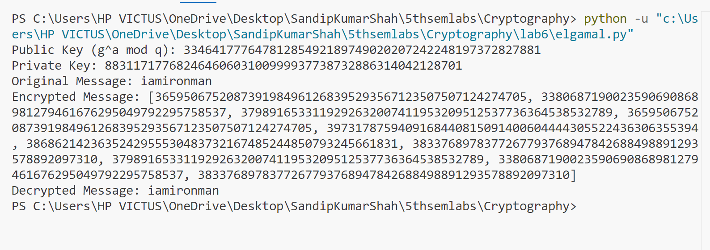

**Output Of Eulertotient Function**

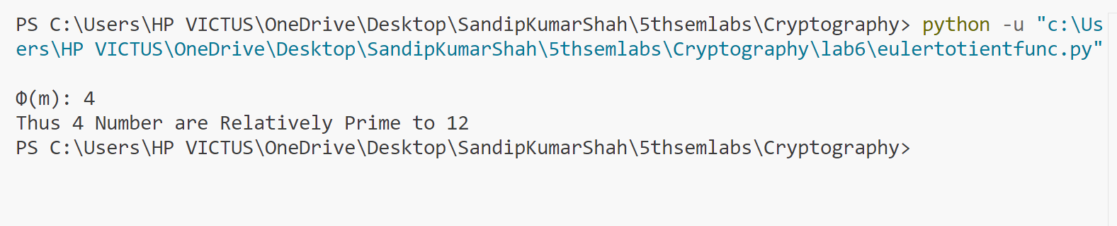

**Output Of Milerrabin**

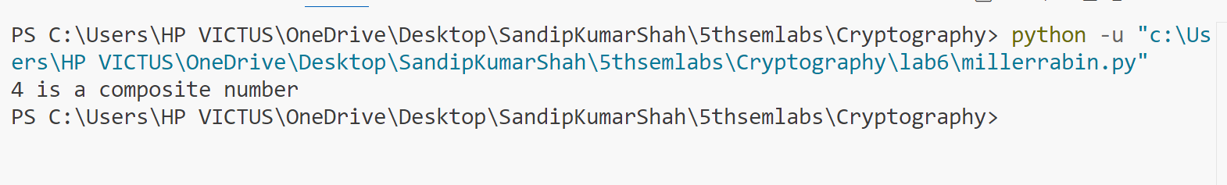

**Output Of Modular_Arithmatics**

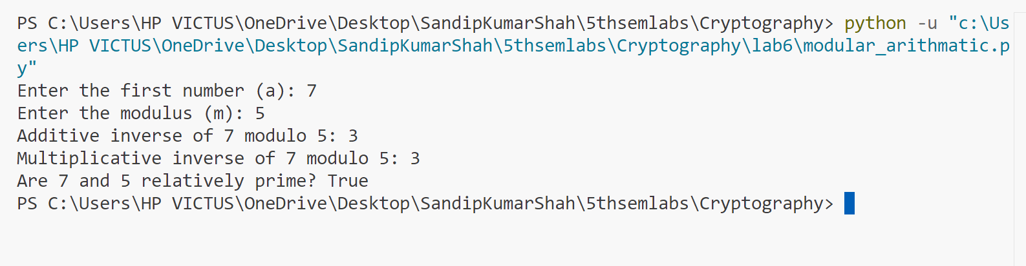

**Output Of Premitive Roots**

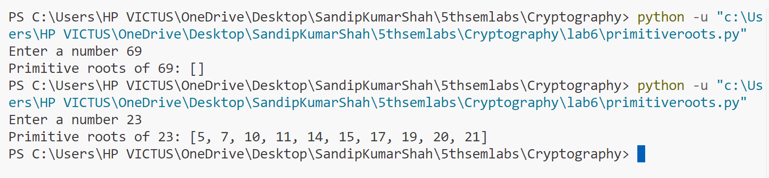

**Output Of RSA**

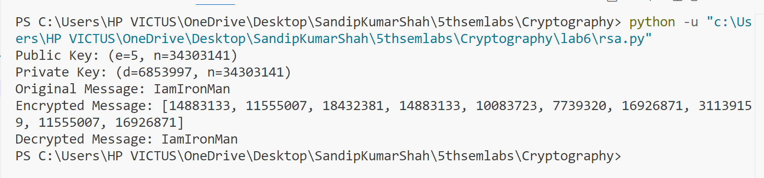

**Output Of Md5**

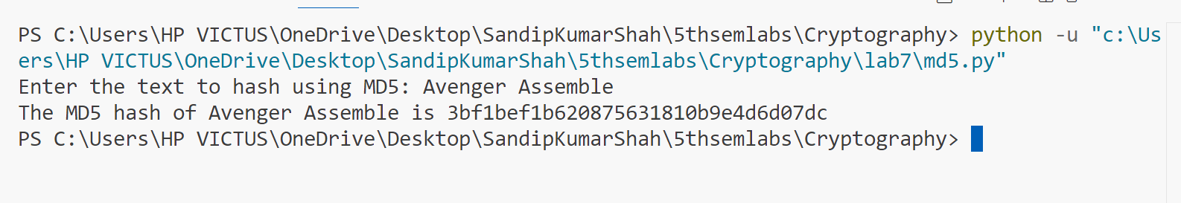

**Output Of Sha256**

