**Output of Fractional knapsack:**

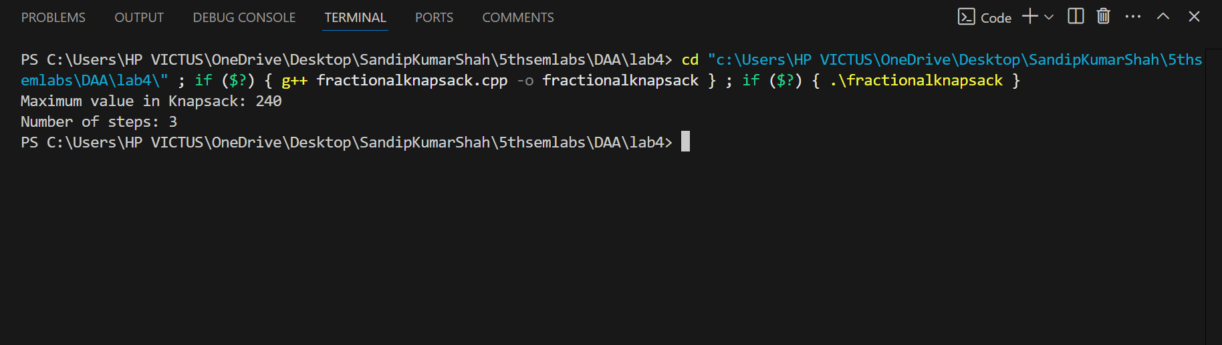

**Output of Kruskal:**

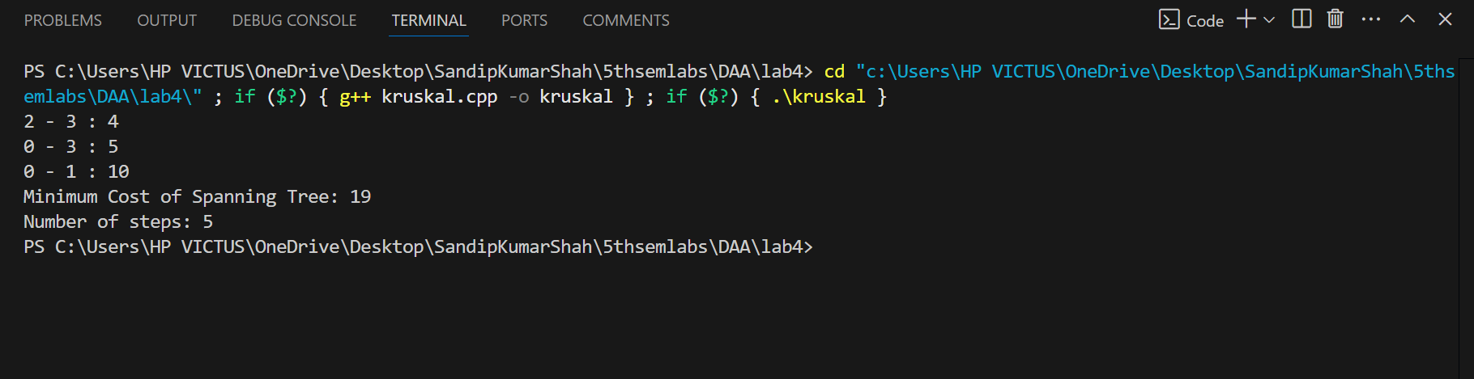

**Output of Prim’s algorithm:**

