**Objective:**

The objective of this lab was to implement and analyze two greedy algorithms—Huffman Coding for data compression and Job Sequencing for profit maximization—focusing on their mathematical logic, time complexity (O(n log n) for Huffman, O(n log n + n·d) for Job Sequencing), and space complexity (O(n) and O(d), respectively), to understand their efficiency in solving optimization problems.

**Output Of Huffman coding:**

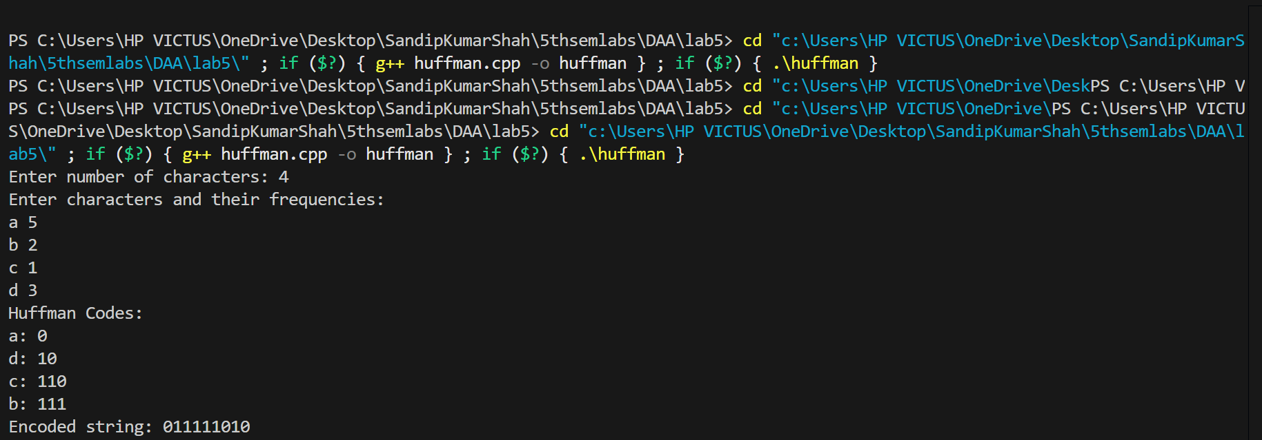

**Output Of Job Sequencing:**

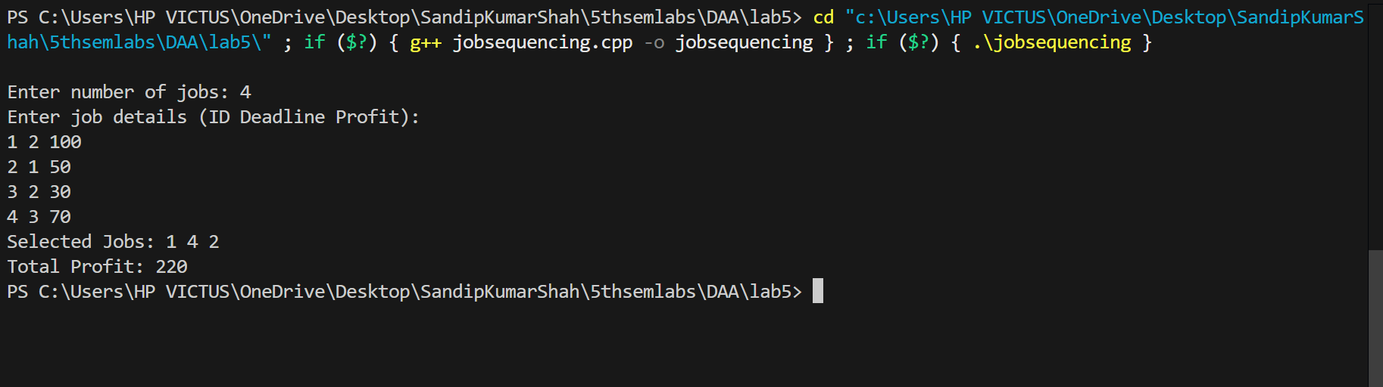

**Conclusion;**

This lab successfully demonstrated the application of greedy strategies in Huffman Coding and Job Sequencing. Huffman Coding efficiently compressed data by assigning shorter codes to frequent characters, achieving O(n log n) time complexity, while Job Sequencing maximized profit by prioritizing high-profit jobs within deadlines, with O(n log n + n·d) time complexity. Both algorithms showcased optimal resource utilization with manageable space complexities (O(n) and O(d)), reinforcing their practical significance in real-world optimization scenarios.