**Lab 1:**

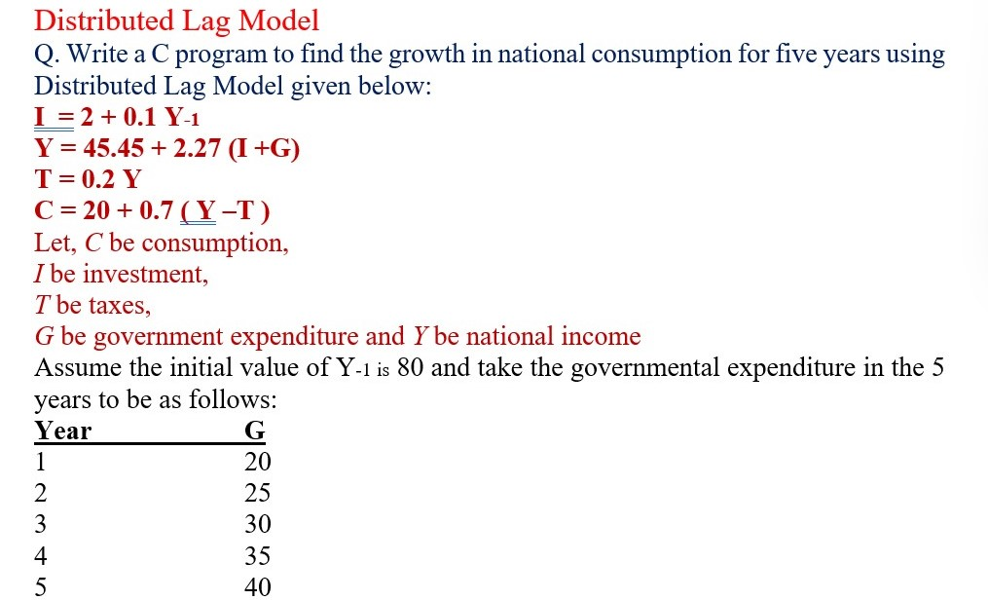

**Source Code:**

#include<stdio.h>

int main(){

int j=0;

float I,Y,T,C,G,YNeg,Cprev;

YNeg=80;

float g[] = {20, 25, 30, 35, 40};

float diff;

printf("Year\tG\tY\t\tI\tC\tGrowth\n");

printf("--------------------------------------------------------\n");

for(j=0;j<5;j++){

I=2+0.1*YNeg;

Y=45.45+2.27*(I+g[j]);

T=0.2*Y;

C=20+0.7*(Y-T);

Cprev=C - (20 + 0.7 * (YNeg - 0.2 * YNeg));

printf("%d\t%.2f\t%.2f\t\t%.2f\t%.2f\t%.2f\n",j+1, g[j], Y, I, C,Cprev);

YNeg=Y;

}

return 0;

}

**Output:**

