**Objectives:**

The objective of this lab is to design and implement a fully functional *ACHS Blogs* website, incorporating essential HTML structure elements like a head section, navigation bar, main content area, and an aside section with links to important events. The website must include a redirection system where the home link leads to a home.html page, which then redirects users to the official ACHS website, ensuring smooth navigation. Additionally, the task requires the integration of multimedia content such as audio, video, and YouTube videos using the iframe tag to enhance interactivity and user engagement. The website should also be designed to be accessible across different platforms, ensuring all elements function correctly. Finally, the footer tag must be used to include copyright information, fulfilling legal requirements for web development.

**Lab 2**

**HTML Basics**

**Q.1. Create a website titled ACHS Blogs. The website tab must have ACHS logo as well. The website must have a head section, nav bar with Home, About and Contact along with ACHS logo. There must be a section in main for article on Sports Week. You may use auto generated paragraphs for the article. Your website must have an aside section for additional contents. Include links for Examination, Music Fest and Hackathon. Finally use footer tag for copyright symbol and year with name of college.**

**Tags Used:**

* <!DOCTYPE html>: Declares the document as an HTML5 document.
* <html>: Represents the root element of the HTML document.
* <head>: Contains meta-information about the document, such as metadata, title, and links to scripts or stylesheets.
* <title>: Specifies the title of the document displayed on the browser tab.
* <body>: Contains the content displayed on the webpage.
* <h1>: Creates the main heading of the page, used for "ACHS Nepal Blogs" in this case.
* <img>: Embeds an image with the specified width, source, and alternative text.
* <a>: Creates hyperlinks to navigate to other pages or sections, such as "Home," "About," and "Contact."
* h2>: Defines secondary headings, such as "Sports Week" and "Sidebar."
* <p>: Defines a paragraph, used here to describe Sports Week.
* align="justify": Aligns the text in the paragraph to both left and right margins.
* <ul>: Creates an unordered list, used for the sidebar navigation items.
* <li>: Represents individual list items within an unordered list, like "Examination" and "Hackathon."
* <footer>: Defines the footer section of the page, displaying copyright information.
* &copy; Inserts the copyright symbol in the footer.

**Source Code:**

<!DOCTYPE *html*>

<html *lang*="en">

<head>

    <meta *charset*="UTF-8">

    <meta *name*="viewport" *content*="width=device-width, initial-scale=1.0">

    <title>Document</title>

</head>

<body>

    <h1>ACHS Nepal Blogs</h1>

    <img *style*="width: 200px;" *src*="achs.png" *alt*="achs photo">

    <a *href*="#">Home</a>

    <a *href*="#">About</a>

    <a *href*="#">Contact</a>

        <h2>Sports Week</h2>

        <p align="justify">

Sports Week is an exciting event that brings together participants to celebrate teamwork, competition, and athleticism. It provides an opportunity for students and enthusiasts to engage in a variety of sports and activities, fostering a spirit of camaraderie and healthy rivalry. From team-based games like football and basketball to individual pursuits such as track events, badminton, or table tennis, Sports Week caters to diverse interests and abilities. Beyond physical activity, it encourages mental resilience, strategic thinking, and leadership skills, offering a holistic development experience for all involved. The event also serves as a platform for building friendships, showcasing talent, and promoting a culture of fitness and well-being among participants. Spectators and supporters add to the excitement, cheering on their teams and creating a vibrant atmosphere of encouragement.

        </p>

        <h2>Sidebar</h2>

        <ul>

            <li><a *href*="#">Examination</a></li>

            <li><a *href*="#">Music Fest</a></li>

            <li><a *href*="#">Hackathon</a></li>

        </ul>

        <footer> &copy; 2025 Asian College of Higher Studies</footer>

</body>

</html>

**Output:**

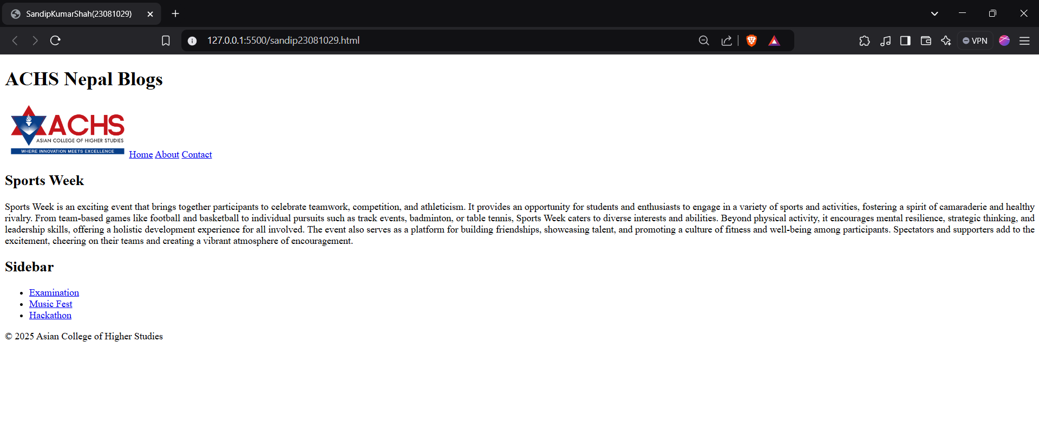

**Q.2. In the previous website, on clicking home the user must be redirected to home.html which then redirects the user to ACHS website** [**https://achs.edu.np/**](https://achs.edu.np/)**.**

**Tags Used:**

* <!DOCTYPE html>: Declares the document as an HTML5 document.
* <html>: Represents the root element of the HTML document.
* <head>: Contains meta-information about the document, such as metadata, title, and links to scripts or stylesheets.
* <meta>: Defines metadata like character set, viewport settings, and auto-refresh behavior.
* <title>: Specifies the title of the document displayed on the browser tab.
* <body>: Contains the content displayed on the webpage.
* <h1>: Denotes the main heading of the webpage.
* <h2>: Represents a secondary heading in the webpage.

**Attributes:**

* http-equiv="refresh" (in <meta>): Instructs the browser to refresh and redirect to a new URL.
* Content="1,url=https://achsnepal.edu.np/" (in <meta>): Specifies the refresh interval (1 second) and the target URL for redirection.

**Source Code:**

1. **q1.html**

<!DOCTYPE html>

<html lang="en">

<head>

<meta charset="UTF-8">

<meta name="viewport" content="width=device-width, initial-scale=1.0">

<title>Document</title>

</head>

<body>

<h1>ACHS Nepal Blogs</h1>

<img style="width: 200px;" src="achs.png" alt="achs photo">

<a href="home.html">Home</a>

<a href="#">About</a>

<a href="#">Contact</a>

<h2>Sports Week</h2>

<p align="justify">

Sports Week is an exciting event that brings together participants to celebrate teamwork, competition, and athleticism. It provides an opportunity for students and enthusiasts to engage in a variety of sports and activities, fostering a spirit of camaraderie and healthy rivalry. From team-based games like football and basketball to individual pursuits such as track events, badminton, or table tennis, Sports Week caters to diverse interests and abilities. Beyond physical activity, it encourages mental resilience, strategic thinking, and leadership skills, offering a holistic development experience for all involved. The event also serves as a platform for building friendships, showcasing talent, and promoting a culture of fitness and well-being among participants. Spectators and supporters add to the excitement, cheering on their teams and creating a vibrant atmosphere of encouragement.

</p>

<h2>Sidebar</h2>

<ul>

<li><a href="#">Examination</a></li>

<li><a href="#">Music Fest</a></li>

<li><a href="#">Hackathon</a></li>

</ul>

<footer> &copy; 2025 Asian College of Higher Studies</footer>

</body>

</html>

1. **home.html**

<!DOCTYPE html>

<html lang="en">

<head>

<meta charset="UTF-8">

<meta name="viewport" content="width=device-width, initial-scale=1.0">

<meta http-equiv="refresh" content="1,url=https://achsnepal.edu.np/">

<title>Document</title>

</head>

<body>

<h1>This is home.html</h1>

<h2>Redirecting to ACHS College website in few seconds</h2>

</body>

</html>

**Output:**



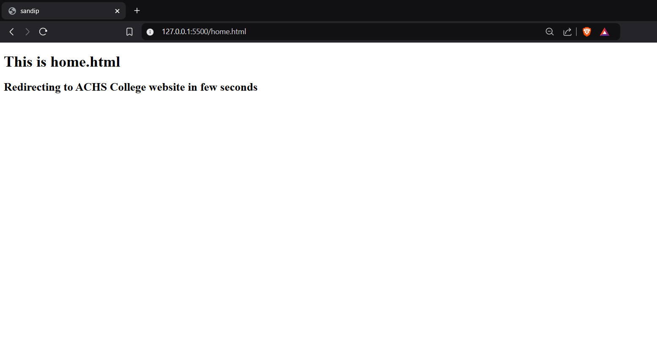

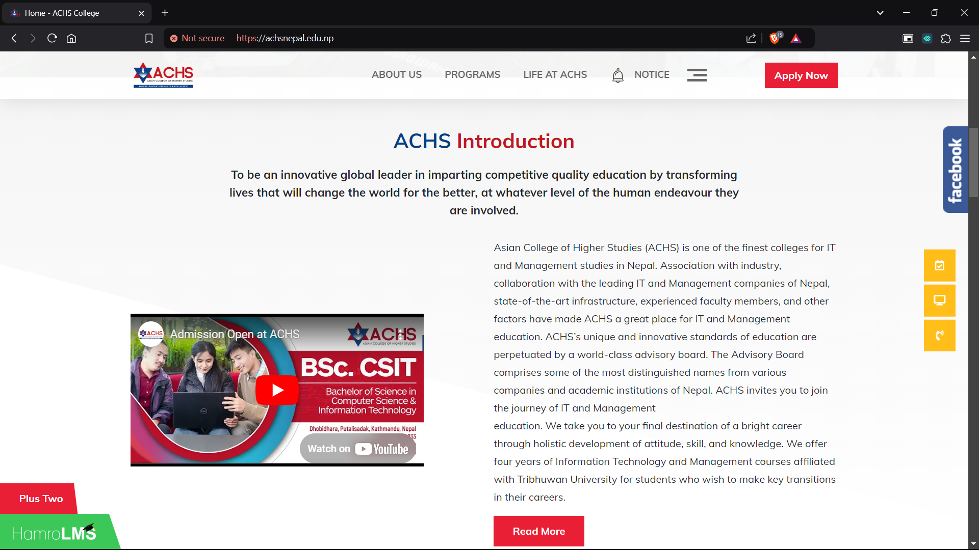

**Q.3. Use audio and video to embed multimedia in your website. Also embed YouTube videos in your website using iframe tag.**

**Tags Used:**

* <!DOCTYPE html>: Declares the document as an HTML5 document.
* <html>: Represents the root element of the HTML document.
* <head>: Contains meta-information about the document, such as metadata, title, and links to external resources.
* <meta>: Defines metadata like character encoding, viewport settings, and other document details.
* <title>: Specifies the title of the document displayed on the browser tab.
* <body>: Contains the main content of the webpage.
* <h1>: Denotes the main heading of the webpage.
* <h2>: Represents a subheading in the webpage.
* <audio>: Embeds an audio player in the webpage.
* <source>: Specifies the source file for multimedia elements like <audio> and <video>.
* <video>: Embeds a video player in the webpage.
* <iframe>: Embeds an external content frame, such as a YouTube video.

**Attributes Used:**

* controls (in <audio> and <video>): Adds playback controls like play, pause, and volume to the media player.
* src="nationalAnthem.mp3" (in <source>): Specifies the path to the audio file.
* type="audio/mpeg" (in <source>): Specifies the media type of the audio file.
* width="640" and height="360" (in <video>): Sets the width and height of the video player.
* src="NationalAnthem.mp4" (in <source>): Specifies the path to the video file.
* type="video/mp4" (in <source>): Specifies the media type of the video file.
* width="702" and height="395" (in <iframe>): Sets the dimensions of the embedded frame.
* src="https://www.youtube.com/embed/MFb7LCqm6FE"(in<iframe>): Specifies the URL of the YouTube video.
* frameborder="0" (in <iframe>): Removes the border around the embedded frame.
* allow="accelerometer; autoplay; clipboard-write; encrypted-media; gyroscope; picture-in-picture; web-share" (in <iframe>): Grants permissions for specific features in the embedded content.
* referrerpolicy="strict-origin-when-cross-origin" (in <iframe>): Controls the referrer information sent with the iframe request.
* allowfullscreen (in <iframe>): Allows the iframe to be displayed in fullscreen mode.

**Source Code:**

<!DOCTYPE *html*>

<html *lang*="en">

<head>

    <meta *charset*="UTF-8">

    <meta *name*="viewport" *content*="width=device-width, initial-scale=1.0">

    <title>Multimedia Embedding</title>

</head>

<body>

    <h1>Embedding Multimedia in a Website</h1>

    <h2>Audio</h2>

    <audio *controls*>

        <source *src*="nationalAnthem.mp3" *type*="audio/mpeg">

    </audio>

    <h2>Video</h2>

    <video *controls* *width*="640" *height*="360">

        <source *src*="NationalAnthem.mp4" *type*="video/mp4">

    </video>

    <h2>YouTube Video</h2>

    <iframe width="923" height="519" src="https://www.youtube.com/embed/4-ftbs8TppY" title="&quot;Genius, Billionaire, Playboy, Philanthropist&quot; Tony Stark vs Steve Rogers - The Avengers (2012)" frameborder="0" allow="accelerometer; autoplay; clipboard-write; encrypted-media; gyroscope; picture-in-picture; web-share" referrerpolicy="strict-origin-when-cross-origin" allowfullscreen></iframe>

</body>

</html>

**HOutput:**

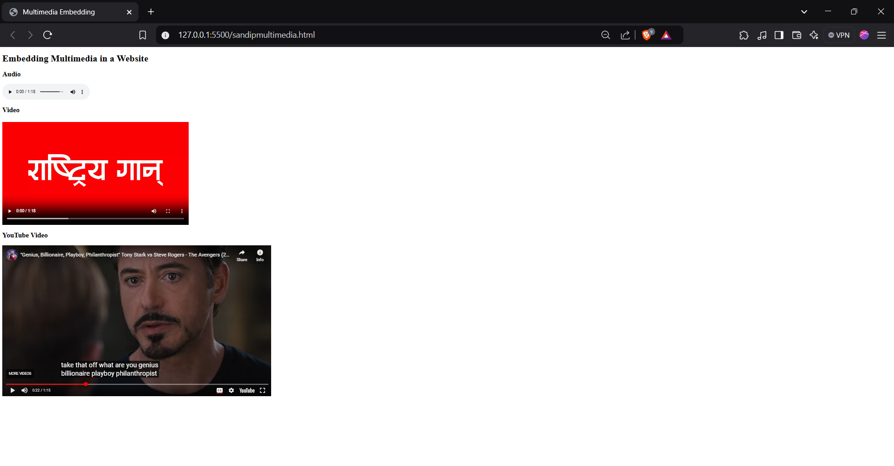

**Conclusion:**

In conclusion, the lab successfully demonstrated the process of creating a well-structured and interactive website for *ACHS Blogs*, which included essential elements like navigation, multimedia integration, and external link redirection. The tasks helped develop a deeper understanding of HTML structure and the importance of user experience in web design, from smooth navigation to content accessibility. By embedding audio, video, and YouTube content, the project enhanced user engagement, making the website more dynamic. The inclusion of the footer with copyright information also highlighted the significance of legal compliance in web development. Overall, the lab provided valuable hands-on experience in creating a functional and professional website that aligns with institutional branding and technical standards.