**// Heap:**

**Analysis of Heap sort:**

* **Time Complexity:**
  + Heapify: O(logn) per node.
  + Building the heap: O(n).
  + Sorting: O(nlogn).   
    **Overall: O(nlogn).**
* **Space Complexity:**
  + O(1), as sorting is done in place.

**Output:**

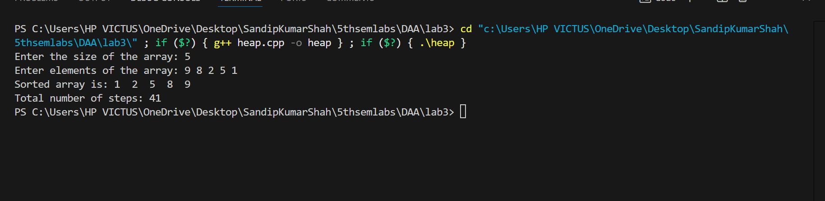

**// Quick Sort:**

**Analysis:**

* **Time Complexity:**
  + Best/Average Case: O(nlogn).
  + Worst Case (skewed partition): O(n2).
* **Space Complexity:**
  + O(logn) for recursion stack in the best case; O(n) in the worst case.

**Output:**

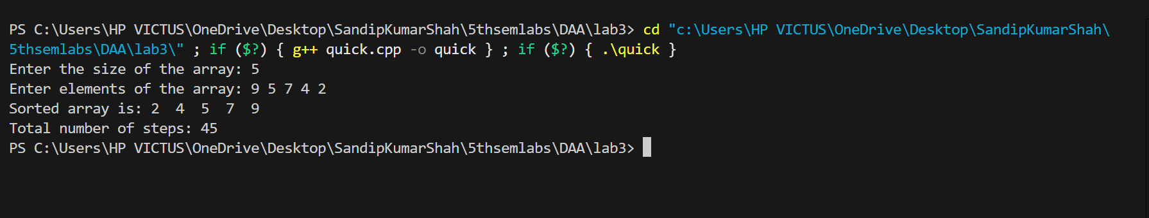

**// Randomized Quick sort:**

**Analysis:**

* **Time Complexity:**
  + Best/Average Case: O(nlogn).
  + Worst Case (rare due to randomization): O(n2).
* **Space Complexity:**
  + O(logn) on average for recursion stack.

**Output:**

