# Eclipse Project screenshots – for MVN build with test case result

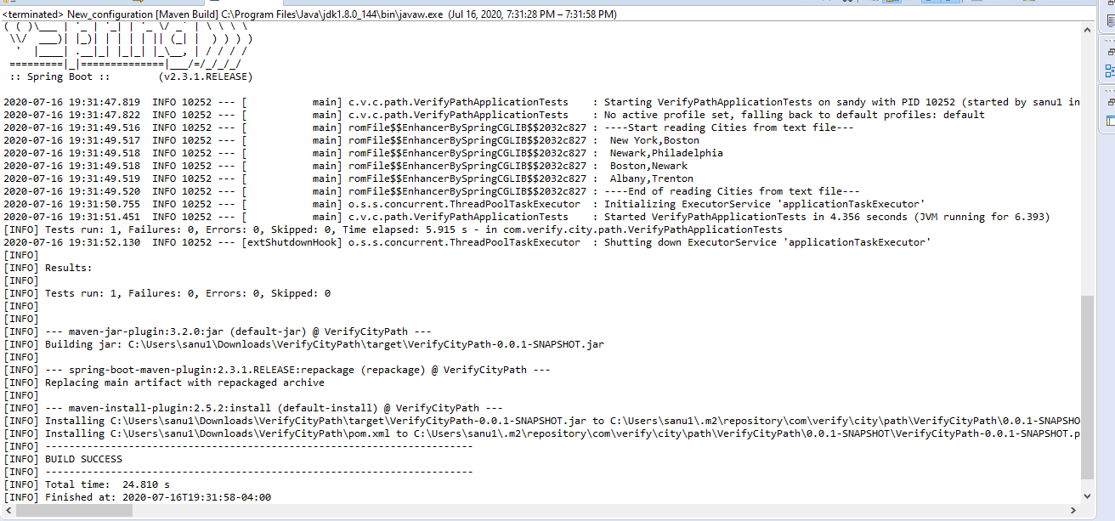

# 2. Screenshots for VerifyCitiesPathControllerTest.java class execution

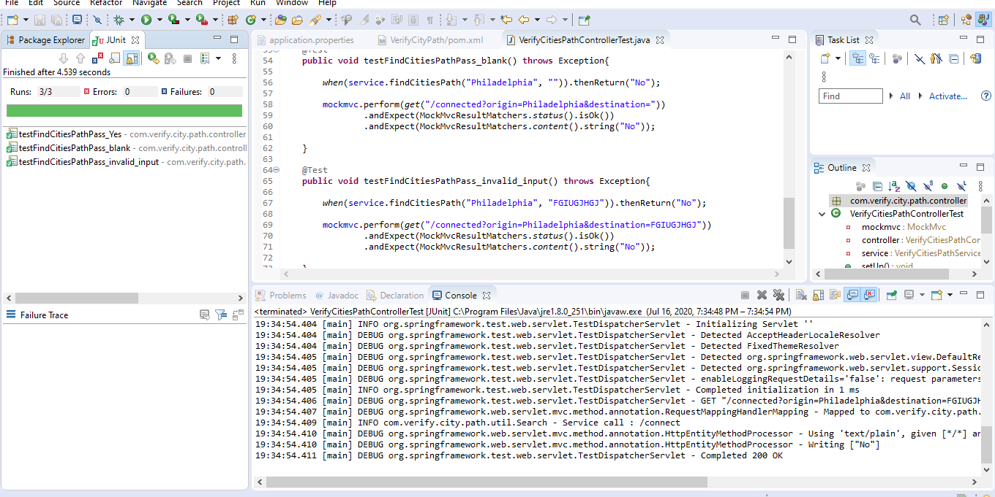

# 3. Postman screenshots for API calls

## Scenario 1 - origin=Boston&destination=Newark

url - <http://localhost:8080/connected?origin=Boston&destination=Newark>

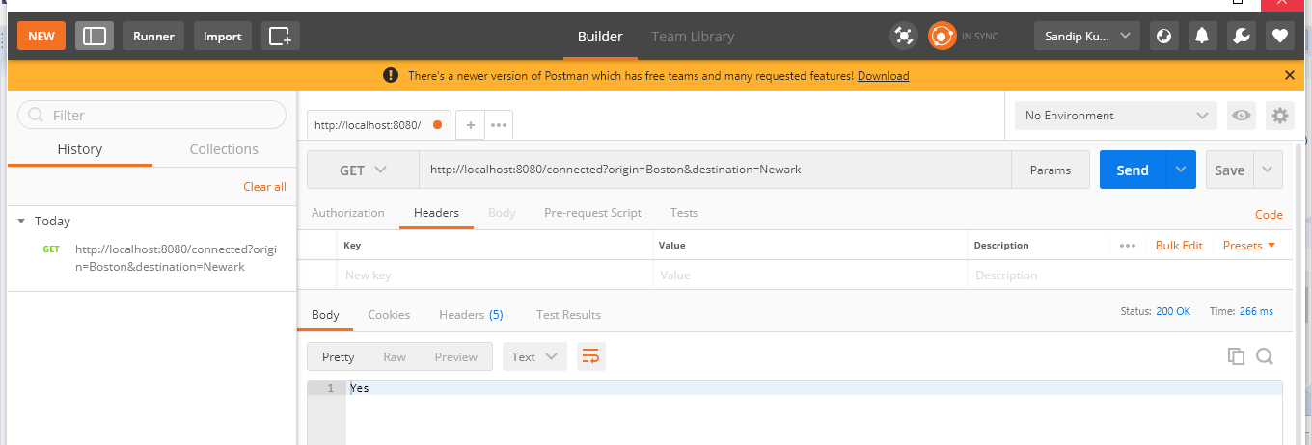

## Scenario 2 – origin=Boston&destination=Newar

url - <http://localhost:8080/connected?origin=Boston&destination=Newar>

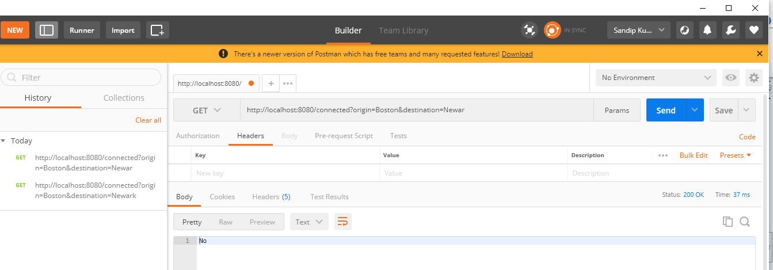

## Scenario 3 – origin=Boston&destination=

url - <http://localhost:8080/connected?origin=Boston&destination>=

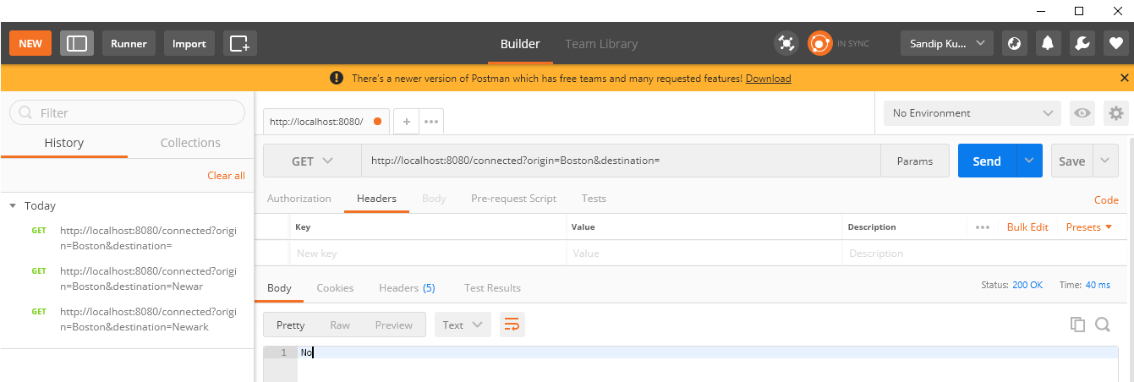

## Scenario 4 - origin=Philadelphia&destination=Boston

url - [http://localhost:8080/connected?origin=Philadelphia&destination=Boston](%20http://localhost:8080/connected?origin=Philadelphia&destination=Boston)

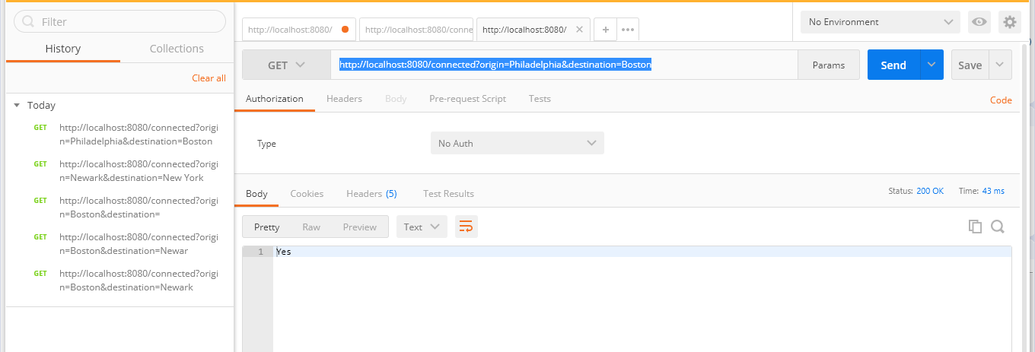

## Scenario 5 - origin=Newark&destination=New York

**url -**http**://localhost:8080/connected?origin=Newark&destination=New York**

