CE / CS / SE 3354 · SOFTWARE ENGINEERING · FALL 2026
Project Deliverable P1
Proposal and Requirements — Team Template
Field | Your entry
Project title
Team number and section
Team members (name · net ID)
Repository URL
Document version | 0.1
Date

0 Revision History and Contribution Record
Both tables below are graded. The contribution record carries the individual 20% of this milestone and must be consistent with your repository history.
Version | Date | Author | Summary of change
0.1 |  |  | Initial baseline for P1

0.1 Individual contribution record
Team member | What this person produced for P1 | Evidence in the repository

1 Introduction
1.1 Purpose of this document and of the system

Type here.

1.2 Scope

In scope — we will build this | Out of scope — we will not, and why

Why the exclusions were excluded:

1.3 Definitions, acronyms and abbreviations

Term or abbreviation | Meaning as used in this project

1.4 References

[R1]

2 Overall Description
2.1 Product perspective and context

Paste the context diagram here, then explain in one paragraph why the boundary sits where it does.

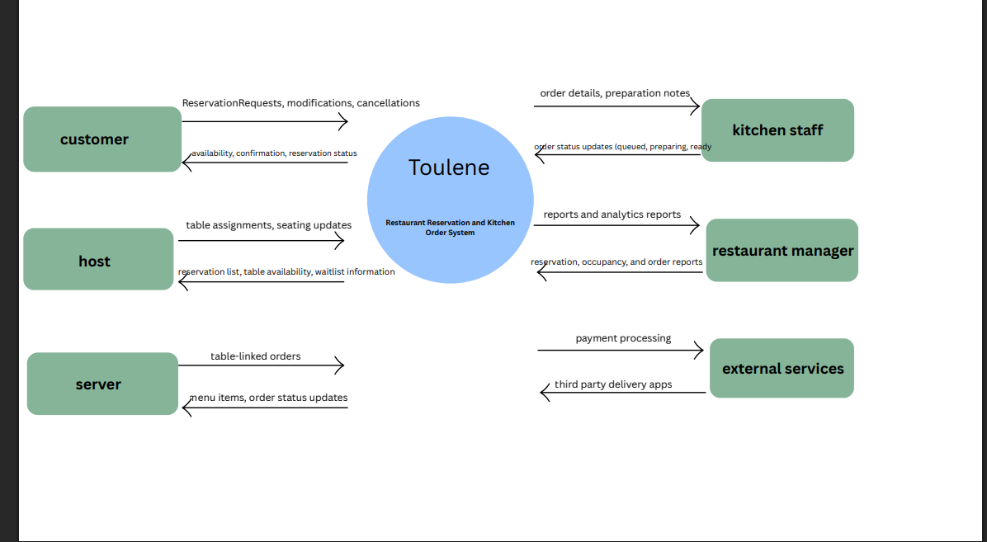

Toulene is a restaurant reservation and kitchen order management system. The purpose of this system is to basically design it to improve the communication with customers, staff (back of the house), and staff (front of the house). Our system will allow customers to be able to see available reservation times, to create or modify reservations, and to be able to cancel bookings as well. The hosts use the software to be able to manage seating availability and table assignments and servers are going to turn in the customer orders to the kitchen (via electronically). The Restaurant staff can manage the menu item availability and the kitchen staff use the KDS system to receive their orders, they also use it to update their status on preparation. The system boundary has table coordination, reservation management, submission of orders, and etc to be able to improve communication and efficiency of the restaurant. The payment processing, delivery services, and inventory are going to be outside the system because they are not required in the initial scope of the project.
2.2 Stakeholders and how you reached them

Stakeholder | Role in relation to the system | What they need from it | How you learned this

2.3 User characteristics

Type here.

2.4 Constraints

Type here.

2.5 Assumptions and dependencies

# | Assumption or dependency | What breaks if it does not hold
A1
A2
A3

2.6 Feasibility summary

Feasibility gate | Verdict | Evidence behind the verdict
Technical | Feasible | For the restaurant features that we have such as order tracking, dashboards, and reservations, we will use the technologies Node.js, and React. We can implement all of these basic functionalities with the web tools we use and our skills as a team.
Operational | Feasible | The evidence is that our system aligns with real workflows of restaurants and needs of the people that use them such as servers, customers, hosts, managers, and kitchen staff. Our interfaces are made well for restaurant systems, and they are very simple to use for training as well.
Schedule | Feasible | Feasible because our scope is basically limited to our reservation and our workflow logic. We have 14 functional requirements and 8 main use cases. These requirements and use cases are most definitely achievable with the semester and 4-5 team members.
Economic / resource | Feasible | Feasible because we can build this with tools that are readily available and that are either free or barely cost anything. We will be using university resources and software that is open sourced.

3 Specific Requirements

3.1 Functional requirements

ID | Requirement — one “shall” sentence | Priority | Source | Acceptance criterion
FR-01 | The system shall … | MUST |  | A tester can confirm this by …
FR-02
FR-03
FR-04
FR-05
FR-06
FR-07
FR-08

3.2 Quality requirements

ID | Requirement — with threshold, condition and method | Priority | Source | How it will be verified
QR-01
QR-02
QR-03
QR-04

3.3 Constraint requirements

ID | Constraint — one sentence | Source | Why it cannot be negotiated
CON-01
CON-02

3.4 Initial use cases

Paste the use case diagram here.

Expanded use case — copy this block for each of your two
Field | Content
Identifier and name | UC-01
Primary actor
Supporting actors
Preconditions — what must be true before it starts
Trigger — what starts it
Main success scenario — numbered steps
Alternative and exception flows
Postconditions — what is true when it succeeds
Requirements realised | FR-

3.5 Requirements to use case traceability

Requirement ID | Use case(s) that realise it | If blank — why, and what you will do
FR-01
FR-02
FR-03
FR-04
…

What the matrix revealed, and what you changed because of it:

4 Project Plan
4.1 Team roles and working agreement
Team member | Role for P1 to P2 | How the team makes a decision when it disagrees

4.2 Plan to P2

Date | What will be finished | Owner

4.3 Risks

# | Risk | Likelihood | Impact | Mitigation — action and owner
R1
R2
R3
R4
R5

4.4 Repository and tooling

Type here.

4.5 Declaration of AI tool use

Tool | What it was used for | Who used it | How the output was checked

5 Open Questions

# | The question | Who can answer it | Needed by | What you assumed in the meantime
Q1
Q2
Q3

6 Baseline Declaration

We confirm that the requirements in section 3 represent our agreed baseline as of the submission date, and that every team member has read this document in full.
Team member | Signature or typed name | Date

How P1 Is Marked
P1 is worth 4% of the course grade. Following the syllabus, 80 points are for the shared team artifact and 20 for individual contribution evidence.
Criterion | Points | What full marks look like
Problem, scope and context (1.1, 1.2, 2.1) | 10 | The problem is a problem somebody actually has. The out-of-scope column is filled and the exclusions are justified. The context diagram's boundary matches what sections 2 and 3 claim.
Stakeholders and elicitation (2.2, 2.3) | 10 | Stakeholders include at least one who will never use the system. Every need has a stated basis, and assumptions are labelled as assumptions rather than disguised as findings.
Requirements quality (3.1, 3.2, 3.3) | 25 | Every requirement is one testable “shall” sentence with an identifier, a priority, a source and an acceptance criterion. Quality requirements carry a threshold, a condition and a method. Constraints are distinguished from quality requirements.
Use cases and traceability (3.4, 3.5) | 20 | Use cases are at actor-goal level, not steps. Two are written out in full, including alternative flows. The matrix is complete and the team says what the gaps mean and what they did about them.
Feasibility and plan (2.6, 4) | 10 | Each feasibility verdict is backed by evidence a reader can check. The plan has dates and owners. Risks are future events with actionable mitigations.
Open questions and baseline (5, 6) | 5 | Real open questions, with an owner and a date, and an honest statement of what was assumed in the meantime.
Document quality | — | Guidance boxes removed, sections in order, within the length budget, readable. Marks are deducted here, not awarded.
Individual contribution evidence (0.1) | 20 | Every member's contribution is distinguishable and traceable to something in the repository a reader can open.

