CE/CS/SE 3354 · Software Engineering · Fall 2026
Project Milestone P2

Analysis and High-Level Design
Toulene
Team | Team 07, section 005
Document version | 1.0 (baseline for P2; grows from your P1 version 0.8)
Date | Nov 7, 2026
Repository URL | https://github.com/sandip10nepal/cs3354-project-p1
Git tag for this milestone | p2 (points at the commit that contains this exact PDF)
Submitted on Canvas by | Sandip Nepal

Team member | NetID | GitHub username
Sandip Nepal | SXN230108 | sandip10nepal
Arpita Lamichane | DAL081920 | aarpitaalamichhane-svg
Mehak Jay | MXJ230030 | mehakjay
Vasudha Silawat | VXS240036 | vsilawat
Gabriel Suarez | GXS220049 | Suarez04
Jarir Ali | JMA240001 | Jarir-al
Manideep Pendyala | mcp230000 | Manideep728

0 Revision History, Contribution Record and Changes Since P1
All three tables below are graded. The contribution record carries the individual 20% of this milestone and must agree with your repository history.
Version | Date | Author | Summary of change
0.8 | Oct 18, 2026 | Sandip Nepal (Integrator) | P1 baseline compiled and submitted.
0.8.1 | Nov 6, 2026 | Sandip Nepal | Added P2 repository scaffold, root README.md, and Section 0 / 0.2 P1 change control log (CH-01–CH-07).
0.8.2 | Nov 6, 2026 | Mehak Jay & Vasudha Silawat | Added /docs/elicitation/interviews.md, split QR-03/QR-05 (Sec 3.2), expanded UC-01 and UC-04 (Sec 4.2), and added QAS-01–03 (Sec 6.1).
0.8.3 | Nov 7, 2026 | Gabriel Suarez | Updated Sec 3.1 MoSCoW priorities & sources, expanded UC-05 (Sec 4.2), completed Sec 4.3 review log, and added UC-05 sequence diagram (Sec 5.2).
0.8.4 | Nov 7, 2026 | Jarir Ali | Added Domain Model (Sec 5.1), UC-01 sequence diagram (Sec 5.2), Architectural Style (Sec 6.2), Component View (Sec 6.3), and Deployment View (Sec 6.4).
0.8.5 | Nov 7, 2026 | Arpita Lamichane | Updated Sec 2.1 & 2.6, ran K1–K6 cross-checks (Sec 5.3), mapped objects & principles (Sec 6.5–6.6), and built Extended Traceability & Gap Analysis (Sec 9).
0.8.6 | Nov 8, 2026 | Manideep Pendyala | Added ADRs & Trade-offs (Sec 7), committed architecture spike S-01 (Sec 8), and updated P3 Plan, Risks, AI log, and Open Questions (Sec 10–11).
1.0 | Nov 8, 2026 | Sandip Nepal (Integrator) | Integrated all merged team PRs, verified Section 0.1 commit/PR links, compiled final P2 baseline PDF into /docs/p2, and pushed Git tag p2.

0.1 Individual contribution record (P2)
Team member | Sections and artifacts this person produced for P2 | Evidence in the repository (commit hashes, PR numbers) | Reviews given (PR numbers)

0.2 Changes since the P1 baseline
Change ID | What changed (IDs affected) | Why (P1 feedback, new finding, spike result) | Knock-on effect | Agreed on
CH-01
CH-02
CH-03

1 to 3 Introduction, Overall Description and Requirements (carried forward)
1 Introduction
1.1 Purpose of this document and of the system

This document serves as the Phase 1 (P1) proposal and baseline requirements specification for Toulene, intended for course instructors, teaching assistants, and project stakeholders following ISO/IEC/IEEE 29148 standards. It outlines the initial system boundaries, constraints, stakeholders, and testable requirements to guide subsequent software design phases.

Toulene addresses the communication breakdown between restaurant front-of-house reservation desks and back-of-house kitchen staff, which currently relies on fragmented phone bookings, lost paper tickets, and uncoordinated table turnover during peak dining hours. The system provides a unified digital platform enabling customers to book tables online, hosts to manage real-time seating, and kitchen chefs to track, prioritize, and update meal preparation statuses via a digital Kitchen Display System (KDS).

1.2 Scope

In scope — we will build this | Out of scope — we will not, and why
Customer-facing web portal for browsing availability, selecting party sizes, and booking time slots. | Physical credit card payment processing hardware or PCI-DSS financial gateway integration (excluded to keep P1 scope focused on reservation and order workflow logic).
Host station dashboard for managing floor plans, assigning tables, and tracking walk-in queues. | Automated robotic food delivery or conveyor belts between the kitchen and dining tables (excluded as physically impractical for standard software engineering projects).
Kitchen Display System (KDS) interface for chefs to view, sort, and mark item preparation statuses. | Third-party food delivery app integrations like UberEats or DoorDash API synchronization (excluded as out of scope for baseline dine-in restaurant operations).
Automated text/email notifications alerting customers when their table is ready or food is prepared. | Inventory supply chain management and automated supplier reordering (excluded as the project is strictly bounded to reservation and order routing).

Why the exclusions were excluded: The exclusions focus on financial payment gateway compliance and third-party logistics integrations that exceed the software development boundaries and timeframe of a semester-long academic project.

1.3 Definitions, acronyms and abbreviations

Term or abbreviation | Meaning as used in this project
KDS | Kitchen Display System; the digital screen interface used by back-of-house staff to manage incoming orders.
FOH | Front-of-House; staff members interacting directly with patrons, including hosts, servers, and managers.
BOH | Back-of-House; kitchen staff members responsible for food preparation and cooking.
Table Turn Time | The total duration a party occupies a table from seating to checkout and cleaning.

1.4 References

- [R1] ISO/IEC/IEEE 29148:2018 — Systems and software engineering — Life cycle processes — Requirements engineering.
- [R2] Standard Restaurant Hospitality Operations and Floor Management Guidelines, Rev. 2024.
- [R3] Stakeholder Interview Transcripts and Elicitation Notes, stored in repository /docs/elicitation/interviews.md.

2 Overall Description
2.1 Product perspective and context

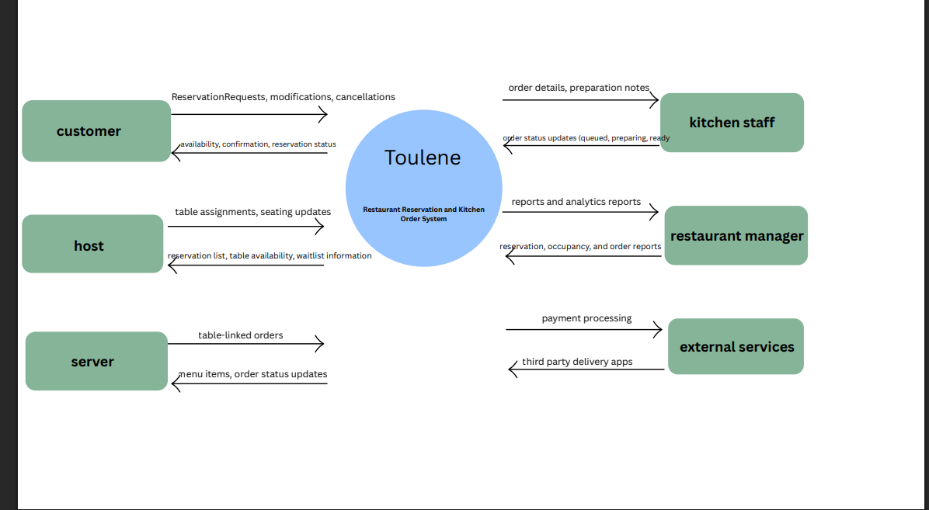

2.2 Stakeholders and how you reached them

Stakeholder | Role in relation to the system | What they need from it | How you learned this
Customers | Reserve tables, fix reservations, and view reservation status. | Ability to view available time slots, make reservations online, receive confirmation notifications, change or cancel reservations, and check reservation status without calling the restaurant. | Researched reservation features used in systems like OpenTable and Yelp Reservations, and as a team we came up with common expectations of restaurant customers.
Hosts | Manage table assignments and customer arrivals. | A real-time view of reservations, table availability, waitlists, customer check-ins, and tools to assign guests to tables quickly. | Assumed based on typical restaurant host responsibilities and observation of restaurant seating workflows.
Servers | View table status and customer orders | Access to assigned tables, customer orders, order status, order updates, and communication with kitchen staff. | Researched Kitchen Display Systems (KDS) and how restaurant kitchens receive, prioritize, and track orders.
Kitchen Staff | Receive and track incoming food orders | Clear order tickets, updates when new orders arrive, information about dietary requests, order priority tracking, and notifications when orders are updated. | Reviewed features of restaurant management software and found some common operational needs like reservation tracking, occupancy monitoring, and performance reporting.
Restaurant Managers | Monitor reservations, restaurant occupancy, and order performance | Dashboards showing reservation activity, table occupancy, wait times, completed orders, peak business hours, and performance reports of the restaurant. | Assumed based on management responsibilities and research on restaurant management software.

2.3 User characteristics

Customers: Restaurant guests use the system to reserve tables, check availability, modify reservations and view reservation status. Most customers can assume to know how to use a smartphone app or website, but they cannot be assumed to understand restaurant operations or technical system features. Customers can access the system from mobile phones, tablets, or computers. Since many customers may make reservations quickly, the system must be easy to use with clear instructions. Basic accessibility features: readable text, clear buttons, and simple layouts should be used.

Hosts: Restaurant hosts are responsible for managing reservations, assigning tables, and checking on arriving customers. They are expected to have basic computer skills and receive training on the system. They cannot be assumed to have advanced technical knowledge. Hosts usually use a desktop computer or tablet near the restaurant entrance. Because they work in busy environments and must get to customers quickly, the system should display information in real time and allow common tasks to be completed with limited steps.

Servers: Restaurant servers use the system to see table assignments, review customer orders, and check order status. Most servers can be assumed to have experience using touchscreen devices and restaurant technology, but not advanced technical expertise. Servers will likely use tablets or restaurant terminals during their shifts. Since servers are frequently moving between tables and maybe handling multiple customers at once, the system should allow fast access to information to prevent unnecessary navigation.

Kitchen Staff: Restaurant kitchen staff use the system to receive, track, and update food orders. They can be assumed to understand restaurant order workflows but may have different levels of computer experience. Kitchen staff usually use a kitchen display screen or terminal. Because the kitchen environment is fast paced and time sensitive, order information must be presented clearly, accurately, and in a format that is easy to read. The system should reduce clutter and make important updates the priority.

Restaurant Managers: Restaurant managers use the system to monitor reservations, occupancy levels, order activity, and restaurant performance. Managers are expected to have moderate experience with business software and reporting tools. They could access the system through desktop computers, tablets, or laptops. Managers often need to make operational decisions quickly, so the system should provide organized reports, dashboards, and summary information that is easy to understand.

2.4 Constraints

Platform | Toluene is web-based. The customer portal must run in current versions of Chrome,  Safari, Firefox, and Edge on phones, tablets, and computers without installing anything.
Kitchen hardware | KDS runs on kitchen screen, terminal or tablet in a fresh environment.  So, the interface must use large touch targets and texts that is easy to read at a glance
Network | The restaurant’s local wifi and internet connection in the only link between  front of house and backhouse so toluene depends on it
privacy | Customer contact details must be handled under applicable privacy laws and must not  be shared with third parties without the customer’s consent.
Payments | Payment processing is out of scope, so Toluene must not process payments or  collect or store card numbers.
Accessibility | The customer-facing interface must meet WCAG 2.1 Level AA, including readable text,  clear buttons, and simple layouts.
Project | Development must be completed within the CS 3354 semester schedule by a team of seven  students with no budget, so only free or open-source tools can be used.
Operations | Toluene must keep running through peak dining hours without staff having to restart it.

2.5 Assumptions and dependencies
# | Assumption or dependency | What breaks if it does not hold
A1 | The restaurant has a stable internet and Wi-Fi connection during service. | Reservations and orders cannot sync, and the KDS stops updating, so kitchen staff miss new orders.
A2 | Hosts and servers are trained and enter all reservations and orders through Toulene. | Orders taken outside the system never reach the kitchen, and the host’s table view becomes inaccurate.
A3 | Customers give a valid phone number or email when booking. | Confirmations and table-ready notifications cannot be sent, which increases no-shows.
# | Assumption or dependency | What breaks if it does not hold

2.6 Feasibility summary

Feasibility gate | Verdict | Evidence behind the verdict
Technical | Feasible | For the restaurant features that we have such as order tracking, dashboards, and reservations, we will use the technologies Node.js, and React. We can implement all of these basic functionalities with the web tools we use and our skills as a team.
Operational | Feasible | The evidence is that our system aligns with real workflows of restaurants and needs of the people that use them such as servers, customers, hosts, managers, and kitchen staff. Our interfaces are made well for restaurant systems, and they are very simple to use for training as well.
Schedule | Feasible | Feasible because our scope is basically limited to our reservation and our workflow logic. We have 14 functional requirements and 8 main use cases. These requirements and use cases are most definitely achievable with the semester and 4-5 team members.
Economic / resource | Feasible | Feasible because we can build this with tools that are readily available and that are either free or barely cost anything. We will be using university resources and software that is open sourced.

3 Specific Requirements

3.1 Functional requirements

ID | Requirement | Priority | Source | Acceptance criterion
FR-01 | The system shall display available reservation time slots for a customer’s selected date and party size based on table capacity and existing reservations. | MUST | Customer need [R2], [R3] | Given a table for four is available at 6:00 PM, a search for four guests includes that slot; a search for five excludes it unless another suitable table is available.
FR-02 | The system shall create a reservation with a unique confirmation number when a customer submits valid contact details, party size, and an available time slot. | MUST | Customer need [R2], [R3] | Submitting valid details for an available slot creates one reservation and displays its unique confirmation number.
FR-03 | The system shall prevent reservations that allocate the same table to overlapping reservation periods. | MUST | Restaurant staff need [R2], [R3] | When two customers attempt to reserve the same table for overlapping periods, only one reservation is confirmed.
FR-04 | The system shall allow a customer to modify their upcoming reservation to an available date, time, or party size. | SHOULD | Customer need [R2], [R3] | A valid change updates the reservation and releases its previous allocation; an unavailable change preserves the original reservation.
FR-05 | The system shall allow a customer to cancel their upcoming reservation. | SHOULD | Customer need [R2], [R3] | Canceling a confirmed reservation changes its status to canceled and makes its allocated table available for that period.
FR-06 | The system shall allow restaurant staff to mark a confirmed reservation as seated and associate it with the occupied table. | MUST | Host need [R2], [R3] | Selecting a confirmed reservation and an available table records the table assignment and changes the reservation status to seated.
FR-07 | The system shall allow a server to create a table-linked order containing available menu items, quantities, and optional preparation notes. | MUST | Server need [R2], [R3] | A server adds two available items with quantities and notes, saves the order, and retrieves it under the correct table.
FR-08 | The system shall reject an order submission containing an item currently marked unavailable. | SHOULD | Kitchen staff need [R2], [R3] | Submitting an order with an unavailable item identifies the item and leaves the order unsubmitted.
FR-09 | The system shall transmit a submitted order to the kitchen queue with its order identifier, table number, items, quantities, preparation notes, and submission time. | MUST | Server and kitchen staff need [R2], [R3] | Submitting a valid order produces a kitchen queue entry whose details match the submitted order.
FR-10 | The system shall allow kitchen staff to change an order’s status from queued to preparing and from preparing to ready. | MUST | Kitchen staff need [R2], [R3] | Kitchen staff advance a queued order through preparing to ready, and each saved status appears on the order.
FR-11 | The system shall display the current kitchen order status to the server responsible for the table. | MUST | Server need [R2], [R3] | After kitchen staff mark an order ready, the responsible server’s order view displays ready.
FR-12 | The system shall allow a server to mark a ready order as served. | SHOULD | Server need [R2], [R3] | Marking a ready order as served updates its status to served and removes it from the active kitchen queue.
FR-13 | The system shall allow restaurant staff to mark a table as available after its dining party leaves. | MUST | Restaurant staff need [R2], [R3] | Releasing an occupied table changes its current occupancy status to available while preserving its future reservations.
FR-14 | The system shall allow authorized restaurant staff to mark a menu item as available or unavailable for ordering. | COULD | Restaurant staff need [R2], [R3] | Marking an item unavailable prevents it from being added to a new order; restoring availability permits it again.

Priority distribution: 9 MUST (64.3%), 4 SHOULD (28.6%), 1 COULD (7.1%). Core reservation, seating, order submission, kitchen preparation, and order tracking remain MUST. No requirement is withdrawn.
Source note: [R3] interview notes are available in PR #4 (cd6a5a7), awaiting merge. Interviews 1/6 cover reservations, 2/7/8 seating, and 3/4/9 ordering. Exact overlap/served-status rules and [R2] still need confirmation.

3.2 Quality requirements

ID | Requirement — with threshold, condition and method | Priority | Source | How it will be verified
QR-01 | Toulene shall display a submitted order on the KDS within 5 seconds for 95% of orders, with 20 active tables on the restaurant Wi-Fi. | MUST | Kitchen staff need | Submit 50 test orders and compare submission and display timestamps.
QR-02 | Toulene shall load any customer-facing page within 3 seconds for 95% of requests with 100 concurrent users. | MUST | Customer need | Load test with 100 simulated users.
QR-03 | Toulene shall be available at least 99% of the time during operating hours. | MUST | Restaurant manager need | Monitor uptime during a multi-day test over simulated operating hours; availability = operating time available / total operating time × 100.
QR-04 | Kitchen staff shall change an order’s status in 2 taps or fewer, using touch targets of at least 44x44 pixels. | SHOULD | Kitchen staff need | Task walkthrough with kitchen-role testers and a design inspection of the KDS.
QR-05 | Toulene shall retain 100% of confirmed reservations and submitted orders across a system restart. | MUST | Restaurant manager need | Create 20 confirmed reservations and 20 submitted orders; restart the system 5 times and verify that all 40 records remain intact after every restart.

3.3 Constraint requirements
CON-01 and CON-02 are unchanged from the P1 v0.8 baseline.

ID | Constraint — one sentence | Source | Why it cannot be negotiated
CON-01 | Toulene shall run in the latest two versions of Chrome, Safari, Firefox, and Edge with no installation. | customers use their own devices | Customers book on their own phones and computers, and the restaurant will not install software for guests.
CON-02 | The KDS shall be fully usable by touch alone on a screen of at least 10 inches. | Kitchen staff | Cooks work with gloved hands and have no keyboard or mouse at the station

3.4 Use cases

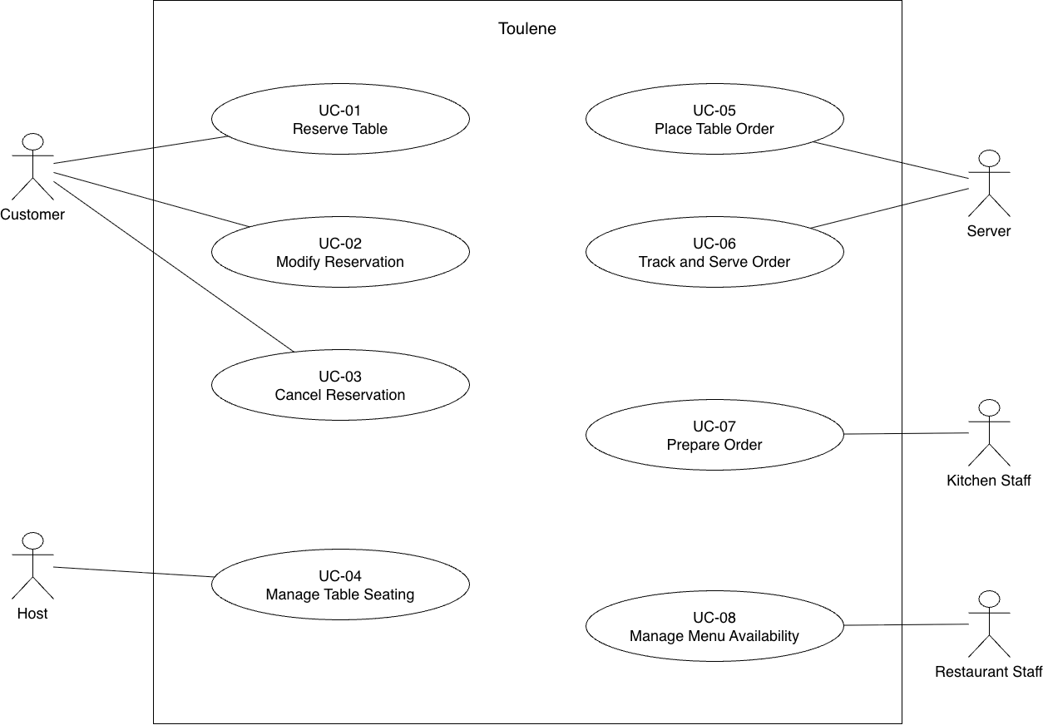

Editable source: docs/p2/diagrams/use-cases.drawio. The actor-goal list remains unchanged; detailed expansions belong in Section 4.2.
ID | Actor goal | Primary actor
UC-01 | Reserve Table | Customer
UC-02 | Modify Reservation | Customer
UC-03 | Cancel Reservation | Customer
UC-04 | Manage Table Seating | Host
UC-05 | Place Table Order | Server
UC-06 | Track and Serve Order | Server
UC-07 | Prepare Order | Kitchen Staff
UC-08 | Manage Menu Availability | Authorized Restaurant Staff

3.5 Requirements to use case traceability

Requirement ID | Use case(s) that realise it | If blank — why, and what you will do
FR-01 | UC-01 Reserve Table | Not applicable — mapped.
FR-02 | UC-01 Reserve Table | Not applicable — mapped.
FR-03 | UC-01 Reserve Table | Not applicable — mapped.
FR-04 | UC-02 Modify Reservation | Not applicable — mapped.
FR-05 | UC-03 Cancel Reservation | Not applicable — mapped.
FR-06 | UC-04 Manage Table Seating | Not applicable — mapped.
FR-07 | UC-05 Place Table Order | Not applicable — mapped.
FR-08 | UC-05 Place Table Order | Not applicable — mapped.
FR-09 | UC-05 Place Table Order | Not applicable — mapped.
FR-10 | UC-07 Prepare Order | Not applicable — mapped.
FR-11 | UC-06 Track and Serve Order | Not applicable — mapped.
FR-12 | UC-06 Track and Serve Order | Not applicable — mapped.
FR-13 | UC-04 Manage Table Seating | Not applicable — mapped.
FR-14 | UC-08 Manage Menu Availability | Not applicable — mapped.

What the matrix revealed, and what you changed because of it:
All 14 functional requirements map to the eight use cases in the diagram; none is unmapped. UC-01 groups availability, confirmation, and overlap prevention (FR-01–03), while UC-05 groups order entry, availability checks, and kitchen submission (FR-07–09). This keeps validation steps within the relevant actor goal instead of adding separate use cases.
The mapping makes table release explicit within UC-04 (FR-13), alongside seating (FR-06), and places both order status viewing and serving within UC-06 (FR-11–12). No additional use cases were needed. UC-01 and UC-05 are expanded in Section 3.4; the other six remain diagram-level use cases for this initial baseline. Sources and workflow assumptions still require team validation before the baseline is agreed.

4 Use-Case Analysis

4.1 Use cases selected for analysis
Use case | Name | Why it was selected | Non-trivial steps
UC-01 | Reserve Table | This use case was selected because a Reserve Table is the first step a customer takes when booking a table, and the rest of the reservation system builds on the reservations this use case creates. This use case covers FR-01, FR-02, and FR-03 and deals with checking which tables are free, checking the reservation details, picking a table that fits party sizes, and stopping two parties from getting booked for the same table at the same time. Without this use case working properly, the host has no reservations to seat people from, and since booking is the first step for the customer, a bad booking flow makes the whole visit start off wrong. The availability checking and conflict prevention matter because if two parties end up booked for the same table at the same time, the host must turn one of them away at the door. | Checking what tables are free, checking the reservation details, picking a table that fits, stopping double bookings, and confirming the reservation.
UC-05 | Place Table Order | This use case was selected because Place Table Order connects the servers taking orders to the kitchen staff making them, so if this use case breaks down the kitchen gets the wrong orders or gets them late. This use case affects how accurate the orders are and how fast the restaurant runs, since a wrong item or a wrong quantity means the kitchen has to remake food and the table waits longer. It also deals with checking the order before it goes to the kitchen, marking that an order is unavailable (lack of ingredients, etc), and keeping the server and the kitchen in sync on what was ordered and what still needs to go out. | Checking what is on the menu, checking the order, dealing with items that are out, saving the order, and sending it to the kitchen queue.
UC-04 | Manage Table Seating | This use case was selected because Manage Table Seating links the reservations customers made and the host seating people at the door, so this use case decides how well the tables get used across a night. If the host seats parties badly, tables sit empty while people wait, and if the host seats parties well, more parties get served. Manage Table Seating also holds a lot of the business rules for giving out tables and freeing them up again, like which tables fit which party sizes, when a table counts as taken, and when a table opens back up after a party leaves. | Checking if the party arrived, finding their reservation, giving them a table, keeping track of which tables are taken, updating the seating status, and freeing the table when they leave.

4.2 Expanded use cases

UC-01 [Reserve Table]
Primary actor | Customer
Supporting actors and external systems | None
TUCBW (this use case begins when) | This use case begins when a customer wants to book a table for a certain date and time.
TUCEW (this use case ends when) | This use case ends when the customer gets a confirmation that their reservation went through.
Preconditions | - The restaurant’s rules, hours, and table size are already set up in the system  - A table is free at the time the customer wants.
Postconditions | - A reservation is saved for a set date and time.  - The table fits the party size.  - Booking has it’s own confirmation number  - The table is blocked off for overlapping times
Traces to requirements | FR-01, FR-02, FR-03, QR-02, QR-03, CON-01

Actor input / action |  |  |  | System response
 |  |  |  | (0) The system requests the reservation information that is needed to check if there is availability.
(1) The customer provides information about the date, time, and party-size for their reservation. |  |  |  | (2) The system finds reservation options using the customers information.
(3) The customer selects the reservation option they want. |  |  |  | (4) The system requests contact information needed for completing the reservation.
(5) The customer provides the contact information and confirms the reservation. |  |  |  | (6) The system creates the reservation and hands back a confirmation number.
Alternate flow | At step | Condition | What happens |  | Ends or rejoins at
A1 | (2) | There is no table free that matches the date, time, and party size the customer asked for. | The system tells the customer there is no table available that matches the requested date, time, and party size. And asks them to pick a different date, time, or party size |  | (1)
A2 | (5) | The customer left out some of the required information to complete the reservation, or they typed in something wrong. | The system points out what needs to be fixed and asks the customers to fill the information in again. |  | (5)

UC-05 [Place Table Order]
Field | Content
Primary actor | Server
Supporting actors and external systems | None; kitchen preparation belongs to UC-07.
TUCBW | The Server needs to place an order for a dining party.
TUCEW | The Server receives submission confirmation, cancellation confirmation, or a failure message.
Preconditions | The Server is authorized. Table and menu information exists.
Success postconditions | One table-linked Order appears once in KitchenQueue with matching details and queued status. The Server receives confirmation.
Minimal guarantee | A rejected or cancelled attempt creates no submitted Order or kitchen entry.
Traces to requirements | FR-07, FR-08, FR-09; QR-01 (kitchen delivery time).

Main success scenario
Actor input / action | System response
— | (0) Lists occupied Tables by table number for a new Order.
(1) The Server chooses a Table and requests a new Order. | —
— | (2) Lists MenuItems and their availability.
(3) The Server gives MenuItems, quantities, and optional preparation notes. | —
— | (4) Shows the draft: table number, MenuItems, quantities, and notes. Requests confirmation or changes.
(5) The Server confirms the Order. | —
— | (6) Confirms kitchen submission with order number, table number, items, quantities, notes, submission time, and queued status.

Alternate flows
Alternate flow | At step | Condition | What happens | Ends or rejoins at
A1 | (0) | No occupied Table exists. | The system reports no occupied Table. Seating must be completed through UC-04. | Ends; restart at (0) after seating.
A2 | (2) or (6) | The chosen Table is no longer occupied. | The system rejects the Table. The Server chooses another or cancels. | Rejoins (2) after a new (1), or ends through A6.
A3 | (4) | Unavailable item, empty Order, or invalid quantity (not a positive whole number). | The system identifies the problem and leaves the Order unsubmitted. The Server corrects it or cancels. | Rejoins (4) after a corrected (3), or ends through A6.
A4 | (5) | The Server finds an error in the summary. | The Server revises the items, quantities, or notes. The system shows the updated draft. | Rejoins (4), then (5).
A5 | (6) | A MenuItem became unavailable after the summary was presented. | The system identifies the item and reports no submission. The Server revises or cancels. | Rejoins (4) after a corrected (3), or ends through A6.
A6 | (1), (3), or (5) | The Server abandons the attempt before submission. | The Server cancels. The system confirms that no Order was submitted. | Ends without submission.
A7 | (6) | The Order cannot be accepted for kitchen preparation. | The system reports failure: no submitted Order or kitchen entry. The Server retries or cancels. | Rejoins (5) for a new confirmation, or ends through A6.

UC-04 [Manage Table Seating]
Primary actor |  |  | Host
Supporting actors and external systems |  |  | None.
TUCBW (this use case begins when) |  |  | An arriving party with a confirmed reservation asks to be seated.
TUCEW (this use case ends when) |  |  | The host receives confirmation that the party is seated; later, after the party leaves, the host receives confirmation that the table is available.
Preconditions |  |  | Tables and capacities are defined. A confirmed reservation exists for seating; an occupied table exists for release.
Postconditions |  |  | The reservation is marked seated and linked to one occupied table. After release, that table is available and its future reservations are preserved.
Traces to requirements |  |  | FR-06, FR-13. No direct QR or CON trace.
Actor input / action |  |  |  |  | System response
 |  |  |  |  | (0) The system presents confirmed reservations due now and their allocated tables and current occupancy.
(1) The host identifies the arriving party’s reservation. |  |  |  |  | (2) The system confirms the reservation and gives the host its party size, time, and allocated table.
(3) The host confirms arrival and asks to seat the party. |  |  |  |  | (4) The system checks that the allocated table is available for this party and confirms the proposed assignment.
(5) The host accepts the proposed table. |  |  |  |  | (6) The system marks the reservation seated and the table occupied, then confirms the assignment to the host.
(7) After the party leaves and the table is cleared, the host asks to release that table. |  |  |  |  | (8) The system identifies the occupied table and its current party, then asks the host to confirm the release.
(9) The host confirms that the party has left and the table is clear. |  |  |  |  | (10) The system marks the table available, preserves future reservations, and confirms the release to the host.
Alternate flow | At step | Condition |  | What happens |  | Ends or rejoins at
A1 | (2) | No confirmed reservation is found, or it was marked no-show. |  | The system tells the host that the party cannot be seated under that reservation. The host may help the party start a new reservation (UC-01). |  | Ends.
A2 | (4) | The allocated table is unavailable. |  | The system proposes the smallest available table that fits the party and does not conflict with another reservation. |  | Rejoins at (5); if none exists, A3.
A3 | (4) | No suitable table is available. |  | The system tells the host that seating cannot yet be confirmed. The host tells the party the expected wait. |  | Rejoins at (3) when a table becomes available, or ends if the party leaves.
A4 | (5) | The host chooses another suitable table. |  | The system checks that table’s availability and reservation conflicts; it accepts the choice or explains why it cannot be used. |  | Rejoins at (6) if accepted, otherwise (5).
A5 | (6) | The assignment cannot be saved. |  | The system reports failure and keeps the reservation confirmed and the table available; no partial seating is recorded. |  | Rejoins at (5) if the host retries, otherwise ends.
A6 | (8) | The selected table is not occupied. |  | The system tells the host there is nothing to release; no table or reservation changes. |  | Ends.
A7 | (10) | The release cannot be saved. |  | The system reports failure and leaves the table occupied; the host can retry after checking its status. |  | Rejoins at (7) if retried, otherwise ends.

4.3 Self-review log
Criteria: Lesson 13 rules in the P2 template. Drafts: UC-01 PR #4 (cd6a5a7), UC-04 PR #5 (68b8da3), and current UC-05.
Use case | Check from the Lesson 13 review checklist | Defect found | How it was fixed
UC-05 | Step (0) and separate turns | Missing initial information and two-column turns. | Added Step (0) and Actor/System turns.
UC-05 | Visible ending, alternate flows, and no background steps | Unclear failure/cancellation endings; internal recording mixed with actor steps. | Added TUCEW and A1–A7; moved internal messages to 5.2.2.
UC-01 | Step (0), turns, and visible ending | Single list instead of two columns; (2) finds options without presenting them. | Open: use two columns; present options at (2).
UC-01 | Precondition or alternate flow | Free-table precondition conflicts with A1; no last-minute availability flow. | Open: remove that precondition; add an availability recheck/failure flow.
UC-01 | Clear alternate-flow turns | A2 starts at actor step (5), without a system validation response. | Open: validate at (6), explain corrections, return to (5).
UC-04 | Step (0) and separate turns | Step (0) is a trigger; single list includes actions outside Host/System turns. | Open: add initial information and two-column Host/System turns.
UC-04 | TUCBW, TUCEW, and visible ending | Missing TUCBW/TUCEW; (7)/(11) lack visible confirmation. | Open: add fields and seating/release confirmations, each with a trigger and ending.
UC-04 | Preconditions and alternate-flow assumptions | Reservation precondition conflicts with 3a; seating rules need a source. | Open: handle reservation lookup as a flow; confirm seating rules.

UC-01/UC-04 have no UI or implementation terms. Open fixes remain with their owners. This log is not a submitted GitHub review. Domain checks await Section 5.1.

5 Analysis Models
Chapter 7, second half. What has to exist inside the system for the use cases in section 4 to happen, and how those parts talk to each other.

5.1 Domain model
Insert dia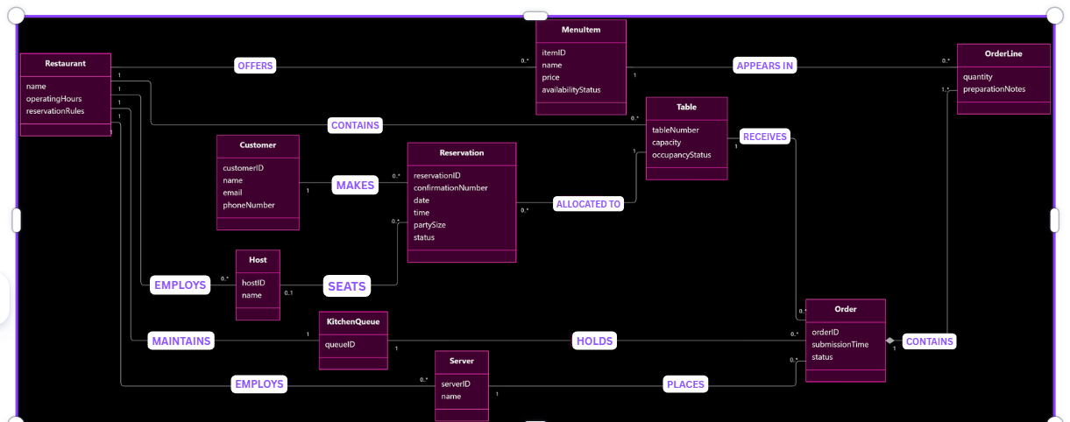gram here, then replace this frame with the image.
Figure 5.1 Domain model (conceptual classes, attributes, associations with multiplicities)
Class | What it represents (one line) | Key attributes | Associations (with multiplicity)
Kitchenqueue | Collection of submitted kitchen orders | queueID | Restaurant(1)  Orders(0)
MenuItem | Food/drink offered | itemID, name, price, availabilityStatus | Restaurant(1)  OrderLines(0)
OrderLine | Basically an individual item in an order | Quantity, preparationNotes | Order (1), MenuItem(1)
Order | A food order linked to a specific table | orderID, submissionTime, status | Table (1), Server(1) OrderLines(1), KitchenQueue(1)
Server | A staff member that’s placing orders | serverID, name | Restaurant (1), Orders (0)
Host | A staff member managing seating | hostID, name | Restaurant(1), Reservations (0)
Table | This is quite literally a physical dining table | tableNumber, capacity, occupancyStatu | Restaurant(1), Reservations(0) Orders(0)
Reservation | This is the record of a table booking basically | reservationID, confirmationNumber, date,time, partySize, status | Customer(1),  Table (1)
Customer | This is the person that’s trying to make a reservation | customerID,name, email, phoneNumber | Reservations (0)
Restaruant | It represents the business operating toulene | The name, operatingHours, and reservationRules | Tables(0)  MenuItems(0)  KitchenQueue(1)  Hosts(0)  Servers(0)

GUIDANCE: DELETE THIS BOX BEFORE SUBMITTING
Conceptual classes only: things and records from the problem domain, with attributes and associations. No operations, no data types, no database tables, no screen classes.
Every item the actor column of section 4.2 mentions is an attribute somewhere in this model. Every association has a multiplicity at both ends.
Budget: one page including the diagram.

EXAMPLE (COMETPARK): DELETE BEFORE SUBMITTING
Lot (name, zone, capacity) 1 ── 0..* Space (number, type) ; Space 1 ── 0..* OccupancyReading (time, state) ; Permit (type, valid until) * ── 1..* Lot "is valid in" ; Building (name) * ── * Lot "is near" (walking time).

5.2 Object interaction models

5.2.2 UC-05 Place Table Order

(a) Non-trivial steps
Section 4.2 step | Why the step needs objects
(0) | Table occupancy determines which table numbers can be offered.
(2) | MenuItem availability must be obtained for the chosen Table.
(4) | Order composes OrderLines and supplies a complete, table-linked draft for review.
(6) | Table occupancy and MenuItem availability must be rechecked, the Order finalized, and kitchen acceptance established before acknowledgment.

Steps (1), (3), and (5) are simple inputs: Table choice, Order details, and confirmation. The table and diagram cover the main success flow.
Objects: OrderPlacement is the interaction controller; Server is the external actor. Proposed domain classes: Table, MenuItem, Order, OrderLine, KitchenQueue. Order contains OrderLines. Final names must match Section 5.1.

(b) Scenario table
M01–M21 match the diagram; parentheses identify Section 4.2 steps.
Step | Subject | Subject action | Other data / objects | Object acted upon
M01 (0) | OrderPlacement | asks for occupied tables | table occupancy | Table
M02 (0) | Table | provides occupied table numbers | table numbers | OrderPlacement
M03 (0) | OrderPlacement | presents occupied tables | table numbers | Server
M04 (1) | Server | identifies table and requests order | table number | OrderPlacement
M05 (2) | OrderPlacement | asks for menu availability | selected Table | MenuItem
M06 (2) | MenuItem | provides items and availability | item names, availability | OrderPlacement
M07 (2) | OrderPlacement | presents items and availability | item names, availability | Server
M08 (3) | Server | supplies order contents | MenuItems, quantities, preparation notes | OrderPlacement
M09 (4) | OrderPlacement | composes draft order | Table, OrderLines with MenuItems, quantities, preparation notes | Order
M10 (4) | Order | provides draft summary | table number, item names, quantities, preparation notes | OrderPlacement
M11 (4) | OrderPlacement | presents draft for confirmation | complete draft summary | Server
M12 (5) | Server | confirms draft order | reviewed draft | OrderPlacement
M13 (6) | OrderPlacement | rechecks table occupancy | chosen Table | Table
M14 (6) | Table | confirms table is occupied | table number, occupancy | OrderPlacement
M15 (6) | OrderPlacement | rechecks item availability | all MenuItems in Order | MenuItem
M16 (6) | MenuItem | confirms all items available | current availability | OrderPlacement
M17 (6) | OrderPlacement | finalizes submitted order | reviewed draft, unique order number, submission time, queued status | Order
M18 (6) | Order | provides submitted order details | order number, Table, OrderLines, submission time, queued status | OrderPlacement
M19 (6) | OrderPlacement | places order in kitchen queue | submitted Order and matching details | KitchenQueue
M20 (6) | KitchenQueue | acknowledges one queued order | order number, queued status | OrderPlacement
M21 (6) | OrderPlacement | acknowledges submitted order | order number, table number, items, quantities, notes, submission time, queued status | Server

A7 requires that failed kitchen acceptance leave no submitted Order or kitchen entry.

(c) Analysis sequence diagram
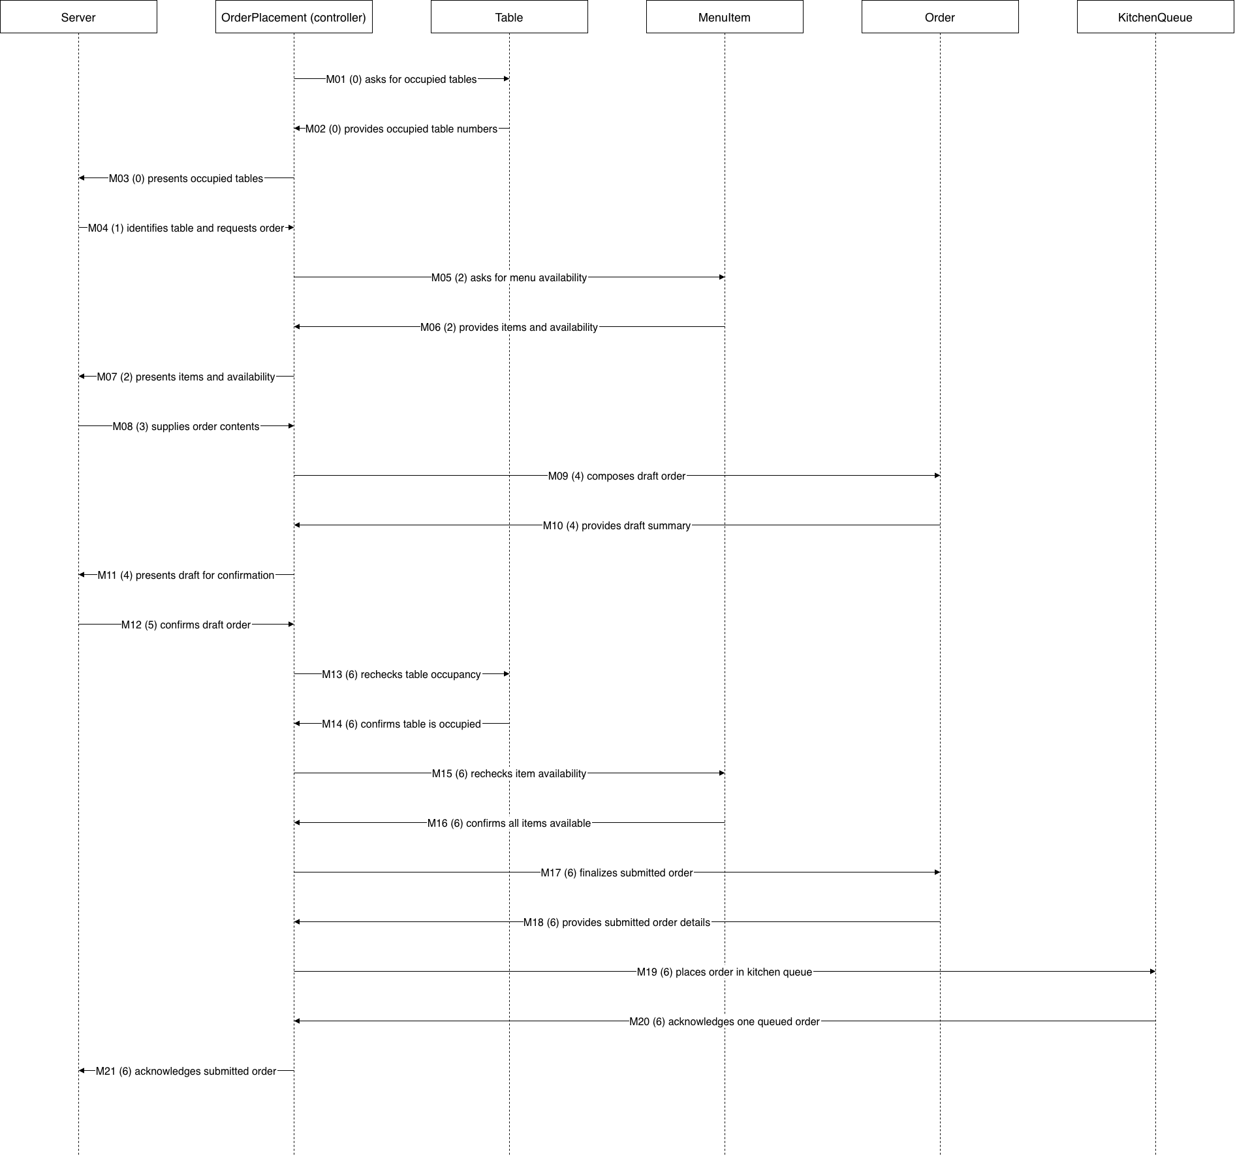
Figure 5.2.2. UC-05 main success flow. Source: docs/p2/diagrams/seq-uc05.drawio.
GUIDANCE: DELETE THIS BOX BEFORE SUBMITTING
Write each step as a declarative sentence first, subject, verb, object, then fill the columns. Tables filled directly produce rows with no subject.
One message per table row, same numbers. Use the four translation cases from Lesson 14; the diagram is a conversion of the table, not a new drawing.
Messages are verb phrases, not operation signatures. "asks for the routes calling at the stop" is analysis; "getRoutes(stopId: int): List<Route>" is Chapter 9 and is not credited here.
Every object on the diagram is a class in 5.1 or an interaction object you name and explain in one line. One object is clearly in control of the interaction.
Budget: one to one and a half pages per use case.

EXAMPLE (COMETPARK): DELETE BEFORE SUBMITTING
Step 2 · Subject: LotFinder · Action: asks for the lots the permit allows · Data: permit type, destination · Object acted upon: PermitRules.

5.3 Consistency cross-check
Check | Result (pass, or what failed) | Fixed in
K1 Every item in an actor column (4.2) is an attribute in the domain model (5.1) | Partial – most of the inputs are represented. The reservation date, the time, party size, contact information, table number, menue items, notes, and quantities are all there. | 5.1
K2 Every object on a sequence diagram is a domain class or a declared interaction object | Partial – UC -05 basically uses the orderplacement as a declared interaction controller. UC – 01 must declare its controller. | 5.2
K3 Every message on a sequence diagram corresponds to exactly one scenario-table row | UC-05 has numbered messages such as M01-M21. UC -01 still requires verification. | 5.2
K4 Every non-trivial step in 5.2 (a) has at least one scenario-table row | The UC-05 steps (0), (2),(4) and (6) are basically covered. UC-01 though still requires verification!! | 5.2
K5 Every analyzed use case traces to at least one functional requirement | PASS!! – the UC-01 maps to FR-01-03 and the UC-05 maps to FR-07-09 | 3.5 and 4.2
K6 The last messages of each diagram make the use case postcondition true | The UC-0 ends with kitchen submission acknowledgement. UC-01 MUST end with confirmed reservation details | 5.2

GUIDANCE: DELETE THIS BOX BEFORE SUBMITTING
Run the six checks across the work of different authors; they are designed to catch the seams between people. A failed check that you found and fixed is more convincing than a column of passes. Budget: a quarter of a page.

6 High-Level Design (Architecture)

6.1 Architectural drivers: quality-attribute scenarios
QAS | Quality attribute | Stimulus | Artifact | Response | Response measure | From
QAS-01 | Performance | A server submits a valid table order during normal service with 20 active tables on restaurant Wi-Fi. | Order submission service and kitchen display (KDS). | The order is saved and appears in the kitchen queue with its identifier, table, items, quantities, notes, and submission time. | At least 95% of 50 test orders appear on the KDS within 5 seconds, measured from submission to display timestamps. | QR-01
QAS-02 | Performance | During the evening peak, 100 customers concurrently request customer-facing pages, including availability, booking, and confirmation. | Customer portal and reservation service. | Requested pages load and availability searches complete without errors. | At least 95% of page loads complete within 3 seconds in a load test with 100 concurrent users. | QR-02
QAS-03 | Data integrity | A system crash or planned restart occurs during operating hours while confirmed reservations and submitted orders exist. | Application service and persistent reservation and order storage. | After restart, the system restores the saved reservations and orders without losing records. | All 20 confirmed reservations and 20 submitted orders remain intact after each of 5 restarts (100% retention). | QR-05

6.2 Architectural style and alternatives
Style considered | Drivers it serves | What it costs | Verdict
 |  |  | Chosen
 |  |  | Rejected
 |  |  | Rejected

6.3 Component view
Insert diagram here, then replace this frame with the image.
Figure 6.3 Component diagram: components, provided and required interfaces, external systems
Component | Responsibility (one sentence) | Provides | Requires | Answers to (UC / QAS / ADR)

GUIDANCE: DELETE THIS BOX BEFORE SUBMITTING
Point at any box and say which use case, which quality scenario or which decision put it there. A box with no answer cannot be credited.
Show external systems outside the boundary. Name interfaces by what they offer ("OccupancyQuery"), not by operation signatures, which are Chapter 9.
Budget: one page including the diagram.

6.4 Deployment view
Insert diagram here, then replace this frame with the image.
Figure 6.4 UML deployment diagram: nodes, execution environments, deployed artifacts, communication paths with protocols, trust boundaries
Node | What runs on it (artifacts, components) | Communicates with (protocol) | Trust zone

GUIDANCE: DELETE THIS BOX BEFORE SUBMITTING
Every component in 6.3 is deployed somewhere in 6.4. Every communication path names its protocol. Mark the trust boundaries: where data crosses from a zone you control into one you do not.
If you use a cloud service, say which responsibilities stay with your team under the shared-responsibility model.
Budget: one page including the diagram.

6.5 From analysis to architecture
Analysis object (from 5.1 and 5.2) | Component that owns it (6.3) | Note (split, merged, external)
ReservationBooking | Reservation Service | Proposed interaction controller for UC-01
OrderPlacement | OrderService | Interaction controller for UC-05
KitchenQueue | Kitchen Queue Service | Tracks orders sent to the kitchen
MenuItem | Menu Service | Maintains Menu details and item availability
OrderLine | OrderService | Groups menu items, quantities, and preparation notes
Order | Order Service | Groups menu items, quanties, and preparation notes
Server | Order Service | Supports table-linked order submission
Host | Seating Service | Supports table assignment and release
Table | Seating Service | Maintains table capacity, the occupancy, and the availaibilty,
Reservation | Reservation Service | This handles the booking, confirmation, and reservation changes,
Customer | Reservation Service | Maintains customer details needed for this booking
Restaurant | Restaurant Configuration Service | This manages restaurant hours and reservation rules

GUIDANCE: DELETE THIS BOX BEFORE SUBMITTING
Every class and interaction object from section 5 lands in exactly one component, or the note says why it was split, merged or left to an external system. This table is how the reader sees that the architecture realizes the analysis rather than replacing it. Budget: a quarter of a page.

6.6 Design principles applied
Principle | Where it shows in your design | Evidence (component, interface, ADR)
Separation of concerns | Reservation booking, seating, order management, and kitchen queue processing have separate responsibilities | Reservation Service, Seating Service, Order Service, Kitchen Queue Service
Information hiding | The customer and staff interfaces access reservation and order information through the responsible services rather than basically directly modifying stored records. | Reservation Service, Order Service
Low coupling | Frontended interfaces basically communicate with backend services through defined interfaces, allowing components to change independently | Reservation Interface, Order Interface
High cohesion | Each component focuses on one related set of tasks such as managing reservations or processing orders | Reservation Service, Order Service
Design for change | The menu availability and reservation rules can be updated within their responsible components without changing unrelated feautures | Menu Service, Restaurant Config service,
Keep it simple (KISS) | This system basically uses a straightforward webased architecture with a React frontend and a Node.js backend, and a persistent storage rather than an unnecessary distributed services | Node.js application server, react frontend

GUIDANCE: DELETE THIS BOX BEFORE SUBMITTING
One line per principle, pointing at something concrete. A principle you cannot point at in your own design should be left blank and explained in one sentence, not filled with a definition from the slides. Budget: a third of a page.

7 Design Rationale

7.1 Architecture decision records
At least three. ADR-01 records the style decision from 6.2. Use the format you practiced in the Lesson 16 workshop, written about your own project. Copy the block for each decision.

ADR-xx [Decision title]
Status | Accepted / Superseded by ADR-
Date and owner
Context (drivers) | Which QAS, use cases and constraints force a decision here
Options considered | At least two, each in one line
Decision
Consequences | Name the quality it favors, the move, and the cost you accept
Evidence | Spike result (section 8), measurement, documentation, or "none yet" with an open question
Related | ADR-, QAS-, R- (risk), CH- (change)

GUIDANCE: DELETE THIS BOX BEFORE SUBMITTING
A decision without a cost is a preference. If you cannot say what you gave up, you have not finished the record.
Options must be real alternatives the team discussed, not a straw man added to fill the row.
Budget: about a third of a page per ADR.

EXAMPLE (COMETPARK): DELETE BEFORE SUBMITTING
ADR-02 · Push occupancy changes to clients rather than polling · Context: QAS-01, CON-02 (campus Wi-Fi limits) · Options: client polling every 10 s; server push over a persistent connection · Decision: server push · Consequences: favors performance and freshness; costs connection management on the occupancy service and a fallback when push fails (A2 in UC-02) · Evidence: spike S-01.

7.2 Trade-off summary
Quality favored | Architectural move | Cost accepted | Recorded in
 |  |  | ADR-
 |  |  | ADR-
 |  |  | ADR-

GUIDANCE: DELETE THIS BOX BEFORE SUBMITTING
One row per real trade-off. This is the table a reviewer reads first. Budget: a quarter of a page.

8 Prototype Evidence: Architecture Spike
Spike ID and title | S-01
Risk or decision it addresses | R- / ADR- / QAS-
Question (answerable yes or no)
Set-up | Stack, data, what was simulated; folder in the repository
How it was measured
Result (numbers)
What it changed or confirmed | Which ADR, QAS or requirement
Where to see it | Commit hash, /spikes/S-01/, screenshot or log file

GUIDANCE: DELETE THIS BOX BEFORE SUBMITTING
Build the smallest thing that answers your riskiest architectural question, run it, and measure it. Time-box it to a few hours. It may be thrown away afterwards; it is not the product.
Good spikes answer questions such as: can we read the external data source, and is it fresh to within 60 seconds? Does the chosen hosting meet QAS-01 under a simulated peak? Does the authentication provider fit our trust boundary?
Never commit passwords, API keys or other credentials; keep them in local configuration excluded from the repository.
The code, the measurement and a short README are committed to /spikes before the deadline. A spike described but not in the repository is not evidence.
Budget: half a page.

9 Traceability

9.1 Extended traceability matrix
Requirement | Use case | Analysis classes | Component(s) | QAS / ADR | Evidence
FR-01
FR-02
QR-01
CON-01

GUIDANCE: DELETE THIS BOX BEFORE SUBMITTING
Extend the P1 matrix one column at a time: from each requirement to the use case, to the analysis classes that realize it, to the component that will own it, to the decision or scenario that shaped it, and to whatever evidence exists (spike, measurement).
Requirements realized by the use cases you analyzed need the full chain. Every other MUST requirement needs at least its component. Withdrawn requirements stay in the matrix, marked as such.
Budget: one page.

9.2 Gap analysis
Gap | Items | What you did about it
Requirements with no component
Components with no requirement, QAS or ADR
Use cases not analyzed (and why that is acceptable)

GUIDANCE: DELETE THIS BOX BEFORE SUBMITTING
An empty gap table is believable only if the matrix above is complete. Say what each gap means and what you did. Budget: a quarter of a page.

10 Project Plan (updated; was P1 section 4)

10.1 Roles and working agreement
GUIDANCE: DELETE THIS BOX BEFORE SUBMITTING
Keep your P1 text and record only what changed. If roles moved between members, say so here and in 0.2.

10.2 Plan to P3
Milestone | Date | Owner | Done when

10.3 Risks (updated)
Risk | Status since P1 | Likelihood / impact | Mitigation and owner
R1
R2
R6 (new)

GUIDANCE: DELETE THIS BOX BEFORE SUBMITTING
Close or downgrade P1 risks with a reason. Add the architectural risks your design created, and point to the spike or ADR that addresses each.

10.4 Repository
GUIDANCE: DELETE THIS BOX BEFORE SUBMITTING
State the repository URL, the folder layout (/docs/p2, /docs/p2/diagrams, /spikes), your branch and pull-request rule, and confirm that the tag p2 points at the commit containing this PDF.
Access: the repository is public, or the instructor account announced on Canvas has read access before the deadline. A repository that cannot be opened at grading time cannot earn repository or contribution credit.

10.5 Use of AI tools in P2
Member | Tool | What it was used for | What you checked or changed

GUIDANCE: DELETE THIS BOX BEFORE SUBMITTING
Declare every use, including code assistants used in the spike. Commit messages carrying an AI co-author line must be matched by a row here. Using AI is permitted; using it without declaring it is not. Write "None" if no tool was used.

11 Open Questions (updated; was P1 section 5)
ID | Question | Raised by | Owner and due date | Status or answer | Assumption meanwhile
Q
Q

GUIDANCE: DELETE THIS BOX BEFORE SUBMITTING
Close the P1 questions you answered and say how. Add the questions analysis and design raised: a step whose triviality was unclear, a scenario with no agreed response measure. If no questions remain open, say how the earlier ones were resolved.

12 Baseline v1.0 Declaration (was P1 section 6)
We declare this document, version 1.0, the baseline for P2. Sections 1 to 9 describe what we will build in P3. Any later change to them is recorded in section 0.2 with its reason.
Team member | Signature or initials | Date

= need to add Arpita sections

