CE / CS / SE 3354 · SOFTWARE ENGINEERING · FALL 2026
Project Deliverable P1
Proposal and Requirements — Team Template
Field | Your entry
Project title
Team number and section
Team members (name · net ID)
Repository URL
Document version | 0.1
Date

0 Revision History and Contribution Record
Both tables below are graded. The contribution record carries the individual 20% of this milestone and must be consistent with your repository history.
Version | Date | Author | Summary of change
0.1 |  |  | Initial baseline for P1

0.1 Individual contribution record
Team member | What this person produced for P1 | Evidence in the repository

1 Introduction
1.1 Purpose of this document and of the system

Type here.

1.2 Scope

In scope — we will build this | Out of scope — we will not, and why

Why the exclusions were excluded:

1.3 Definitions, acronyms and abbreviations

Term or abbreviation | Meaning as used in this project

1.4 References

[R1]

2 Overall Description
2.1 Product perspective and context

Paste the context diagram here, then explain in one paragraph why the boundary sits where it does.

2.2 Stakeholders and how you reached them

Stakeholder | Role in relation to the system | What they need from it | How you learned this

2.3 User characteristics

Type here.

2.4 Constraints

Type here.

2.5 Assumptions and dependencies

# | Assumption or dependency | What breaks if it does not hold
A1
A2
A3

2.6 Feasibility summary

Feasibility gate | Verdict | Evidence behind the verdict
Technical
Operational
Schedule
Economic / resource

3 Specific Requirements

3.1 Functional requirements

ID | Requirement — one “shall” sentence | Priority | Source | Acceptance criterion
FR-01 | The system shall display available reservation time slots for a customer’s selected date and party size based on table capacity and existing reservations. | MUST | Customer need (assumption; pending validation) | Given a table for four is available at 6:00 PM, a search for four guests includes that slot; a search for five excludes it unless another suitable table is available.
FR-02 | The system shall create a reservation with a unique confirmation number when a customer submits valid contact details, party size, and an available time slot. | MUST | Customer need (assumption; pending validation) | Submitting valid details for an available slot creates one reservation and displays its unique confirmation number.
FR-03 | The system shall prevent reservations that allocate the same table to overlapping reservation periods. | MUST | Restaurant staff need (assumption; pending validation) | When two customers attempt to reserve the same table for overlapping periods, only one reservation is confirmed.
FR-04 | The system shall allow a customer to modify their upcoming reservation to an available date, time, or party size. | MUST | Customer need (assumption; pending validation) | A valid change updates the reservation and releases its previous allocation; an unavailable change preserves the original reservation.
FR-05 | The system shall allow a customer to cancel their upcoming reservation. | MUST | Customer need (assumption; pending validation) | Canceling a confirmed reservation changes its status to canceled and makes its allocated table available for that period.
FR-06 | The system shall allow restaurant staff to mark a confirmed reservation as seated and associate it with the occupied table. | MUST | Host need (assumption; pending validation) | Selecting a confirmed reservation and an available table records the table assignment and changes the reservation status to seated.
FR-07 | The system shall allow a server to create a table-linked order containing available menu items, quantities, and optional preparation notes. | MUST | Server need (assumption; pending validation) | A server adds two available items with quantities and notes, saves the order, and retrieves it under the correct table.
FR-08 | The system shall reject an order submission containing an item currently marked unavailable. | MUST | Kitchen staff need (assumption; pending validation) | Submitting an order with an unavailable item identifies the item and leaves the order unsubmitted.
FR-09 | The system shall transmit a submitted order to the kitchen queue with its order identifier, table number, items, quantities, preparation notes, and submission time. | MUST | Server and kitchen staff need (assumption; pending validation) | Submitting a valid order produces a kitchen queue entry whose details match the submitted order.
FR-10 | The system shall allow kitchen staff to change an order’s status from queued to preparing and from preparing to ready. | MUST | Kitchen staff need (assumption; pending validation) | Kitchen staff advance a queued order through preparing to ready, and each saved status appears on the order.
FR-11 | The system shall display the current kitchen order status to the server responsible for the table. | MUST | Server need (assumption; pending validation) | After kitchen staff mark an order ready, the responsible server’s order view displays ready.
FR-12 | The system shall allow a server to mark a ready order as served. | MUST | Server need (assumption; pending validation) | Marking a ready order as served updates its status to served and removes it from the active kitchen queue.
FR-13 | The system shall allow restaurant staff to mark a table as available after its dining party leaves. | MUST | Restaurant staff need (assumption; pending validation) | Releasing an occupied table changes its current occupancy status to available while preserving its future reservations.
FR-14 | The system shall allow authorized restaurant staff to mark a menu item as available or unavailable for ordering. | MUST | Restaurant staff need (assumption; pending validation) | Marking an item unavailable prevents it from being added to a new order; restoring availability permits it again.

3.2 Quality requirements

ID | Requirement — with threshold, condition and method | Priority | Source | How it will be verified
QR-01
QR-02
QR-03
QR-04

3.3 Constraint requirements

ID | Constraint — one sentence | Source | Why it cannot be negotiated
CON-01
CON-02

3.4 Initial use cases

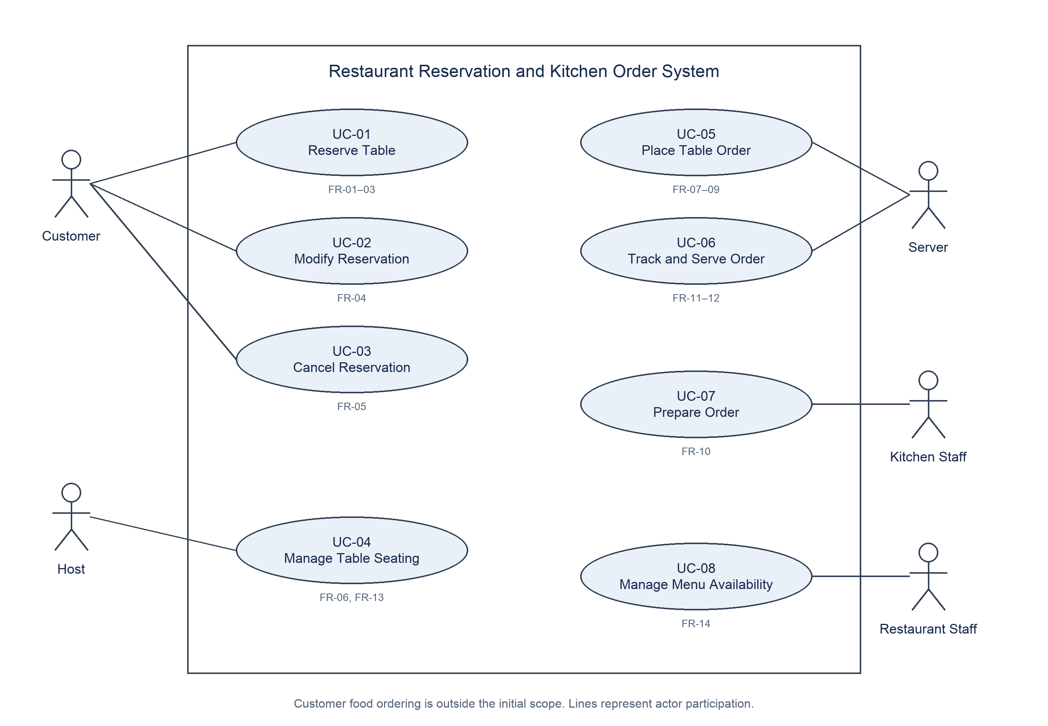

Expanded use case UC-01 Reserve Table
Field | Content
Identifier and name | UC-01 Reserve Table
Primary actor | Customer
Supporting actors | None
Preconditions — what must be true before it starts | The restaurant has configured its tables, capacities, opening hours, and reservation duration. The customer can access the reservation interface.
Trigger — what starts it | The customer chooses to make a table reservation.
Main success scenario — numbered steps | 1. The customer enters a date and party size.  2. The system displays available reservation time slots based on table capacity and existing reservations.  3. The customer selects a time slot and enters contact details.  4. The customer submits the reservation request.  5. The system validates the submitted details and rechecks availability.  6. The system allocates a suitable table for the reservation period without creating an overlapping allocation.  7. The system saves the confirmed reservation and displays its unique confirmation number and reservation details.
Alternative and exception flows | 2a. No suitable table is available: The system displays no available slots. The customer may change the date or party size and return to step 1, or exit without a reservation.  5a. Contact details or party size are invalid: The system identifies the invalid fields. The customer corrects them and returns to step 4; no reservation is created until validation succeeds.  5b. The selected slot is no longer available: The system informs the customer and refreshes availability. The customer returns to step 3 to choose another slot, or exits.  6a. Another request acquires the same table first: The system prevents the overlapping allocation and follows flow 5b.  7a. The reservation cannot be saved: The system reports that confirmation failed and retains no partial reservation or table allocation.
Postconditions — what is true when it succeeds | One confirmed reservation exists with a unique confirmation number, valid contact details, party size, date, time, and table allocation. The allocated table cannot be reserved for an overlapping period.
Requirements realised | FR-01, FR-02, FR-03
Expanded use case UC-05 Place Table Order
Field | Content
Identifier and name | UC-05 Place Table Order
Primary actor | Server
Supporting actors | None. Kitchen staff receive the resulting order through UC-07 Prepare Order.
Preconditions — what must be true before it starts | The server is authorized to enter orders. The dining party is seated at an identified table. Menu items and their current availability are configured.
Trigger — what starts it | The server starts an order for the seated table.
Main success scenario — numbered steps | 1. The server selects the occupied table and starts a new order.  2. The system displays menu items and their current availability.  3. The server selects available items, enters quantities, and adds optional preparation notes.  4. The system displays the draft order with its table number, items, quantities, and notes.  5. The server reviews and submits the order.  6. The system validates the order and rechecks item availability.  7. The system records the submitted order with a unique order identifier and submission time.  8. The system places the order in the kitchen queue with its identifier, table number, items, quantities, notes, and submission time.  9. The system confirms submission to the server.
Alternative and exception flows | 3a. An item is unavailable: The system prevents the item from being added. The server selects another item or continues without it.  5a. The server finds an error during review: The server changes the draft items, quantities, or notes and returns to step 4.  6a. An item became unavailable after it was added: The system rejects submission and identifies the item. The server removes or replaces it and returns to step 4.  6b. The order is empty or has an invalid quantity: The system identifies the problem and leaves the order unsubmitted. The server corrects the draft and returns to step 4.  7a. The order cannot be saved: The system reports failure and leaves the draft unsubmitted; no kitchen queue entry is created.  8a. The kitchen queue cannot accept the order: The system reports submission failure and leaves the order unsubmitted. The server may retry after service is restored; no duplicate queue entry is created.
Postconditions — what is true when it succeeds | One submitted order is associated with the selected table and appears once in the kitchen queue with matching order details. Its initial kitchen status is queued.
Requirements realised | FR-07, FR-08, FR-09

3.5 Requirements to use case traceability

Requirement ID | Use case(s) that realise it | If blank — why, and what you will do
FR-01 | UC-01 Reserve Table | Not applicable — mapped.
FR-02 | UC-01 Reserve Table | Not applicable — mapped.
FR-03 | UC-01 Reserve Table | Not applicable — mapped.
FR-04 | UC-02 Modify Reservation | Not applicable — mapped.
FR-05 | UC-03 Cancel Reservation | Not applicable — mapped.
FR-06 | UC-04 Manage Table Seating | Not applicable — mapped.
FR-07 | UC-05 Place Table Order | Not applicable — mapped.
FR-08 | UC-05 Place Table Order | Not applicable — mapped.
FR-09 | UC-05 Place Table Order | Not applicable — mapped.
FR-10 | UC-07 Prepare Order | Not applicable — mapped.
FR-11 | UC-06 Track and Serve Order | Not applicable — mapped.
FR-12 | UC-06 Track and Serve Order | Not applicable — mapped.
FR-13 | UC-04 Manage Table Seating | Not applicable — mapped.
FR-14 | UC-08 Manage Menu Availability | Not applicable — mapped.

What the matrix revealed, and what you changed because of it:
All 14 functional requirements map to the eight use cases in the diagram; none is unmapped. UC-01 groups availability, confirmation, and overlap prevention (FR-01–03), while UC-05 groups order entry, availability checks, and kitchen submission (FR-07–09). This keeps validation steps within the relevant actor goal instead of adding separate use cases.
The mapping makes table release explicit within UC-04 (FR-13), alongside seating (FR-06), and places both order status viewing and serving within UC-06 (FR-11–12). No additional use cases were needed. UC-01 and UC-05 are expanded in Section 3.4; the other six remain diagram-level use cases for this initial baseline. Sources and workflow assumptions still require team validation before the baseline is agreed.

4 Project Plan
4.1 Team roles and working agreement
Team member | Role for P1 to P2 | How the team makes a decision when it disagrees

4.2 Plan to P2

Date | What will be finished | Owner

4.3 Risks

# | Risk | Likelihood | Impact | Mitigation — action and owner
R1
R2
R3
R4
R5

4.4 Repository and tooling

Type here.

4.5 Declaration of AI tool use

Tool | What it was used for | Who used it | How the output was checked

5 Open Questions

# | The question | Who can answer it | Needed by | What you assumed in the meantime
Q1
Q2
Q3

6 Baseline Declaration

We confirm that the requirements in section 3 represent our agreed baseline as of the submission date, and that every team member has read this document in full.
Team member | Signature or typed name | Date

How P1 Is Marked
P1 is worth 4% of the course grade. Following the syllabus, 80 points are for the shared team artifact and 20 for individual contribution evidence.
Criterion | Points | What full marks look like
Problem, scope and context (1.1, 1.2, 2.1) | 10 | The problem is a problem somebody actually has. The out-of-scope column is filled and the exclusions are justified. The context diagram's boundary matches what sections 2 and 3 claim.
Stakeholders and elicitation (2.2, 2.3) | 10 | Stakeholders include at least one who will never use the system. Every need has a stated basis, and assumptions are labelled as assumptions rather than disguised as findings.
Requirements quality (3.1, 3.2, 3.3) | 25 | Every requirement is one testable “shall” sentence with an identifier, a priority, a source and an acceptance criterion. Quality requirements carry a threshold, a condition and a method. Constraints are distinguished from quality requirements.
Use cases and traceability (3.4, 3.5) | 20 | Use cases are at actor-goal level, not steps. Two are written out in full, including alternative flows. The matrix is complete and the team says what the gaps mean and what they did about them.
Feasibility and plan (2.6, 4) | 10 | Each feasibility verdict is backed by evidence a reader can check. The plan has dates and owners. Risks are future events with actionable mitigations.
Open questions and baseline (5, 6) | 5 | Real open questions, with an owner and a date, and an honest statement of what was assumed in the meantime.
Document quality | — | Guidance boxes removed, sections in order, within the length budget, readable. Marks are deducted here, not awarded.
Individual contribution evidence (0.1) | 20 | Every member's contribution is distinguishable and traceable to something in the repository a reader can open.

