

**TRIBHUVAN UNIVERSITY**

**INSTITUTE OF ENGINEERING**

**PULCHOWK CAMPUS**

A REPORT

ON

FLUID MACHINES

DESIGN OF SPIRAL CASING

BY

Sandip Poudel

SUBMITTED TO

DEPARTMENT OF MECHANICAL AND AEROSPACE ENGINEERING

IOE PULCHOWL CAMPUS

LALITPUR, NEPAL

**Abstract**

The spiral casing is an important component of the Francis and Kaplan hydro turbines. The flow condition of a spiral casing affects the fluid flow around the runner. The shape of the casing is critical for proper flow distribution. This report is hence based on the design of that very component, a spiral casing for a Francis turbine. The spiral casing is designed with its main function in mind: to provide an equal flow rate in all sections. Several different approaches have been used to develop more efficient spiral casings. Given parameters were analyzed and geometric parameters were calculated using SOLIDWORKS, which allowed for easy design modification. The designs were then tested and verified in ANSYS, and suitable modifications were made to improve the final design.

**Acknowledgement**

We are grateful to our lecturer Mr. Neeraj Adhikari for this opportunity to explore our ability to design a component, in this case spiral casing of Francis turbine, based on given parameters and to learn about operations and simulations through application of CAD and CAE software namely SOLIDWORKS and ANSYS. This project provided an excellent learning opportunity for which we feel indebted to and for his overall guidance and instructions as a teacher.

**Table of Contents**

1. **Introduction…………………………………………………………………..1**  
   1.1. Objective  
   1.2. Theory
2. **Methodology………………………………………………………………….3**
3. **Design and Calculations……………………………………………………..4**3.1. Design Theory
4. Constant Circulation Method
5. Design Using Past Research

3.2. Stay Vanes  
3.3. Calculations

1. **Simulation Setup……………………………………………………………10**4.1. Mesh Controls  
   4.2. Boundary Conditions  
   4.3. Solver Parameters
2. **Initial Results………………………………………………………………..12**
3. **Design with Stay Vanes……………………………………………………..15**
4. **Final Design…………………………………………………………………19**
5. **Conclusion…………………………………………………………………...23**
6. **References…………………………………..……………………………….24**

**1. INTRODUCTION**

**1.1 Objectives**

* The overall objective of this report is to study the spiral casing for Francis turbine: its design and simulation.
* To determine the geometrical parameters i.e., dimensions of the casing as per the given parameters.
* To learn about the operation and uses of SOLIDWORKS and ANSYS

**1.2 Theory**

SolidWorks is a computer-aided design (CAD) and computer-aided engineering (CAE) program for solid modeling that covers the entire design process, from design and validation to technical communications and data management. It is a solid modeler that creates models and assemblies using a parametric feature-based approach. It is the market leader in 3D CAD technology, providing product design teams with intuitive, high-performance software that is simple to use and allows them to freely design products.

ANSYS is a general-purpose engineering simulation software that predicts how product designs will behave in real-world environments. ANSYS generates simulated computer models of machine components, fluid (Computational Fluid Dynamics), electronics, and structures, among others, for the purpose of simulating various properties such as fluid flow, strength, toughness, electromagnetism, pressure distribution, and so on. The importance of ANSYS stems from the fact that it allows one to predict how an experiment will work computationally without actually performing it in real life. This assists in identifying flaws before performing them in real life, which can save a lot of resources.

Turbine

A turbine is a machine that converts the kinetic energy of fluids into mechanical energy via a designed mechanism. The turbine is made up of several blades that are connected to an axle that is used to drive a generator. The turbine's basic operation is that the moving fluid (e.g., steam, water, gas, etc.) rotates the turbine's blades, which in turn rotates the axle, which is connected to a device that uses the rotational energy for the required use.

A water turbine is the Francis turbine. It is a reaction turbine with inward flow that combines radial and axial flow concepts. Water enters the turbine radially with respect to the shaft and is discharged axially. 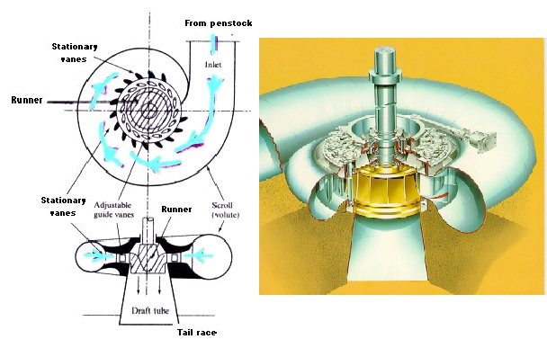

*Fig.1. Francis Turbine Working Mechanism*

Spiral casing is a closed passage with a decreasing cross-sectional area along the flow direction. Casing's purpose is to provide an even distribution of water around the circumference of the runner while maintaining an approximately constant velocity of water. Depending on the pressure applied, the casing is made of cast steel, plate steel, or concrete.

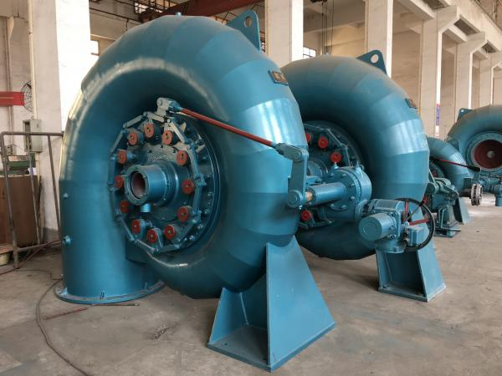

*Fig.2. Spiral casing*

**2.** **METHODOLOGY**

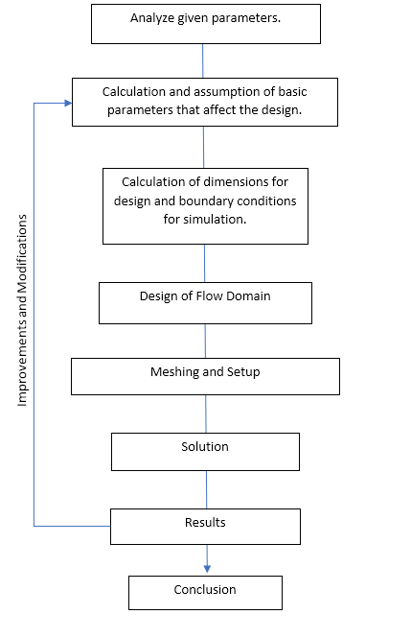

**3. DESIGN AND CALCULATIONS**

**3.1 Design Theory**

The design of spiral casing is done based on its main function, to provide equal flow rate in all the sections. Several approaches have been used to design more efficient spiral casings. Flow distribution in the runner is only uniform when flow is uniform in the vanes. The spiral casing ensures that the flow in the vanes is uniform. The casing design is determined by the runner's flow and pressure conditions. Since we were given a certain set of parameters to work with in mind. Using them basic parameters that affect the design were calculated and also some parameters were assumed as required. Commonly used shapes of sections are circular, rectangular, and trapezoidal.

Some methods used to design spiral casing are:

1. **Constant Circulation Method**

This method is based on the law of constant velocity moment.

This design process revolves around providing the required flow profile in the vanes. The inlet flow is transformed into inward radial (Cm) and tangential (Cu) flow. For the circular section, the radius of each circular section is determined with the help of circulation Ct.

i.e. Cu. R = Ct = constant.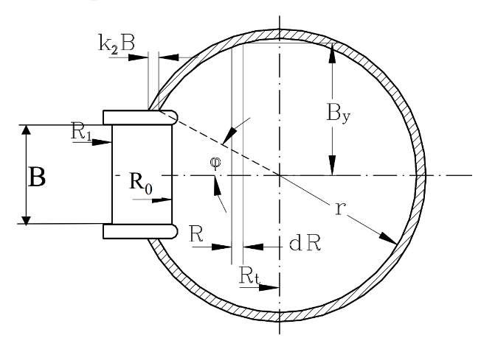

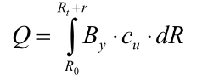

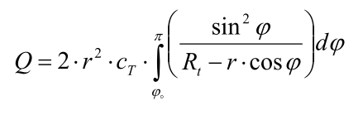

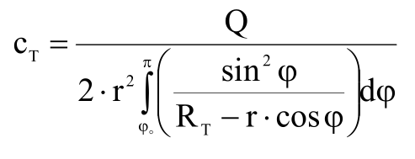 *Fig.3. Circular Cross Section of Spiral Casing*

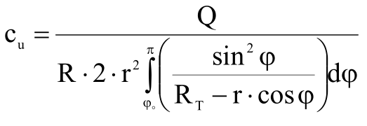

This method is an iterative process in which each section area is determined by computing the available flow at each section after reducing the flow distributed in the previous section to maintain the constant circumferential velocity.

1. **Design using Past Research**

These methods are developed through research and testing, so the entire geometry can be determined through Charts or Formulae using common parameters. A research by F. de Siervo and F. de Leva studies the correlation between commonly used design parameters and shows high degree of uniformity in spiral casing design. The graphs obtained are used to develop formulae to determine the geometry for spiral casing of required parameters.

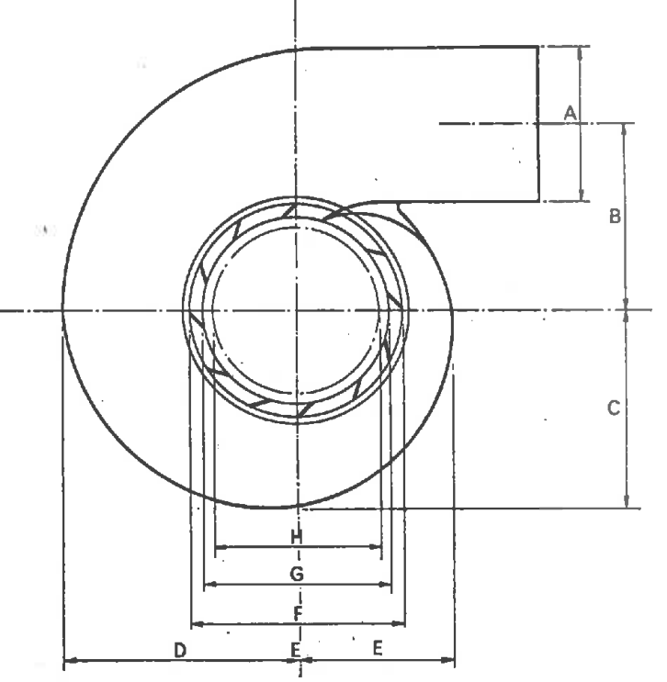

*Fig.4. Spiral Casing dimensions with parameters to be determined*

From this study, all design parameters can be determined using specific speed and runner discharge diameter.

In case of spiral casing with circular cross-section, they should be designed in sections to be manufacturable.

**3.2 Stay Vanes**

Stay Vanes are designed to follow the path of free vortex flow of spiral casing such that the flow is not disturbed. The inlet and outlet angles of stay vanes determine the blade profile. The length and thickness are chosen according to the force experienced by it.

L=Fmax/(σ*t s*Z s)

Fmax is maximum force due to water head

σ is the allowable stress on guide vane

t s is the thickness of stay vane

Z s is the number of stay vanes

Thick stay vanes will disturb the flow and decrease flow area, so optimal blade thickness should be chosen. For best efficiency, the number of stay vanes should be equal to the number of guide vanes.

For optimal shape of tongue and angle of stay vanes, decomposition method can be used so it follows stream surface of velocity field calculated by optimal circulation. In this case, the flow will attack guide vanes as smoothly as possible, minimizing losses.

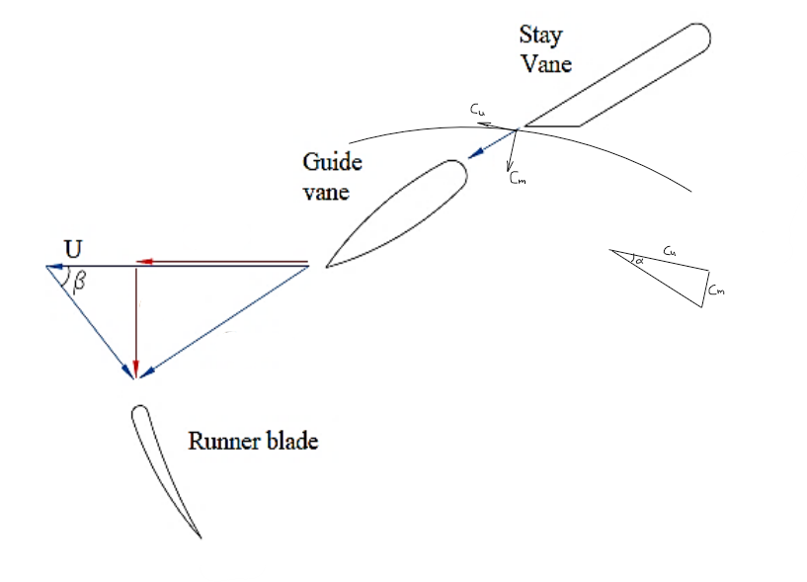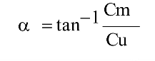

*Fig.5. Stay vane angle*

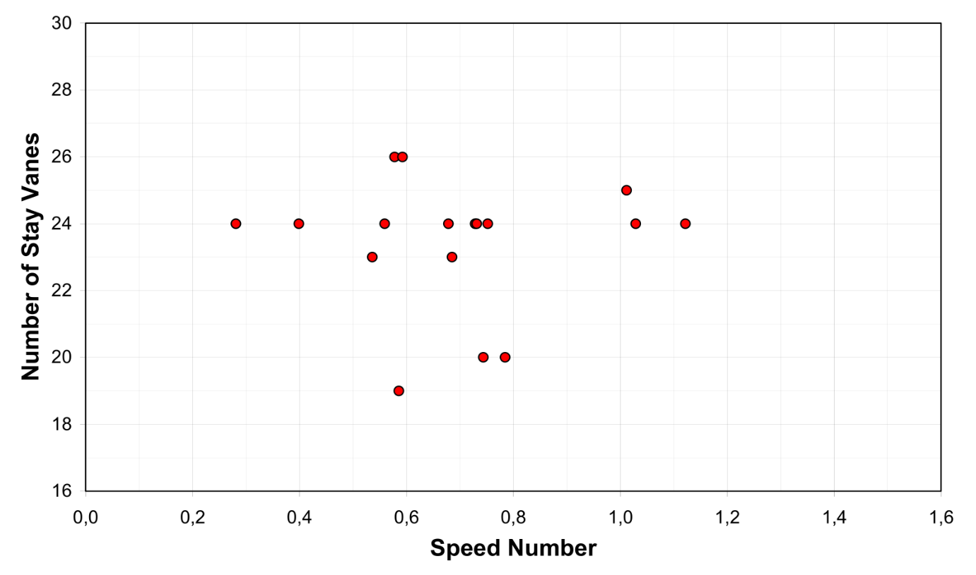

*Fig.6. Chart to calculate number of stay vanes*

**3.3 Calculations**

Given Parameters:

Q=50m3/s

H=150m

N=333.33 RPM

Assumptions and Basic Calculations for Runner:

|  |  |
| --- | --- |
| Vane Thickness Factor  kt = 0.95 |  |
| Flow Ratio  kf = 0.2 | Range: 0.15-0.3 |
| Speed Ratio  n = 0.25 | Range: 0.1-0.45 |
| Overall Efficiency  ɳ = 0.90 |  |

Shaft Power, P = ɳ* ρ *g *Q *H = 66217.5 KW

Static Pressure = ρ*g*H = 1471500 Pa

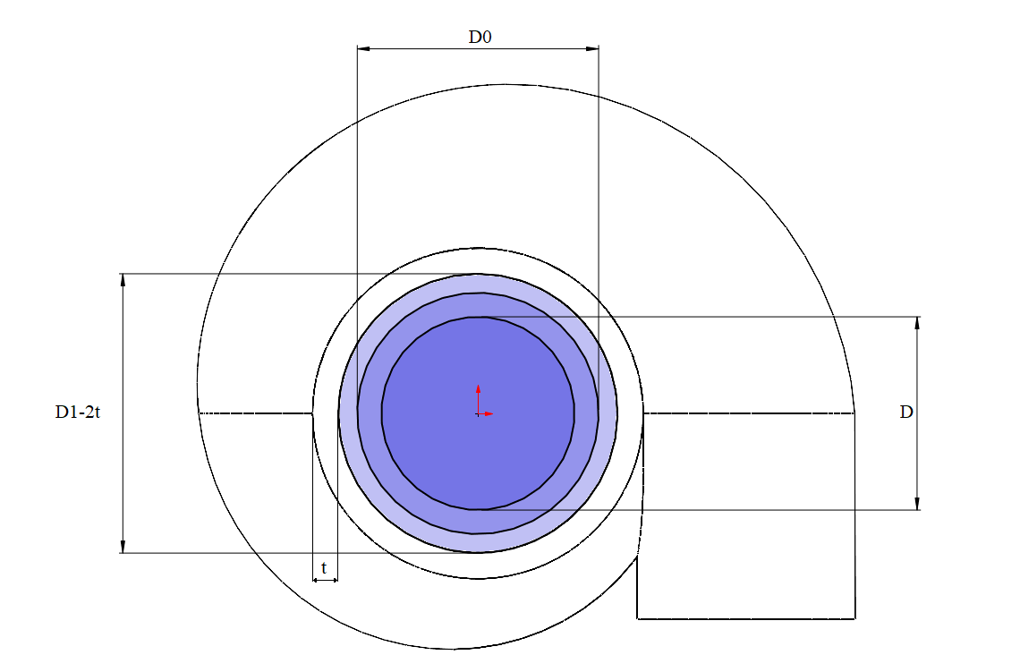

*Fig.7. Basic Geometry*

Specific Speed, Ns = N*P1/2/H5/4 = 163.398 kW min-1 m

Calculation of Speed Number:

ω = 2* π*n/60 = 34.9062

ω’ = ω /(2gH)1/2 = 34.9062 / (2*9.81*150)1/2 = 0.6434

Q’ = Q /(2gH)1/2 = 50 / (2*9.81*150)1/2 = 0.9217

Ω = ω’*(Q’)1/2 = 0.6177

Number of Guide Vanes = 20

Calculation of geometric parameters were done through SOLIDWORKS equations, which allows modification of the design easily by modifying the values of variables.

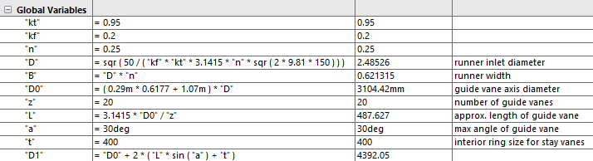

Since the length of the guide vane is longer towards the inlet than outlet, the calculated dimension also includes clearance between guide vanes and stay vanes.

The center of the circular cross section of the spiral casing is defined by Spiral Curve of SOLIDWORKS. The pitch of this spiral affects each cross section and diameter of penstock, so design can easily be modified if required.

For spiral of pitch 1.5 m,

Penstock Diameter = 3.0712 m

Penstock Area = 7.4072 m2

Penstock Velocity = Q/A = 6.75 m/s

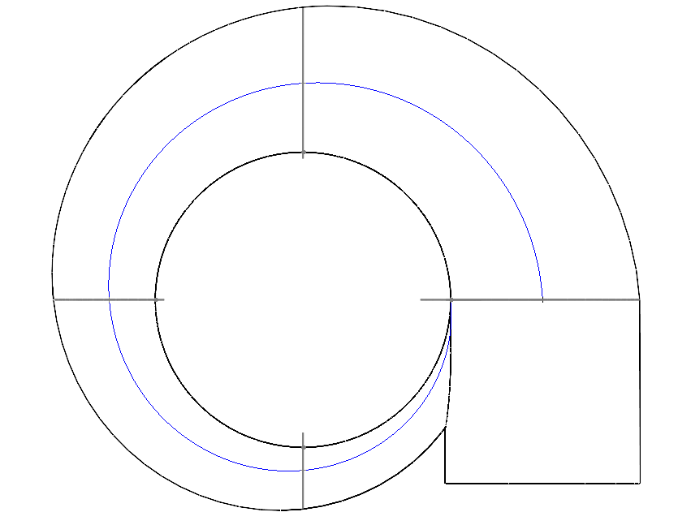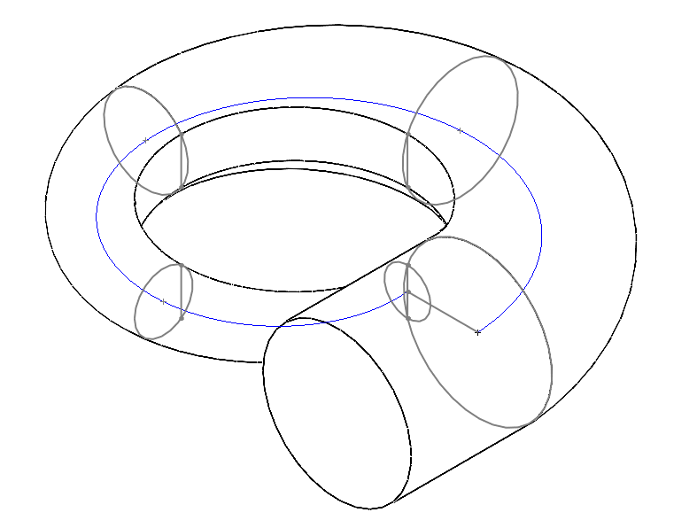

*Fig.8. Cross-Section defined by spiral and circles*

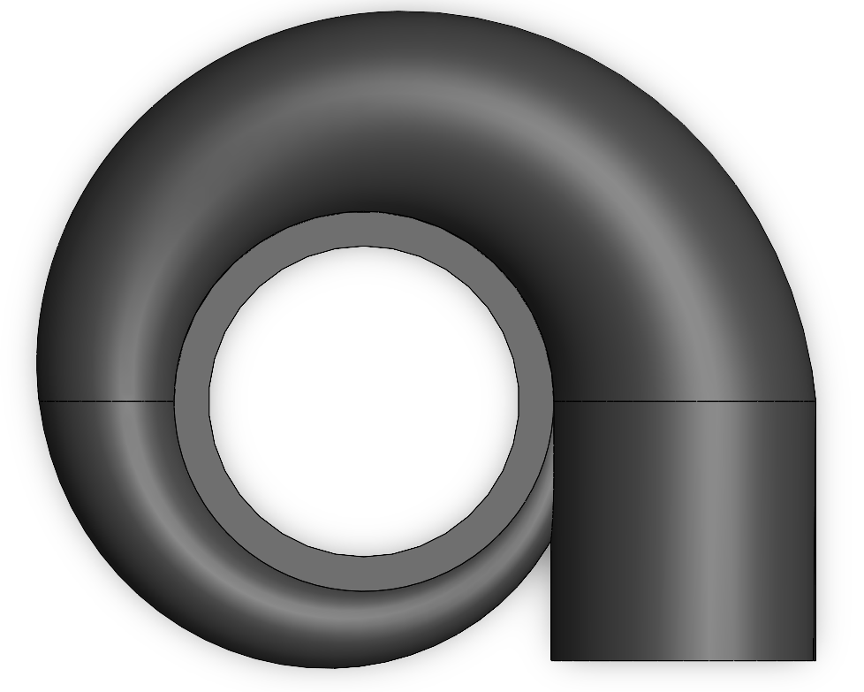

*Fig.9. Design of Flow Domain*

**4. Simulation Setup**

**4.1Mesh Controls:**

Body Sizing 100mm – Whole Body

Body Sizing 30mm – Sphere of Influence 2300mm from center

Face Sizing 75mm – Inlet Face

Edge Sizing 25mm – Edge reconnecting the Smallest Cross-section

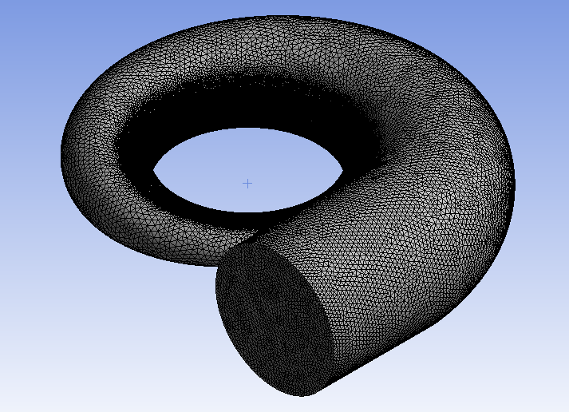

*Fig.10. Mesh of Flow Domain*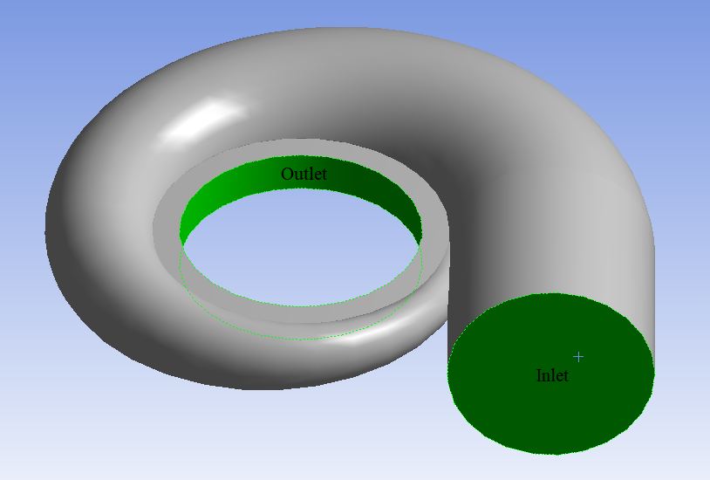

*Fig.11. Named Selections*

The inlet and outlet named selections were defined as shown, rest of the faces were named as walls.

**4.2 Boundary Conditions:**

Walls: No Slip

Inlet:

Velocity Magnitude = 6.75m/s

Initial Gauge Pressure = 1471500 Pa

Outlet:

Gauge Pressure = 1471500 Pa

Material Type: water-liquid (from Fluent Database)

**4.3 Solver Parameters:**

For solving the setup, ANSYS 2019R3 Fluent was used. SST k-omega model was chosen for all simulations in this study due to convergence problem with k-epsilon model. The number of iterations were changed to 1000, and after the mesh, materials and boundary conditions were checked, solution was calculated.

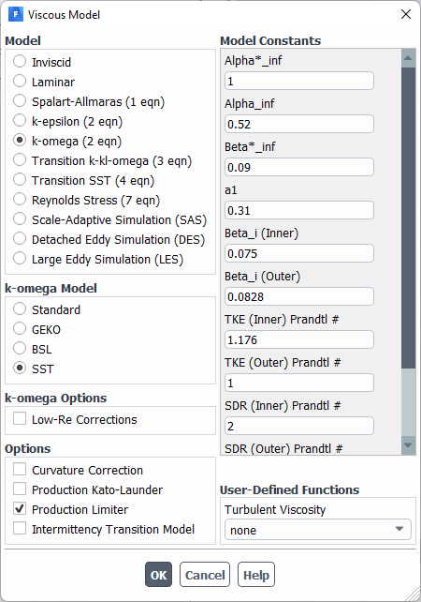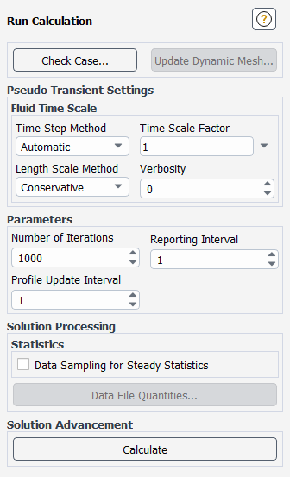

Fig.12. Solver Settings

**5. Initial Results**

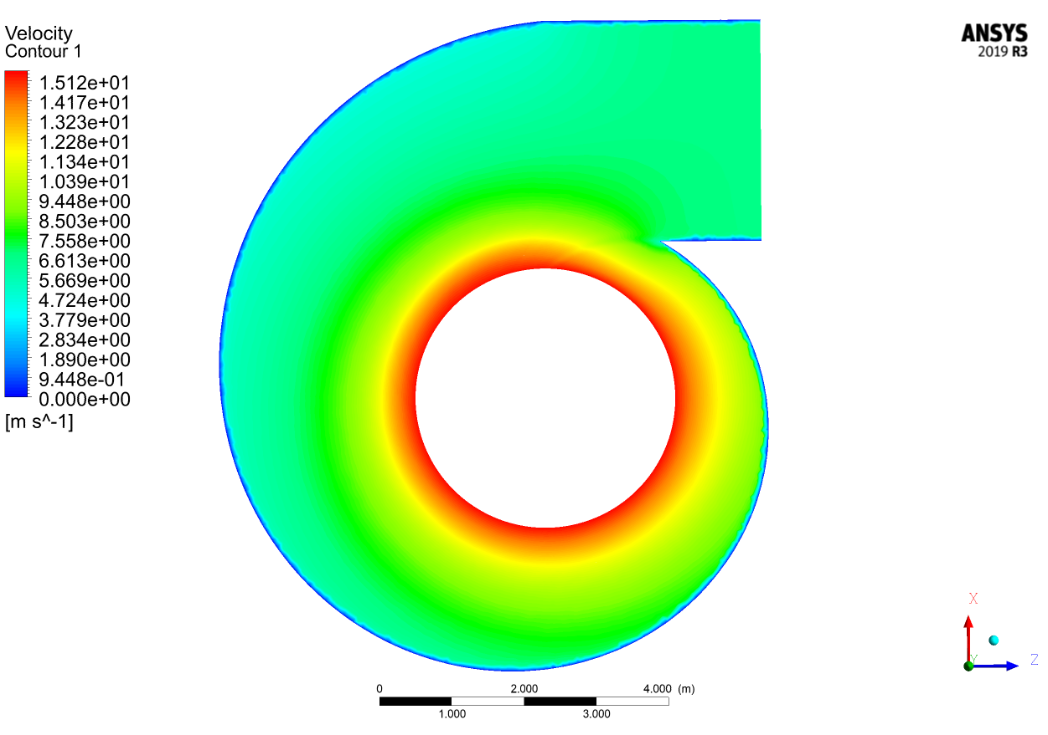

*Fig.13. Velocity Contours*

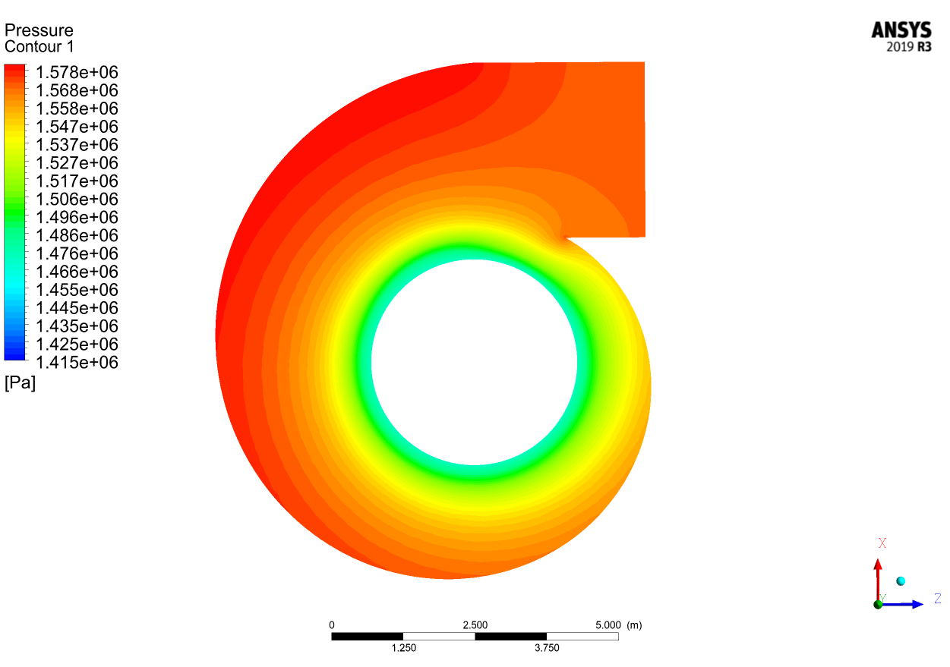

*Fig.14. Pressure Contours*

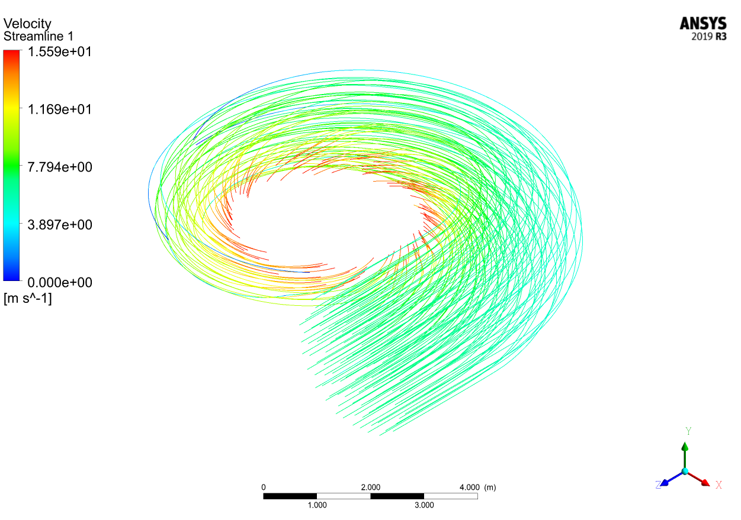

*Fig.15. Streamlines*

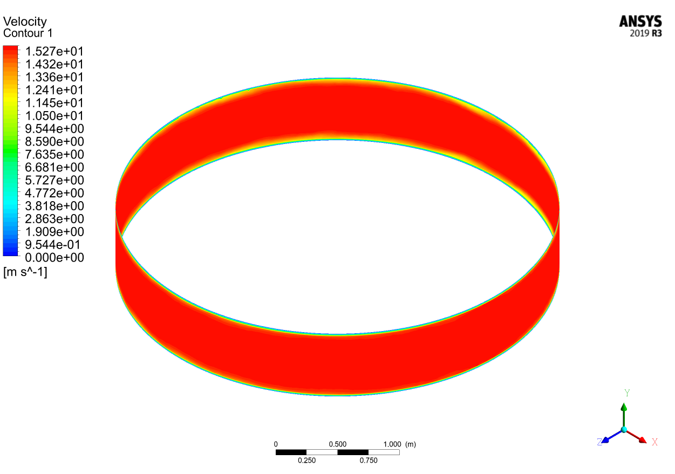*Fig.16. Velocity Contours at Outlet*

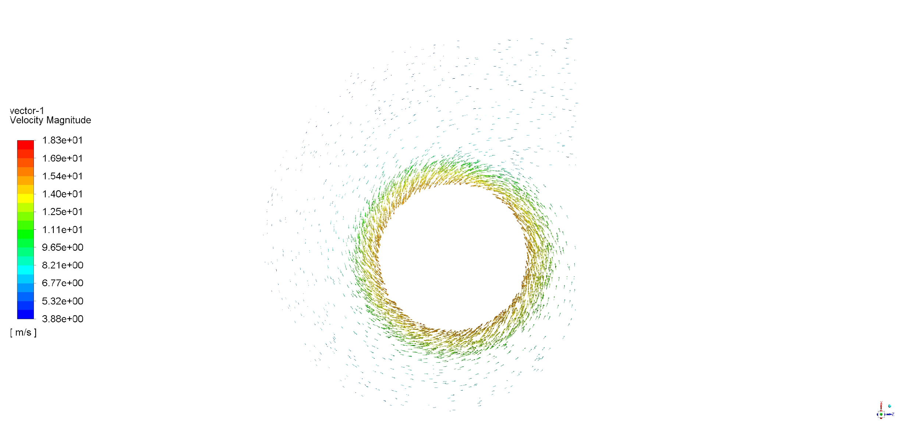

*Fig.17. Velocity Vectors*

This design without stay vanes was made to study the flow characteristics so proper guide vanes can be designed. The flow appears to behave as expected, providing uniform velocity at the outlet, but there is some unwanted recirculation which can reduce efficiency of the turbine.

**6. Design with Stay Vanes**

The previous results obtained were used to design stay vanes. Using point monitors of X and Z components of velocity in inlet of stay ring, the required inlet angle for guide vanes was obtained. 12 simple stay vanes of were designed to approximately provide 15° inlet flow angle to the guide vanes.

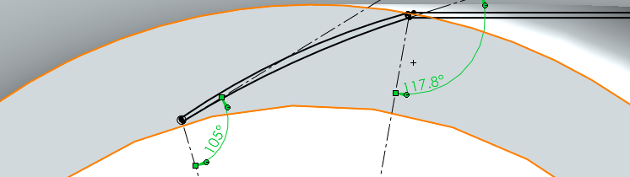

*Fig.18. Blade Profile for Stay Vanes*

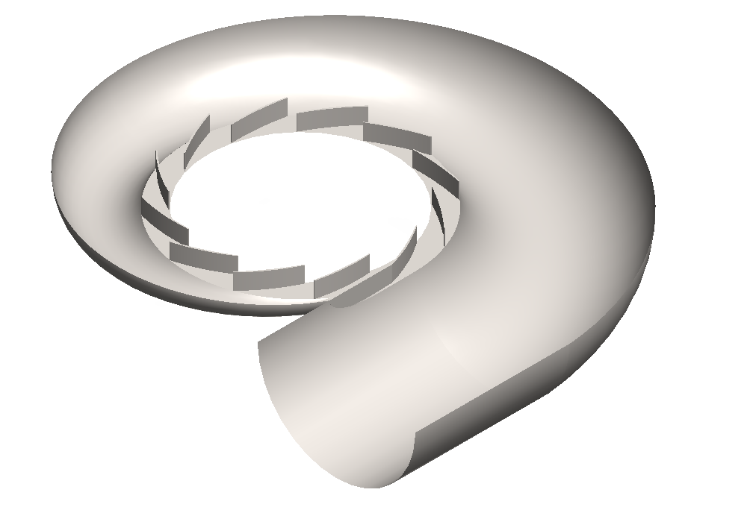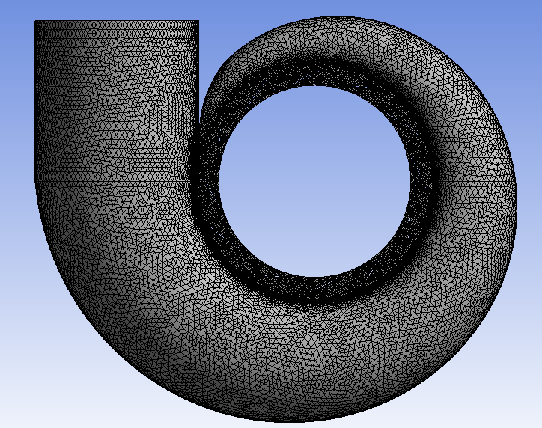

*Fig.19. Section View and Mesh*

The boundary conditions, mesh controls and solver parameter used for this simulation is same as before with only inclusion of guide vanes.

**Results**

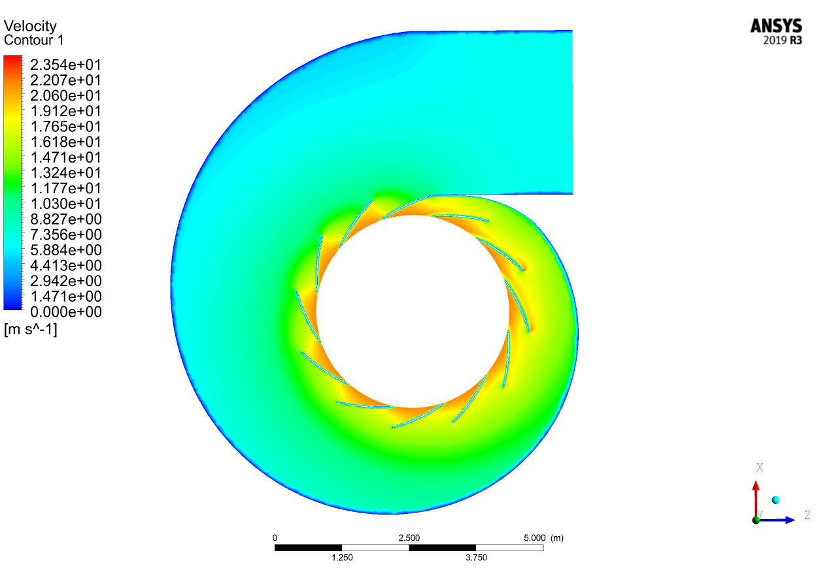

*Fig.20. Velocity Contours*

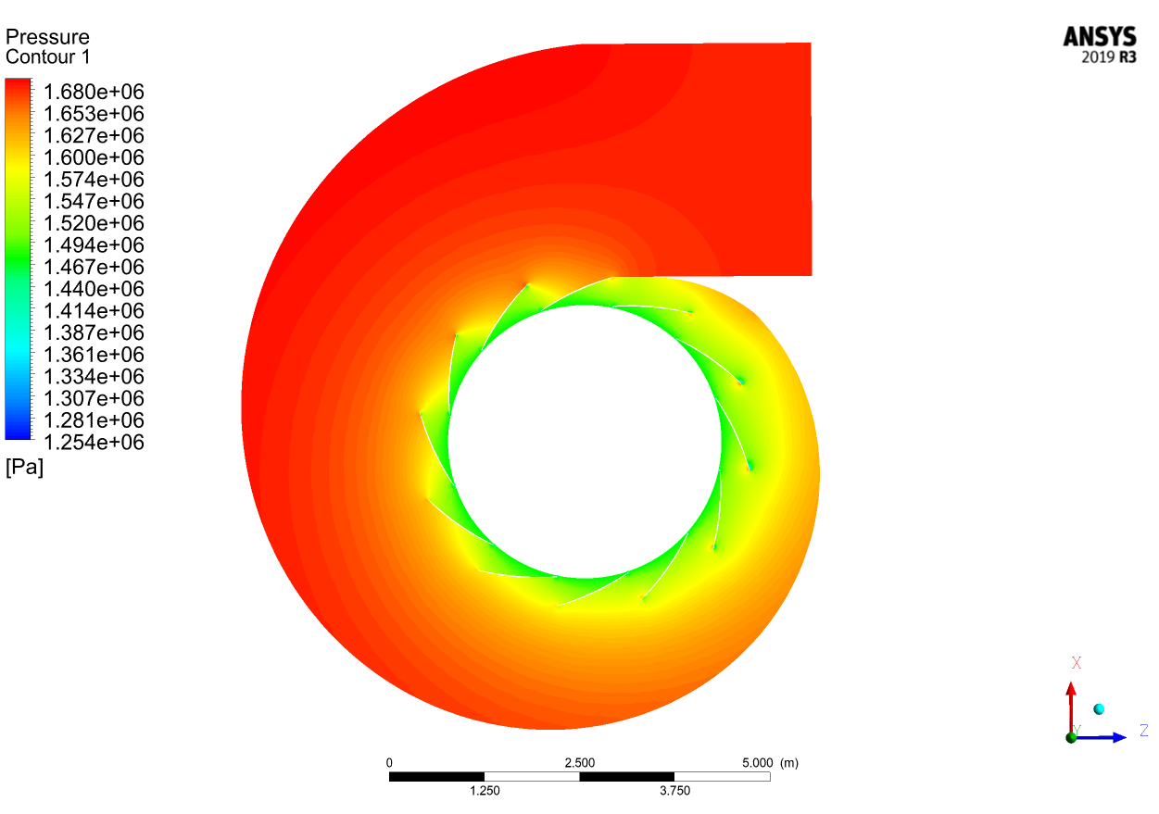

*Fig.21. Pressure Contours*

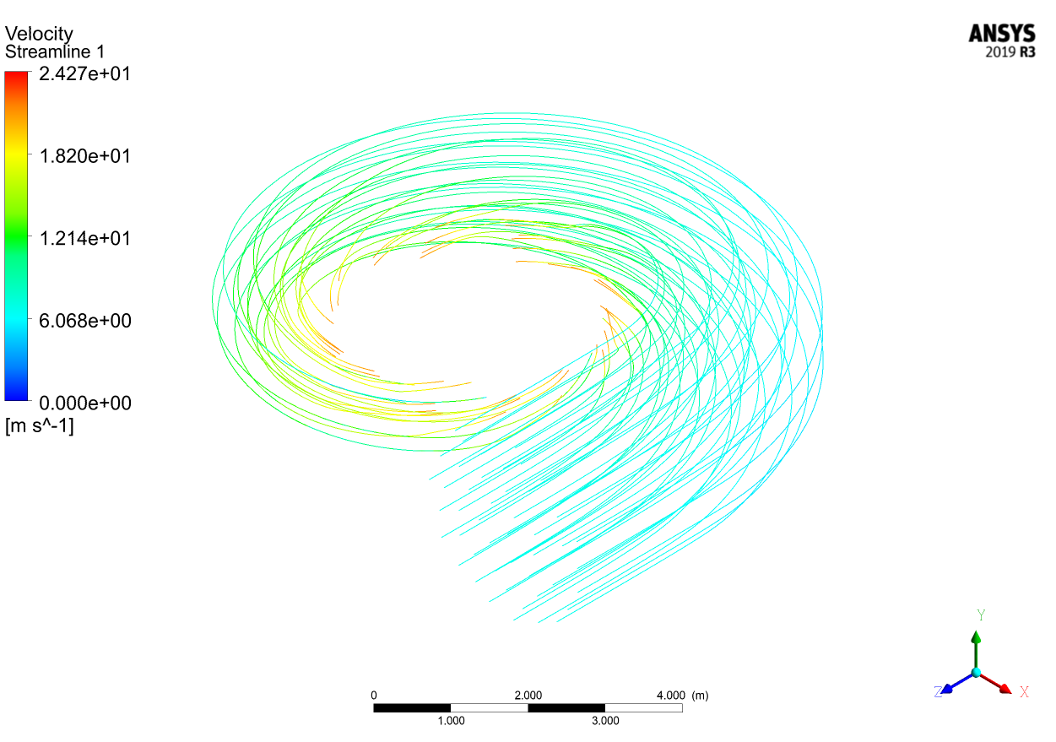

*Fig.22. Streamlines*

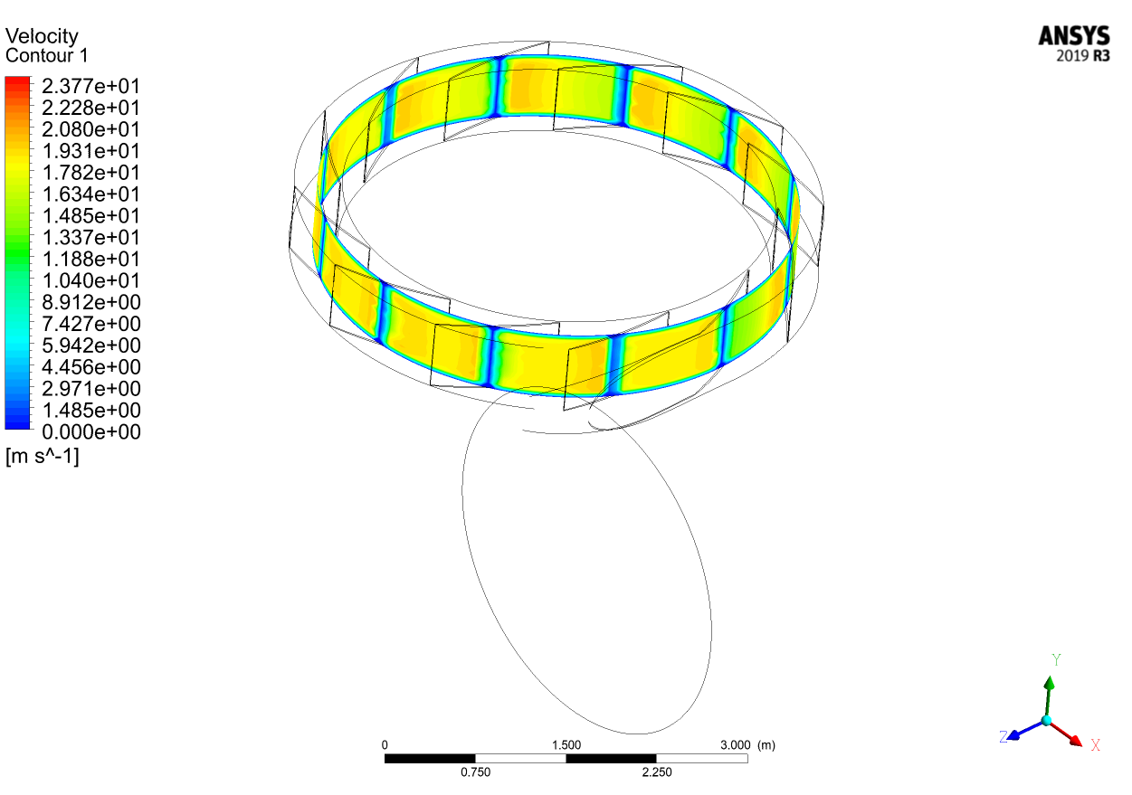

*Fig.23. Velocity Contours at a section between Stay Vanes*

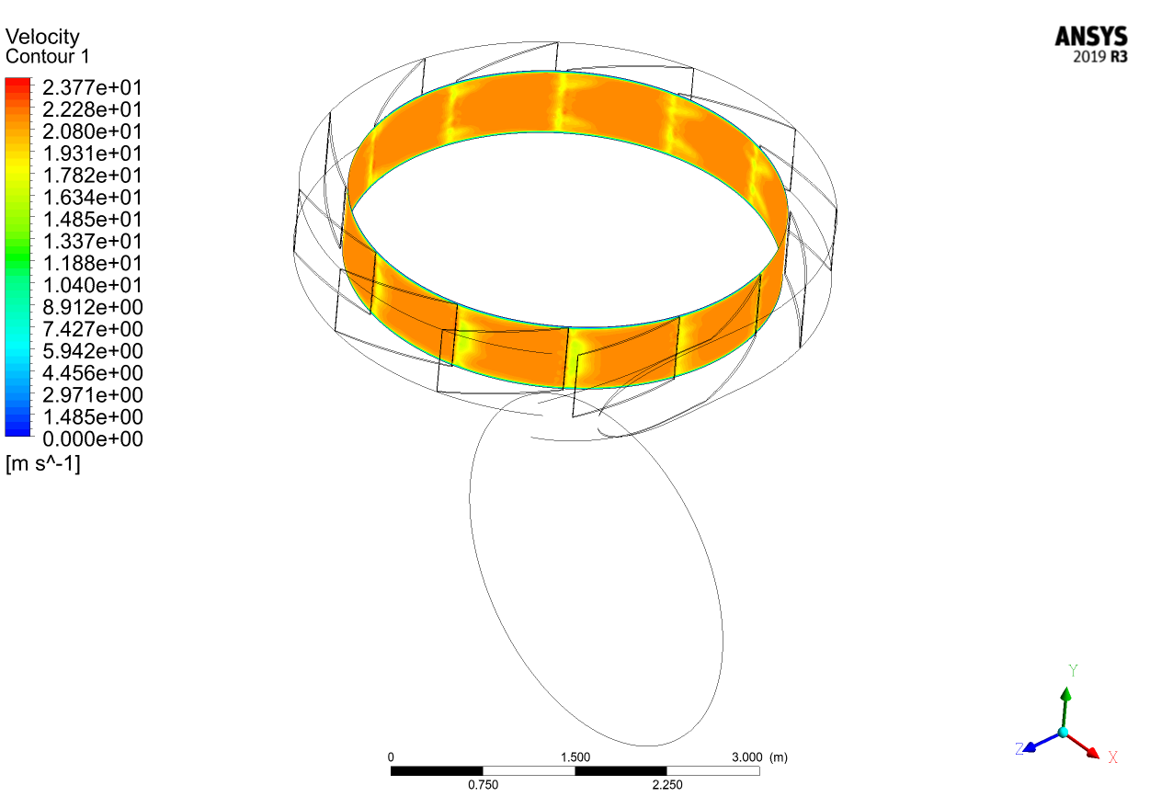

*Fig.24. Velocity Contours at Outlet*

With the inclusion of guide vanes, flow is guided to the outlet properly, giving a uniform velocity profile across all sections. It is noticed that the static pressure is not uniformly distributed around the guide vanes. This design can be improved by modifying the values of parameters kf, n and the angle of stay vanes.

**7. Final Design**

The target of this design is to provide more uniform pressure distribution around the stay vanes and to eliminate lower pressure region in the smallest part of the casing. Using information from previous results and literature review, we get the following design.

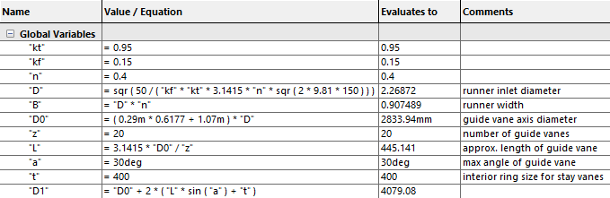

|  |  |
| --- | --- |
| Penstock Diameter | 2.94439 m |
| Penstock Velocity | 7.3483 m/s |
| Runner Inlet Diameter | 2.26872 m |
| Runner Inlet Width | 0.907489 m |
| Stay Vane Inlet Angle | 20° |
| Stay Vane Outlet Angle | 15° |
| Stay Ring Size | 0.4 m |
| Number of Stay Vanes | 12 |
| Diameter of Circle Defining the Spiral Curve | 4.07908 m |

*Table. Final Parameters Calculated*

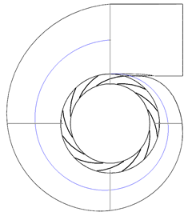

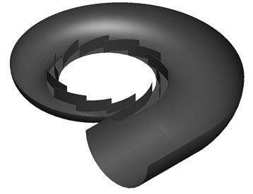

*Fig.25. Final Design of Spiral Casing with Guide Vanes*

**Simulation Setup**

Mesh Controls:

Body Sizing 100mm – Whole Body

Body Sizing 25mm – Sphere of Influence 2300mm from center

Face Sizing 50mm – Inlet Face

Face Sizing 25mm – Face Separating Spiral from Penstock

Boundary Conditions:

Walls: No Slip

Inlet:

Velocity Magnitude = 7.3483 m/s

Initial Gauge Pressure = 1471500 Pa

Outlet:

Gauge Pressure = 1471500 Pa

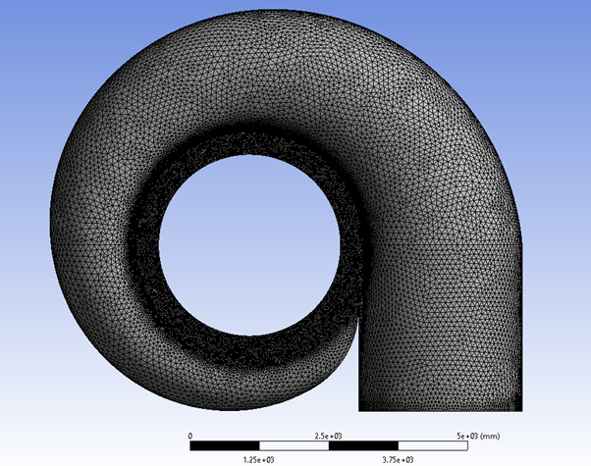

*Fig.26. Mesh of Flow Domain*

**Results**

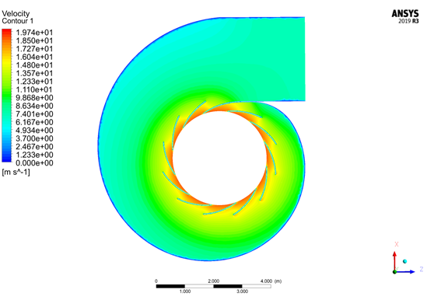

*Fig.27. Velocity Contours*

*Fig.28. Pressure Contours*

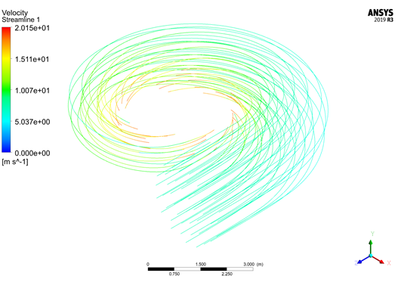

*Fig.29. Streamlines*

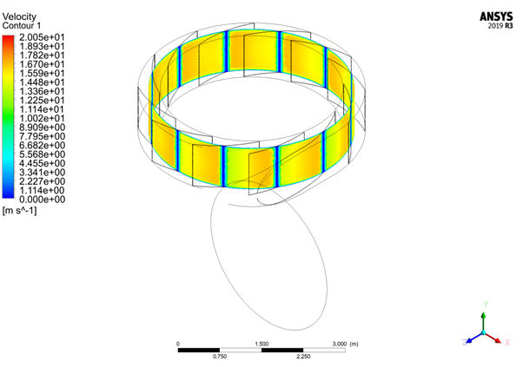

*Fig.30. Velocity Contours at a section between Stay Vanes*

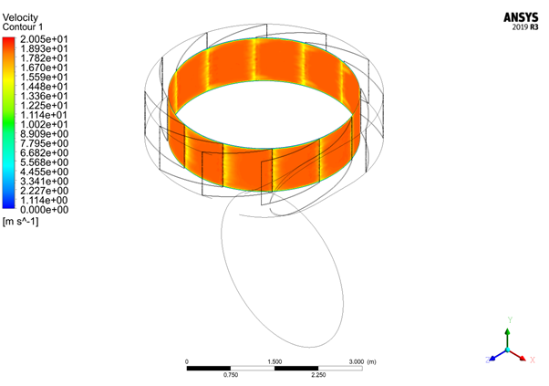

*Fig.31. Velocity Contours at Outlet*

**8. CONCLUSION**

Hence, spiral casing for Francis Turbine with circular cross section was designed as per the given parameters (head, flow rate and runner speed). The given parameters were analyzed, and geometric dimensions were calculated using SolidWorks equations (using completely spiral geometry). Using the obtained results an initial design of spiral casing was developed in SolidWorks

The computational fluid dynamics analysis of the flow in the spiral casing was done in ANSYS. Initially without guide vanes the flow had a uniform velocity profile at the outlet, but some unwanted re-circulations were observed. Introduction to guide vanes resulted in uniform velocity distribution at the outlet and removed the unwanted recirculation but the static pressure distribution was not uniform at the vanes. With slight modification in design, uniform pressure distribution was obtained. Comparing with studies by other researchers, the fully spiral geometry used in this design is more suitable for high head applications. For design of spiral casing to be more efficient, iterative optimization methods should be used to calculate geometry at specified conditions.

For the stay vanes, proper blade profile and thickness should be chosen according to material used and forces experienced by them. The design of tongue needs to be optimized to ensure equal flow angle for each guide vanes.

This fulfilled the basic objective of designing a spiral casing i.e., distribution of water equally around Stay vanes in order to obtain uniform flow in the runner.

**9. REFERENCES**

[1] Rajput, R.K., (1998), Fluid Mechanics and Hydraulic Machines, S. Chand, New Delhi, India.

[2] D.R.Dahal, S.Chitrakar, A.Kapali, B.S.Thapa and H.P.Neopane, “Design of Spiral Casing of Francis Turbine for Micro Hydro Applications”, Journal of Physics: Conference Series, vol. 1266, 2019, Article number 012013.

[3] L. Wang and D. Wei, “The Optimum Structural Design for Spiral Case in Hydraulic Turbine,” Procedia Eng., vol. 15, pp. 4874–4879, Jan. 2011

[4] de Siervo, F., & de Leva, F. (1976). “Modern trends in selecting and designing Francis turbines”, Water Power and Dam Construction 28(8), 28–35.

[5] C. A. Sánchez-Ríos, J. Graciano-Uribe, S. Vélez García, and D. A. Hincapié-Zuluaga, "Comparative analysis between a discrete spiral chamber and a continuous spiral chamber via ansys", Tecciencia, vol. 12, no. 23, pp. 25-32, 2017. DOI: 10.18180/tecciencia.2017.23.4.

[6] Trivedi C., Cervantes M.J. State of the art in numerical simulation of high head francis turbines Renew. Energy Environ. Sustain., 1 (20) (2016)