Steps :-
1) Fine tuning in api.testleaf.com

Create a Fine tuning dataset
1) Extract the Zip Folder -leaftaps.zip
2) Import the leaftaps folder in VS code
3) Change the input and output path (src/main/framwork/converter/TrainingDataConverter.java)
4) Run the java program
5) Check for the data in the training folder in jsonl format
future Create a new dataset for create lead

2) Fine tuning in api.testleaf.com
1) Prepare jsonl file with the converter (Create a new training data for createlead)
2) Go to api.testleaf.com ---Menu --Storage --upload the dataset (copy the file id -
file-R3jftEJrhj2fSMbATZr8k9)
3) Go to Finetuning menu
select existing data(File ID will be populated)
Learning multiplier-0.1 or 0.2
Epochs -4 or 5
Copy the Fine tuned model
ft:gpt-4o-mini-2024-07-18:testleaf-2::DiZlHRx7
4)Generate the Key (api.testleaf.com)

Import the training files and Leaftaps code and update the paths for input and output files

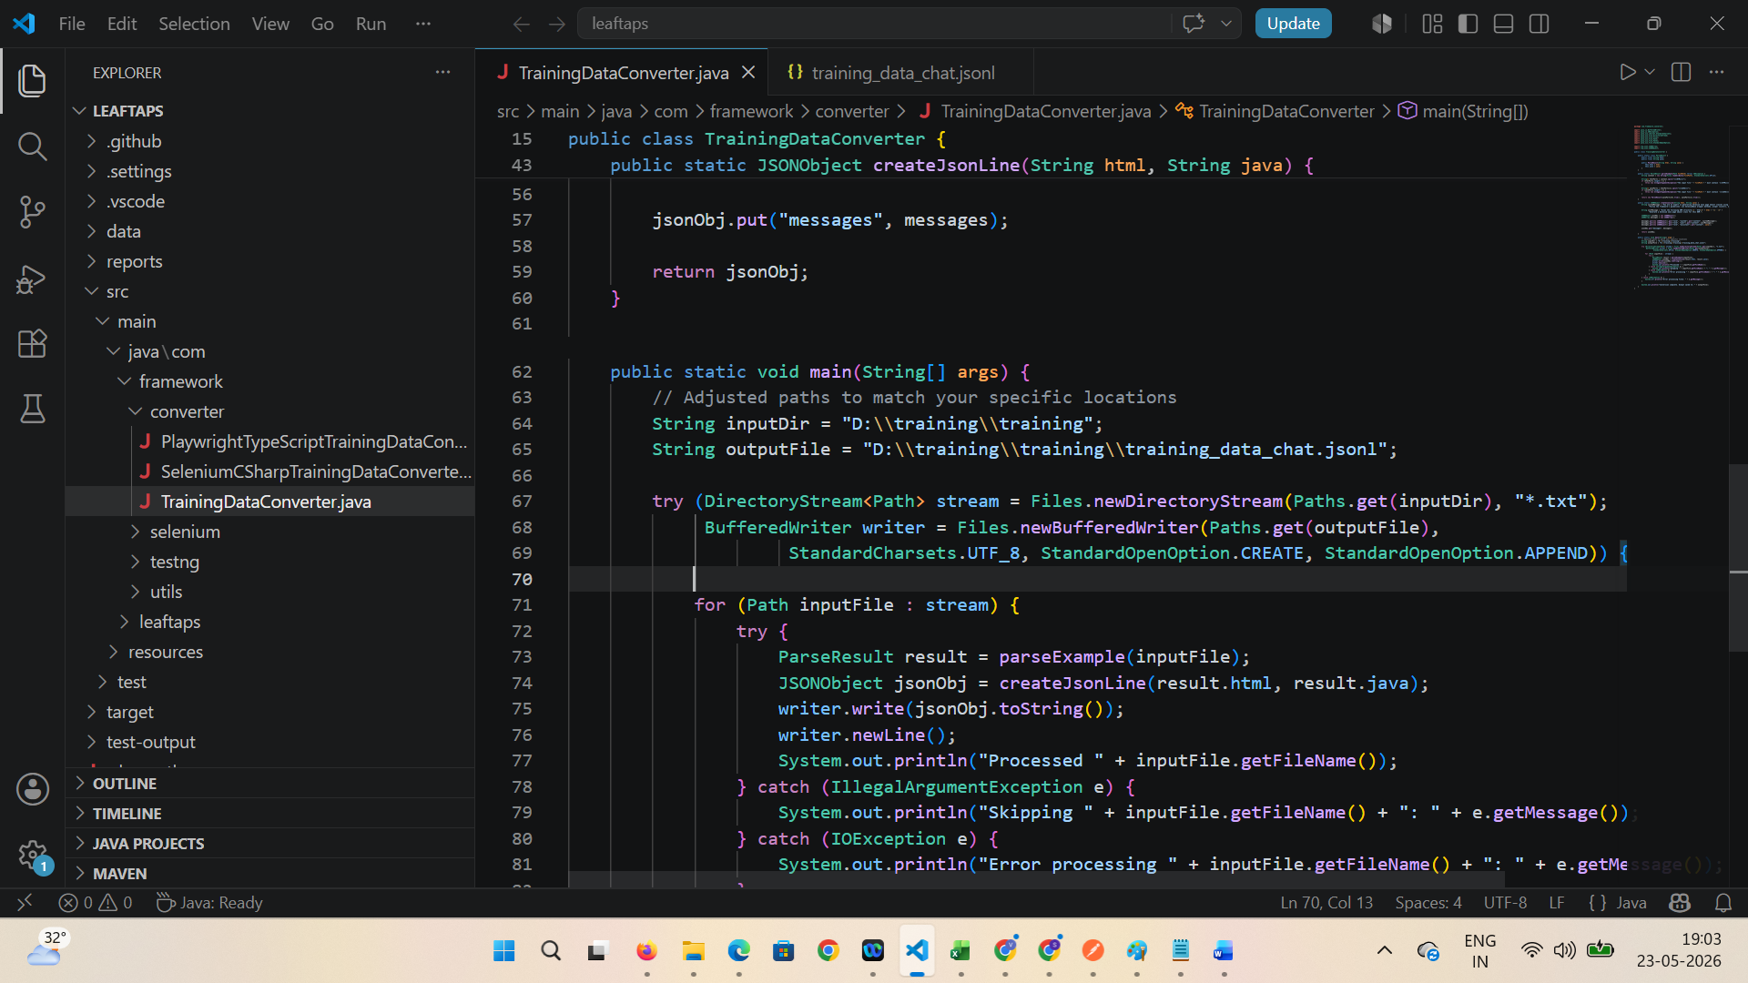

Run the java code and verify output jsonl file is created
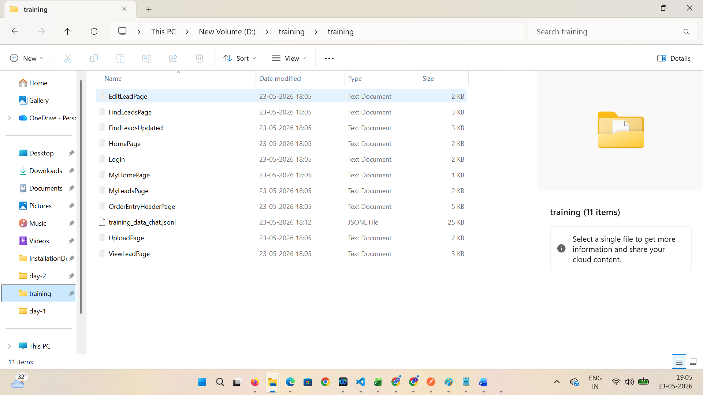

Upload this jsonl file to Storage
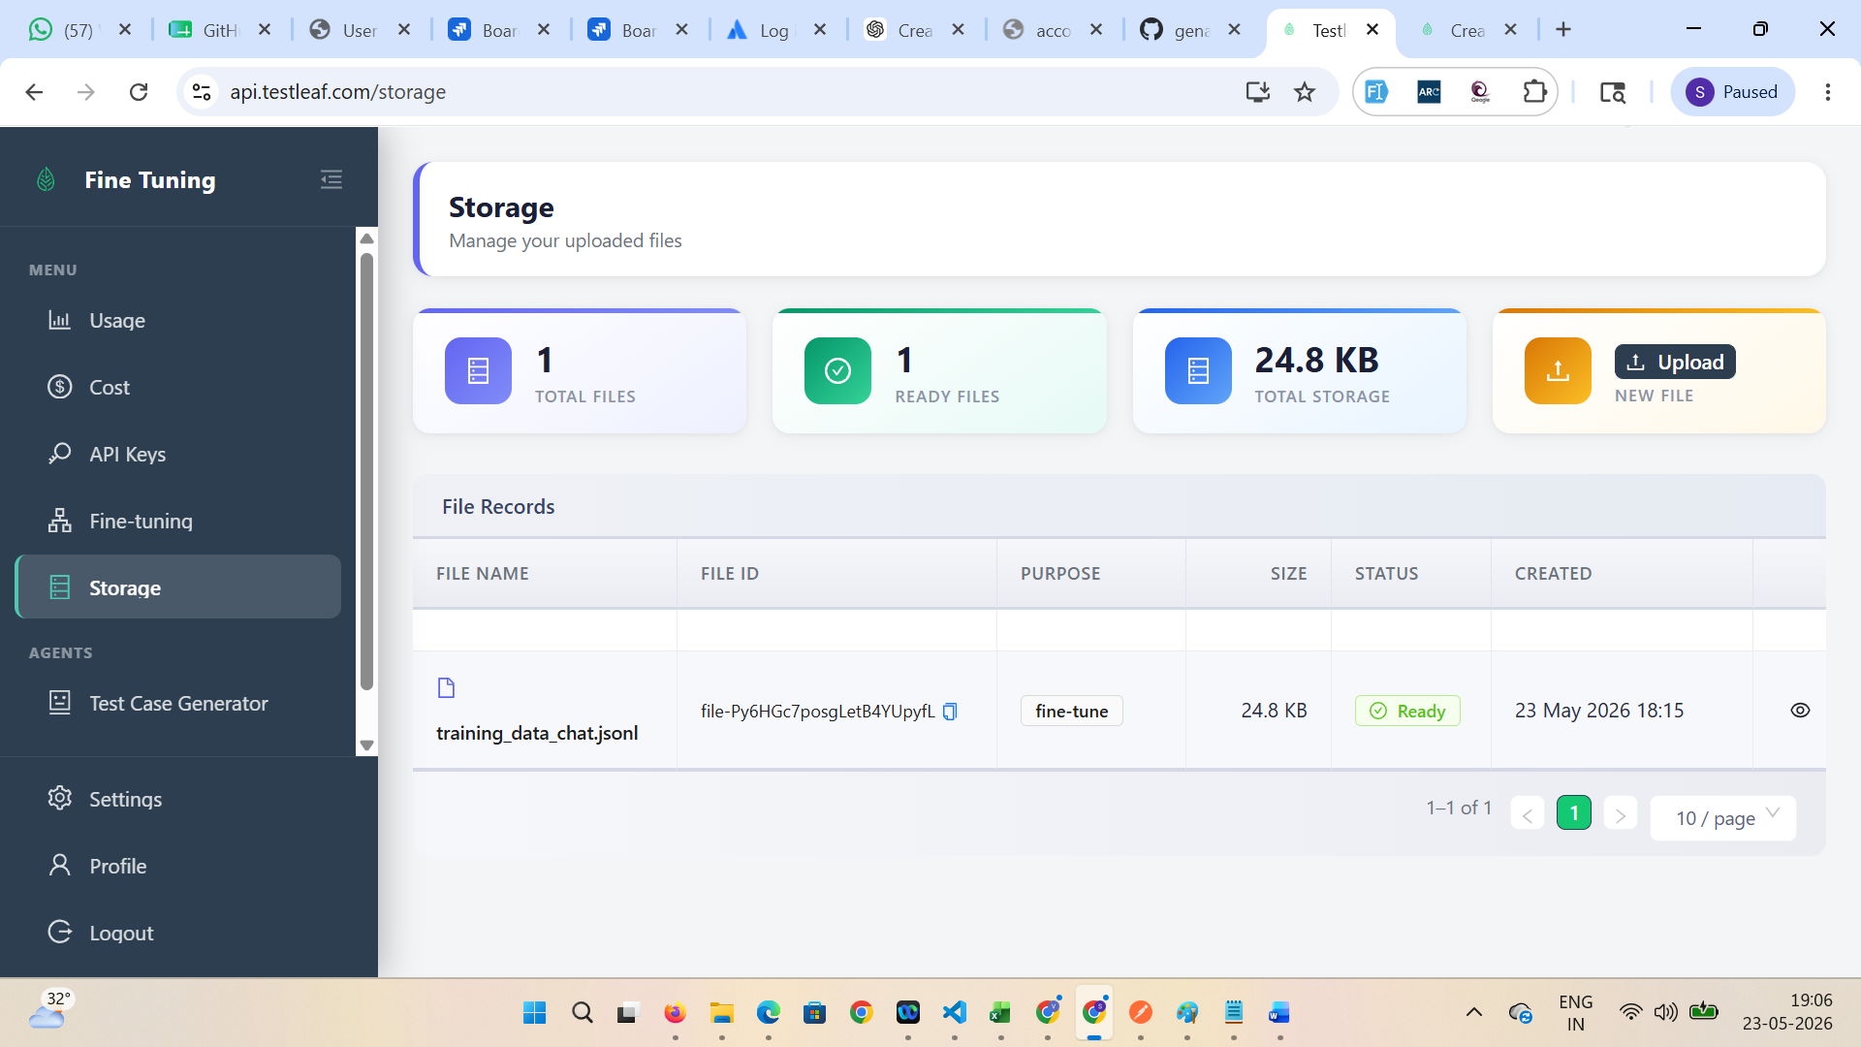

Navigate Fine-Tuning folder > Select the uploaded file > select the required parameters
Batch size - 1
Learning multiplier-0.1 or 0.3
Epochs -4 or 5
Wait until it is successfully completed

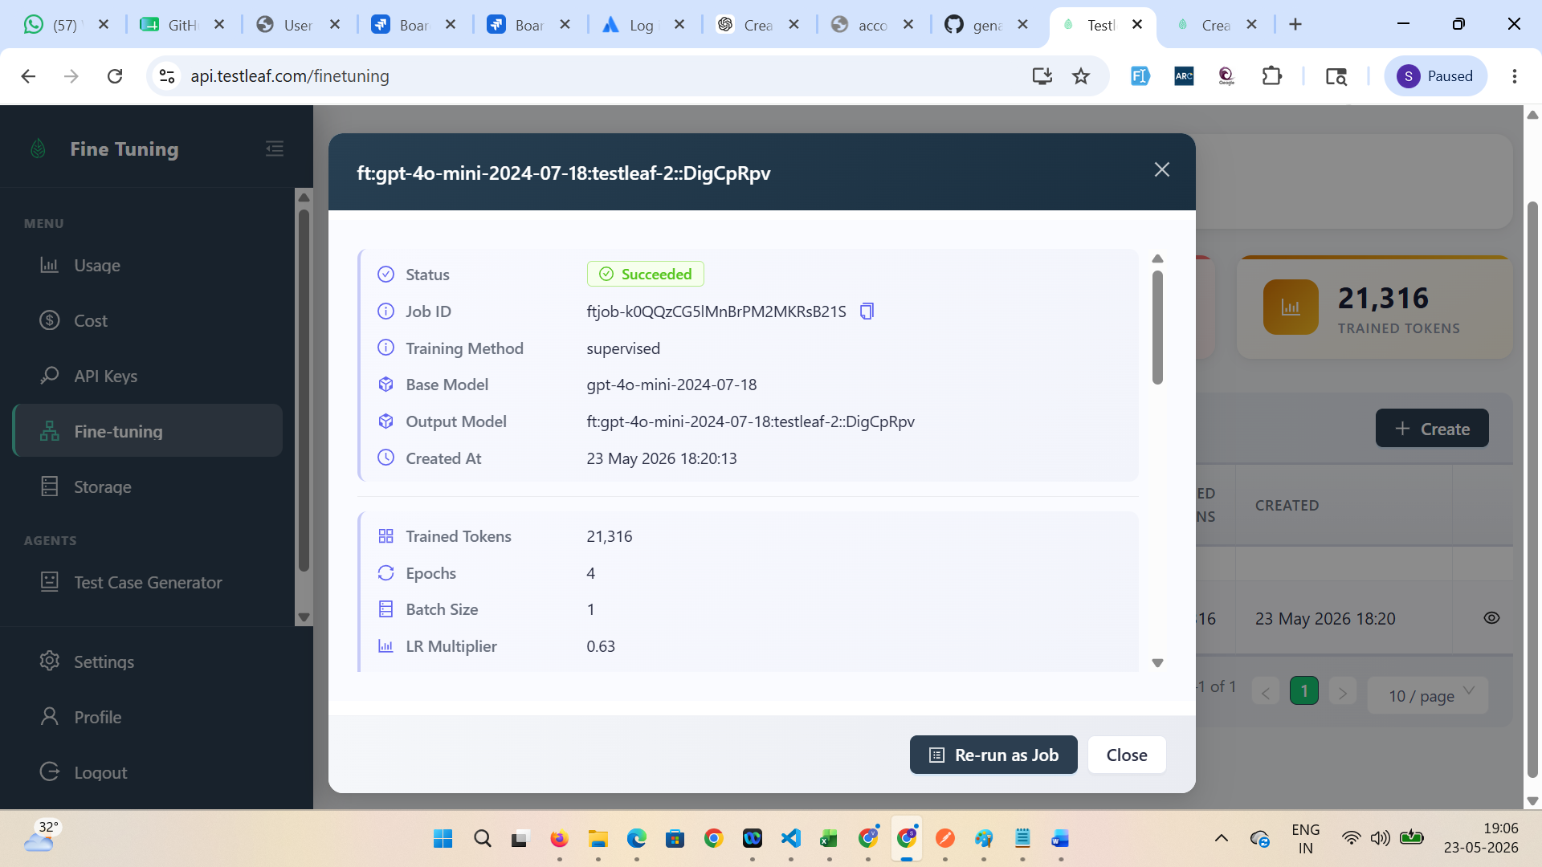

Add the newly trained model in the AI extension code
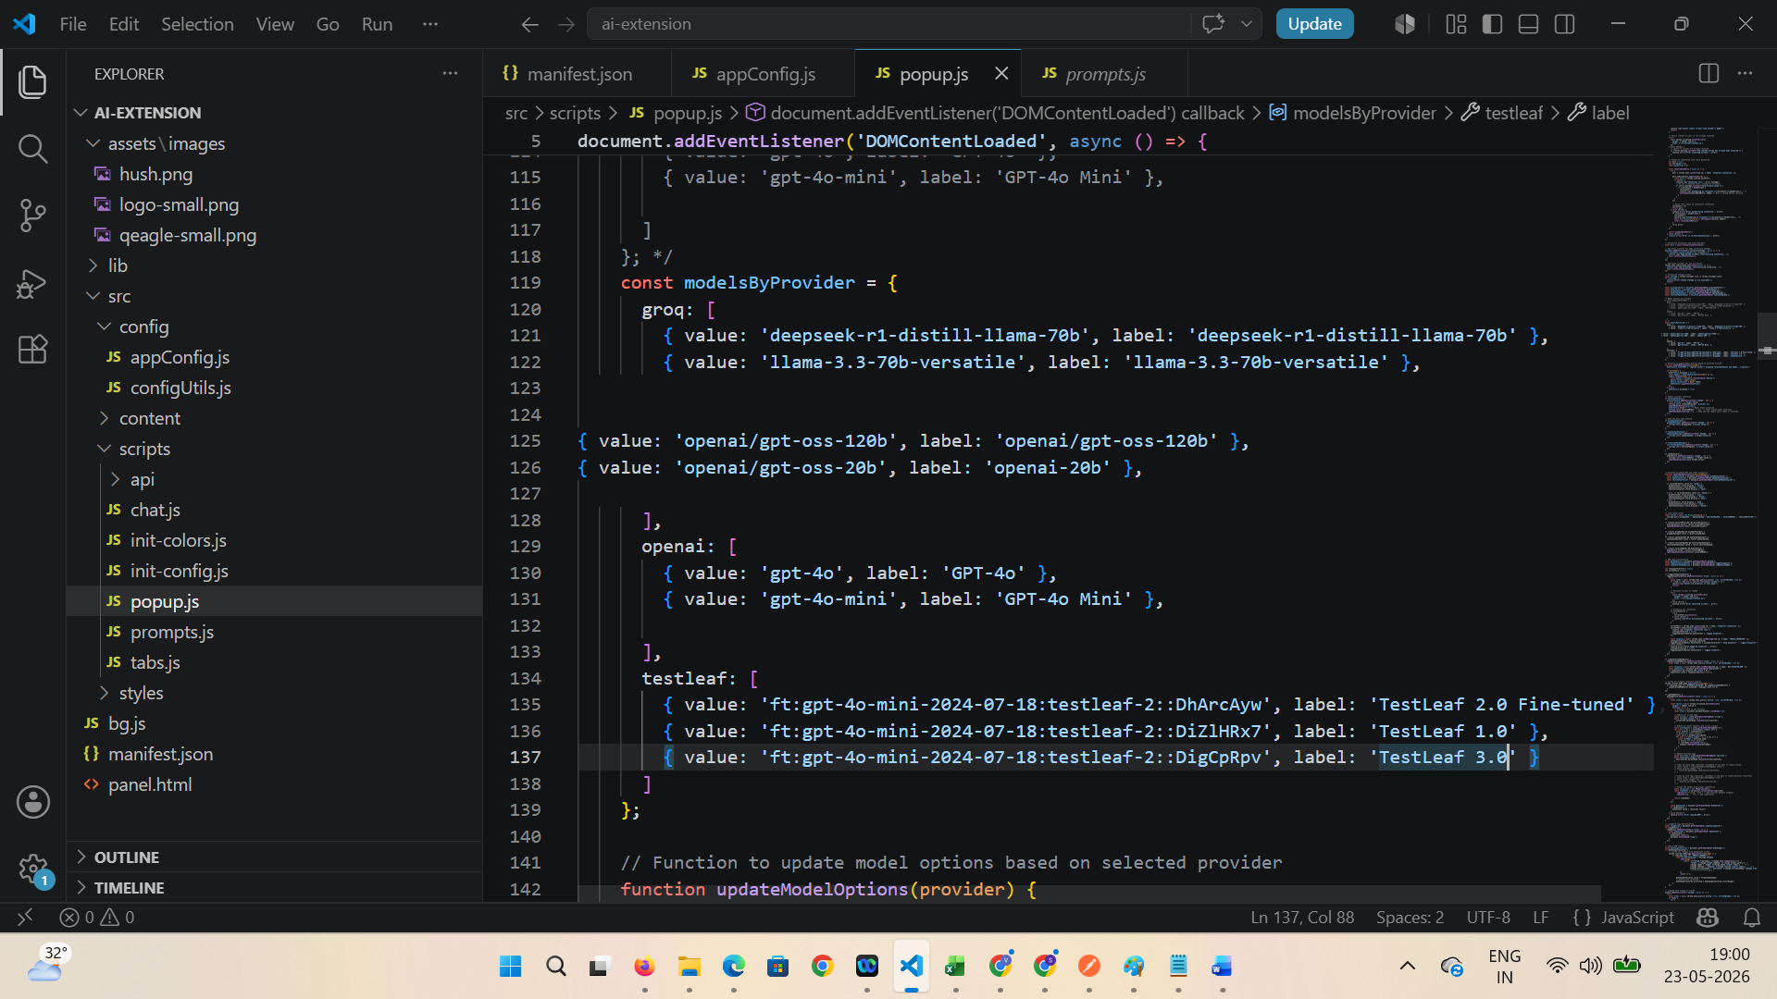

Open the extension > verify newly added model name is displayed ex. TestLeaf 3.0
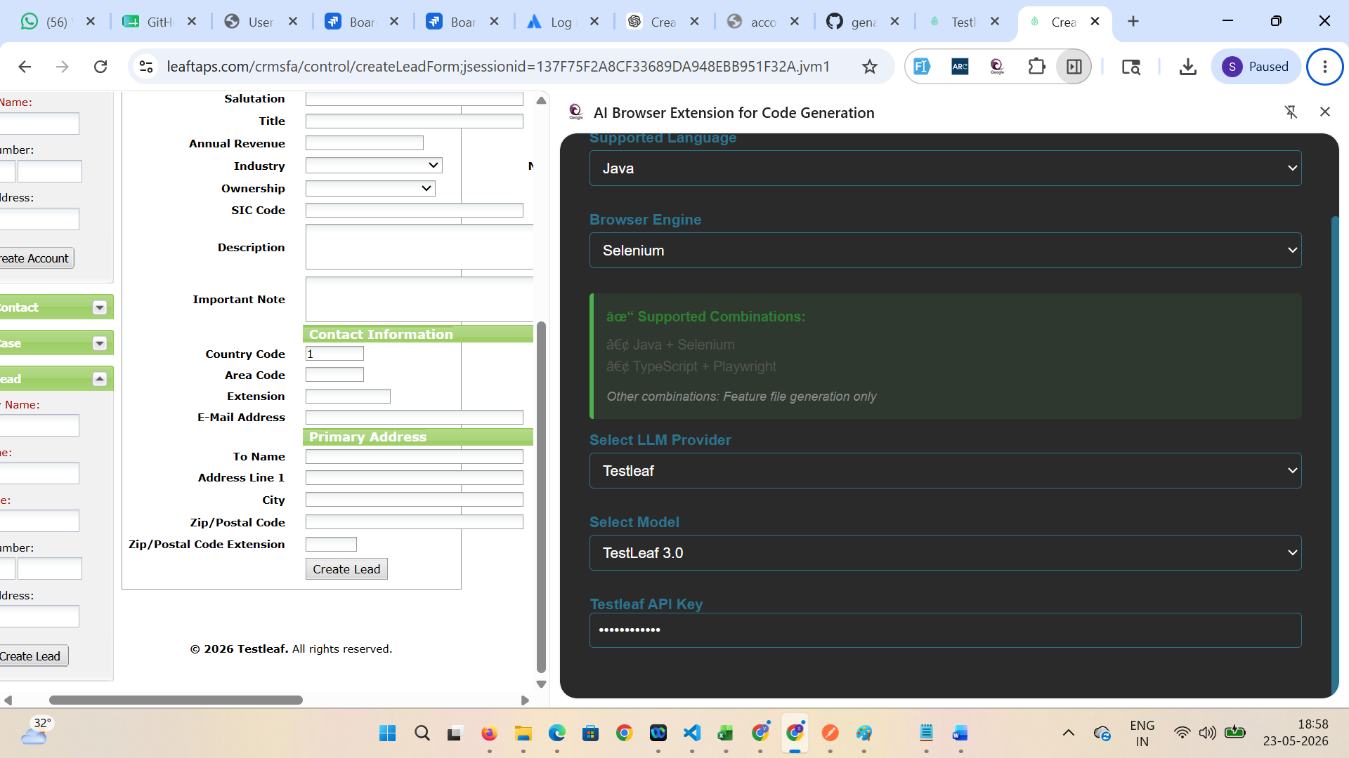

Verify code is generated for selected page with help of newly selected trained model
ex. Create Lead page
