Go to the code of browser extension and in ask mode of copilot – give the prompt to enable option for playwright with typescript
Prompt - Go through the entire workspace structure and understand the implementation for Selenium with Java.
I want to implement the same with Playwright with Typescript.
Please tell me the impacted files.
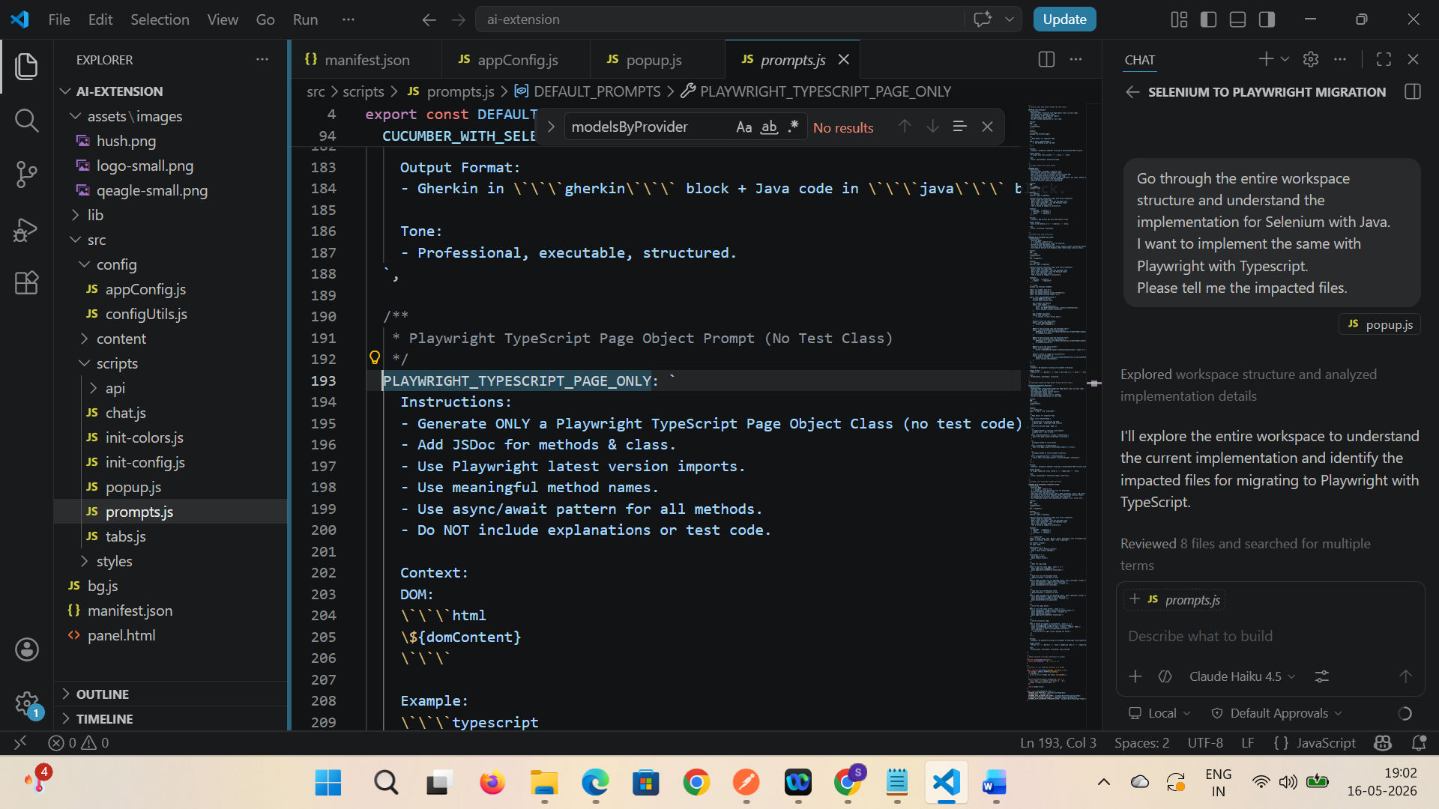

Start with suggested phases
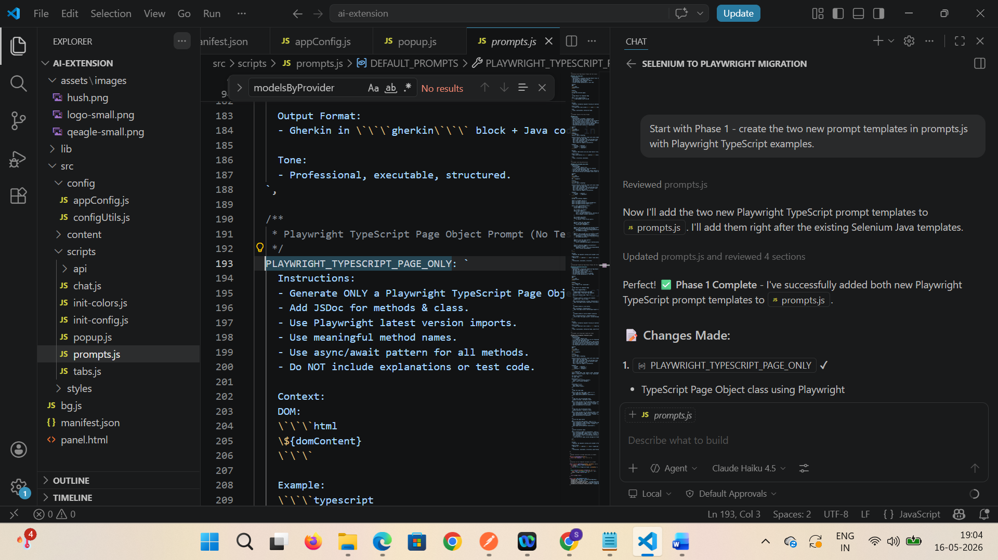
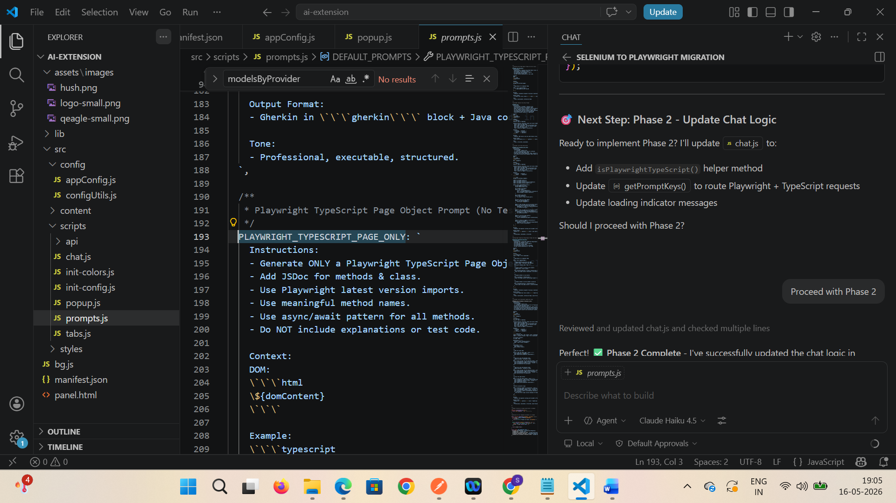

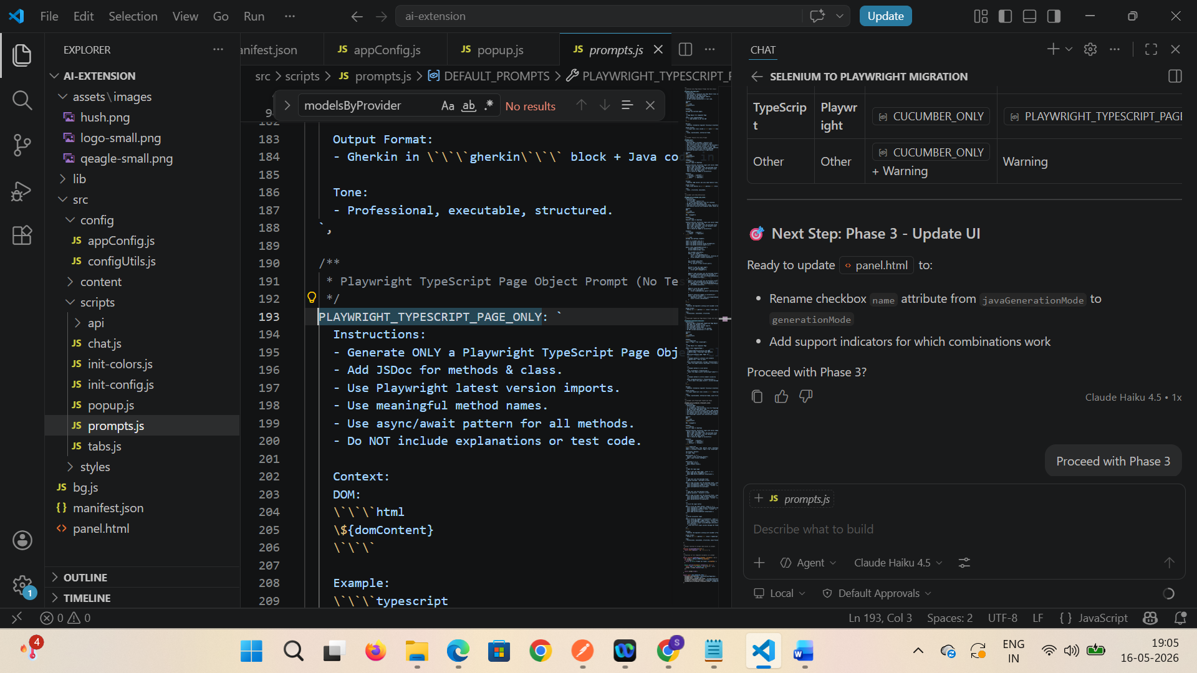

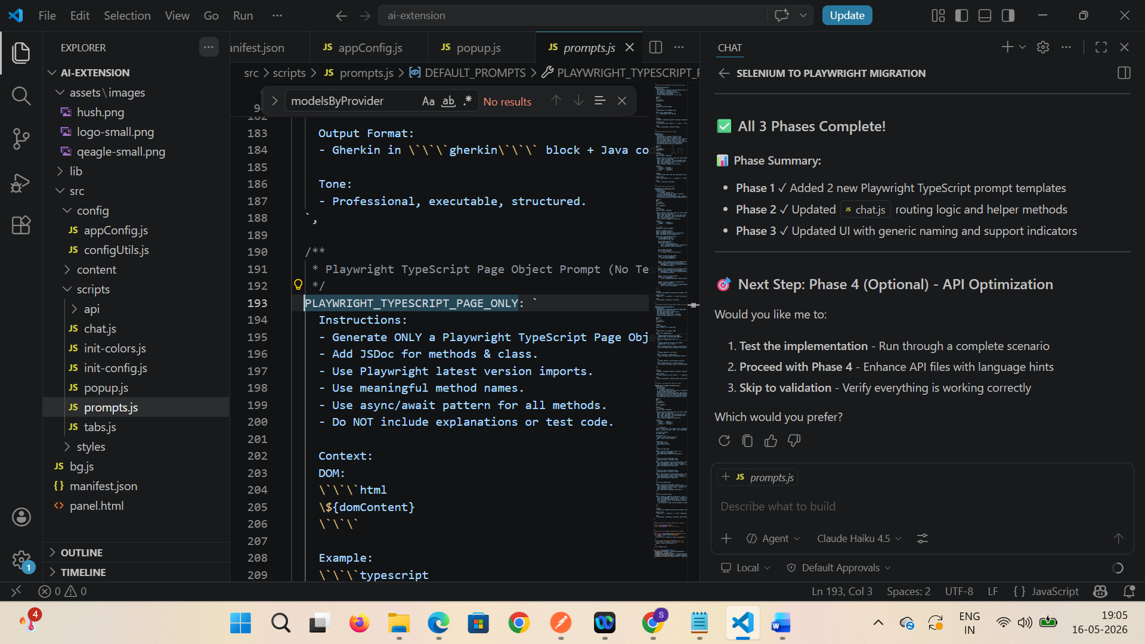

Close browser extension and reload again
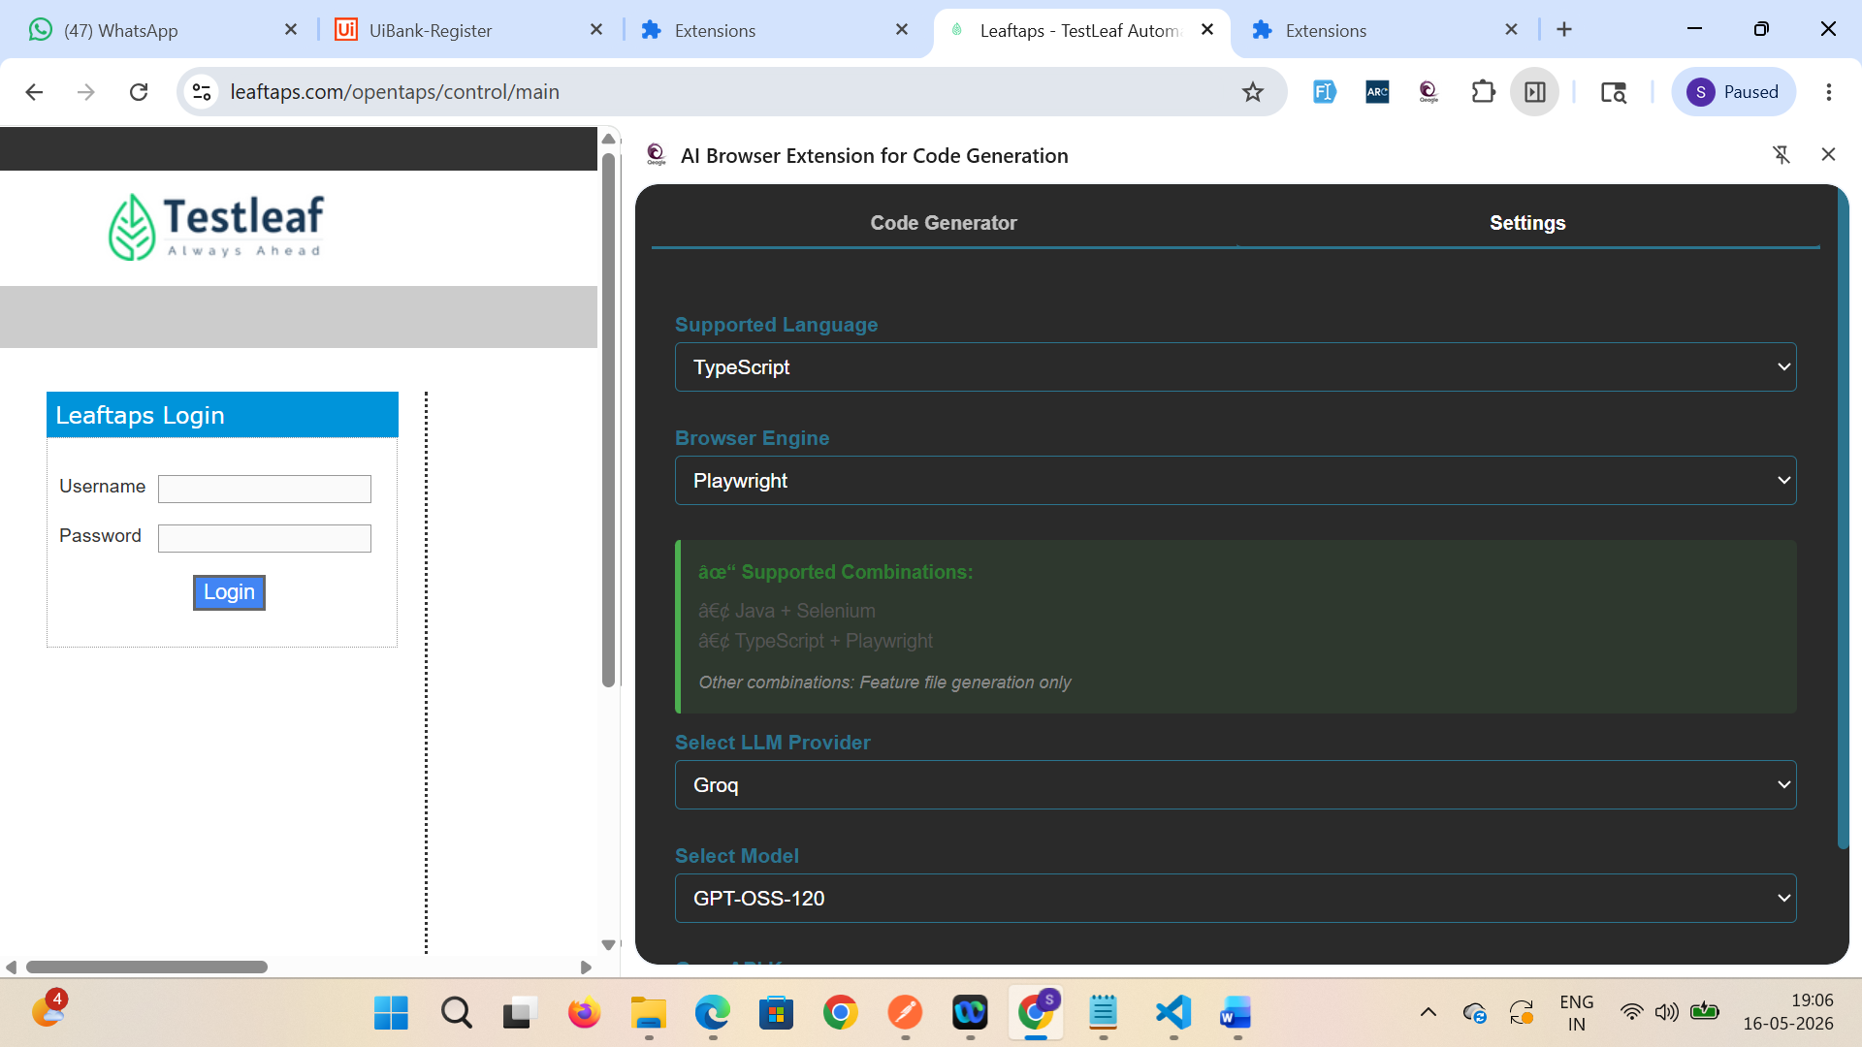

Verify playwright with typescript option is supported now and able to generate the code for the same
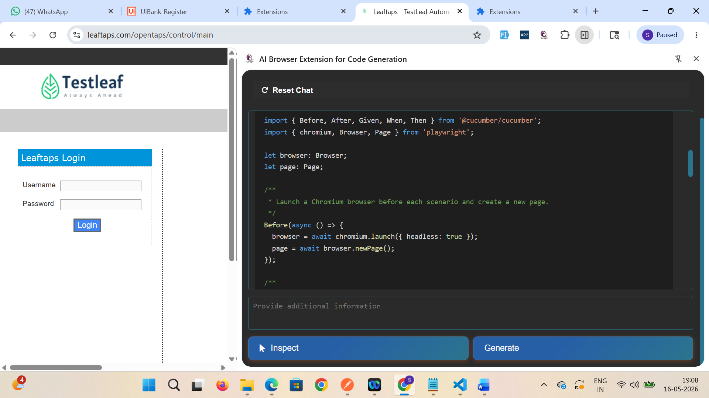
Code generated -
Feature: Login to OpenTaps

As a QA engineer I want to verify that users from South-India can log in
successfully using valid credentials.

Scenario Outline: Successful login with valid credentials
Given I open the OpenTaps login page
When I type "<username>" into the Username field
And I type "<password>" into the Password field
And I click the Login button
Then I should be logged in successfully

Examples:
| username | password |
| krishnan | Krish@123 |
| sundar | Sundar#2023 |
| lakshmi | Lakshmi$456 |

import { Before, After, Given, When, Then } from '@cucumber/cucumber';
import { chromium, Browser, Page } from 'playwright';

let browser: Browser;
let page: Page;

/**
* Launch a Chromium browser before each scenario and create a new page.
*/
Before(async () => {
browser = await chromium.launch({ headless: true });
page = await browser.newPage();
});

/**
* Close the page and the browser after each scenario.
*/
After(async () => {
await page.close();
await browser.close();
});

/**
* Open the OpenTaps login page.
*/
Given('I open the OpenTaps login page', async () => {
await page.goto('https://leaftaps.com/opentaps/control/main');
// Wait until the network is idle and the login form is visible
await page.waitForLoadState('networkidle');
const loginForm = page.locator('form#login');
await loginForm.waitFor({ state: 'visible' });
});

/**
* Fill the Username field.
*/
When('I type {string} into the Username field', async (username: string) => {
const usernameInput = page.locator('#username');
await usernameInput.waitFor({ state: 'visible' });
await usernameInput.fill(username);
});

/**
* Fill the Password field.
*/
When('I type {string} into the Password field', async (password: string) => {
const passwordInput = page.locator('#password');
await passwordInput.waitFor({ state: 'visible' });
await passwordInput.fill(password);
});

/**
* Click the Login button.
*/
When('I click the Login button', async () => {
// The login button is an <input type="submit"> with class decorativeSubmit
const loginBtn = page.locator('input.decorativeSubmit');
await loginBtn.waitFor({ state: 'visible' });
await loginBtn.click();

// Wait for navigation after the form submission
await page.waitForLoadState('networkidle');
});

/**
* Verify that the user is logged in.
*
* The OpenTaps application shows a "Logout" link after a successful login.
* We assert its visibility as proof of a successful login.
*/
Then('I should be logged in successfully', async () => {
const logoutLink = page.locator('a[href*="logout"]');
await logoutLink.waitFor({ state: 'visible', timeout: 5000 });

const isVisible = await logoutLink.isVisible();
if (!isVisible) {
throw new Error('Logout link not found – login may have failed.');
}
});

