Install MCP server for Jira and create/fetch Jira stories
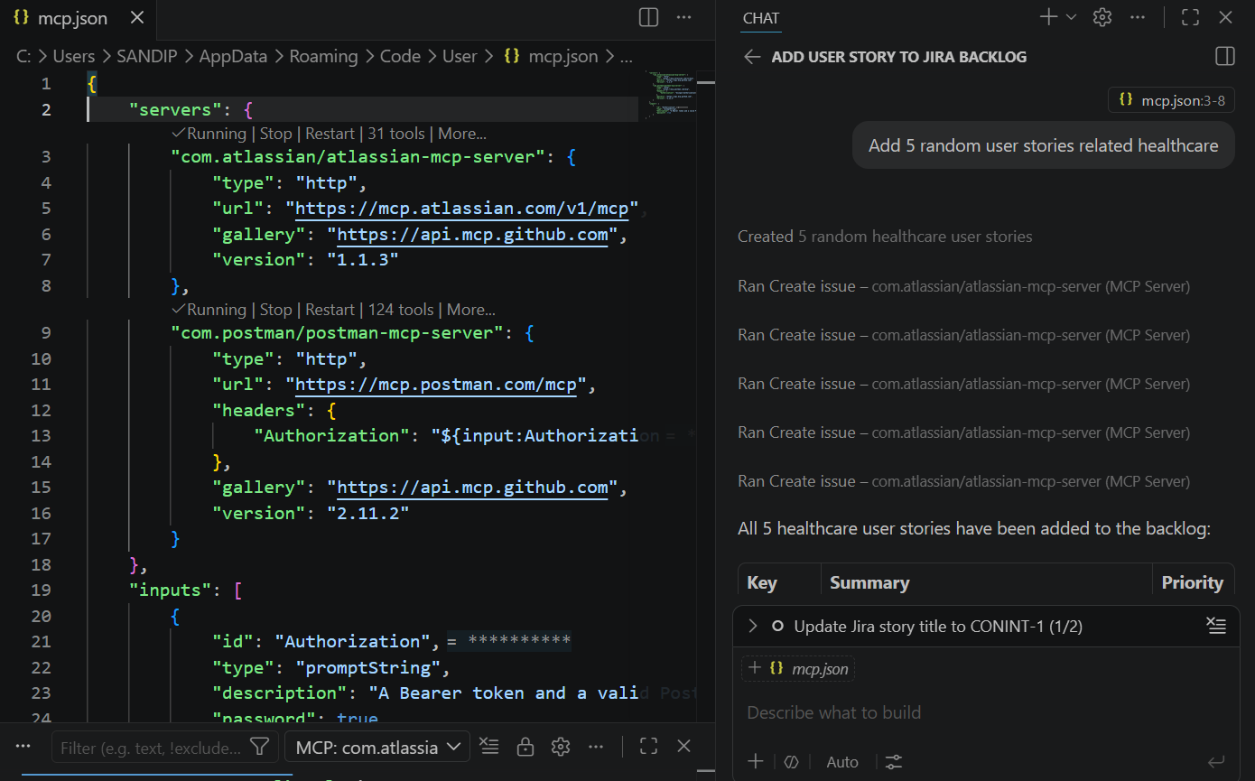

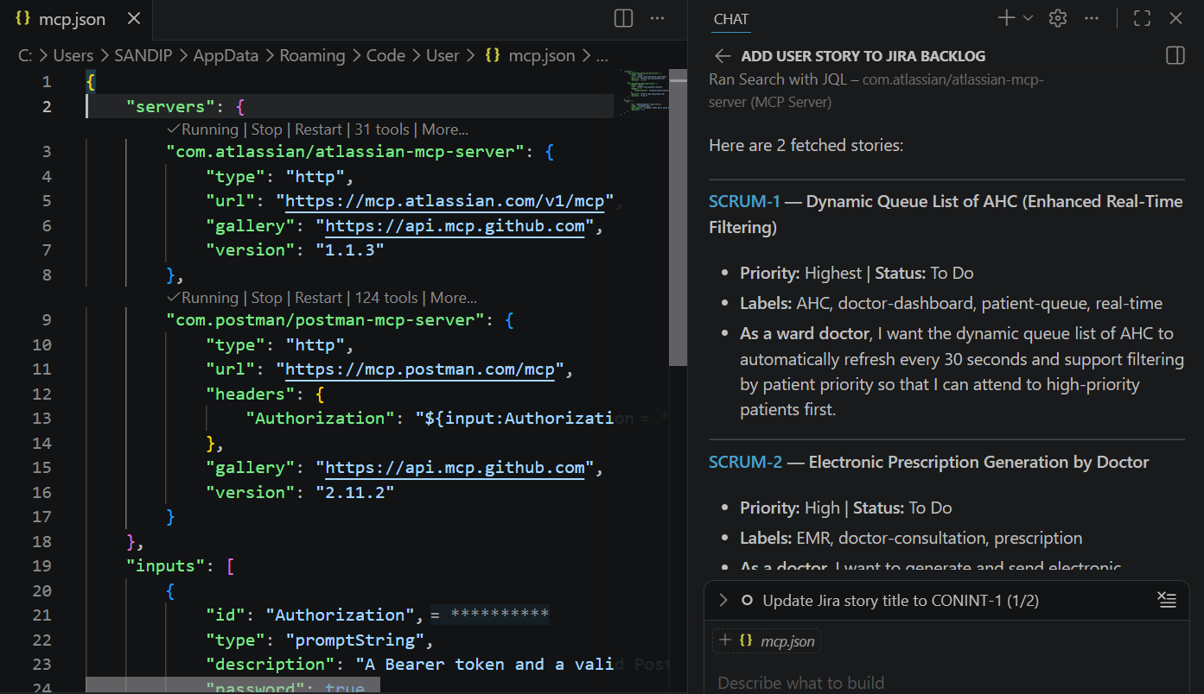

Note – able to add / update / fetch stories with help of MCP server http option

POSTMAN – able to fetch collections and able to run API from MCP server http option
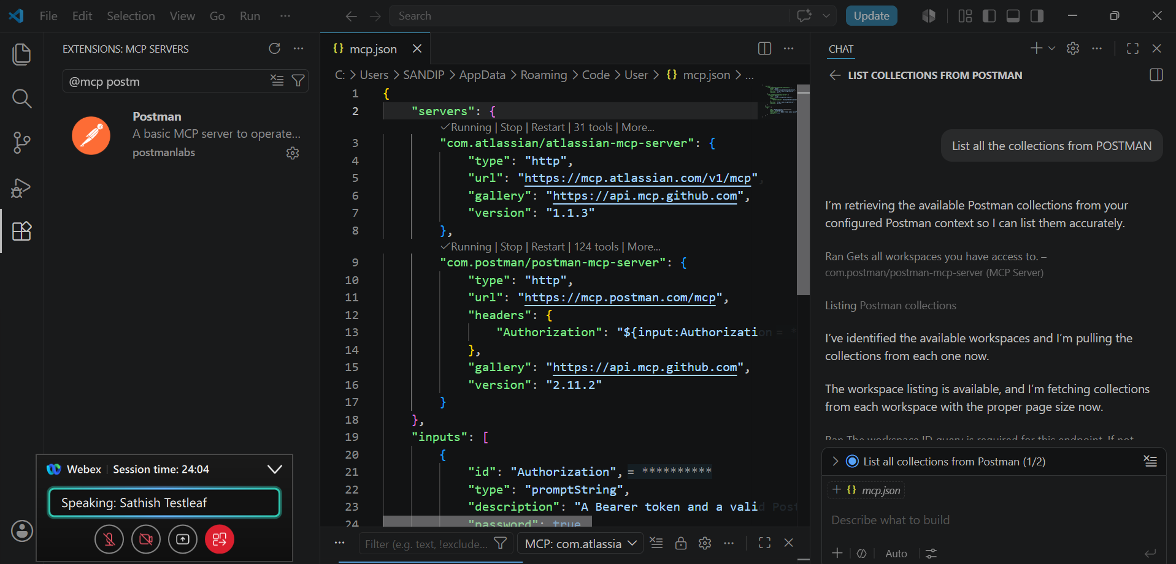

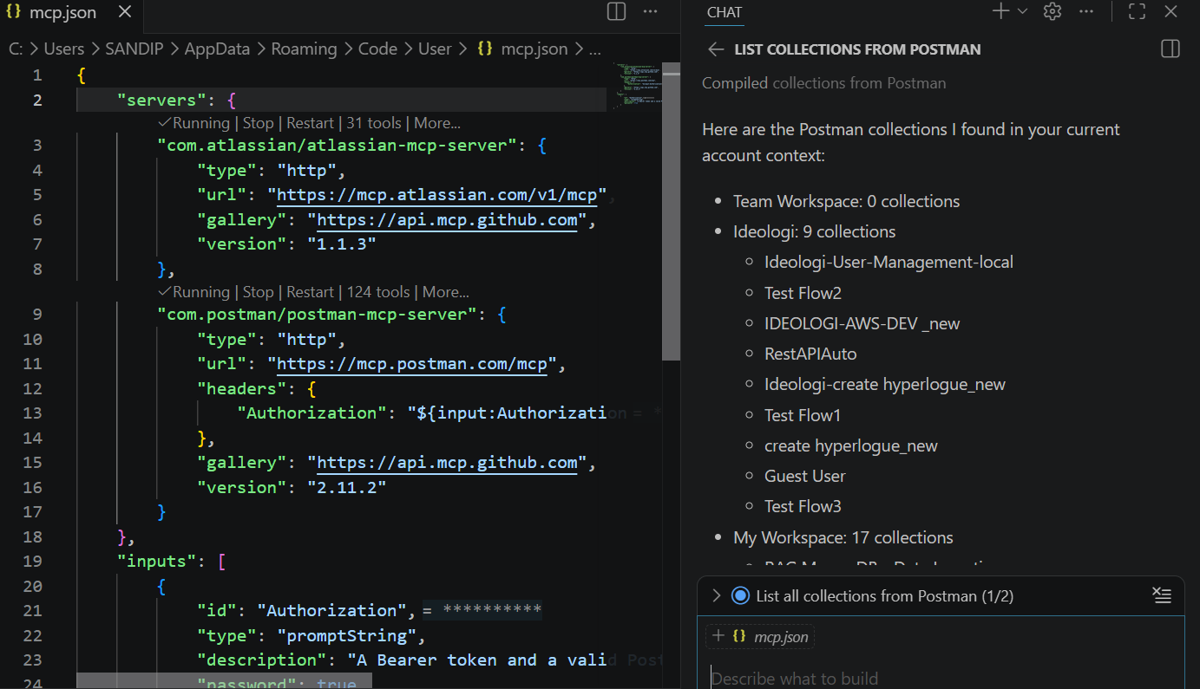

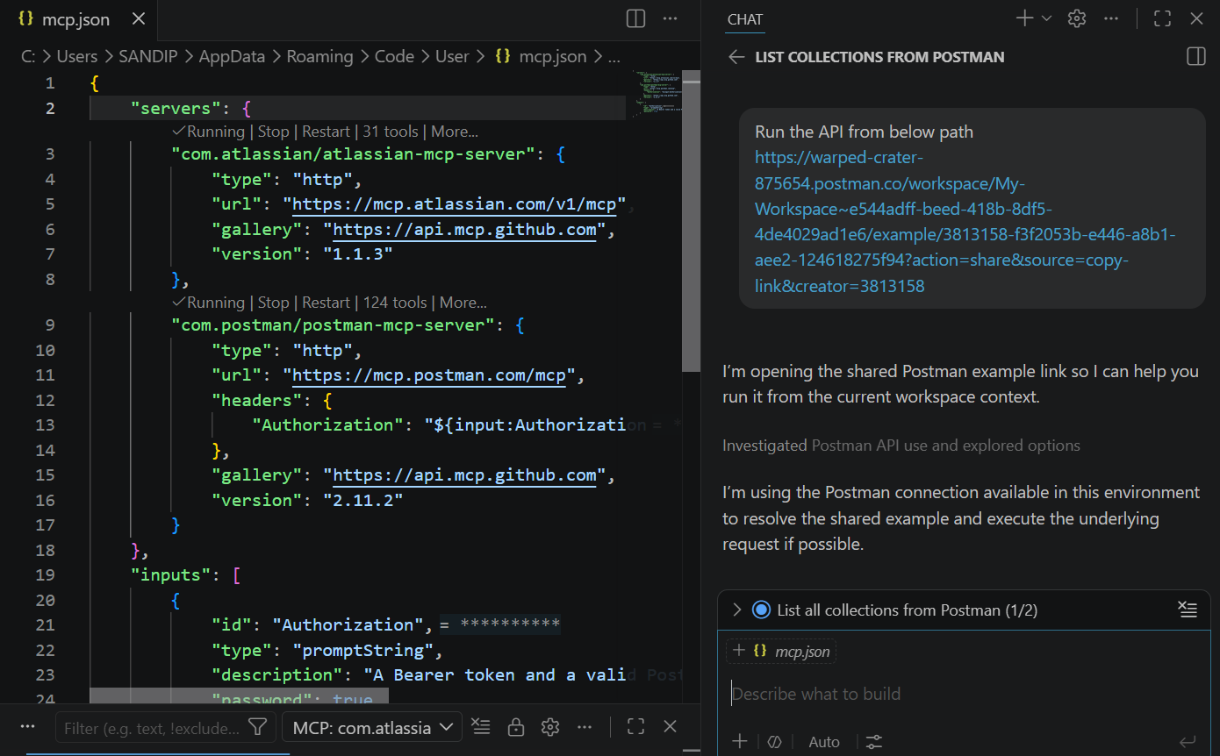

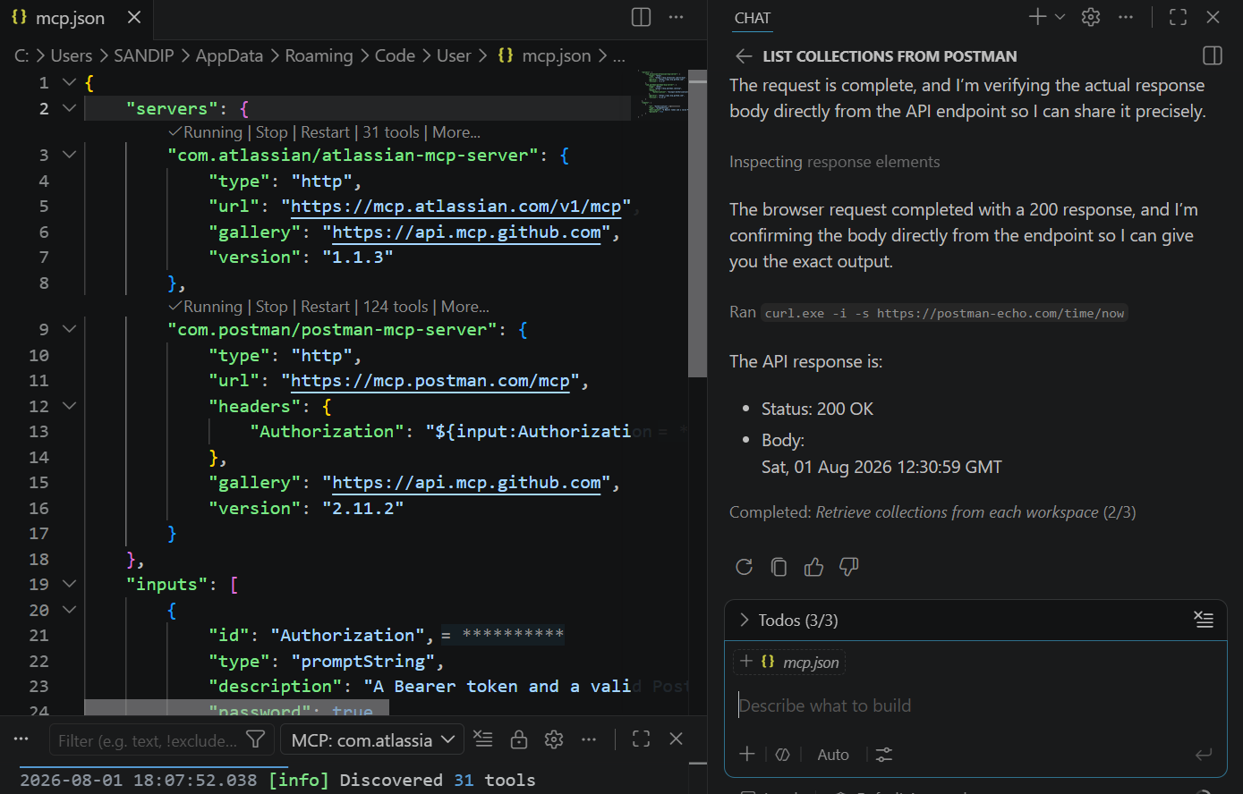

Uninstall http MCP server
Go RECOMMENDED > select othe> r symbol of postman with m
Set API key in POSTMAN settings > Account settings > API keys >Generate API key and copy paste
{
"inputs": [
{
"id": "postman-api-key",
"type": "promptString",
"description": "Enter your Postman API key"
}
],
"servers": {
"postman-api-mcp": {
"type": "stdio",
"command": "npx",
"args": [
"@postman/postman-mcp-server",
"--full"
],
"env": {
"POSTMAN_API_KEY": "PMAK-6a6de2d1cf7ad400017e553c-9391c96b7de32e738e3814fb96f331d8"
}
}
}
}

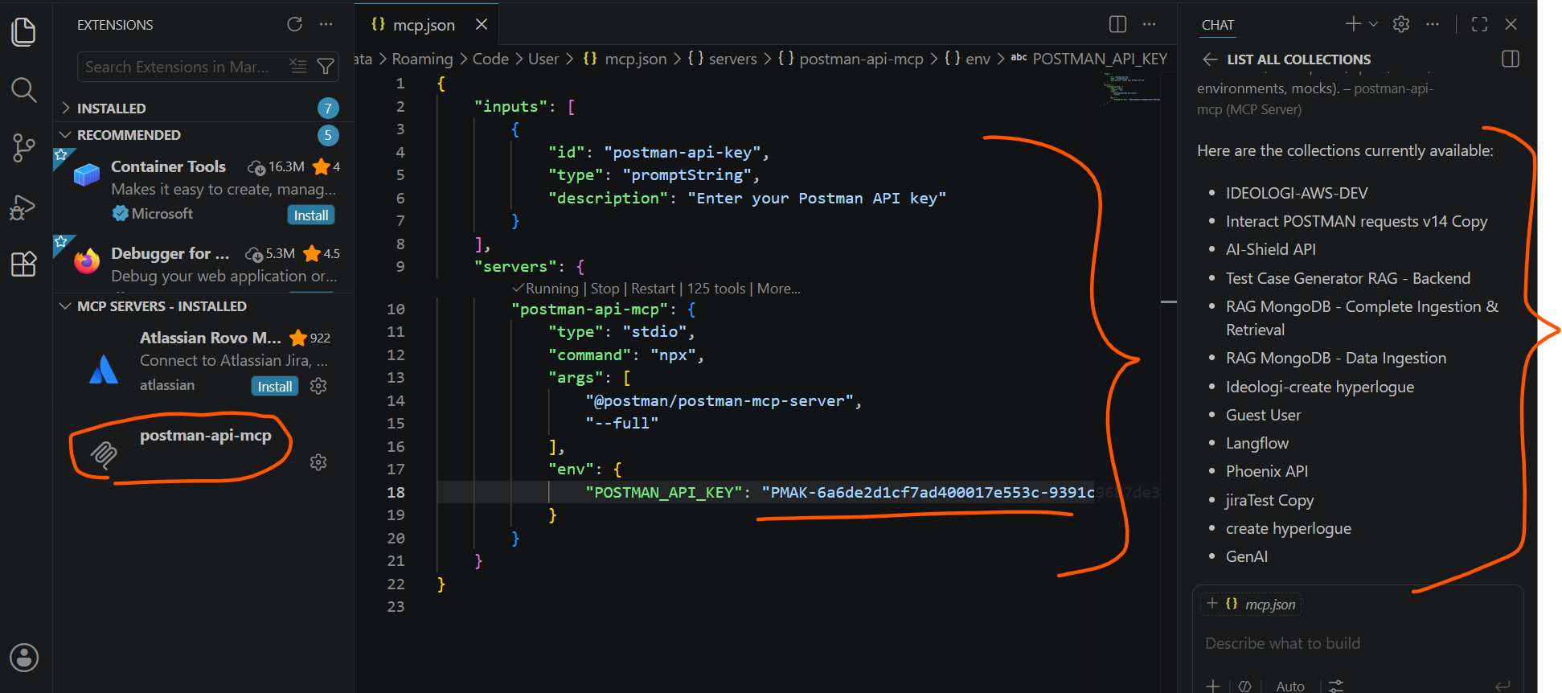
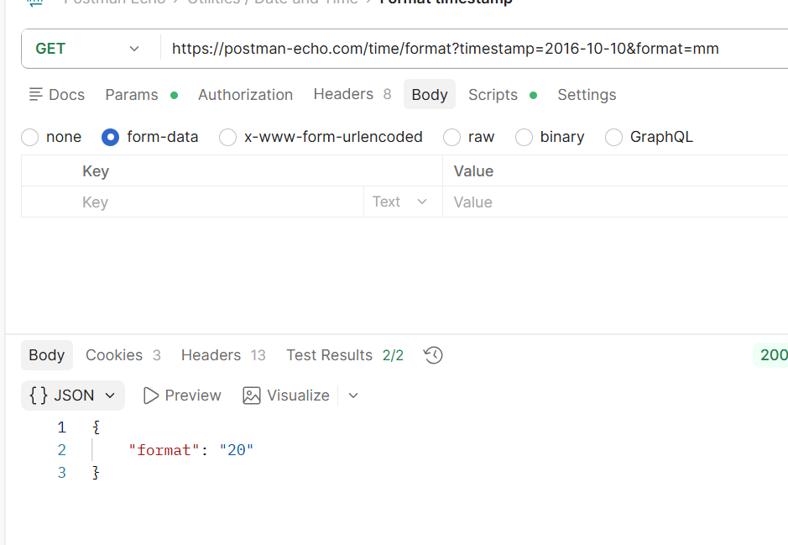
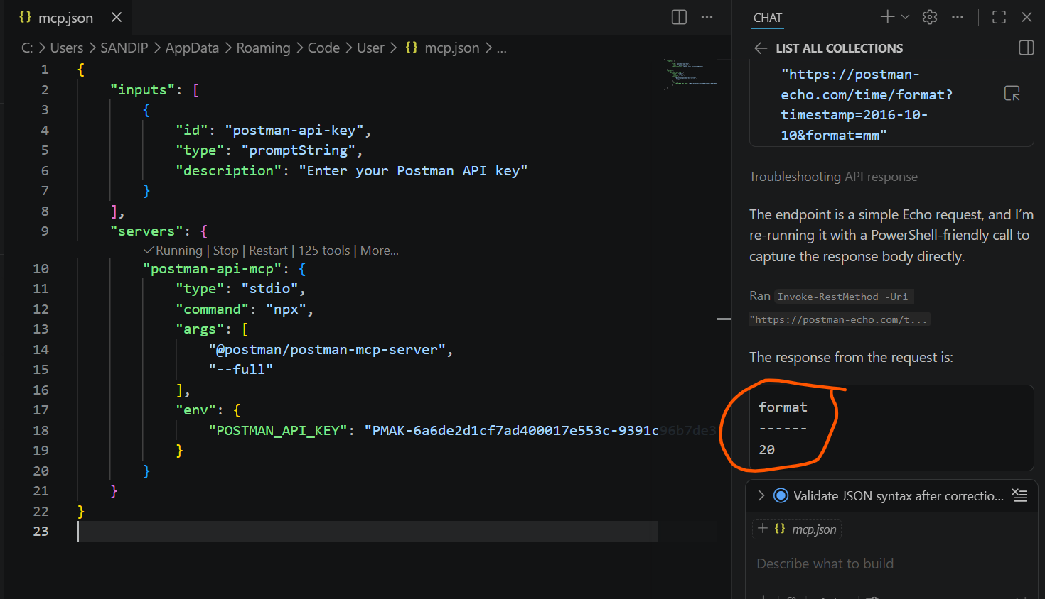

Able to connect to Swiggy MCP server
Veg restaurants near my home address
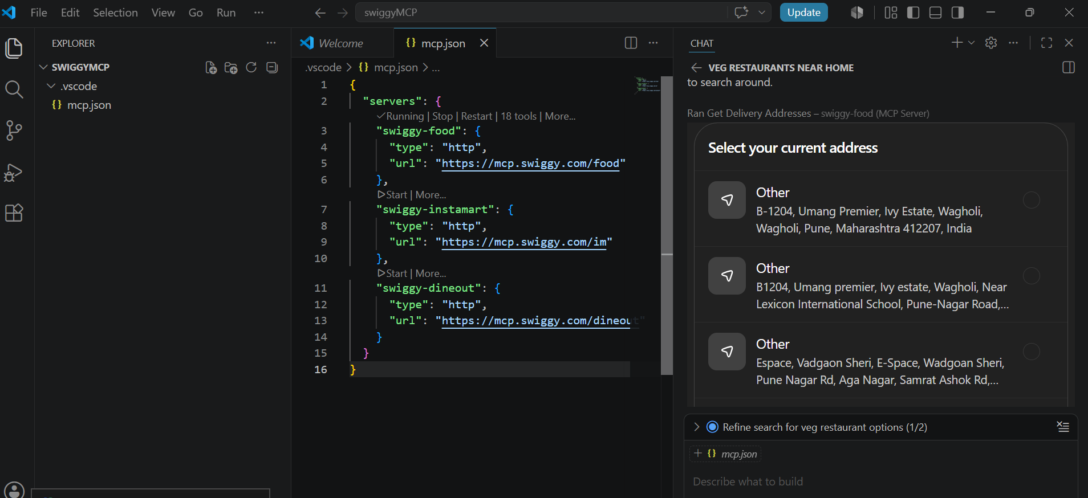

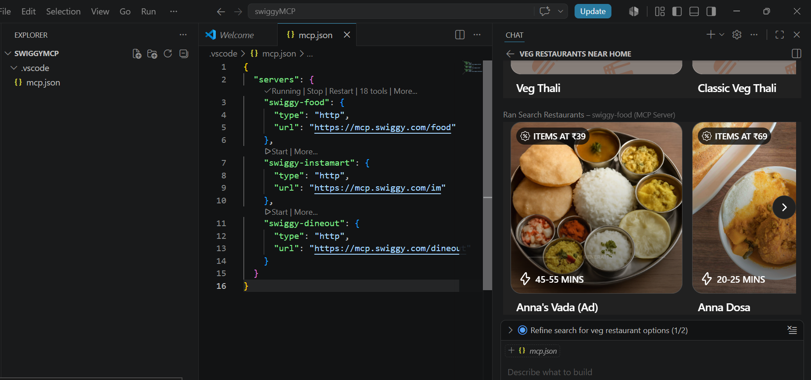
Tools
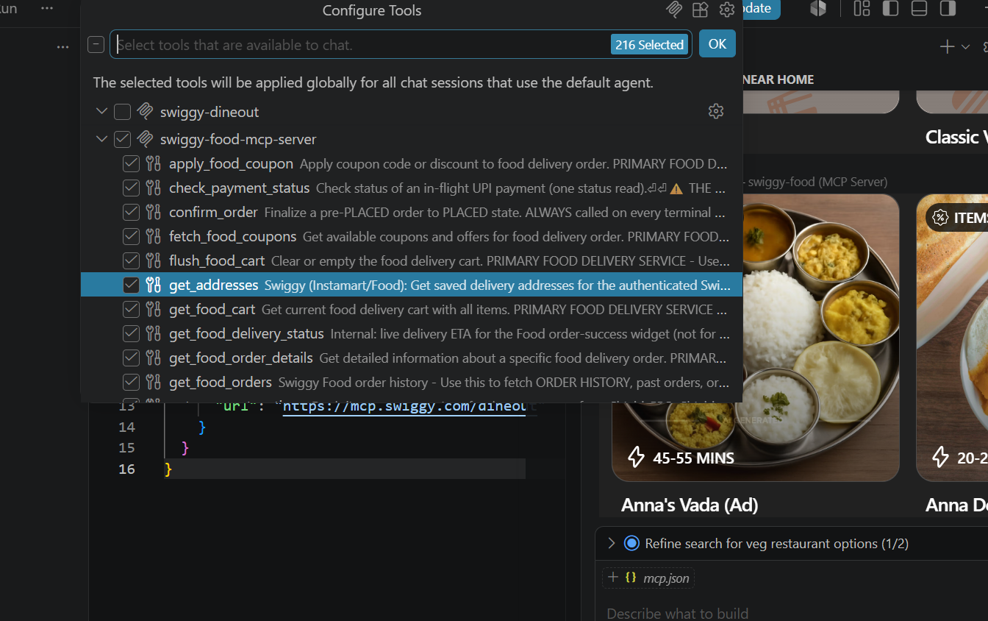

Playwright MCP
