Add below Jira fields to connect to Jira
Jira Base URL
Jira API Key
Jira Email ID

Also, add ‘Test Case ID’ field with Search button

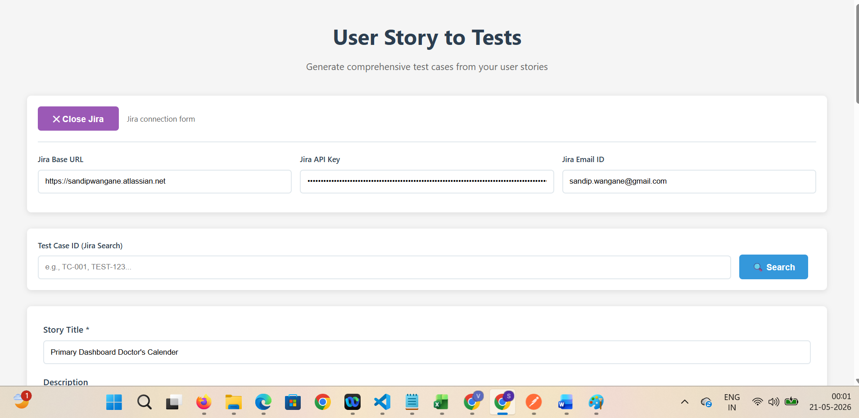

After clicking on Search button, Jira API will call and fetch the details via API
Jira Story – FP-27
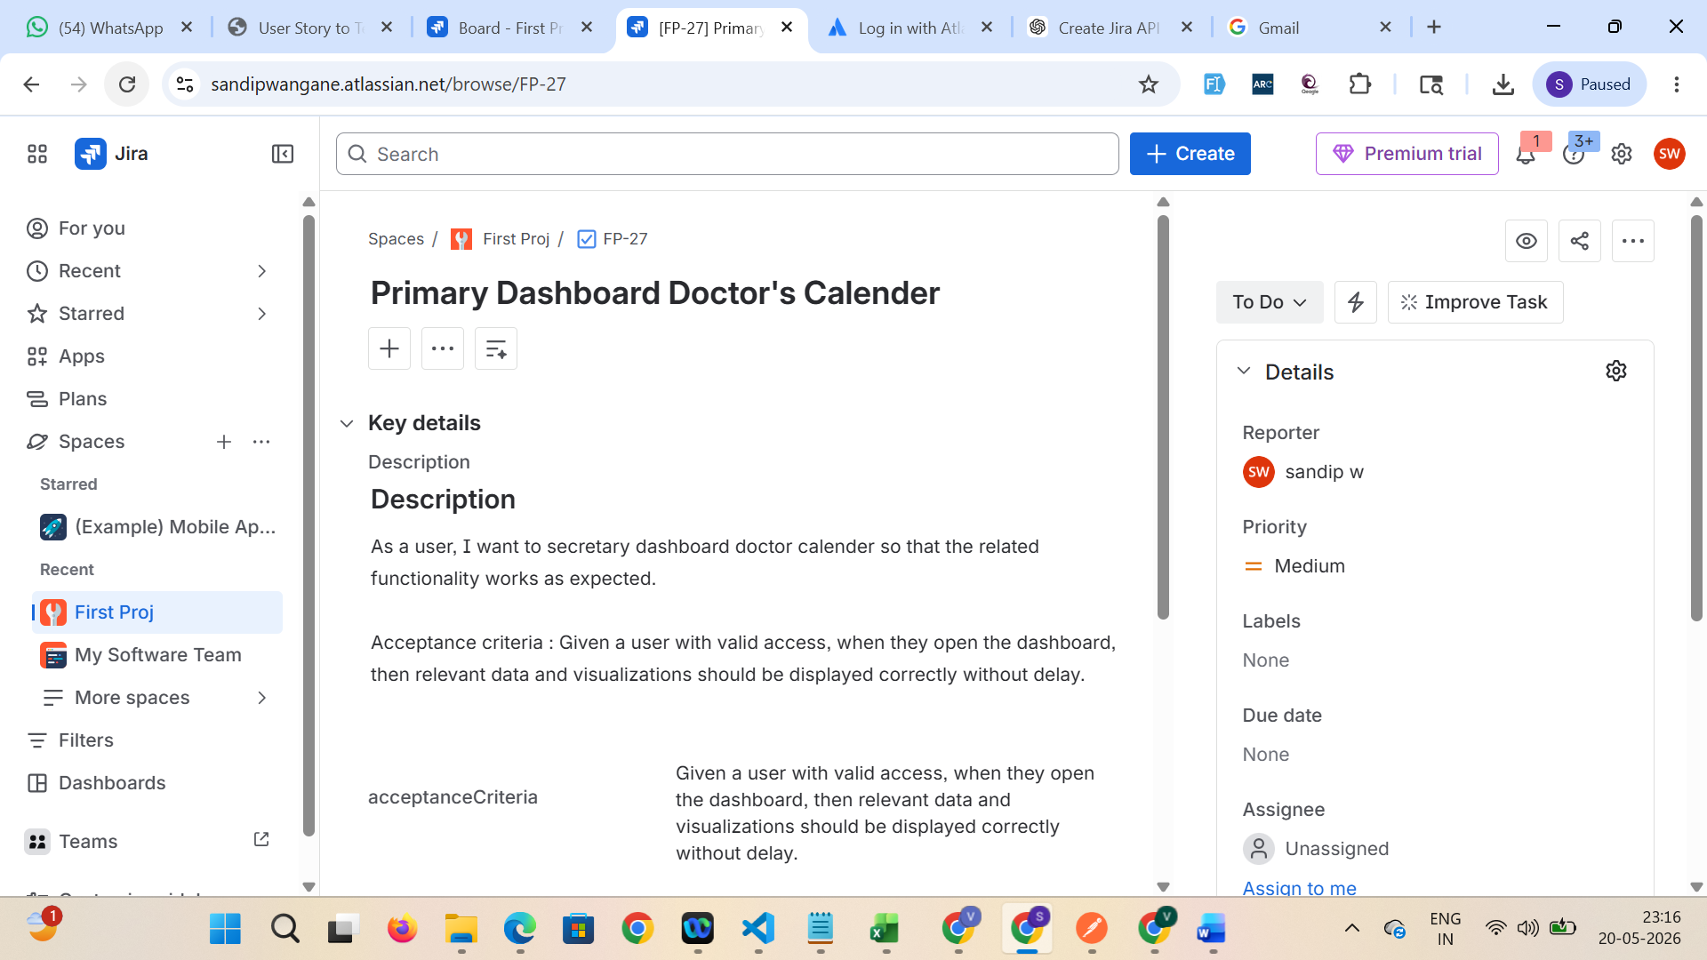

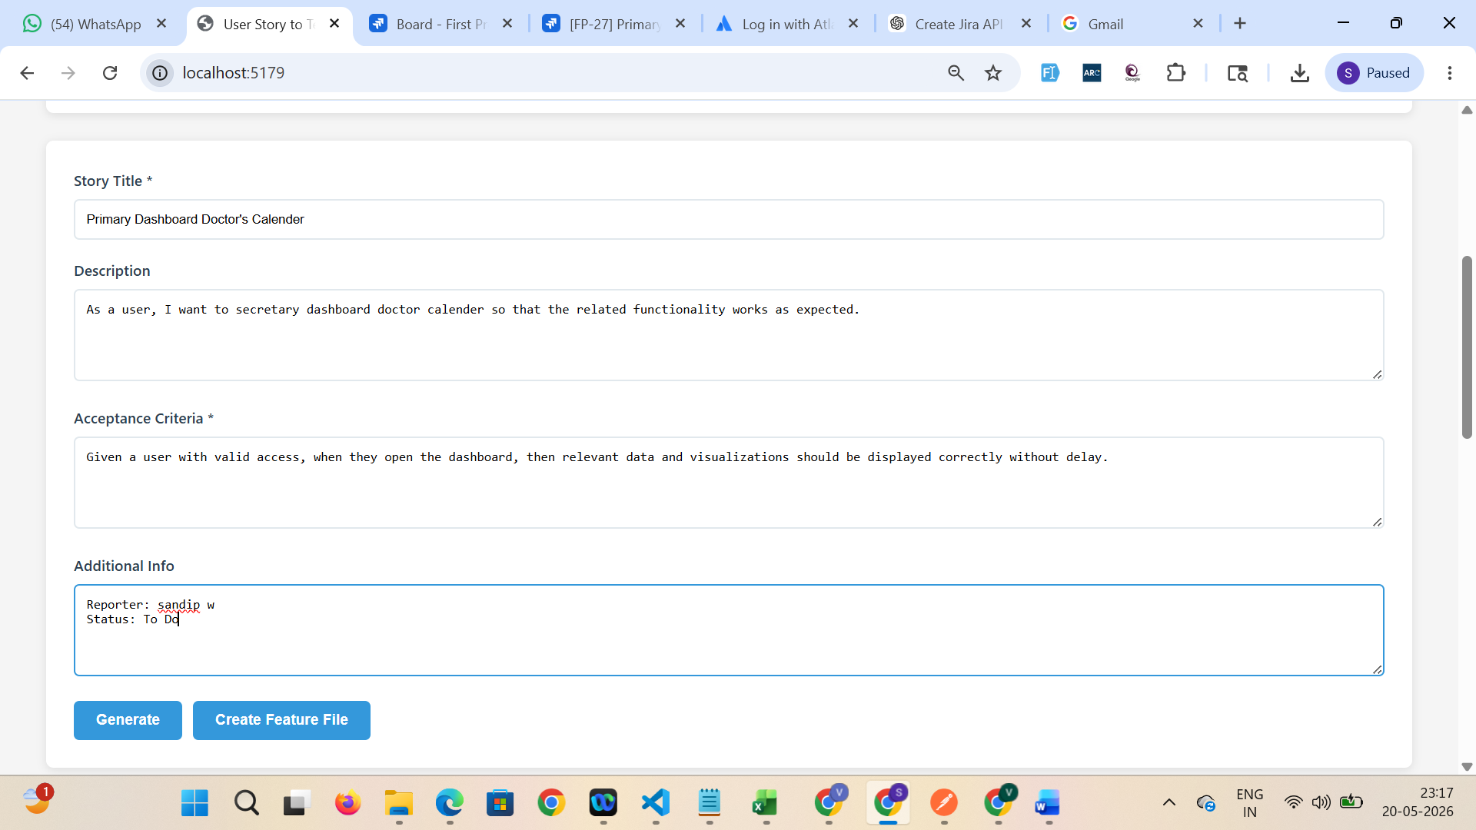

API integration
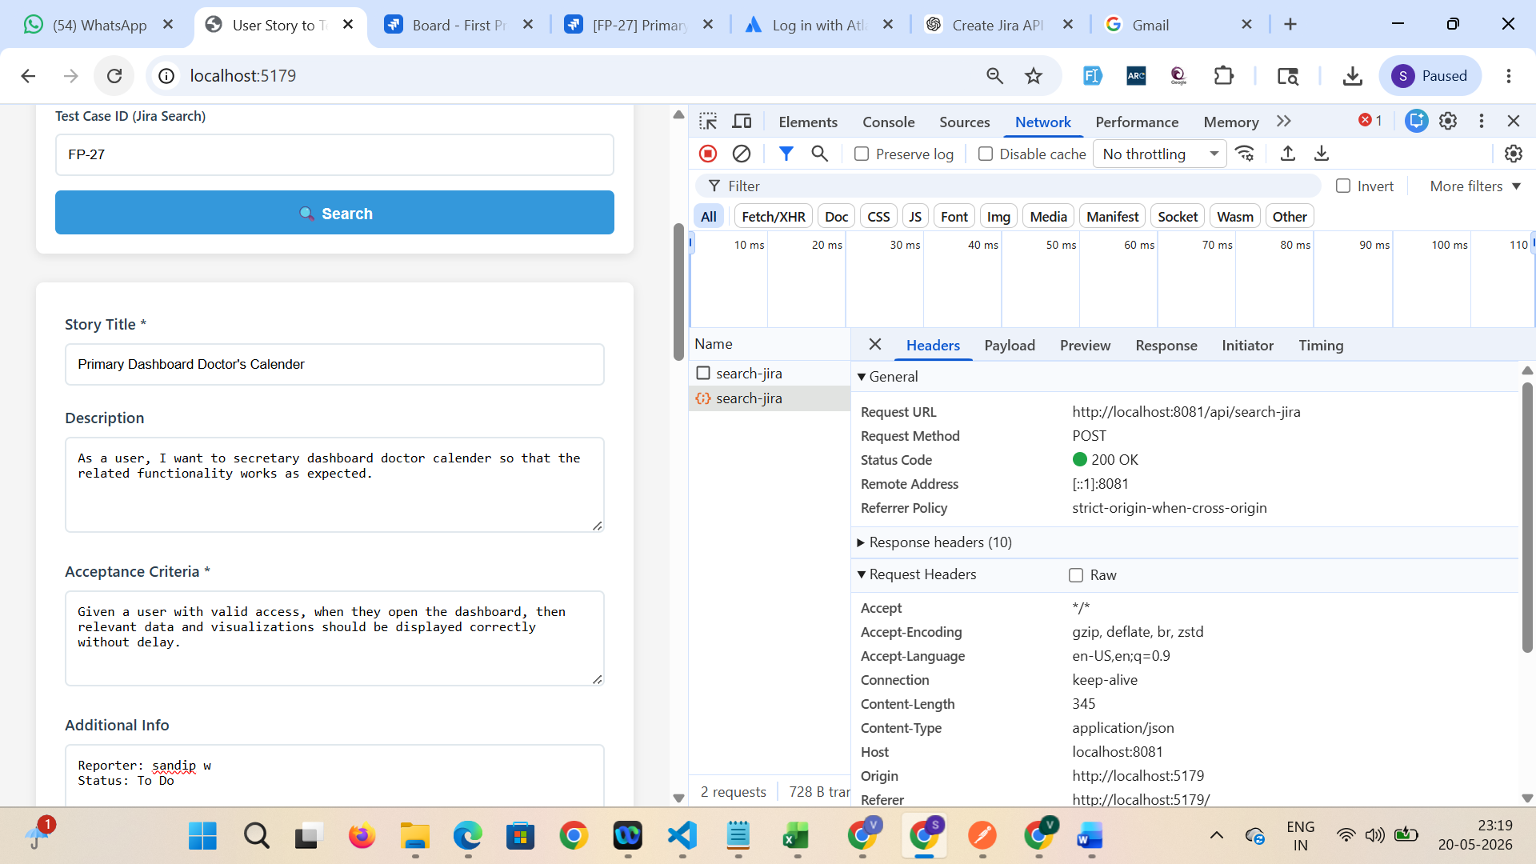

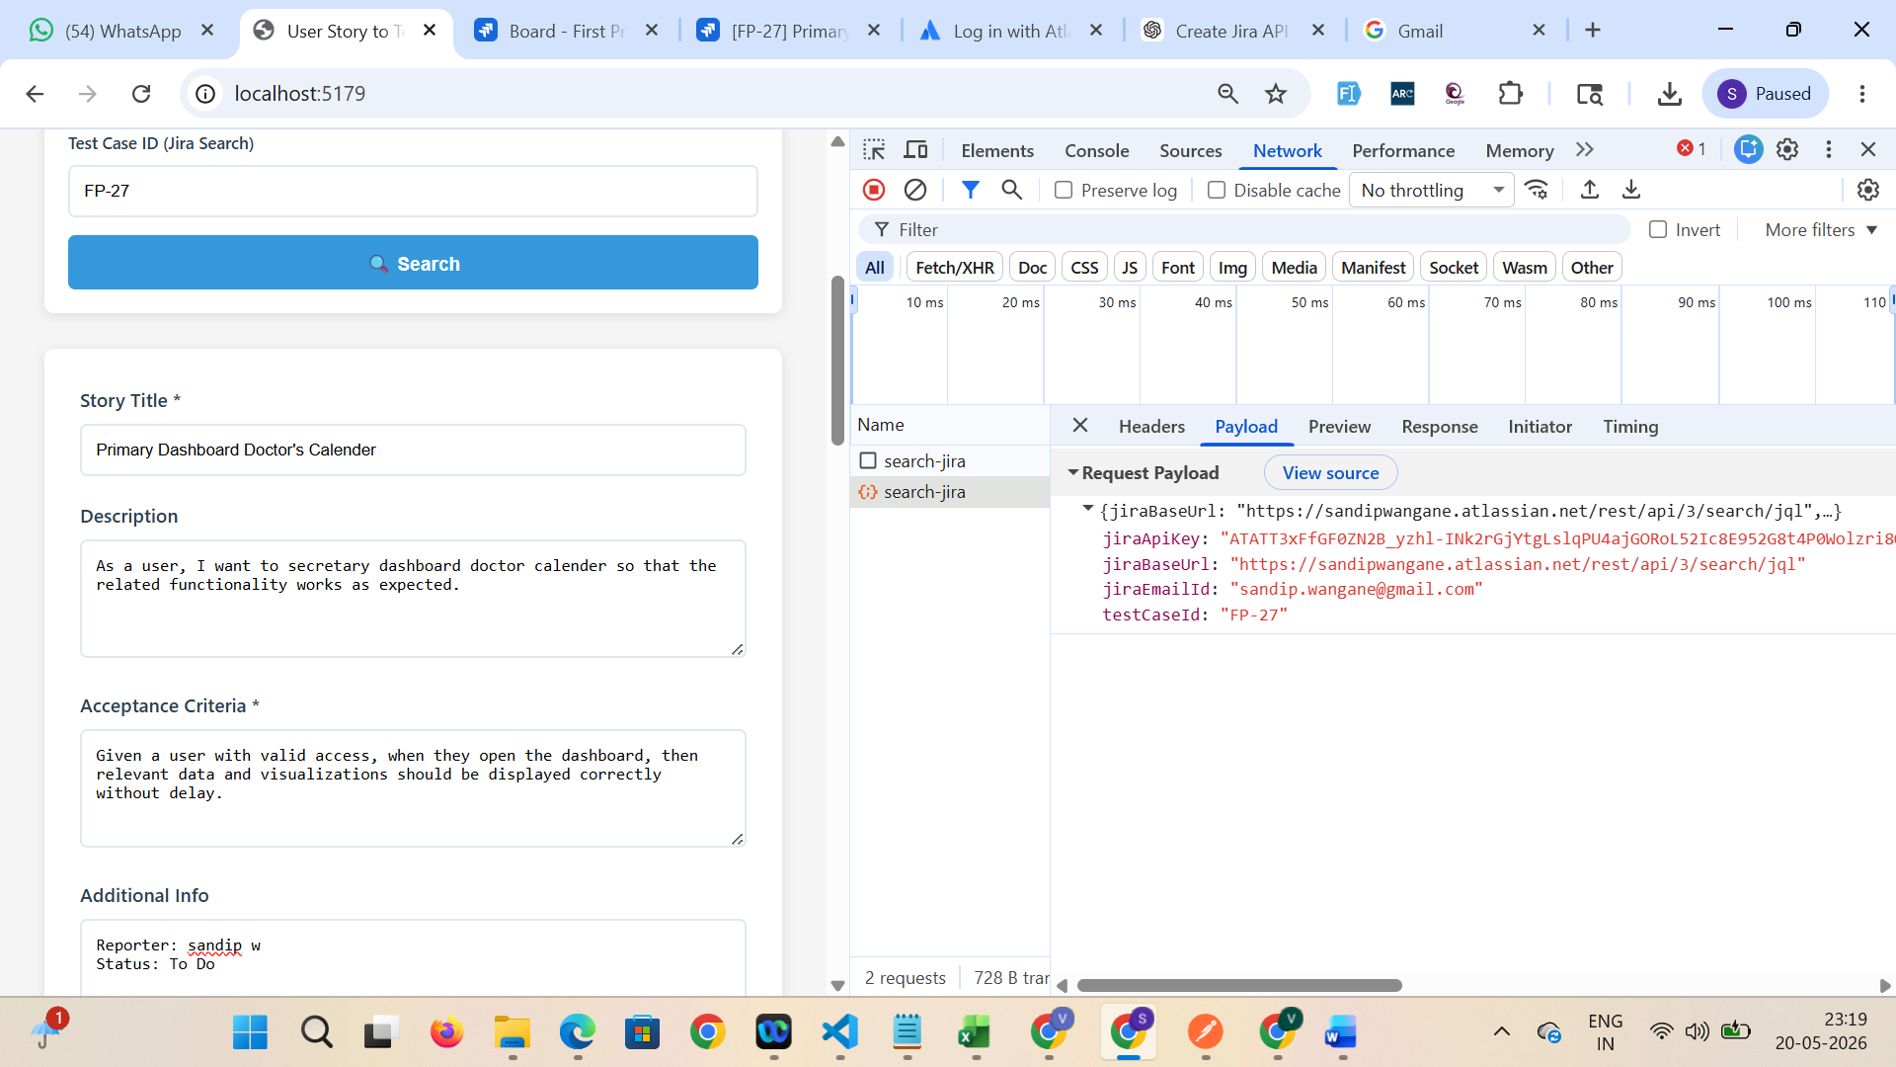

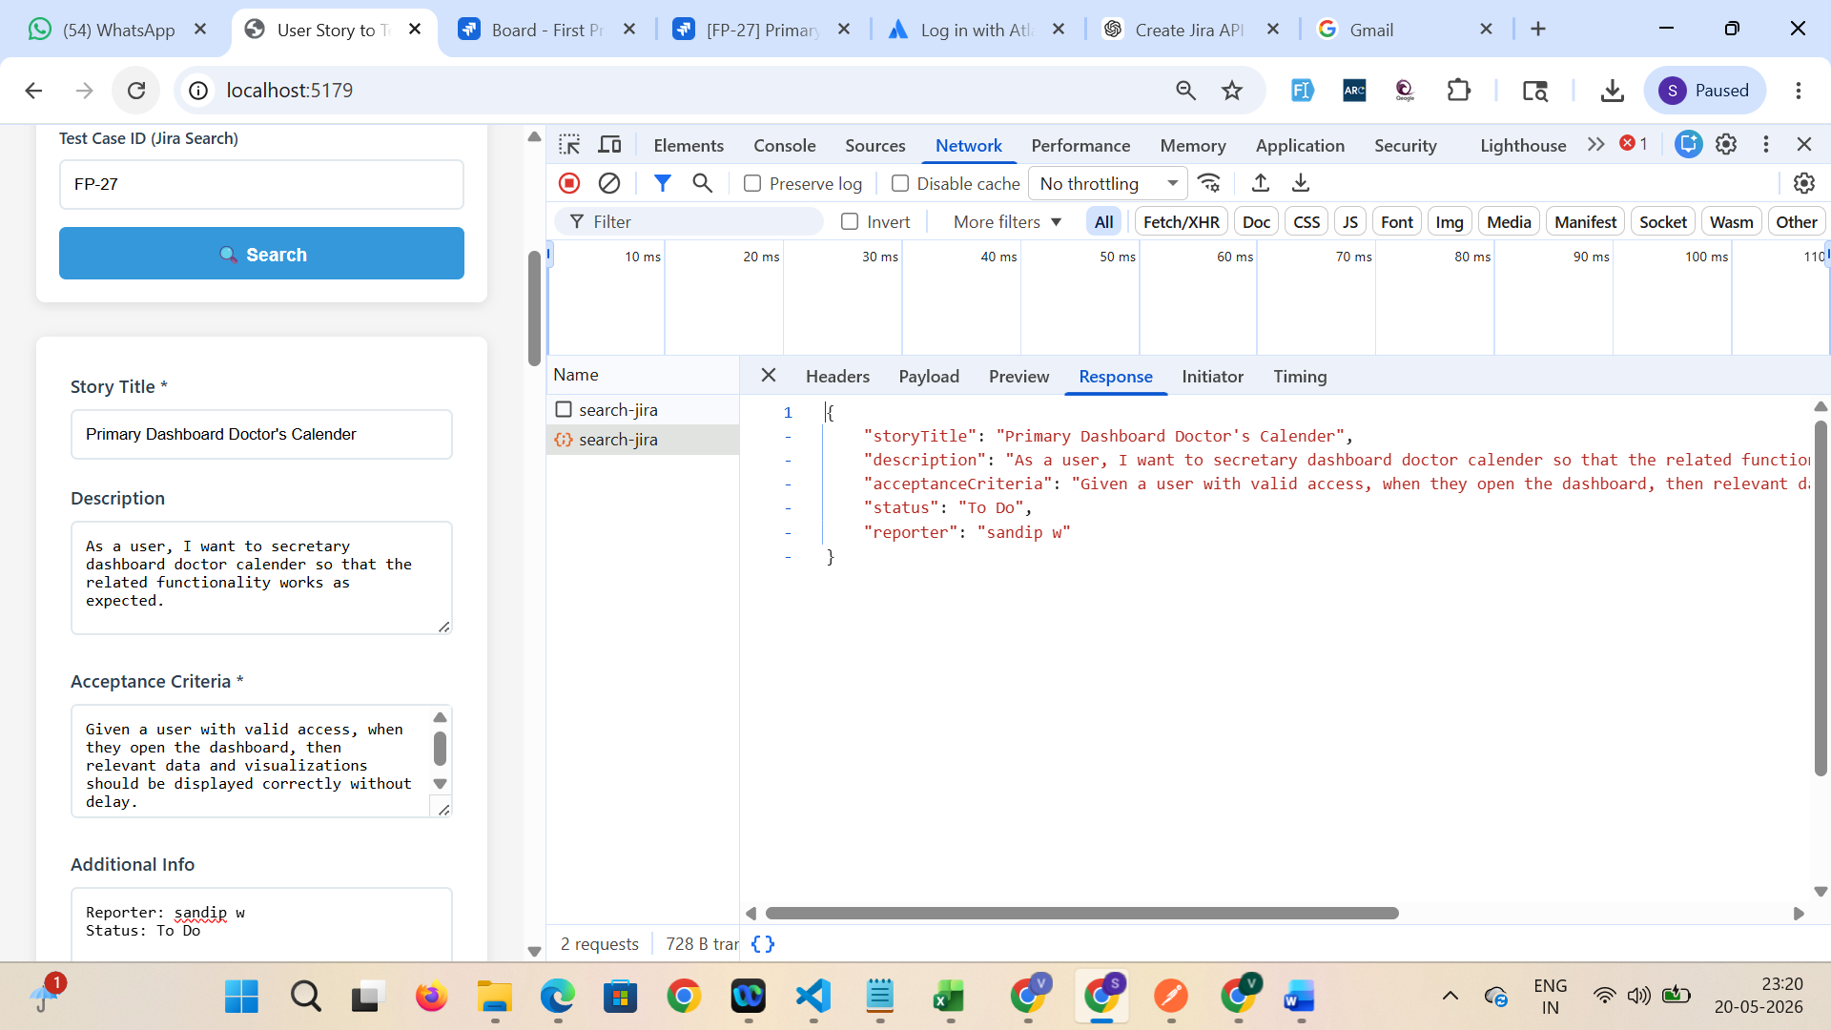

After Clicking on Generate button, it is generating the test cases
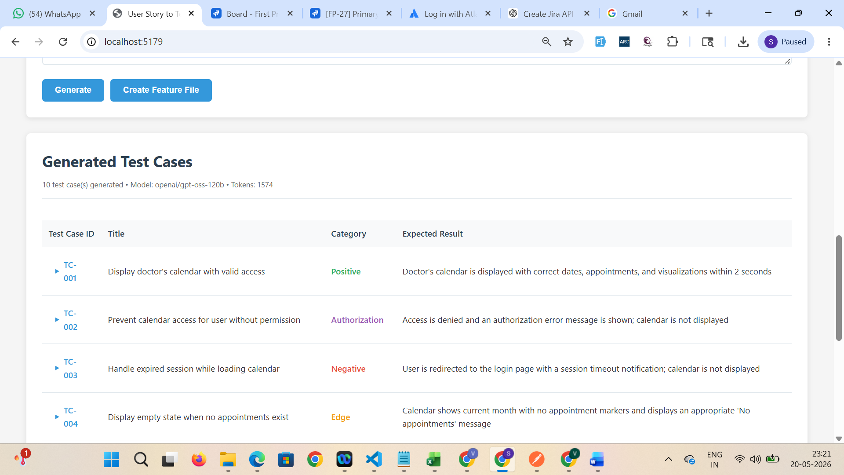

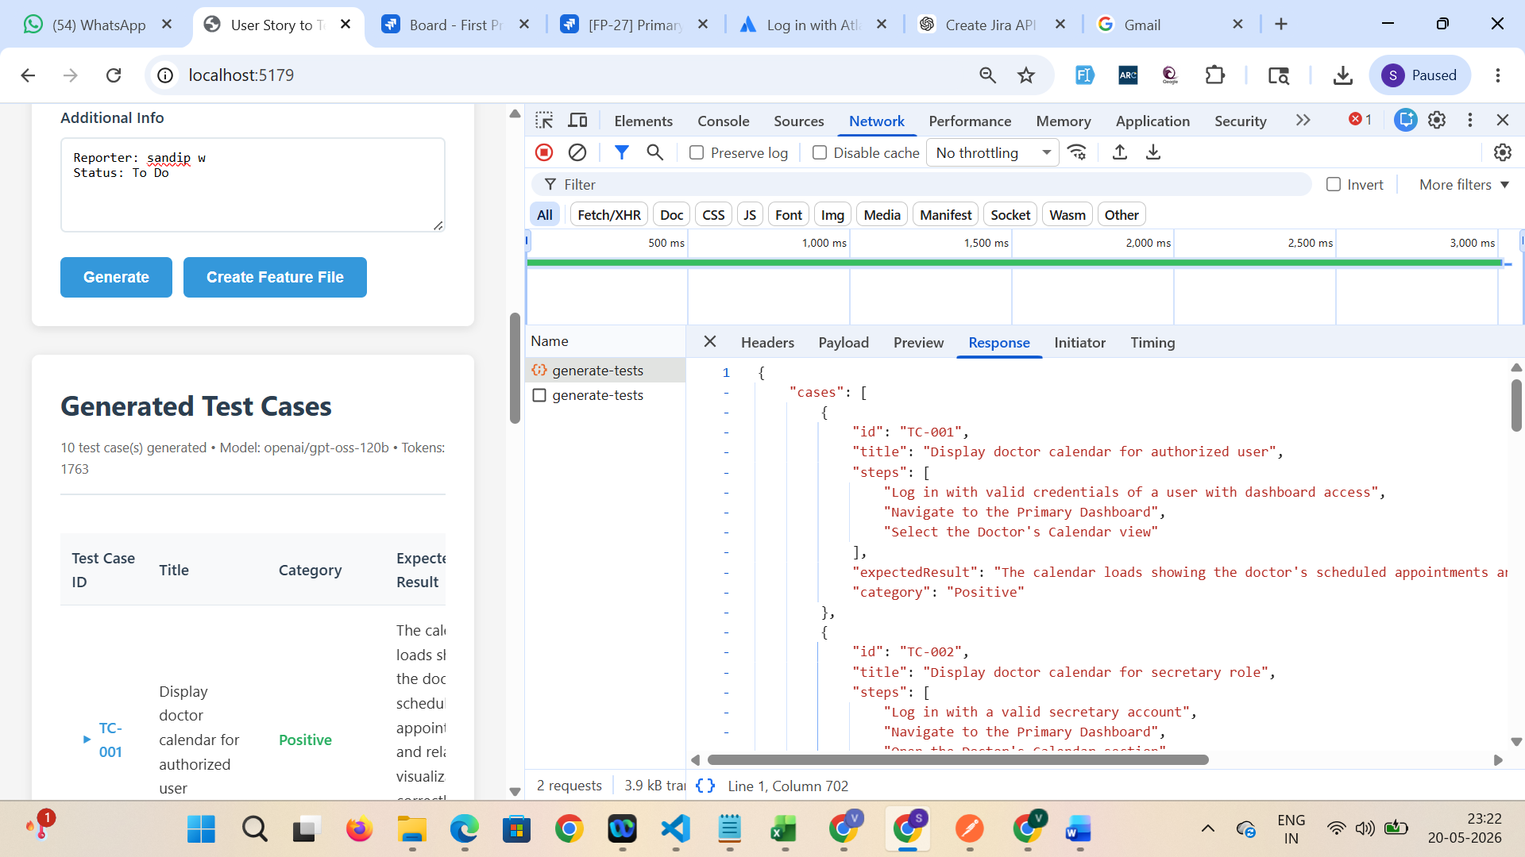

After clicking on ‘Create feature File’ button, it displays Feature file and download button to download feature file
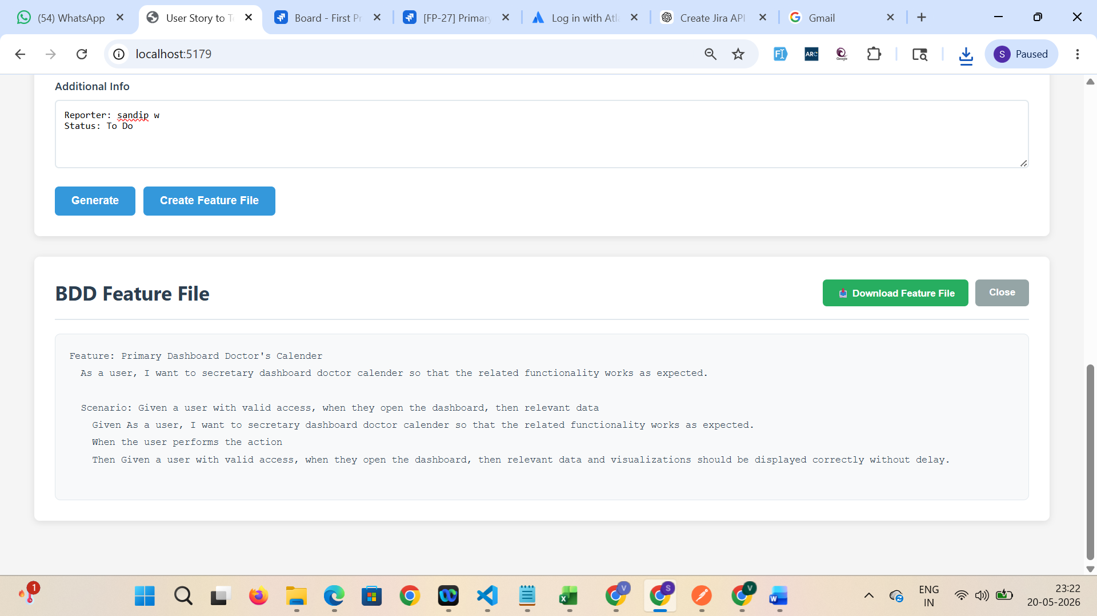

Downloaded feature files
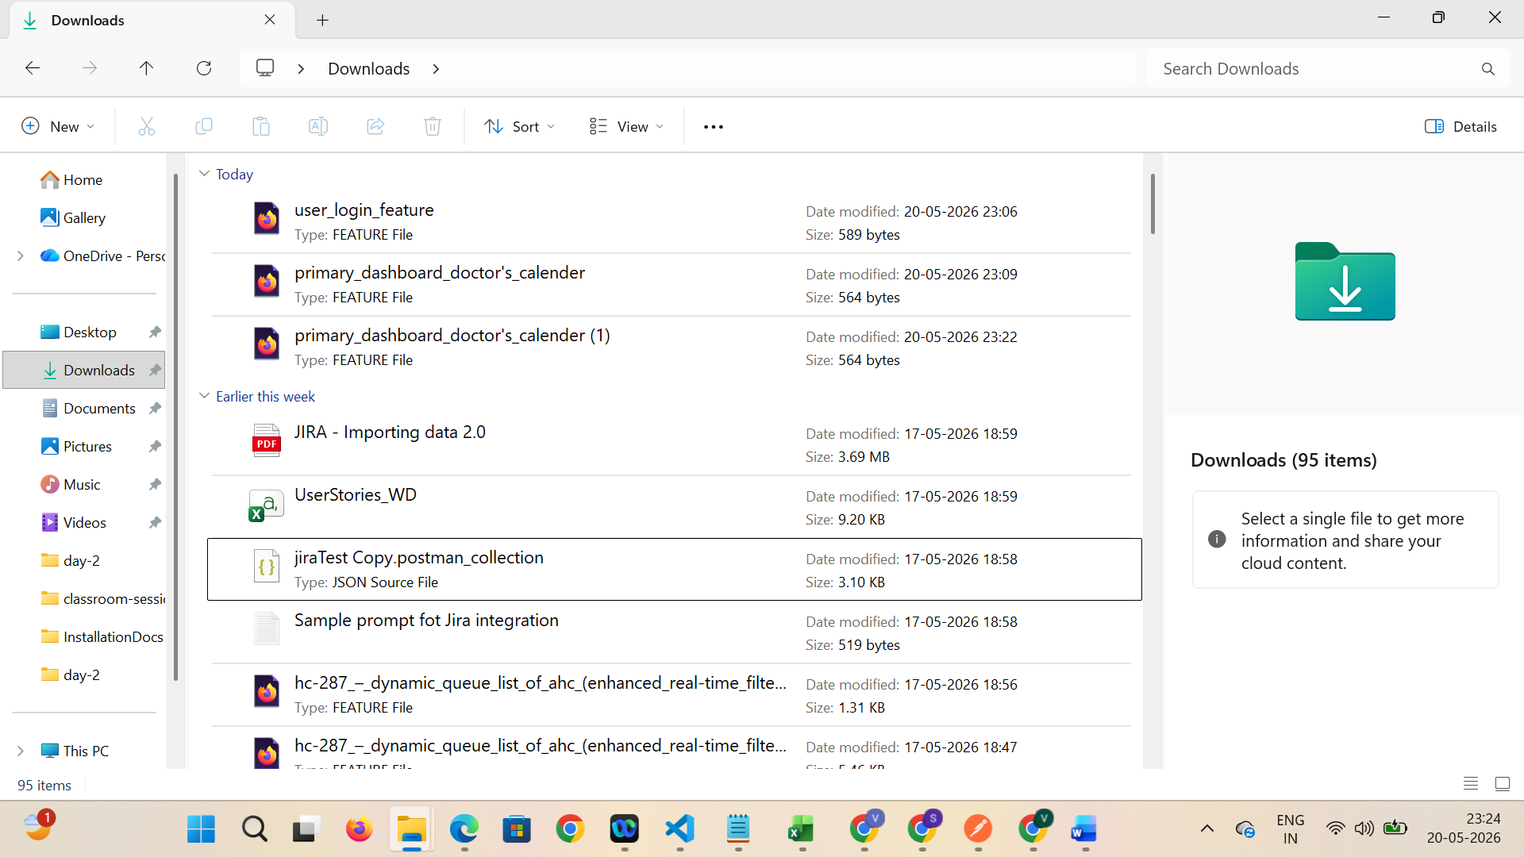

I used 3 different mail ids due to token expiry so session management was not done. Taking screenshot for last session.
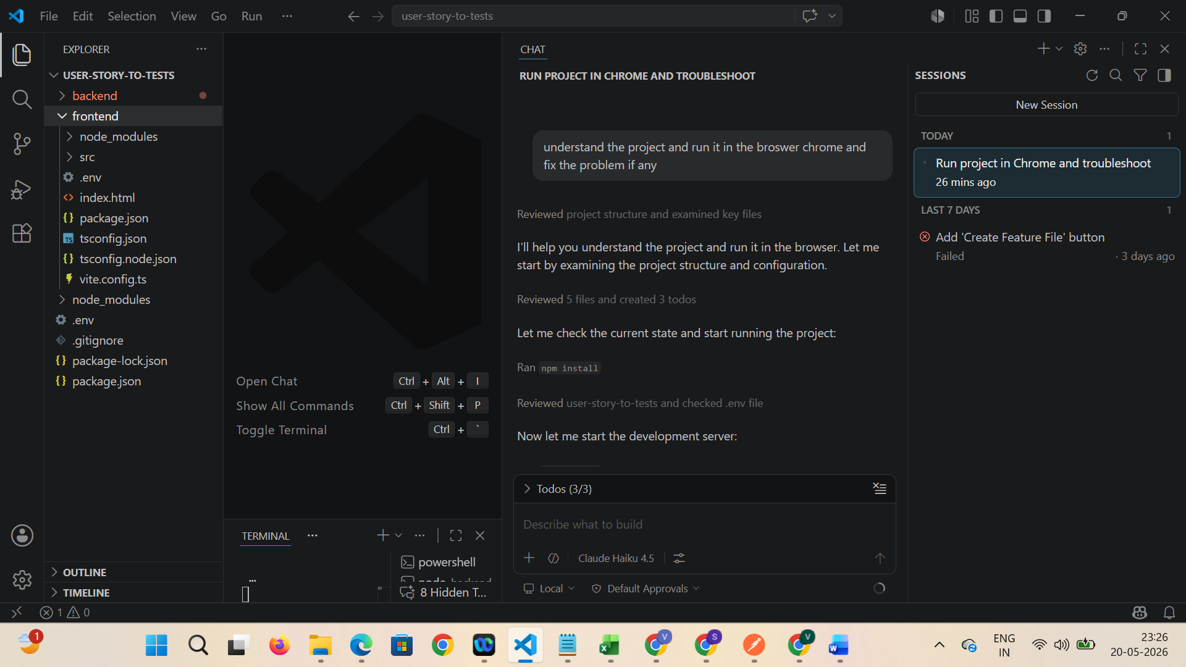





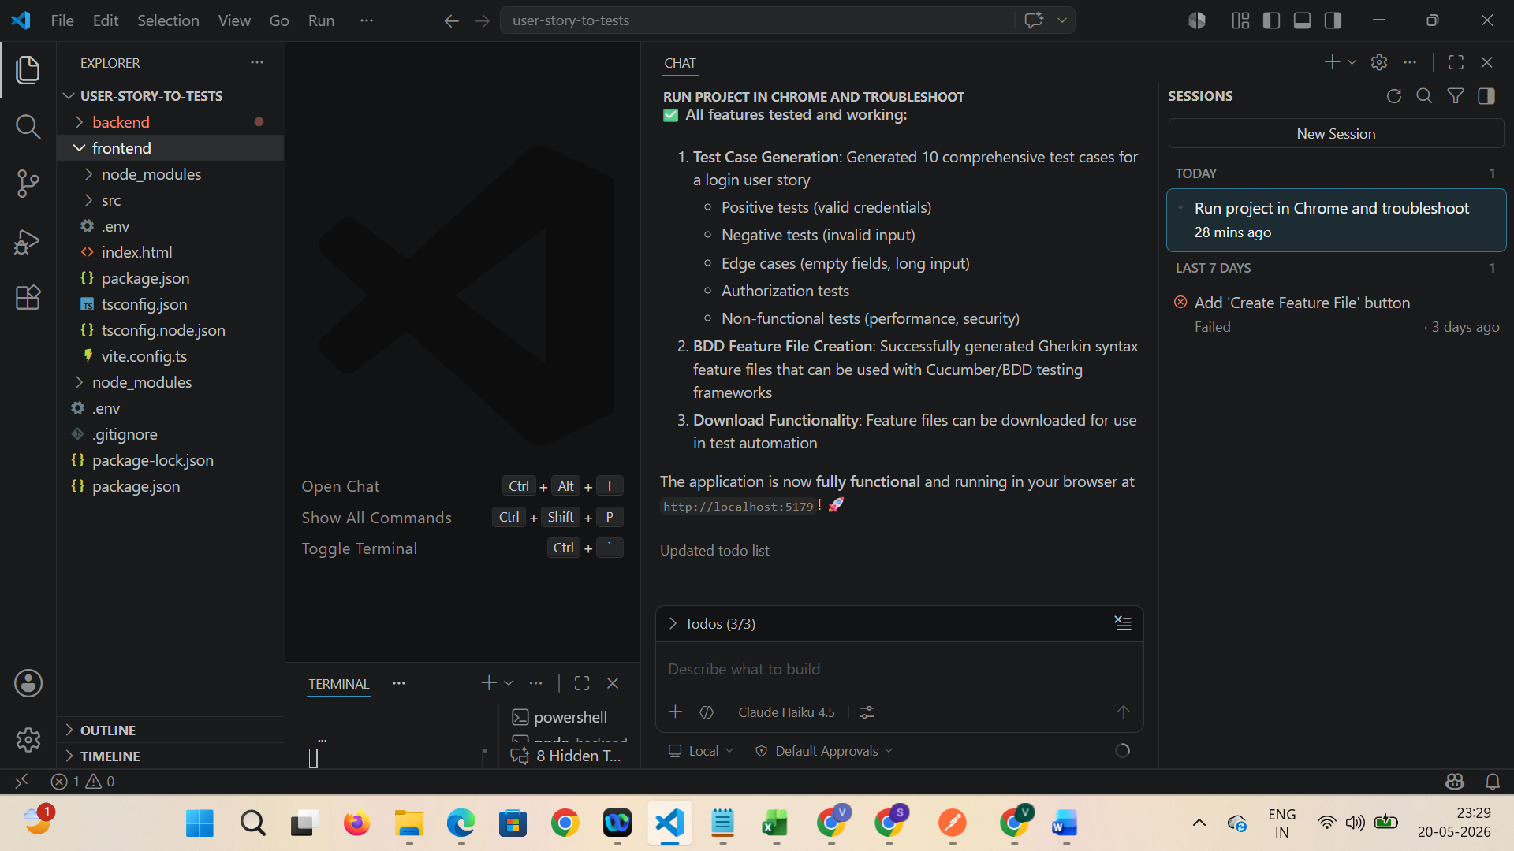



Later I updated

