Import the shared workflows to the LangFlow
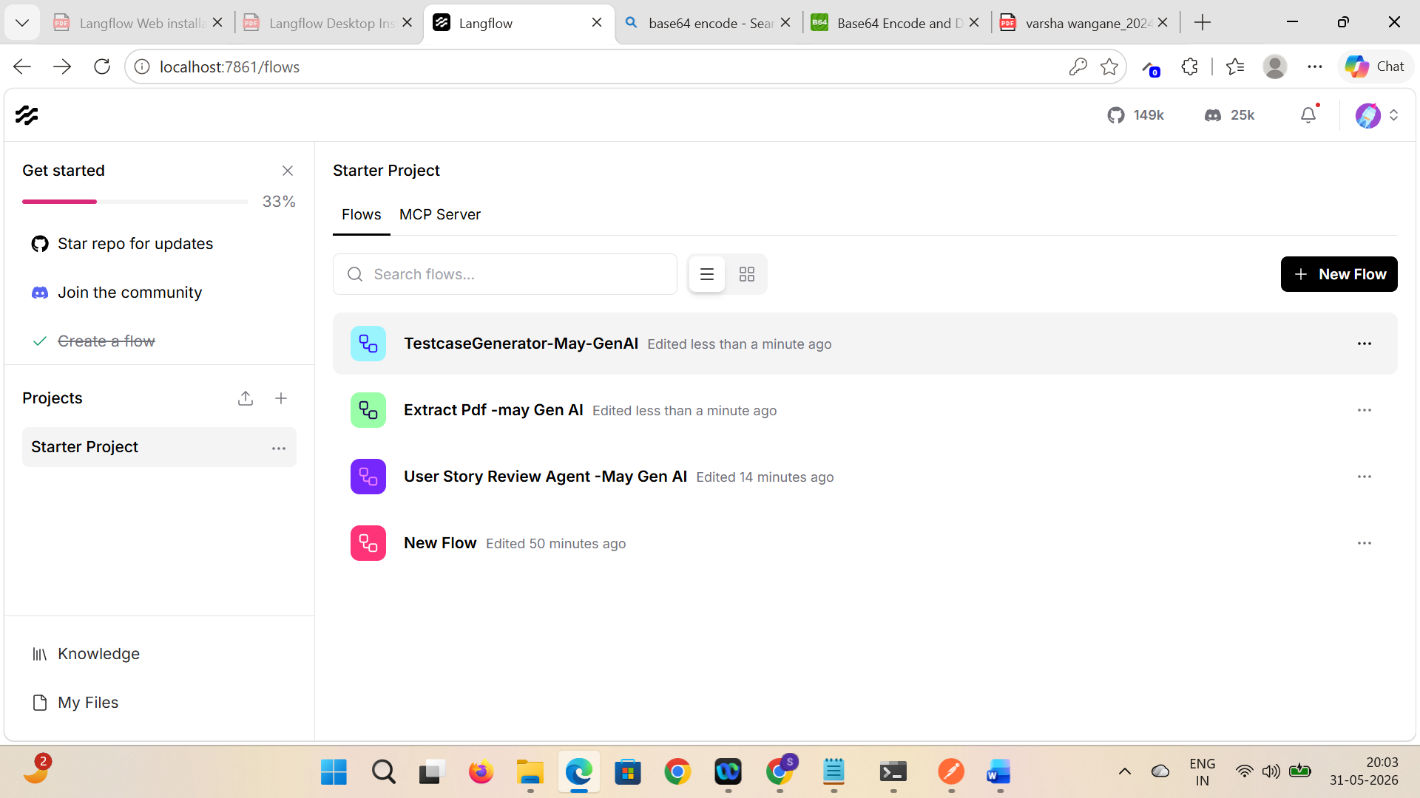

Flow 1 : Generate test cases
Do the suggested configurations and run the workflow
- Updated the Prompt for giving me 5 test cases
- Set groqAPIKey as global variable
- Verified by giving System prompt
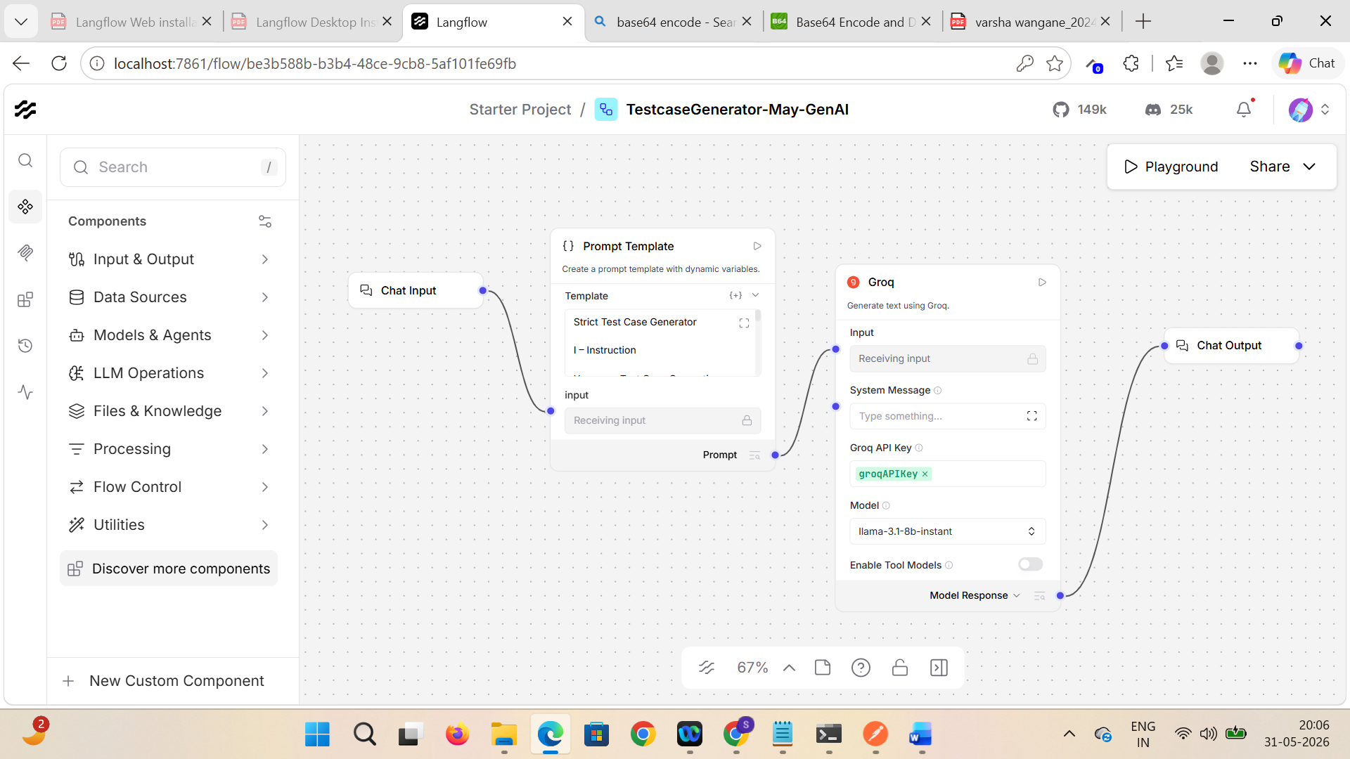

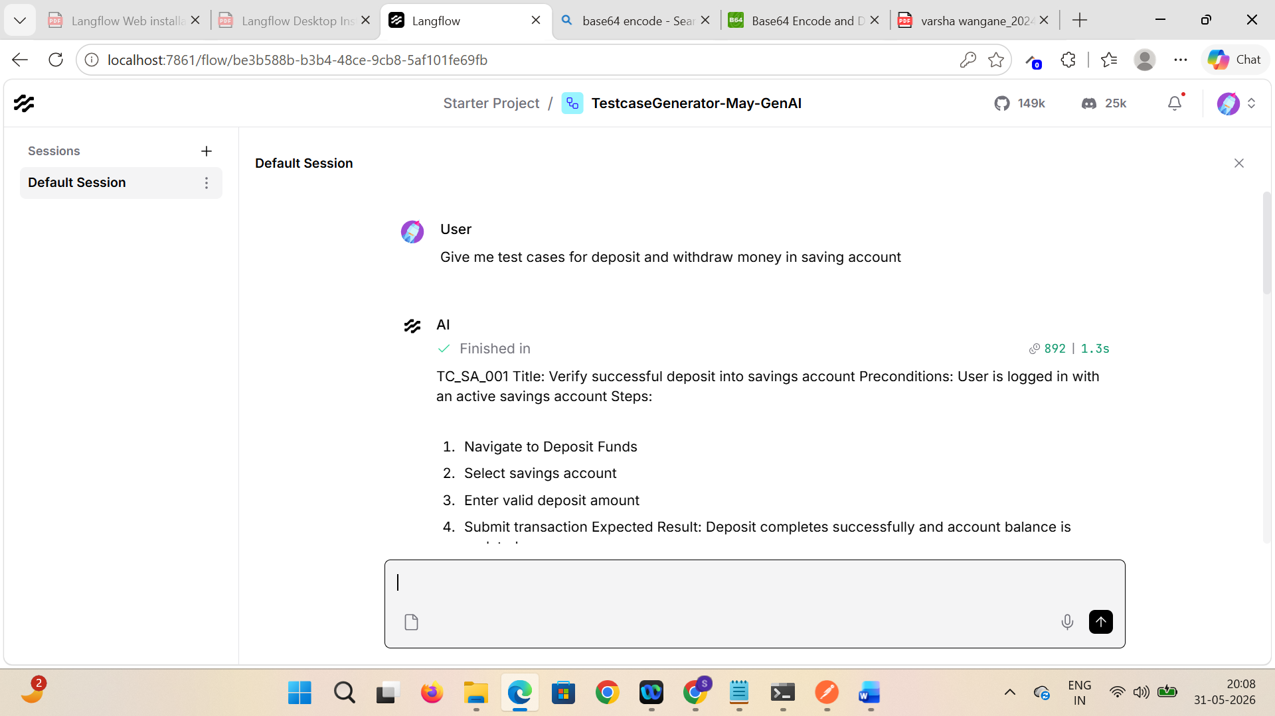

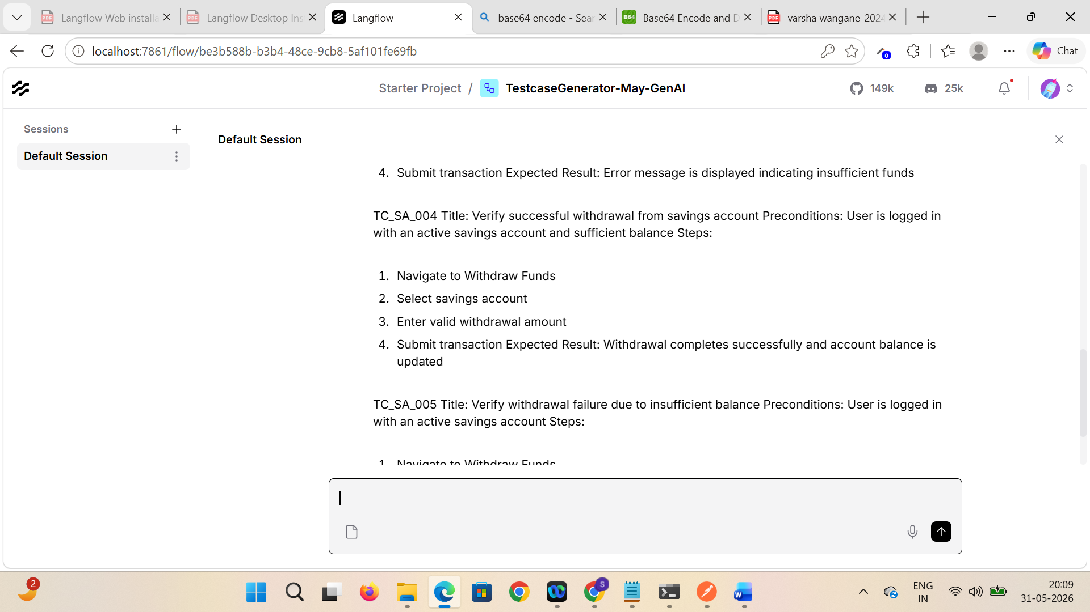

Flow 2 : Review user stories and rate them
- Run the individual component and debug output for each component
- Generate authentication with help of basic 64 encode
- Verify the entire workflow
- After updating the story, verify % of completion is updated
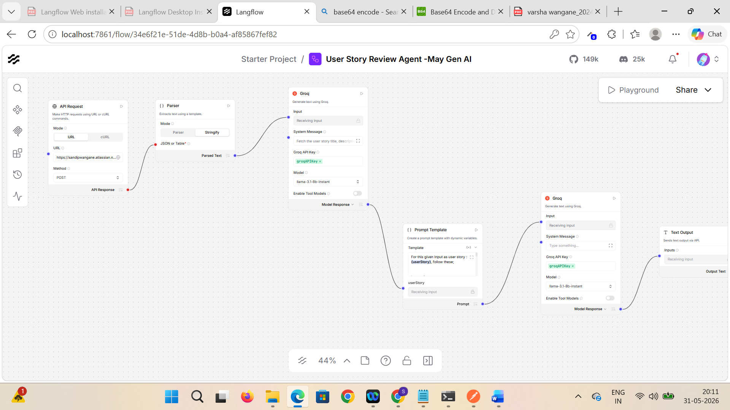

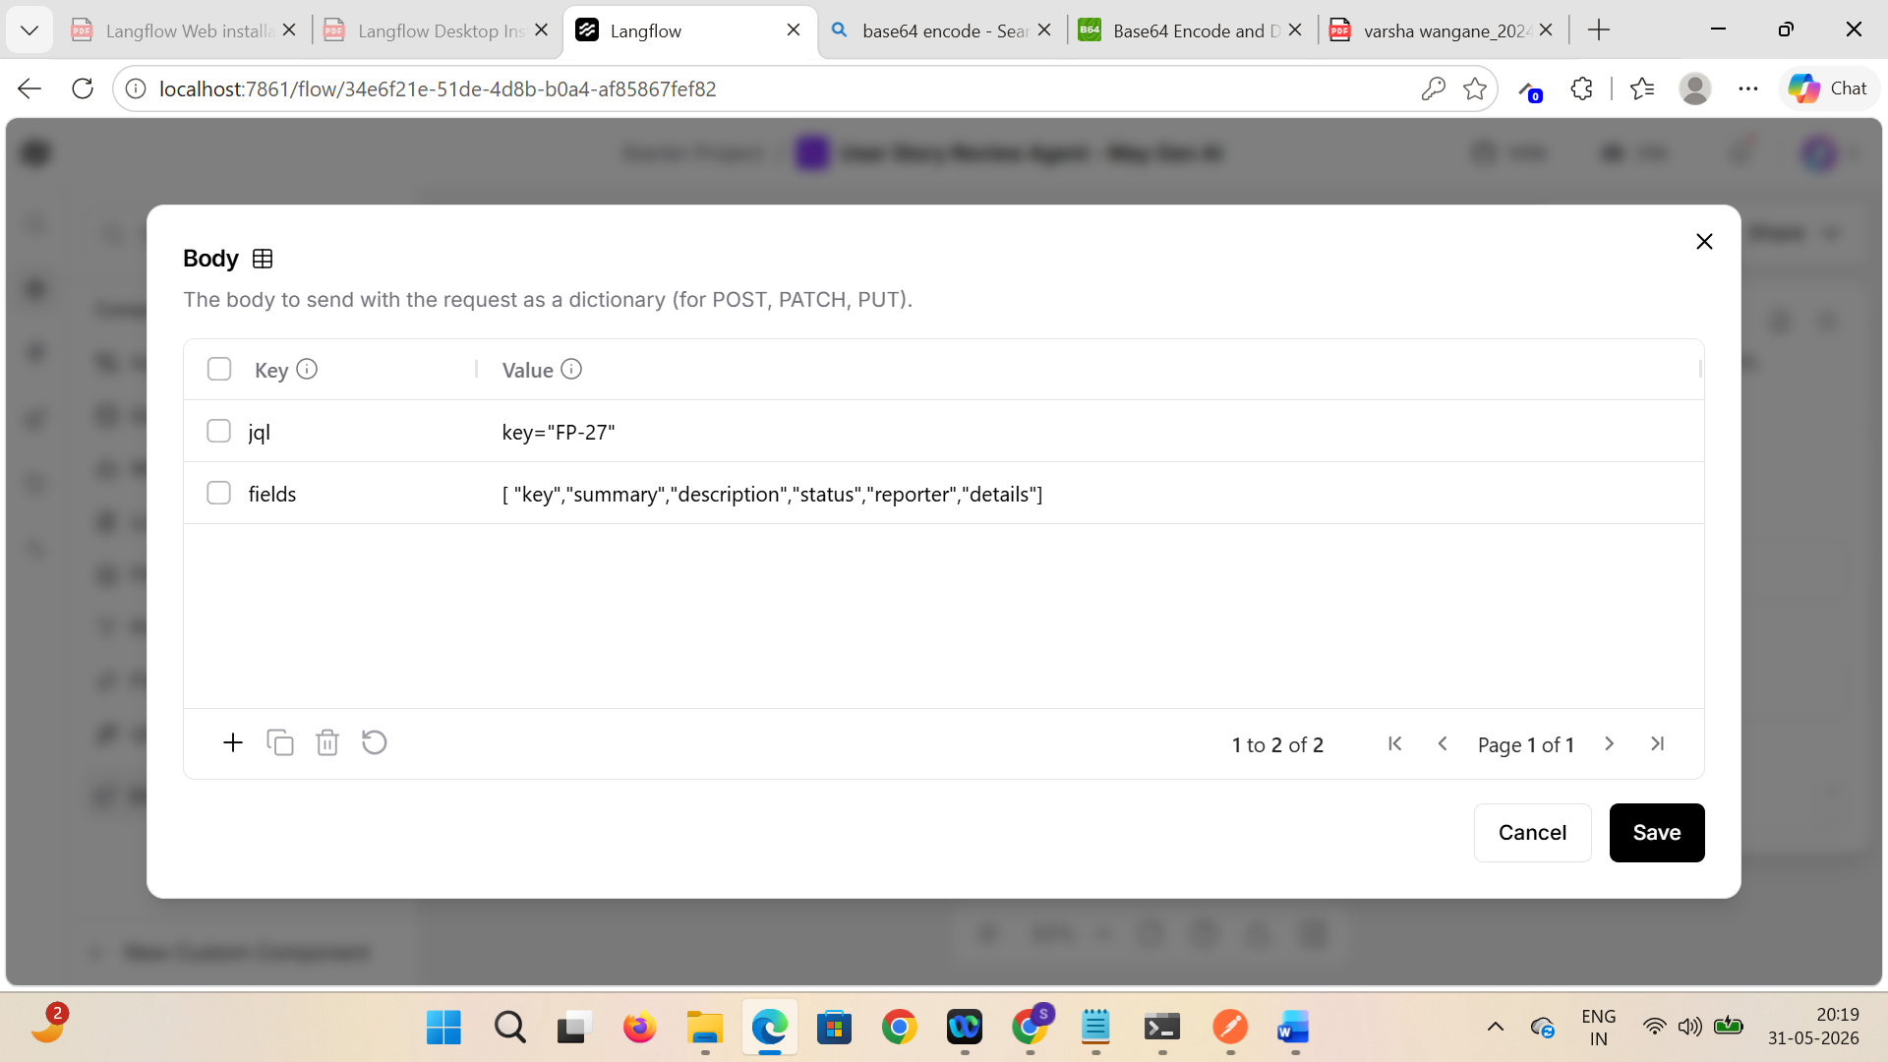

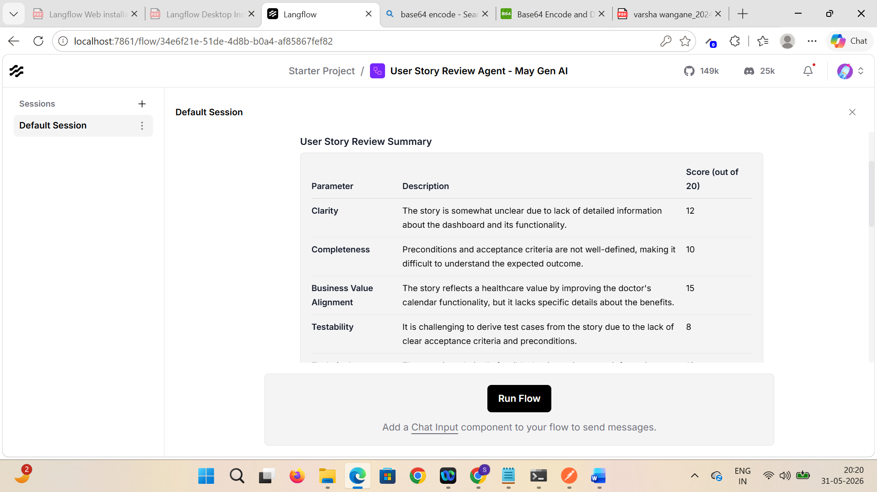

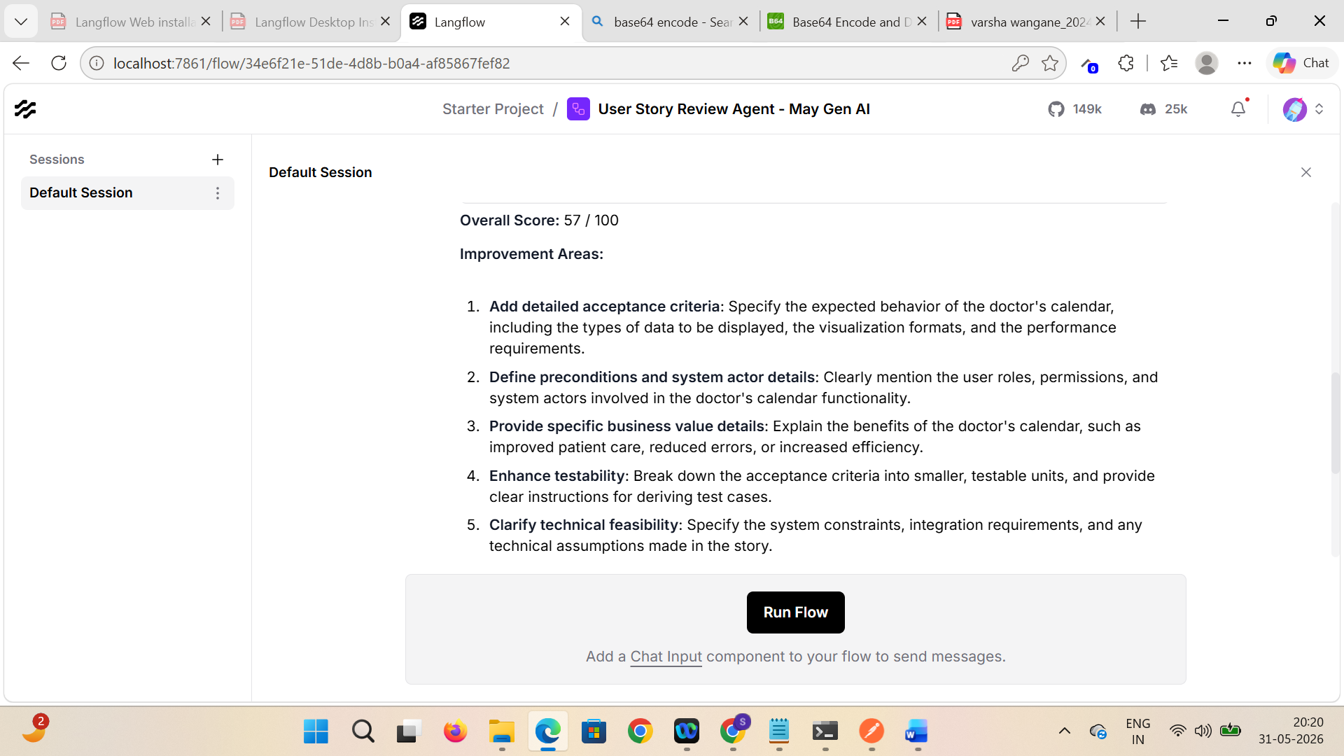

Now, customise the fields in the grog component
- Update Temprature and Max output Tokens as 50 and verify results
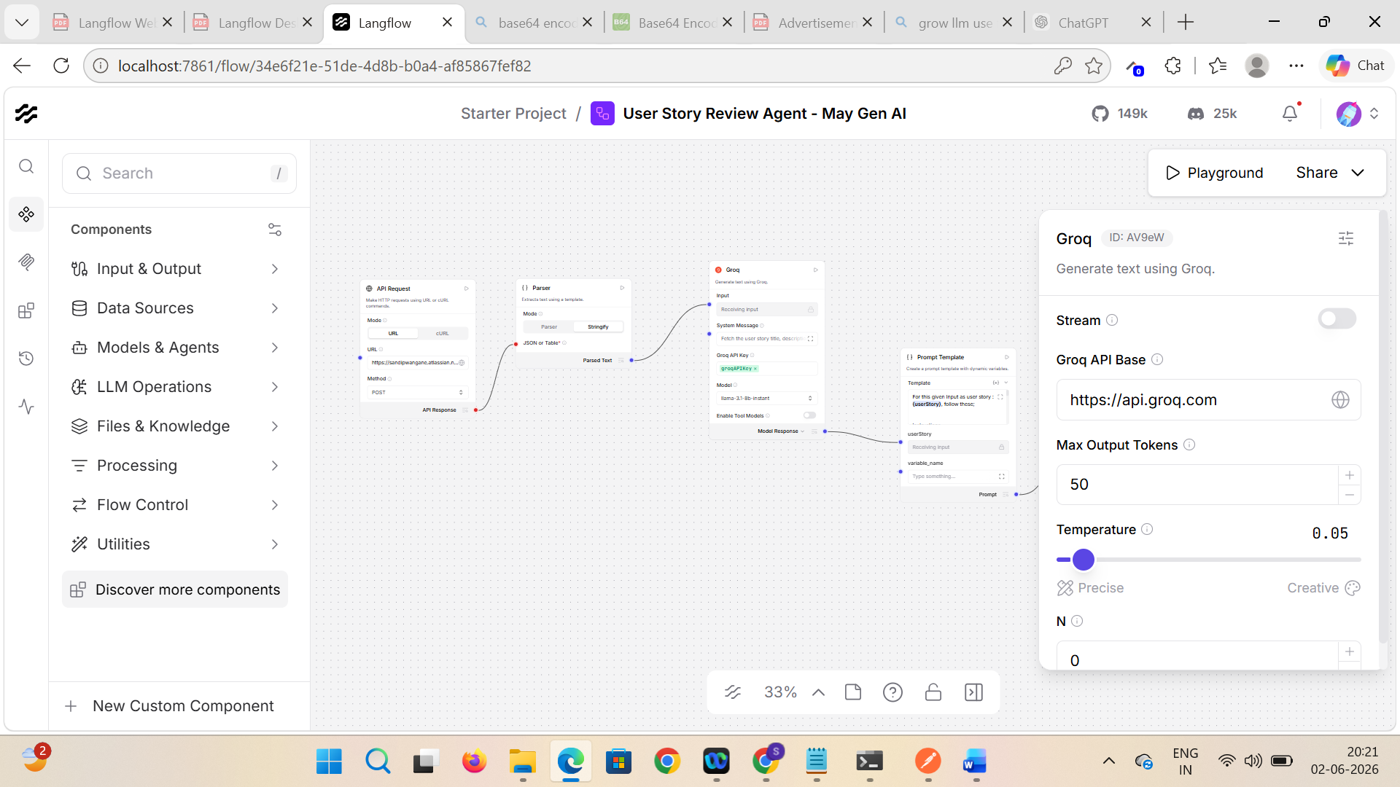

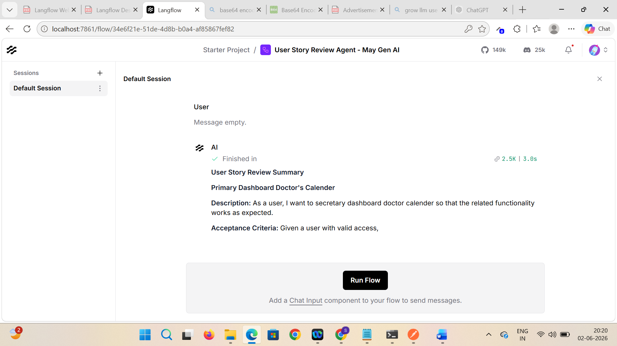

Flow 3 : Extract pdf and fetch details
- Upload pdf
- Extract with help of Prompt Template

