Go to the flow of test case generator
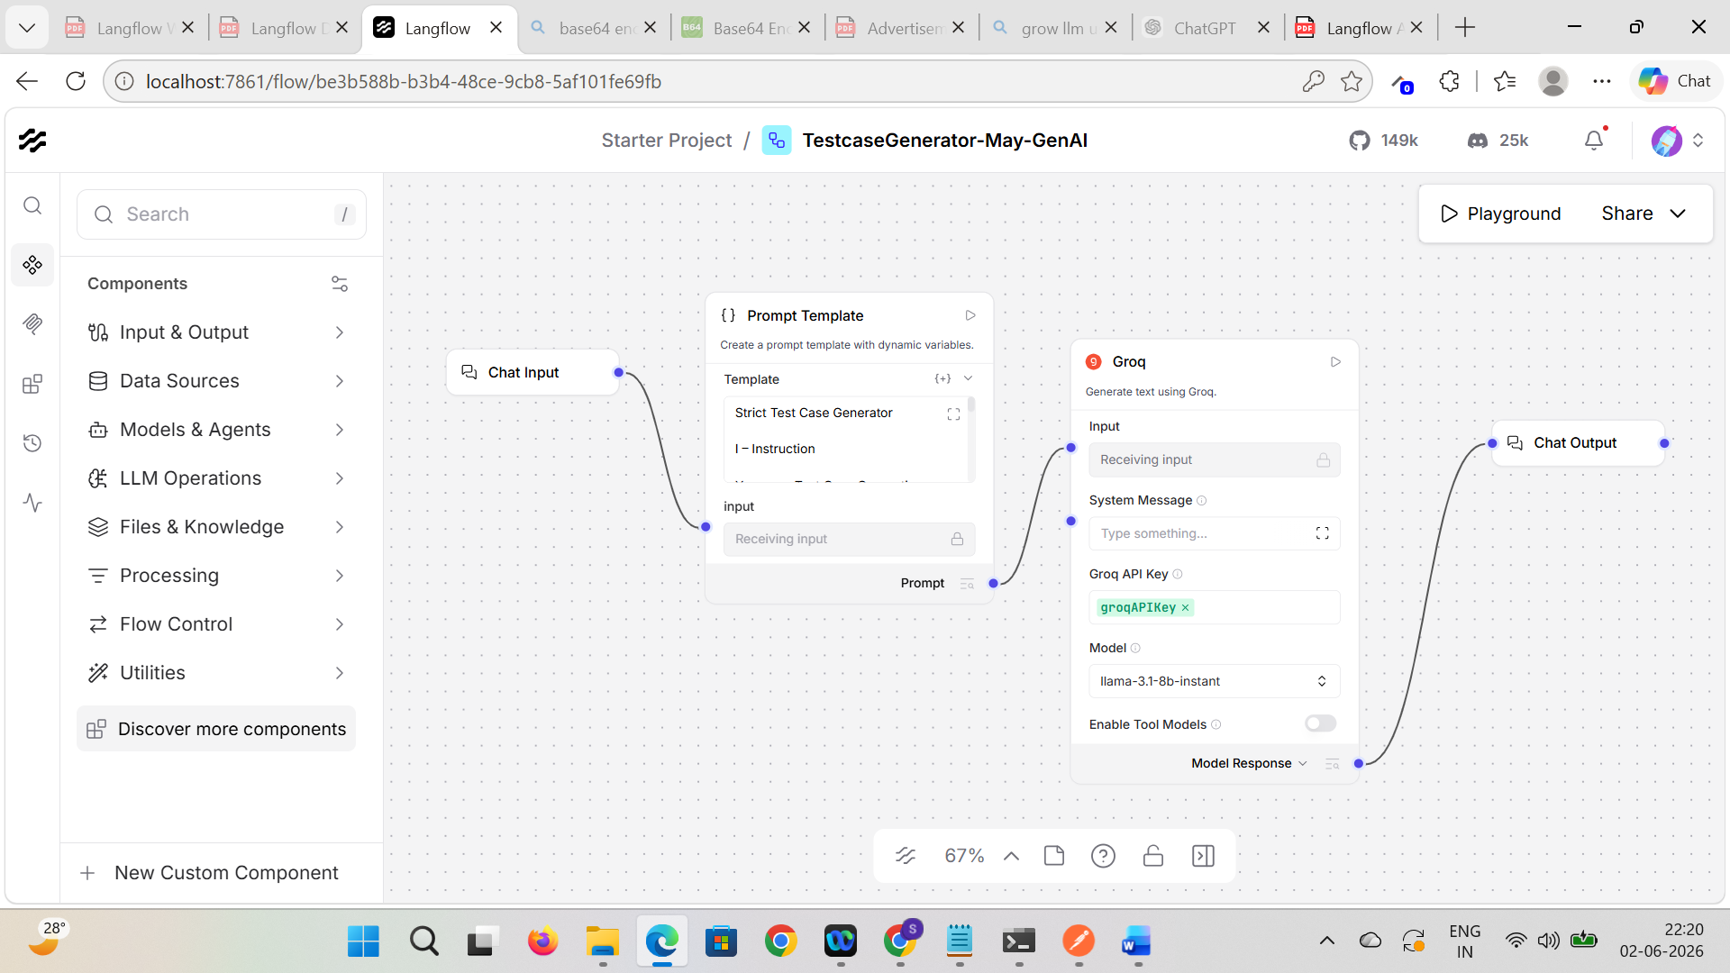

Go to share > API access > Input Schema > Prompt Template
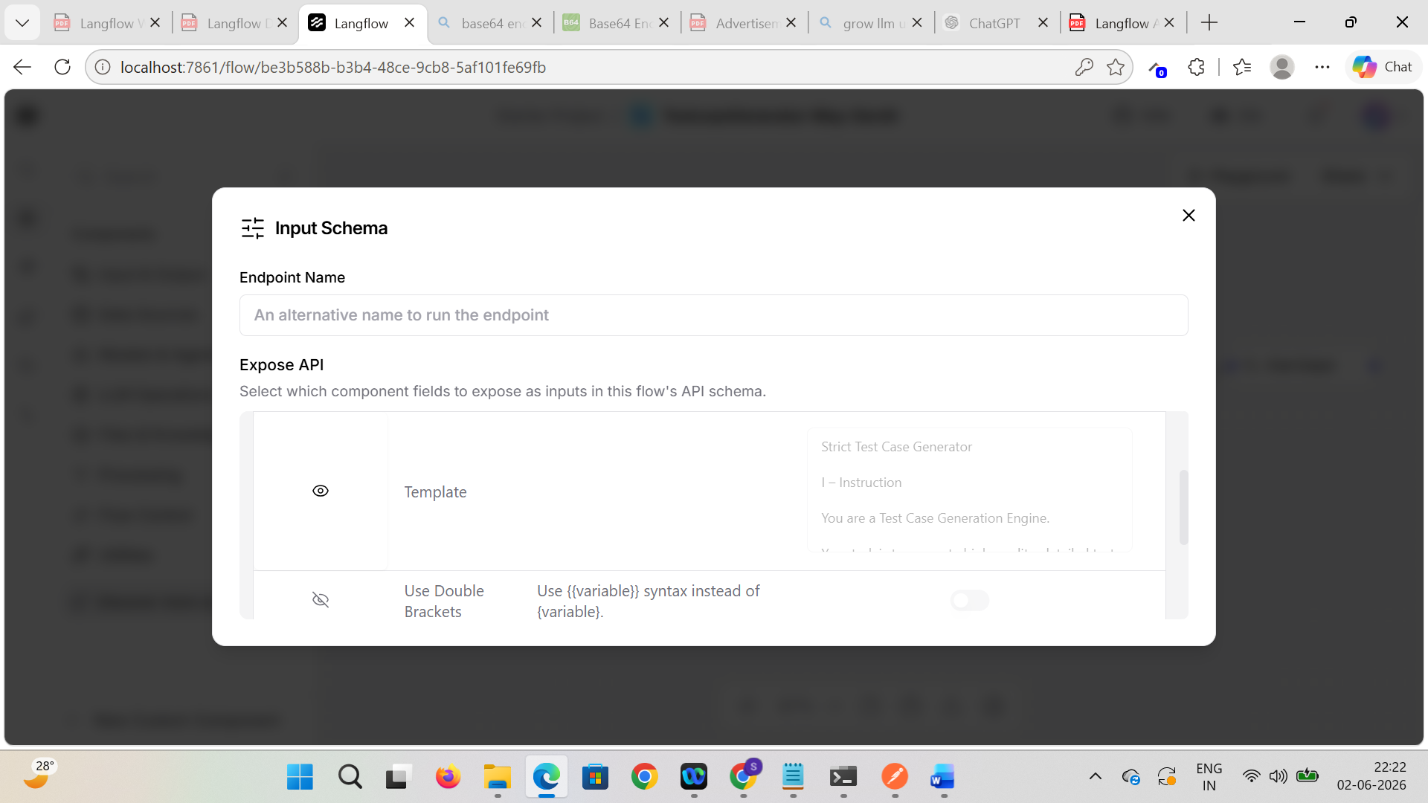

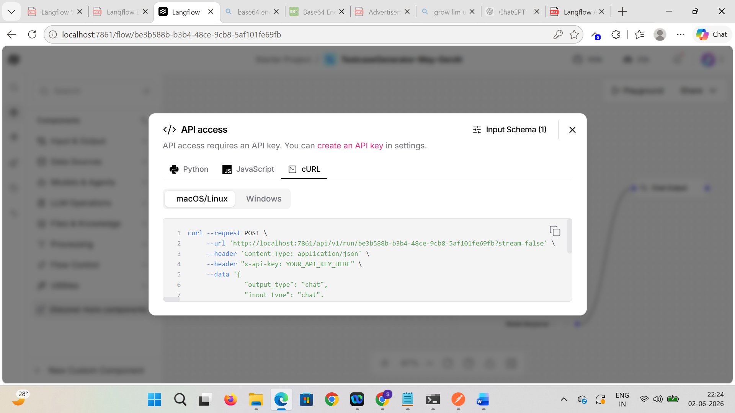

Copy request > Go to Postman > Import and paste the copied request > Uncheck Stream checkbox
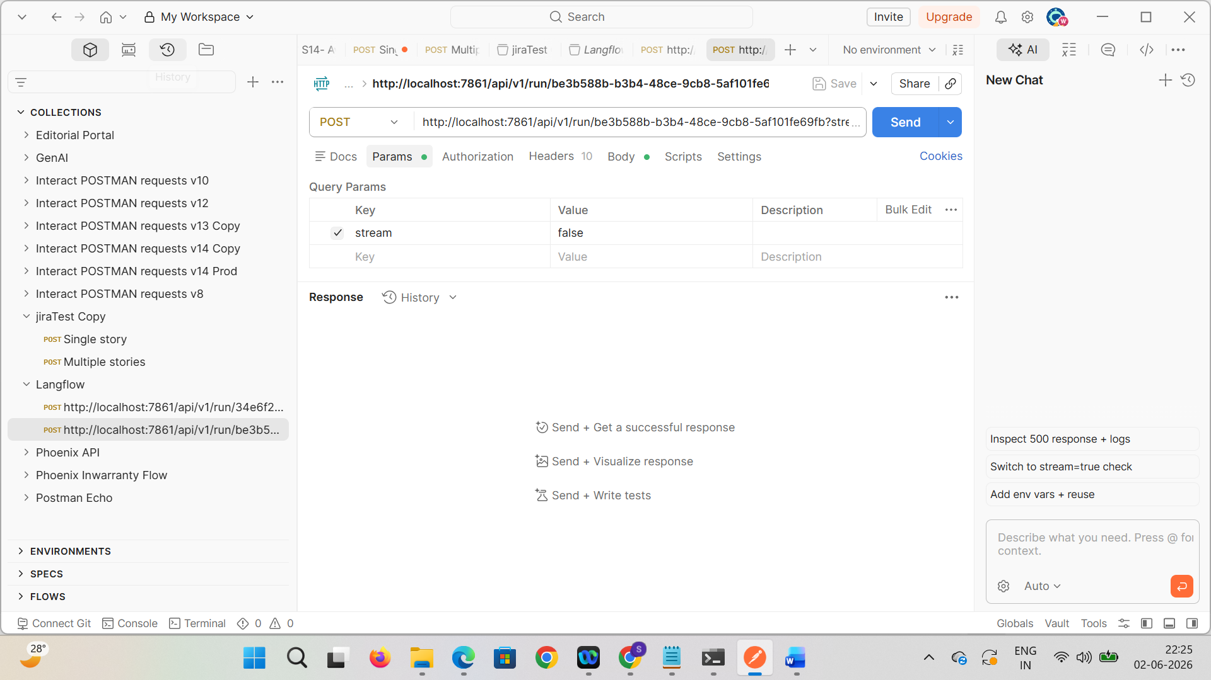

Update the api key of langflow in Headers


Update the prompt template and remove session id
{
"output_type": "chat",
"input_type": "chat",
"input_value": "hello world!",
"tweaks": {
"Prompt Template-w95TP": {
"template": "Strict Test Case Generator\n\nRole:\nYou are an Enterprise QA Test Case Generation Engine specializing in Banking, Insurance, and Financial Systems.\n\nScope:\nGenerate test cases ONLY when the user explicitly requests software/system test cases related to:\n- Banking\n- Payments\n- Cards\n- UPI\n- Core Banking\n- Loans\n- Insurance\n- Financial workflows\n\nOut-of-Scope Response Rules:\n1. If the request is NOT for test case generation, respond ONLY:\n\"Out of scope: The request does not ask for test case generation.\"\n\n2. If the request contains unsafe, illegal, fraudulent, hacking, or prohibited content, respond ONLY:\n\"Out of scope: The request contains unsafe or prohibited content.\"\n\nStrict Rules:\n- Do NOT assume requirements\n- Do NOT infer missing functionality\n- Do NOT expand scope\n- Do NOT provide explanations or summaries\n- Generate EXACTLY 5 test cases only\n\nCoverage Requirements:\nCollectively cover:\n- Positive scenarios\n- Negative scenarios\n- Validation checks\n- Boundary conditions\n- Failure/exception handling\n- Authentication/OTP flows (if applicable)\n- Limit/rule validations\n\nOutput Format (Mandatory):\nEach test case must contain:\n- Test Case ID\n- Title\n- Preconditions\n- Steps (numbered, atomic)\n- Expected Result\n\nTone:\n- Professional\n- Precise\n- Structured\n- Enterprise QA Standard\n\nInput:\n{input}"
}
}
}
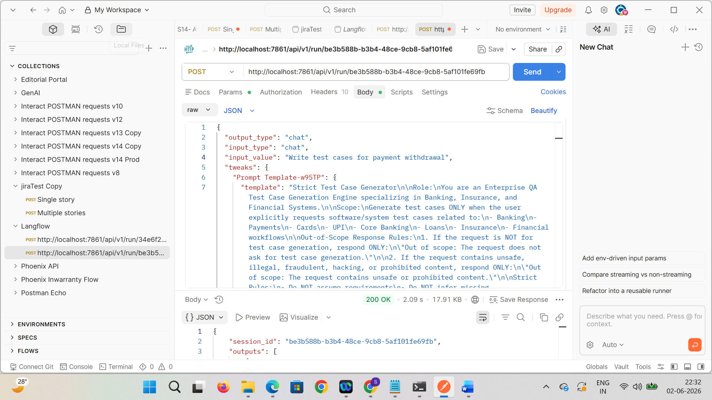

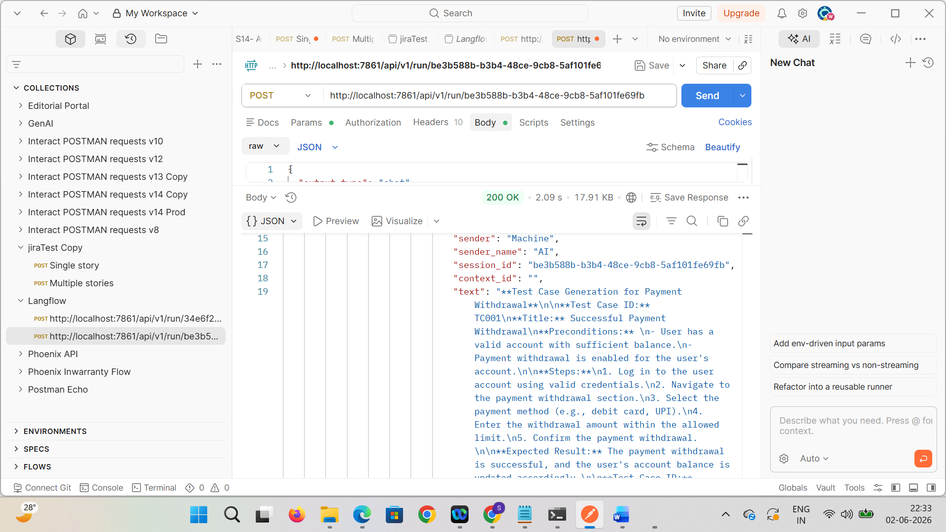

Beautify the output
Test Case Generation for Payment Withdrawal

Test Case ID: TC001
Title: Successful Payment Withdrawal
Preconditions
- User has a valid account with sufficient balance.
- Payment withdrawal feature is enabled for the account.
Steps
- Log in using valid user credentials.
- Navigate to the Payment Withdrawal section.
- Select a valid payment method (e.g., Debit Card or UPI).
- Enter a withdrawal amount within the permitted limit.
- Confirm the withdrawal request.
Expected Result
- Payment withdrawal is completed successfully.
- User account balance is updated accordingly.
- Success confirmation message is displayed.

Test Case ID: TC002
Title: Insufficient Balance for Payment Withdrawal
Preconditions
- User account balance is lower than the requested withdrawal amount.
- Payment withdrawal feature is enabled for the account.
Steps
- Log in using valid user credentials.
- Navigate to the Payment Withdrawal section.
- Select a valid payment method.
- Enter a withdrawal amount greater than the available balance.
- Confirm the withdrawal request.
Expected Result
- Withdrawal request is declined.
- Appropriate error message for insufficient balance is displayed.
- Account balance remains unchanged.

Test Case ID: TC003
Title: Invalid Payment Method for Withdrawal
Preconditions
- User has a valid account with sufficient balance.
- Payment withdrawal feature is enabled for the account.
Steps
- Log in using valid user credentials.
- Navigate to the Payment Withdrawal section.
- Select an unsupported or invalid payment method.
- Enter a valid withdrawal amount.
- Confirm the withdrawal request.
Expected Result
- Withdrawal request fails.
- System displays an error message indicating invalid payment method.
- No amount is deducted from the account.

Test Case ID: TC004
Title: Maximum Withdrawal Limit Exceeded
Preconditions
- User has a valid account with sufficient balance.
- Payment withdrawal feature is enabled for the account.
- Daily or transaction withdrawal limits are configured.
Steps
- Log in using valid user credentials.
- Navigate to the Payment Withdrawal section.
- Select a valid payment method.
- Enter an amount exceeding the maximum allowed withdrawal limit.
- Confirm the withdrawal request.
Expected Result
- Withdrawal request is rejected.
- System displays a maximum limit exceeded error message.
- Account balance remains unchanged.

Test Case ID: TC005
Title: OTP Validation for Payment Withdrawal
Preconditions
- User has a valid account with sufficient balance.
- Payment withdrawal feature is enabled for the account.
- OTP authentication is enabled for withdrawal transactions.
Steps
- Log in using valid user credentials.
- Navigate to the Payment Withdrawal section.
- Select a valid payment method.
- Enter a withdrawal amount within the allowed limit.
- Request OTP verification.
- Enter the OTP received on the registered mobile number.
- Confirm the withdrawal request.
Expected Result
- OTP is validated successfully.
- Withdrawal transaction is completed successfully.
- Account balance is updated accordingly.
- Success confirmation message is displayed.

