Go to the flow
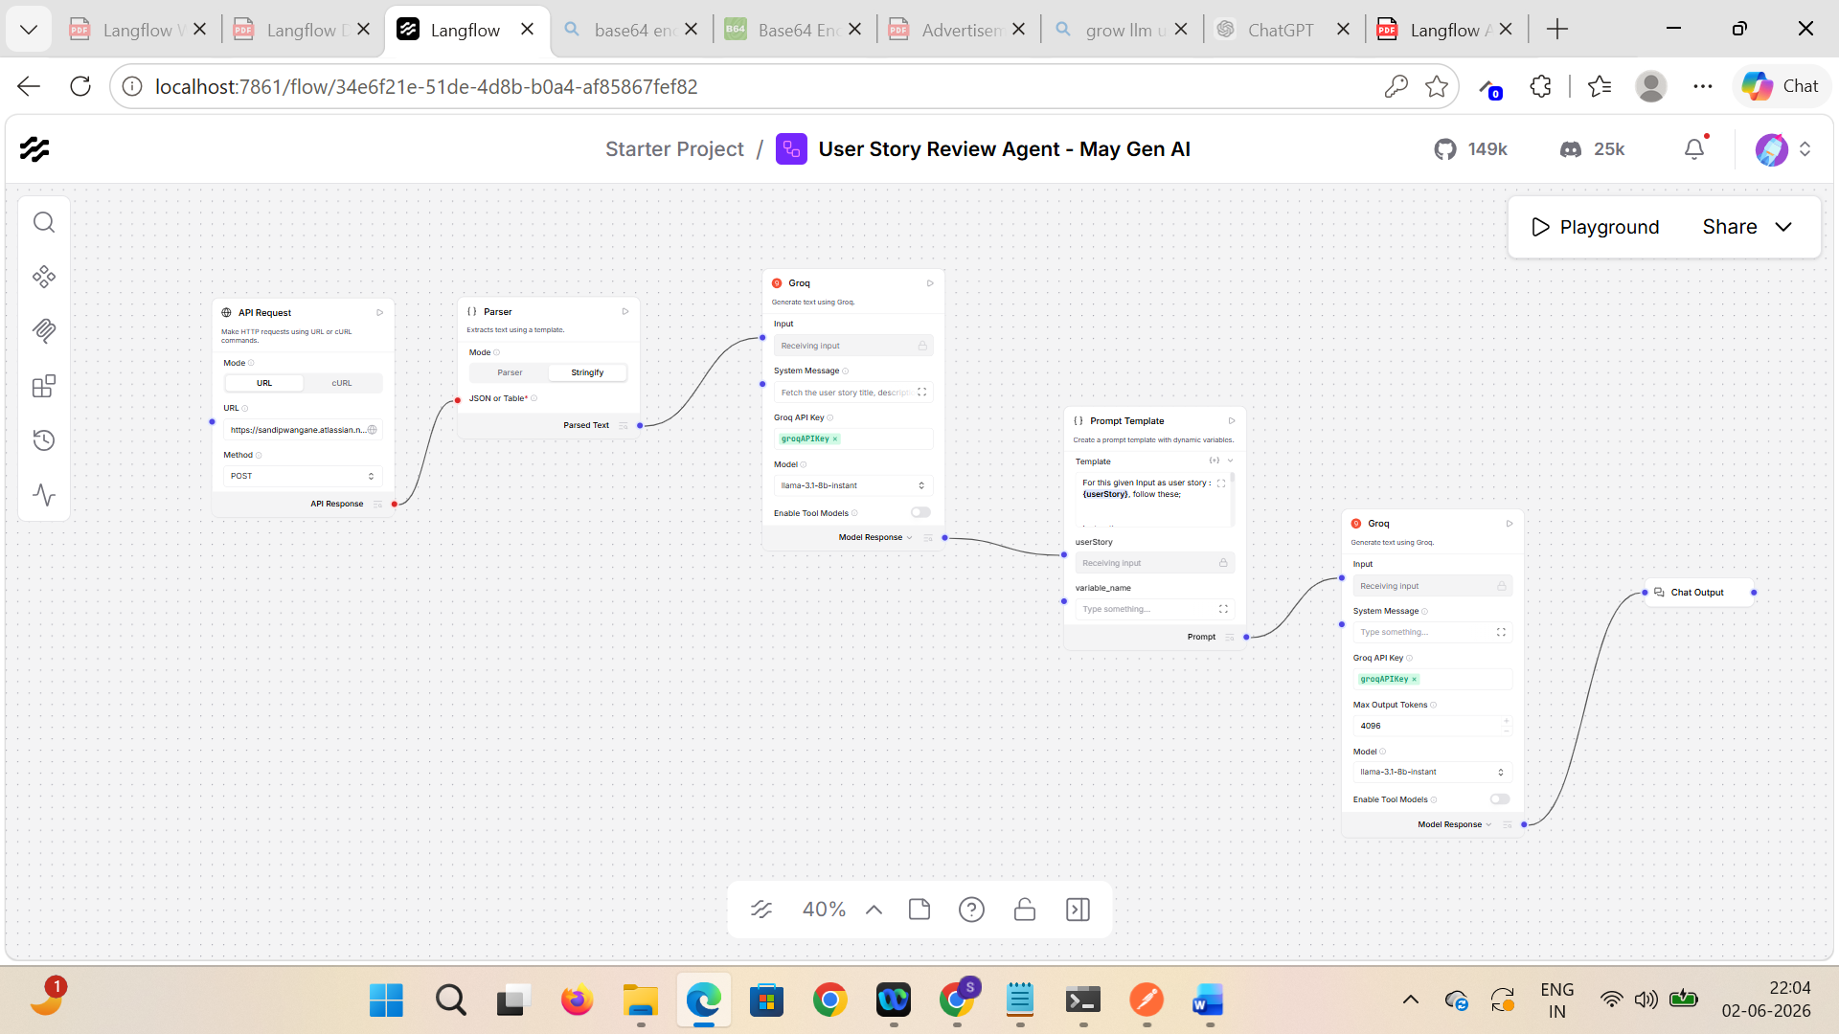
Go to Share > API Access > Input schema

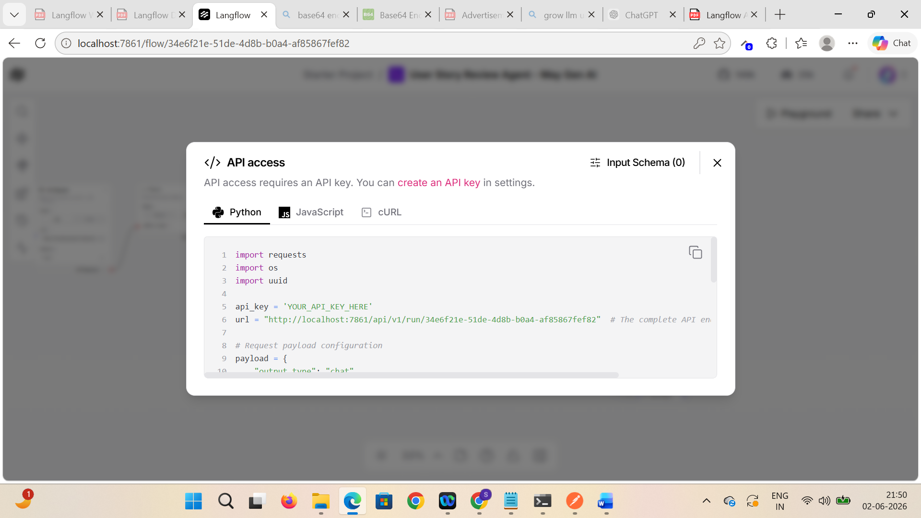

Update input schema
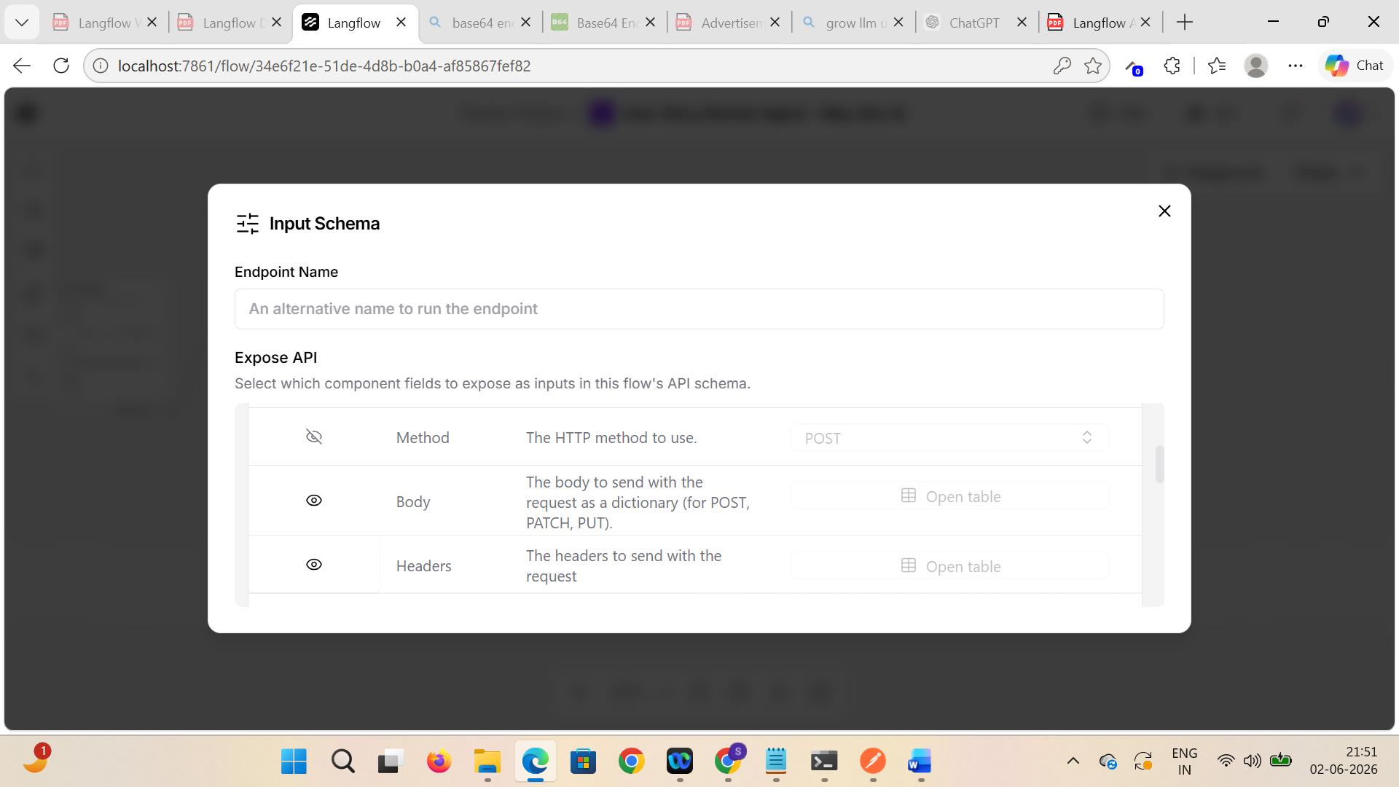

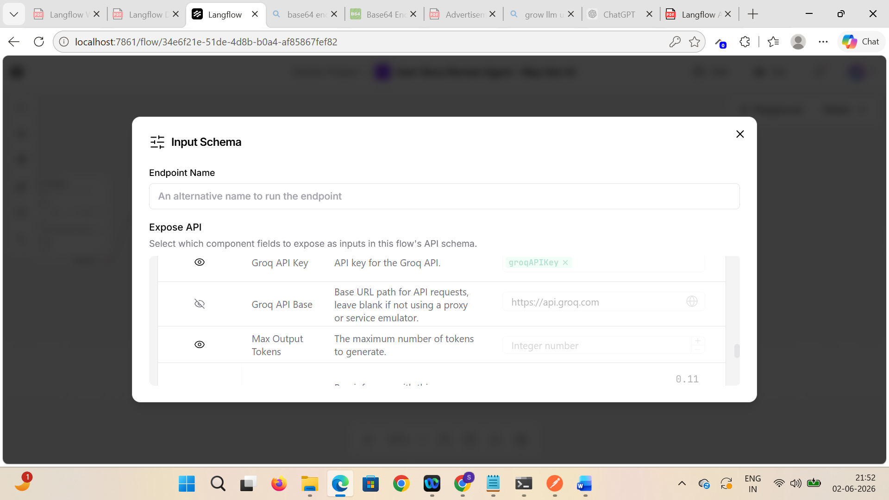

See the updated schema count is correct (2 here)
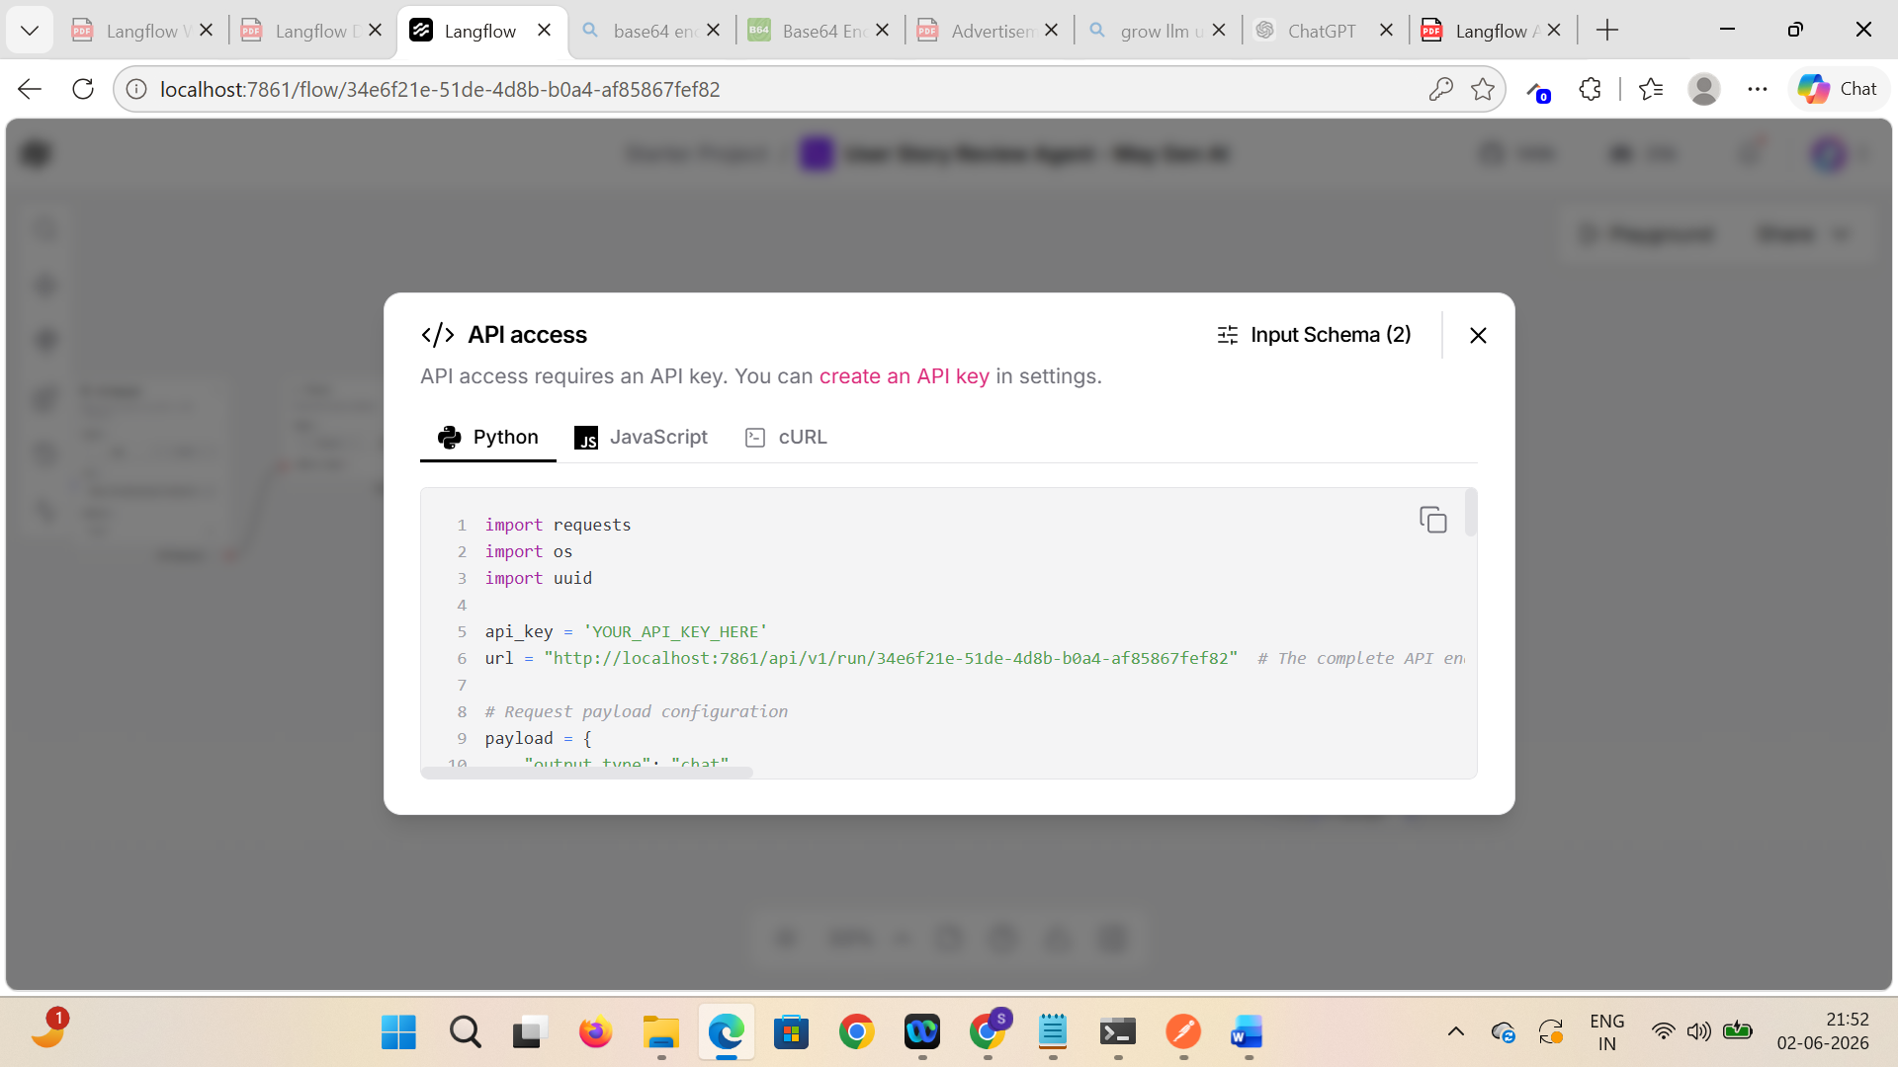

Go to Curl > MacOS/Linux and copy the request body > verify input request updated fields are enabled in the request body

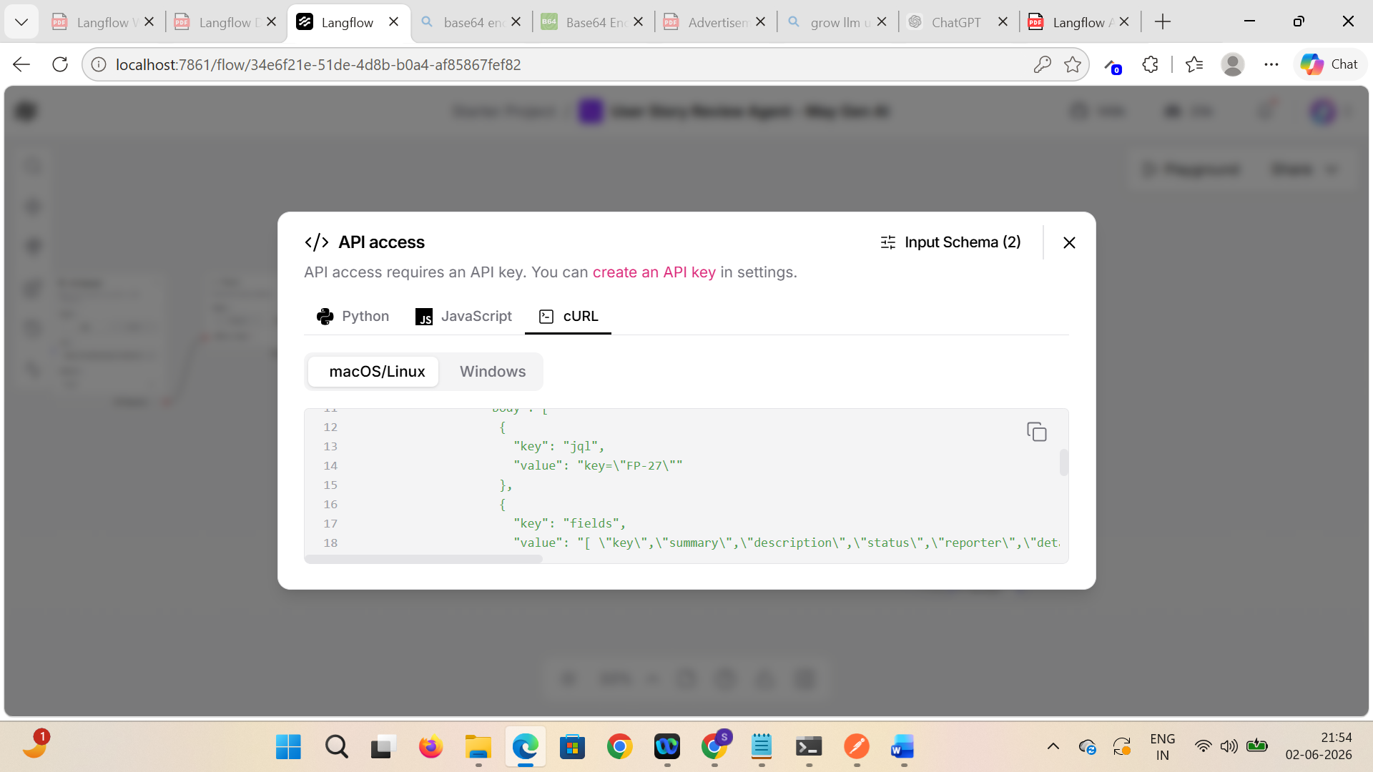



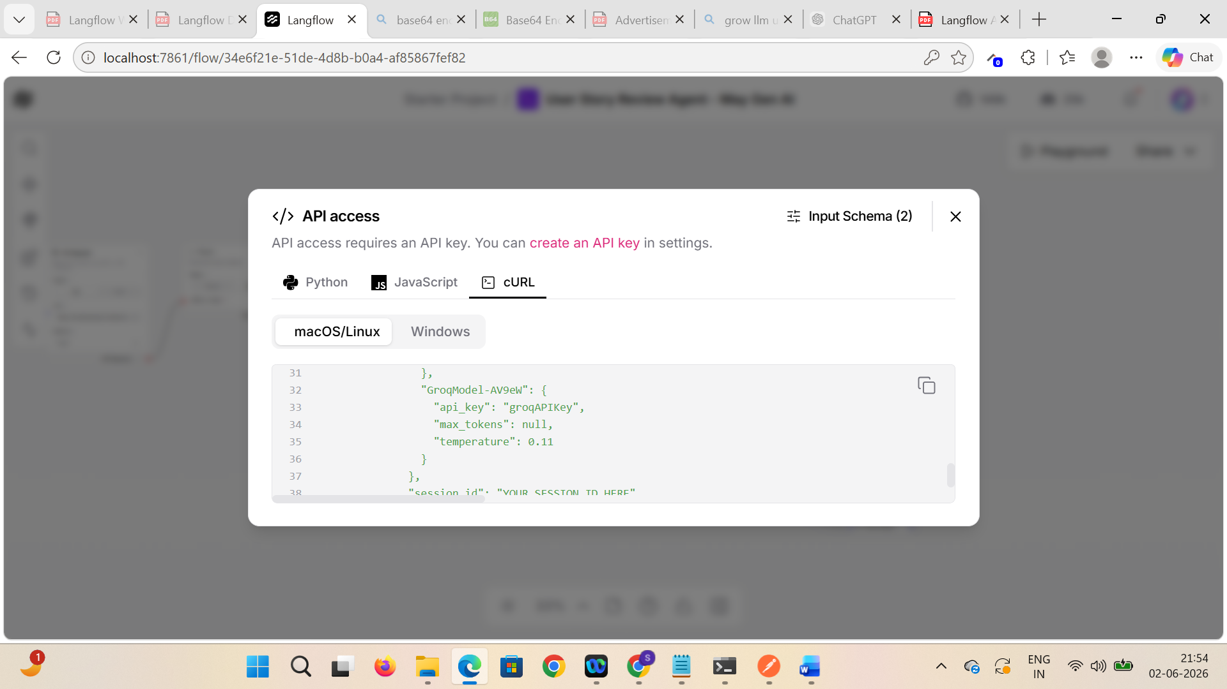

Click on Import and paste the copied request and select the collection
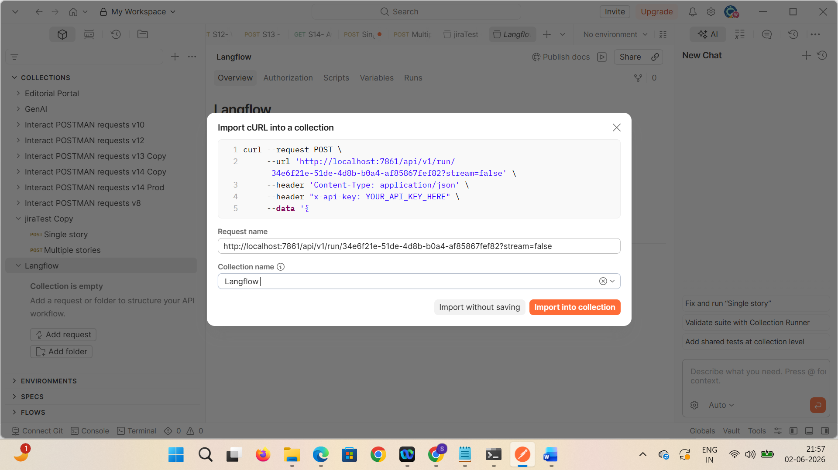

Uncheck the stream from Params
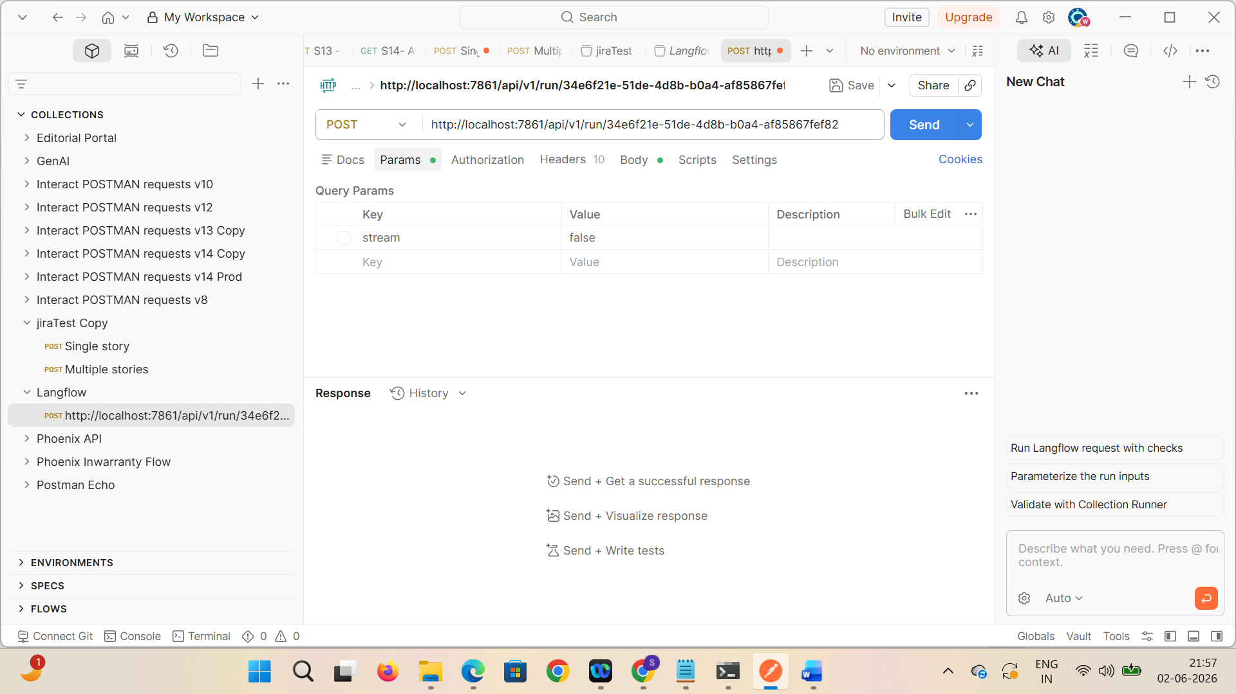

Copy langflow key and paste it in Headers
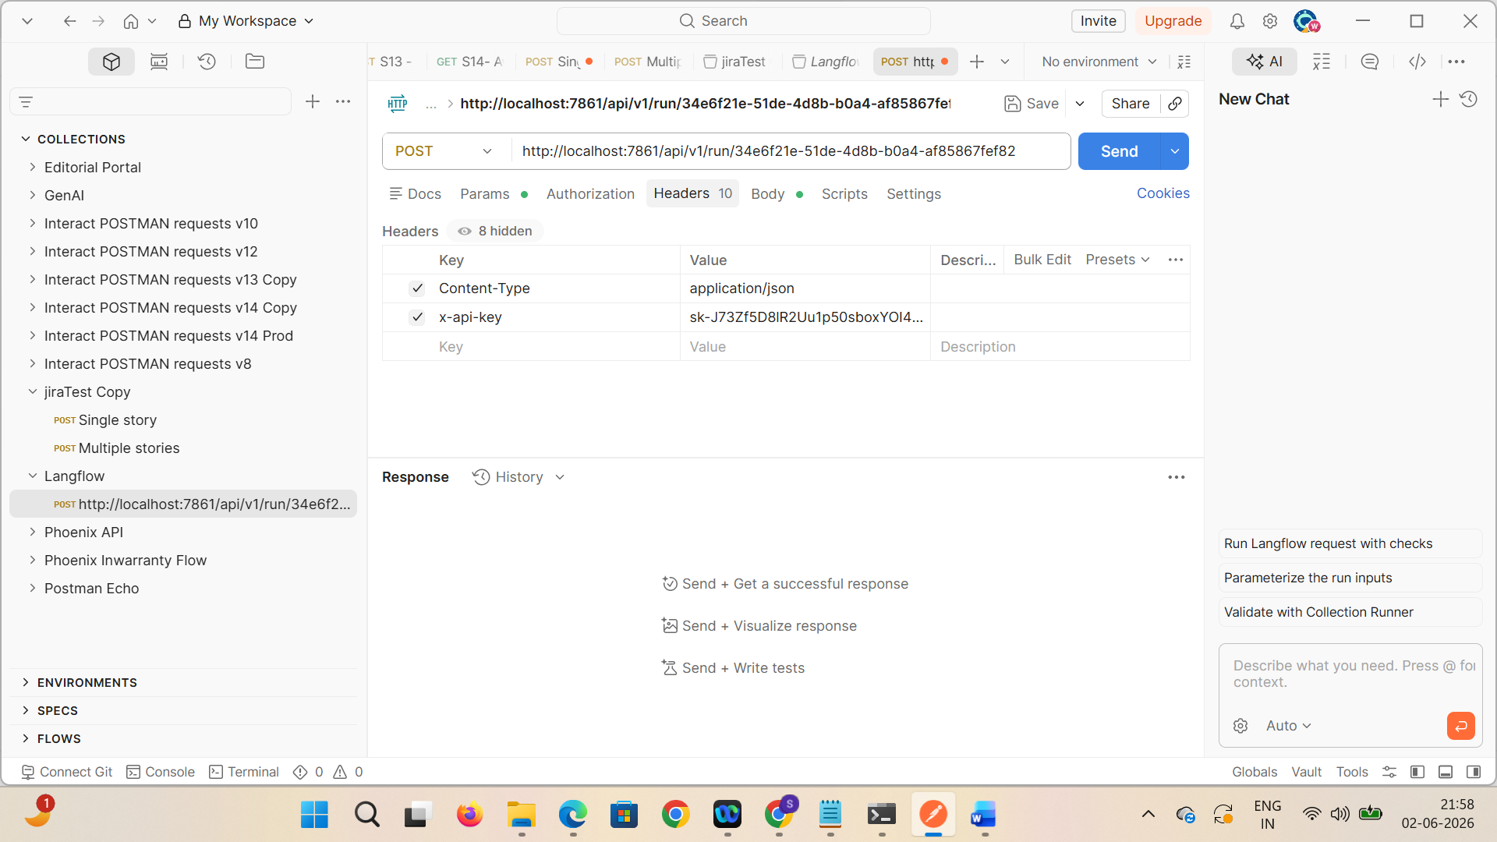

Verify all the parameters are displayed in request body to update
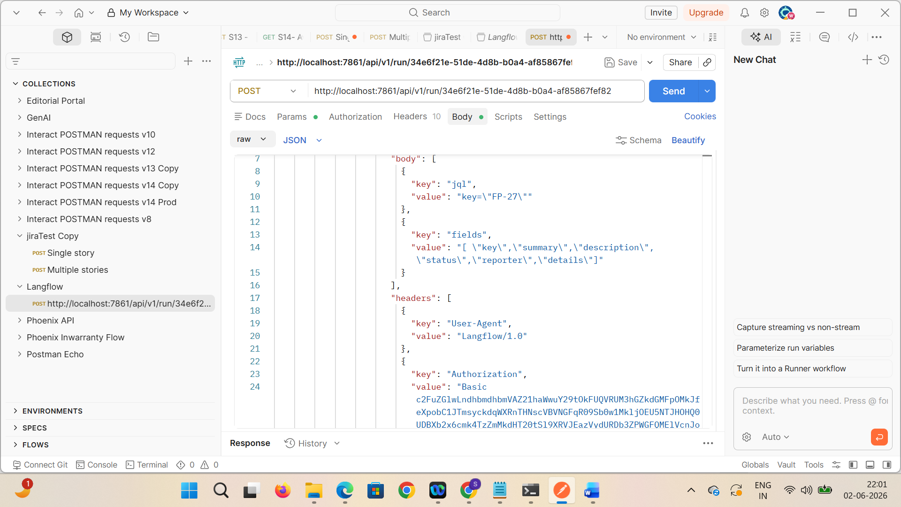

Remove session id
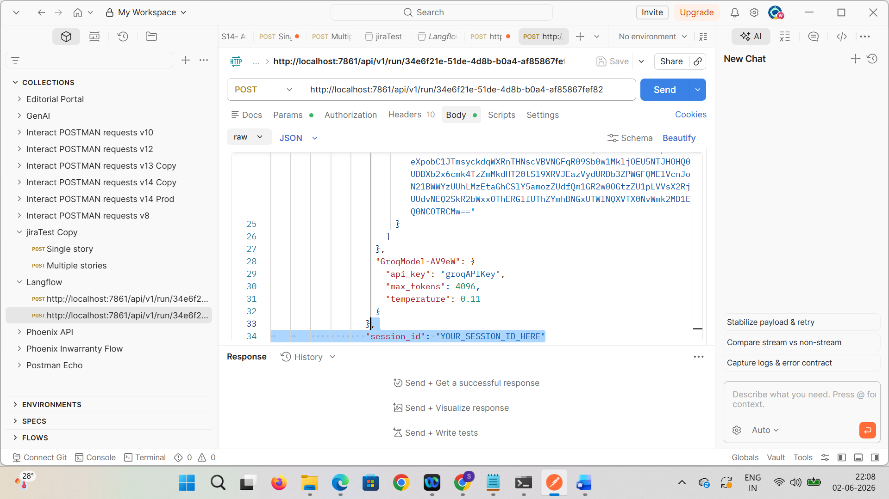

Update the input text, groq key
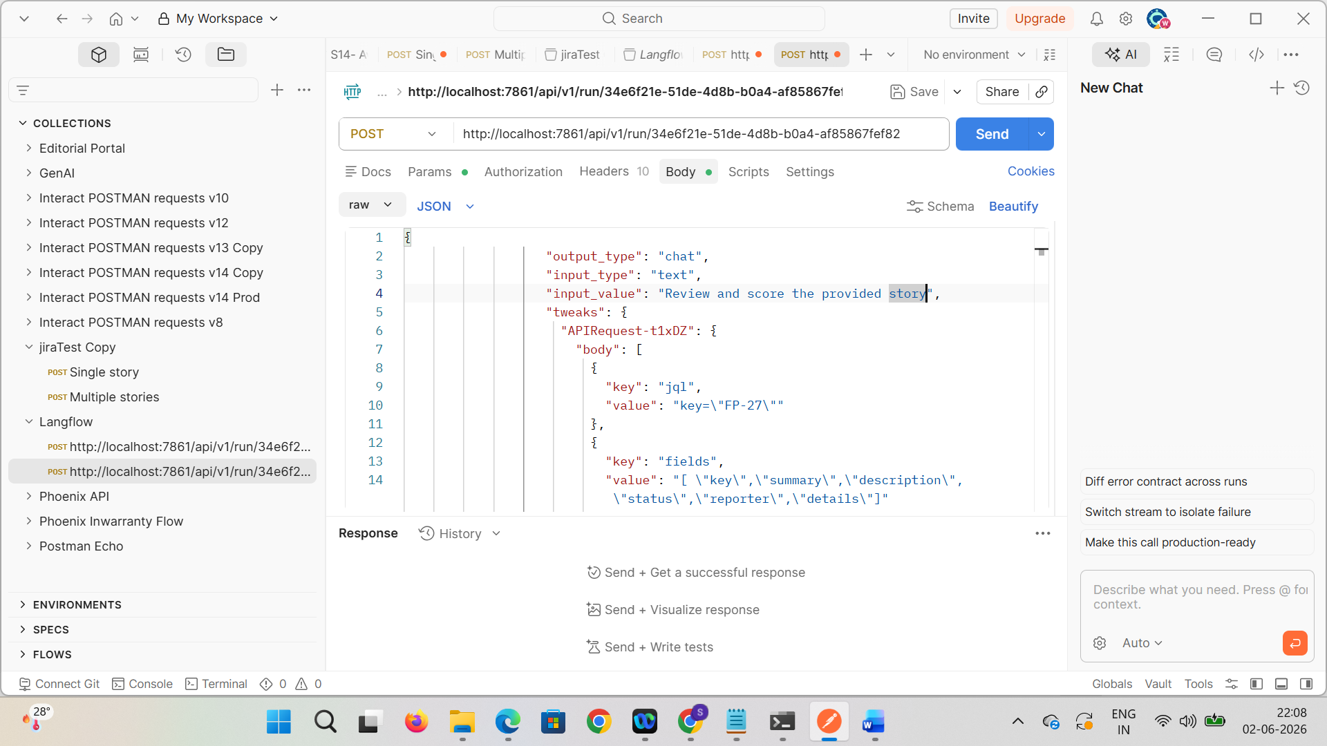

Hit API
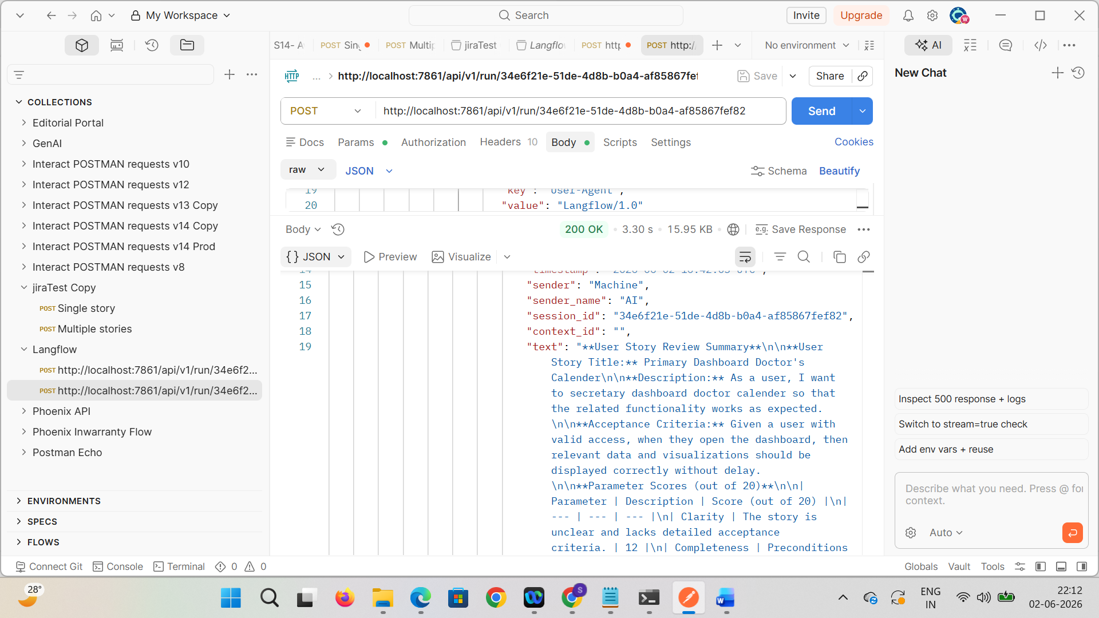

Beautify the response
User Story Review Summary
User Story Details
User Story Title
Primary Dashboard – Doctor’s Calendar
Description
As a secretary user, I want to access the doctor’s calendar from the primary dashboard so that I can efficiently manage appointments, schedules, and related activities.
Acceptance Criteria
- Given a user with valid access permissions, when the user opens the dashboard, then the doctor’s calendar and related visualizations should load correctly without delay.
- The dashboard should display accurate appointment and scheduling information.
- Users should receive appropriate error messages in case of data unavailability or system issues.
- The dashboard should comply with role-based access controls and healthcare data security standards.

Parameter Evaluation (Out of 20)
Parameter | Evaluation Summary | Score
Clarity | The story requires clearer functional expectations and more detailed acceptance criteria. | 12 / 20
Completeness | Preconditions, dependencies, and user role details are partially missing. | 10 / 20
Business Value Alignment | The healthcare and operational value is identified but needs stronger alignment with compliance and efficiency goals. | 15 / 20
Testability | The functionality is testable through UI and automation testing; however, detailed test scenarios are not defined. | 15 / 20
Technical Feasibility | The implementation is feasible within the current system architecture and infrastructure. | 16 / 20

Overall Quality Score
68 / 100

Key Improvement Areas
1. Enhance Acceptance Criteria
Define detailed and measurable acceptance criteria covering:
- Dashboard loading behavior
- Calendar visibility
- Error handling
- Data accuracy
- Performance expectations
- Role-based access validation
2. Define Preconditions Clearly
Specify:
- Required user roles and permissions
- Login/authentication prerequisites
- Data availability assumptions
- System dependency requirements
3. Strengthen Business Value Alignment
Clearly connect the feature to healthcare outcomes such as:
- Improved appointment management
- Increased operational efficiency
- Reduced scheduling conflicts
- Better patient coordination
- Compliance with healthcare standards
4. Improve Testability
Include:
- Functional test scenarios
- UI validation checkpoints
- Automation feasibility details
- Negative test cases
- Performance validation requirements
5. Refine Technical Feasibility Considerations
Evaluate:
- API/data dependencies
- Dashboard rendering limitations
- Performance bottlenecks
- Scalability considerations
- Security and compliance constraints

Recommendations
- Revise the user story with detailed acceptance criteria and clearly defined preconditions.
- Conduct a healthcare business value assessment to identify operational and compliance benefits.
- Collaborate with QA teams to prepare a comprehensive test strategy and automation coverage.
- Discuss implementation constraints and technical dependencies with the development team.
- Refine the story structure to ensure it is actionable, testable, compliant, and aligned with Agile best practices.

Action Items
- Update and refine the user story based on the identified improvement areas.
- Schedule a review session with cross-functional stakeholders.
- Prepare detailed test scenarios and automation plans for dashboard validation.
- Validate business and compliance expectations with healthcare stakeholders.
- Finalize the technical implementation and deployment approach after feasibility review.

