Create HTML page with CDN integration and create test case generator
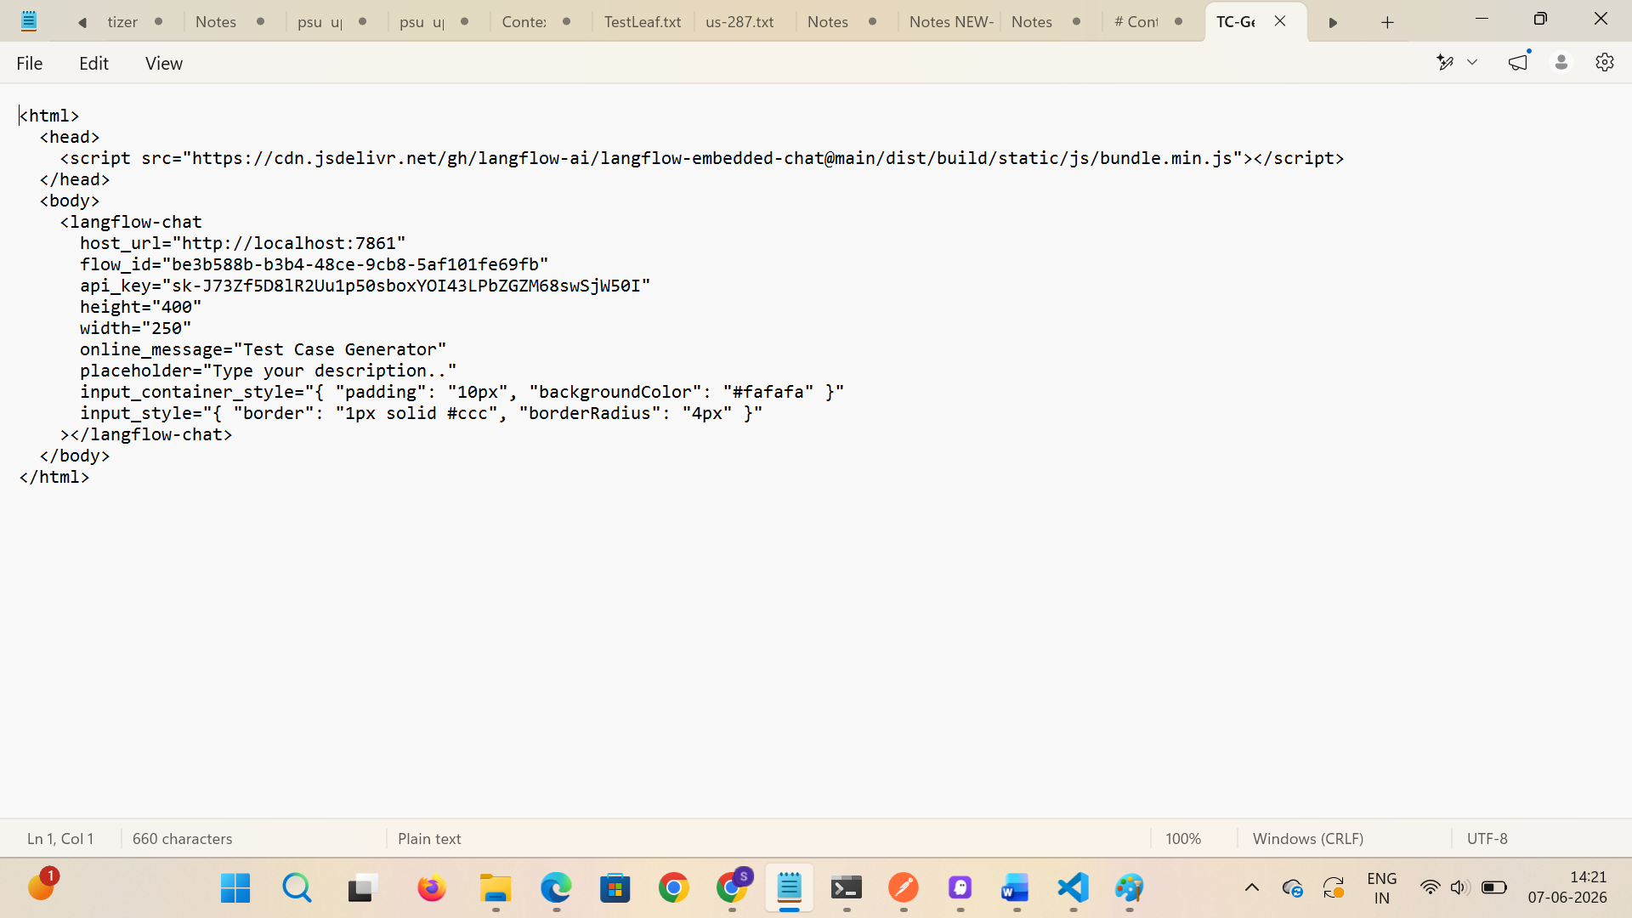

Run the HTML and verify TC are generated for the given scenario
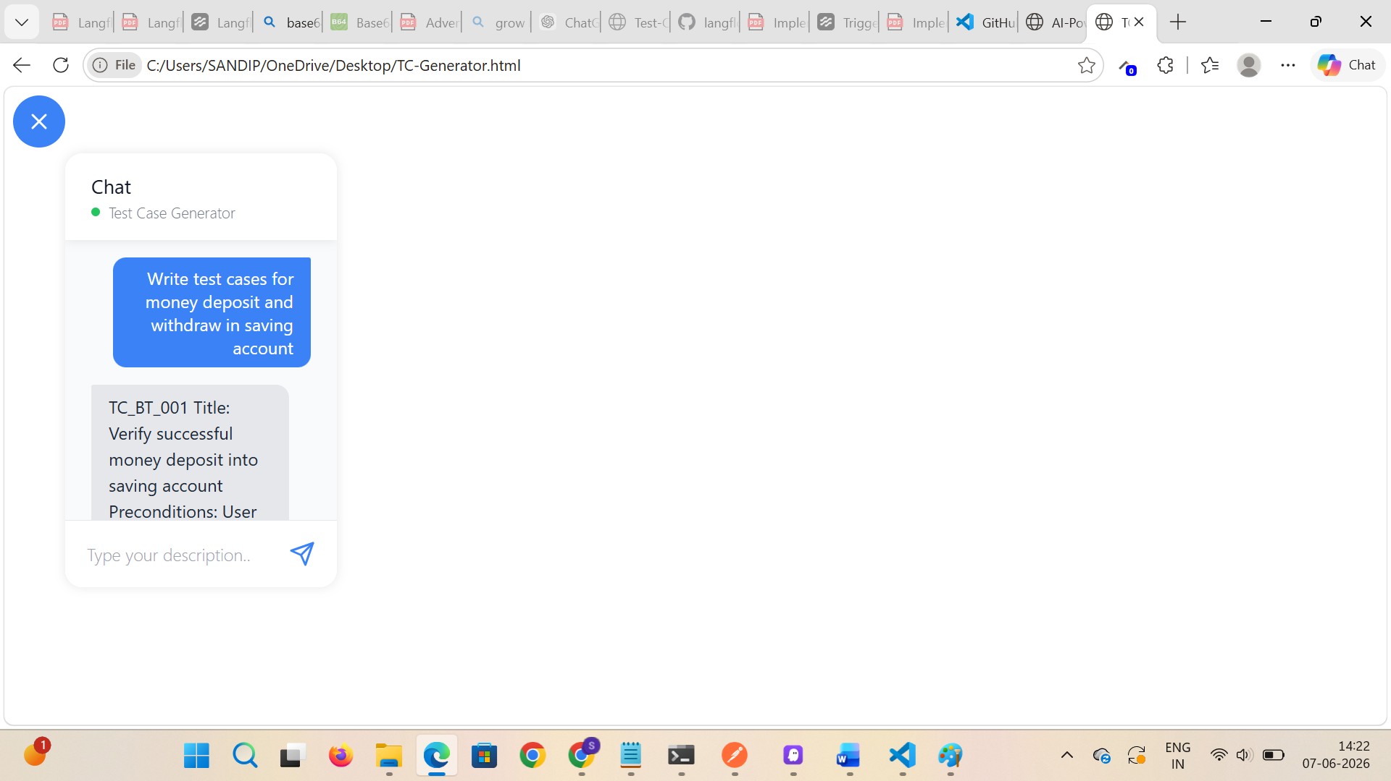

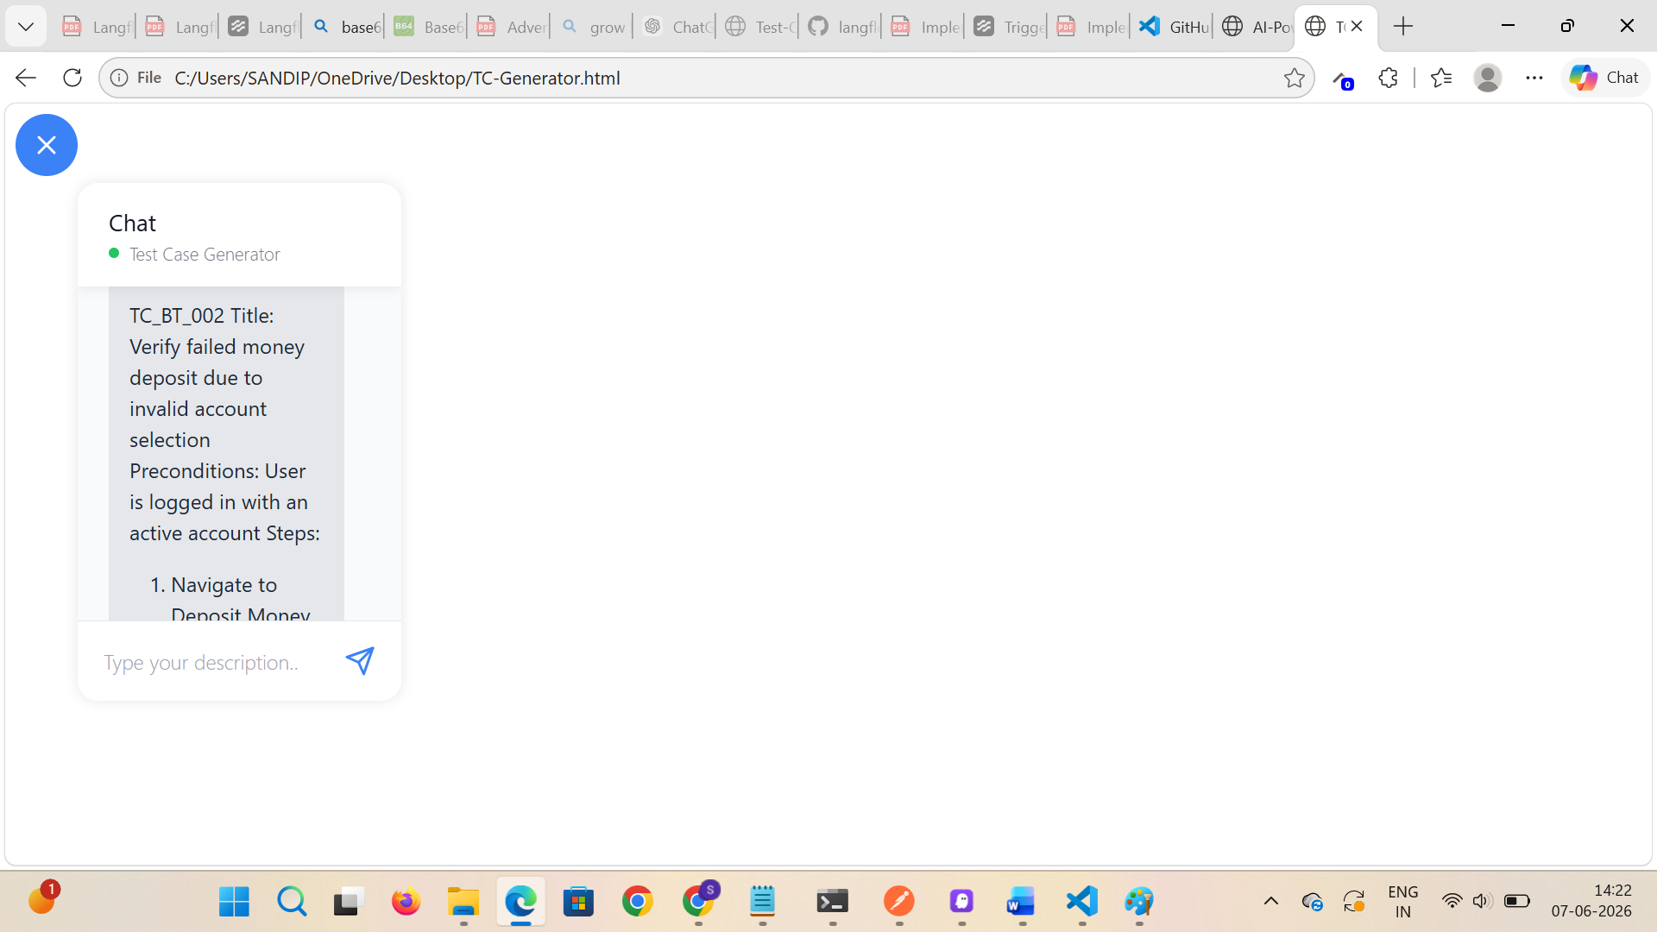

Now, create the folder and open it in VS code
Give the prompt as .md file and implement single page html implementation for embedded langflow chat
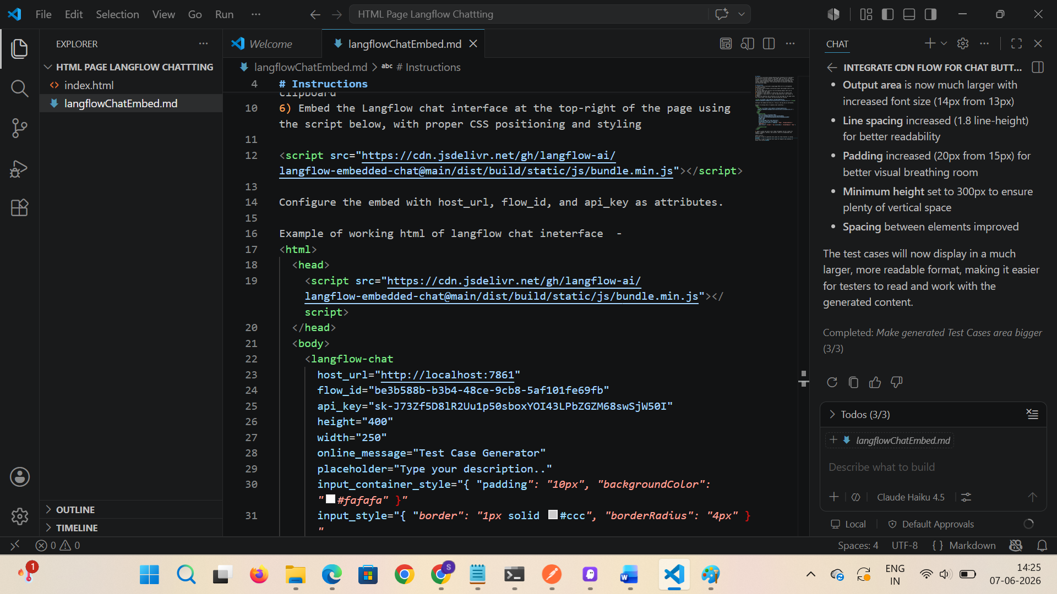

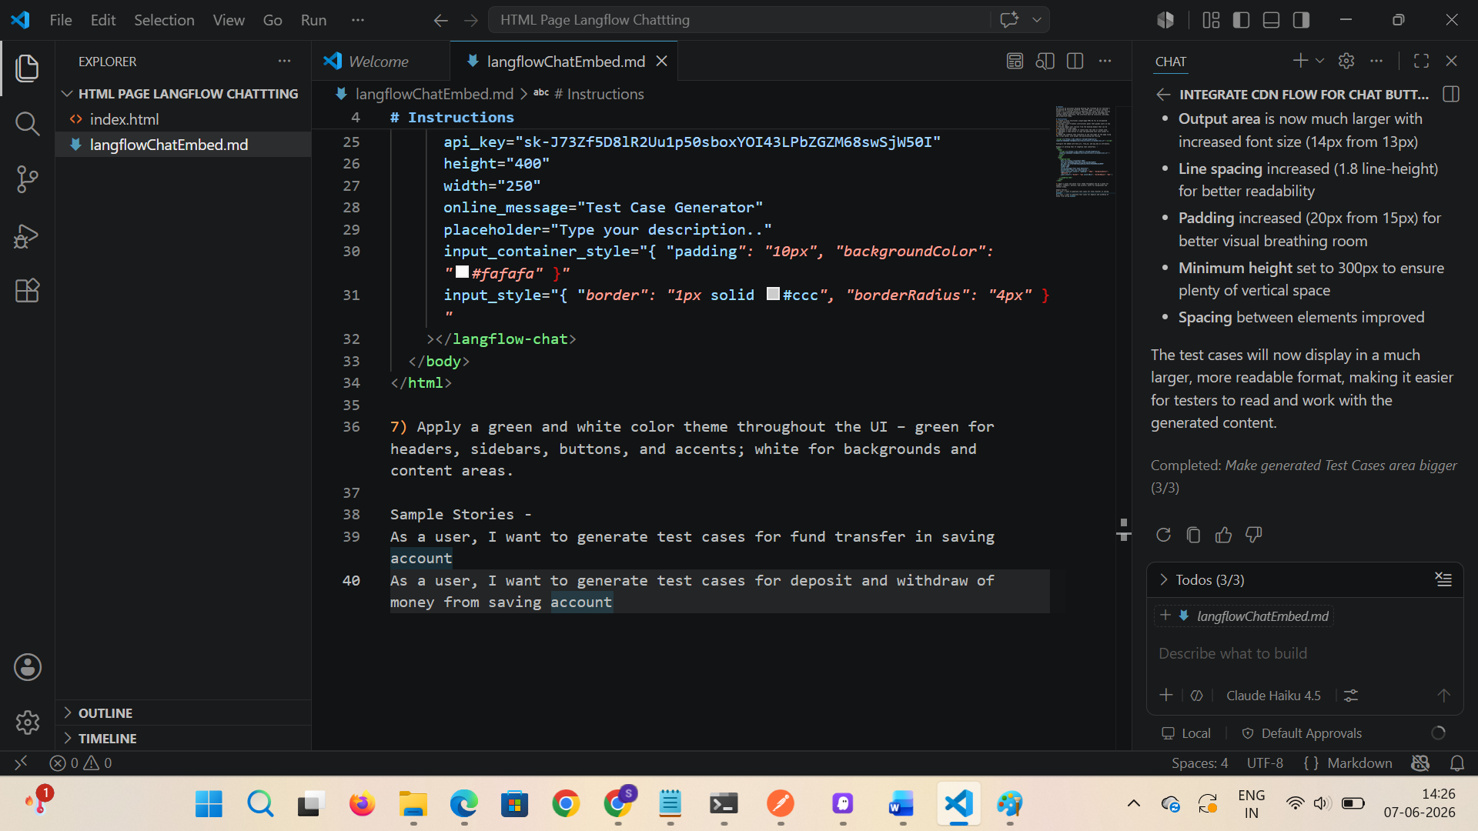
Instructions are displayed at LHS
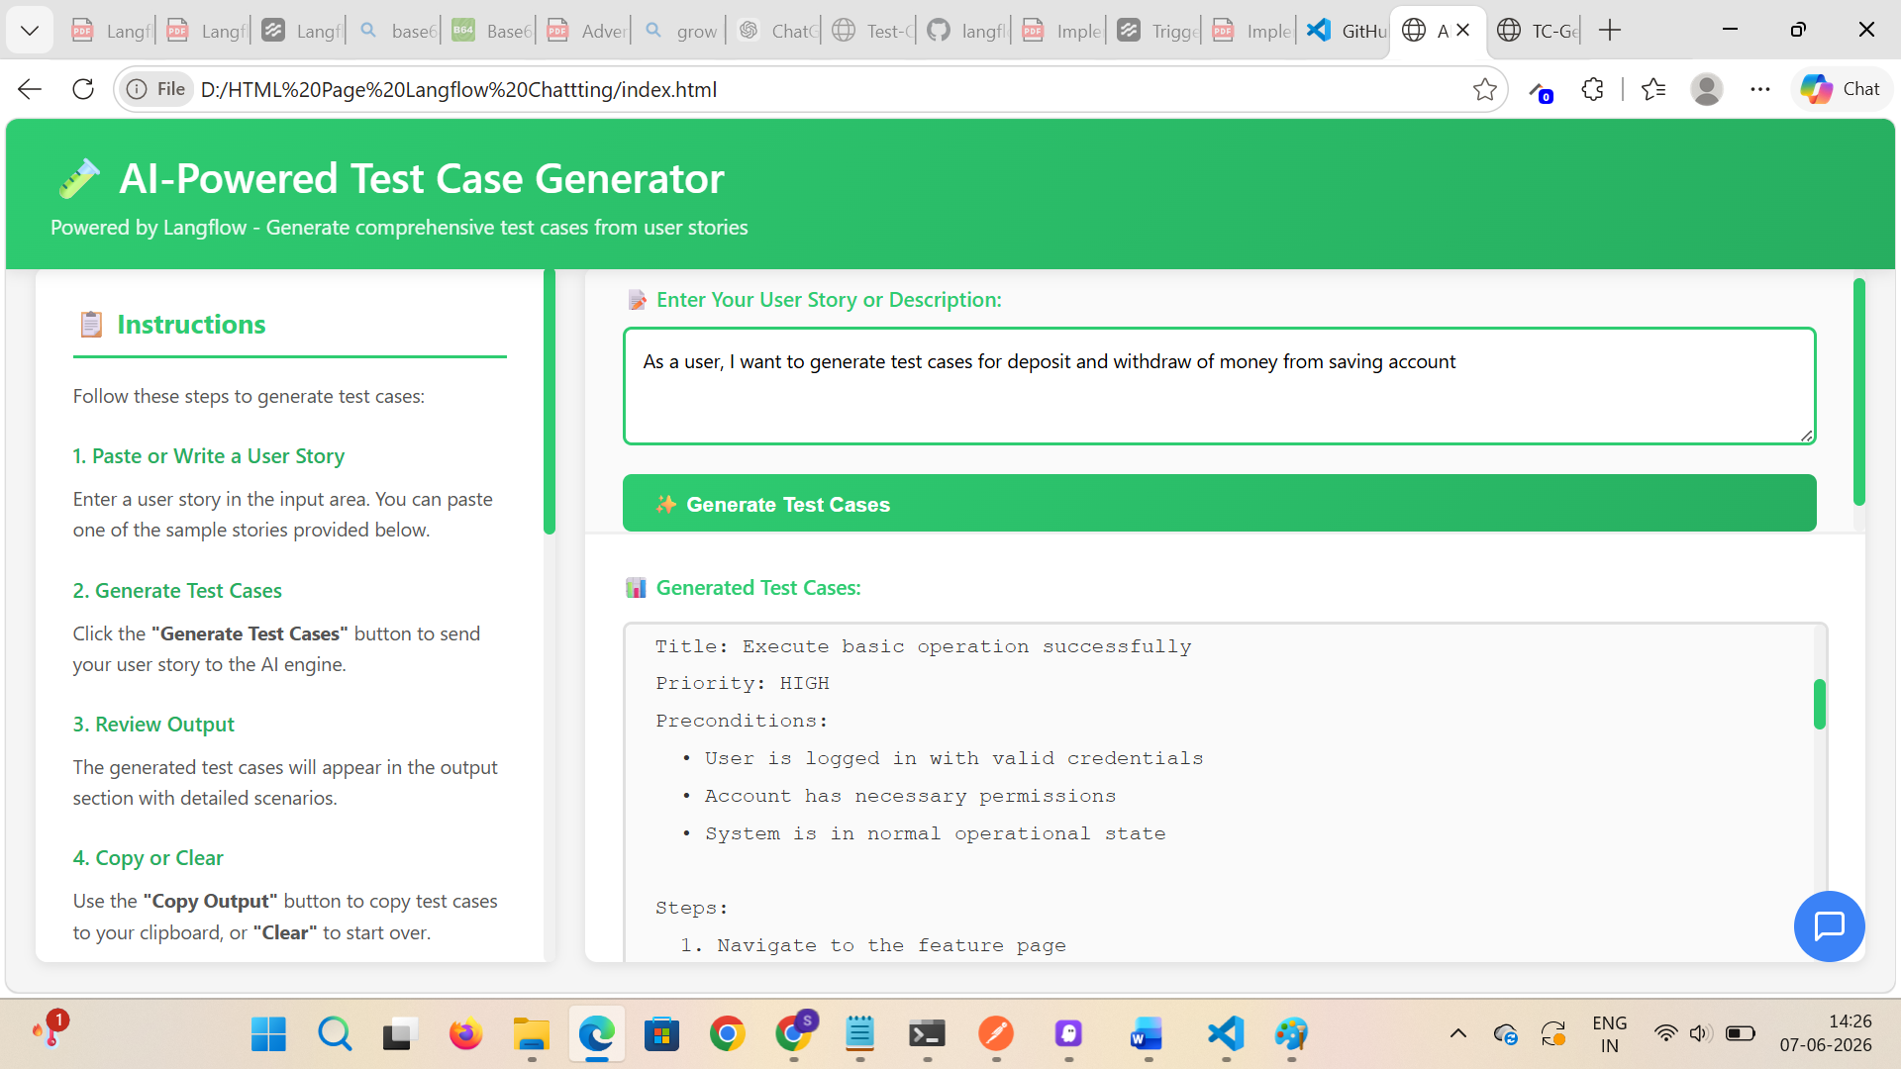

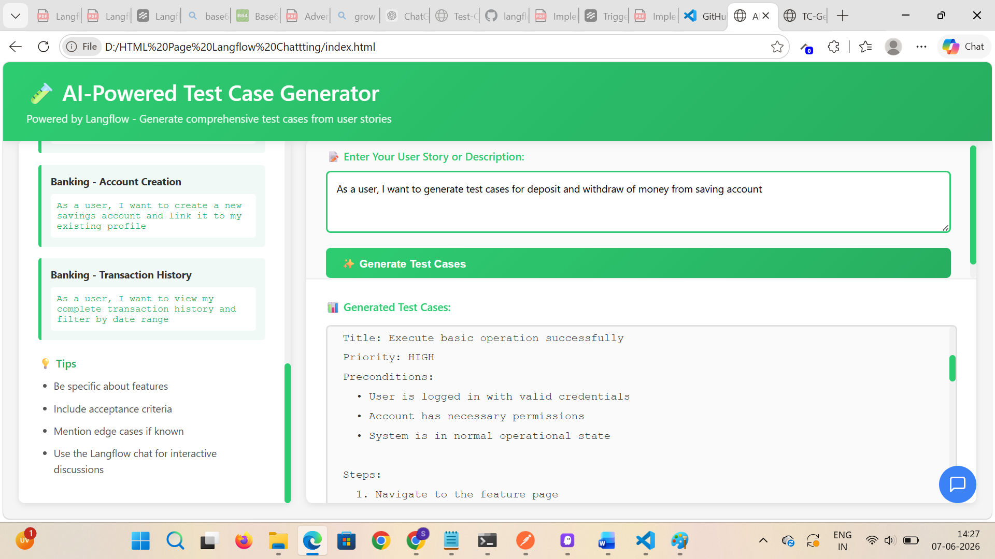

If user clicks on the sample test case, it is loaded in user story or description field
OR user can enter his new description
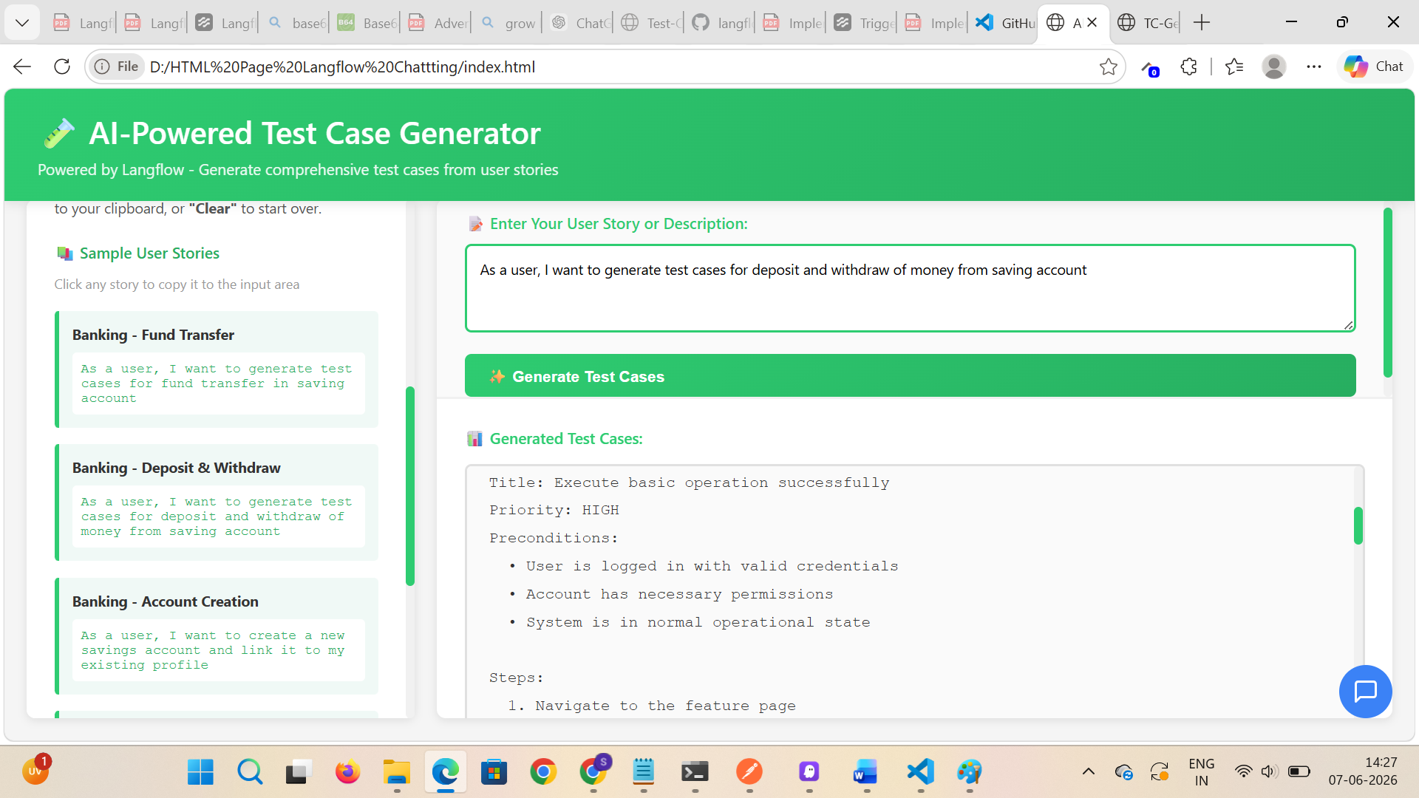

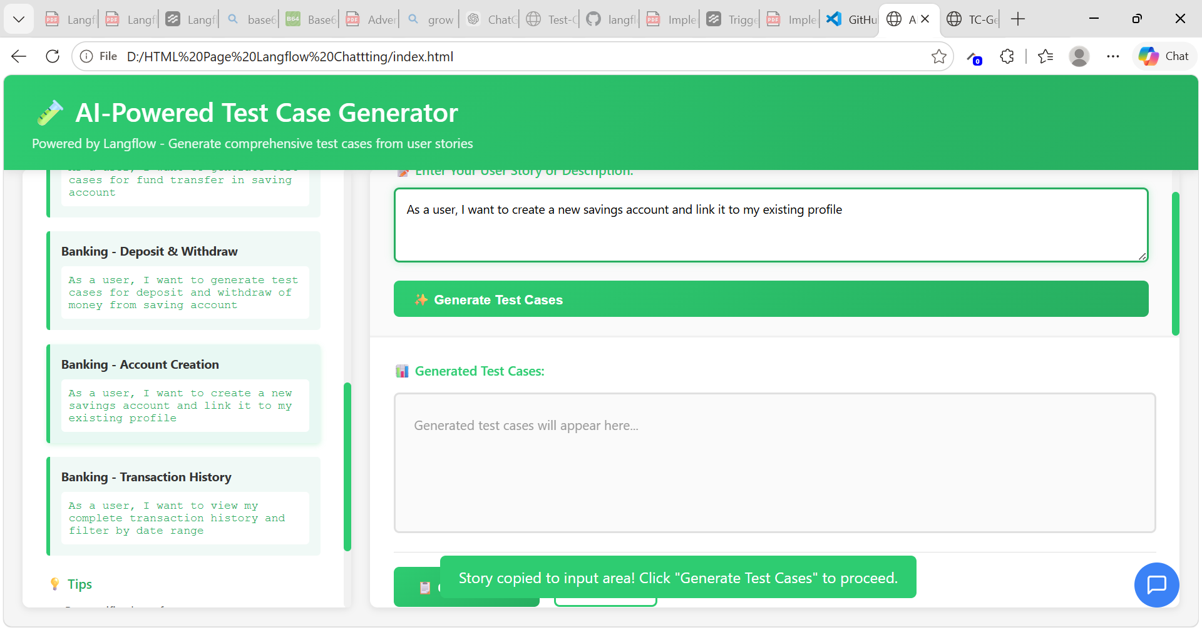

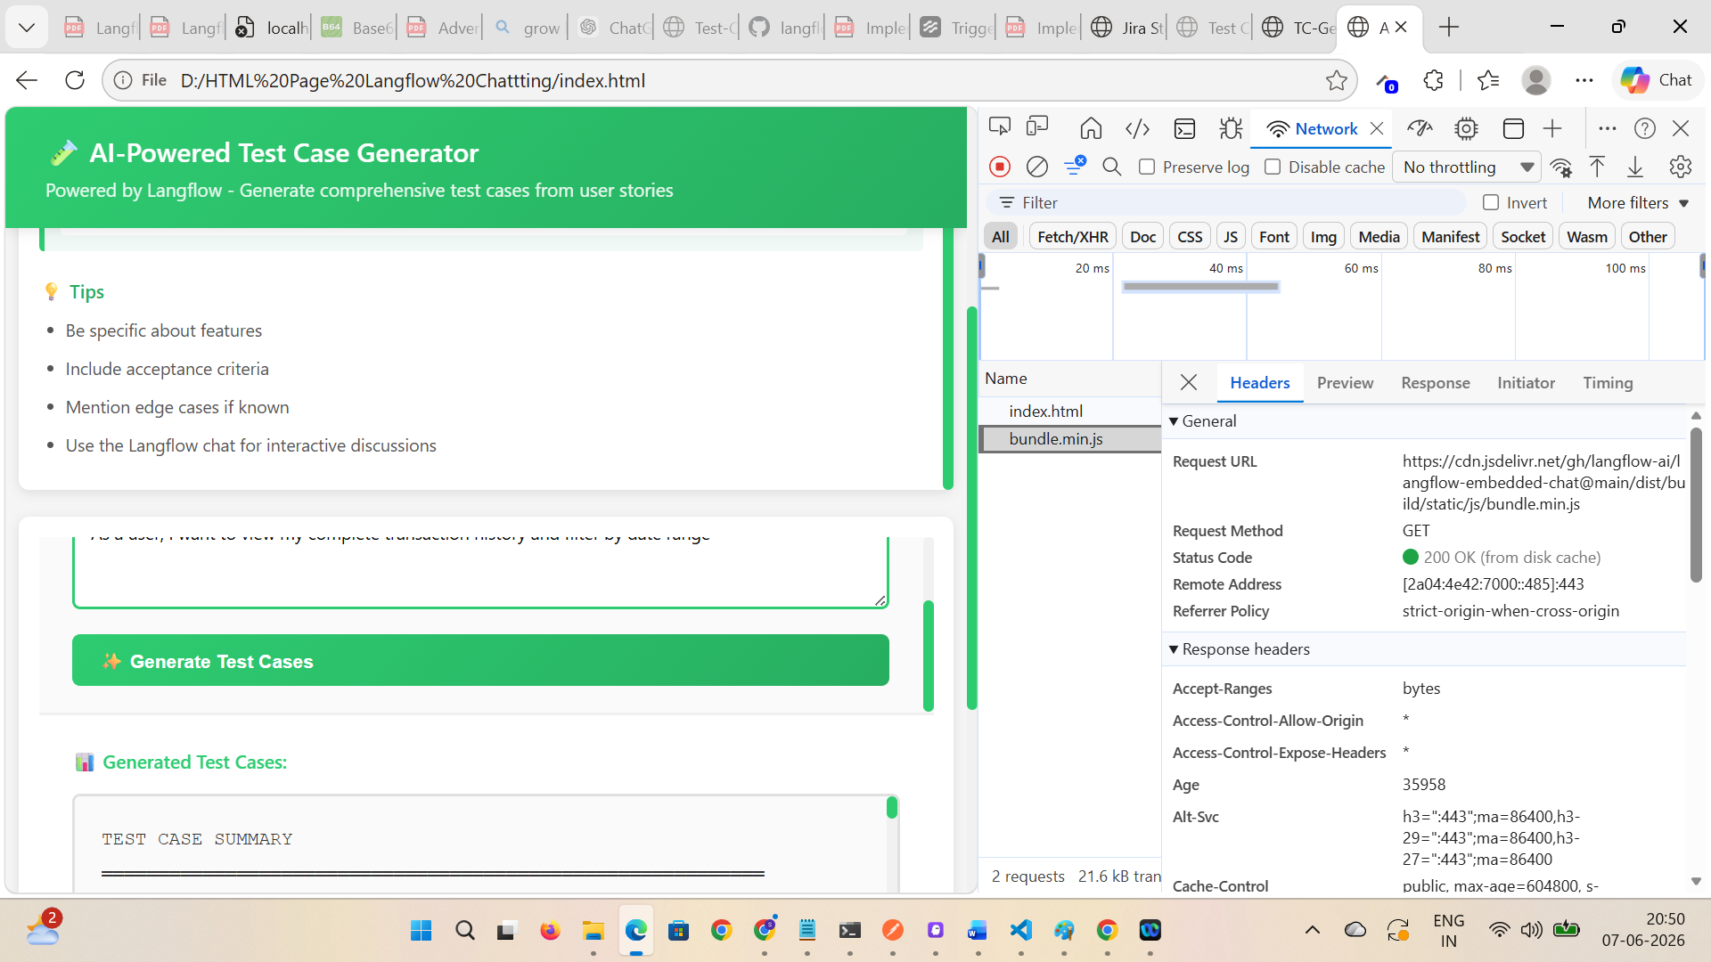

Click on Generate button is generating the test cases
User can scroll to read the test cases
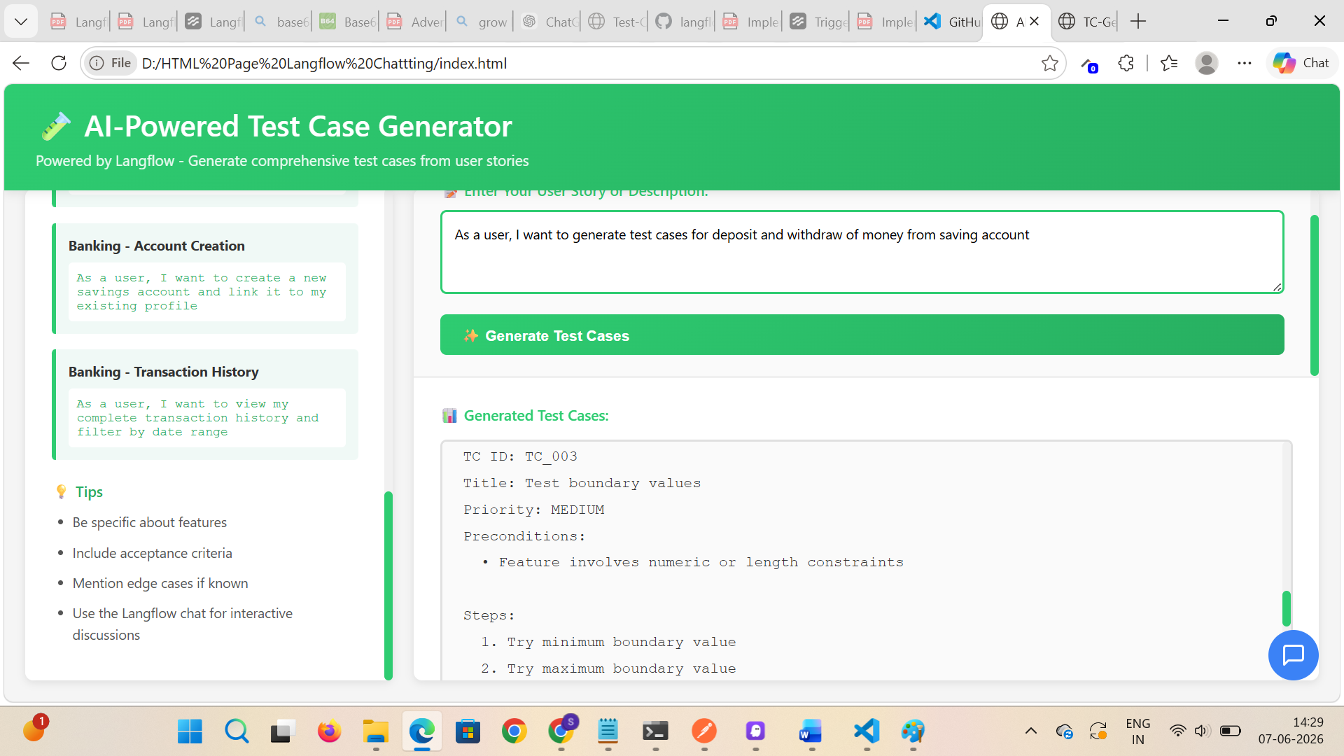
Verify Copy button is working
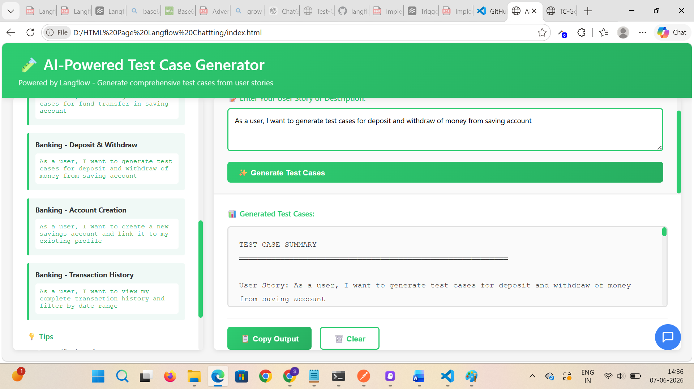
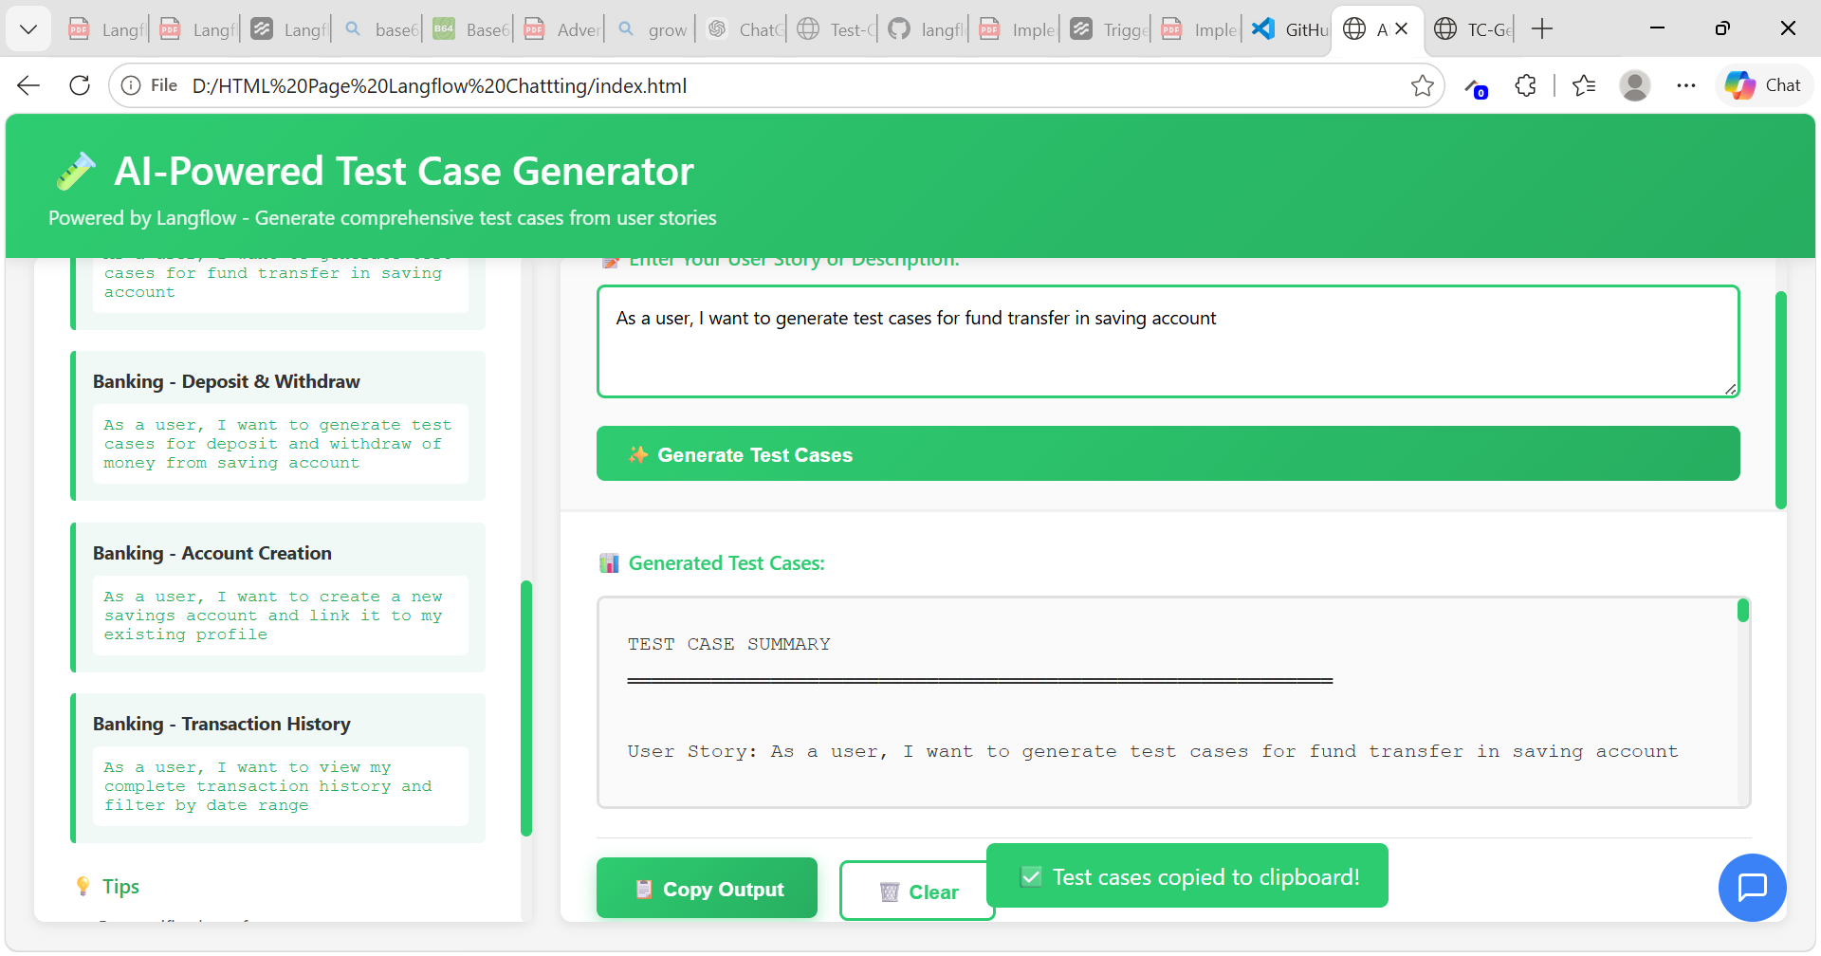

Copy and pasted the output
TEST CASE SUMMARY
═══════════════════════════════════════════════════════════

User Story: As a user, I want to generate test cases for deposit and withdraw of money from saving account

Test Cases Generated: 5

─────────────────────────────────────────────────────────

TEST CASE 1: Valid Scenario - Happy Path
TC ID: TC_001
Title: Execute basic operation successfully
Priority: HIGH
Preconditions:
• User is logged in with valid credentials
• Account has necessary permissions
• System is in normal operational state

Steps:
1. Navigate to the feature page
2. Perform the primary action
3. Verify successful completion
4. Check confirmation message

Expected Result: Operation completes successfully with confirmation

─────────────────────────────────────────────────────────

TEST CASE 2: Negative Scenario - Invalid Input
TC ID: TC_002
Title: Handle invalid input gracefully
Priority: HIGH
Preconditions:
• User has access to the feature
• Feature accepts input validation

Steps:
1. Navigate to input field
2. Enter invalid/malformed data
3. Click submit/confirm button
4. Observe error handling

Expected Result: Error message displayed, operation prevented

─────────────────────────────────────────────────────────

TEST CASE 3: Boundary Testing
TC ID: TC_003
Title: Test boundary values
Priority: MEDIUM
Preconditions:
• Feature involves numeric or length constraints

Steps:
1. Try minimum boundary value
2. Try maximum boundary value
3. Verify system behavior
4. Validate error messages

Expected Result: System handles boundaries correctly

─────────────────────────────────────────────────────────

TEST CASE 4: Permission/Authorization
TC ID: TC_004
Title: Verify access control
Priority: MEDIUM
Preconditions:
• Different user roles available

Steps:
1. Login with restricted user account
2. Attempt to access feature
3. Verify authorization checks
4. Check error responses

Expected Result: Unauthorized access blocked appropriately

─────────────────────────────────────────────────────────

TEST CASE 5: Error Handling & Recovery
TC ID: TC_005
Title: System recovery after errors
Priority: MEDIUM
Preconditions:
• System can simulate failures

Steps:
1. Trigger error condition
2. Observe error message
3. Attempt recovery action
4. Verify system state

Expected Result: System recovers gracefully, data integrity maintained

═══════════════════════════════════════════════════════════

Generated on: 7/6/2026, 2:36:01 pm
Status: ✅ Ready for QA Execution

Verify Clear button is working
