Download the Langflow for Jira Story Review
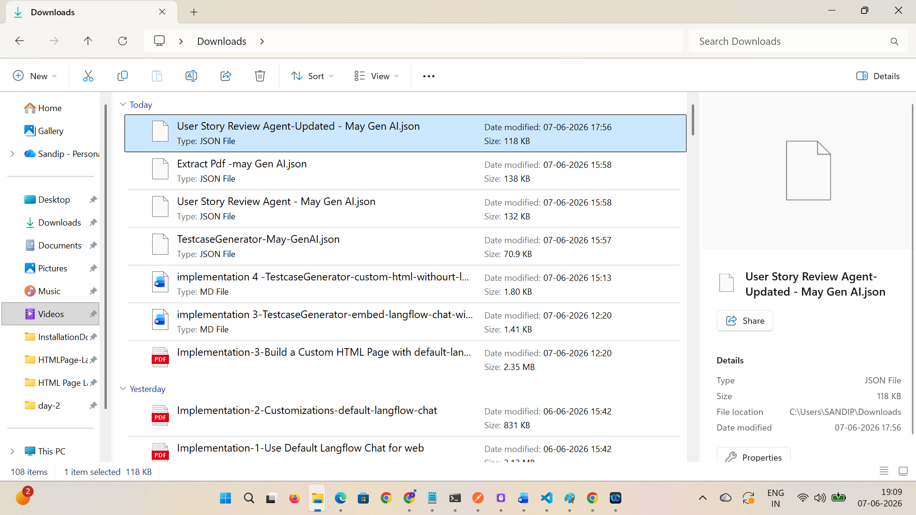

Navigate to Langflow and make sure it is running > Share > API Access > cURL > Copy request
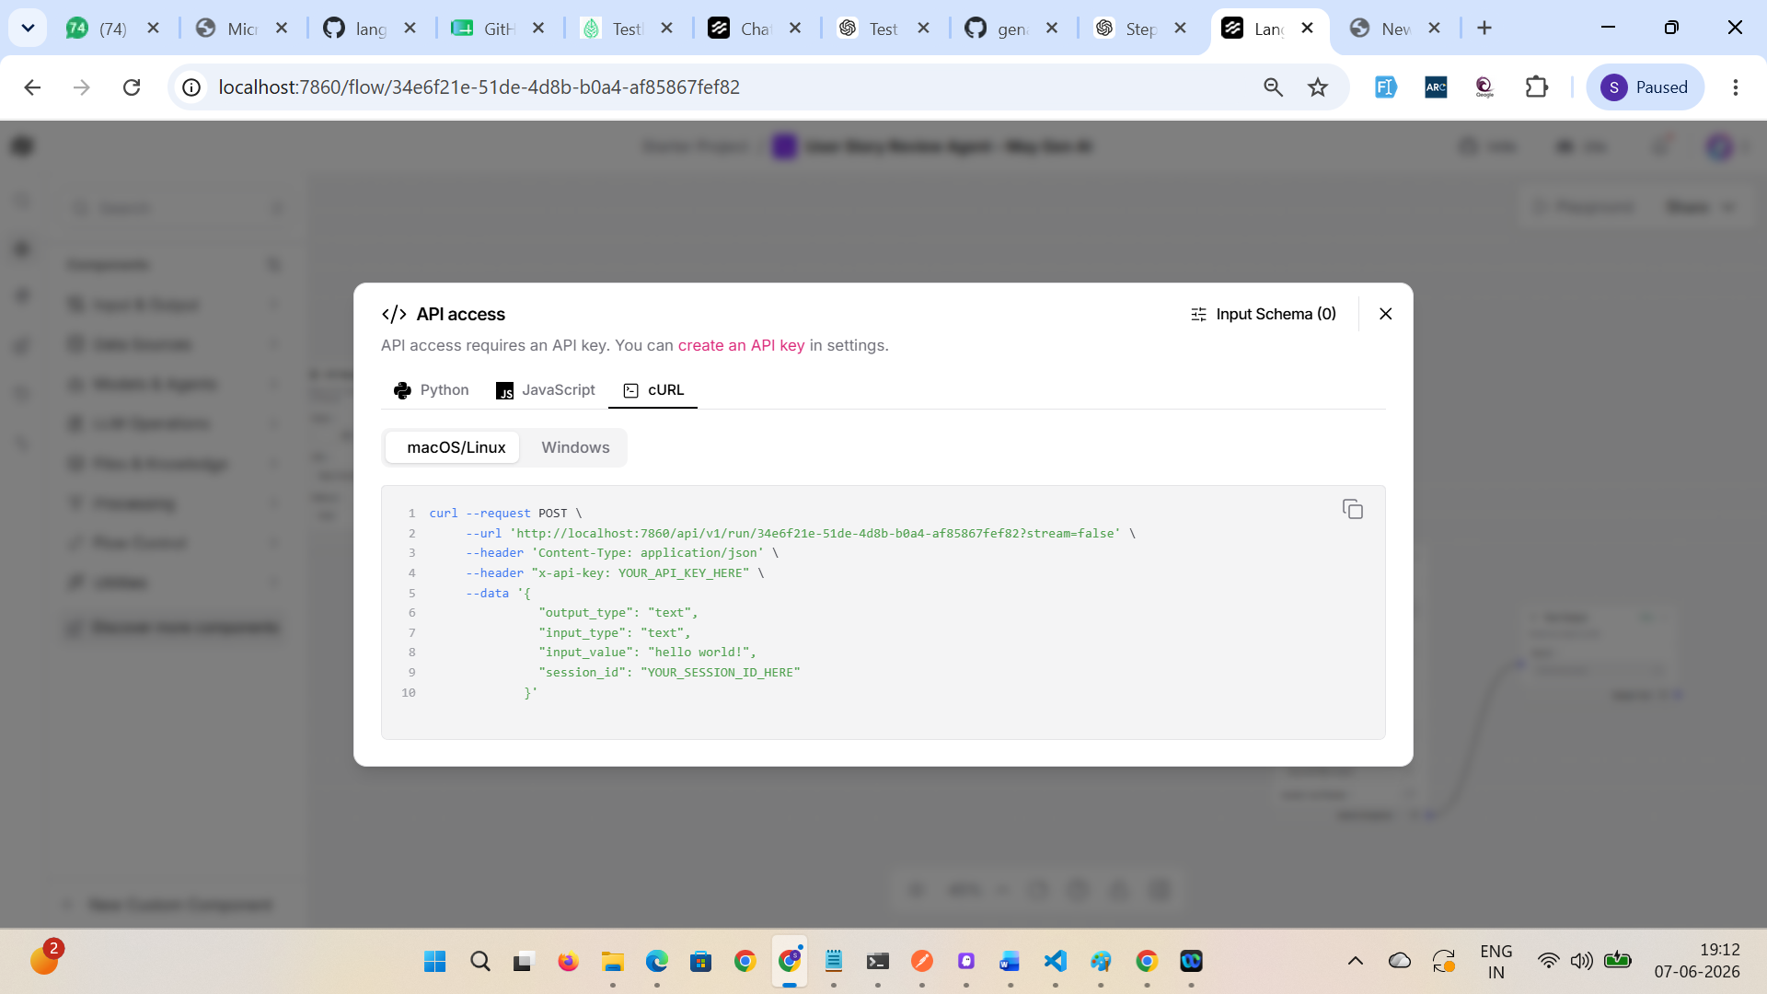

Paste it in the POSTMAN and test it
Note headers, request body and response body
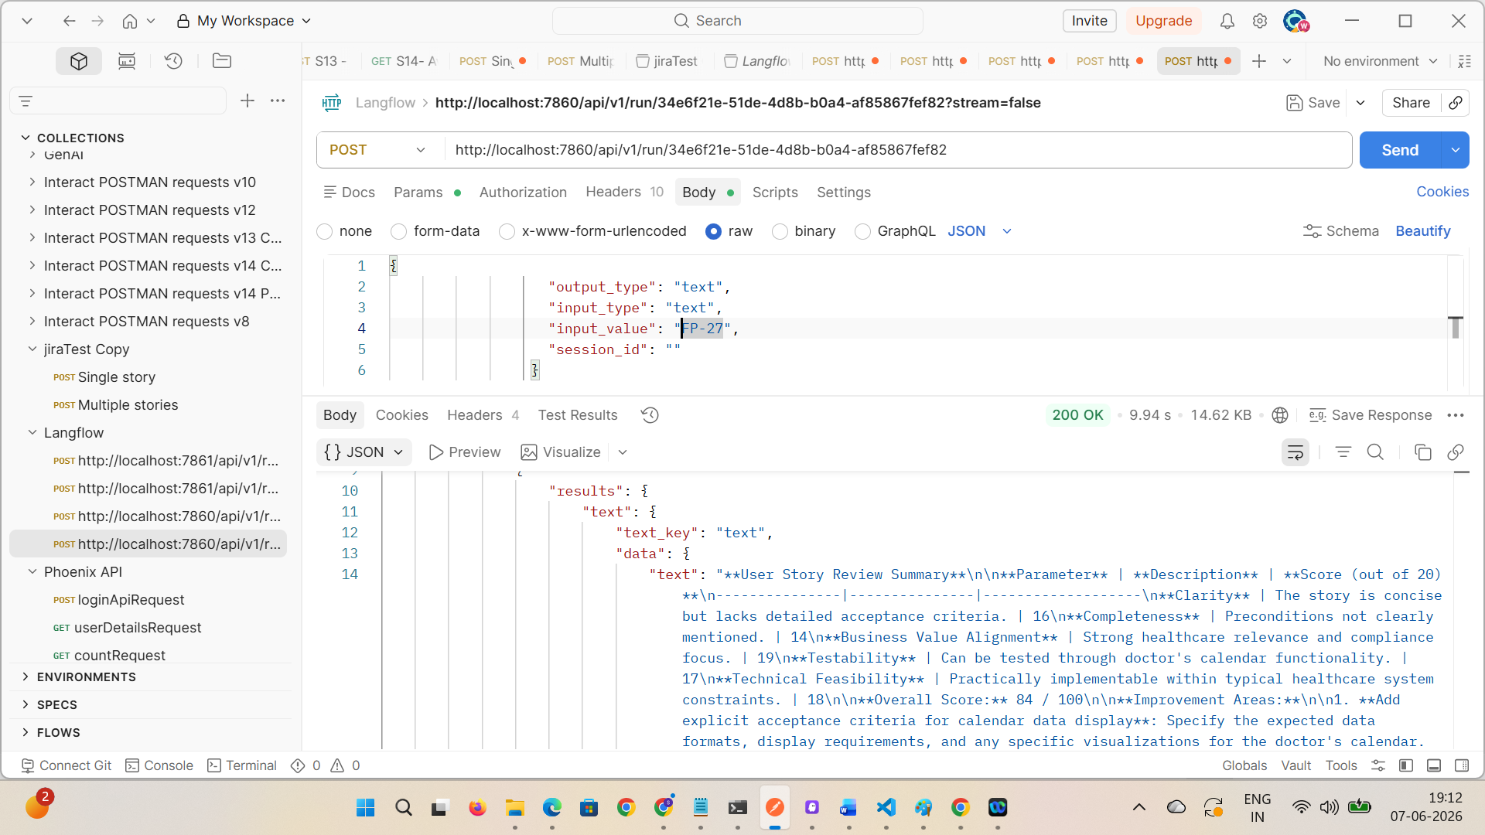

Create the best prompt by giving Langflow and API details to chatgpt or copilot
And create .md file
# Context
You are an AI Assistant, create a single HTML page with CSS and JavaScript for an AI-powered Jira Story Review Agent.
This application is used by QA Teams, Scrum Masters, and Product Owners to review Jira User Stories using a Langflow workflow API.

GO STEP BY STEP FOLLOWING THE INSTRUCTIONS PROVIDED. UP ON MY APPROVAL PROCEED WITH NEXT STEP.

---

# STEPS

## Instructions:

[STRICTLY] DO NOT USE THE LANGFLOW EMBED CHAT

[MANDATORY] Generate a SINGLE HTML FILE with embedded CSS and JavaScript

[MANDATORY] Create a professional UI for Jira Story Review Agent

[MANDATORY] Add input field to enter Jira Story Number

[MANDATORY] Example Jira Story Format:

FP-27

[MANDATORY] Add a "Review Story" button that calls the Langflow API

[MANDATORY] Use JavaScript Fetch API to call the backend API directly

[MANDATORY] Dynamically replace the Jira Story Number inside:

key=\"FP-27\"

[MANDATORY] Display AI-generated Story Review in output section

[MANDATORY] Add loading spinner while API request is processing

[MANDATORY] Add option to Copy Review Output

[MANDATORY] Add Clear button to clear input and output

[MANDATORY] Add success and error toast notifications

[MANDATORY] Use professional Blue and White enterprise UI theme

[MANDATORY] Make the page fully responsive for Desktop, Tablet, and Mobile

[MANDATORY] Use only:

* HTML
* CSS
* Vanilla JavaScript

[STRICTLY] DO NOT USE:

* React
* Angular
* Vue
* Bootstrap
* Tailwind
* jQuery

[MANDATORY] Add a sample Jira Story section with copy/load option

[MANDATORY] Sample Jira Story Keys:

* FP-27
* FP-99
* FP-120

[MANDATORY] Create professional output panel with:

* Story Review
* Quality Score
* Missing Details
* Suggestions
* QA Feedback

[MANDATORY] Handle API errors gracefully

[MANDATORY] Add comments in code for easy understanding

[CRITICAL] Keep the UI beginner-friendly and production-ready

---

# API DETAILS
URI - http://localhost:7860/api/v1/run/34e6f21e-51de-4d8b-b0a4-af85867fef82
Method - POST
Headers -
Content-Type : "application/json",
x-api-key : "sk-TYUtixnVNJFEFPTvQWDJdwzaHI8KBDHxseedgBs0FdA"

Sample Request:
{
"output_type": "text",
"input_type": "text",
"input_value": "FP-27",
"session_id": ""
}

Sample expected Resposne :
{
"session_id": "34e6f21e-51de-4d8b-b0a4-af85867fef82",
"outputs": [
{
"inputs": {
"input_value": "FP-27"
},
"outputs": [
{
"results": {
"text": {
"text_key": "text",
"data": {
"text": "**User Story Review Summary**\n\n**Parameter** | **Description** | **Score (out of 20)**\n---------------|---------------|-------------------\n**Clarity** | The story is concise but lacks detailed acceptance criteria. | 16\n**Completeness** | Preconditions not clearly mentioned. | 14\n**Business Value Alignment** | Strong healthcare relevance and compliance focus. | 19\n**Testability** | Can be tested through doctor's calendar functionality. | 17\n**Technical Feasibility** | Practically implementable within typical healthcare system constraints. | 18
"text": "**User Story Review Summary**\n\n**Parameter** | **Description** | **Score (out of 20)**\n---------------|---------------|-------------------\n**Clarity** | The story is concise but lacks detailed acceptance criteria. | 16\n**Completeness** | Preconditions not clearly mentioned. | 14\n**Business Value Alignment** | Strong healthcare relevance and compliance focus. | 19\n**Testability** | Can be tested through doctor's calendar functionality. | 17\n**Technical Feasibility** | Practically implementable within typical healthcare system constraints. | 18\n\n**Overall Score:** 84 / 100\n\n**Improvement Areas:**\n\n1. **Add explicit acceptance criteria for calendar data display**: Specify the expected data formats, display requirements, and any specific visualizations for the doctor's calendar.\n2. **Specify validation rules for calendar data**: Include rules for handling conflicting appointments, ensuring adequate time slots, and validating doctor availability.\n3. **Include system actor details for calendar access**: Define the roles and permissions required for accessing the doctor's calendar, including secretary and doctor roles.\n4. **Clarify preconditions for calendar access**: Specify the conditions under which a user can access the doctor's calendar, such as authentication and authorization requirements.\n\n**Recommendations for Improvement:**\n\nTo enhance the overall quality of the user story, consider the following:\n\n1. **Use clear and concise language**: Avoid ambiguity and ensure that the story is easy to understand for all stakeholders.\n2. **Provide detailed acceptance criteria**: Include specific, measurable, and testable criteria to ensure that the story is well-defined and implementable.\n3. **Align with business value**: Emphasize the tangible healthcare value of the story, such as improving patient safety, compliance, or operational efficiency.\n4. **Ensure testability**: Make it easy for QA engineers to derive test cases from the story by providing clear and concise acceptance criteria.\n\nBy addressing these areas, you can improve the overall quality of the user story and ensure that it aligns with the project's goals and objectives.",
"sender": null,
"sender_name": null,
"files": [],
},
]
}

------
Understand the response and
Display different fields on UI in different sections by adding sutaible titles-

Example -
Review Scorecard
Overall Score
Improvement Areas
........................................................................

Run it in the copilot and give few try with chain of thoughts till we are not getting desired results
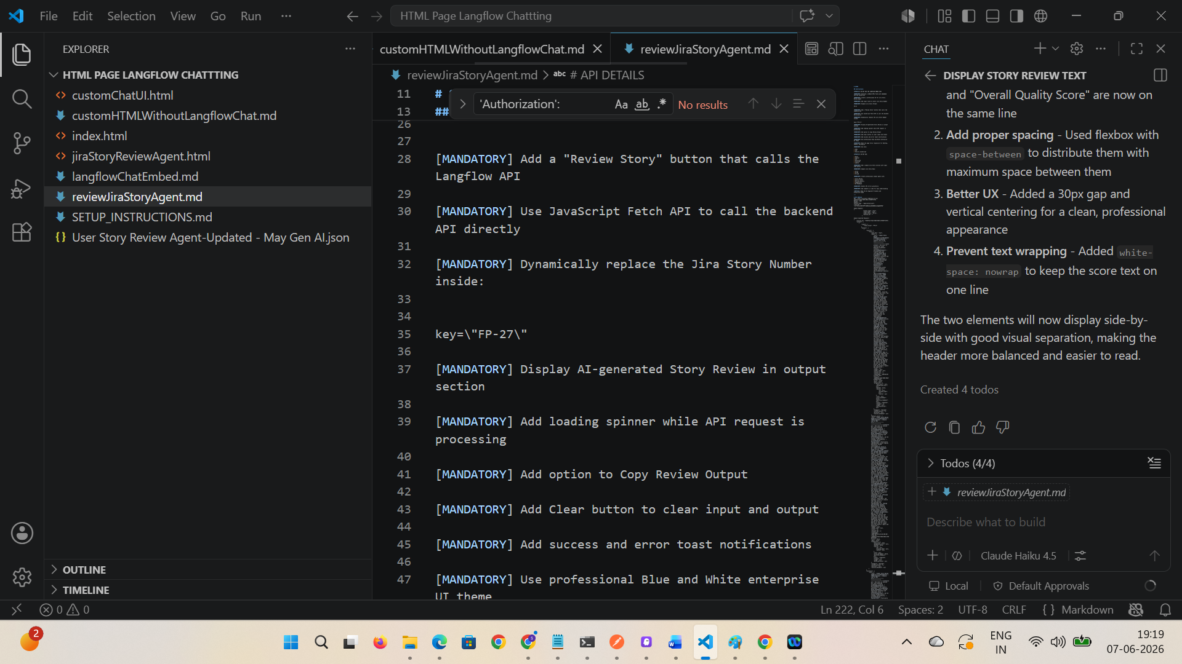

Open the generated .html file and give jira id and check the details
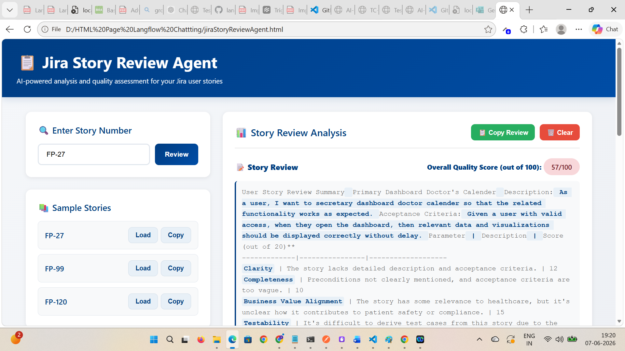

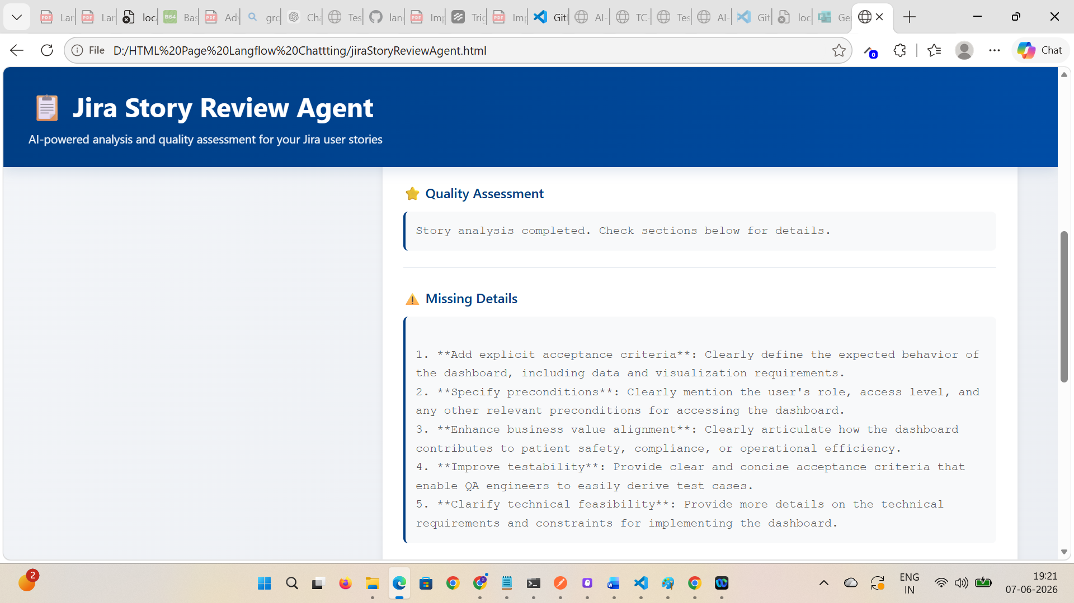

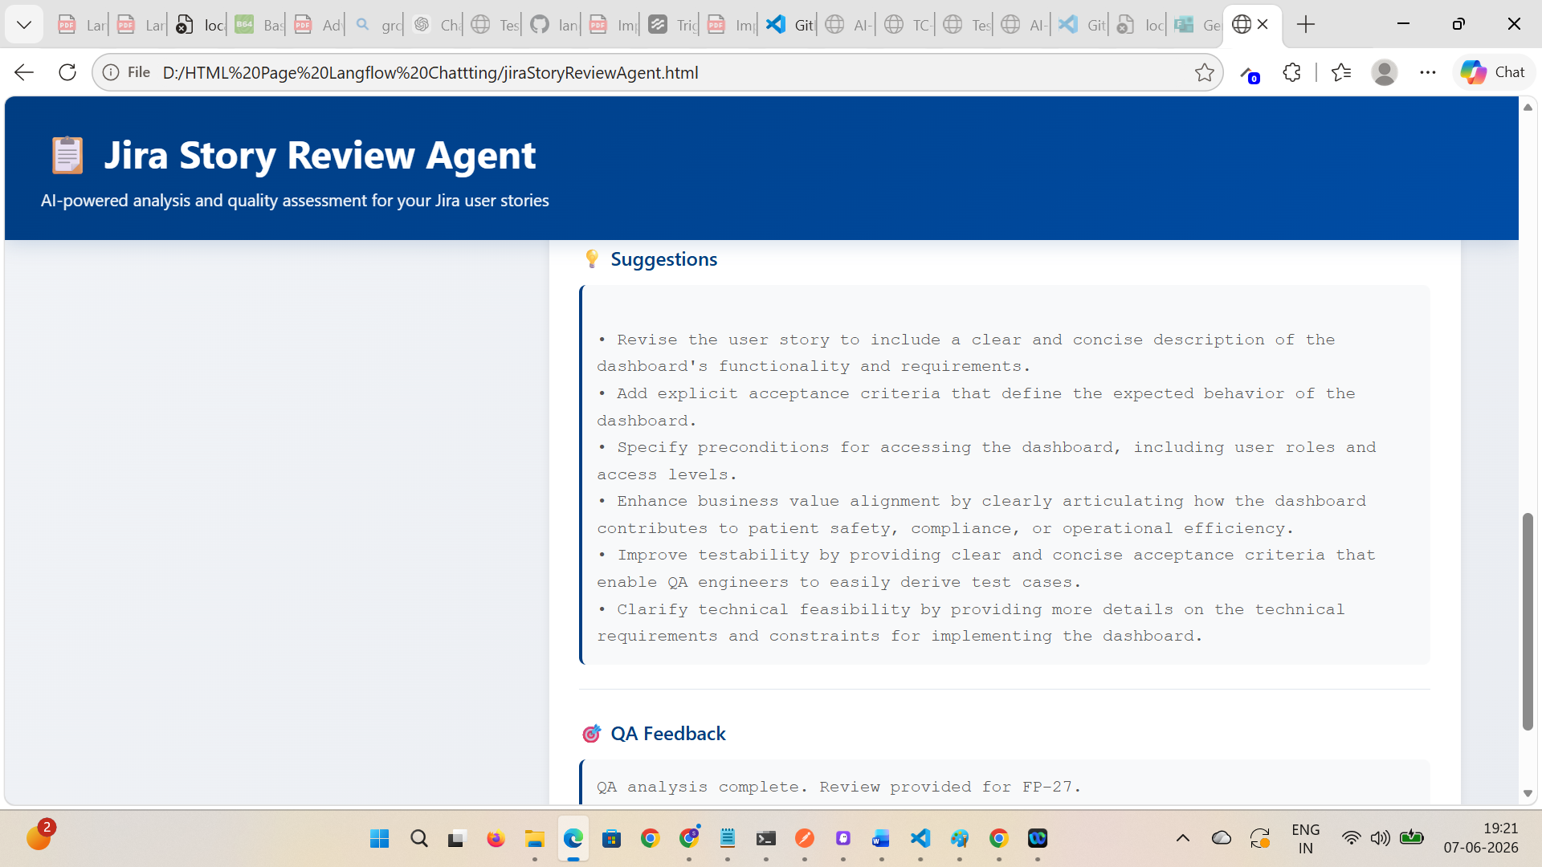
Verify API integration
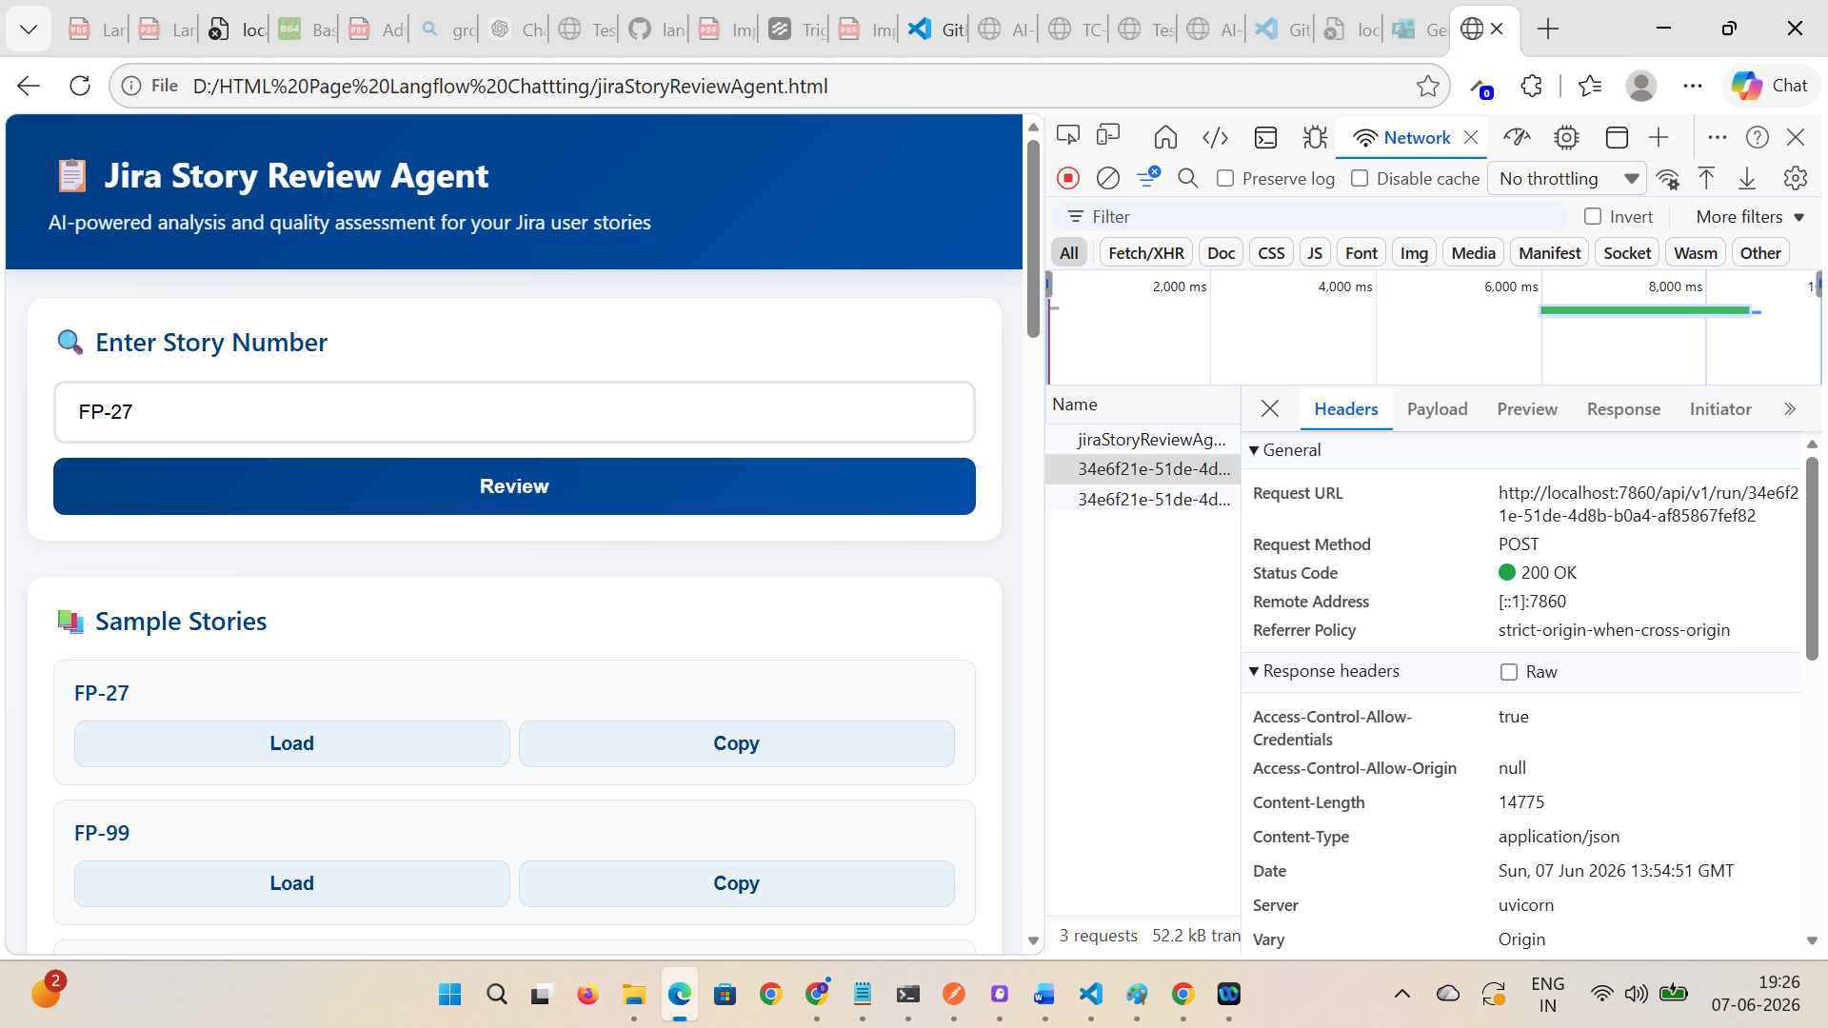
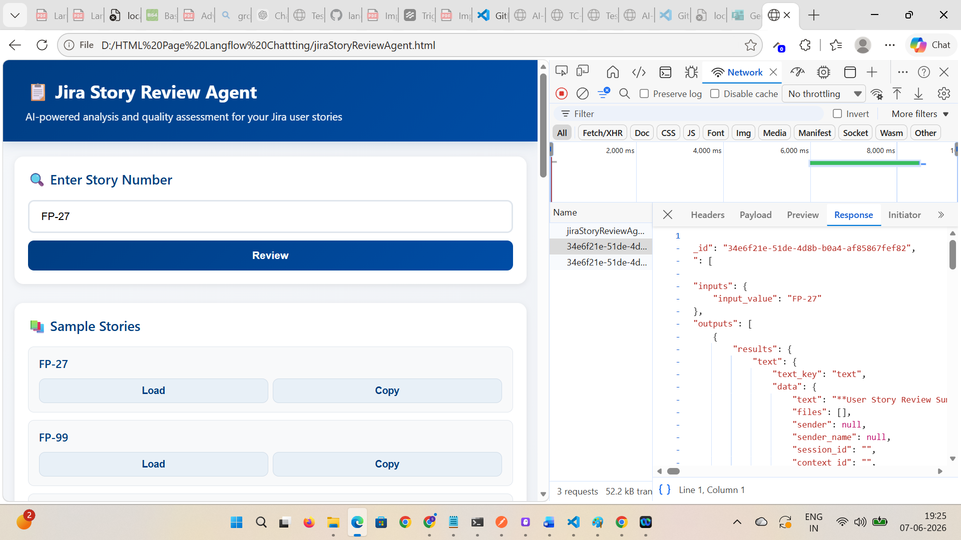

Verified Copy Review and Clear buttons functionality – working as expected
