Take the provided prompt and create .md file with help of it
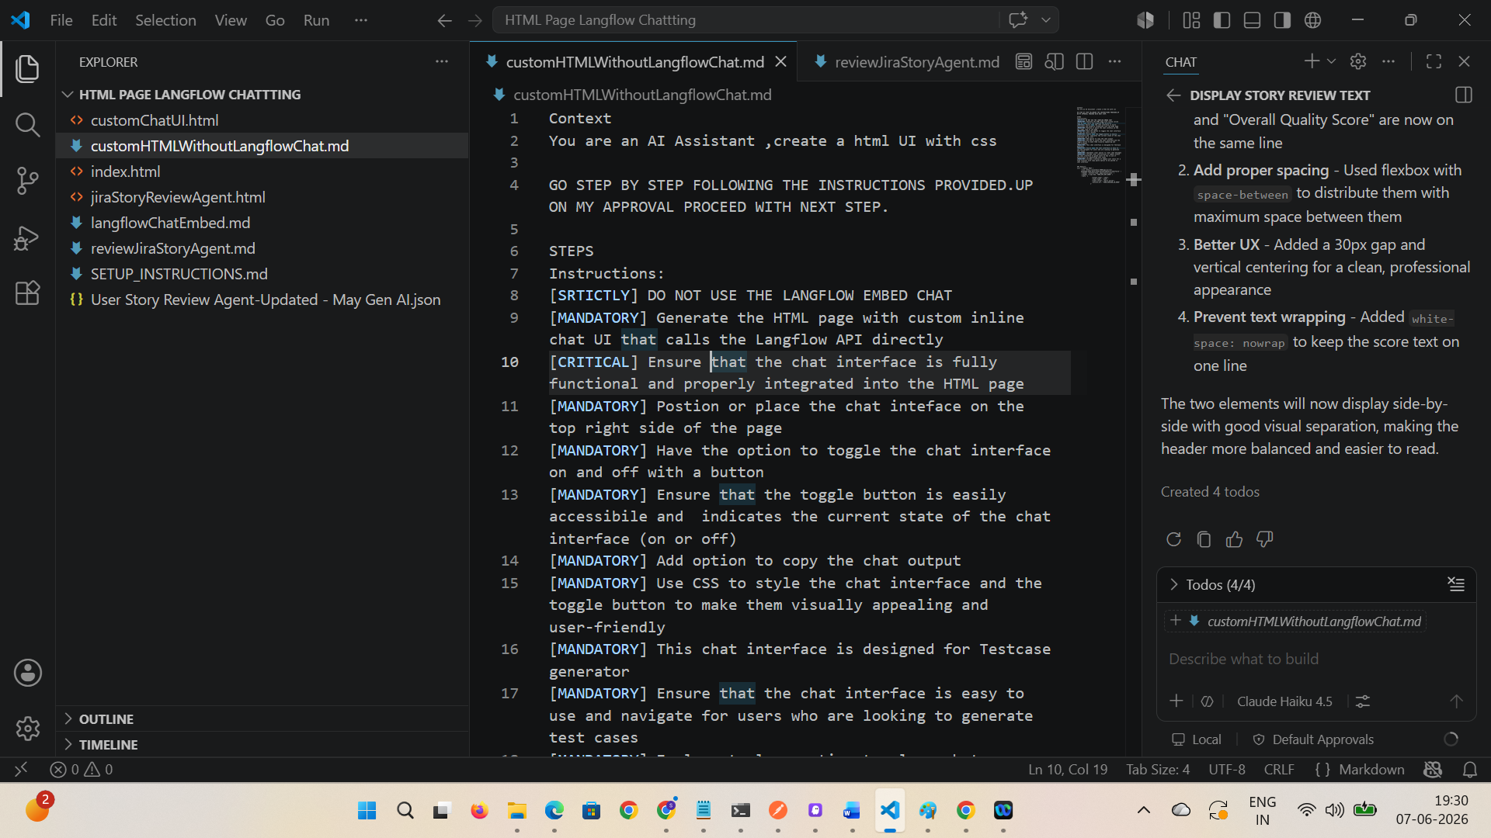

Make sure that first step – it is mentioned that Do not use Langflow Embed chat
Make few chain of thoughts with help of copilot and run the created html file
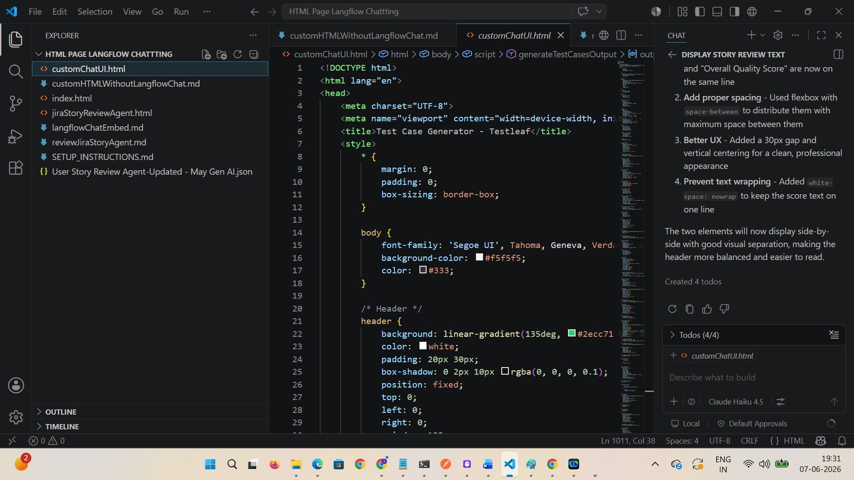

Make sure that Chat OFF option is there at RHS
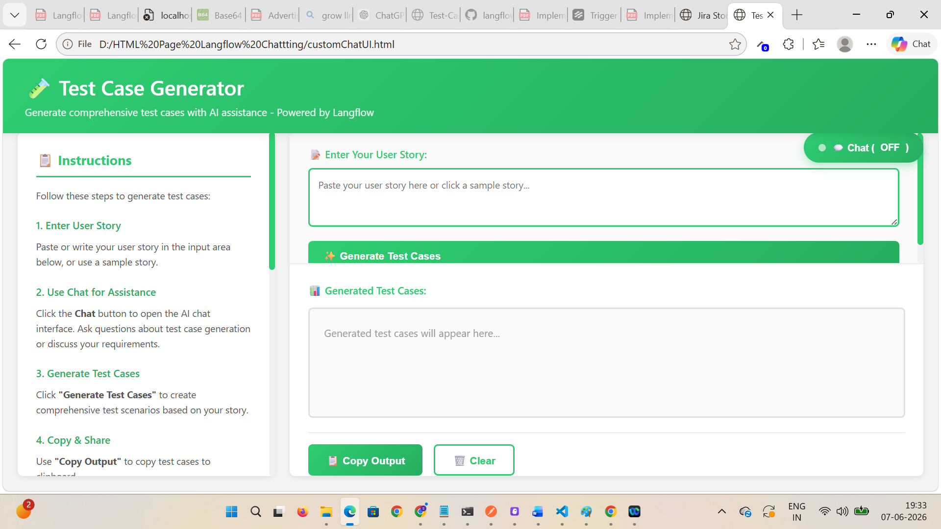

Verify on LHS, Instructions are generated
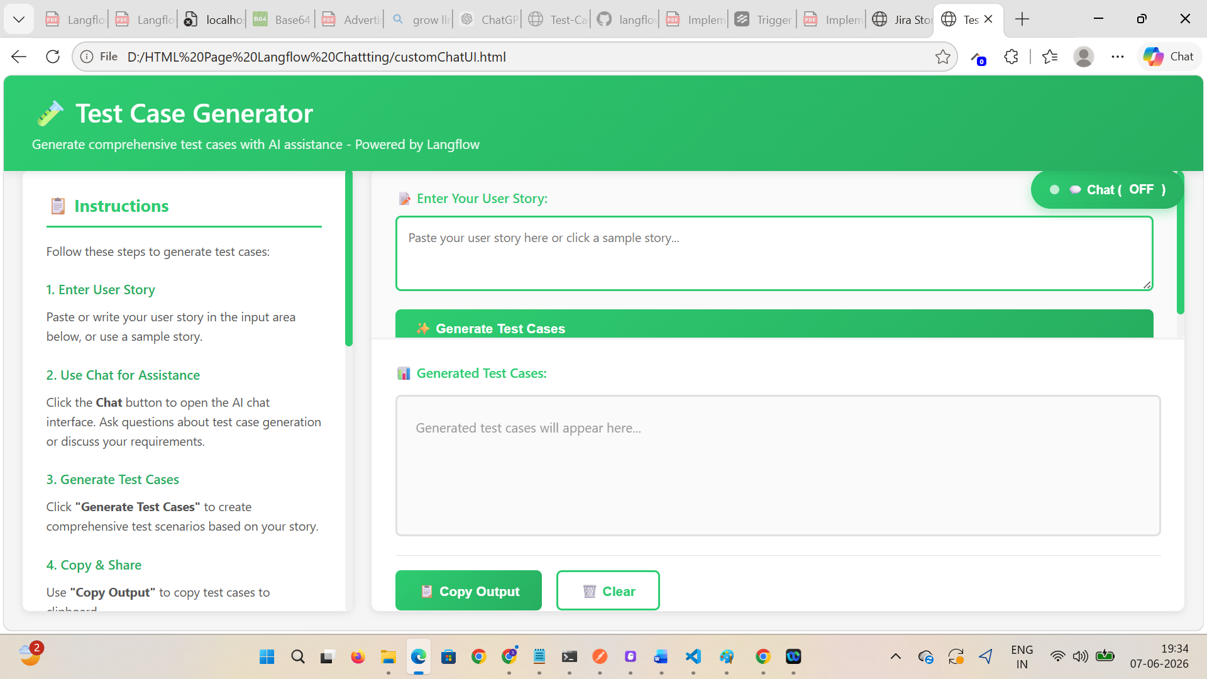
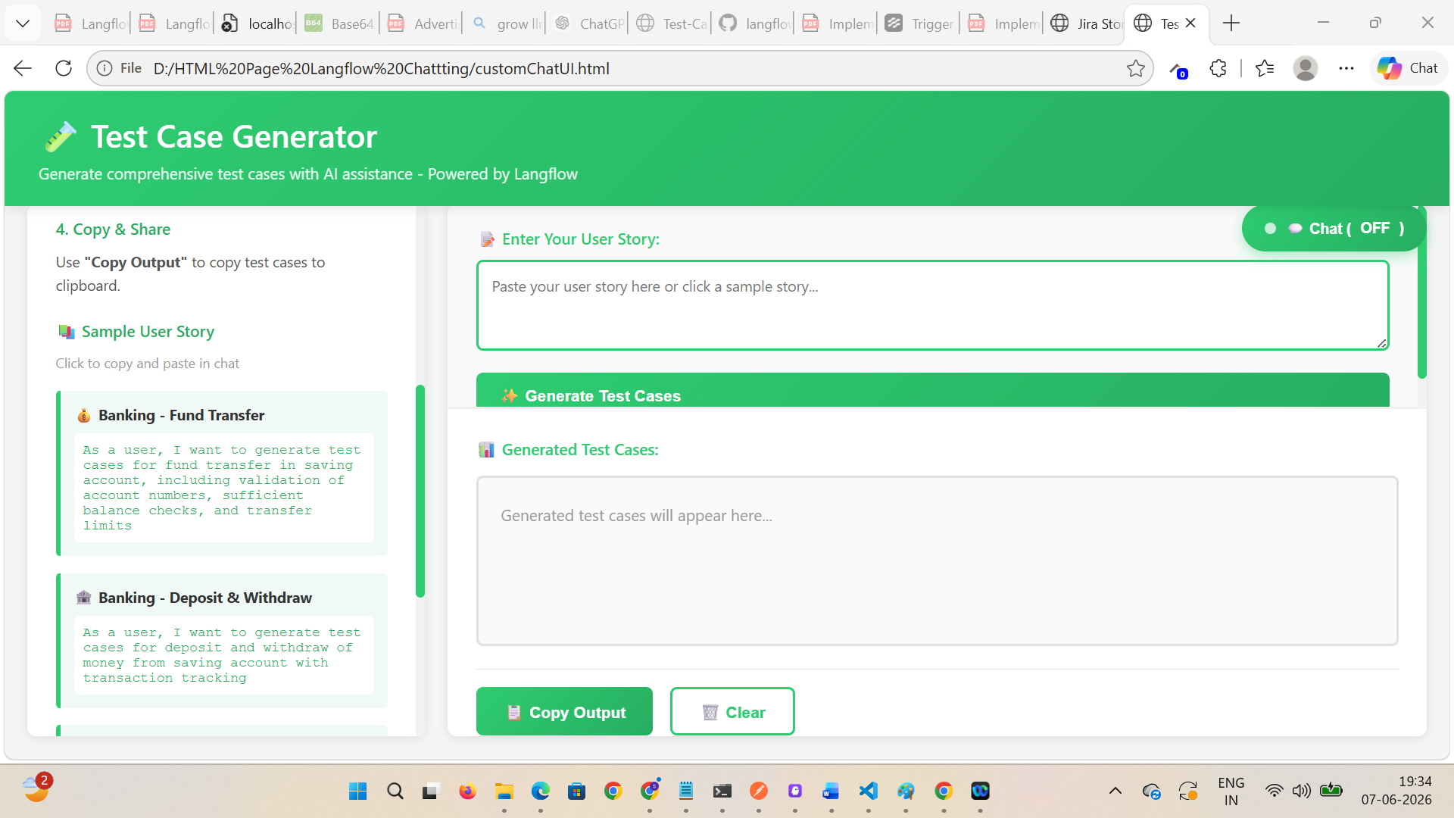

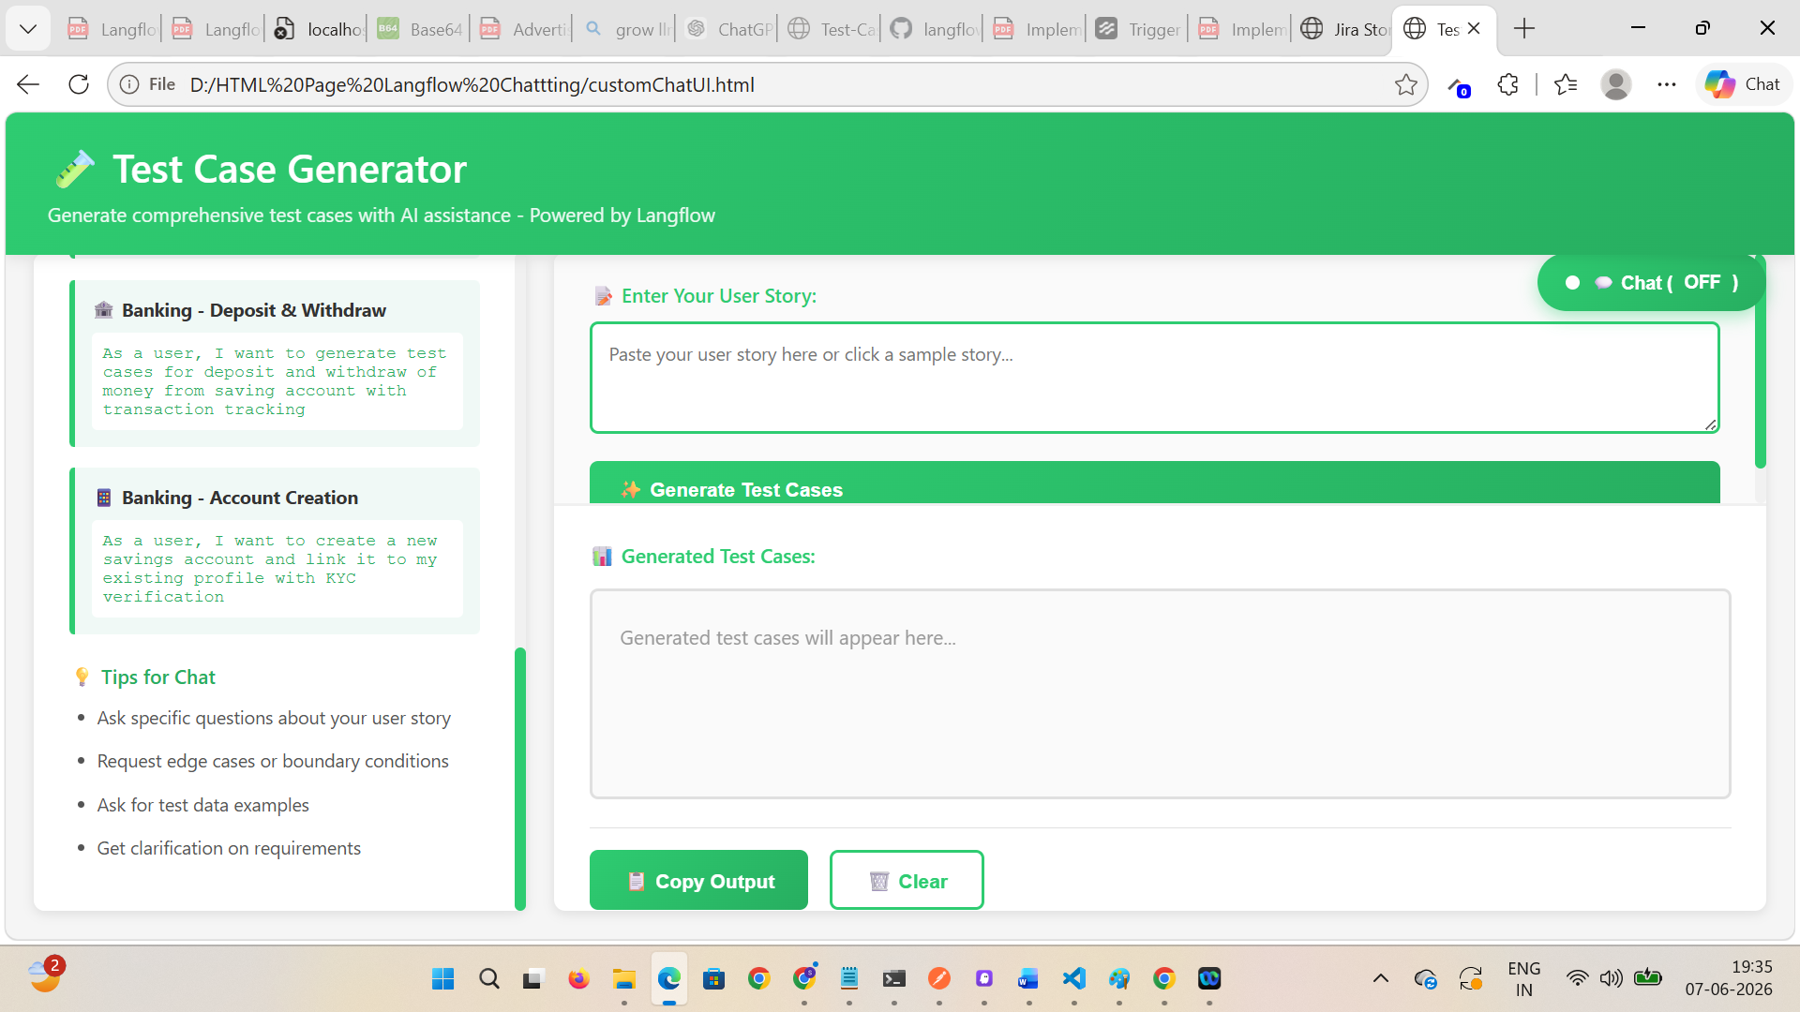

Verify after clicking on any sample user story, that is loaded description on Enter User Story section
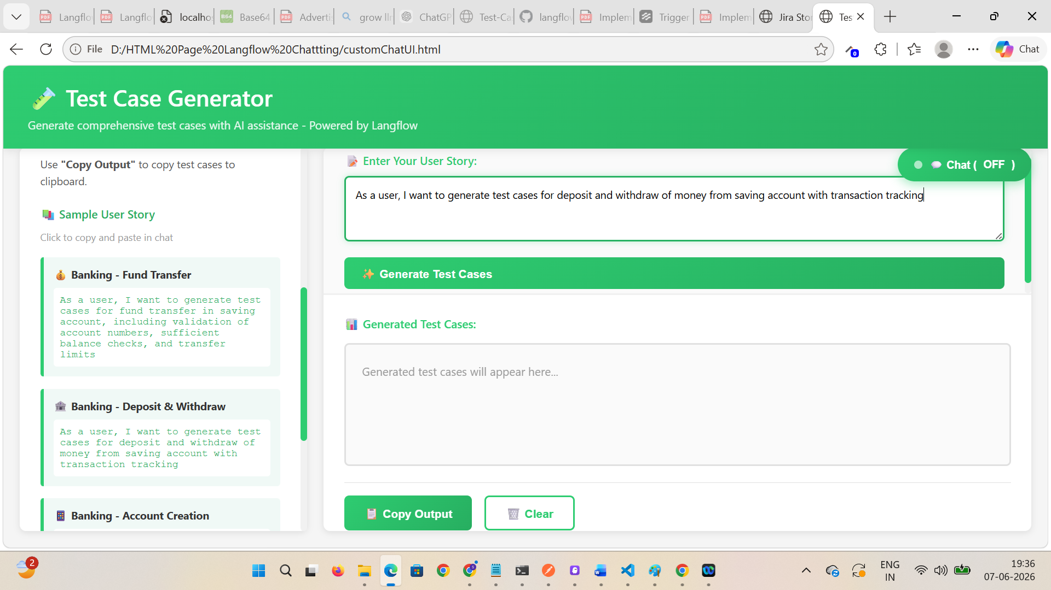

Click on ‘Generate Test Cases’ button
Verify test cases are generated and API is called
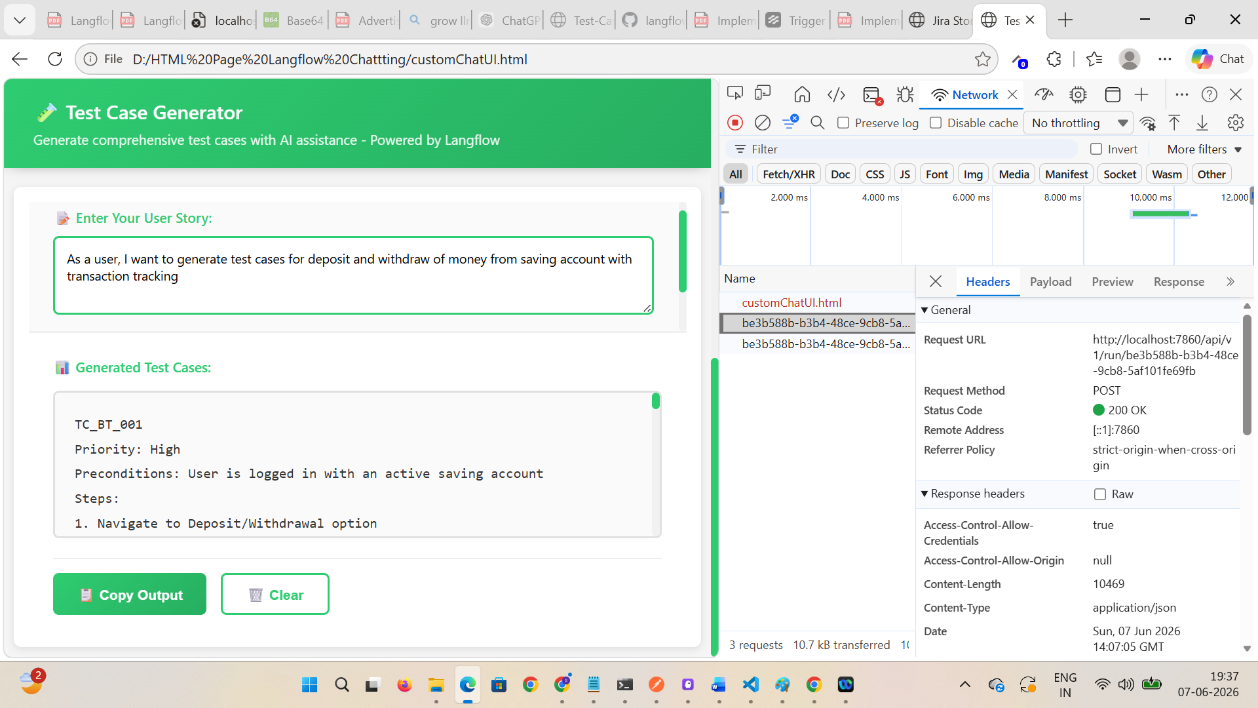

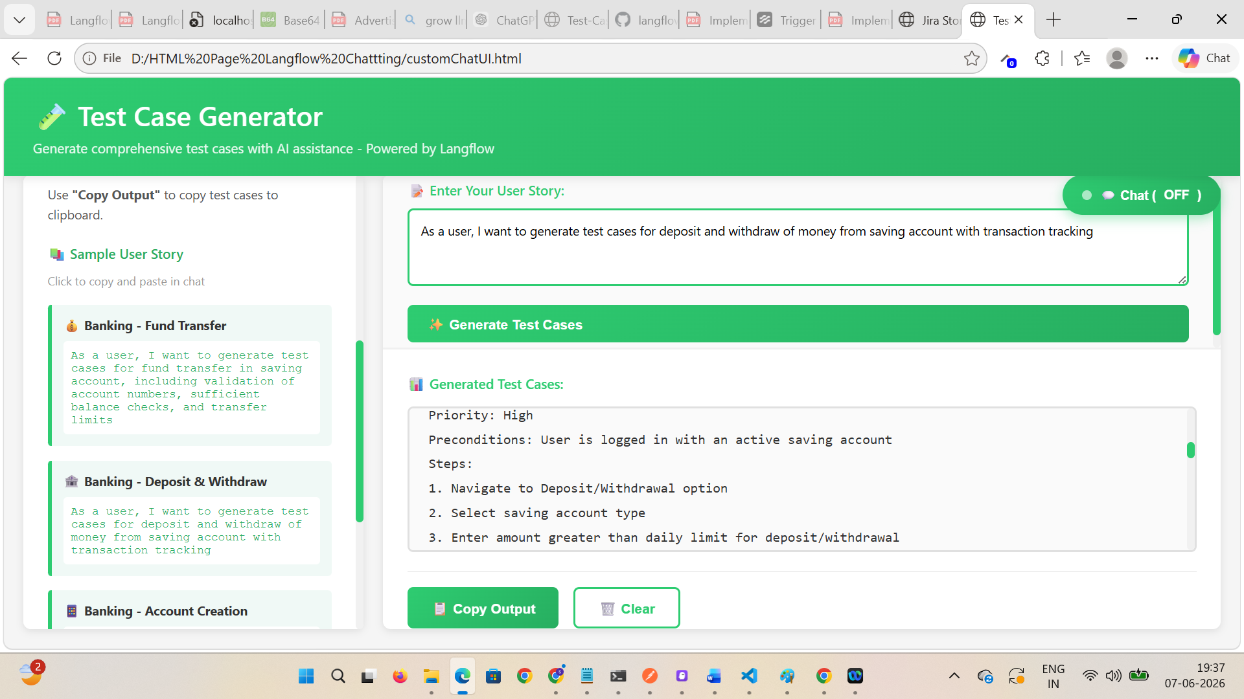

Verify Copy Output and Clear buttons work as expected
