Run AI shield project in VS code – instance 1
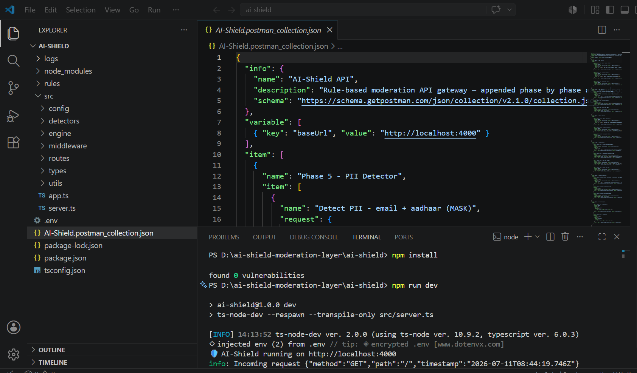

Run TC generated proj of LangChain in VS code – instance 2 with provided prompt
Generate Prompt.md and with help of Copilot generate IntegratiopnPlanm.md
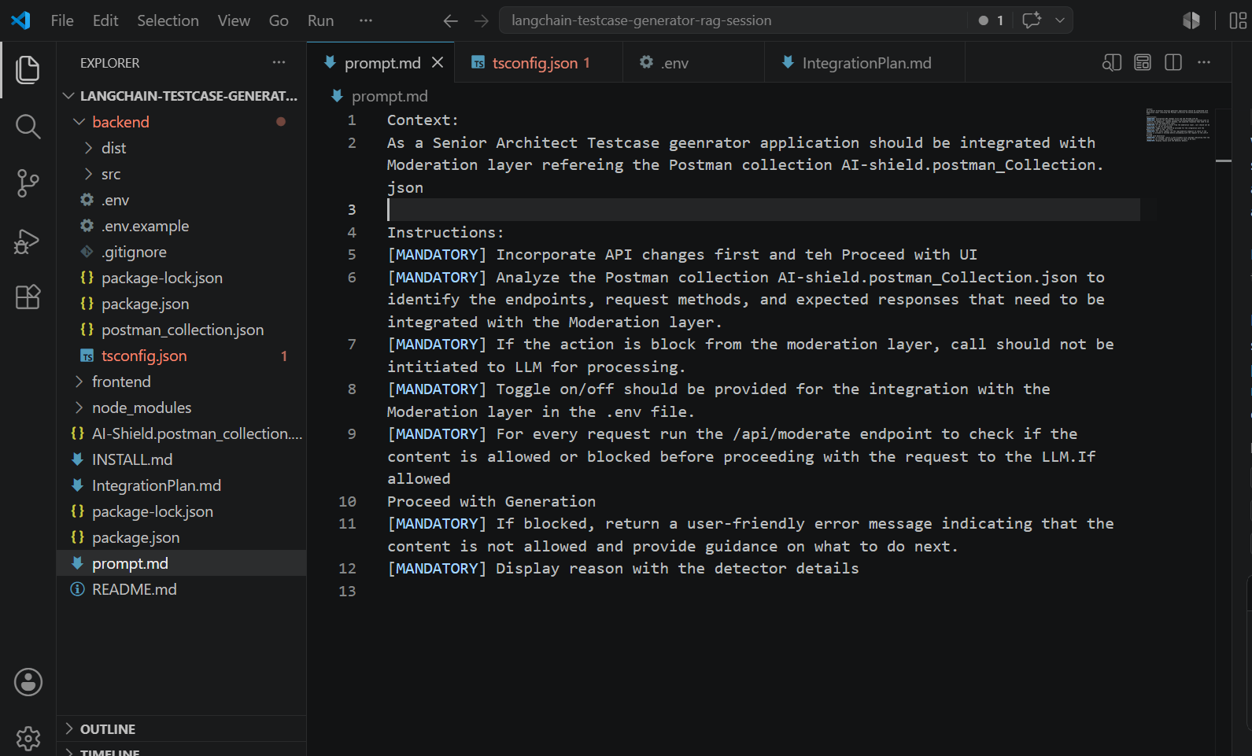
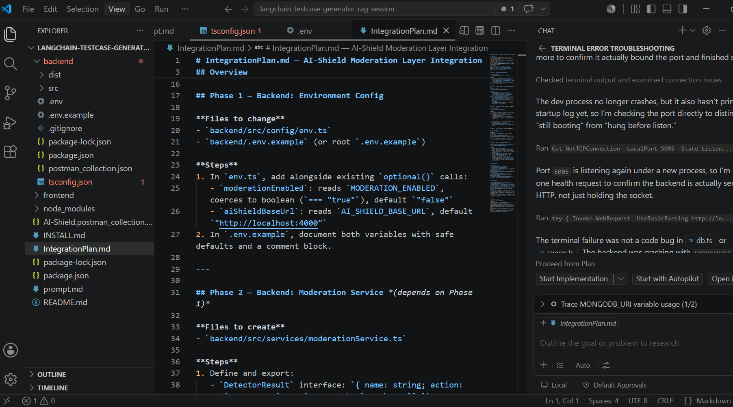

Now, run all the phases of IntegrationPlan.md with phases and execute it
Now, Run the backend and frontend for TC generator
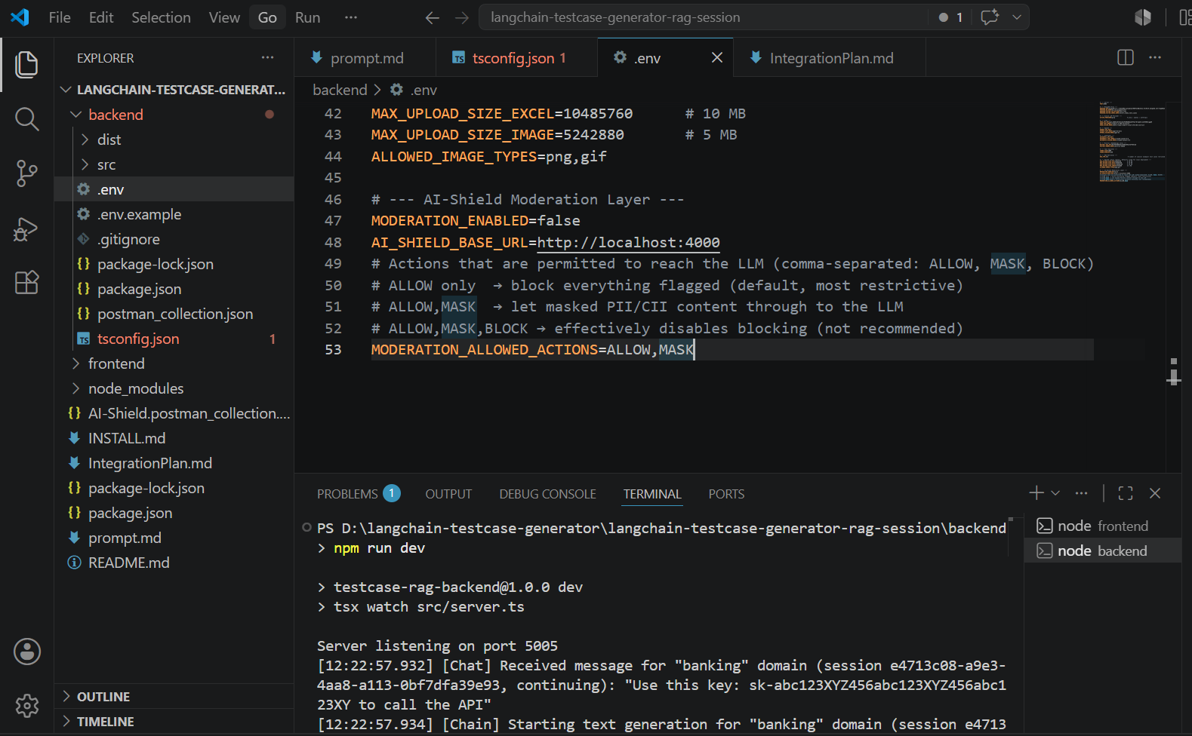

Open in browser and verify response accordingly
MODERATION_ENABLED=true
Mask request
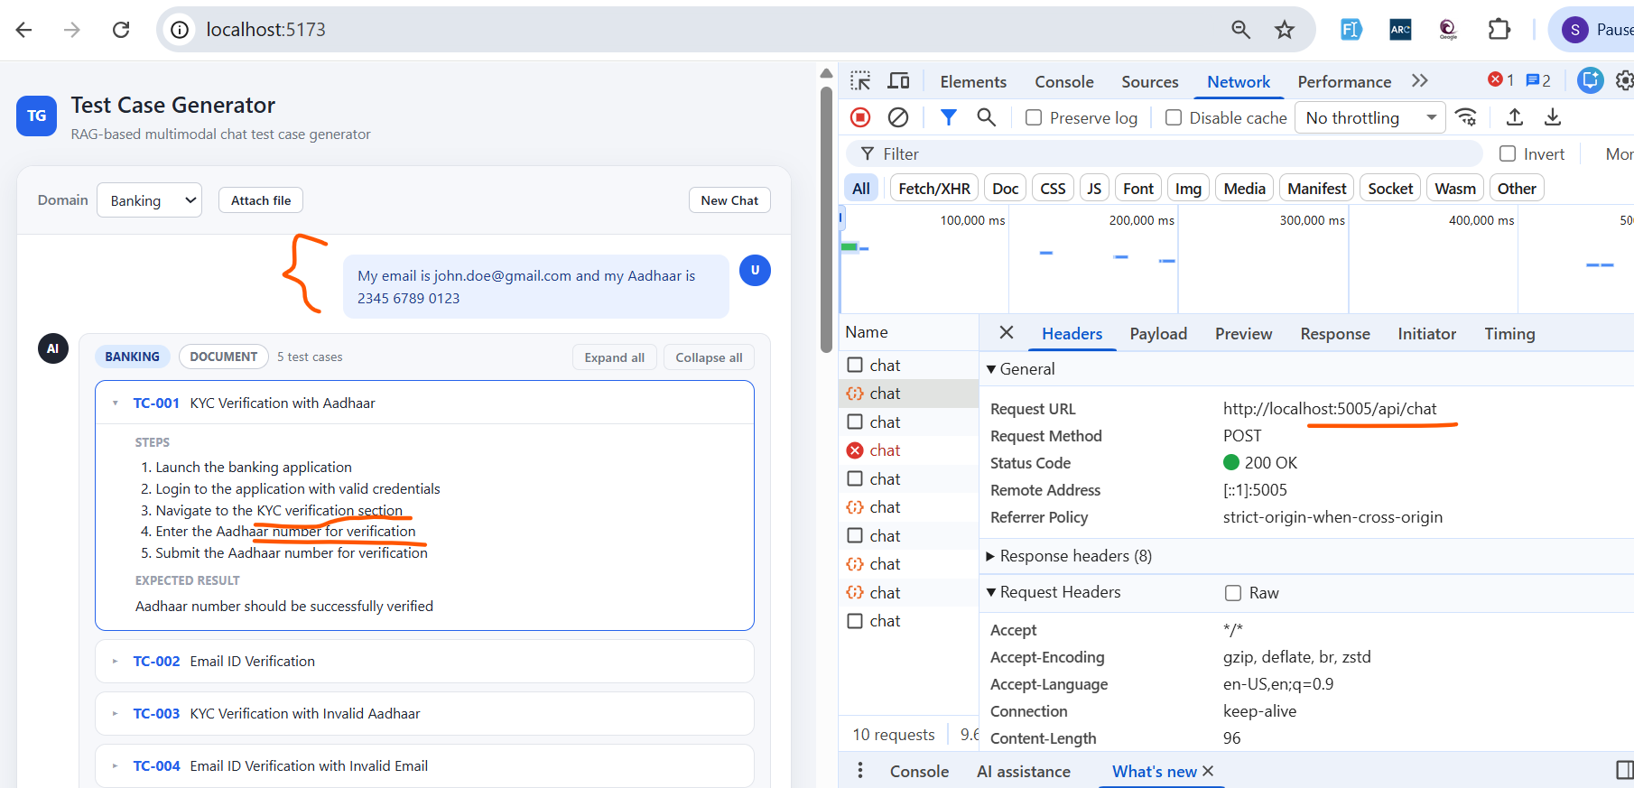

Blocked content
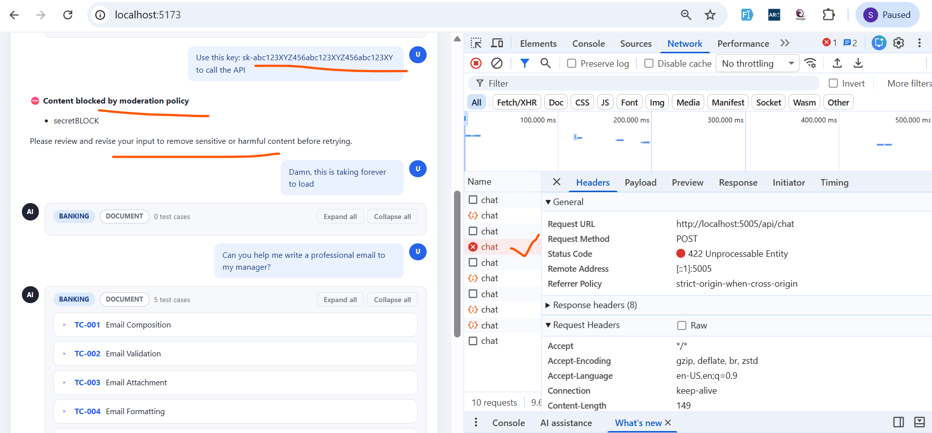

Allow action
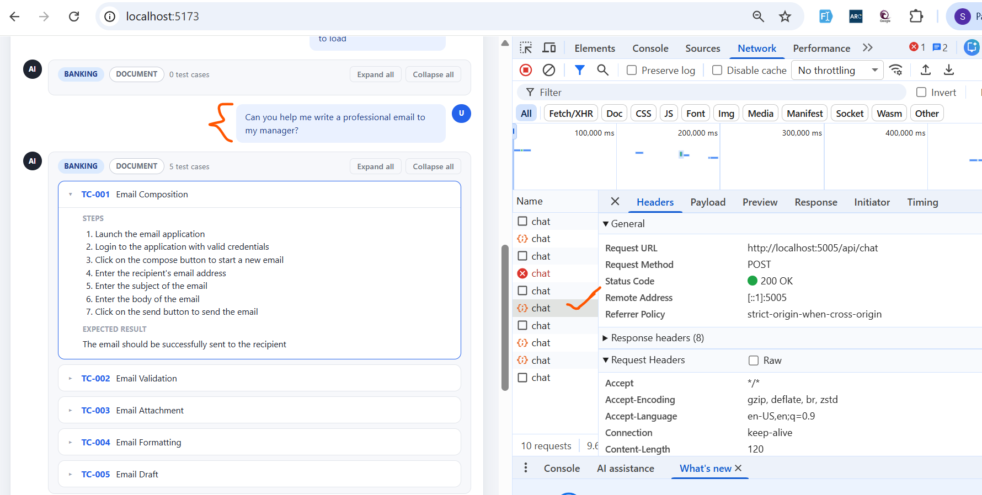

MODERATION_ENABLED=false
For blocked content also, generating test cases
