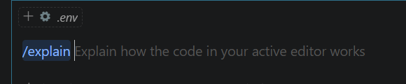

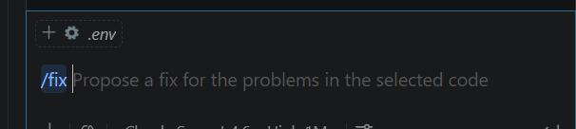

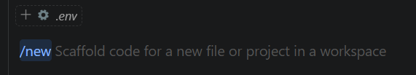

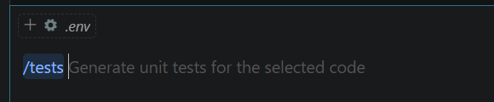

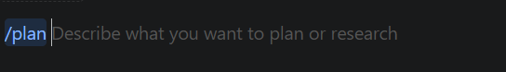

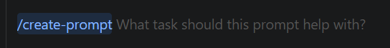

/clear – clear the prompt
/hooks – show all the hooks

