Navigate Langfuse and create project in it and note down APIs of Langfuse
LANGFUSE_SECRET_KEY="sk-lf-2f19bc32-22cf-4460-a85c-c52eb166b291"
LANGFUSE_PUBLIC_KEY="pk-lf-e6bf876c-52f2-449b-ad04-243d1b317ec6"
LANGFUSE_BASE_URL="https://cloud.langfuse.com"
------------------------------------------------------------------------------------------------------------------

Download the zip file and extract it
Update .env file with own credentials
Navigate Vector Search and enter search criteria and click on search button
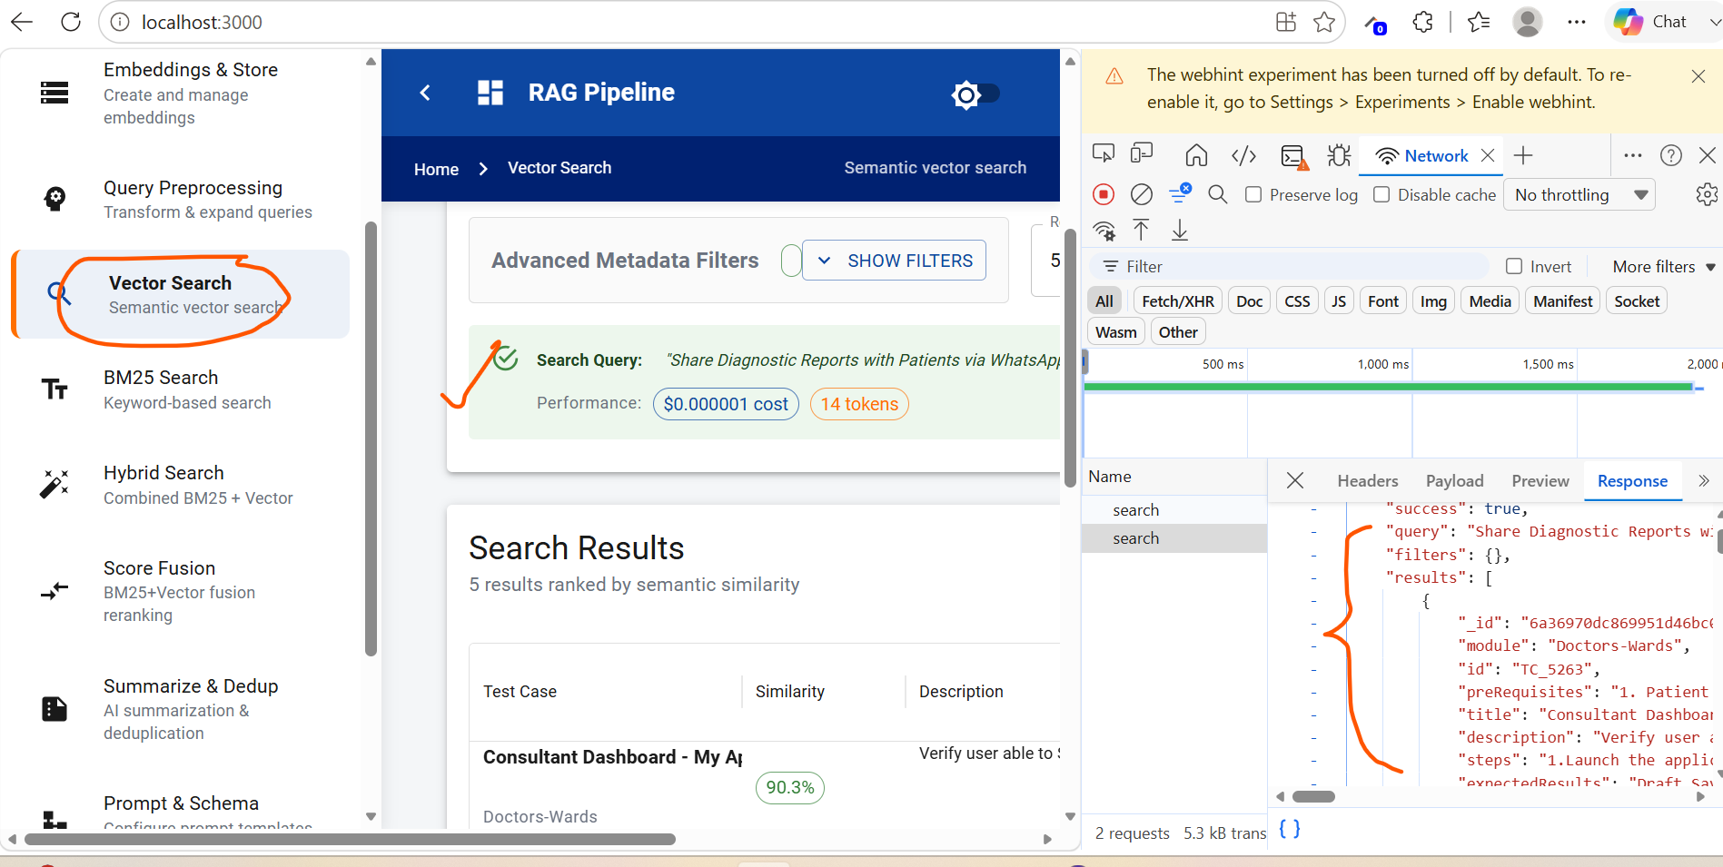

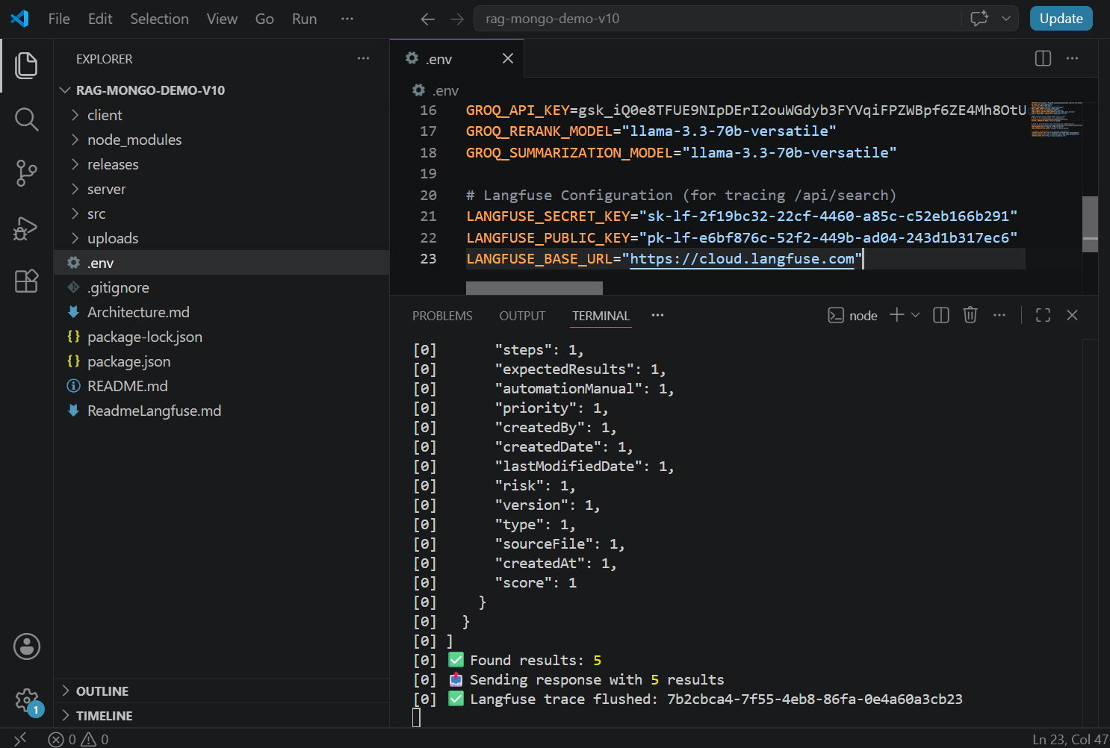

Wait for some time (10 to 15 min) and verify in Langfuse the traces
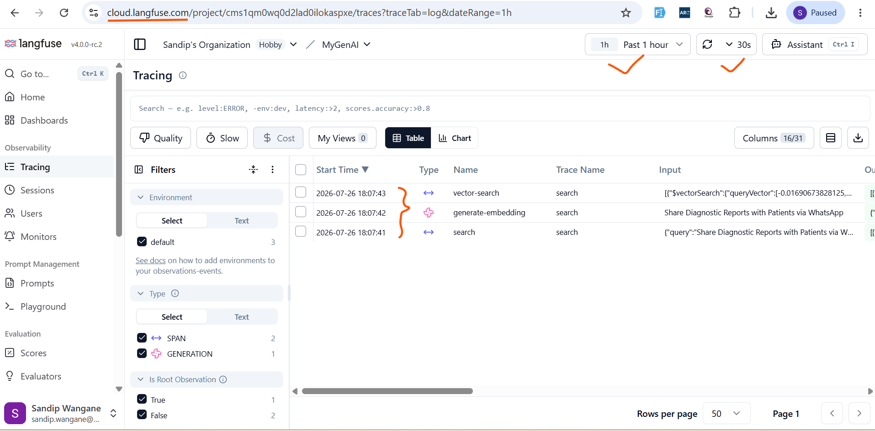

Verify span details
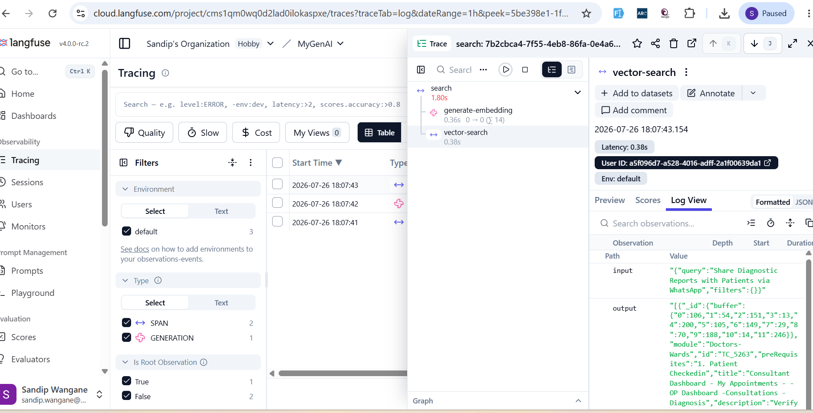

Verify Generation details
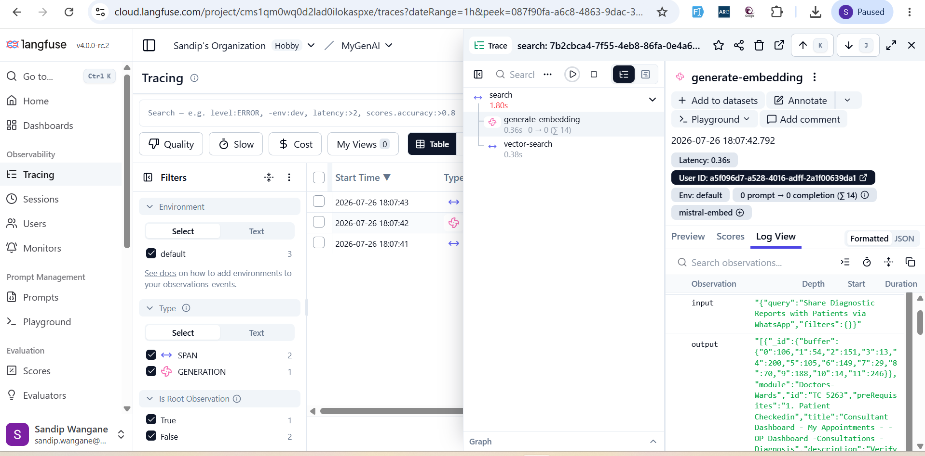

Now, with copilot, update Readmelangfuse.md file and Architecture.md file
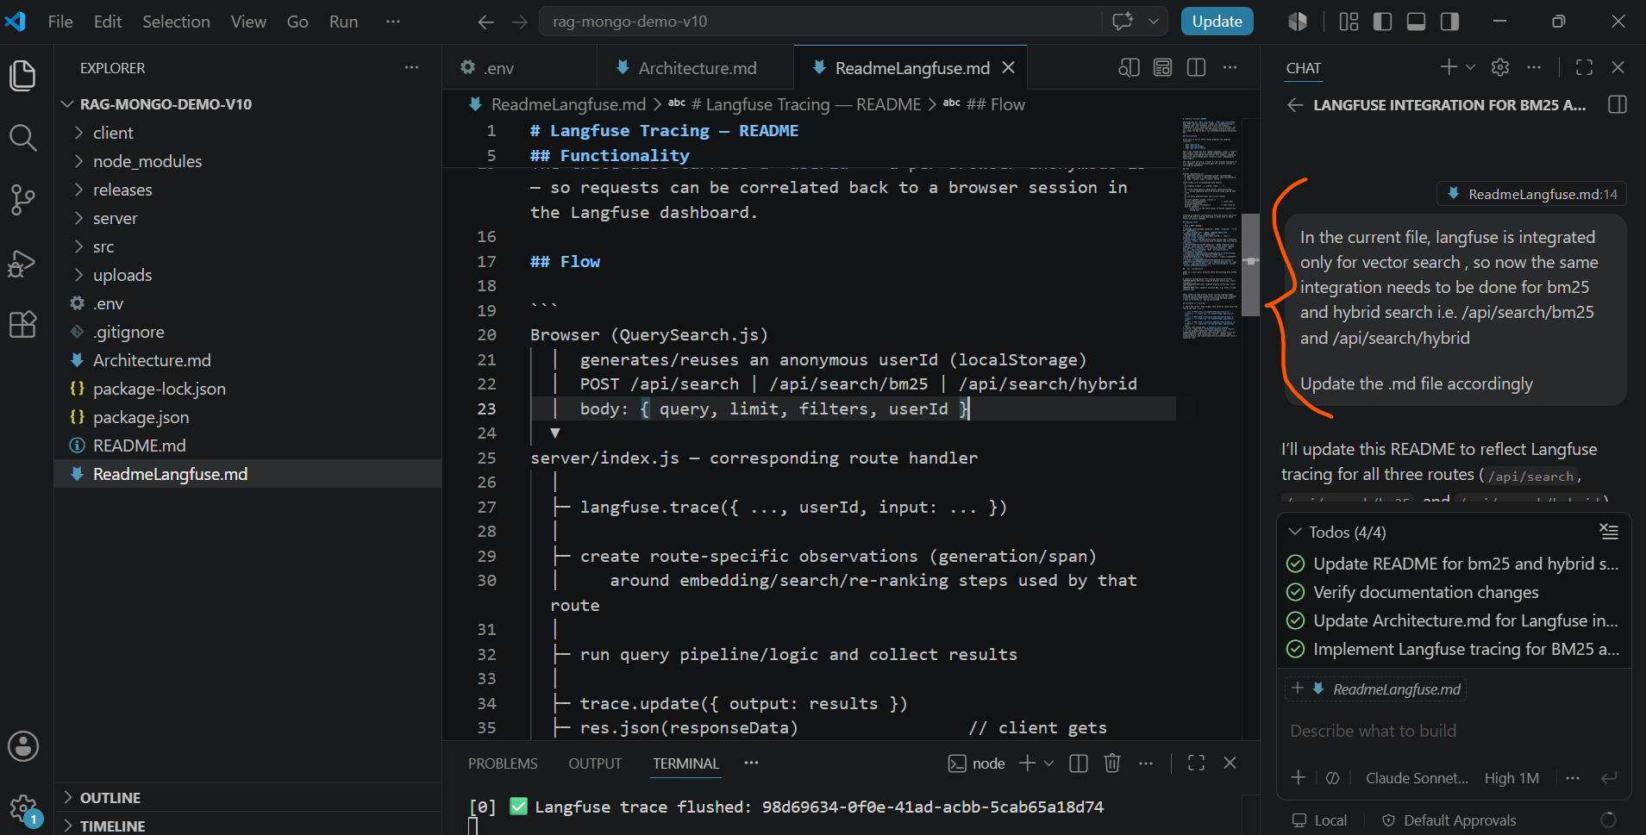

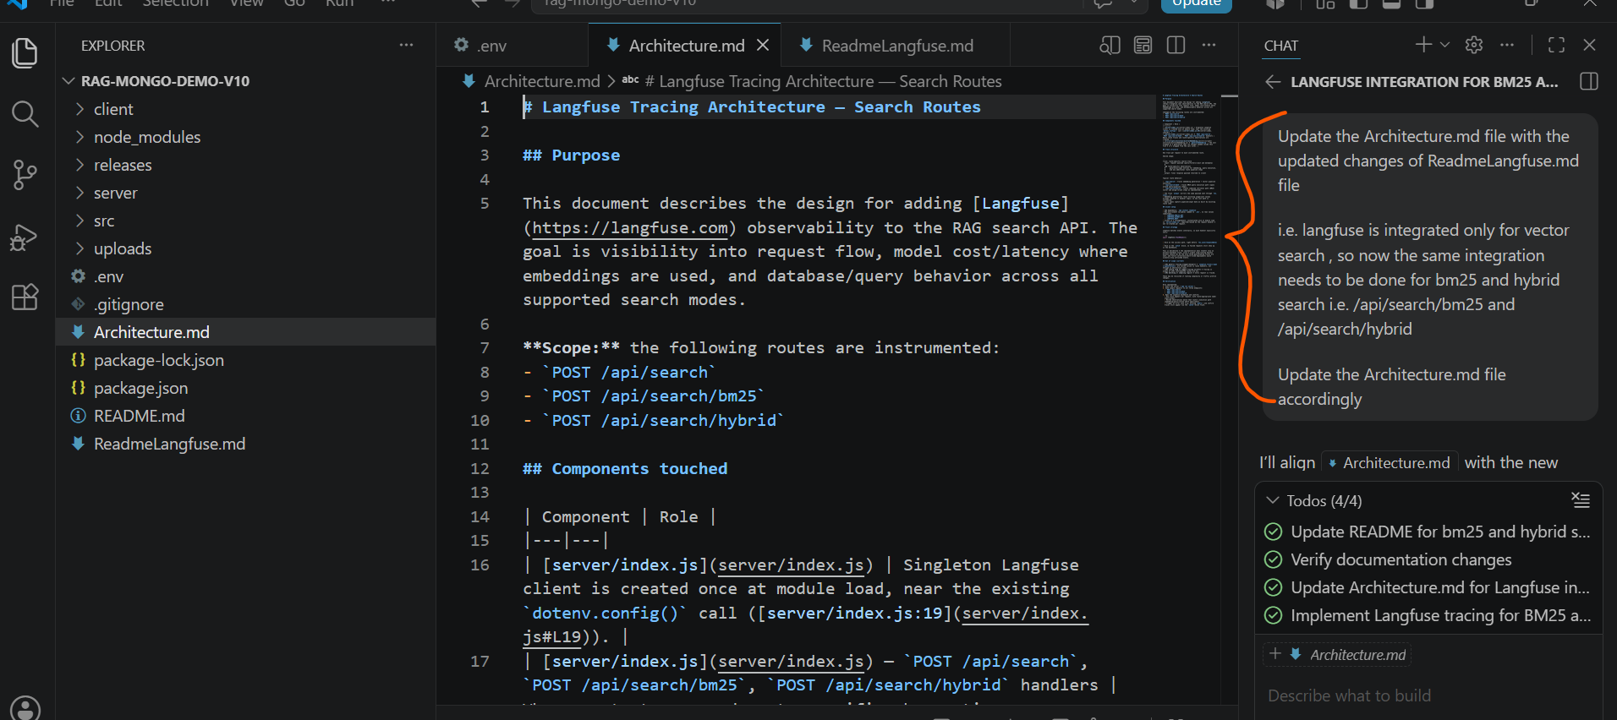

Now, ask copilot to understand the project structure and ask him to follow code changes in the current project referring Architecture.md file

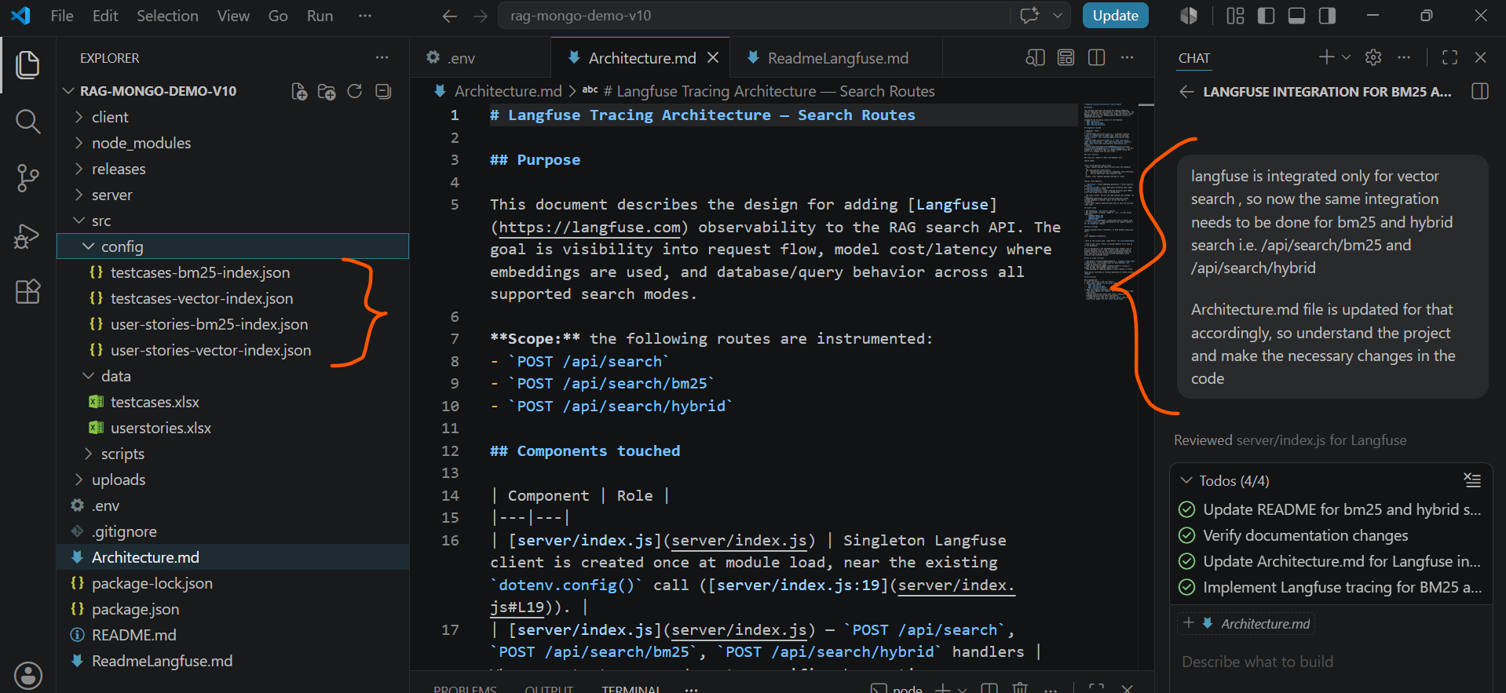

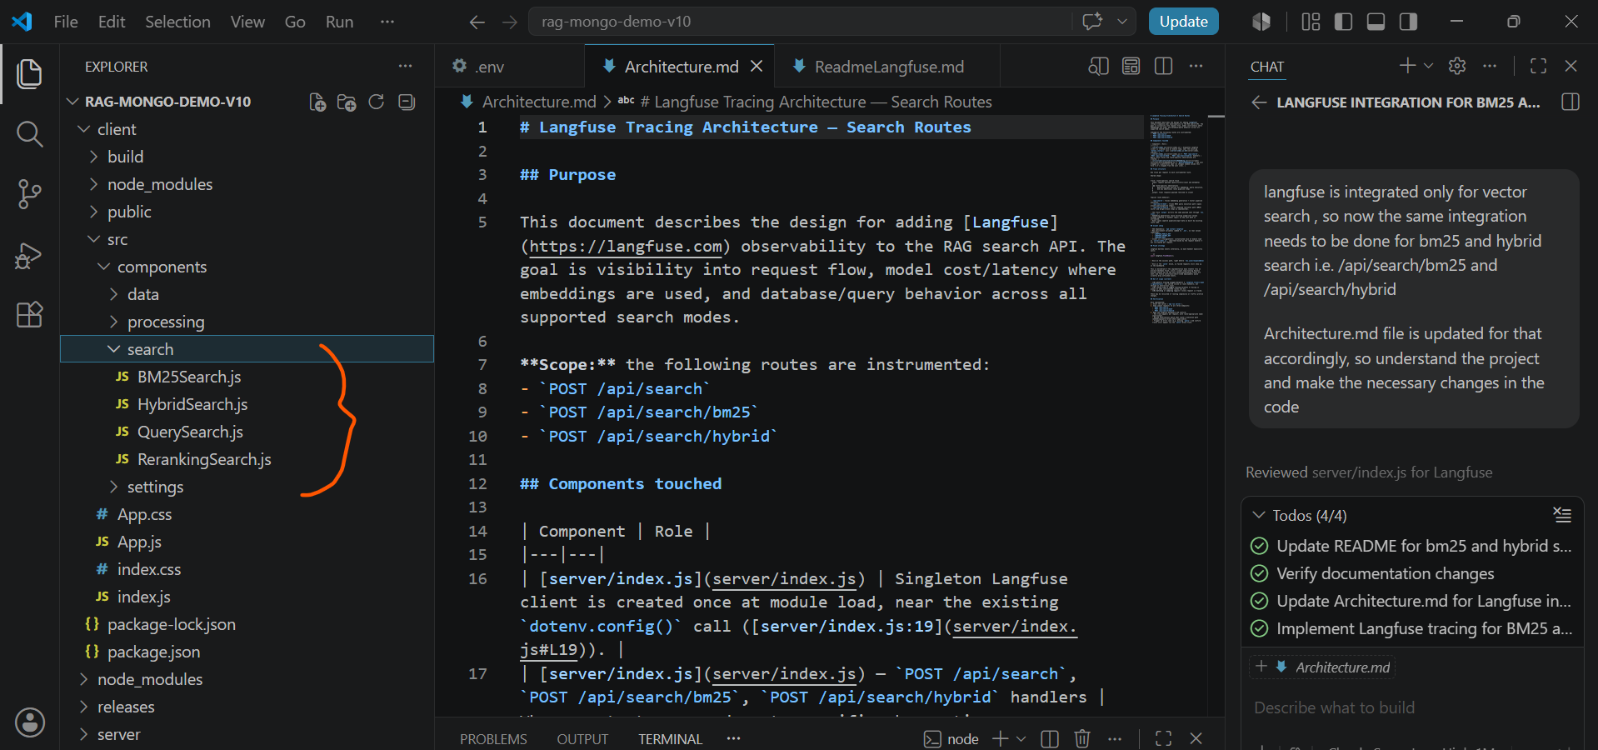

Now, restart the application and hit BM25 and hybrid search
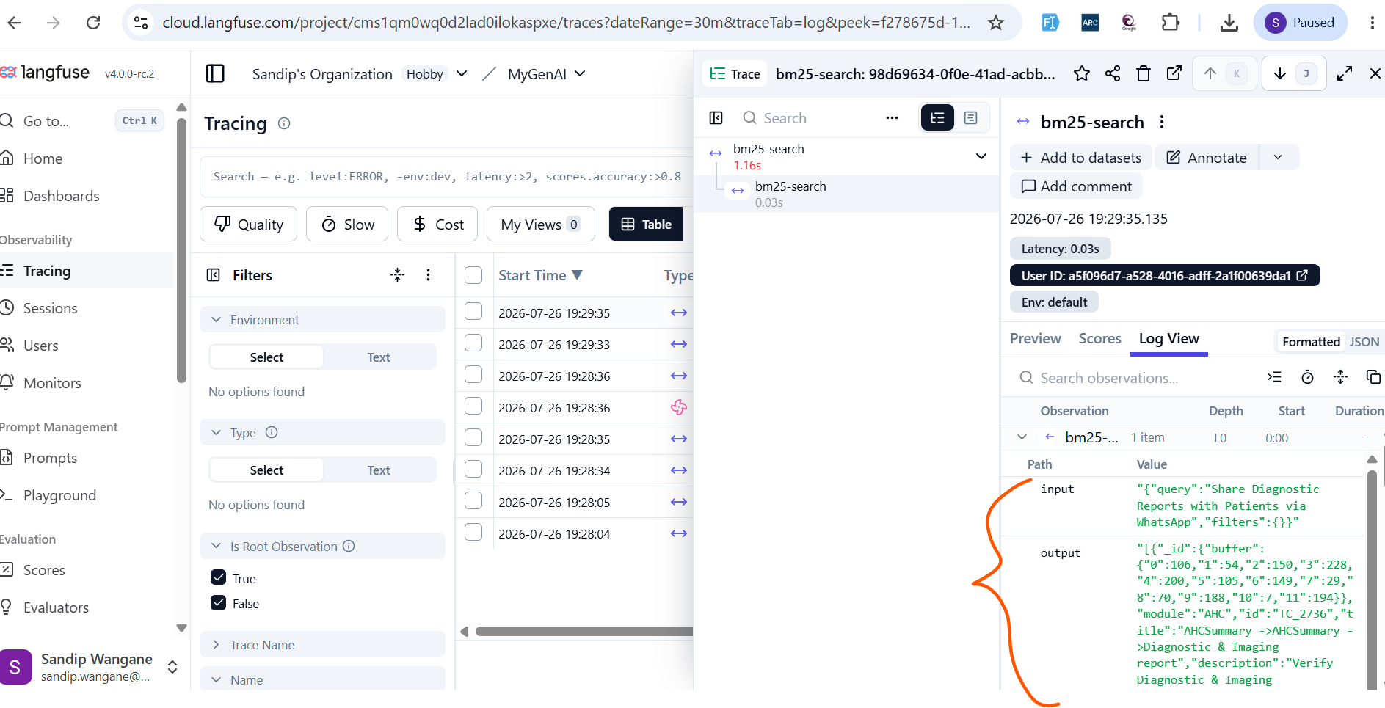

Enter input to search for BM25
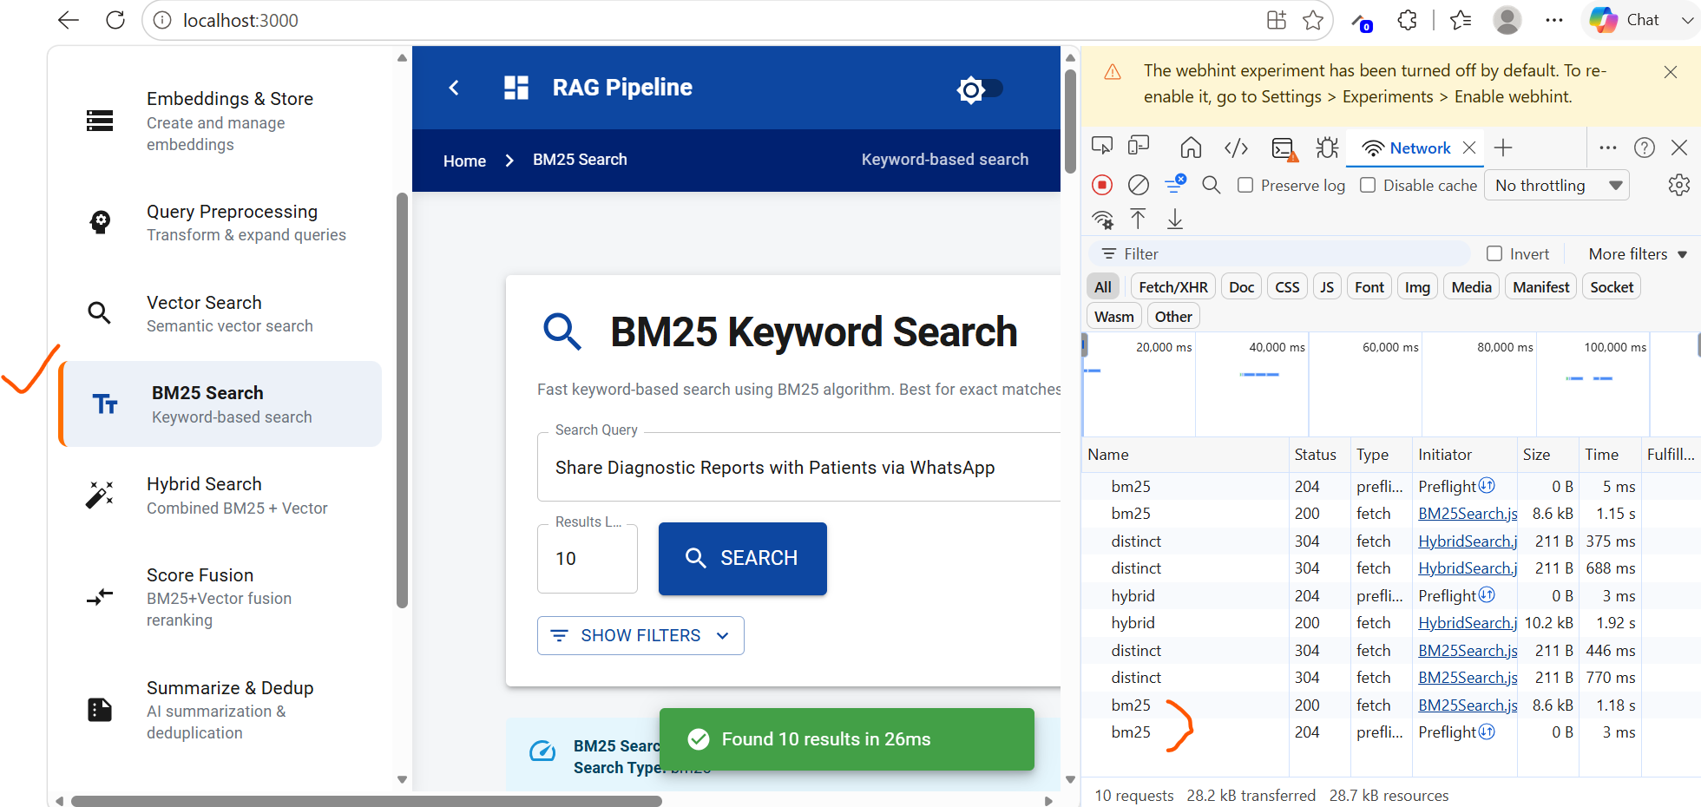

Enter input to search for Hybrid search
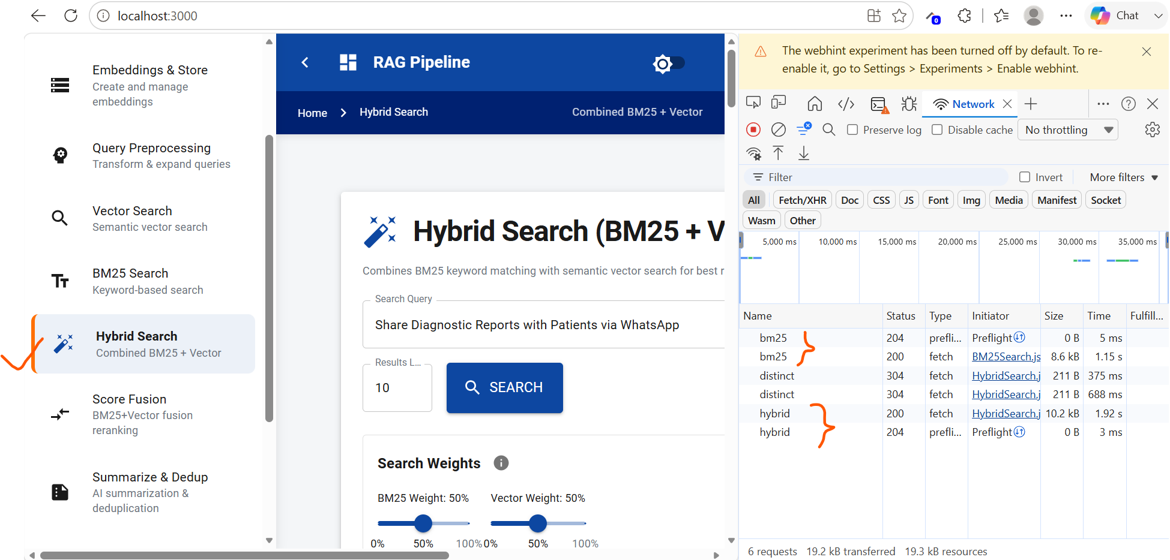

Verify the traces for bm-25 and hybrid search are available in Langfuse
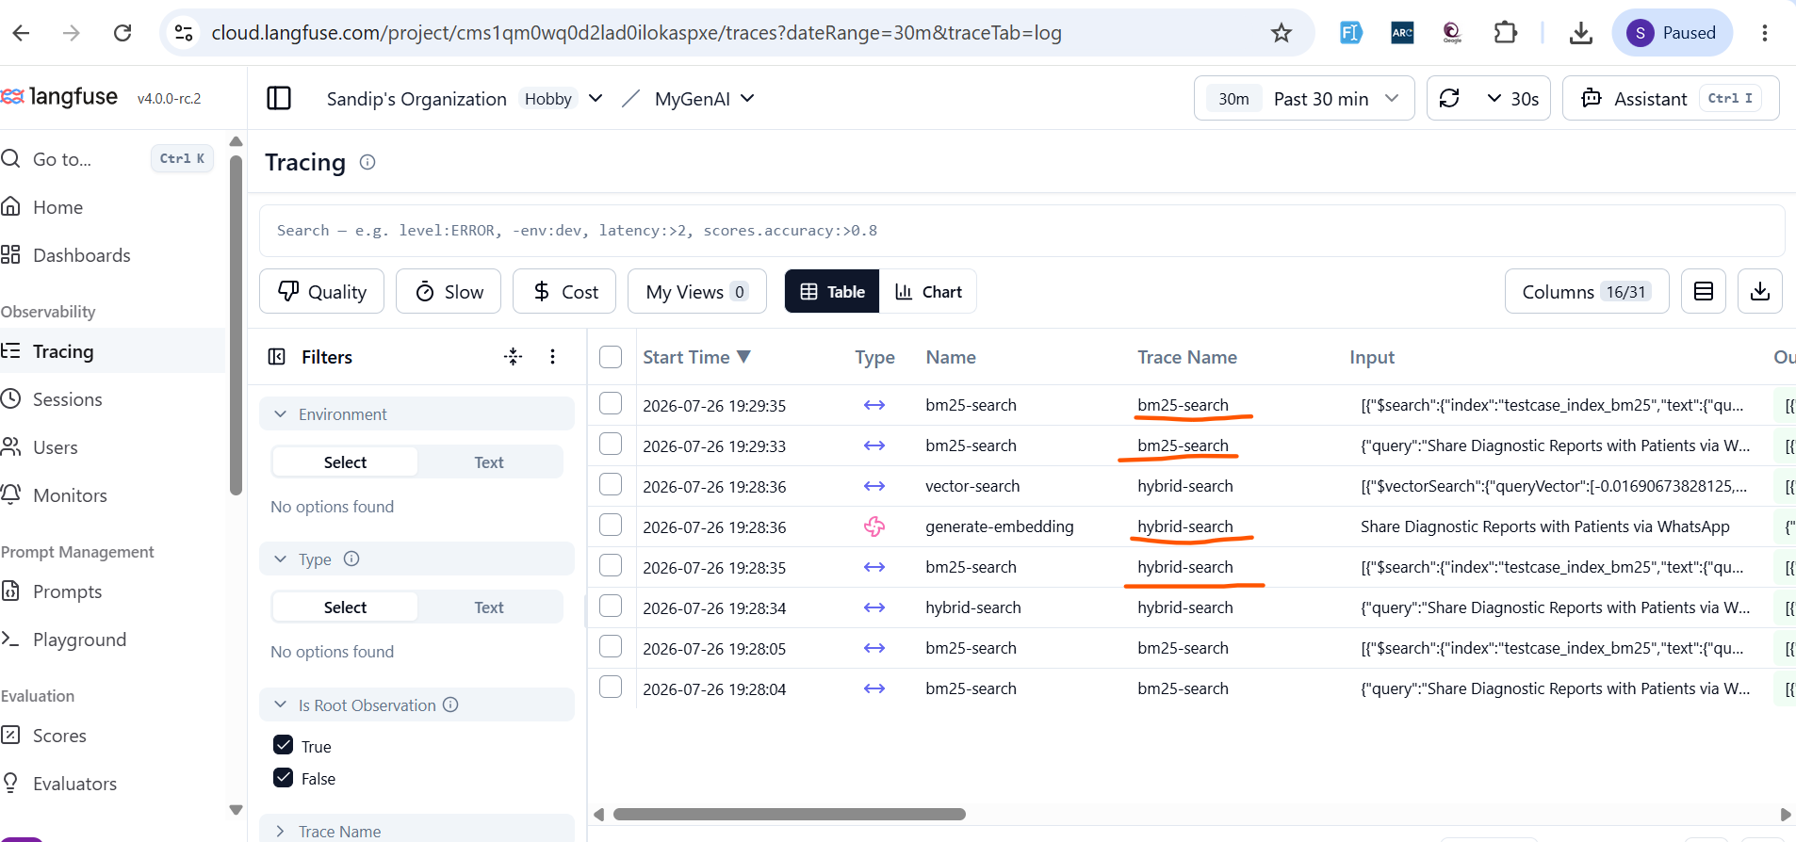

Also, done for Summarization and deduplication as well
