IV. Situated Learning – Workplace Application
Application: Change Validation Audit Copilot – auditing whether the evidence on a change ticket supports its validation plan
Builds on: RBI KYC & PSL Compliance Copilot (Parts I–III): NER, text generation, extractive QA and RAG chatbot.
Data note: the workplace's change records, evidence and internal standards are confidential, so every record in this section is synthetic and the knowledge base is a generic change-control standard written for this prototype. It reflects the shape of the real workflow, not any real ticket or policy.

1. Anchor – the workplace problem

1.1 Organisational context and current workflow
The workplace is the technology risk and governance function of a large financial institution. Production changes are raised, approved and closed as ServiceNow change requests. Each change carries a validation plan: the checks the application team promises to run after implementation (smoke test, health check, data reconciliation, rollback verification and so on). After implementation the team attaches evidence and closes the ticket.
The governance team audits the quality of these tickets every year. The central test is whether the evidence matches the validation plan. Where it does not, the application team receives a recommendation describing what is missing or wrong and what to do about it.
Current workflow, as a reviewer experiences it:
- Pull the audit population of closed change tickets for the year.
- Open each ticket and read the validation plan step by step.
- Open each attachment and work note (mostly screenshots, logs, exports and emails) and decide which step it supports.
- Check the details that make evidence valid: captured after implementation started and not too long after it ended, from production, for the right application and version, and showing an explicit result.
- Write findings and a recommendation to the application team, citing the standard.

1.2 Limitations of the current process
- Reading-bound and repetitive. Every ticket needs the same cross-reading of plan, attachments, timestamps and environment names, so reviewer time limits how many tickets can be examined in depth.
- Inconsistent judgement. Whether “tested OK” or a UAT screenshot is acceptable depends on who reviews it. Recommendations vary in wording and in the clause they cite.
- Annual and retrospective. Problems are found months after the change, when the evidence can no longer be re-captured.
- Weak feedback loop. Application teams see their gaps once a year, so the same defects recur.

1.3 Why the Part I–III solution fits, and expected benefit
The RBI copilot checks free text against a body of rules and answers with grounded, cited explanations. The audit task has the same structure: free text (plan steps and evidence) is checked against a body of rules (the change standard) and the answer must cite the clause that was breached. The expected benefits are:
- A consistent first-pass review of every ticket, so reviewers start from a ranked list of probable findings instead of a blank ticket.
- Findings that always cite the clause and the exact evidence reviewed, which keeps them defensible and easy to challenge.
- Recommendations drafted in a standard form, leaving reviewer time for judgement calls.
- The ability to run continuously, so teams get feedback while evidence can still be corrected.
Positioning. The copilot is a triage and drafting aid. A human auditor owns every finding.

2. Apply – adapting the AI solution

2.1 Mapping of Parts I–III onto the audit workflow
Part I–III component | Original use (RBI copilot) | Use in the change-audit workflow
Fine-tuned NER (Part II) | Extract Act, Section, Amount, Date from RBI text | Extract APP, VERSION, ENV, HOST, TIME and RESULT from evidence captions, so timing, environment, scope and outcome can be checked
Semantic similarity / extractive QA | Answer a question from a clause | Decide which evidence item supports which validation-plan step, using the same MiniLM-style embedding approach as the RAG index
RAG over documents (Part III) | Retrieve RBI directions and answer | Retrieve clauses of the change standard to justify findings and to answer auditors' questions
Text generation (Part I) | Summary / checklist of a clause | Draft the recommendation note for the application team, grounded in the finding and clause
Table 1 – Component mapping.

2.2 Workplace data sources
Source | Content | How it would be accessed
ServiceNow change_request | Number, application/CI, type, risk, category, environment, planned start/end, versions, validation plan, close code | Table API (read-only service account)
Attachments and work notes | Screenshots, logs, exports, emails, with capture time | Attachment API plus text extraction/OCR
Change management standard | Evidence, timing, environment and minimum-validation rules | Document store, chunked and indexed for RAG
CMDB | Valid application names | Dictionary for the APP entity and scope check
Past audit results | Findings and recommendations from prior years | Labelled data for tuning and evaluation (see Section 4)
Table 2 – Workplace data sources. The prototype uses synthetic equivalents of rows 1, 2 and 3.
The prototype generates 200 synthetic ServiceNow-style tickets with planted, labelled defects: missing evidence, wrong environment, stale or late evidence, evidence with no stated result, evidence for another application or version, a validation plan missing a step the standard requires, and a failed result on a ticket closed as Successful. A further 2 percent of steps carry an honest failure on a ticket correctly closed as Failed or Successful with issues, so that correct behaviour is also tested. Because the defects are planted, precision and recall can be measured. The planting rates are an evaluation setting and say nothing about real defect rates.
The synthetic standard has 23 clauses (rules plus check-type definitions). Rules such as the required checks per risk and category, the 24-hour (48-hour for emergency) evidence window and the severity of each finding type are read from machine-readable tags on the clauses, not hard-coded, so changing the document changes the audit.

2.3 How the pipeline works
- Classify each validation-plan step into a check type by similarity to the standard's check-type clauses.
- Plan gap: compare the check types covered with those the standard requires for this risk and category.
- Match each step to its best evidence item (similarity of step to attachment name plus caption). Evidence is also classified, documents the standard says are not validation evidence (approvals, release notes, runbooks) are excluded, and same-type pairs are boosted.
- Run the NER/entity extractor on the matched evidence and apply the clause rules: timing, environment, scope (application and version), explicit outcome, and failed-but-closed.
- Generate a recommendation per finding, citing the clause and the evidence reviewed, and an overall result: Meets standard, Needs remediation or Non-compliant.
What runs in this prototype. The measured results use a TF-IDF similarity backend and a rule-based entity extractor, because the build environment had no access to Hugging Face. This extractor plays the role of the regex pre-labeller in the Part II fine-tuning recipe. The MiniLM backend (the Part III embedder), the fine-tuned NER (training script fine_tune_change_ner.py on 695 BIO-tagged evidence sentences generated with exact span labels) and SmolLM2 wording polish are wired in as switchable options but are not part of the numbers below.

2.4 Demonstration with representative inputs and outputs
The app is a fifth tab of the existing Streamlit application. Figure 1 shows a High-risk batch-schedule change. The trace table links each plan step to the evidence the system matched and shows the audit result per step.
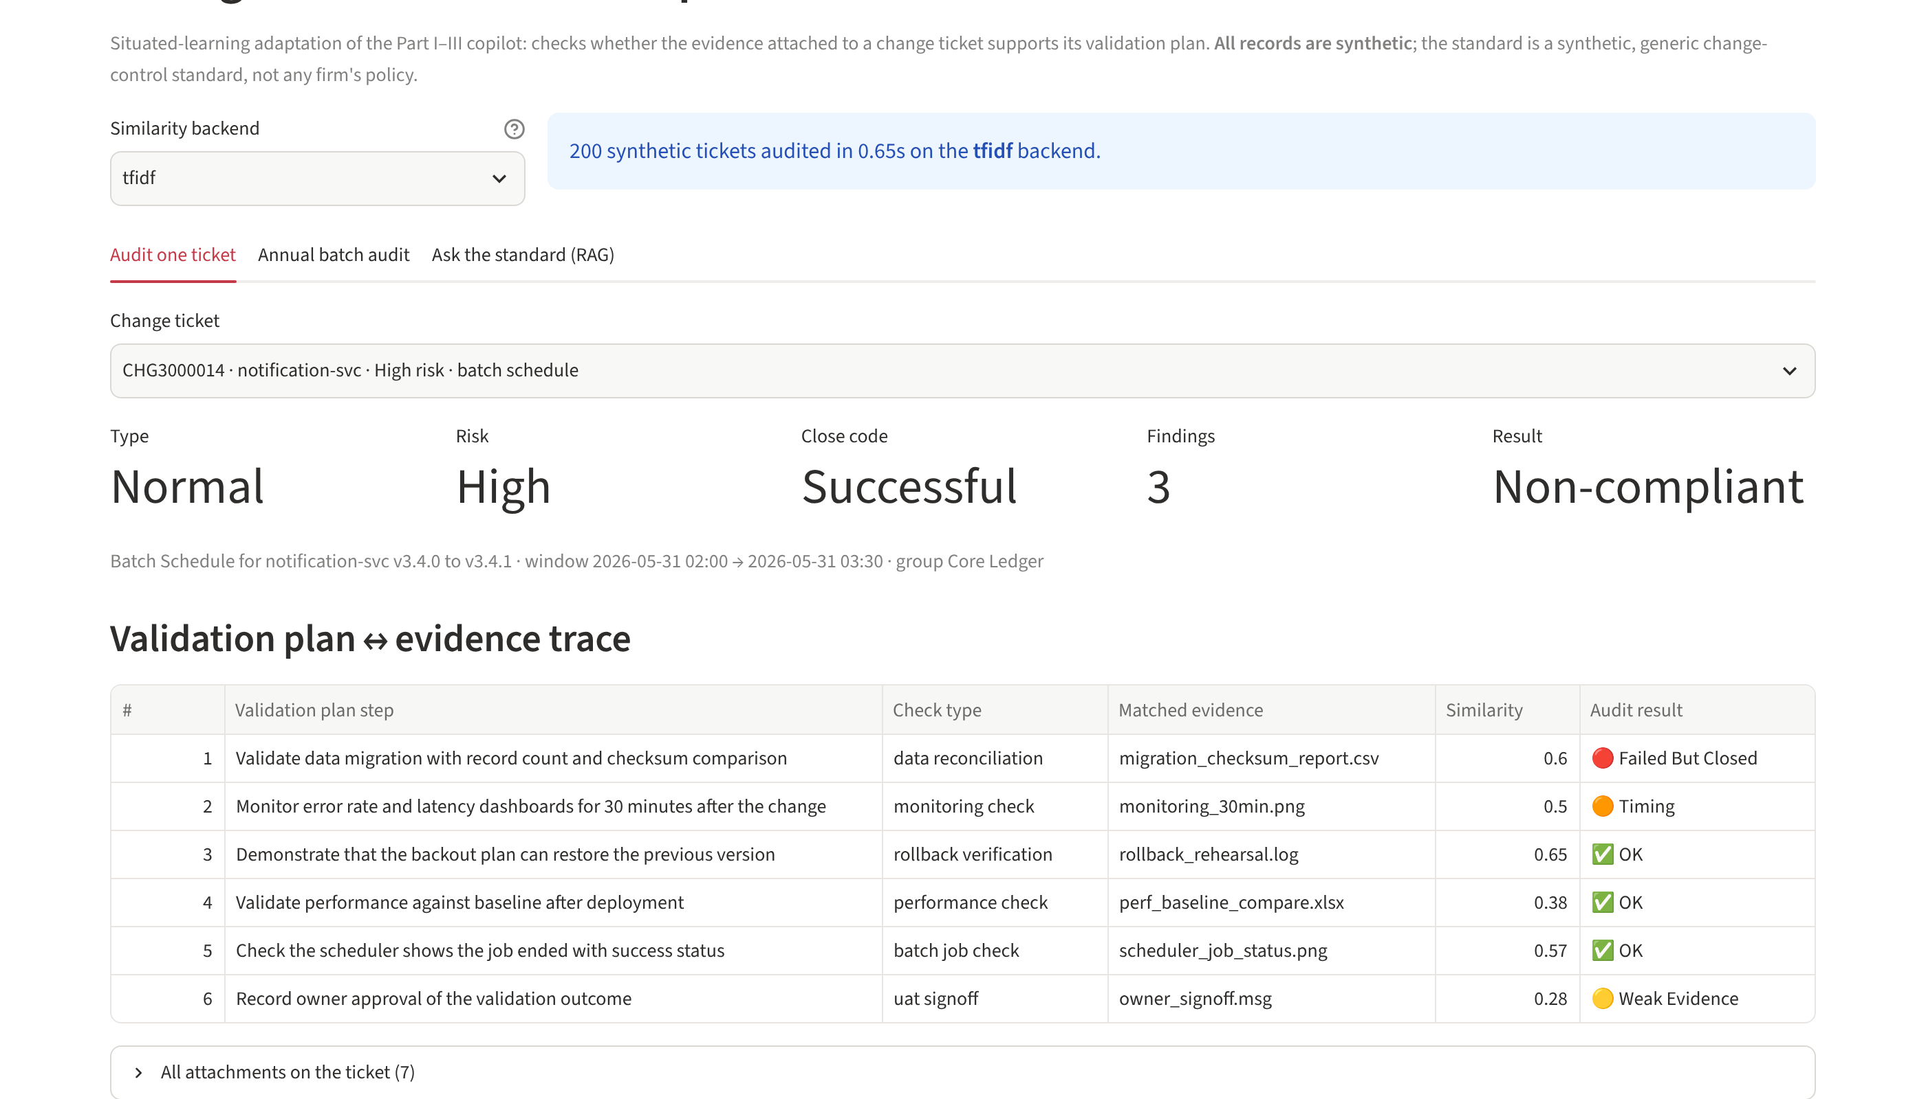
Figure 1 – Plan-to-evidence trace for ticket CHG3000014 (synthetic).
Figure 2 shows the findings for that ticket and the generated recommendation. Each finding names the step, quotes the evidence reviewed and cites the clause breached: here a failed row-count reconciliation on a ticket closed as Successful (High), a monitoring screenshot captured more than two days before the change (Medium), and a sign-off with no stated result (Low).
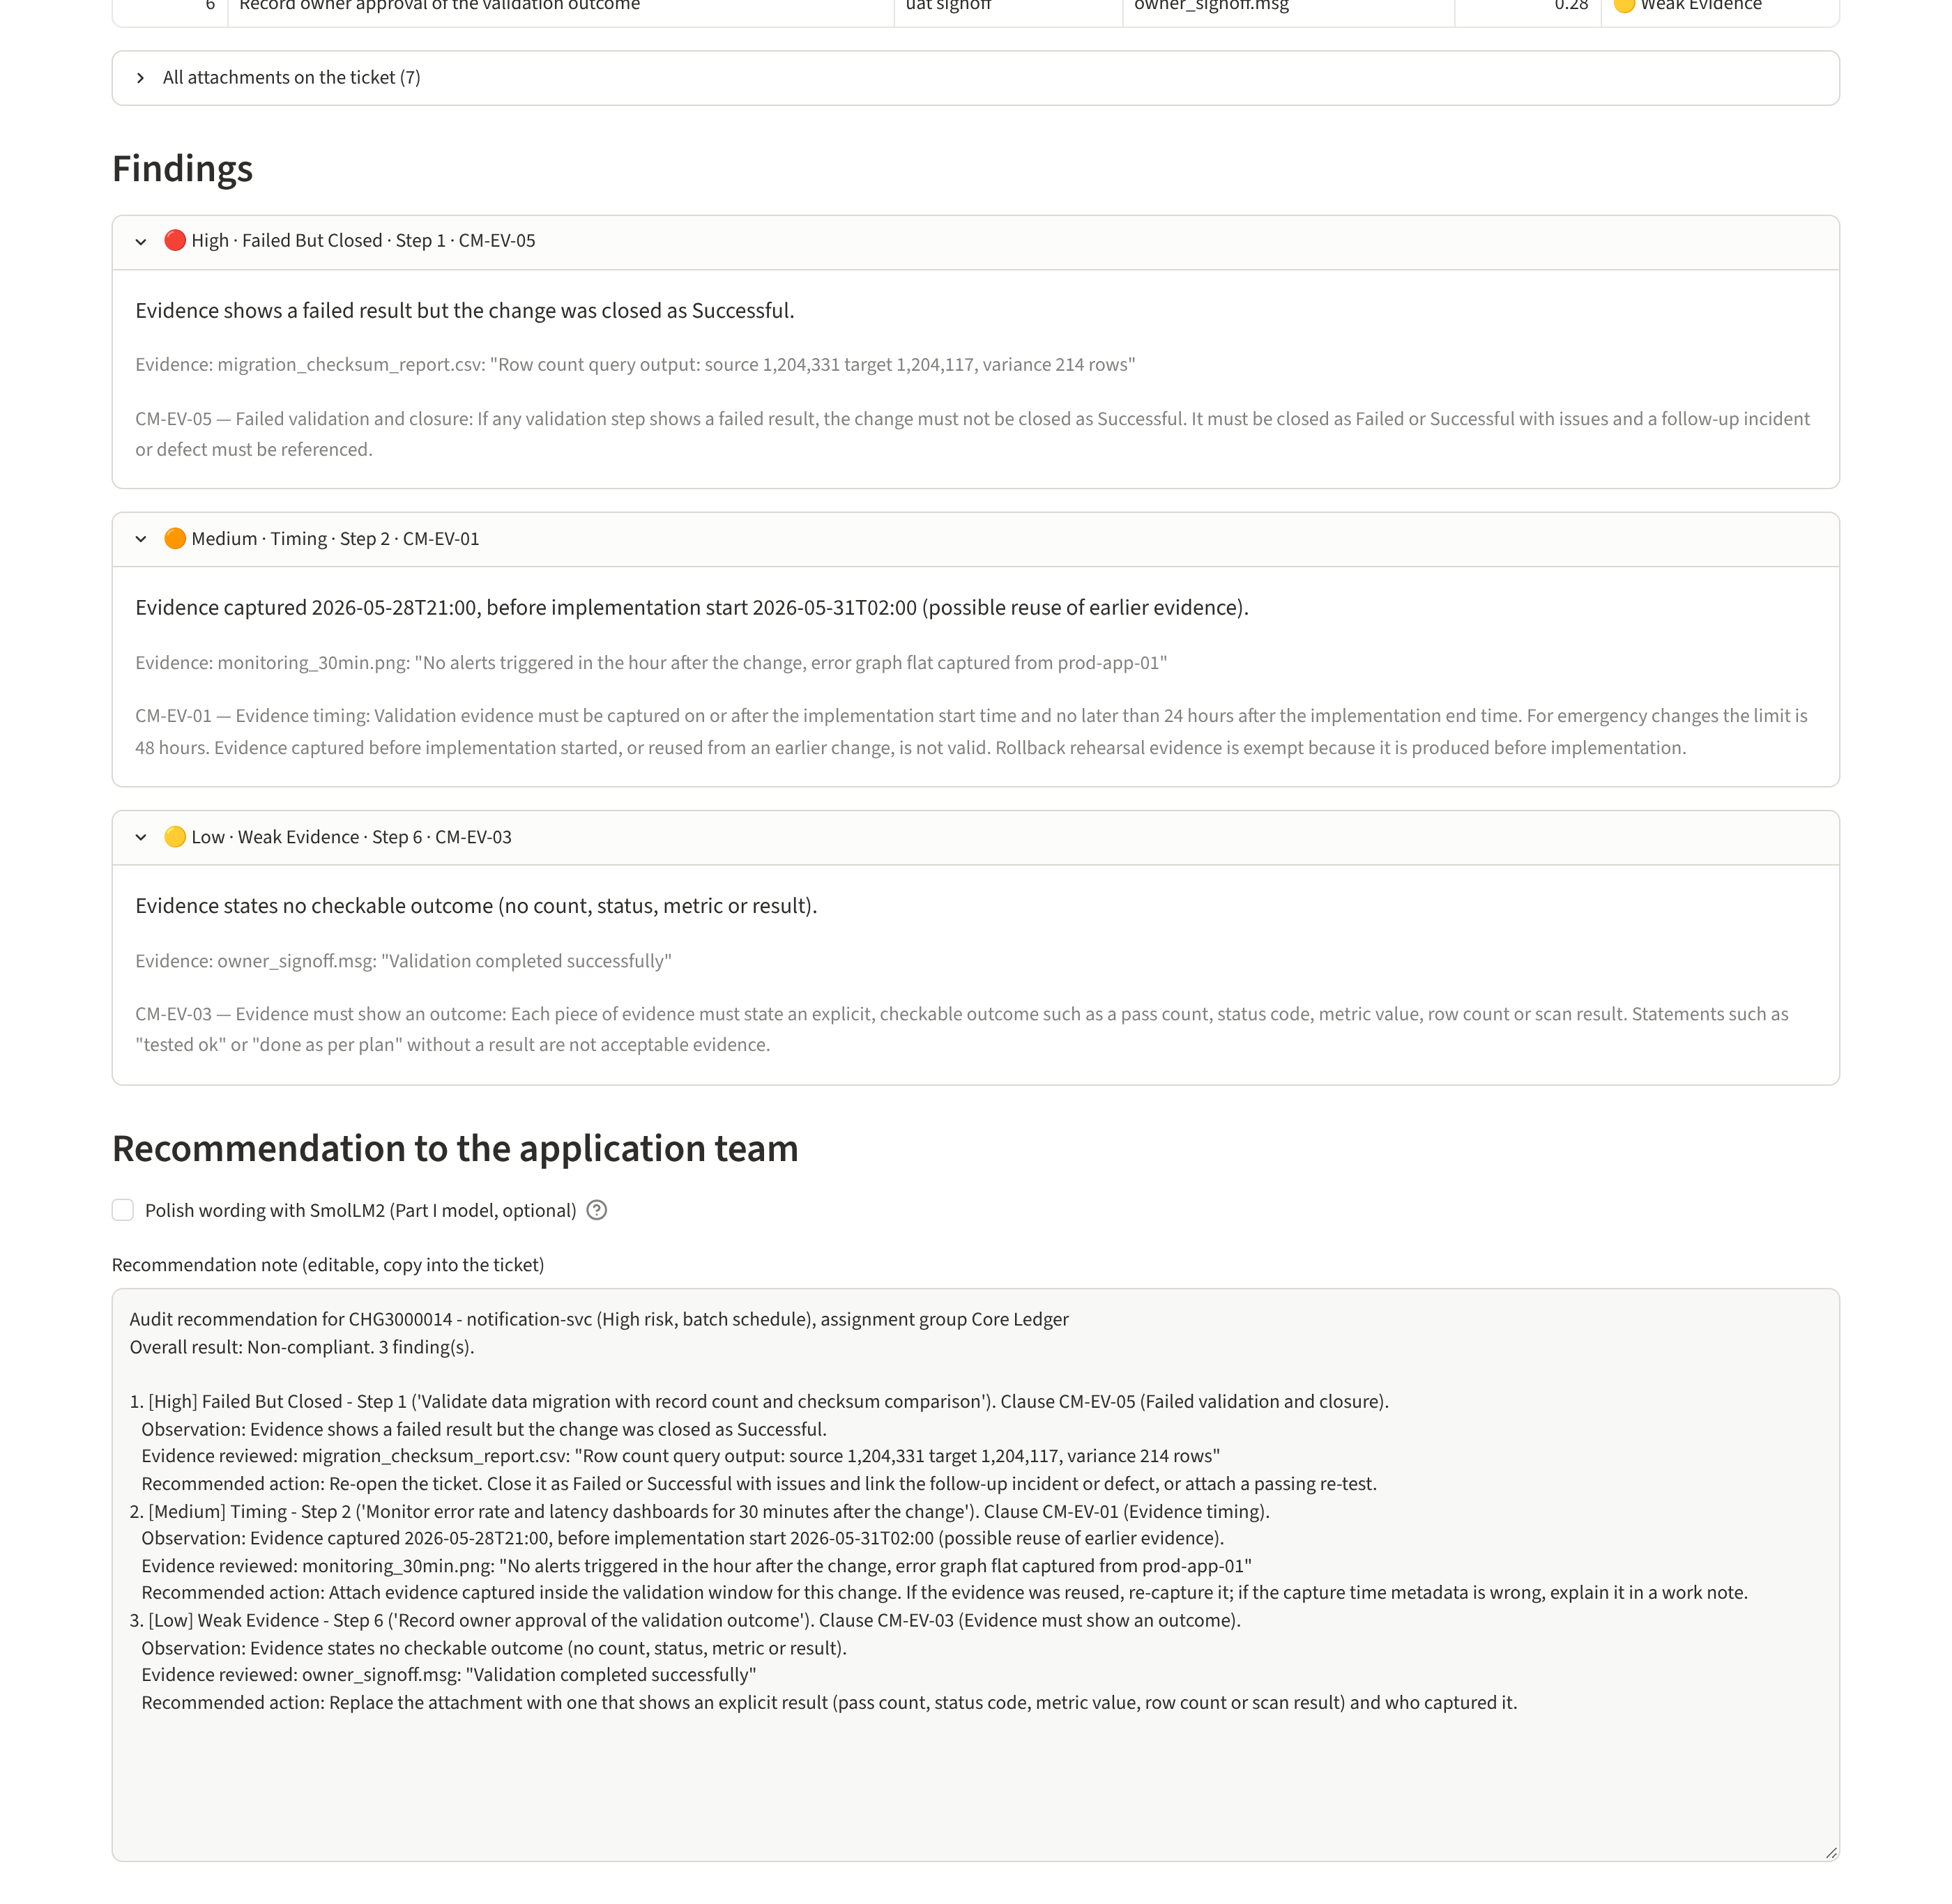
Figure 2 – Findings with clause citations and the recommendation note for the application team.
Figure 3 shows the annual batch view: all 200 tickets audited in under a second, a distribution of finding types, a triage queue ordered by severity and a CSV export of every finding for follow-up with application teams.
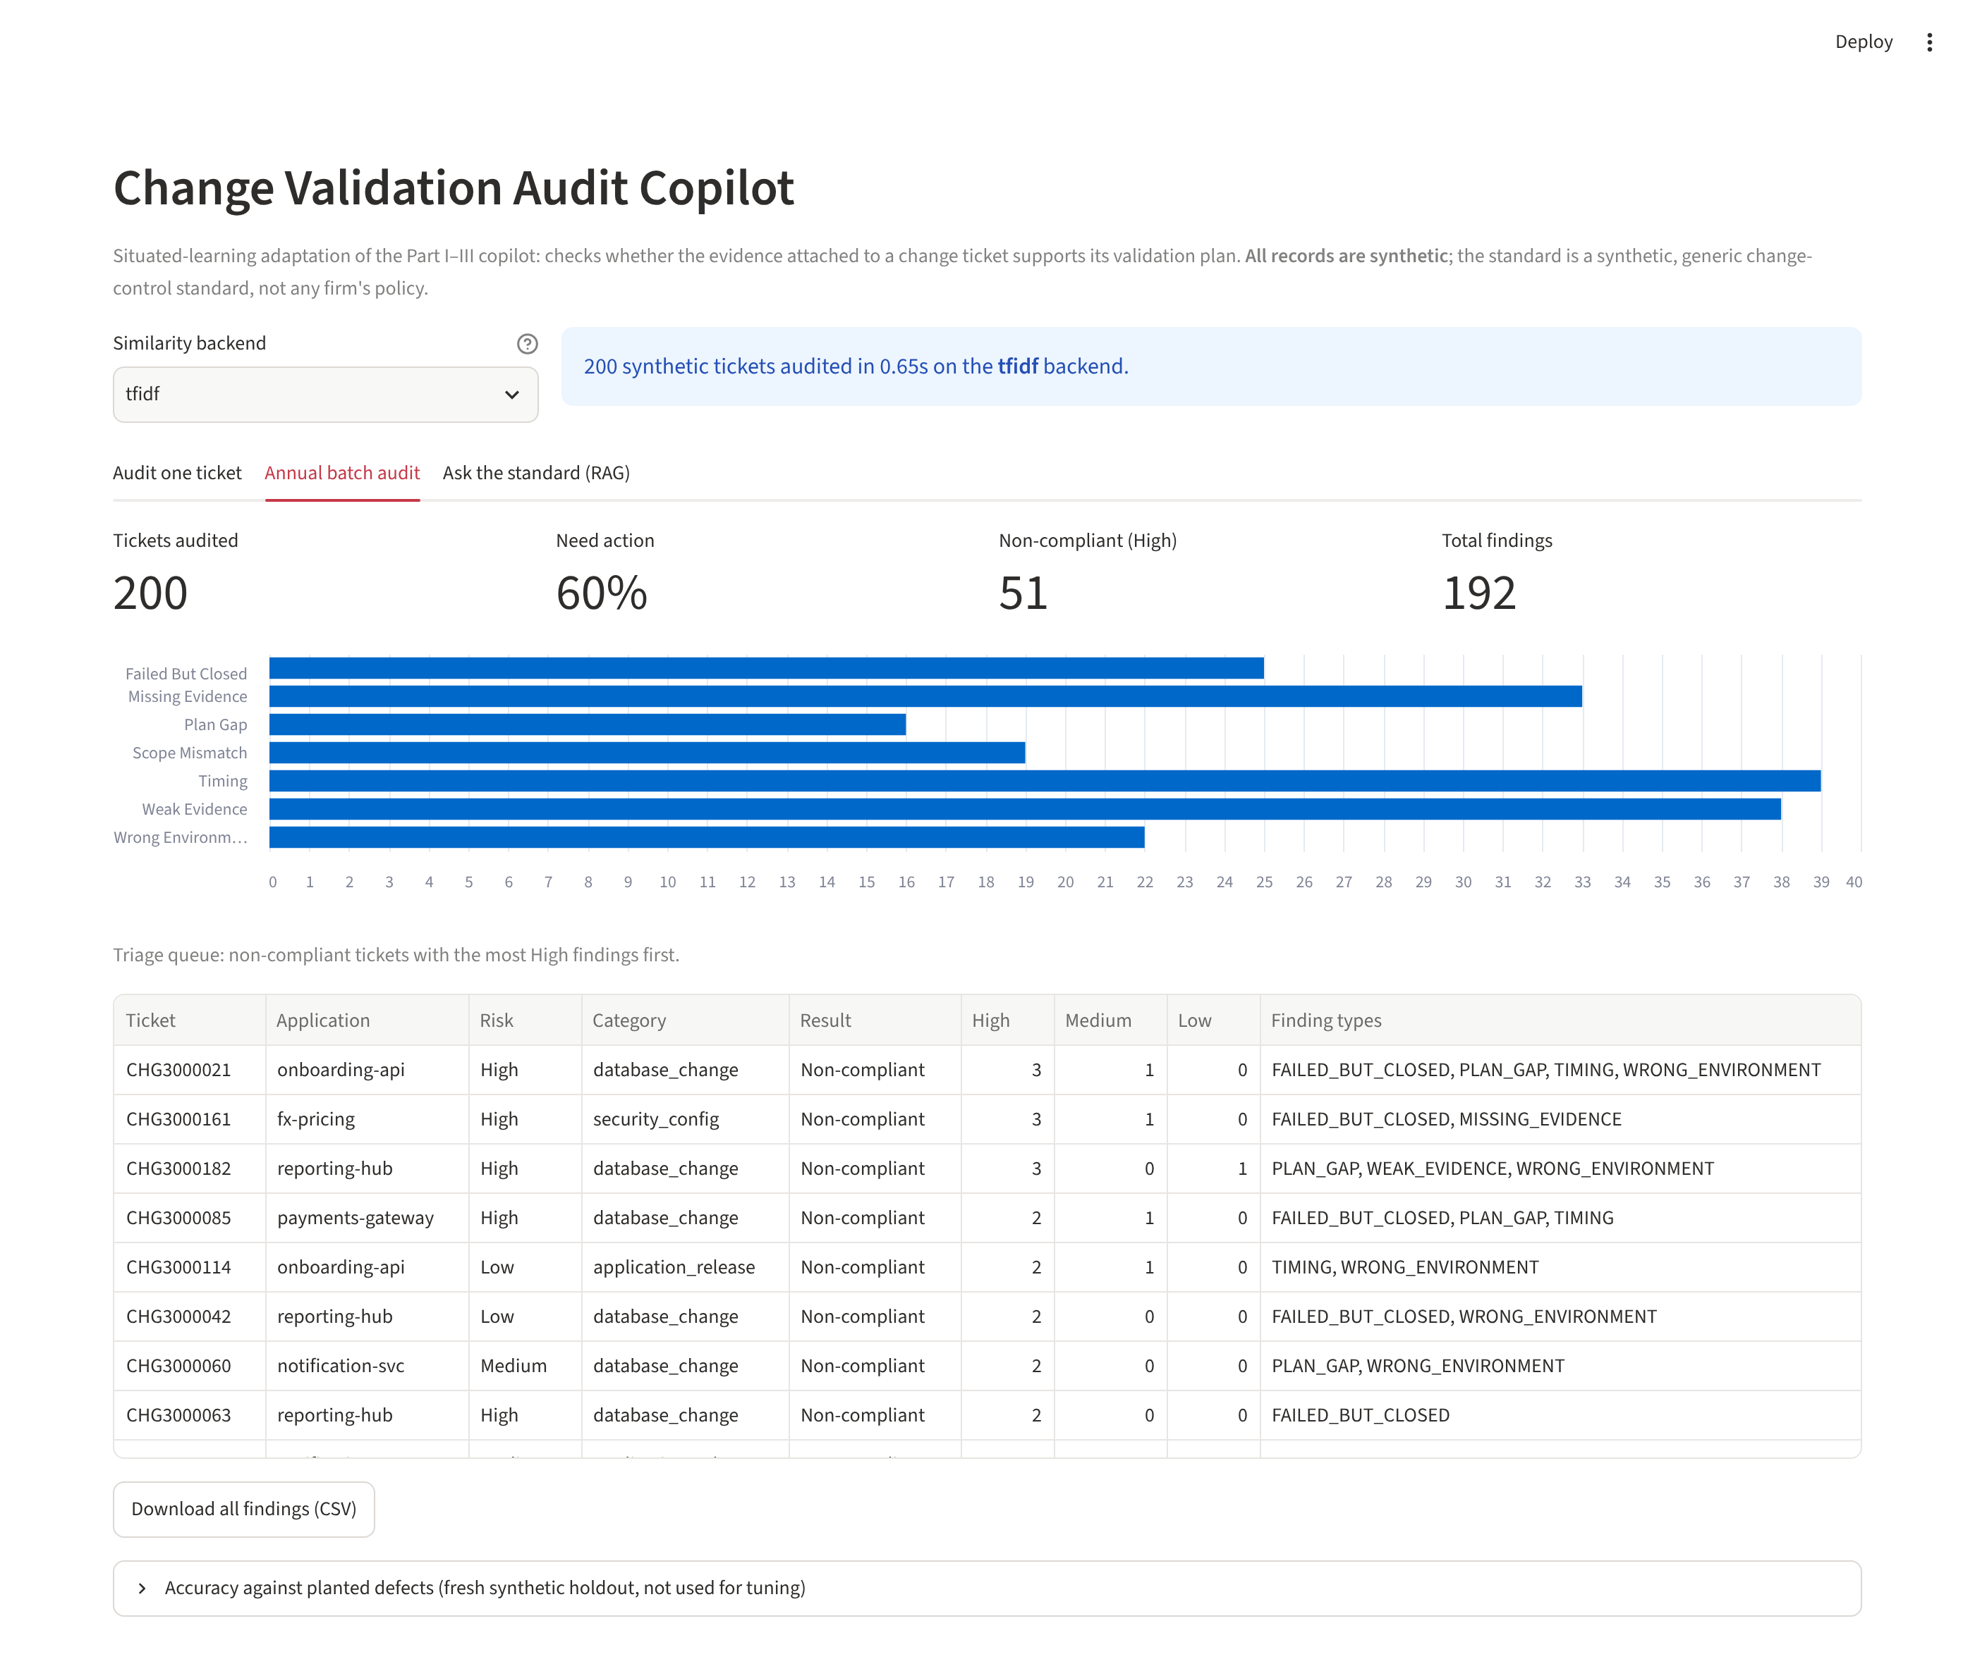
Figure 3 – Annual batch audit and triage queue.
Figure 4 shows the RAG component answering an auditor's question about the standard. The top-ranked clause is the one that governs the question.
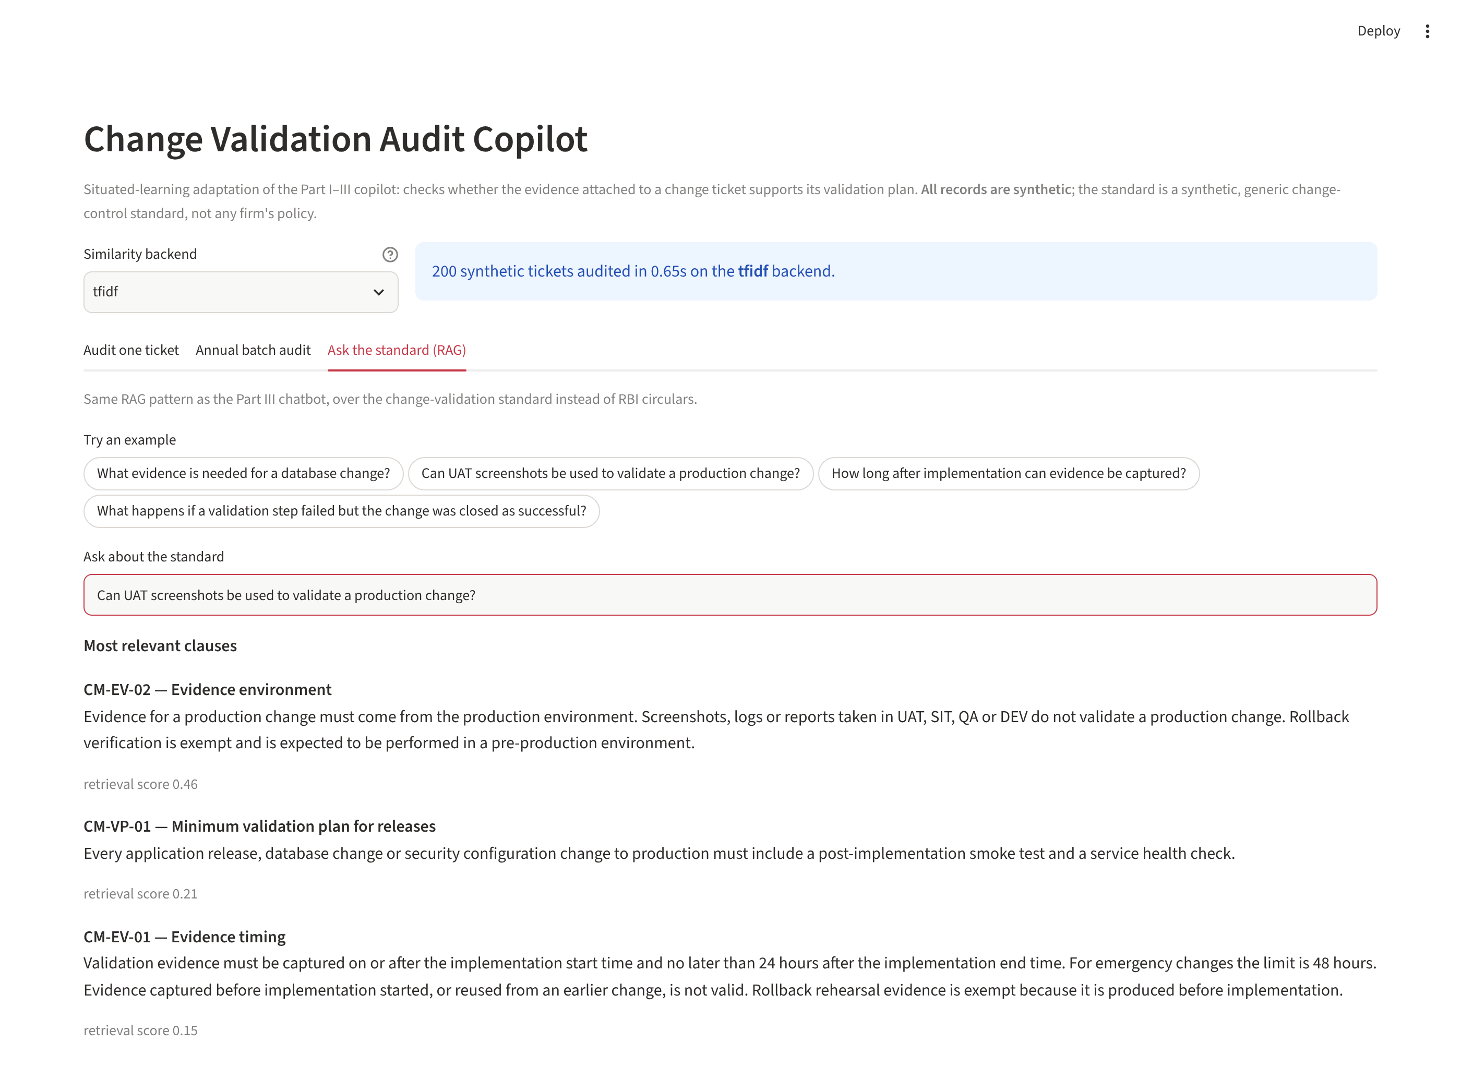
Figure 4 – RAG over the change standard.

3. Analyse – evaluating workplace relevance

3.1 Method
Match thresholds were calibrated on the first 60 tickets of one synthetic set. Results are reported on a fresh 200-ticket holdout generated with a different random seed, which was not used for calibration or for fixing any rule. An earlier 140-ticket split of the first set was used during development, since error analysis on it guided two fixes (a regex bug and the non-validation-document rule), so it is a development result, not an independent one. A finding counts as correct only if ticket, finding type and plan step (or missing check type) all match the planted label.

3.2 Results
Finding type | Precision | Recall | F1 | Planted
Failed but closed | 1.00 | 1.00 | 1.00 | 9
Missing evidence | 0.66 | 0.89 | 0.76 | 28
Plan gap | 1.00 | 1.00 | 1.00 | 11
Scope mismatch | 1.00 | 0.96 | 0.98 | 27
Timing | 1.00 | 0.97 | 0.98 | 29
Weak evidence | 1.00 | 0.90 | 0.95 | 30
Wrong environment | 0.95 | 1.00 | 0.97 | 18
Overall | 0.91 | 0.95 | 0.93 | 152
Table 3 – Holdout results, 200 tickets, TF-IDF backend. Ticket-level accuracy (does the ticket have any finding): 0.98.
Configuration (holdout) | Precision | Recall | F1
Similarity matching only | 0.57 | 0.81 | 0.67
+ evidence typing and non-validation filter (full) | 0.91 | 0.95 | 0.93
Table 4 – Ablation: effect of classifying evidence and excluding approval and runbook documents.
- Response quality and accuracy. Rule-driven findings (failed-but-closed, plan gap, wrong environment, scope, timing, weak evidence) reach F1 of 0.94 or higher on the holdout. Matching a plan step to its evidence is the hard part. Similarity alone gave F1 0.67; classifying evidence and discarding non-validation documents raised it to 0.93.
- Where it fails. Missing-evidence has the lowest precision (0.66). Of its 13 false alarms, 11 were business sign-off or security-check steps whose wording differs from the matching evidence (for example “Verify TLS certificate” against “SSL certificate chain verified”, or “owner approval” against “Approval message from…”). This is a lexical-similarity limit, not a rule error.
- Efficiency. About 3.1 ms per ticket on CPU, so the whole population is audited in seconds. The real cost is reviewer time on the flagged tickets, which is where the triage queue helps.
- Entity extraction. The rule-based extractor scores F1 1.00 on 209 held-out synthetic sentences. This is not evidence it will work on real evidence. It shares its vocabulary with the generator that wrote the sentences, and real captions vary far more. It is the reason the fine-tuned model is needed.
- Scalability. Matching is per ticket and independent, so it parallelises trivially. Embedding backends add model-loading and inference cost but remain small next to reviewer time.

3.3 Gap between prototype and what the organisation needs
Dimension | Prototype | Needed for practical use
Evidence format | Evidence is clean text (caption or extracted content) | Most real evidence is screenshots and PDFs, so OCR or a multimodal reader is required; extraction errors will propagate to every rule
Data realism | Synthetic, templated, generated by the same author as the rules | Real tickets with free-form language, partial captions, multiple steps per attachment and one attachment covering several steps
Accuracy evidence | Measured only against planted defects | Measured against real, auditor-confirmed findings from prior years
Thresholds | Calibrated on synthetic data for TF-IDF | Recalibrated per backend and per check type on real data, with the cost of a missed finding weighed against the cost of a false alarm
Judgement | Binary rules | Risk-based nuance, waivers, compensating controls and approved exceptions
Explainability and audit trail | Clause and evidence are cited | Versioned model, standard and thresholds recorded with every finding, and reviewer accept or reject captured
Integration | Standalone Streamlit app over files | Read from ServiceNow, write recommendations back as work notes or audit tasks, with access control
Table 5 – Prototype versus production requirements.
Caveat on the numbers. These metrics show that the pipeline works as designed on data of known structure. They are an upper bound, not a forecast of accuracy on real tickets.

4. Reflect – deployment constraints and the key improvement
Constraint | Implication for deployment
Data privacy | Tickets and attachments contain hostnames, names and internal system detail. Processing must stay inside the organisation's environment, with no calls to external model APIs and no copying of evidence to public hosting. Models would be obtained once, scanned and served from an internal registry. Personal data should be minimised or masked before indexing.
Security | Read-only service account with least privilege, secrets in a vault, access to findings limited to the governance team and the owning application team, and logging of every access.
Regulation and model governance | The tool influences audit conclusions, so it falls under the organisation's model-risk and AI governance processes: documented purpose, validation, monitoring, and a human who owns each finding. The standard in the knowledge base must be the approved version, with change control on it.
Infrastructure | The TF-IDF and rule path runs on a CPU. A MiniLM backend also runs on CPU. A small language model for wording needs modest GPU or optimised CPU serving. OCR adds a heavier component.
Cost | Compute is small compared with reviewer time. The main costs are building the labelled evaluation set, OCR, integration and ongoing monitoring.
Integration | ServiceNow REST for read and write-back, scheduled or event-driven runs after closure, and findings exposed to the existing audit workflow rather than a separate tool.
Table 6 – Deployment constraints.

The single most important improvement
Validate and calibrate the system on real, auditor-confirmed findings from prior audit cycles, inside the organisation's environment, before any deployment.
Justification:
- Every number in this report comes from synthetic data in which the answer key and the rules share a vocabulary. Nothing yet shows how the system behaves on real tickets, so nothing yet supports relying on it.
- The audit has asymmetric costs. A missed non-compliant ticket is a control failure, while a false alarm costs reviewer minutes. The right operating point can only be set from real outcomes, and it will differ by check type.
- Prior years' audited tickets, with their findings and recommendations, are a ready-made labelled dataset. Using it also gives the fine-tuning data for the NER model and the examples needed to measure the lexical-matching weakness seen in Section 3, and to test whether the MiniLM embedder fixes it.
- Reading screenshots with OCR is the next most important item. It is a well-understood engineering step, whereas real-world accuracy is the open risk, so validation comes first. OCR output would be part of what gets validated.
A sensible rollout is shadow mode: run the tool alongside the human audit on one cycle, compare its findings with the auditors' findings ticket by ticket, tune thresholds, and only then let it produce first-pass drafts that an auditor reviews and accepts or rejects.

Learning from the exercise
The most useful lesson was that the language model was the least important part. The value came from reading rules out of the standard, matching evidence carefully and citing the clause. Two failures during development (a regex that rejected valid results, and approval documents being treated as test evidence) were found only by looking at individual errors, which is why a reviewer-in-the-loop design with visible evidence matters.

