Financial Institutional Setup & Auto-Bank Data Import

Connecting a Financial Institution to NetSuite (United States)
- Login to NetSuite via Administrator role and navigate: Setup > Accounting > Financial Institution > List.
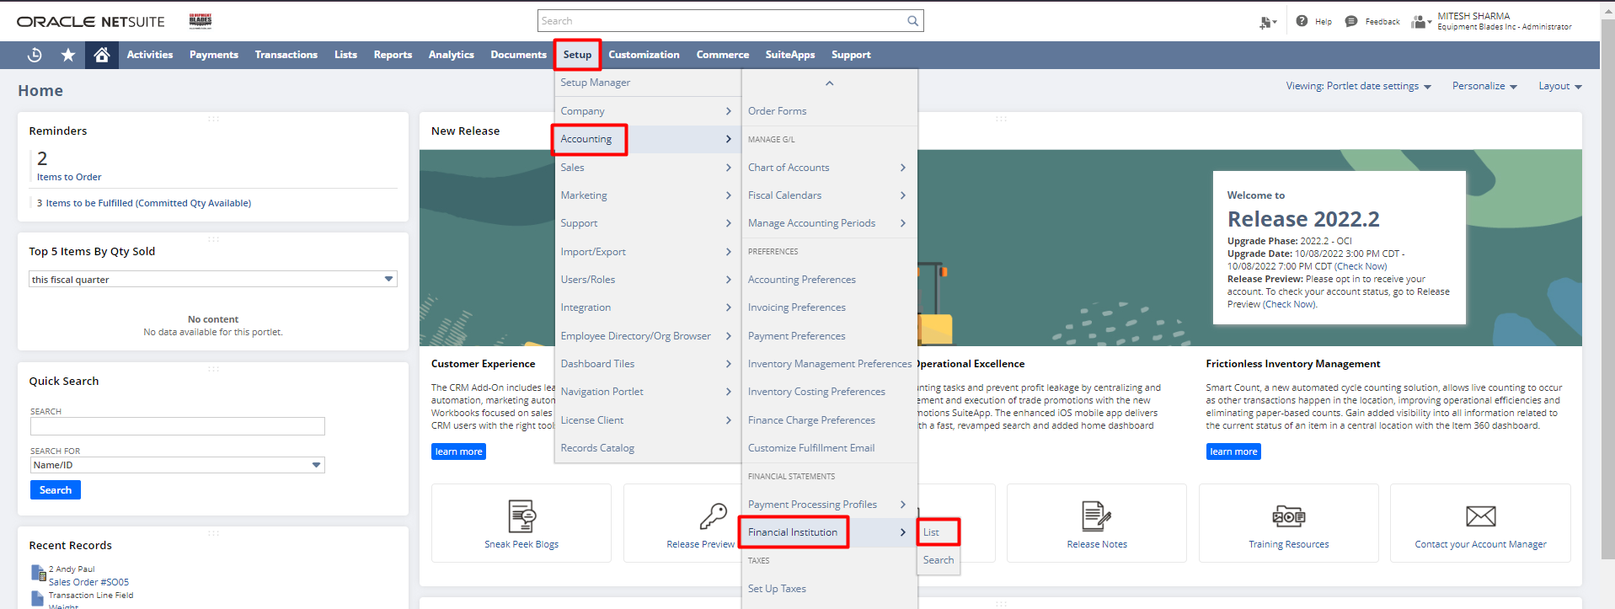

- From the Financial Institutions list, click View next to the Bank Feeds financial institution record.
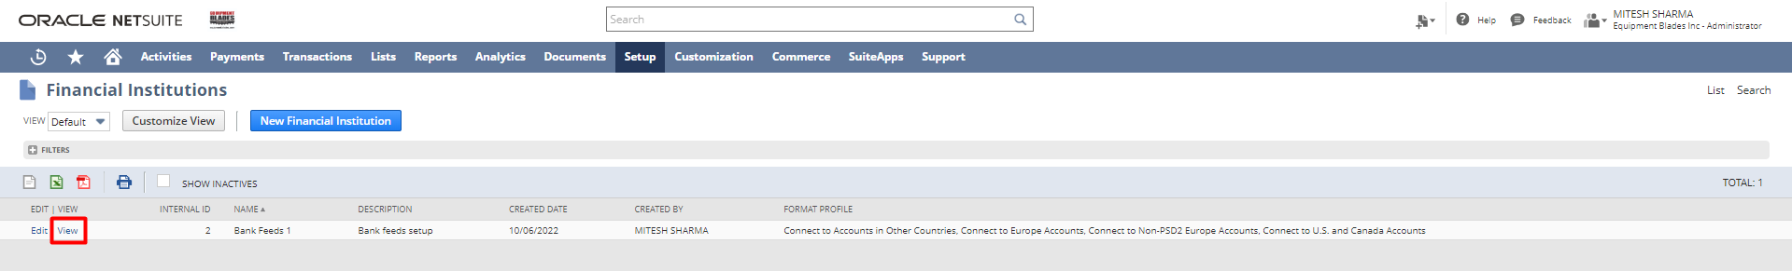

- Under the Format Profile: Configuration subtab – click Edit next to Connect to U.S. and Canada Accounts.
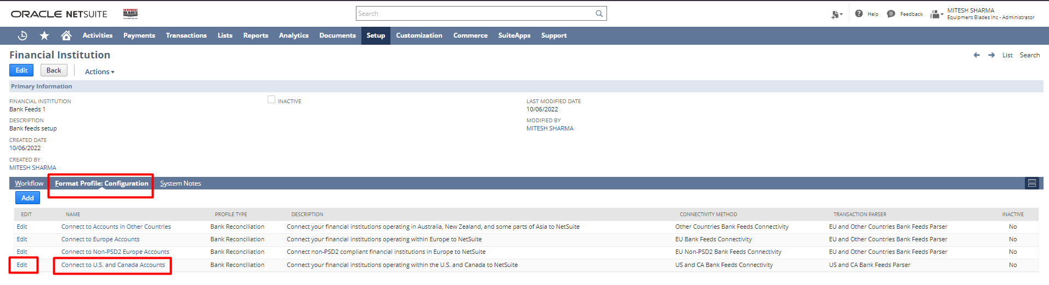

- On the Format Profile page, under the Connectivity Configuration subtab – click on the Connect New Institution button.
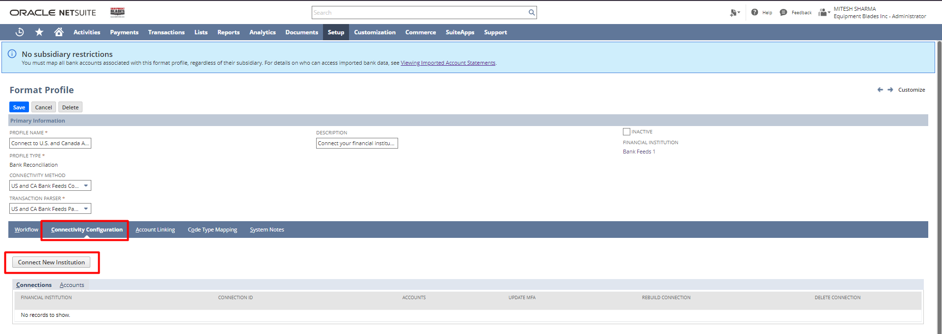

- A new window pops up with the Select Institution page selected.
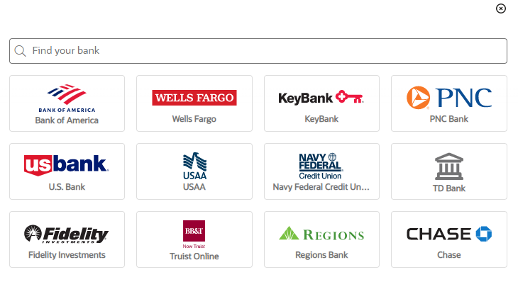
- Select your Bank.
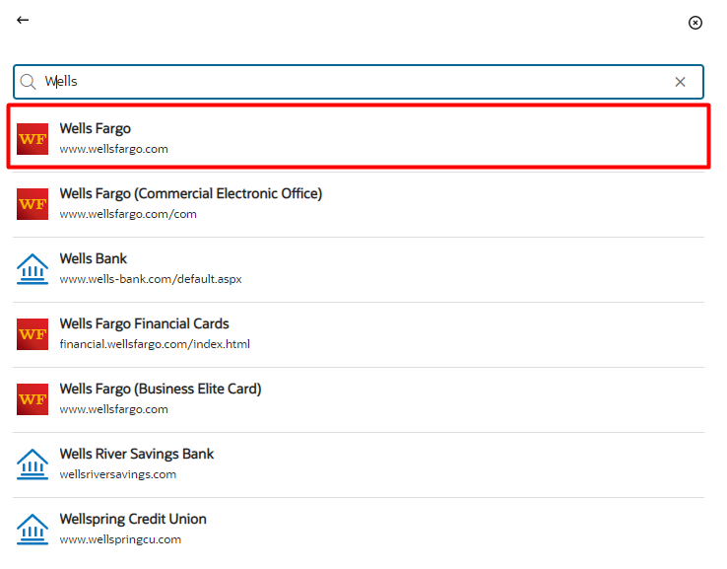

- On the Authenticate page, enter your Bank’s login credentials and click on Submit.
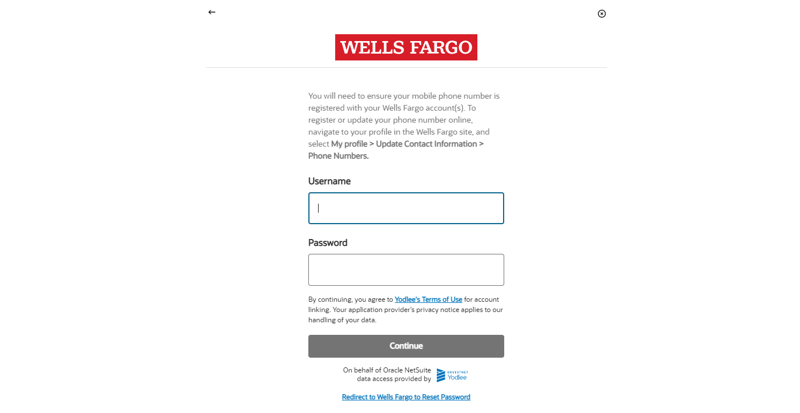

- On the Review Accounts page, review the accounts that got listed. To remove an account, click on the trash icon. Click on the Connect New Institution button.

- After successful connection, on the Format Profile page, under the Account Linking subtab – map the bank accounts to the GL accounts created in NetSuite.
Once the setup is complete, the bank data for the last 60 days will start getting downloaded automatically. NetSuite automatically imports bank data of up to seven days from the selected bank every day.

Signature: _________________________________
Date: _____________________________________

Disclaimer:
Upon signing off on the process flow document, you are confirming that the process has been set up per the SOW within NetSuite per your business's needs. Any changes or modifications requested after sign-off will need to be a "change request" at an additional fee.

*** PLEASE ensure that you have logged into NetSuite and tested the process prior to signing off on the setup. Paapri requires sign-off on this document prior to moving forward with any additional design meetings.

