Statement of Work Addendum

PMC enhancement - Integrate Downtime functionality for Record Setup Operation


Company Name: The Strouse Corporation
Company Address: 1211 Independence Way. Westminster, MD 21157
T: 443.605.1332
E: info@strouse.com

Date: 03/27/2025


Prepared by: Paapri Cloud Technologies

Objective:
- Team Strouse currently uses PMC for tracking production-related activities on the shop floor.
- They also track Downtime in PMC, while recording Production Time for a specific operation. Once Downtime is activated, the production timer gets paused and the downtime timer gets started in PMC.
- Currently, Team Strouse wants to track downtime while recording setup time for an operation. They want to add downtime functionality in Record Setup Operation in PMC, which will allow them to pause the Setup timer. Additionally, they want to trigger email notifications for specific Downtime Categories. The email will be sent to the designated email addresses, which will be pre-defined for the selected Downtime Category.
- While entering downtime, currently users select the downtime category and reason from a dropdown list. Now, they would like to update the dropdown values of downtime categories for both the Record Setup and Production Operation stages.

Leading Practice:
- As per the leading practice, currently, there are no provisions to track Downtime while recording the Setup time for an operation.
Scope of Work:
- Team Paapri will provide consultation services to integrate the Downtime feature while recording the Setup Time for an operation. After the change, once the user clicks the Downtime button, they will be able to select the Downtime Category and specify the Downtime Reason for the Record Setup operation. Additionally, they will be able to include supplementary notes to describe more about the Downtime Reason. After activating the downtime for the setup operation, the setup timer will pause and an email notification will trigger. The triggered email will be sent to the designated email addresses, set for the selected Downtime Category. Apart from that, this downtime information will also be stored in the PMC Transaction Record on NetSuite.
Functionality:
- Team Paapri will perform some scripting modifications to PMC, in order to integrate the Downtime feature into the Record Setup Operation.
- If the user clicks the downtime button while recording setup time, the downtime details window will populate on the PMC screen. Then, the user will provide the Downtime Category, Downtime Reason, and Additional Notes for the downtime record. After providing the downtime details, the user needs to click on the Submit button – to initiate downtime.
- Once downtime is initiated, the setup timer on PMC will pause and an email alert will be triggered.
- The triggered email will be sent to the respective addresses who are responsible for the selected downtime reason.
- When the Work Order Completion will be created, with the recorded setup time; it will subtract the clock time for the “Downtime” record which was entered while recording Setup Time, from the total clock time in PMC. For example, if the total clock time in PMC for a specific setup operation is 10 minutes, and there are 2 minutes of downtime for that operation; the recorded setup time will be (10 – 2) = 8 minutes, which will be stored in the PMC-generated work order completion record. (Recorded Setup Time in Work Order Completion = Total Clock Time recorded for the setup operation – Downtime recorded for the setup operation)
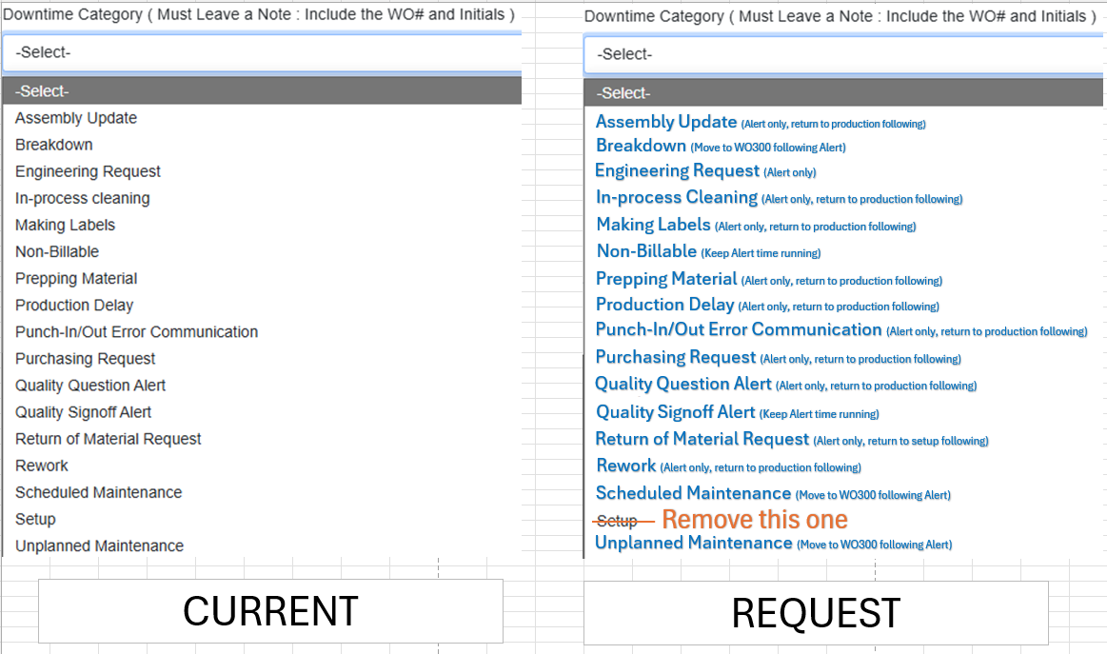
- Team Paapri will also update the downtime category values as shared via email (refer to the screenshot below.

Limitation:
- The downtime button won’t be clickable in PMC if the user is not recording setup/production time for an operation.
- The Record Setup button won’t be clickable in PMC if the downtime is initiated.
- The email recipients for a specific downtime reason need to be pre-defined. If there are no recipients for the selected downtime reason, the emails won’t be triggered after submitting the downtime record in PMC.
- There may be a slight delay while recording/halting the downtime for a setup operation in PMC.

The changes highlighted in the Objective will only be implemented in the current SOWA. Any modifications or deviations will need to be covered in a separate SOWA.
Impact Analysis:
- Once the SOWA is implemented, Team Strouse will be able to record downtime for the Setup Operation as well. They will also be able to trigger email alerts for a specific Downtime Category.

Terms and Conditions:

Implementation Services
Item | Rate | Quantity | Total
Scripting changes | $175 | 33 | $5,775
Total: |  |  | $5,775

CUSTOMER | PAAPRI CLOUD TECHNOLOGIES
SIGNATURE: | SIGNATURE:
PRINT NAME: | PRINT NAME:
TITLE: | TITLE:
COMPANY: | COMPANY:
DATE: | DATE:

