TD-DCC
Time-Dependent Dynamic Cross-Correlation Analysis
User Manual & Installation Guide
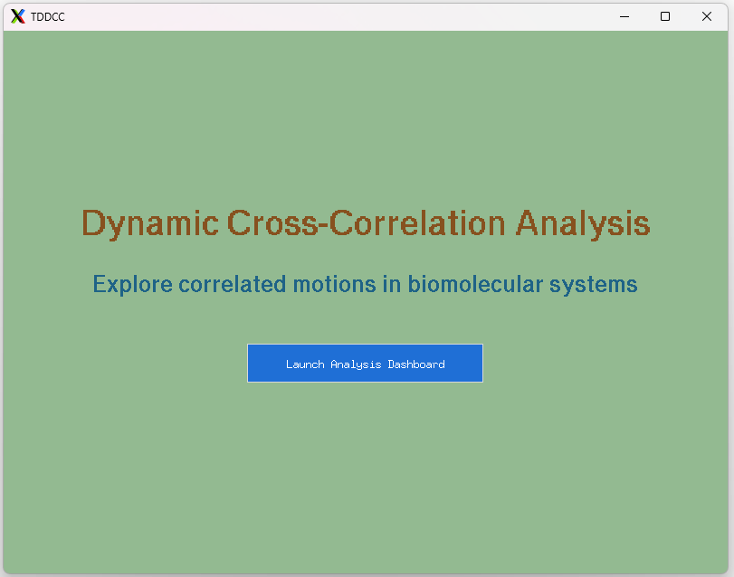
Document version 1.0
Covers TD-DCC_gui.py — standalone desktop edition

Contents
1. Introduction
2. System Requirements
3. Installation Guide
3.1. Install Python
3.2. Create a virtual environment (recommended)
3.3. Install required packages
3.4. Download TD-DCC
3.5. Verify the installation
4. Launching TD-DCC
5. Interface Tour
6. Step-by-Step Workflows
6.1. Workflow — Starting from an MD trajectory
6.2. Setting residue limits and correlation filters
6.3. Running the analysis and reading the dashboard
6.4. Inspecting a residue pair's time series
6.5. Exporting results
7. Output Files
8. Troubleshooting

1. Introduction
TD-DCC (Time-Dependent Dynamic Cross-Correlation) is a standalone desktop application for computing and exploring dynamical cross-correlation matrices (DCCMs) from molecular dynamics (MD) trajectories. Unlike a conventional DCCM, which averages an entire trajectory into a single static matrix, TD-DCC computes correlations over a sliding window of frames and tracks how each residue pair's correlation behaves across the whole trajectory — whether it stays consistently positive, consistently negative, or fluctuates between the two.
The application provides everything needed for this workflow in a single window: an optional built-in trajectory-to-matrix compute engine, a statistics engine that aggregates per-window matrices into mean correlation, standard deviation, and positive/negative occurrence probability for every residue pair, and an interactive dashboard for filtering, visualizing, and exporting the results.

TD-DCC System Architecture
The diagram below summarizes the overall pipeline: a trajectory is streamed and split into windows; each window's correlation matrix is computed in parallel; and the resulting matrices are aggregated into statistics that drive the interactive dashboard.
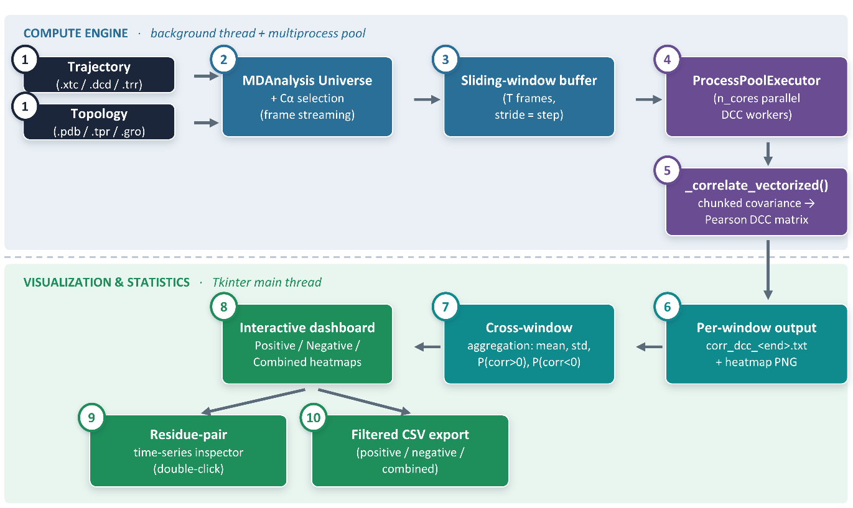
Figure 1 — Overview of the TD-DCC compute and visualization pipeline.

2. System Requirements
TD-DCC is a Python desktop application that runs on Windows and Linux. It has modest hardware requirements:
• Python 3.9 or later (3.10–3.12 recommended).
• 8 GB or more recommended for proteins larger than a few hundred residues.
• A graphical desktop session. TD-DCC uses Tkinter and will not run over a plain text-only SSH connection without a display (a remote desktop with X11 forwarding works).
• All computation in TD-DCC runs locally; no internet connection or API key is needed at any point.

3. Installation Guide
This section walks through installing everything TD-DCC needs on Windows and Linux. If you already have a working Python 3.9+ environment, you can skip ahead to Section 3.3.

3.1. Install Python

Windows
1. Download the latest Python 3 installer from python.org/downloads.
2. Run the installer and check “Add python.exe to PATH” at the bottom of the first screen before clicking Install Now.
3. Open Command Prompt and confirm the install by typing the command below.
python --version
NOTE: The standard Windows installer from python.org includes Tkinter automatically — no extra step is needed.

MacOS
1. Download the latest macOS universal installer (`.pkg`) from [python.org/downloads/macos](https://www.python.org/downloads/macos/).
2. Run the installer and follow the on-screen prompts.
3. Open **Terminal** and confirm the install:
python3 --version
NOTE: The official python.org installer for macOS bundles Tkinter automatically. Avoid using the system `/usr/bin/python3` included with Xcode Command Line Tools, as it often lacks a working Tkinter build.

Linux (Ubuntu / Debian)
1. Install Python, pip, and the Tkinter system package (Tkinter is not bundled with Python on Debian-based distributions and must be installed separately).
sudo apt update
sudo apt install python3 python3-pip python3-venv python3-tk

Linux (Fedora / RHEL)
sudo dnf install python3 python3-pip python3-tkinter

3.2. Create a virtual environment (recommended)
A virtual environment keeps TD-DCC's dependencies isolated from other Python projects on your system. This step is optional but strongly recommended. You can use either conda or the standard venv module.
Option A: Using Conda (Anaconda/Miniconda)
Conda is an excellent choice for isolating environments, especially when deploying on Slurm-based HPC clusters or managing complex scientific pipelines.
Create a new conda environment specifically for TD-DCC, specifying a compatible Python version, and activate it:
conda create -n TD-DCC_env python=3.12
# Activate it:
conda activate TD-DCC_env
Option B: Using standard venv
python3 -m venv TD-DCC_env
# Activate it:
source TD-DCC_env/bin/activate # Linux / MacOS
TD-DCC_env\Scripts\activate # Windows (Command Prompt)
Your terminal prompt should now show (TD-DCC_env) at the start of the line, confirming the environment is active. Repeat the activation command every time you open a new terminal to work with TD-DCC.

3.3. Install required packages
With your environment activated, install the core dependencies:
pip install numpy pandas matplotlib
If you want to use the built-in “Compute DCC from Trajectory” panel to generate correlation matrices directly from a simulation, also install MDAnalysis.
pip install MDAnalysis
NOTE: On recent Ubuntu/Debian systems running outside a virtual environment, pip may refuse to install with an “externally-managed-environment” error. Either use a virtual environment as in Section 3.2 (recommended), or add --break-system-packages to the pip command.
Tkinter is part of the Python standard library and does not need to be installed via pip; on Windows (Python.org installer), it is included automatically, and on Linux, it is installed via your system package manager, as shown in Section 3.1.

3.4. Download TD-DCC
TD-DCC is distributed as a single Python file, TD-DCC_gui.py. Save it anywhere convenient on your computer, for example, a folder named TD-DCC in your home directory or Documents folder. No further files are required to run the application.

3.5. Verify the installation
From the folder containing TD-DCC_gui.py, with your virtual environment activated, run:
python TD-DCC_gui.py # Windows
python3 TD-DCC_gui.py # Linux / MacOS
A small window titled “Dynamic Cross-Correlation Analysis” should appear within a few seconds (Figure 2). If it does, installation is complete, and you can proceed to Section 4.
Figure 2 — The TD-DCC intro screen confirms a successful installation.
CAUTION: If nothing appears and you instead see an error in the terminal, check Section 8 (Troubleshooting) for the most common causes.

4. Launching TD-DCC
Every time you want to use TD-DCC:
1. Open a terminal (Command Prompt, Terminal, or your shell of choice).
2. If you created a virtual environment, activate it (Section 3.2).
3. Navigate to the folder containing TD-DCC_gui.py using cd.
4. Run the script, then click “Launch Analysis Dashboard” on the screen that appears to open the main workspace.
cd path/to/your/TD-DCC/folder
python3 TD-DCC_gui.py

5. Interface Tour
Clicking “Launch Analysis Dashboard” opens the main workspace, a single 1400×900 window split into two halves: a scrollable control panel on the left, and a plotting area on the right that stays empty until you run an analysis.
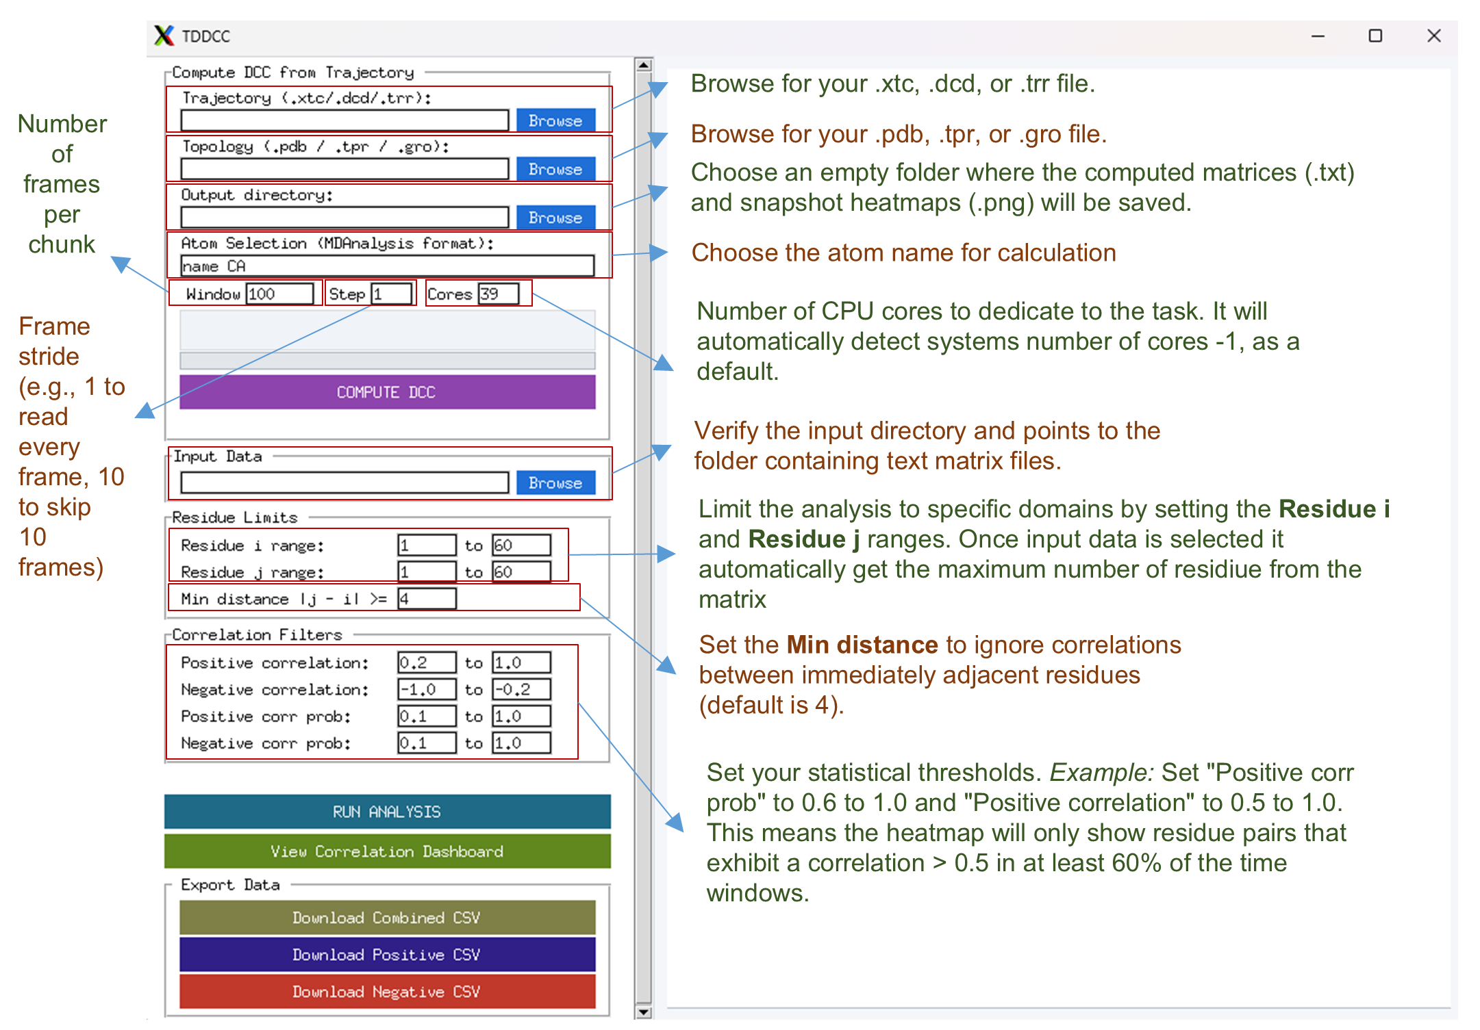

Figure 3 — The top of the control panel: Sections related to Run Analysis, View Correlation Dashboard, and Export Data.

The control panel is organized into different sections, from top to bottom:
• Compute DCC from Trajectory: runs the built-in compute engine on a trajectory file.
• Input Data: the folder of correlation matrices to analyze.
• Residue Limits: which residue-pair range to include.
• Correlation Filters: the thresholds used to flag a pair as positively or negatively correlated.
• Run Analysis, View Correlation Dashboard, and Export Data, towards the bottom of the panel (scroll down to reach them).
NOTE: The control panel is taller than the window. Use the thin scrollbar at the right edge of the panel, or drag it directly, to reach the lower sections.

6. Step-by-Step Workflows

6.1. Workflow — Starting from an MD trajectory
Use this workflow if you have a raw trajectory and topology file and want TD-DCC to compute the correlation matrices for you. This requires MDAnalysis to be installed (Section 3.3).
1. In the first section, click Browse next to Trajectory and select your trajectory file (.xtc, .dcd, .trr, or any format MDAnalysis supports).
2. Click Browse next to Topology and select the matching topology file (.pdb, .tpr, .gro, etc.).
3. Click Browse next to Output directory and choose where the resulting matrices should be written.
4. Set Window (the number of frames per sliding window), Step (the frame stride used when streaming the trajectory), and Cores (how many windows to compute in parallel). The defaults (Window 100, Step 1) are a reasonable starting point for most trajectories.
5. Click COMPUTE DCC. Progress is reported in the log box and the progress bar; this can take anywhere from a few seconds to several minutes, depending on the trajectory length and Window/Step settings.
6. When finished, TD-DCC automatically fills the next section (Input Data) with the output directory, so you can go straight to Section 6.2.

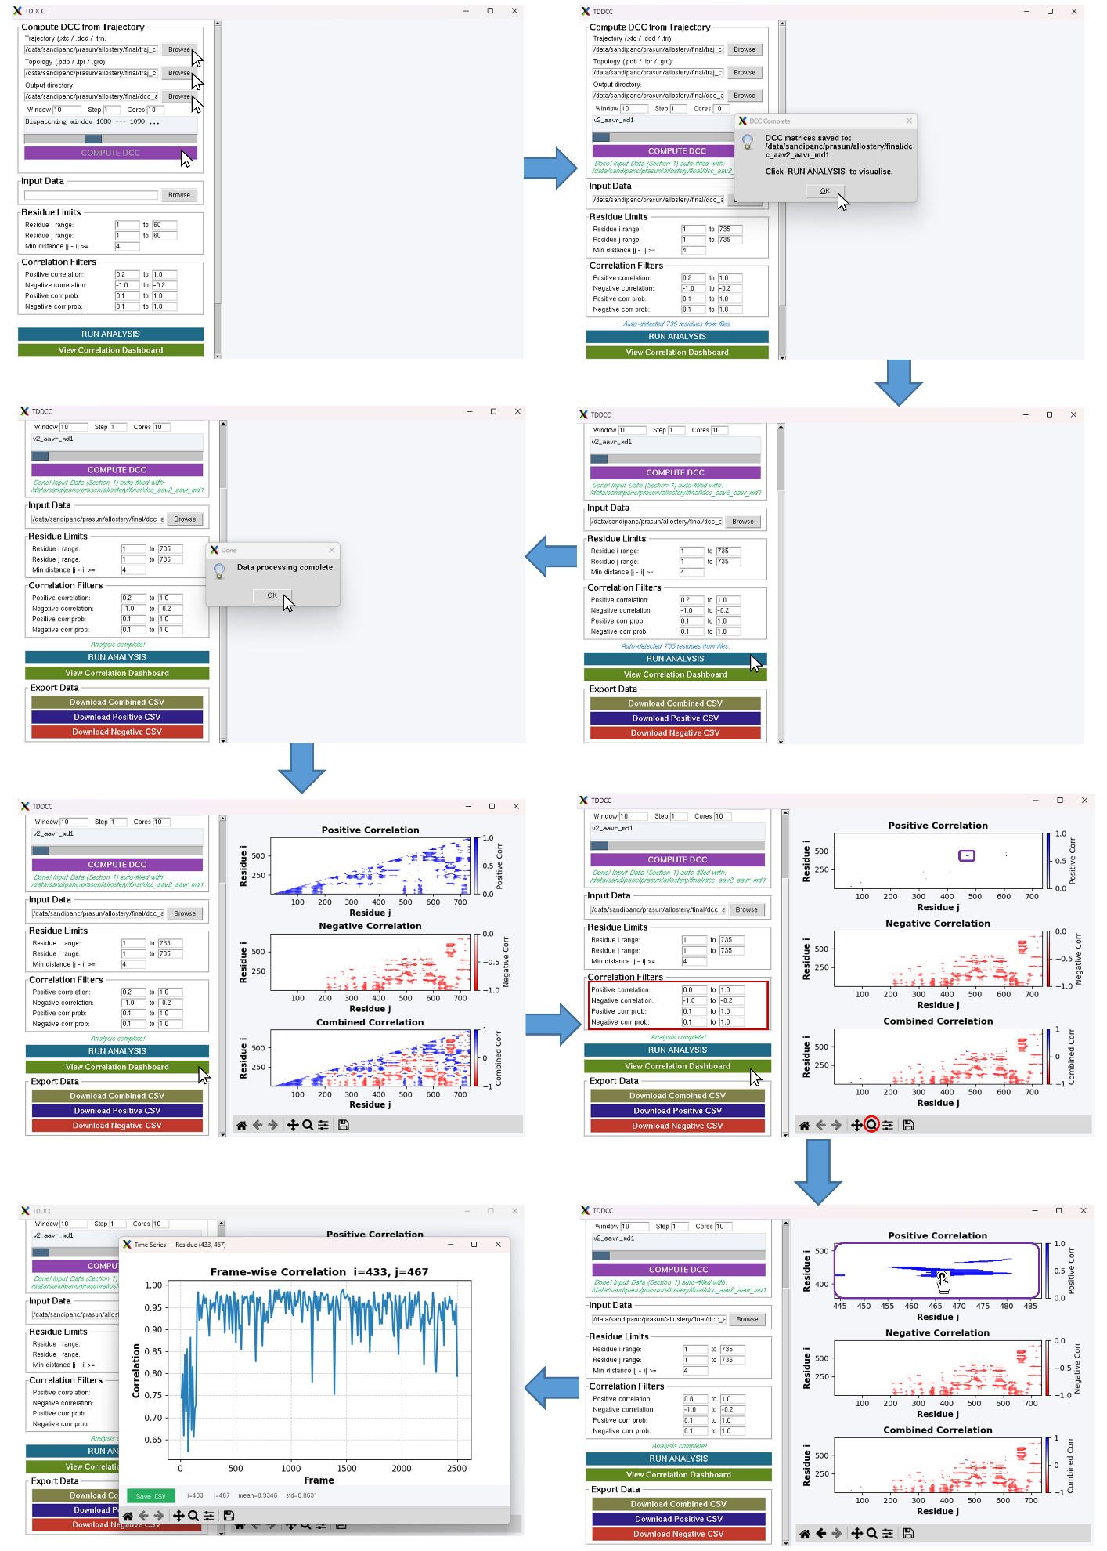
Figure 4 — The dashboard, showing DCC calculation for a sample data set.
NOTE: If MDAnalysis is not installed, it will report an error when you click COMPUTE DCC. Install it with pip install MDAnalysis.

6.2. Setting residue limits and correlation filters
Residue Limits controls which part of the matrix is analyzed:
• Residue i range / Residue j range: the rows and columns to include. Narrowing these speeds up analysis for very large proteins.
• Min distance |j − i| ≥: excludes residue pairs closer together than this threshold along the sequence, which are almost always trivially correlated and are not usually of biological interest.
Correlation Filters controls which residue pairs are highlighted once the statistics are computed:
• Positive correlation/Negative correlation: the range of mean correlation values that count as positively or negatively correlated.
• Positive corr. Prob. / Negative corr. Prob.: the range of occurrence probability — the fraction of windows in which a pair showed that sign of correlation — required for a pair to be included. A high probability means the correlation is consistent across the trajectory rather than driven by a few outlier windows.
Figure 5 — The populated dashboard, showing setting residue limits and running the analysis for a sample data set.
NOTE: The default filters (correlation magnitude ≥ 0.2, probability ≥ 0.1) are a reasonable starting point. You can re-enter different values and click Run Analysis again at any time without reloading your data.

6.3. Running the analysis and reading the dashboard
1. Scroll down and click RUN ANALYSIS. TD-DCC loads every matrix in the Input Data folder and computes, for every qualifying residue pair, the mean correlation, standard deviation, and positive/negative occurrence probability across all windows.
2. When the status line reads “Analysis complete!”, click View Correlation Dashboard.
3. Three heatmaps appear in the right-hand panel: Positive Correlation, Negative Correlation, and Combined Correlation, each showing only the residue pairs that satisfy the filters from Section 3.
Figure 6 — The populated dashboard, showing positive, negative, and combined correlation heat maps for a sample data set.
Each heatmap supports the standard Matplotlib navigation toolbar beneath it, so you can pan, zoom, and save any panel as an image independently of the rest of the dashboard.

6.4. Inspecting a residue pair's time series
To examine how a specific residue pair's correlation behaves across the trajectory rather than just its summary statistic, double-click that cell in any of the three heat maps. A new window opens showing the pair's correlation value across the frames, along with its mean and standard deviation. From this window you can save the plot as a PNG or export the underlying values as a CSV.
Figure 7 — The dashboard, showing the residue pair time series for a sample data set.
TIP: This view is the best way to confirm that a filtered hit reflects a persistent, biologically meaningful correlation rather than one driven by a handful of unusual windows.

6.5. Exporting results
The Export Data section provides three buttons:
• Download Combined CSV — every residue pair satisfying either the positive or the negative filter.
• Download Positive CSV — pairs only satisfying the positive filter.
• Download Negative CSV — pairs only satisfying the negative filter.
Each CSV contains one row per residue pair, with columns for residue i, residue j, mean correlation, and positive/negative/occurrence probability — ready for further analysis in a spreadsheet, R, or Python.

7. Output Files
File | Description
corr_dcc_<frame>.txt | Plain-text N×N correlation matrix for one window, named by the index of the window's last frame. Produced by the Section “Compute DCC from Trajectory” and consumed by Section “Input Data”.
corr_dcc_<frame>.png | A heat map image of the same window's matrix, using TD-DCC's diverging blue–white–red colormap, saved alongside the text file for quick visual inspection without reopening the dashboard.
Combined/Positive/ Negative CSV | Exported from the dashboard via the Export Data buttons; one row per qualifying residue pair with mean correlation, standard deviation, and occurrence probability.
Time-series PNG / CSV | Exported from the double-click time-series inspector window for a single residue pair.

8. Troubleshooting
Symptom | Likely cause and fix
ModuleNotFoundError: No module named 'tkinter' | Tkinter is missing from your Python installation. On Linux, install it with your system package manager (e.g. sudo apt install python3-tk). See Section 3.1.
“Please select a valid trajectory file” when clicking COMPUTE DCC | Browse to a folder containing the MD simulation trajectory first.
“Please select a valid topology file” when clicking COMPUTE DCC | Browse to a folder containing the MD simulation topology.
“Please select an output Directory” file when clicking COMPUTE DCC | Create and browse to a folder where the time windowed dcc images and txt files will be generated.
COMPUTE DCC fails immediately or reports MDAnalysis is unavailable | MDAnalysis is not installed. Run pip install MDAnalysis in the same environment you use to launch TD-DCC.
The window opens but appears blank or frozen while computing | Large trajectories or a high Window/Step/Cores combination can take time. Progress is reported in the Section log box and the main status line; avoid closing the window while a computation is in progress.
“Invalid input directory” when clicking Run Analysis | Browse to a folder containing the .txt matrices first.
“No .txt files found in selected folder” when clicking Run Analysis | The selected Input Data folder does not contain any plain-text matrix files. Confirm you selected the output directory from Workflow.
“No valid matrix data with selected range” when clicking Run Analysis | In Residue limit, j must be greater than or equal to i. Confirm you selected the residues properly.
Plots or buttons look cut off at the bottom of the screen | The control panel is scrollable. Drag the thin scrollbar at its right edge downward to reveal Run Analysis, View Correlation Dashboard, and Export Data.
End of document.

