**TURTLE**

Turtle is a **pre-installed library** in Python that is similar to the **virtual canvas** that we can **draw pictures and attractive shapes**.

The **turtle** Library is primarily designed to **introduce children to the world of programming**. With the help of Turtle's library, new programmers can get an idea of how we can do programming with [Python](https://www.javatpoint.com/python-tutorial) in a fun and interactive way.

It is beneficial to the children and for the experienced programmer because it allows **designing unique shapes, attractive pictures, and various games**.

The Python turtle **library** **consists** of all important **methods and functions** that we will need to create our designs and images. Import the turtle library using the following command:

**import** turtle

**Get blank screen:**

**import** turtle

s = turtle.getscreen()

**Output:**

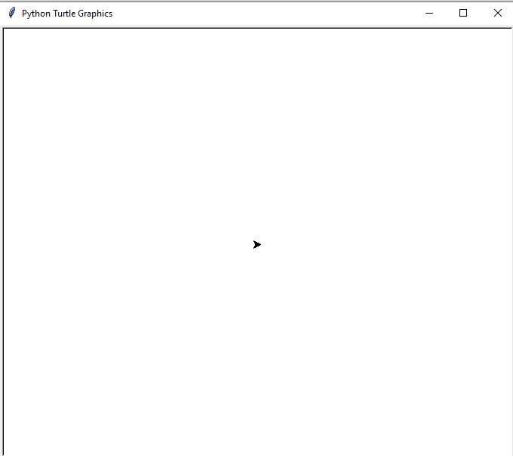

The screen same as the canvas and **turtle acts like a pen.** You can **move the turtle to design the desired shape**. The turtle has certain changeable features such as **color, speed, and size.** It can be moved to a specific direction, and move in that direction unless we tell it otherwise.

Turtle can be moved in **four directions.**

* Forward
* Backward
* Left
* Right

**Move forward:**

import turtle

# Creating turtle screen

t = turtle.Turtle()

# To stop the screen to display

t.forward(100)

turtle.mainloop()

**Output**:

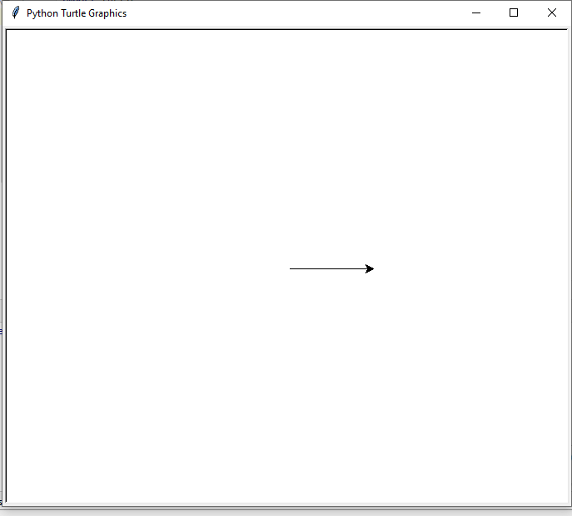

**Move Backward:**

import turtle

# Creating turtle screen

t = turtle.Turtle()

# Move turtle in opposite direction

t.backward(100)

# To stop the screen to display

turtle.mainloop()

Output:

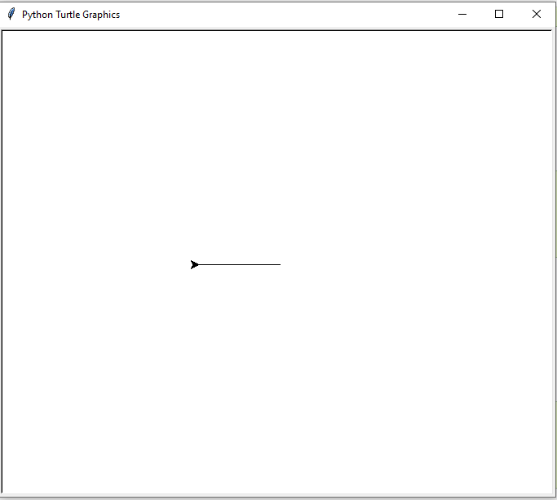

**Drawing Shapes:**

import turtle

# Creating turtle screen

t = turtle.Turtle()

t.circle(50)

turtle.mainloop()

**Output**:

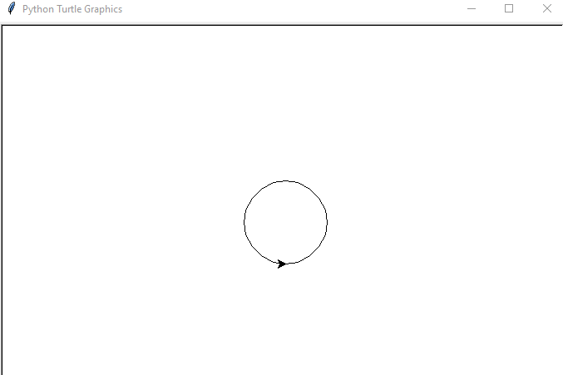

e.g.

import turtle

# Creating turtle screen

t = turtle.Turtle()

t.dot(50)

turtle.mainloop()

Output:

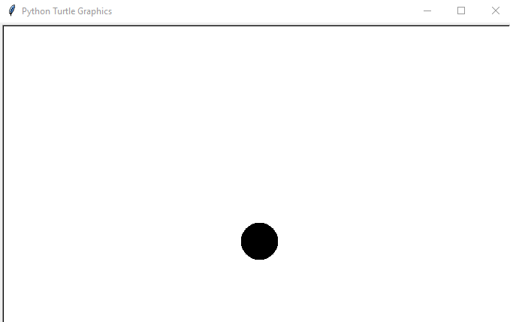

e.g.

**import** turtle  
  
*# Creating turtle screen*t = turtle.Turtle()  
  
turtle.bgcolor(**"red"**)  
  
turtle.mainloop()

Output:

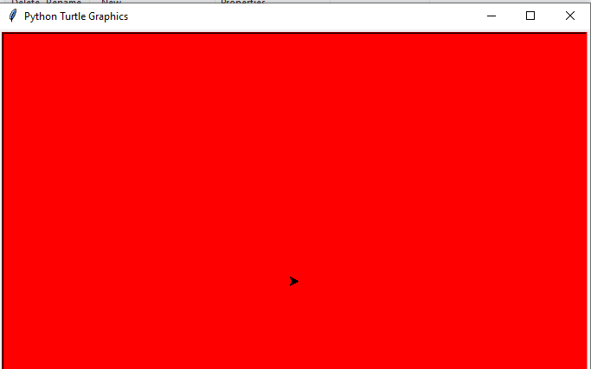

e.g.

**import** turtle  
**import** time  
turtle.color(**"blue"**)  
turtle.begin_fill()  
turtle.circle(500)  
turtle.end_fill()  
time.sleep(2)

thank you