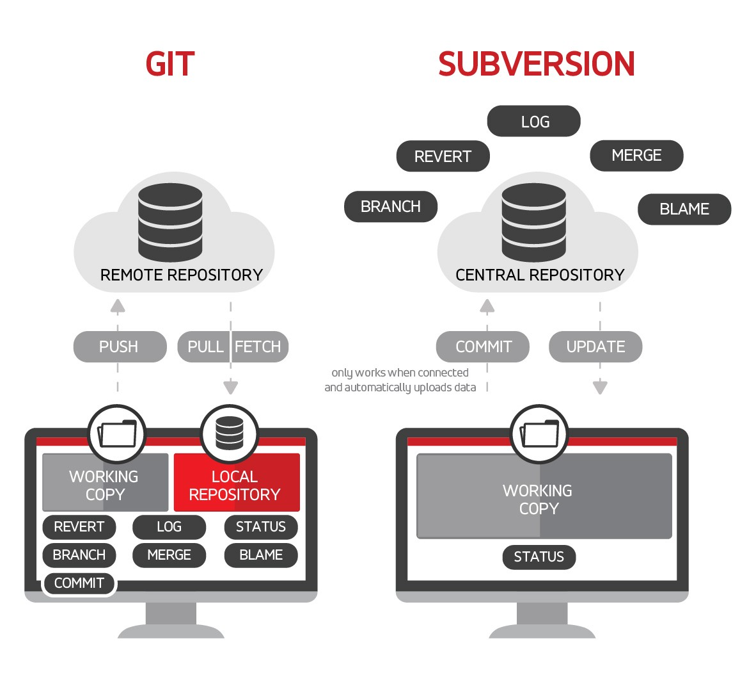

**Distributed Version Control System**: Git has a **remote repository** which is stored in a **server** and a **local repository(distributed copies)** which is stored in the computer **of each developer**. This means that the **code is not just stored in a central server, but the full copy of the code is present in all the developers’ computers.** Git is a Distributed Version Control System since the code is present in every developer’s computer.

**Benefit:Even if server /remote repository fails 🡪You will have local copy**