**Assignment No 1**

**C# Console Application**

**Last date of submission: 21st August 2025**

1. C# Program to Check Whether a Given Number is even or odd

2. C# Program to Check Whether a Number is Positive or Not

3. C# Program to Find the Largest of three Numbers

4. C# Program to Swap Two Numbers

5. C# Program to Find the Sum of All the Multiples of 3 and 5

6. C# Program to Find Sum of Digits of a Number

7. C# Program to Reverse a Number and Check if it is a Palindrome

8. C# Program to Calculate the Sum, Multiplication, Division and Subtraction of Two Numbers

9. C# Program to Read a Grade and Display the Equivalent Description

10. C# Program to Convert Lowercase Characters by Uppercase and Vice-Versa

11. C# Program to Check Whether a Given Number is Perfect Number

12. C# Program to Check Armstrong Number

13. C# Program to Reverse a Number

14. C# Program to Concatenate Two Strings

15. C# Program to Find the Length of a String

**Assignment No 2**

**Function and Delegates**

**Last date of submission: 25th August 2025**

**Using Functions:**

1. C# Program to Check Whether a Given Number is even or odd

2. C# Program to Check Whether a Number is Positive or Not

3. C# Program to Find the Largest of three Numbers

4. C# Program to Swap Two Numbers

5. C# Program to Find the Sum of All the Multiples of 3 and 5

6. C# Program to Find Sum of Digits of a Number

**Using Delegates:**

1. C# Program to Reverse a Number and Check if it is a Palindrome
2. C# Program to Calculate the Sum, Multiplication, Division and Subtraction of Two Numbers
3. C# Program to Read a Grade and Display the Equivalent Description
4. C# Program to Convert Lowercase Characters by Uppercase and Vice-Versa
5. C# Program to Check Whether a Given Number is Perfect Number
6. C# Program to Check Armstrong Number
7. C# Program to Reverse a Number
8. C# Program to Concatenate Two Strings
9. C# Program to Find the Length of a String

**Assignment No 3**

**Web Form Applications**

**Last date of submission: 8th Sept. 2025**

Q.1. Write C# Program to Design following form and Display appropriate result in message box after clicking command button.

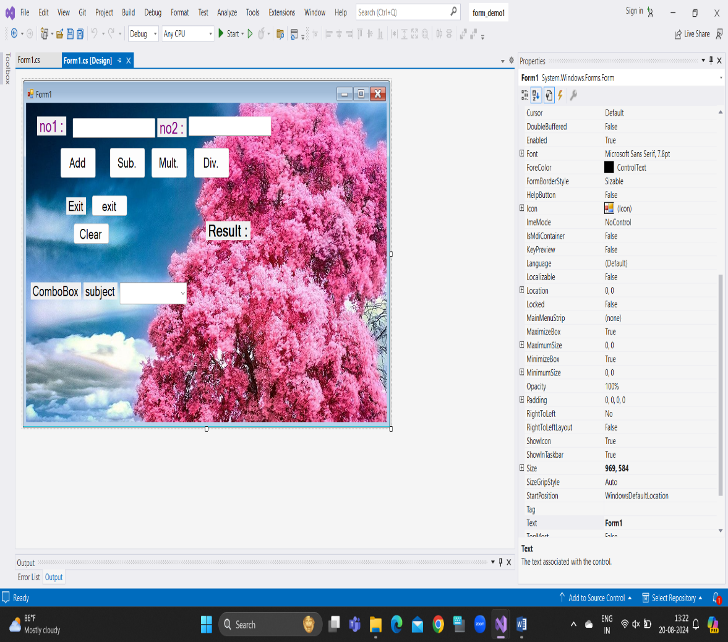

Q.2.Write C# Net program to take three text boxes and two buttons on the form. Enter different strings in first and second textbox. On clicking the First command button, **concatenation of two strings** should be displayed in third text box and on clicking second command button, **reverse of string** should display in third text box.

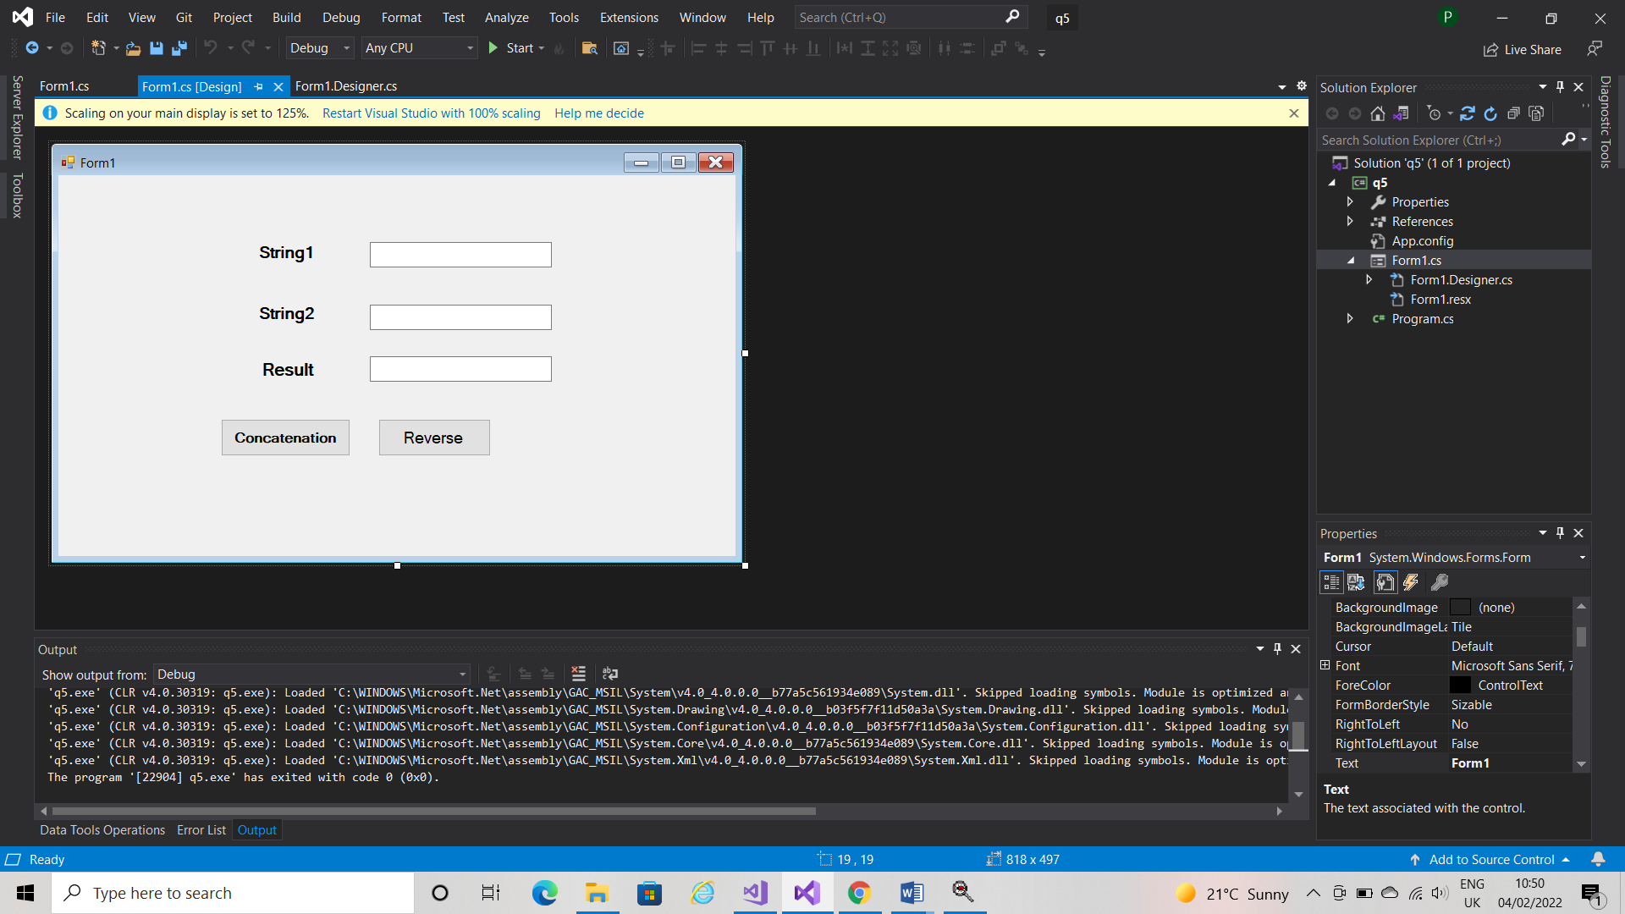

Q.3. Write C#.Net Program to Design following form to display Selected Stream & Computer Knowledge (Use panel) and Display following Message box. When clicked on New button form should be reset.

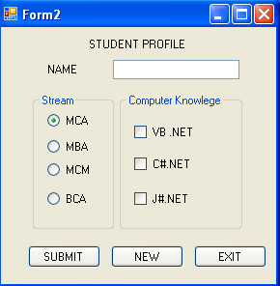

Q.4. Write c#.Net Program to Design following form to store numbers in single dimensional array and to find Maximum no & sum of all numbers in array.

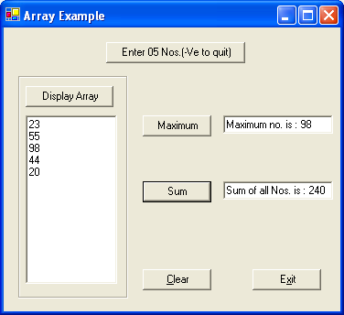

Q.5. Write C# Program to Design following form and Display appropriate result in message box after clicking command button.

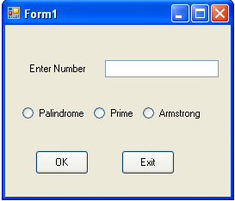

Q.6. Create windows application enter the list of cities name in combo box control and user select city name from combo box and display the city on dialog box.

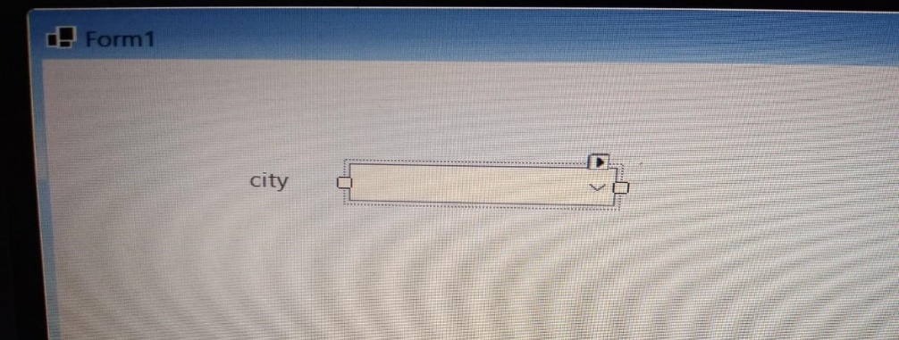

Q.7. Create windows application to select the date using calendar and display the selected date in label and message box.

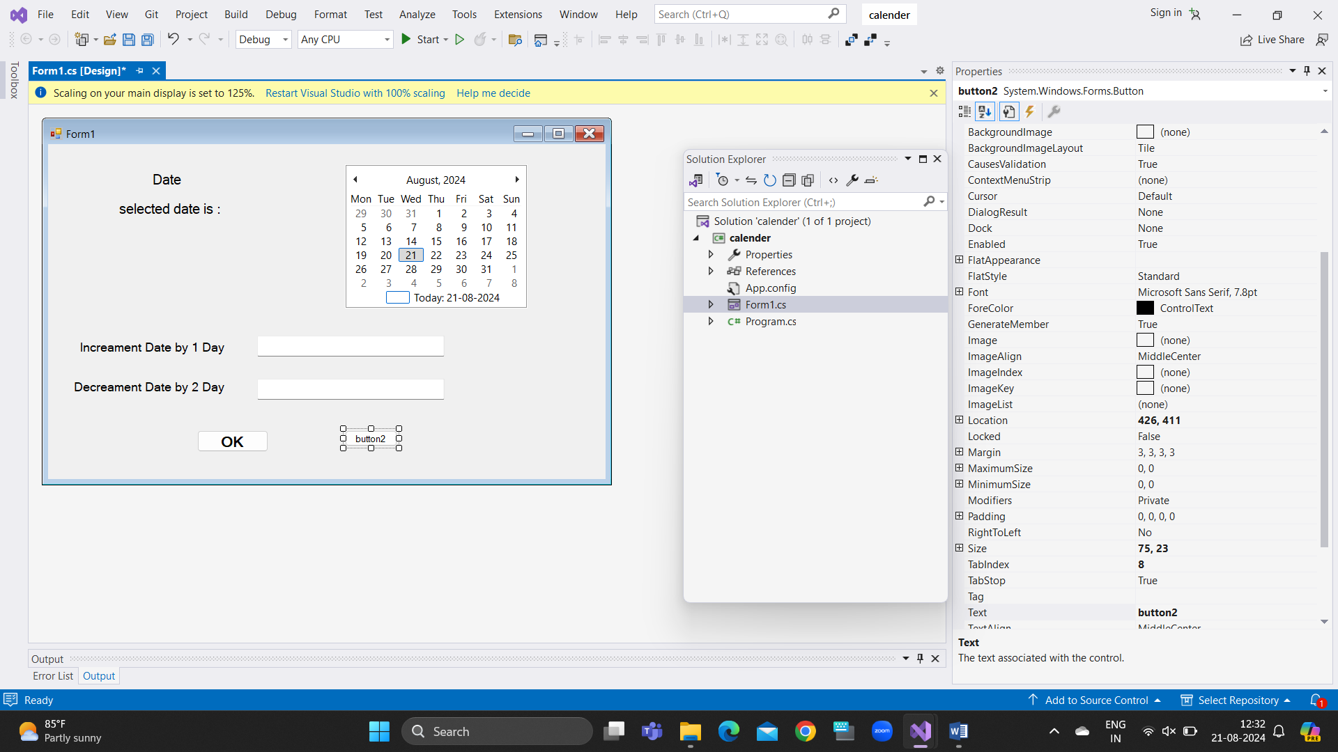

Q.8. Create windows application to design following form and display array in list Box ,find maximum value from array and sum of array values in particular text boxes.

