Insurance

ABSTRACT

The objective of the project is to automate the management of insurance activities of an insurance company. The einsurance firms take entire charge of any such losses against the payment forfeited every month in the form of premium. EInsurance is a commercial means for relocating risks and covering fiscal losses.The purpose is to design a system using which users can perform all activities related to insurance company. E-insurance should reduce internal administration and management costs by automating business processes, permitting real-time networking of company departments, and improving management information. It should reduce the commissions paid to intermediaries since it can be sold directly to clients. For insurance sold to individuals, agents typically receive a commission of 10 to 15 percent for non-life policy sales and renewals and from35 to 100 percent for life insurance policies in the first policy year, but much lesson renewal. However, some of the income gained in commissions that are not paid to intermediaries must be spent on online customer acquisition and marketing.

EXISTING SYSTEM:

The present systems are ineffective in maintaining all the relevant details. The information is maintained across files and ledgers. Often the data is mismanaged and this results in data losses. It is difficult to retrieve the required data efficiently. It is also difficult to coordinate information arising from different branches.

PROPOSED SYSTEM:

Users of library can login to the portal and they can refer the availability of required policies. The proposed system is a web based application which maintains a centralized repository of all information. This makes it convenient to access required data easily. Various reports can be generated by the managers. The system integrated all information related to various branches. Using the system customers can make online payments.

MODULE DESCRIPTION

Number of Modules:
After careful analysis the system has been identified to have the following modules:

- CEO
- Manager
- Agent
- Customer

1. CEO Module:
The CEO is the Super user of the System. The CEO is responsible for defining the policies, policy terms and conditions, policy amounts, establishing the different branches, registration of the branch managers. CEO will also get information about policy details, branch details, manager details, agents details, customers details, customers policy details
2. Manager Module:
Manager is responsible for all activities at a specific branch. A manager appoints agents and interacts with customers. A manager can get data about customer policies, dues and payment details. A manager can also get agent details and commission information. A manager can generate various reports.

3. Agent Module:
Agents are employees of the insurance company who interact with potential customers and offer the necessary details, agents typically act as a liaison between customers and company. Agents are entitled for commission for each policy they sell. Using the system an agent can find customer’s policies details, customer’s personal details, commission collected, reports, available policy details, concerned manager details and agent personal details.
4. Customer Module:
Each customer must register with the system before one can avail the services. Customers can seek information regarding policies, register new policies, make online payments etc

PROCESS FLOW:

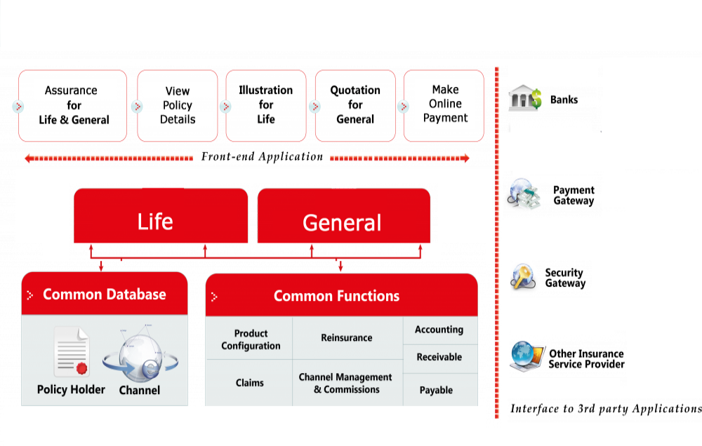

Software requirements:

Operating System : Windows
Technology : Java and J2EE
Web Technologies : Html, JavaScript, CSS ,Servlet
IDE : My Eclipse
Web Server : Tomcat
Tookit : Android Phone
Database : Oracle
Java Version : J2SDK1.8

Hardware requirements:

Hardware - Pentium
Speed - 1.1 GHz
RAM - 1GB
Hard Disk - 20 GB
Floppy Drive - 1.44 MB
Key Board - Standard Windows Keyboard
Mouse - Two or Three Button Mouse
Monitor - SVGA

