RENT AND DRIVE APPLICATION USING MICRO-SERVICES

- Application will support user and admin role. Use HTML/CSS either for admin or front end.
- Platform to hire cars from someone for specific time and drive.
- Admin will add cars brand and respective models. (Variants details can be added if required)
- User can see various cars options available to for rent.
- Car owner can add car detail under specific brand and model with the below mentioned information.
  - Make of cars.
  - Cost for a single day
  - Images.
  - Mileage.
  - Car Availability.
  - City and Area code/location.
- Security document and other information required.
- User can choose the car by applying filter make, brand and model.
- User can also apply filter on fuel and transmission type, millage etc.
- Once user shot list the car to rent, user can send enquiry for the car with schedule.
- Admin will add all offers and services details.
Project Requirement
- MICRO-SERVICE

- MySql

- Rest Web Services API

MODULES :
      - HOME PAGE
      - RENTER
      - USER
      - ADMIN
      - FEEDBACK
      - ADMIN LOGIN PAGE
      - USER REGISTER AND LOGIN PAGE
      - RENTER REGISTER

DESIGN:

ADMIN PAGE

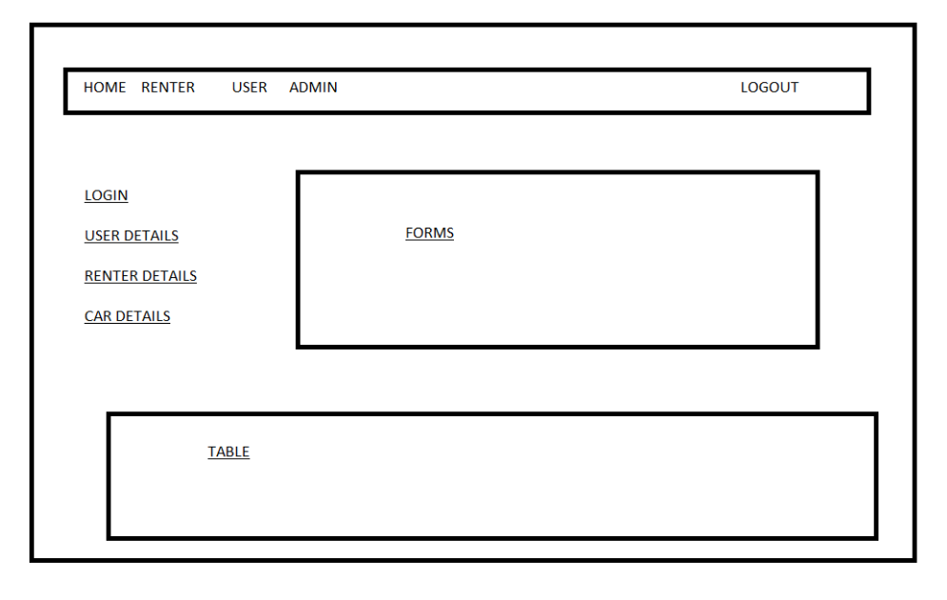

HOME PAGE

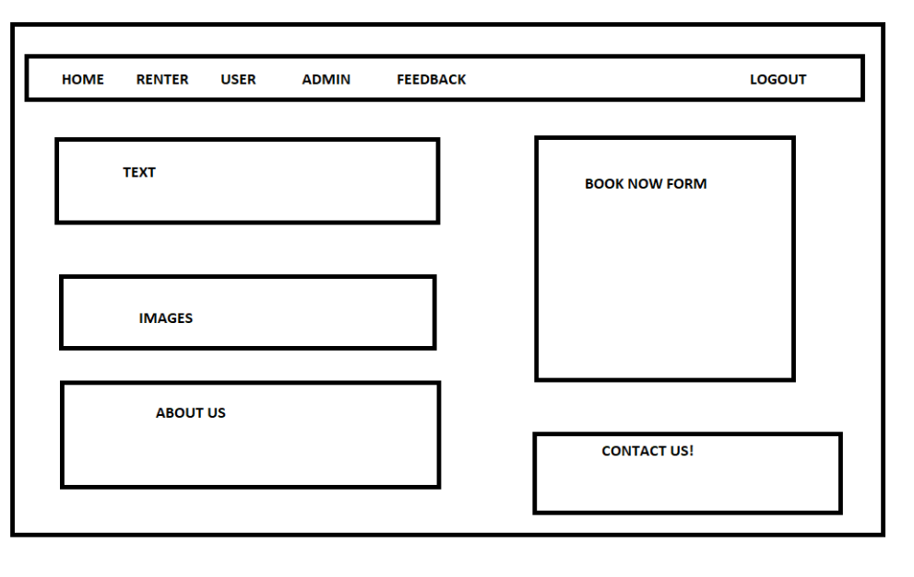

USER MODULE
1.USER PAGE

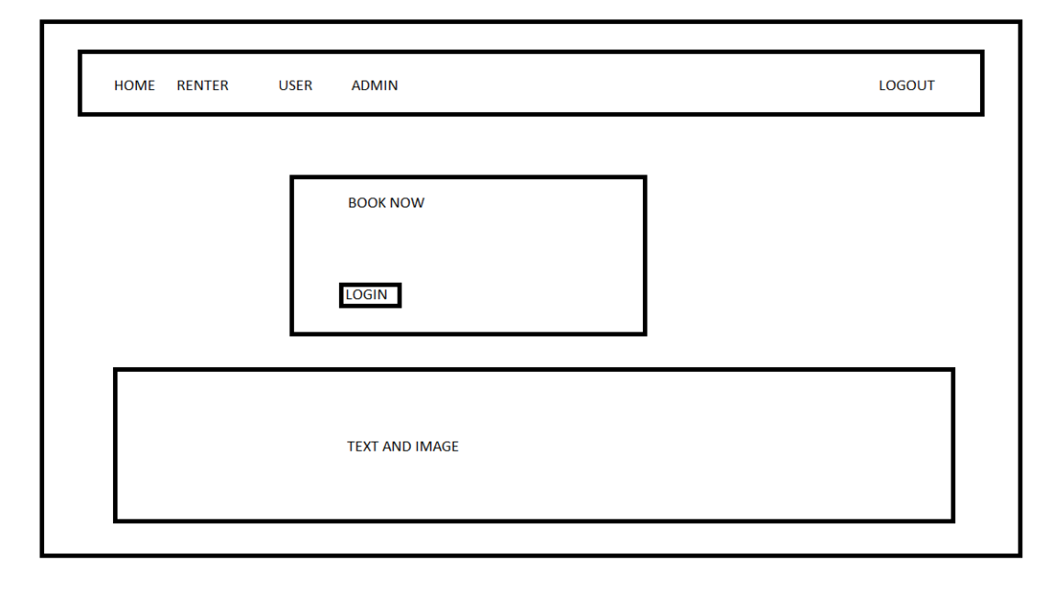
2. VEIW CAR DETAILS

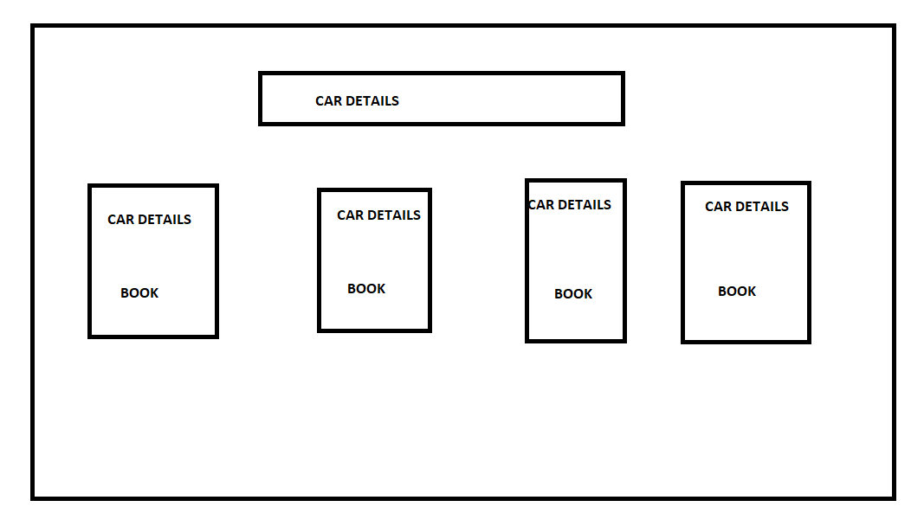

3. LOGIN PAGE

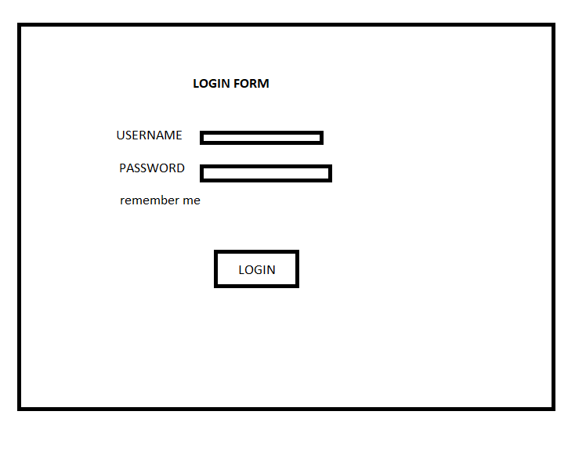

4.BOOKING PAGE
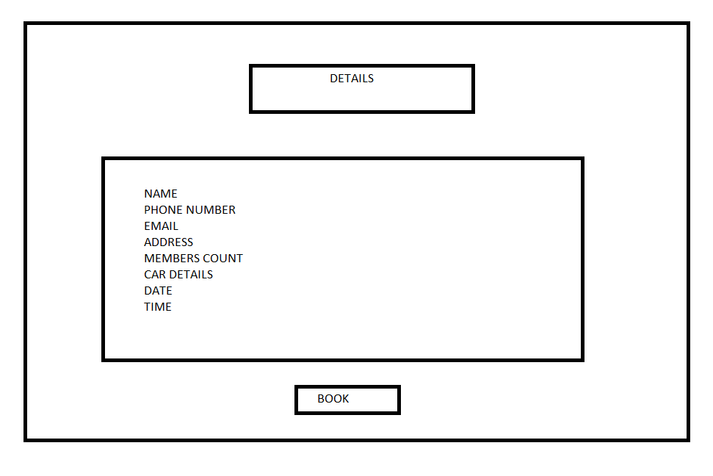

FEEDBACK
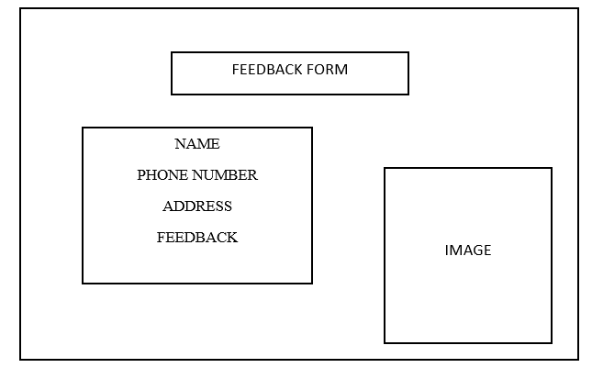

RENTER MODULE:

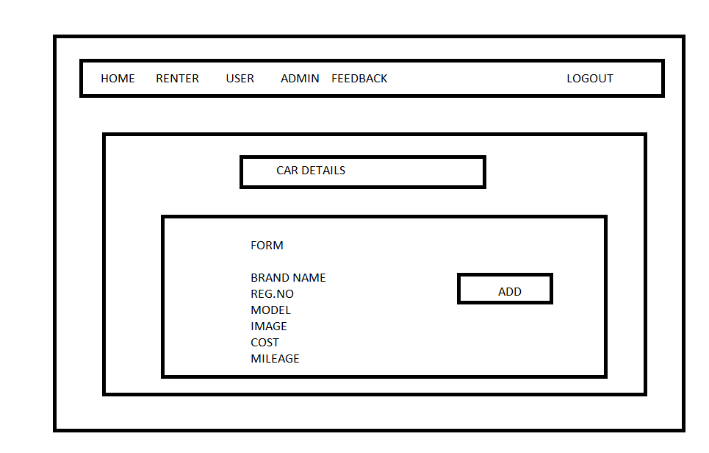

USER REGISTRATION PAGE

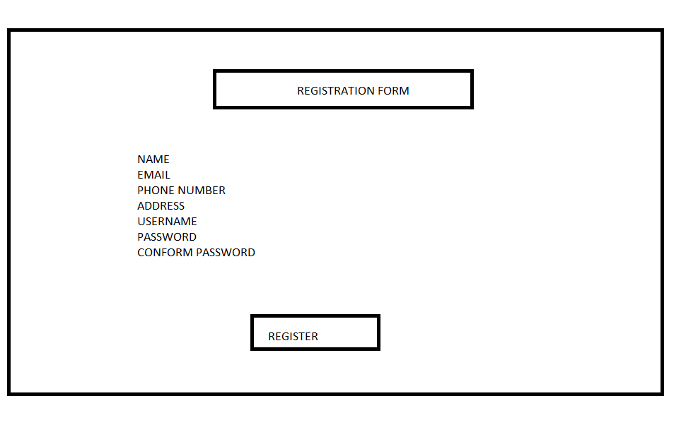

RENTER REGISTRATION PAGE

