**Clustering with Real Application Clusters**

Clustering is ideal for two or more servers that have shared resources, such as disks. In case there is a hardware failure on one server in the cluster, the other servers can pick up the workload until the failed server is brought back up.

Oracle RAC servers share a disk and have the same Oracle Database but with different instances running on each node. If one node fails, the connections failover to the other nodes. The instances do not failover, because they are just the processes on each server that access the same data. Oracle Database is available from any of the nodes in the cluster.

[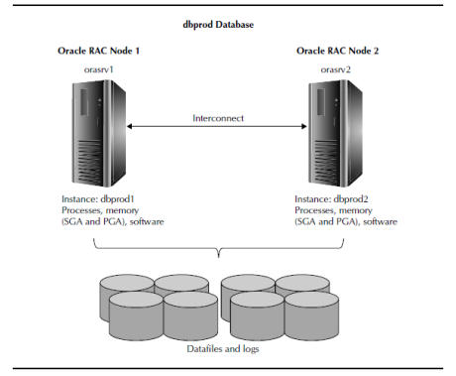](https://intellipaat.com/wp-content/uploads/2015/09/oracle-rac-servers-share-the-same-database-on-all-nodes.png)

The **advantage of Oracle RAC** is that resources on both nodes are used by the database, and each node uses its own memory and CPU. Information is shared between nodes through the interconnect—the virtual private network.

**Real Application Clusters** provide high availability because of the failover of connections in the event of a hardware failure or server connection failure. The RAC environment also provides high availability for patching with rolling upgrades (Oracle Database 11g). We can easily add a new server with memory and CPU to the cluster, make new connections to the new node, and the workload will be rebalanced among all of the nodes.