**Flume Installation**

**Step 1:**

**Java Runtime Environment - Java 1.6 or later (Java 1.7 Recommended).**

**Memory - Sufficient memory for configurations used by sources, channels or sinks.**



**Disk Space - Sufficient disk space for configurations used by channels or sinks.**



**Directory Permissions - Read/Write permissions for directories used by agent.**



**Hadoop releases - 0.20, 0.23, 1.0 and 2.0. HBase releases – 0.98.0 and above versions.**



**Step 2:**

**Download flume from the following link**

**http://**

**Step 3:**

**Untar the file what we are download in the site as the following way.**

**$ cp /home/babu/Downloads/apache-flume-1.4.0-bin.tar /usr/local $ cd /usr/local**

**$ sudo tar -xzvf apache-flume-1.4.0-bin.tar**

**$ sudo ln -s apache-flume-1.4.0-bin.tar flume**

**Step 4:**

**Set the add $FLUME_HOME path in ~/.bashrc file**

**$ sudo nano ~/.bashrc**

**export FLUME_HOME=/usr/local/flume**

**export PATH=$FLUME_HOME/bin:$PATH { OR }**

**export FLUME_HOME=/usr/local/flume**

**export PATH=$PATH:$FLUME_HOME/bin**

**Step 5:**

**NOTE:**

**After setting the “ FLUME_HOME ” path, we must check weather all daemons of Hadoop is running are not using “jps”**

**Here, we give an example configuration file, describing a single-node Flume deployment.**

**This configuration lets a user generate events and subsequently logs them to the console.**

**NOTE: Create one configuration file using nano or gedit editor , the name can be anything for that file, but it ends with .conf**

**$ gedit netcat.conf**

* **netcat.conf: A single-node Flume configuration**
* **Name the components on this agent a1.sources = r1**

**a1.sinks = k1 a1.channels = c1**

* **Describe/configure the source a1.sources.r1.type = netcat a1.sources.r1.bind = localhost a1.sources.r1.port = 44444**
* **Describe the sink**

**a1.sinks.k1.type = logger**

* **Use a channel which buffers events in memory a1.channels.c1.type = memory a1.channels.c1.capacity = 1000 a1.channels.c1.transactionCapacity = 100**
* **Bind the source and sink to the channel a1.sources.r1.channels = c1 a1.sinks.k1.channel = c1**

**Step 6:**

**Copy that .conf file into $FLUME_HOME/conf/ using the following command.**

**$sudo cp /home/babu/Desktop/netcat.conf /usr/local/flume/conf/**

**Step 7:**

**Then the run the following command $ cd /usr/local/flume/bin/**

**bin$ flume-ng agent -n a1 -c conf -f /usr/local/flume/conf/netcat.conf**

**then you can see the following trace :**

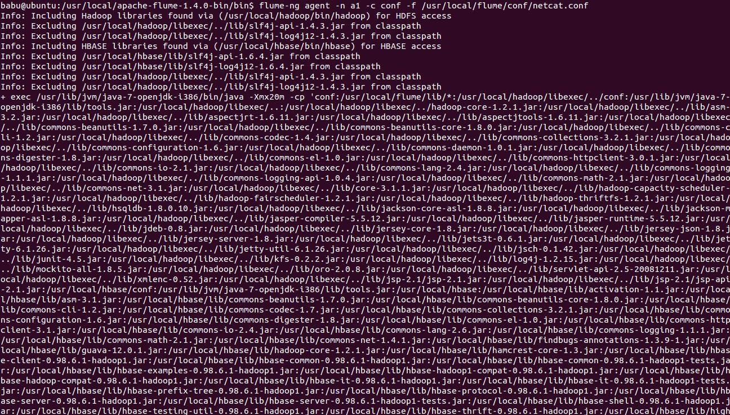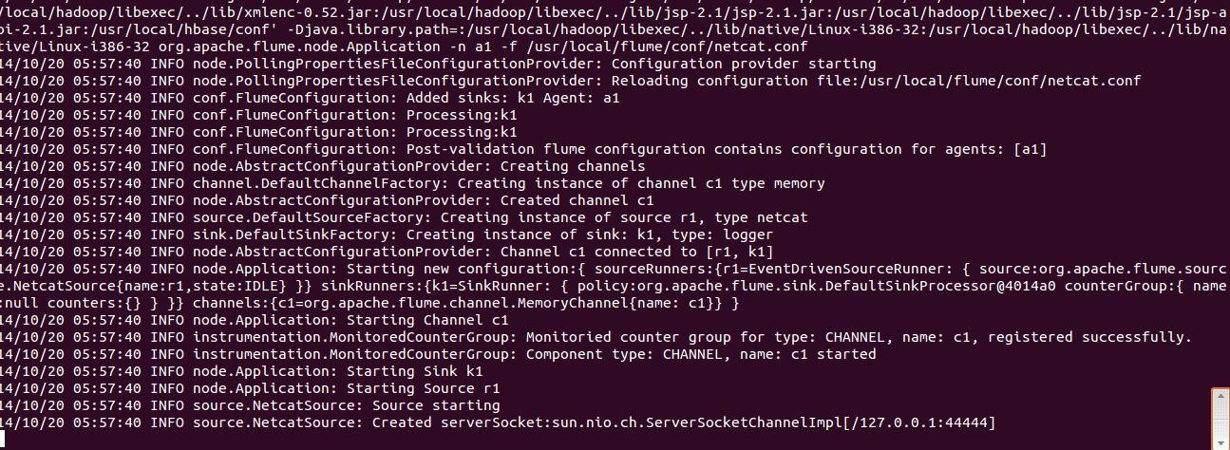

**If you get the trace successfully , you need to open another terminal for testing the flume**

**Press Ctrl+t**

**Then communicate with the connection $ telnet localhost 44444**

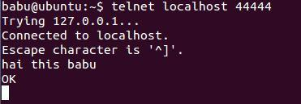

**After getting the trace , you just type something press ENTER**

**Step 8:**

**Now you able to find ASCII code trace similar to your message on previous window.**



http://www.thecloudavenue.com/2013/03/analyse-tweets-using-flume-hadoop-and.html